**ASSIGNMENT 18.3 :**

Merge the small files in hadoop by following the below blog.

STEP 1: I’ve listed all the files inside the directory merging.

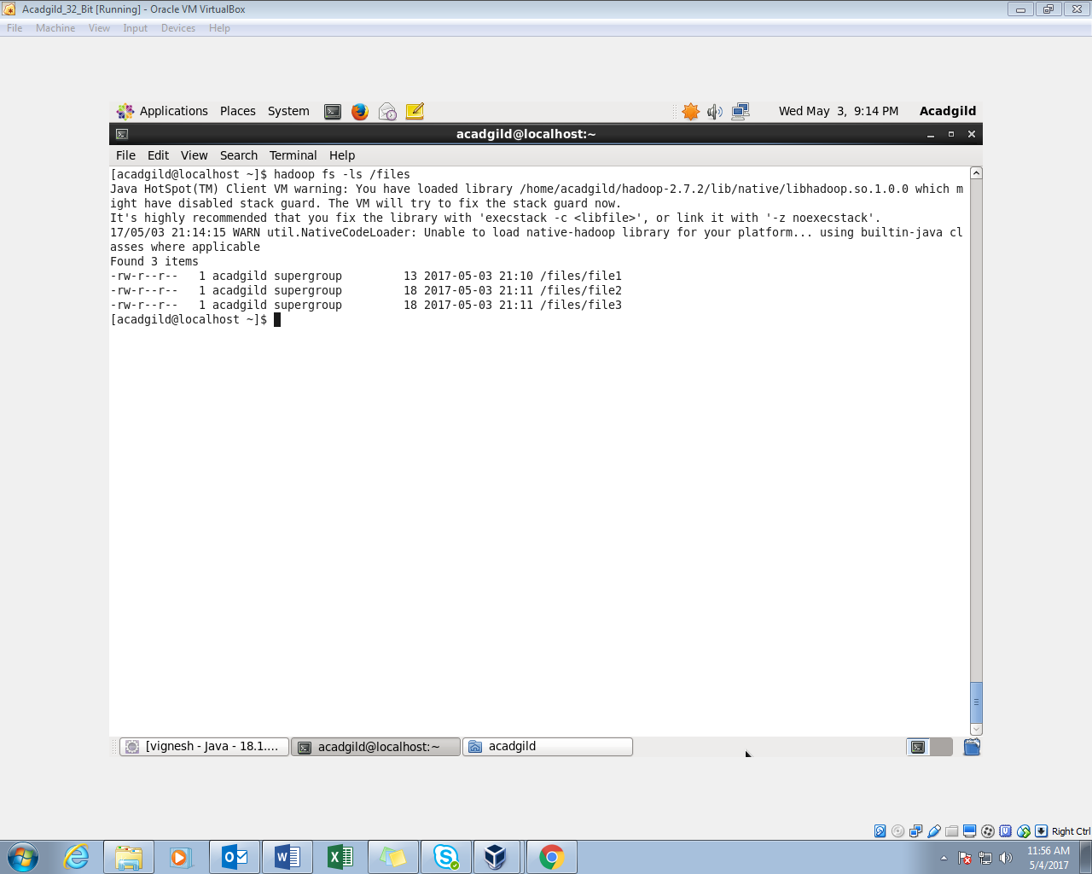

STEP 2: I’ve opened the contents of the file using cat command

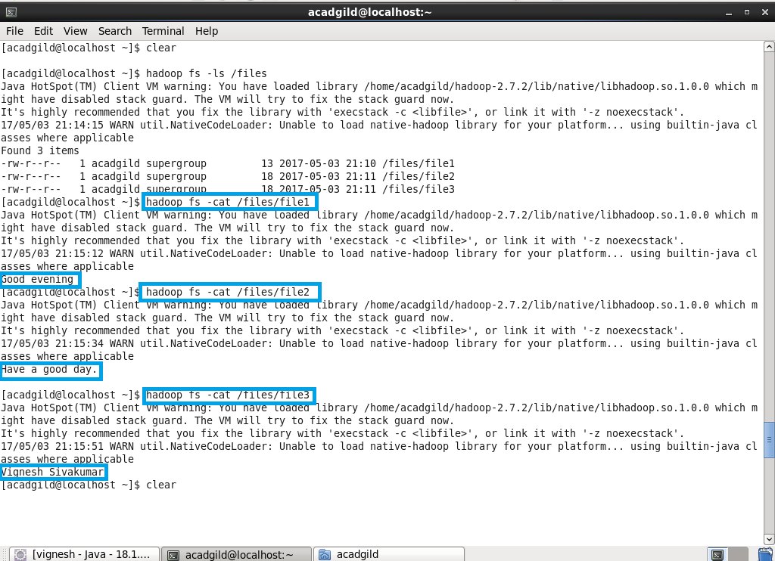

STEP 3: Using getmerge command, contents of all the 3 files will be merged to form a new file called mergedop.txt which will be in local system.

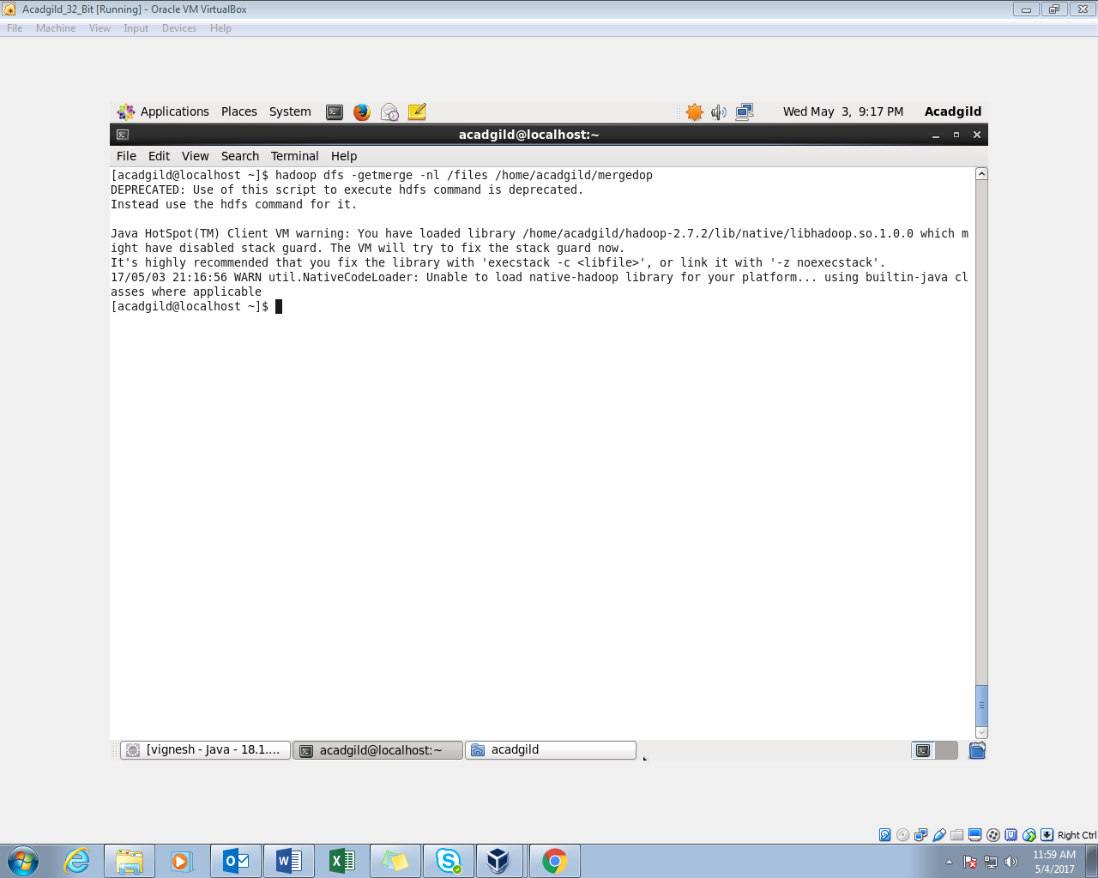

STEP 4: Reading the mergedtext.txt using cat command

Previously the above three lines were in 3 different files. By merging these 3 files into a single file, I got this output.

