**ASSIGNMENT 19.3 :**

Write a MapReduce program that takes the output of Task 5 (refer session 7, assignment 1) as input, and produce output which is sorted on the total units sold. You may use a single reducer for the sorting. Use Sequence File formats as an output of Task 5 and as input for this task

**DRIVER CLASS:**

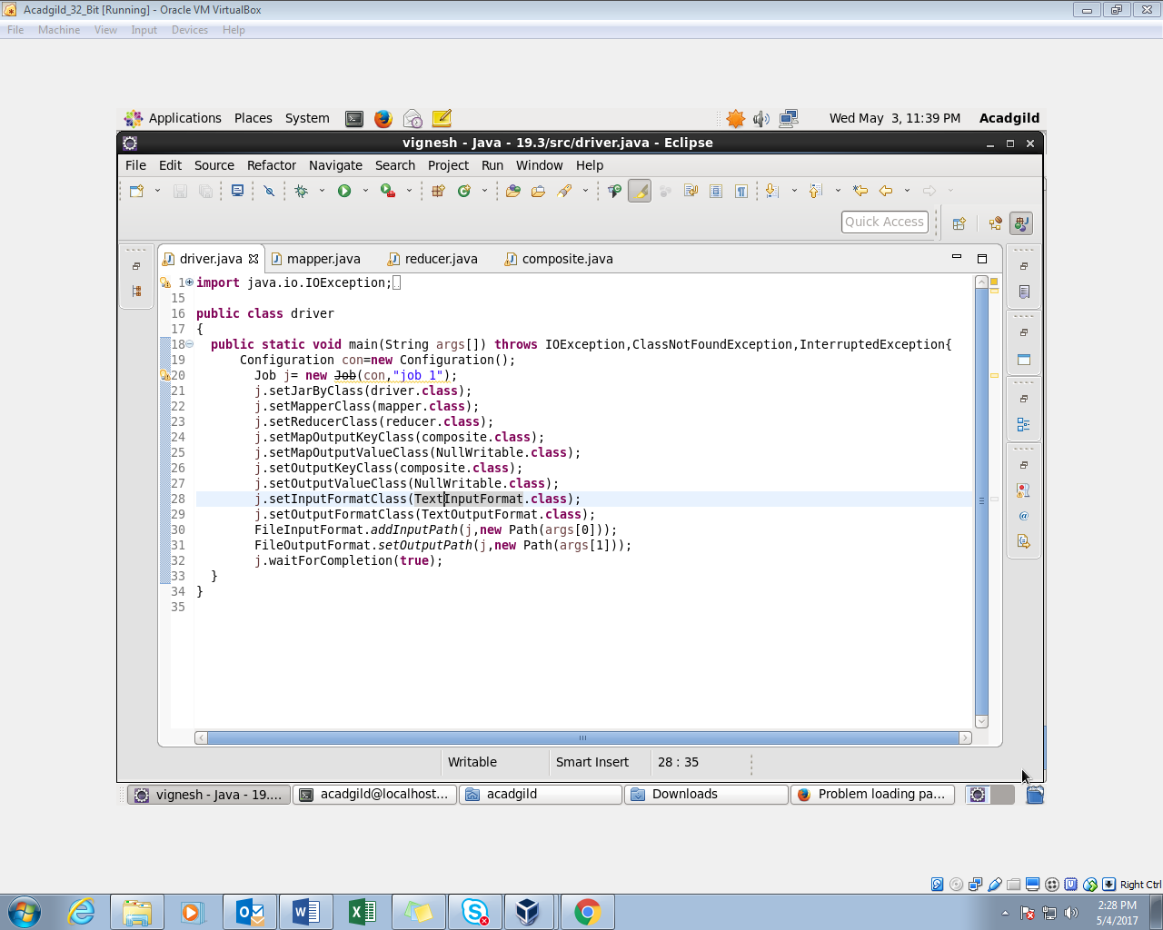

**MAPPER CLASS:**

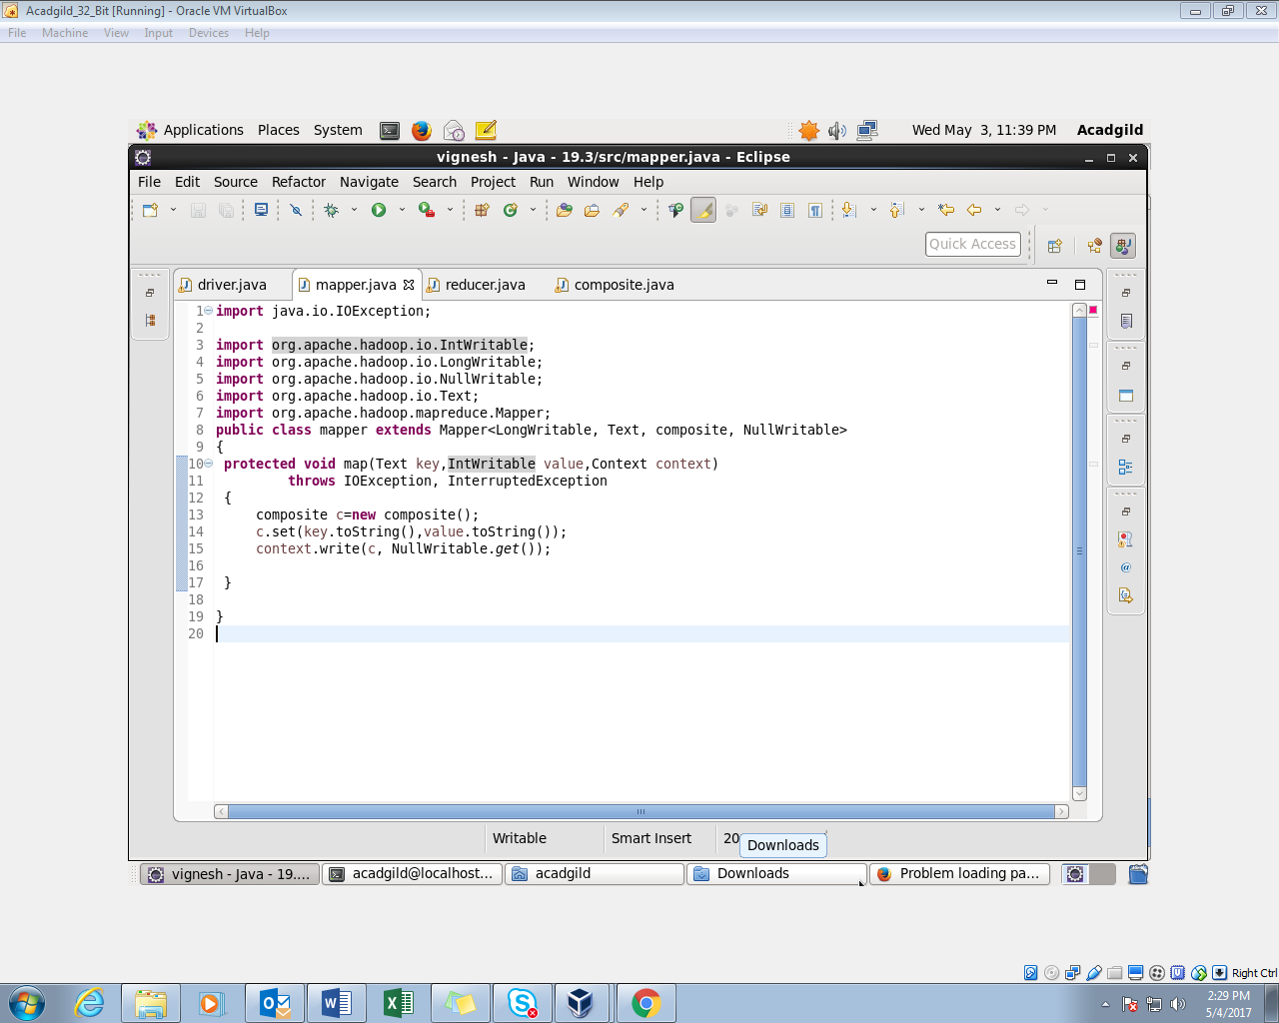

**COMPOSITE KEY:**

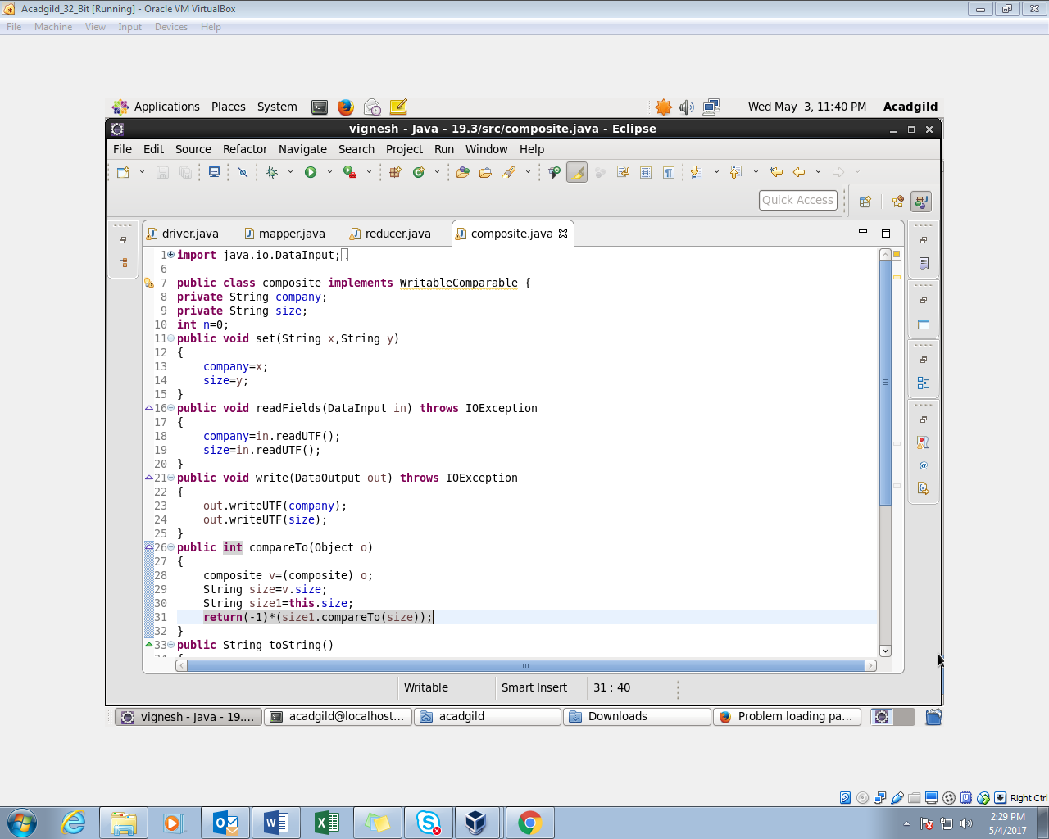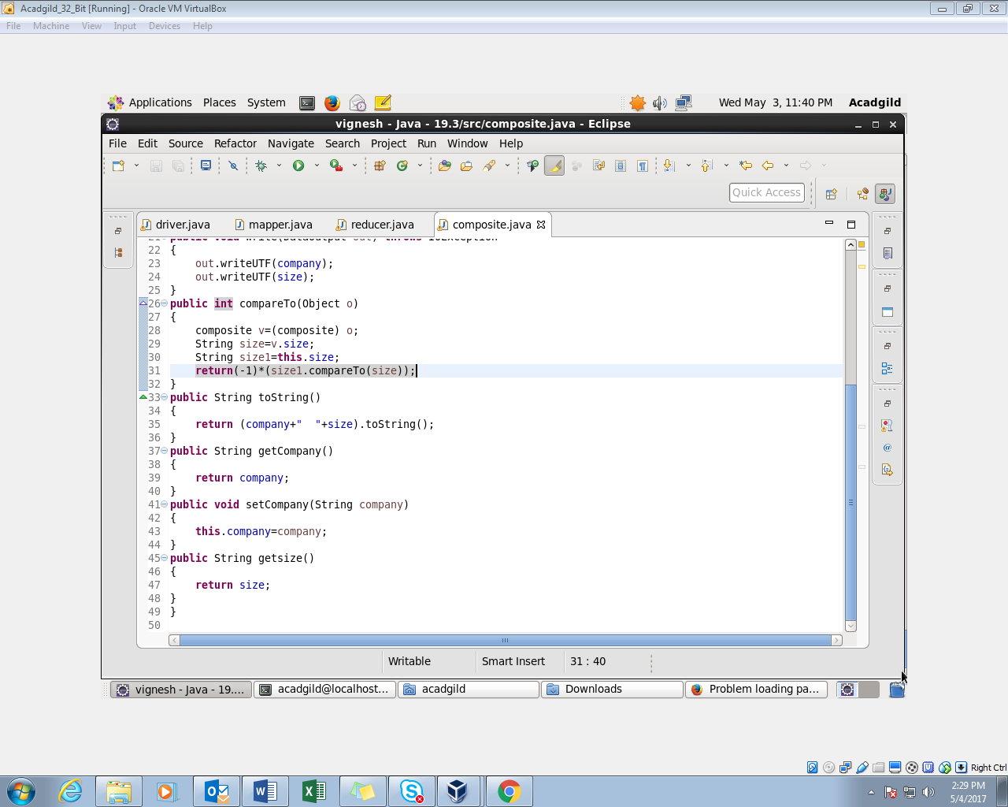

**REDUCER CLASS:**

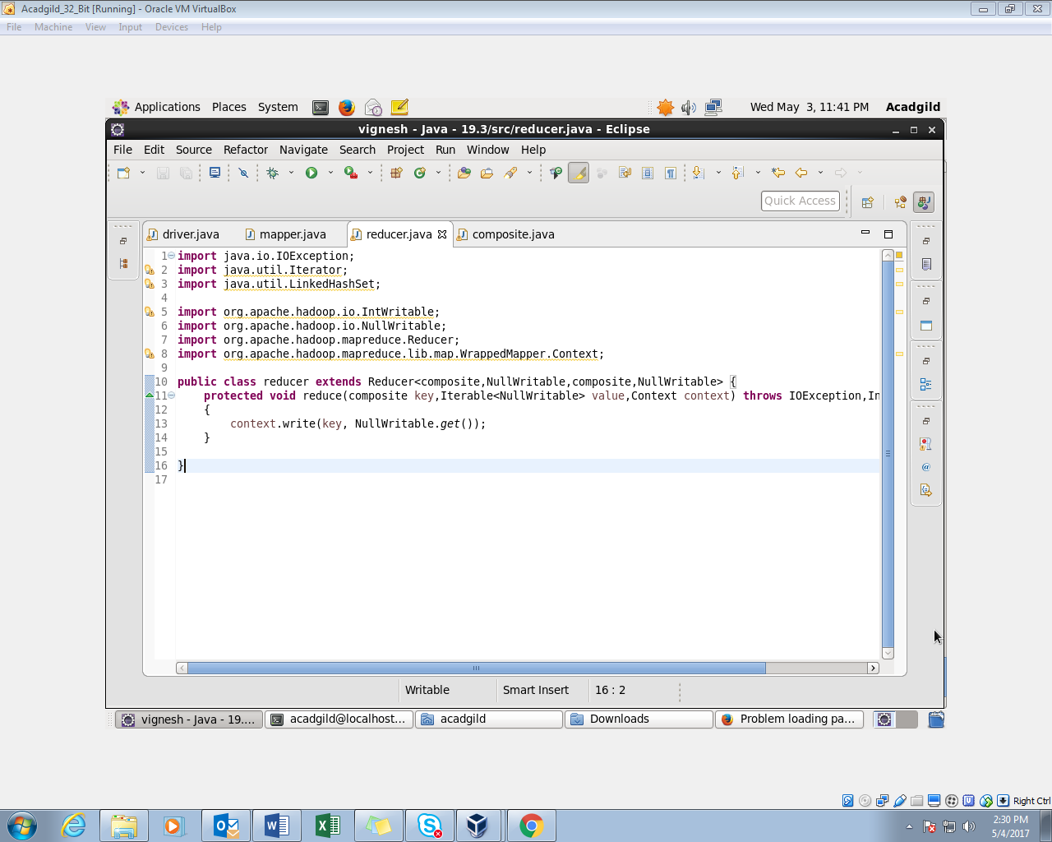

**OUTPUT:**

