**ASSIGNMENT 20.2 :**

Enhance the task 8 (refer session 19, assignment 1) to calculate the top 3 state-wise sales for each company. You may use multiple reducers for this activity.

DRIVER CLASS:

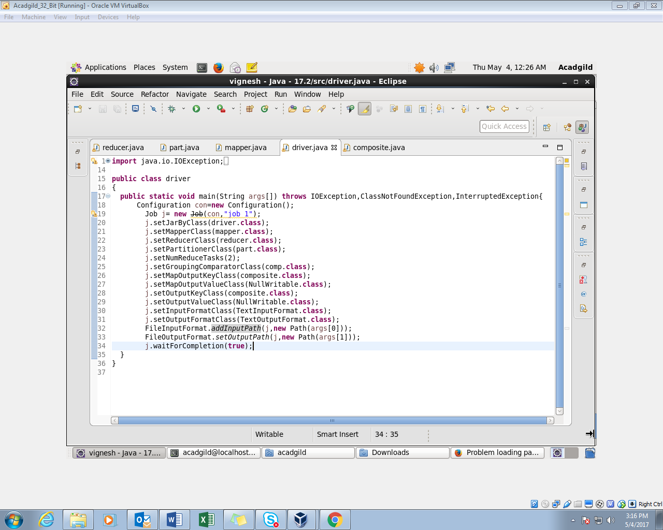

MAPPER CLASS:

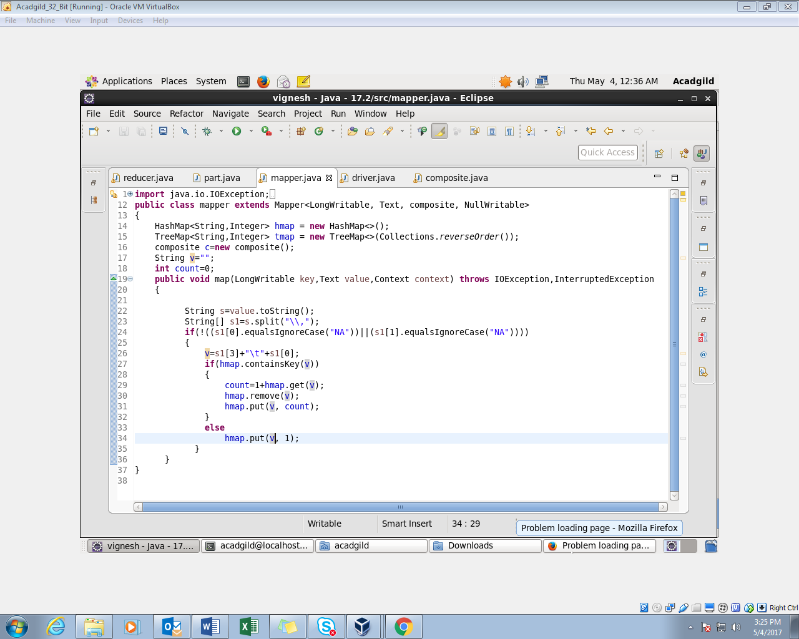

COMPOSITEKEY CLASS:

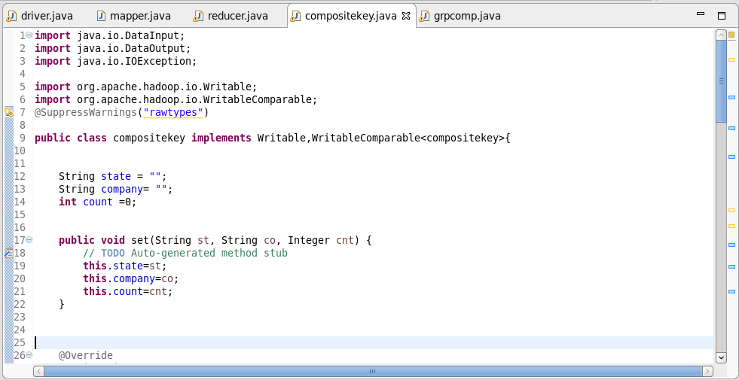

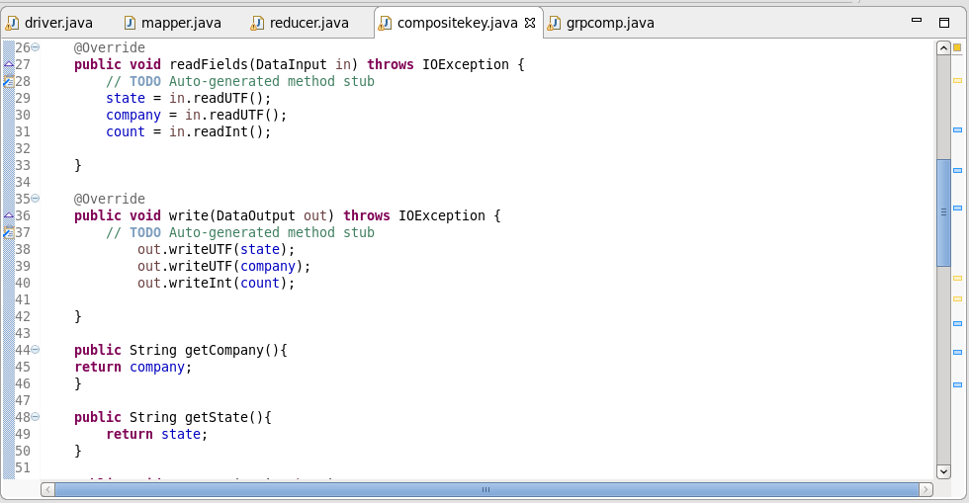

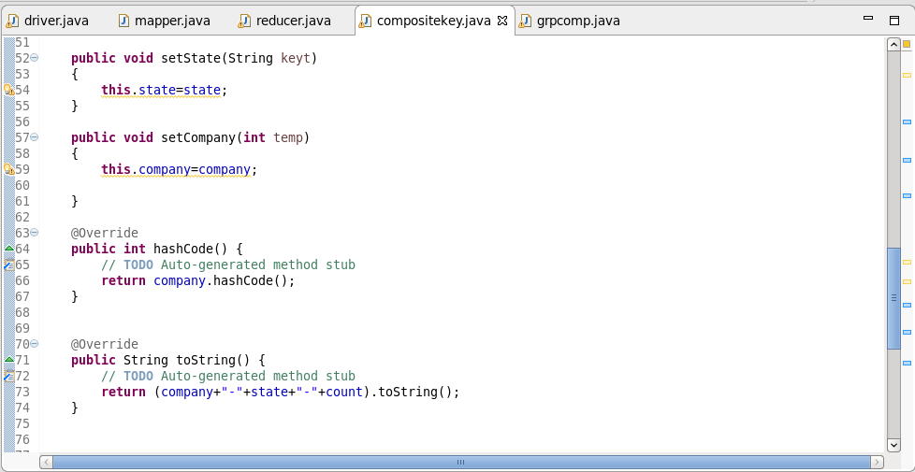

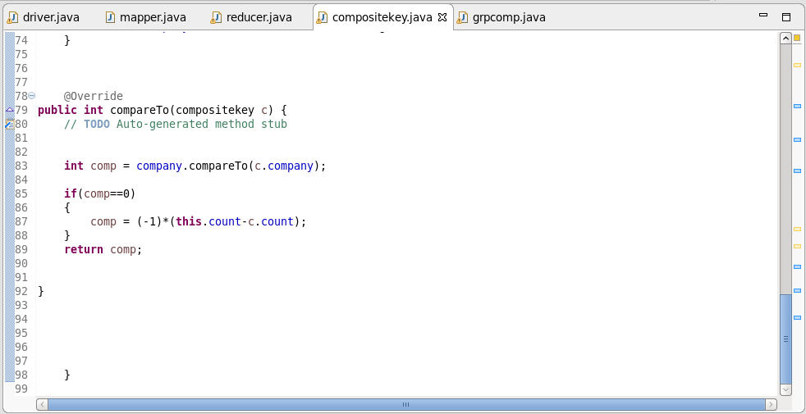

GROUP COMPARATOR:

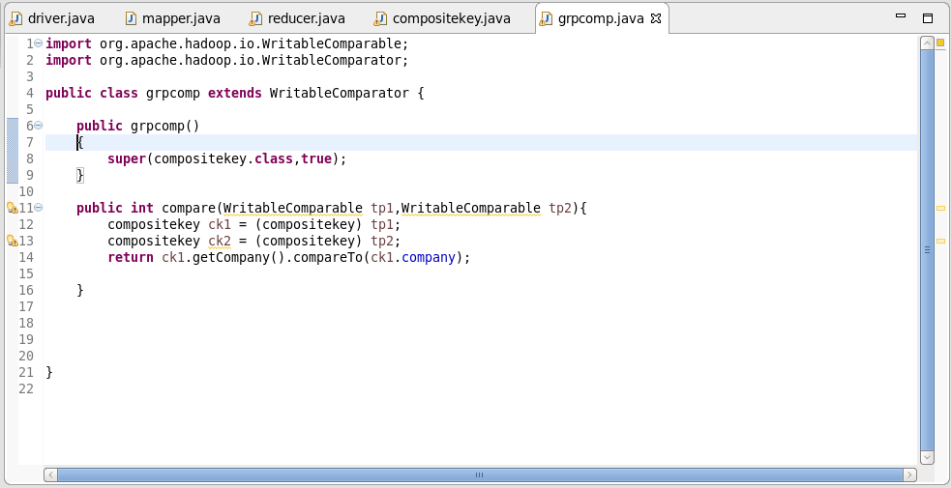

REDUCER CLASS:

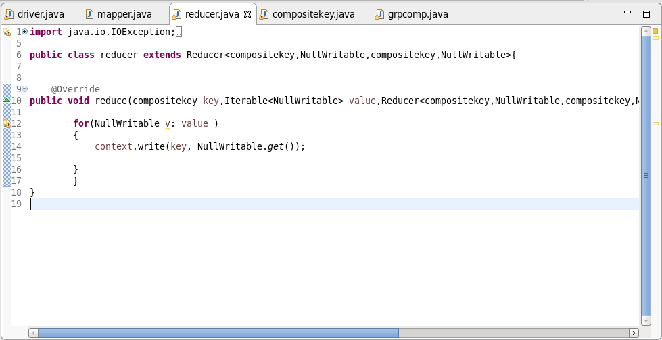

OUTPUT:

