**ASSIGNMENT 21.1 :**

Write a mapreduce program to use CombineFileInputFormat. Pass a directory containing multiple small files. The program should be able to pick multiple files in a single mapper.

**DRIVER CLASS:**

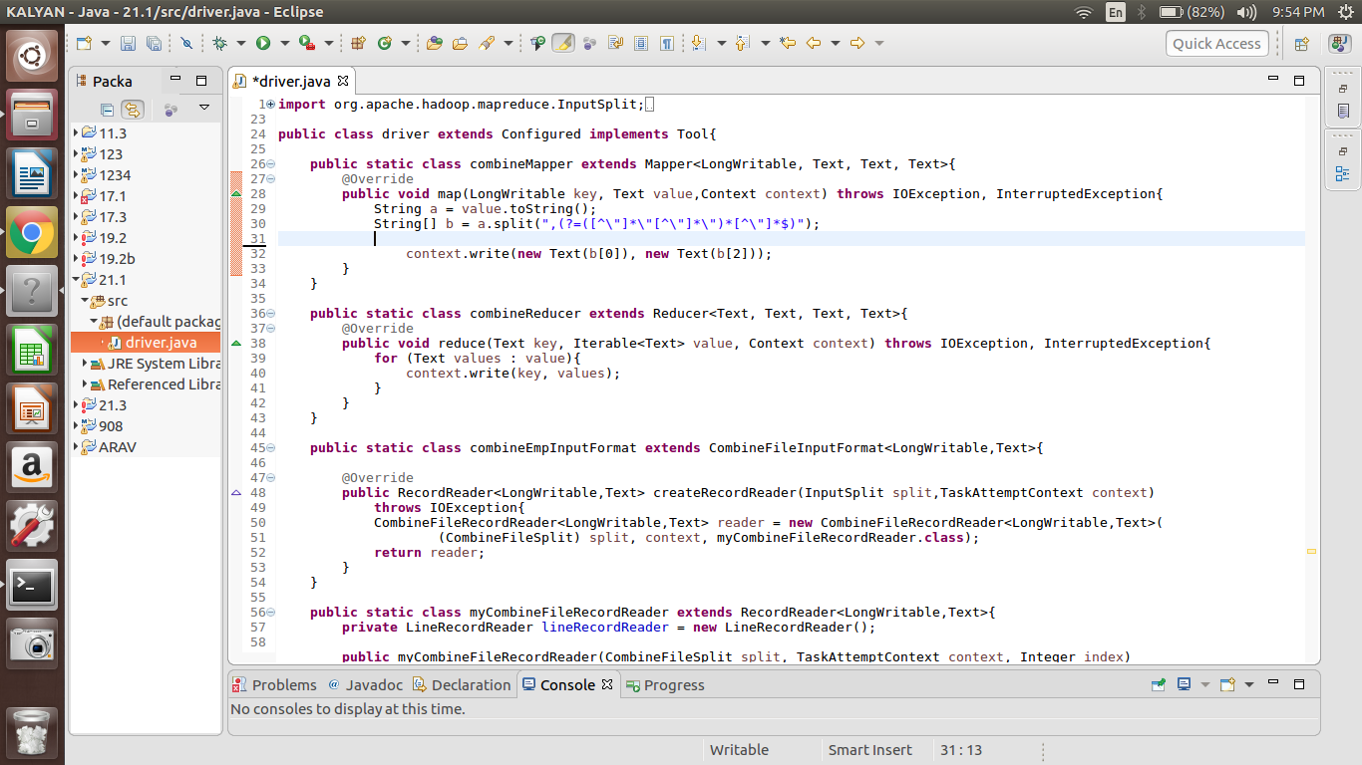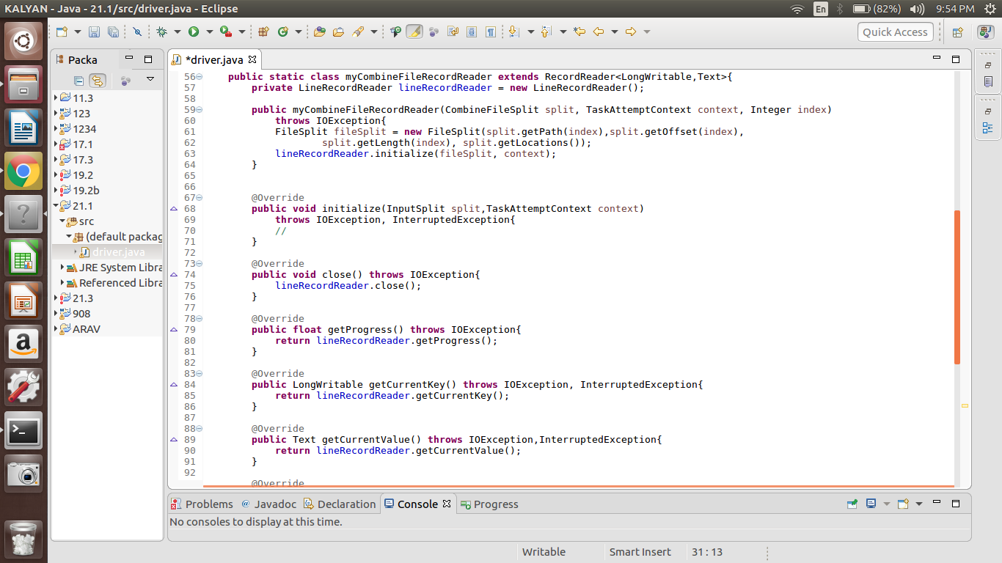

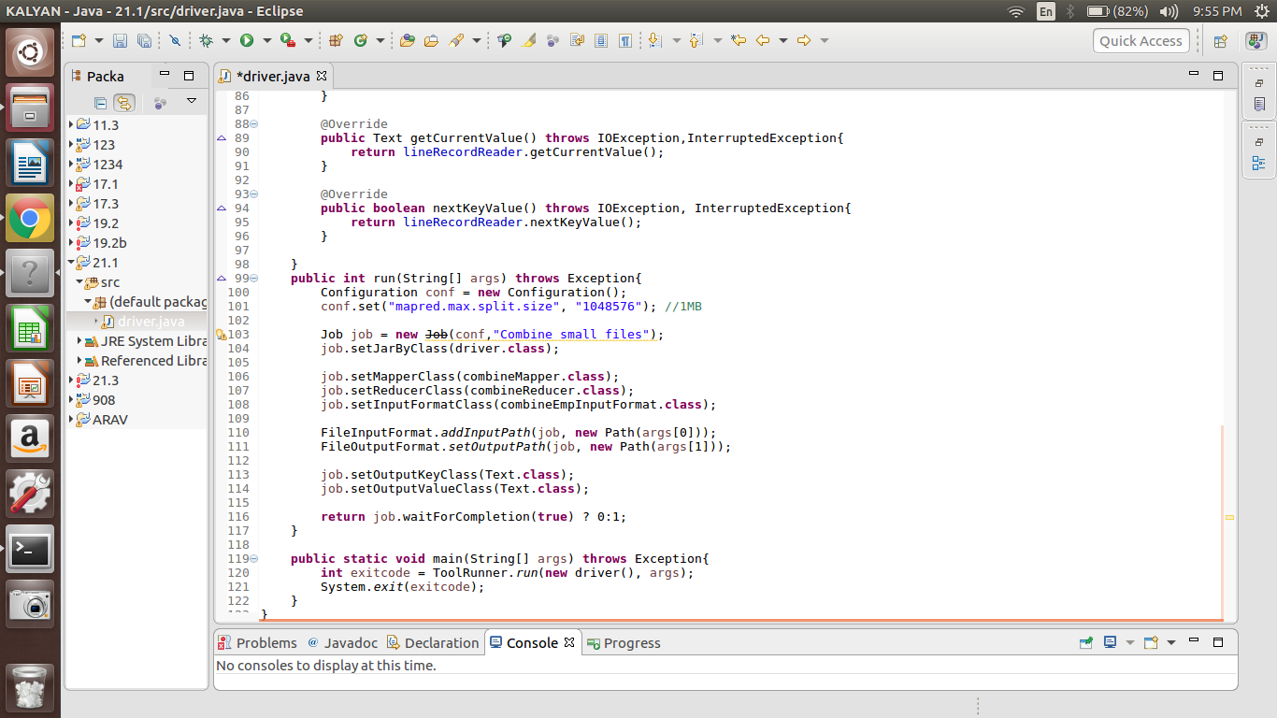

**OUTPUT:**

