**ASSIGNMENT 21.3 :**

This dataset consists of two columns i,e., first_name & last_name &city use custom input format to read the key as the combination of first_name and last_name and arrange the output of the program should be the key sorted by last_name.

**DRIVER CLASS:**

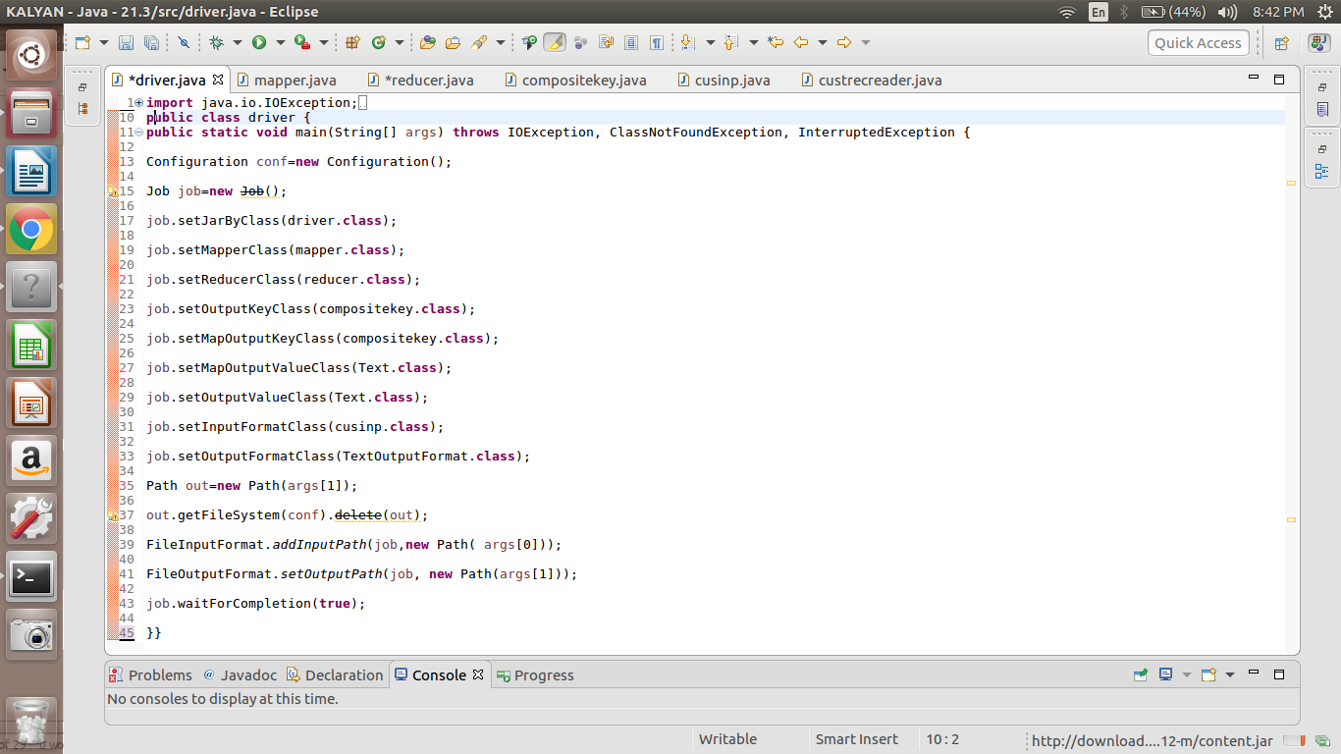

**MAPPER CLASS:**

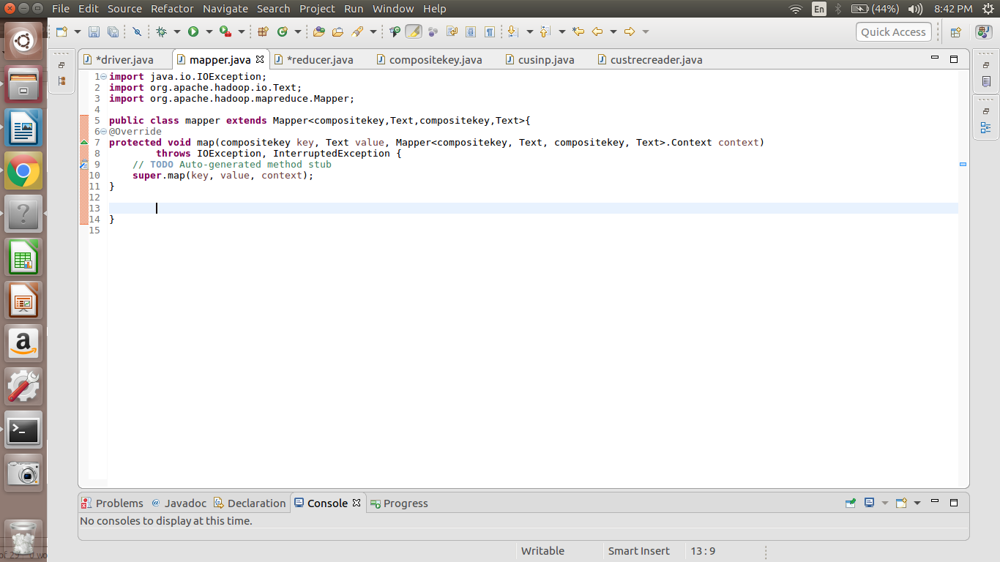

**REDUCER CLASS:**

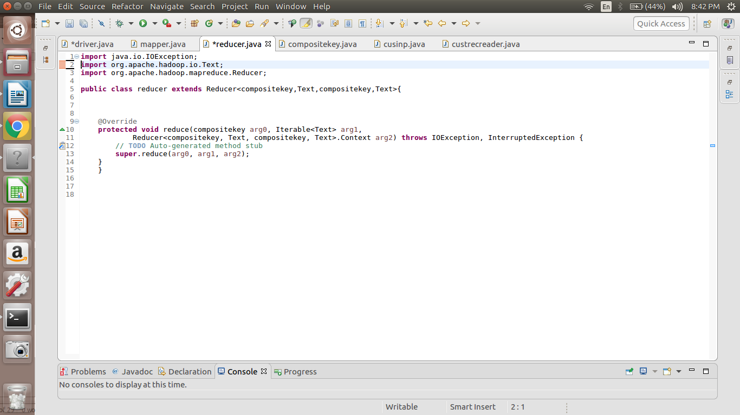

**COMPOSITEKEY CLASS:**

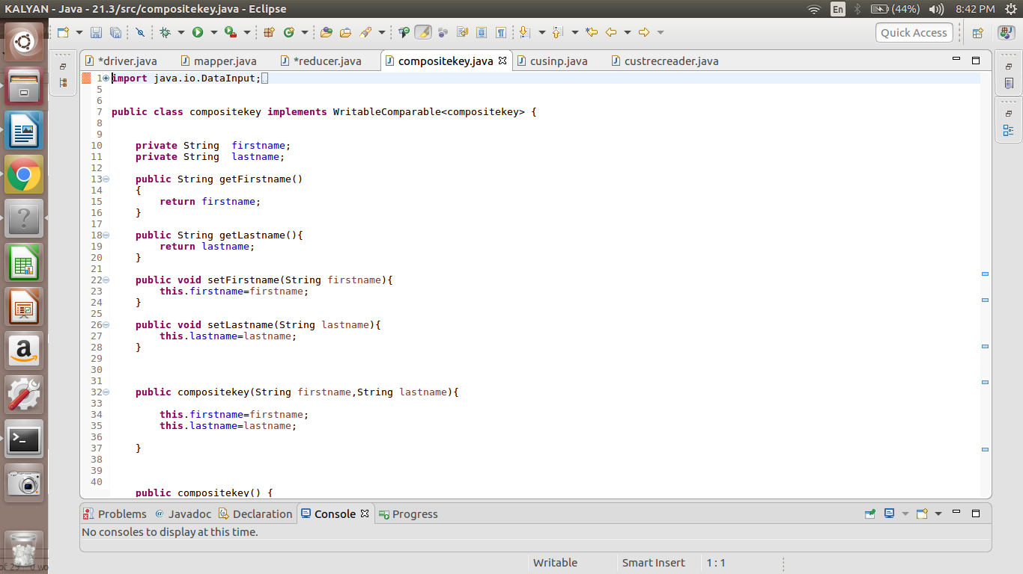

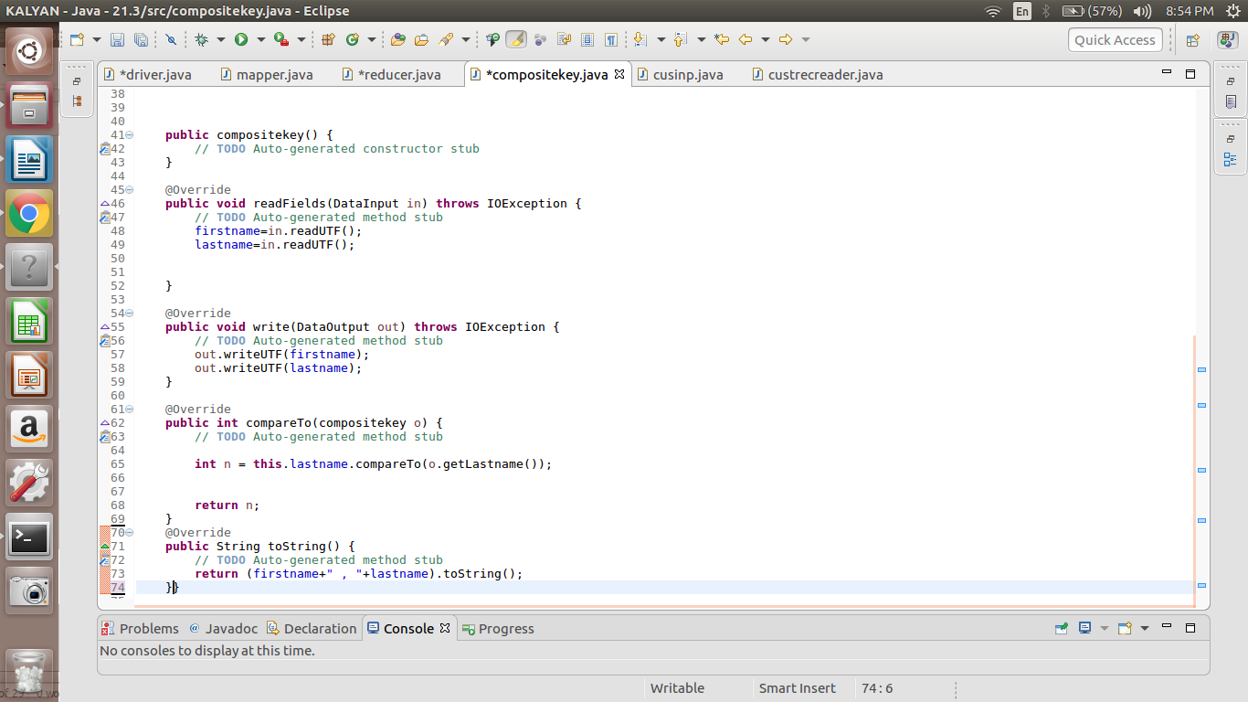

**CUSTOM INPUT CLASS:**

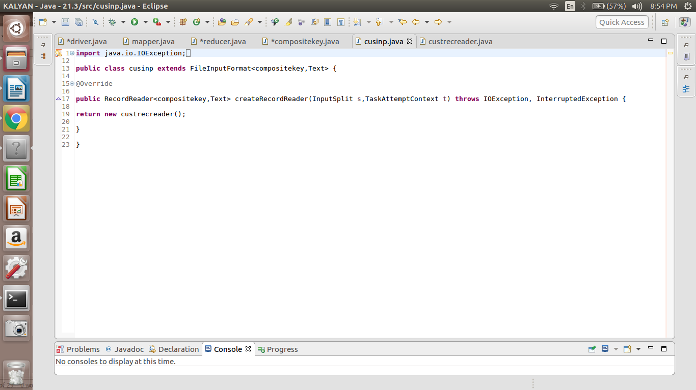

**CUSTOM RECORD READER:**

