**ASSIGNMENT 24.5**

Firstly create a hive table and load the dataset into the table and evaluate the below problem statements

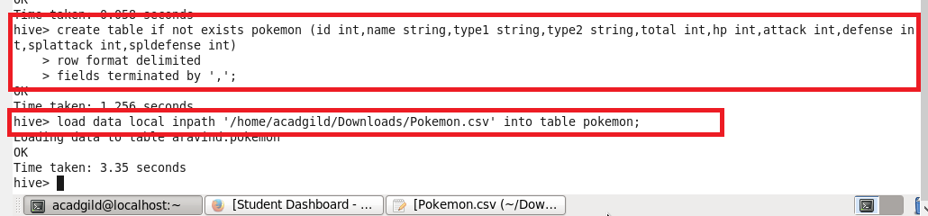

**QUESTION 1 :** Find out the average HP (Hit points) of all the Pokémons

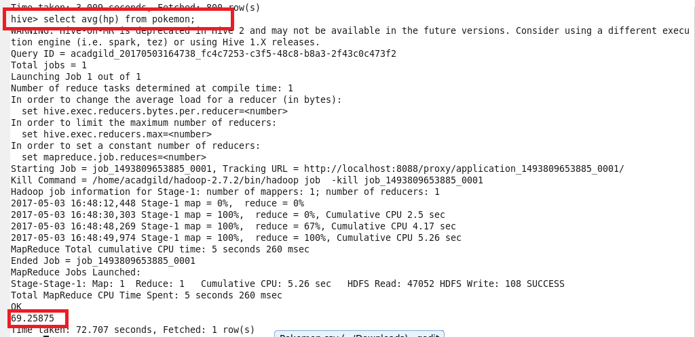

**QUESTION 2 :** Find out the average Defense of all the Pokémon

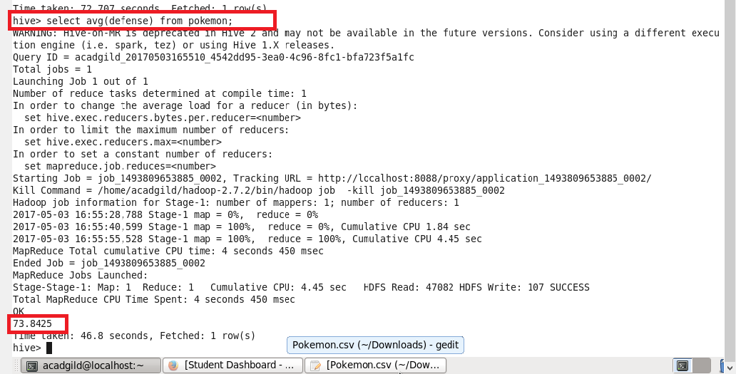

**QUESTION 3 :** Find out the average Sp.Atk of all the pokemons

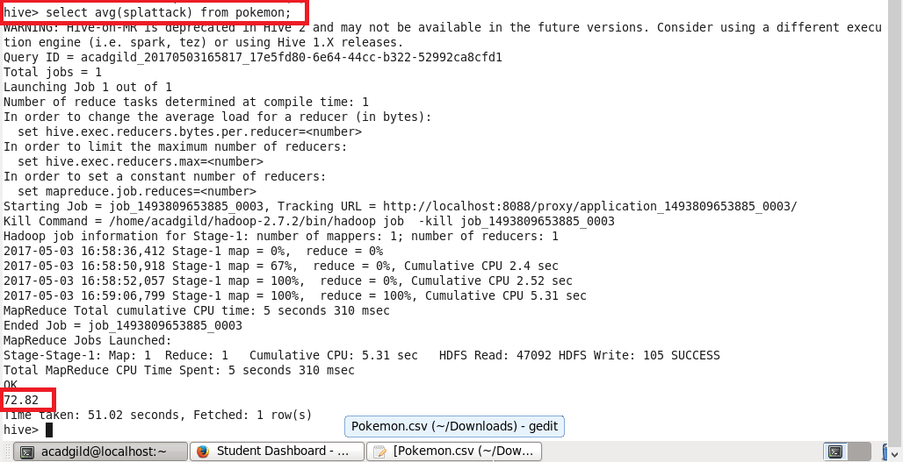

**QUESTION 4 :** Find out the average specialDefencw of all the pokemons

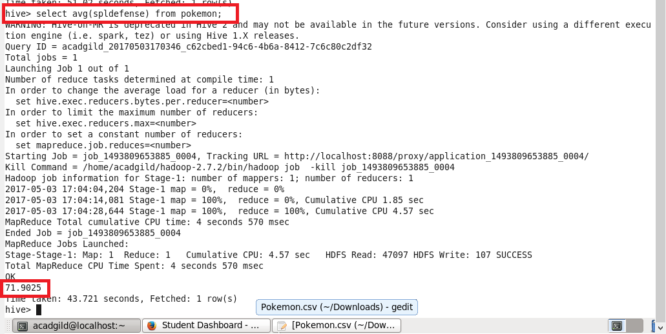

**QUESTION 5 :** Find out the average Speed of all the pokemons

