**ASSIGNMENT 28.1**

**QUESTION : What are ACID properties and Explain Transactions in Hive.**

ACID stands for Atomicity, Consistency, Isolation, and Durability.

**Atomicity:** Atomicity means, a transaction should complete successfully or else it should fail completely i.e. it should not be left partially.

**Consistency:** Consistency ensures that any transaction will bring the database from one valid state to another state.

**Isolation:** Isolation states that every transaction should be independent of each other i.e. one transaction should not affect another.

**Durability:** Durability states that if a transaction is completed, it should be preserved in the database even if the machine state is lost or a system failure might occur.

These ACID properties are essential for a transaction and every transaction should ensure that these properties are met.

**TRANSACTIONS IN HIVE:**

* **Setting configurations in hive shell:**

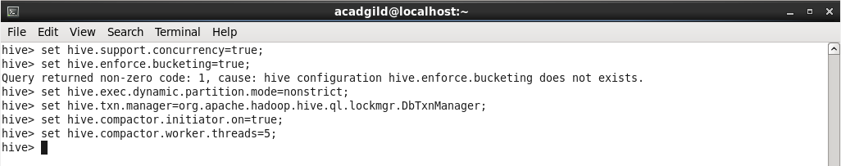

* **Creating table and inserting data into it.**

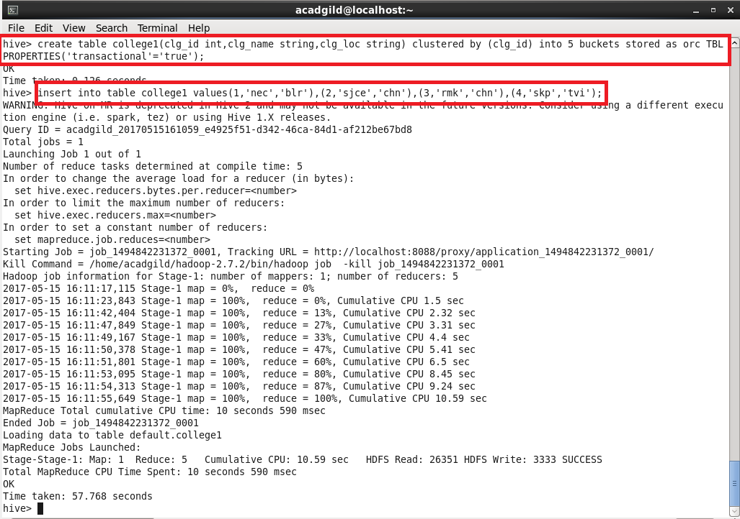

* **Showing the table with inserted values.**

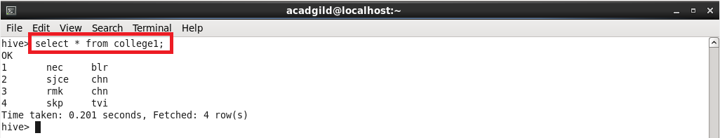

* **Inserting the same values again does the append operation.**

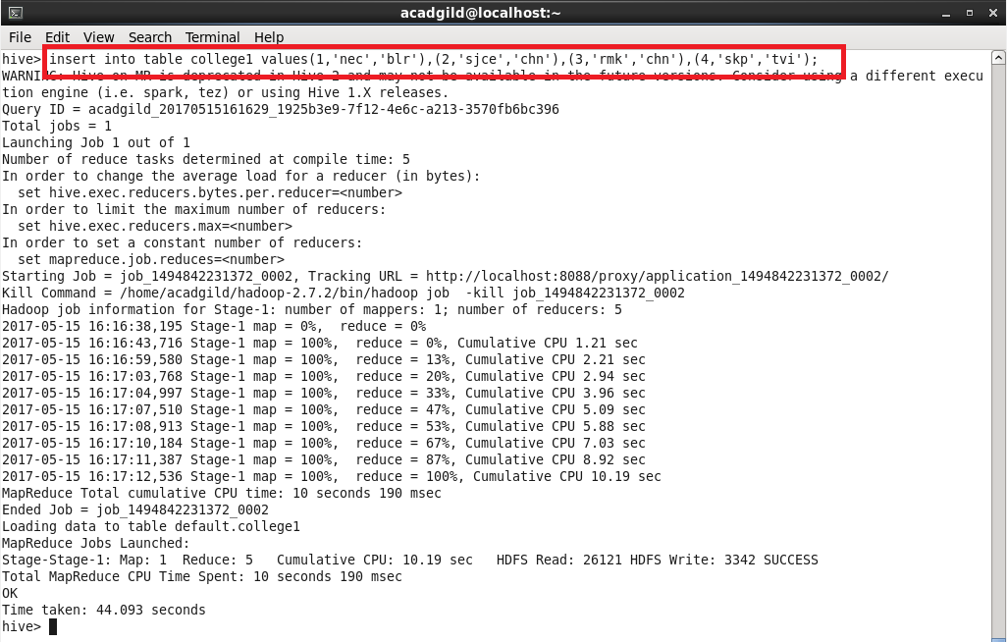

* **Showing the appended data**

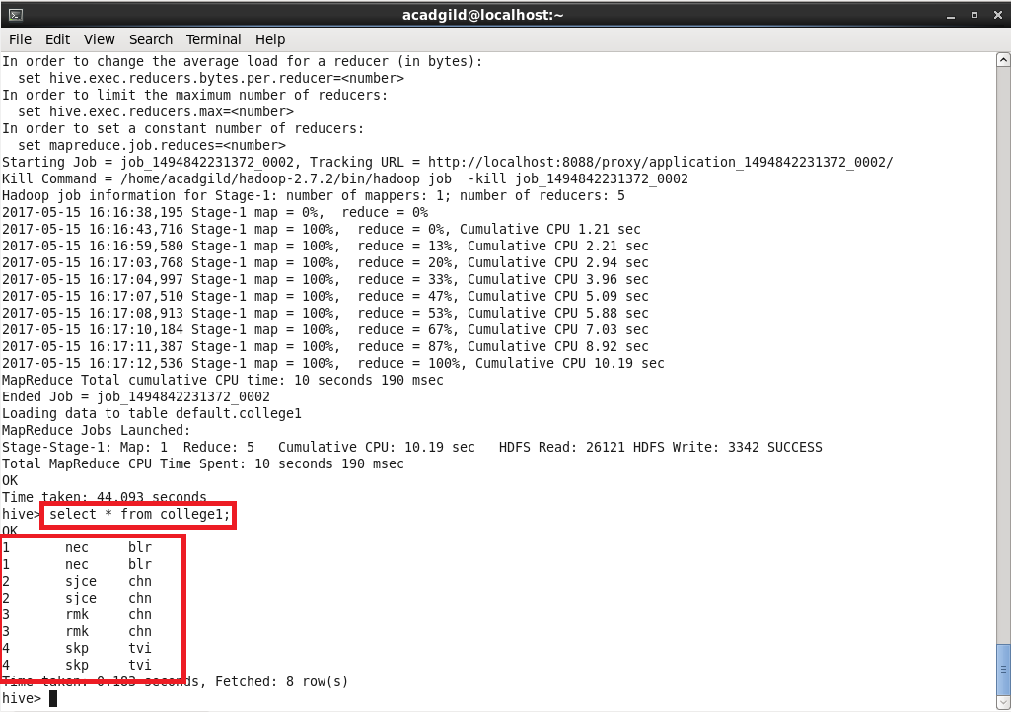

* **Performing update operation in the rows of the table**

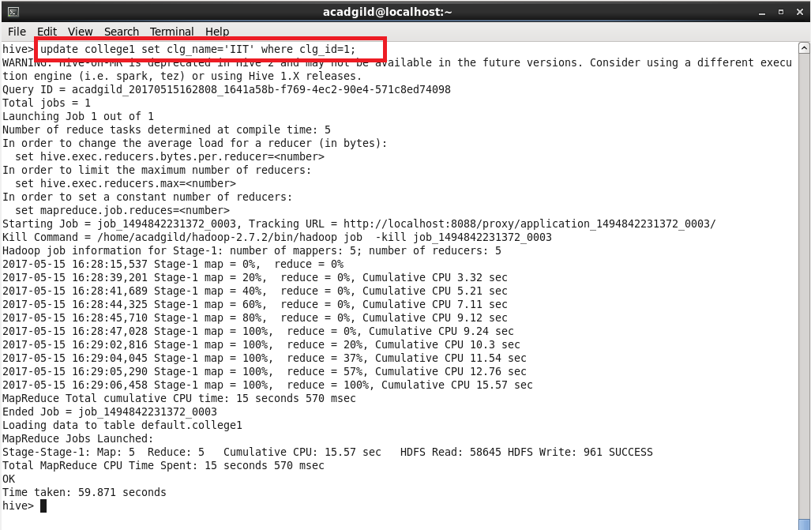

* **Showing the updated table:**

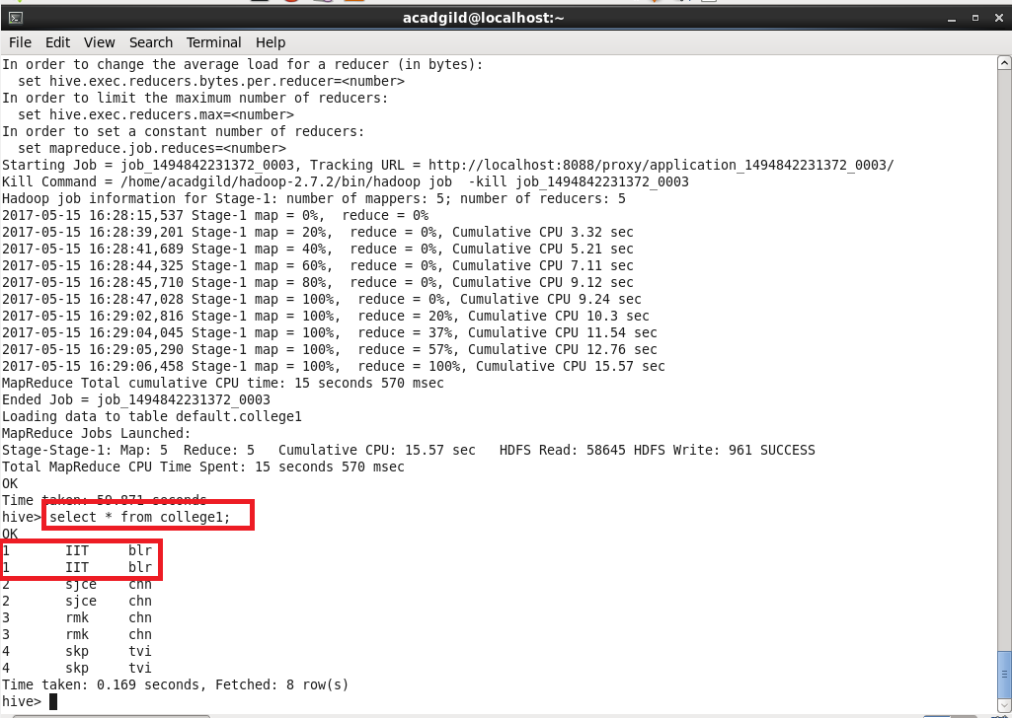

* **Performing delete operation:**

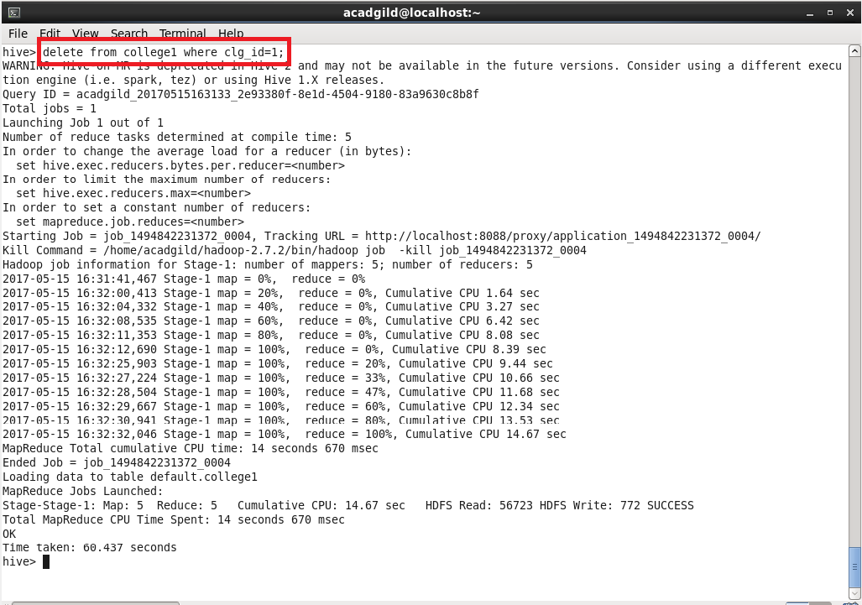

* **Showing the updated table with deleted rows:**

