**ASSIGNMENT 28.3**

Question 1 : Get a list of employees who receive a salary less than 100, compared to their immediate employee with higher salary in the same unit.

**QUERY:**

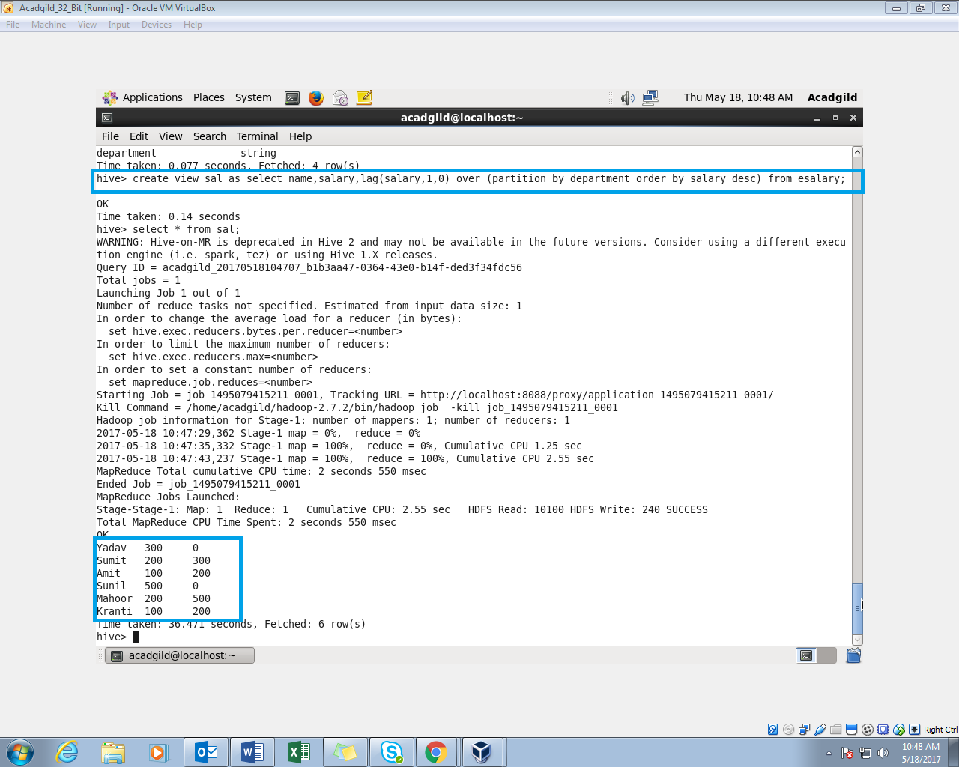

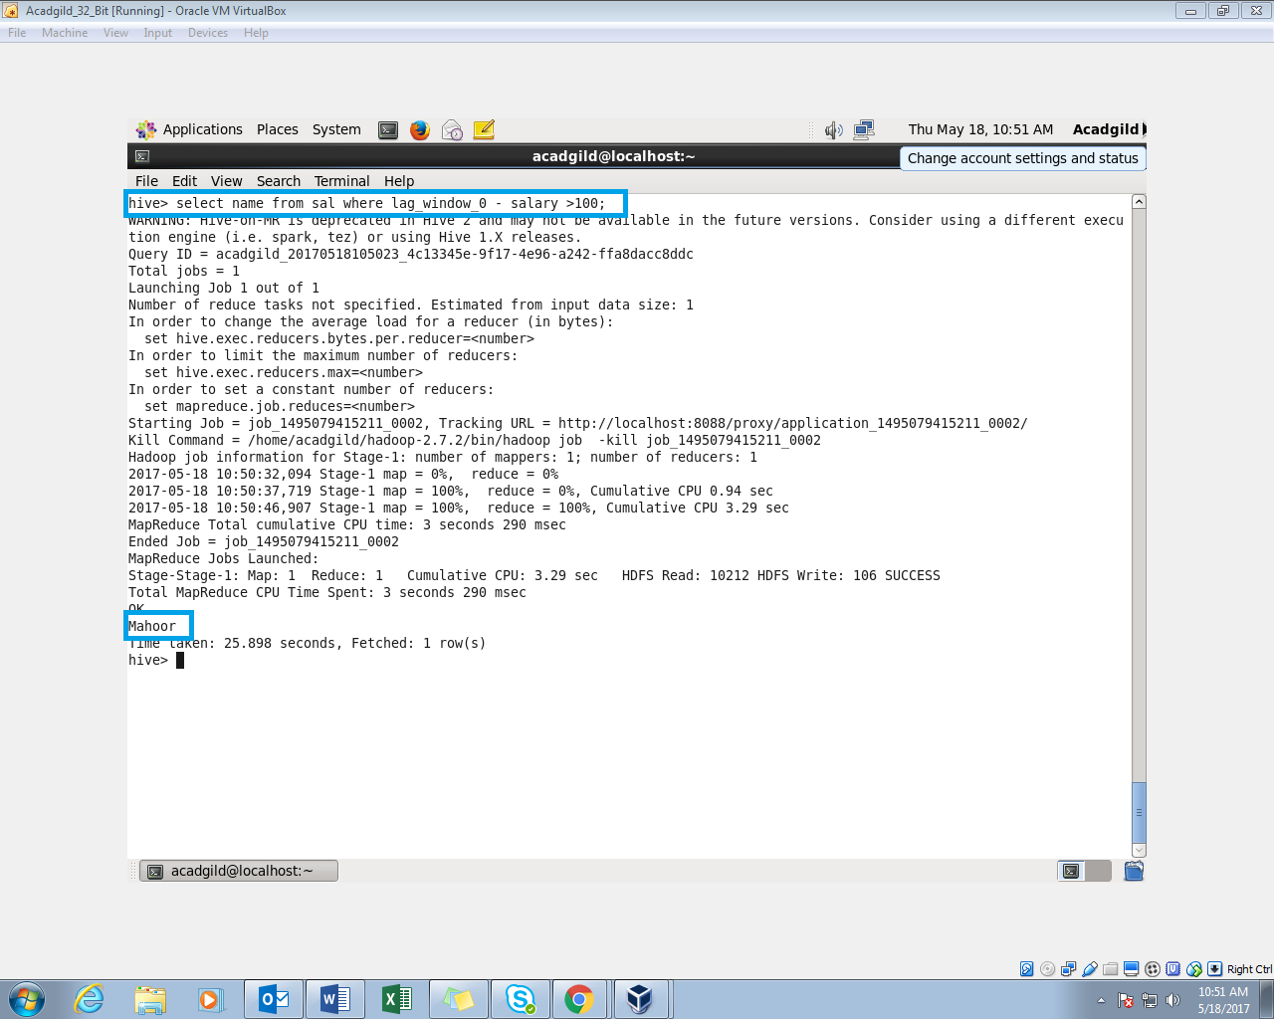

**Question 2** : List of all employees who draw higher salary than the average salary of that department.

**Query:**

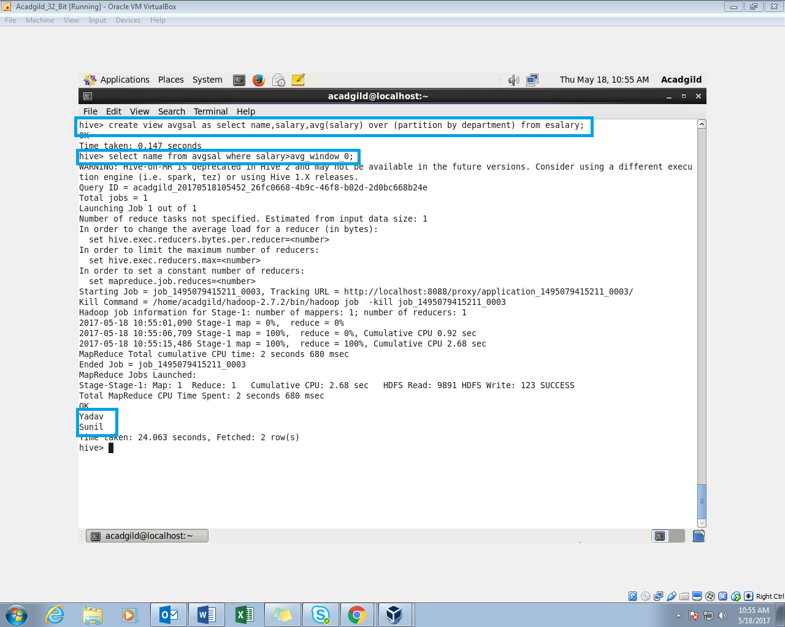

**Question 3** : Link: olympic_data.csv Store the above dataset into the following file formats.

**● SEQUECEFILE**

**● RCFILE**

**● ORC FILE**

* **SEQUENCE FILE FORMAT:**

Creating table with sequence file as input.describe

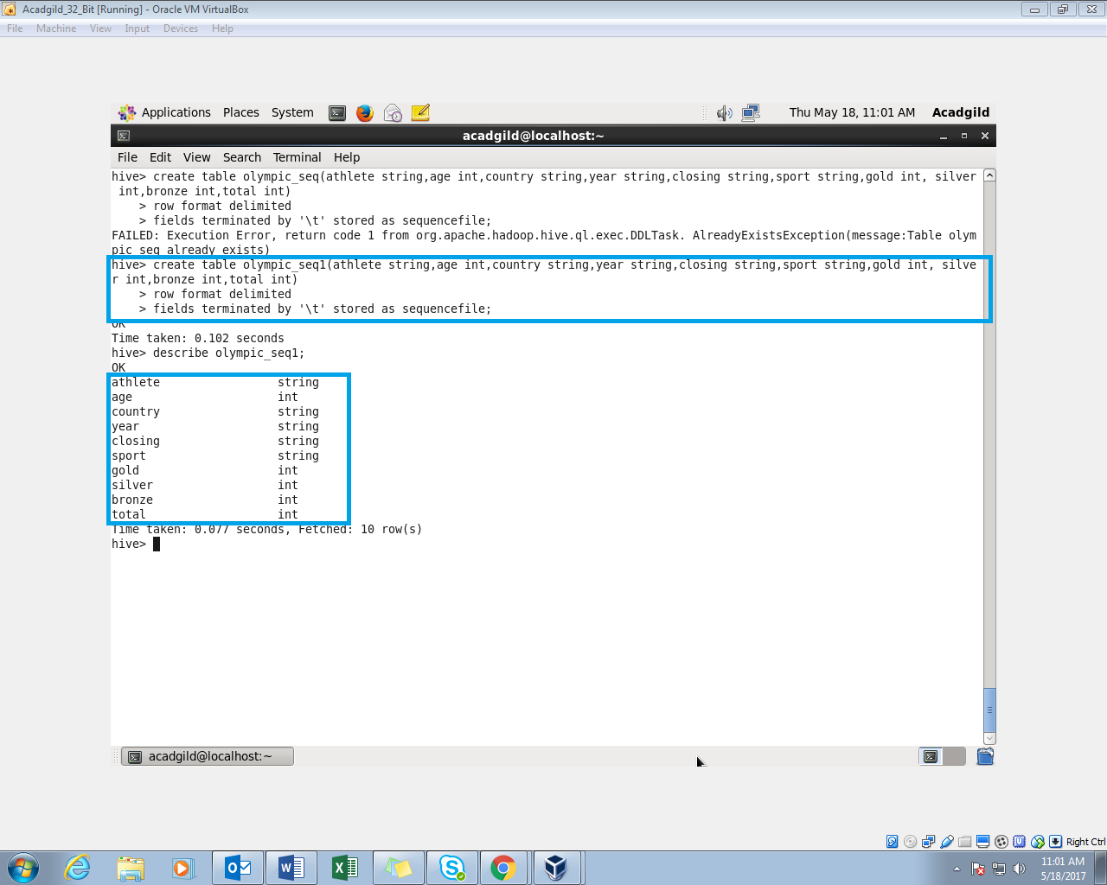

**Query:**

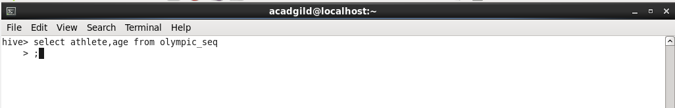

**Sample output:**

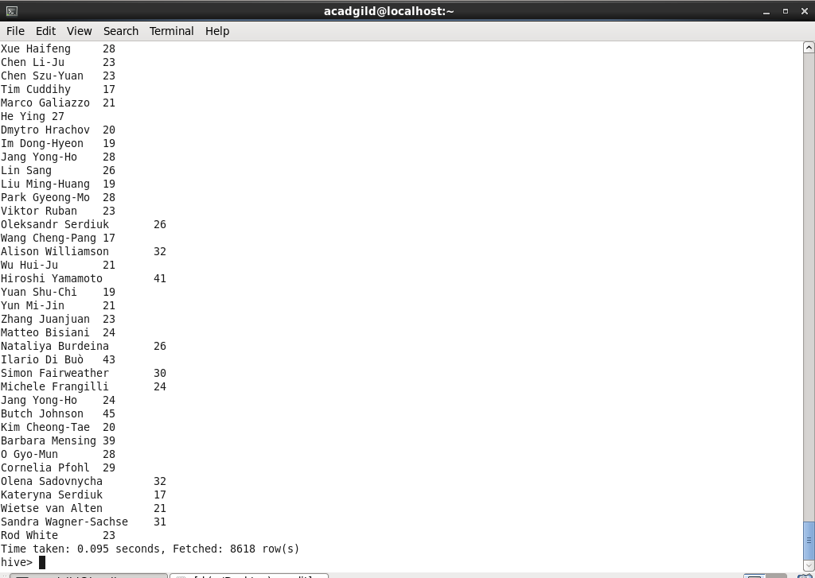

* **RCFILE:**

Creating a table and storing it as rc file

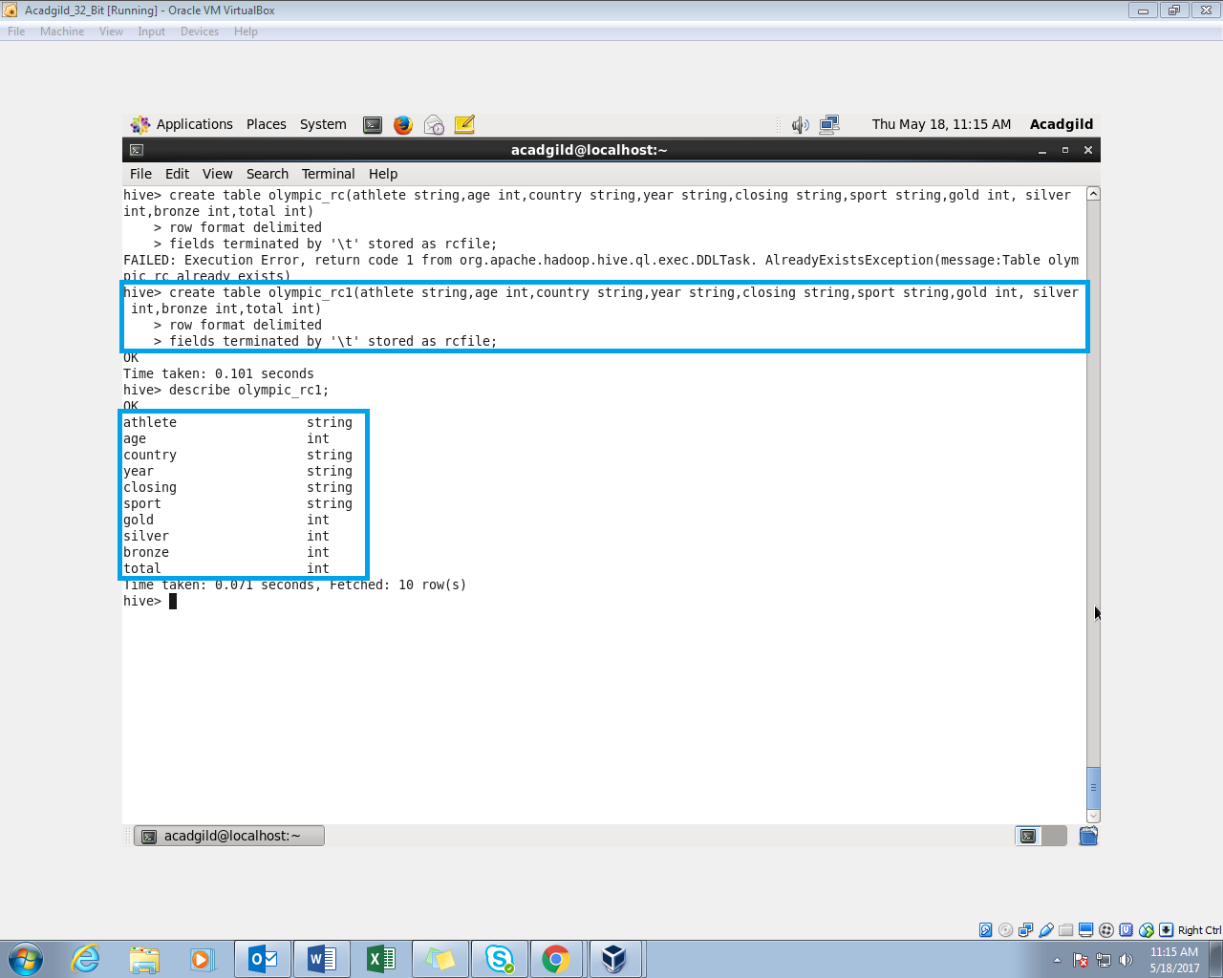

**Inserting into the table with insert command.**

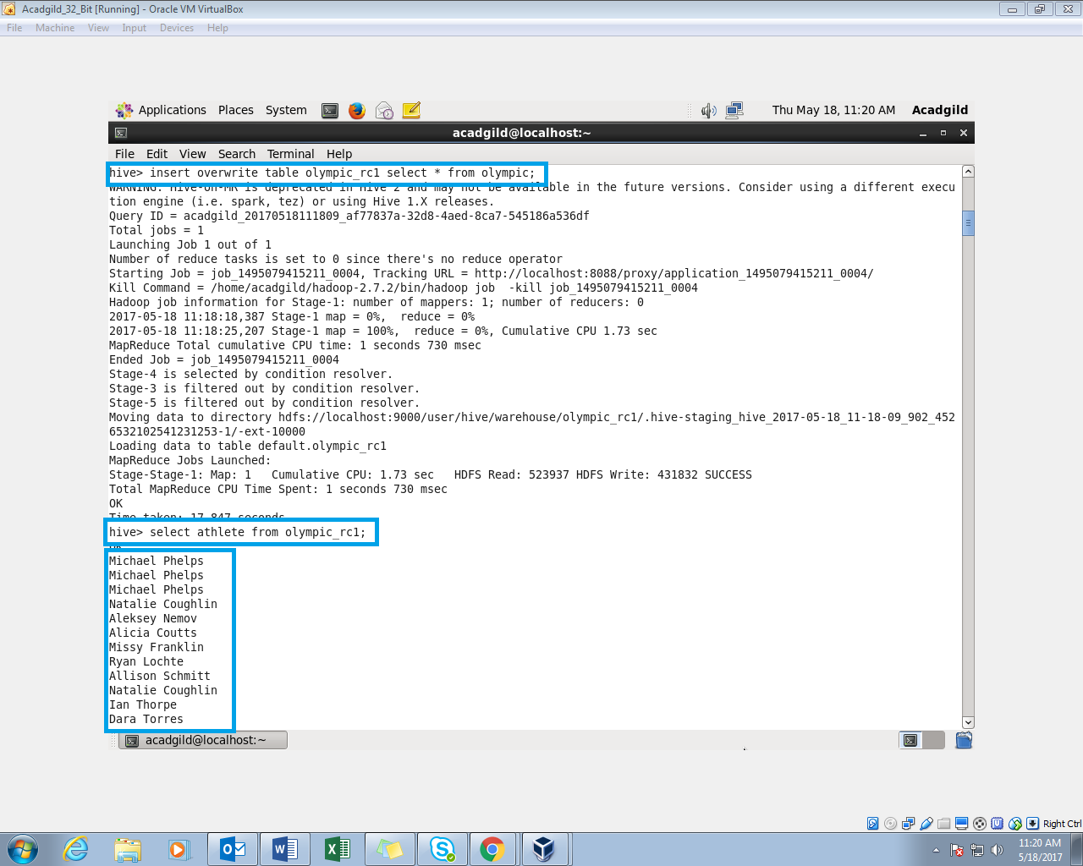

* **ORC FILE:**

Creating a table and storing it as orc file.

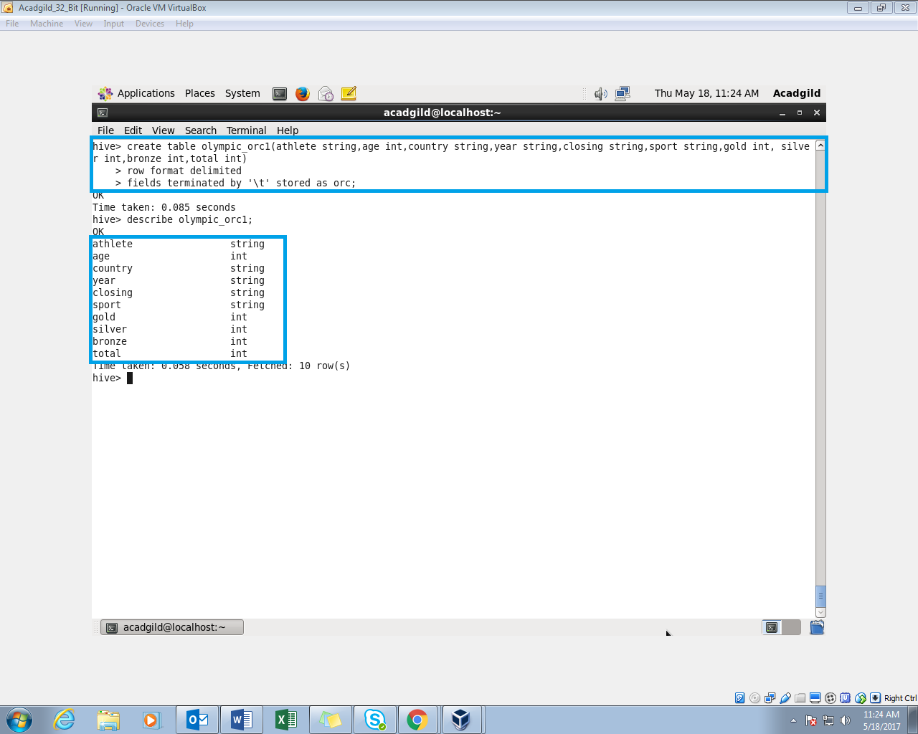

**Inserting into the table with insert command.**

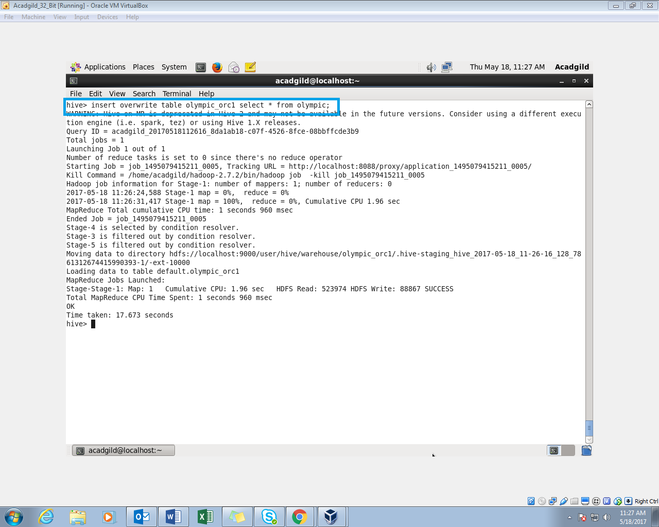

**Query and Output:**

