**ASSIGNMENT 29.1**

**QUESTION :** Write a hive UDF that implements functionality of string concat_ws(string SEP, array). This UDF will accept two arguments, one string and one array of string. It will return a single string where all the elements of the array are separated by the SEP.

**ANSWER :-**

**Step 1:** This java code is used to return all elements of the string separated by a separator.

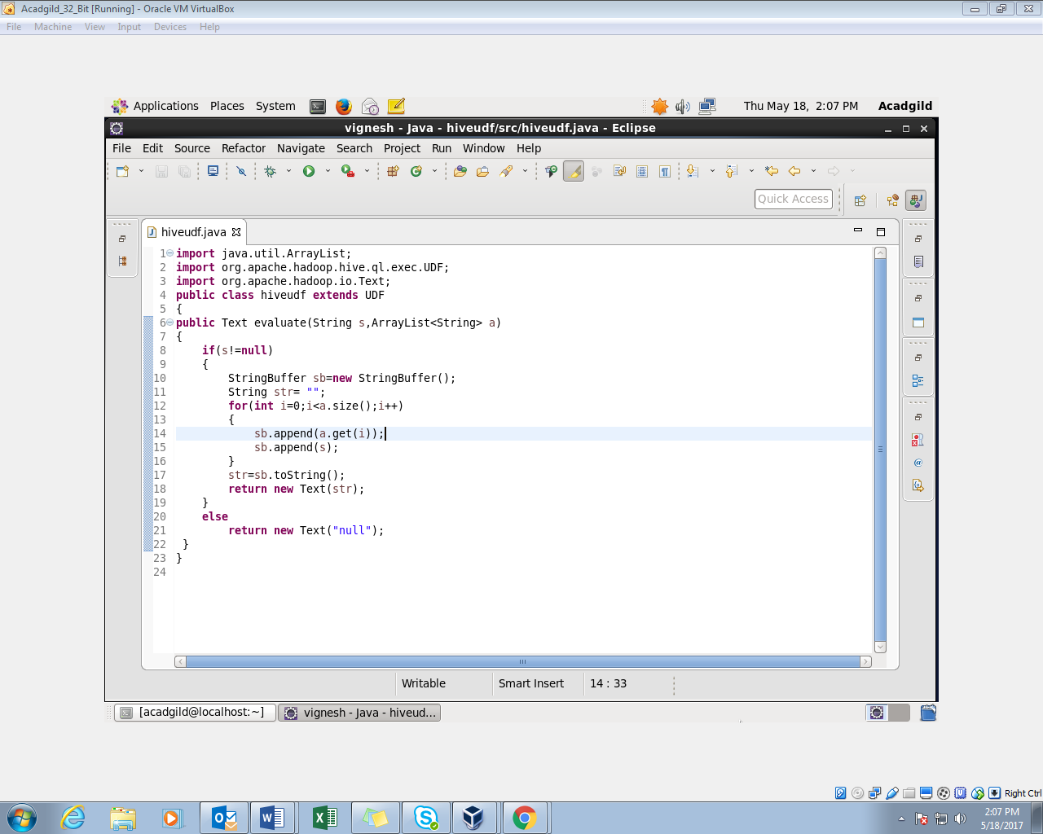

**Step 2**: The jar file is added to the shell.

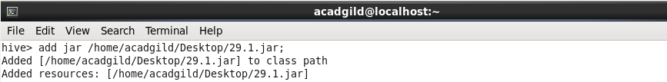

**Step 3:** Create a temporary function and also a table;the contents of the table being a string(sep) and array(arr).

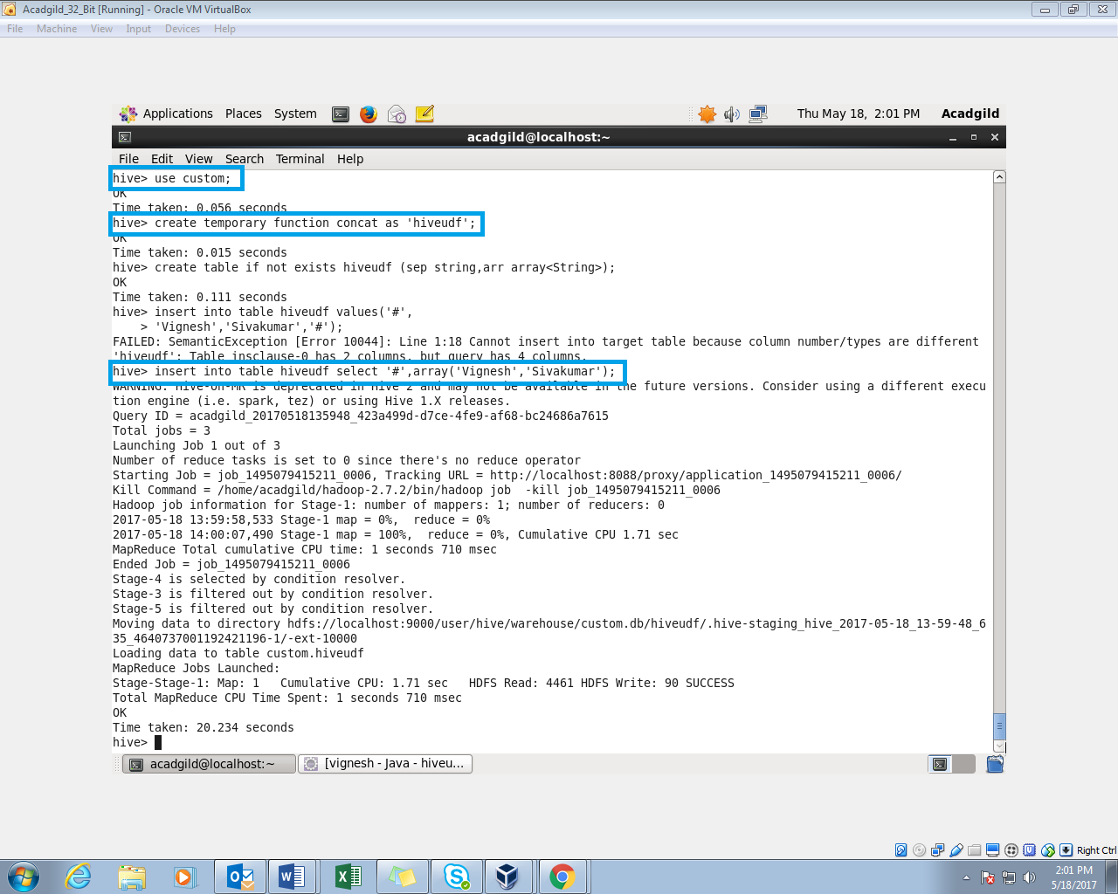

**Step 4:** The table is described

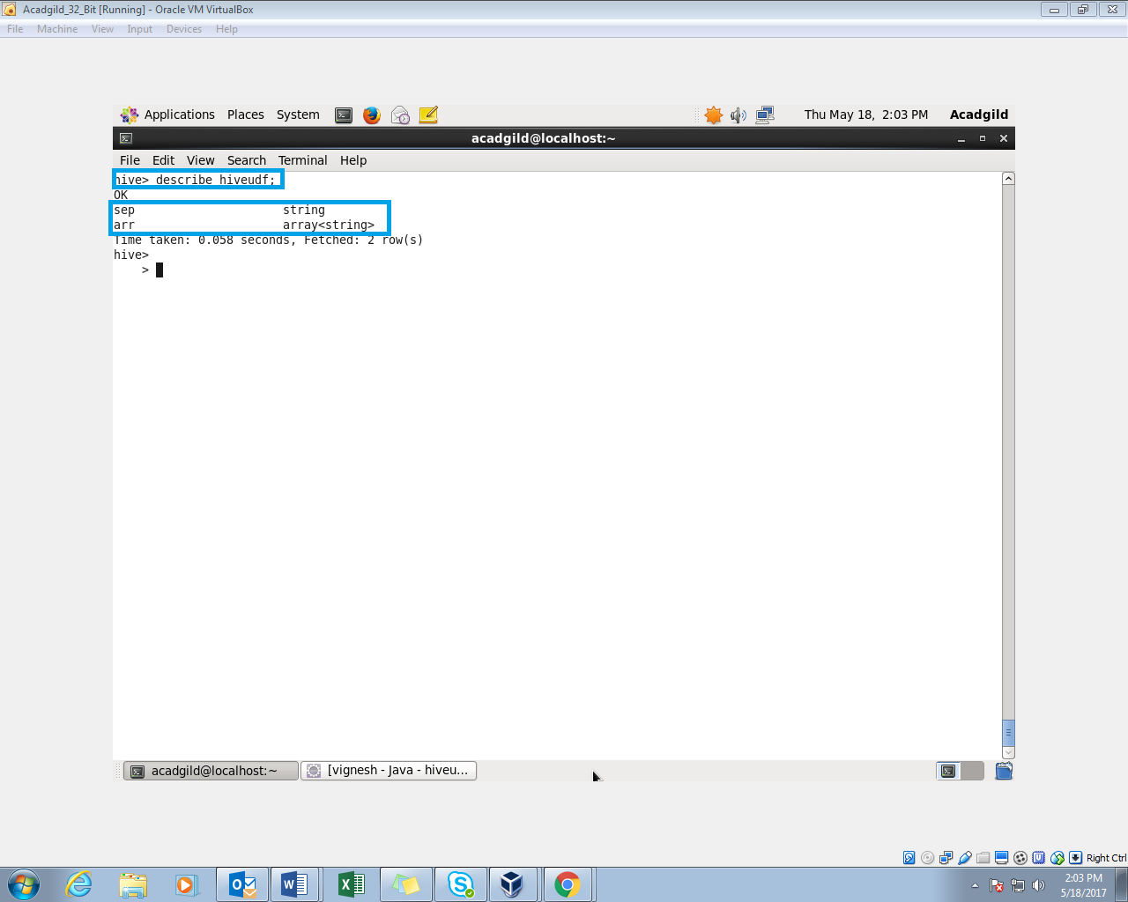

**Step 5:** The temporary function concat is used to get the output as following.

