**ASSIGNMENT 29.2**

**QUESTION** : Write a hive UDAF to find the largest integer in a column. Use your own dataset for the above problem statement and attach the steps performed, codes used with the result.

**STEP 1**: Writing Java Code To Find Largest Integer In The Column

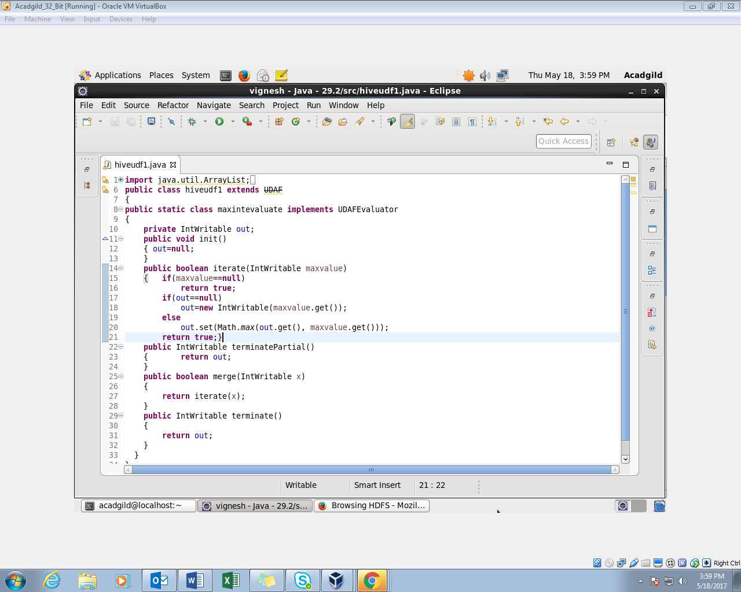

**STEP 2**: Adding Jar To The Hive Shell

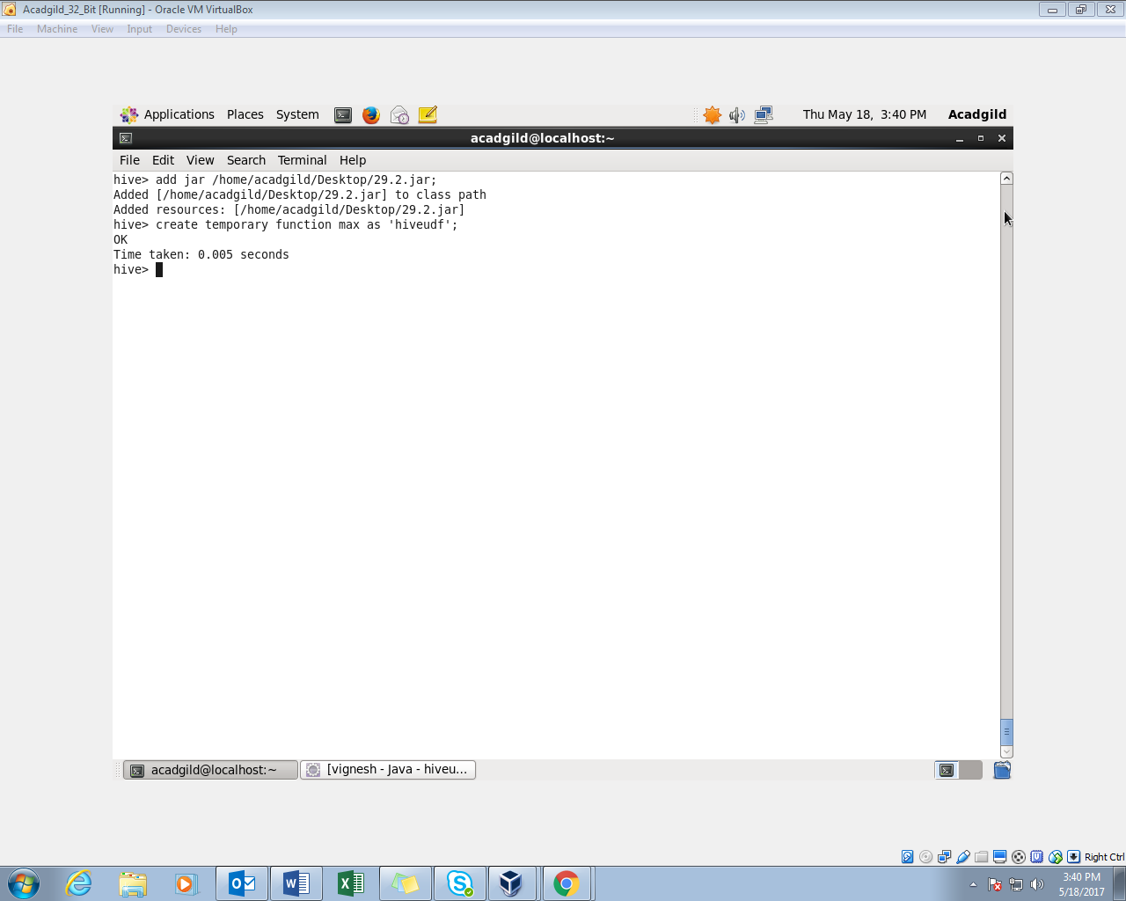

**STEP 3:** Using Customer Table For Finding Maximum Salary

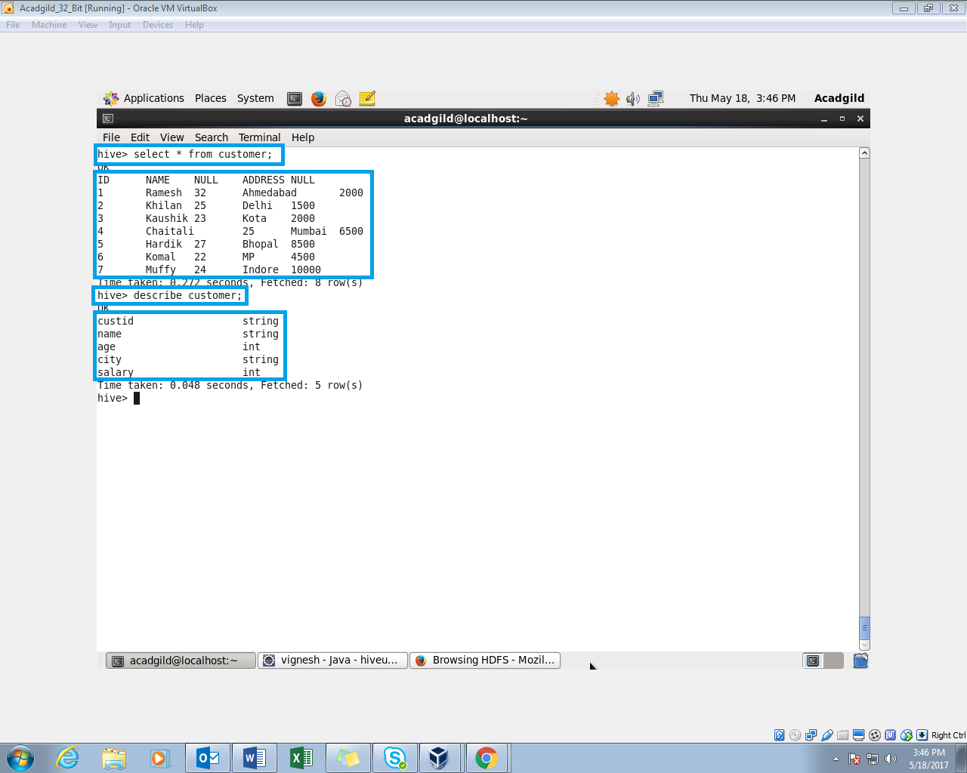

**STEP 4:** Using Maximum (Temporary Function)

