**ASSIGNMENT 35.2**

* Explain and perform Sqoop Incremental Import operation to load data from Mysql To HDFS using Sqoop.
* Explain the procedures performed, Share the screenshots of commands and results for the same.

STEP 1: CREATING A TABLE AND INSERTING VALUES INTO IT.

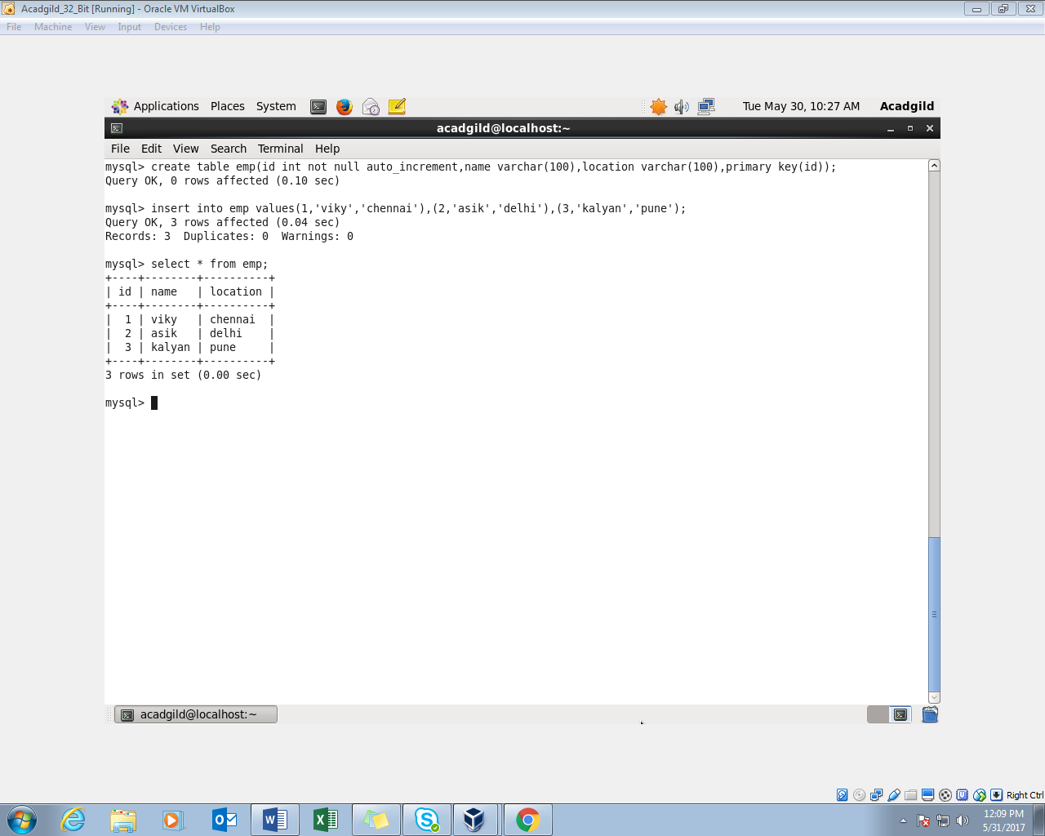

STEP 2: IMPORTING THE TABLE FROM MYSQL TO HDFS

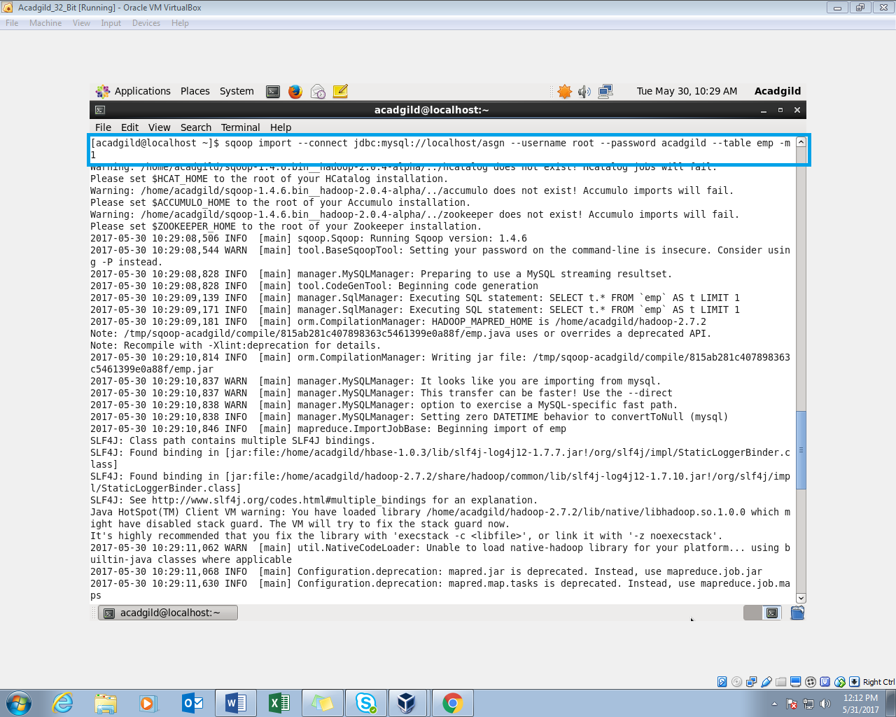

STEP 3: TABLE WITH 4 ENTRIES IS SUCCESSFULLY IMPORTED FROM MYSQL

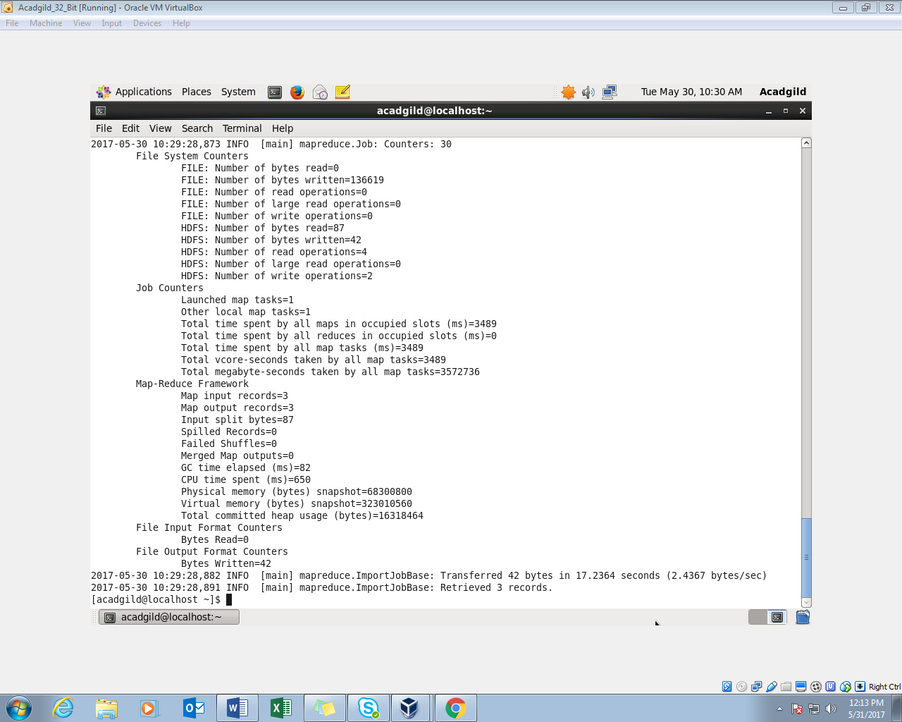

STEP 4: READING THE FILE TO CHECK WHETHER IMPORT IS DONE SUCCESSFULLY OR NOT

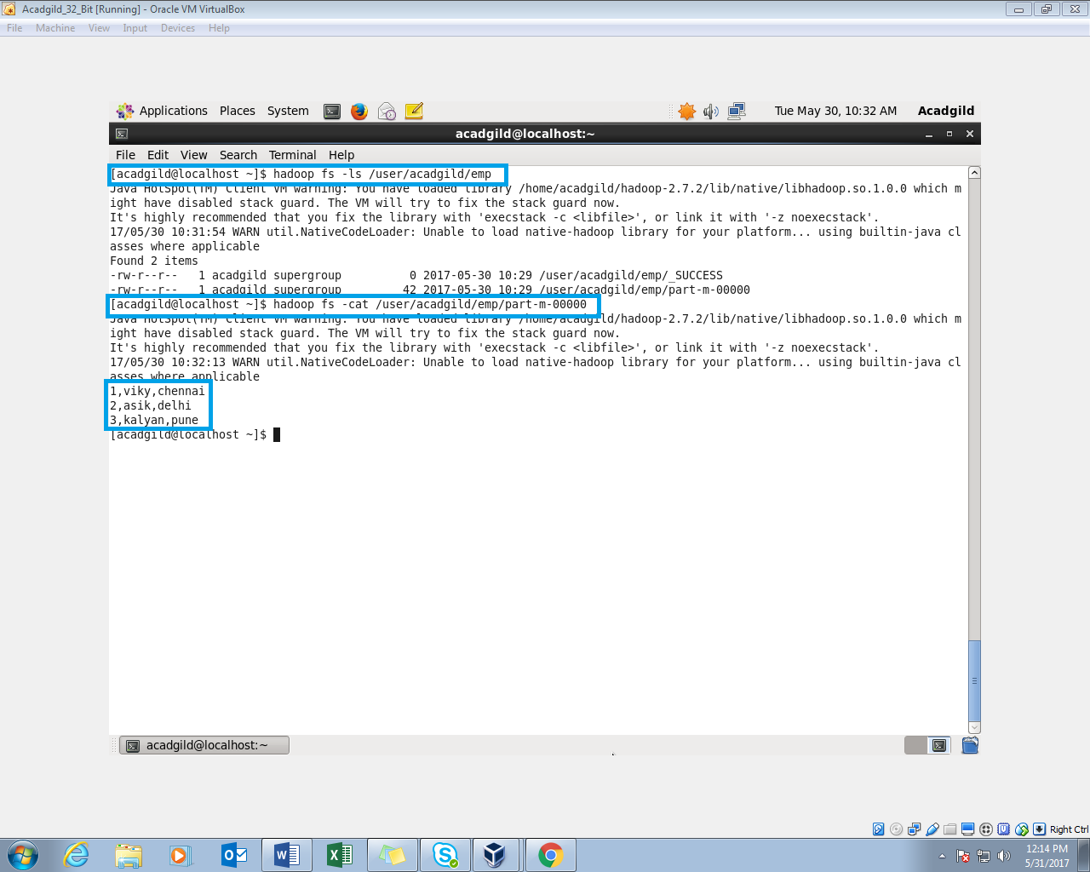

STEP 5: INSERTING FEW MORE ROWS INTO THE TABLE IN MYSQL

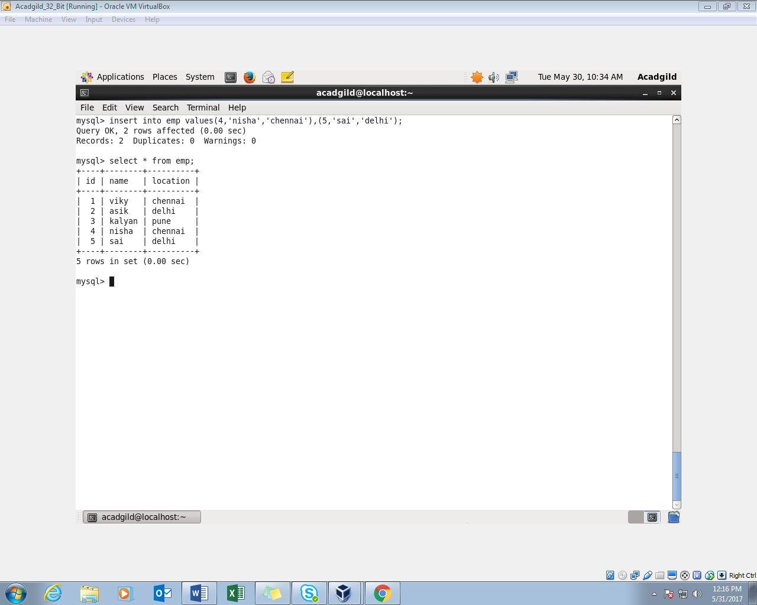

STEP 6: DOING INCREMENTAL APPEND

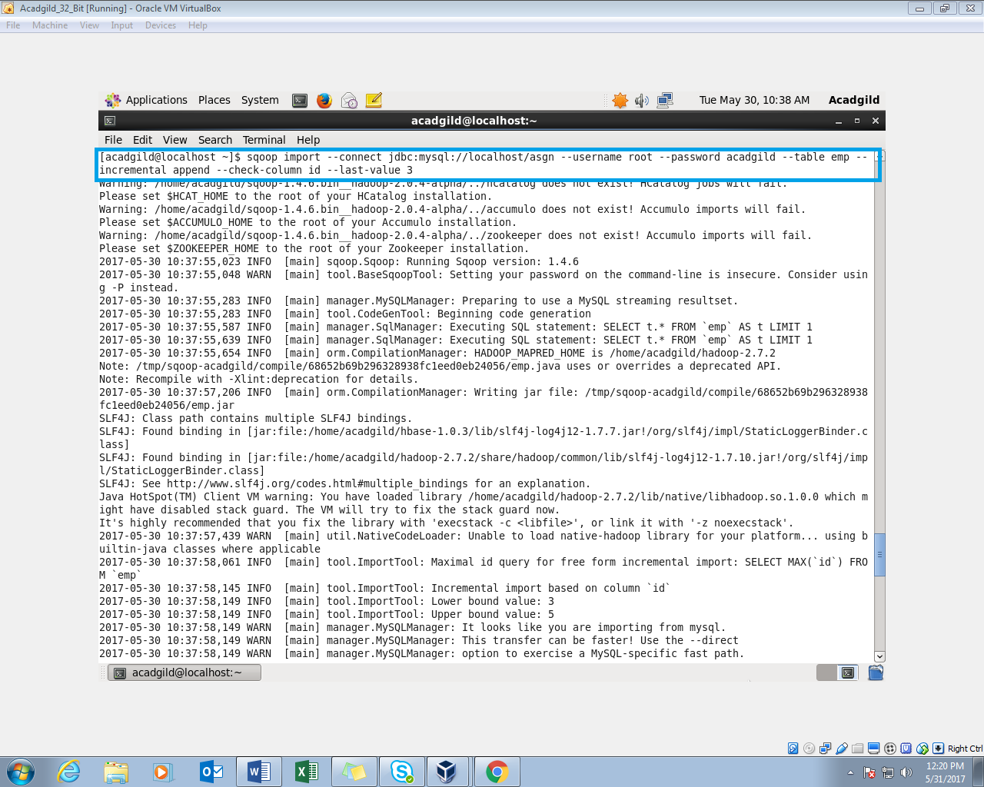

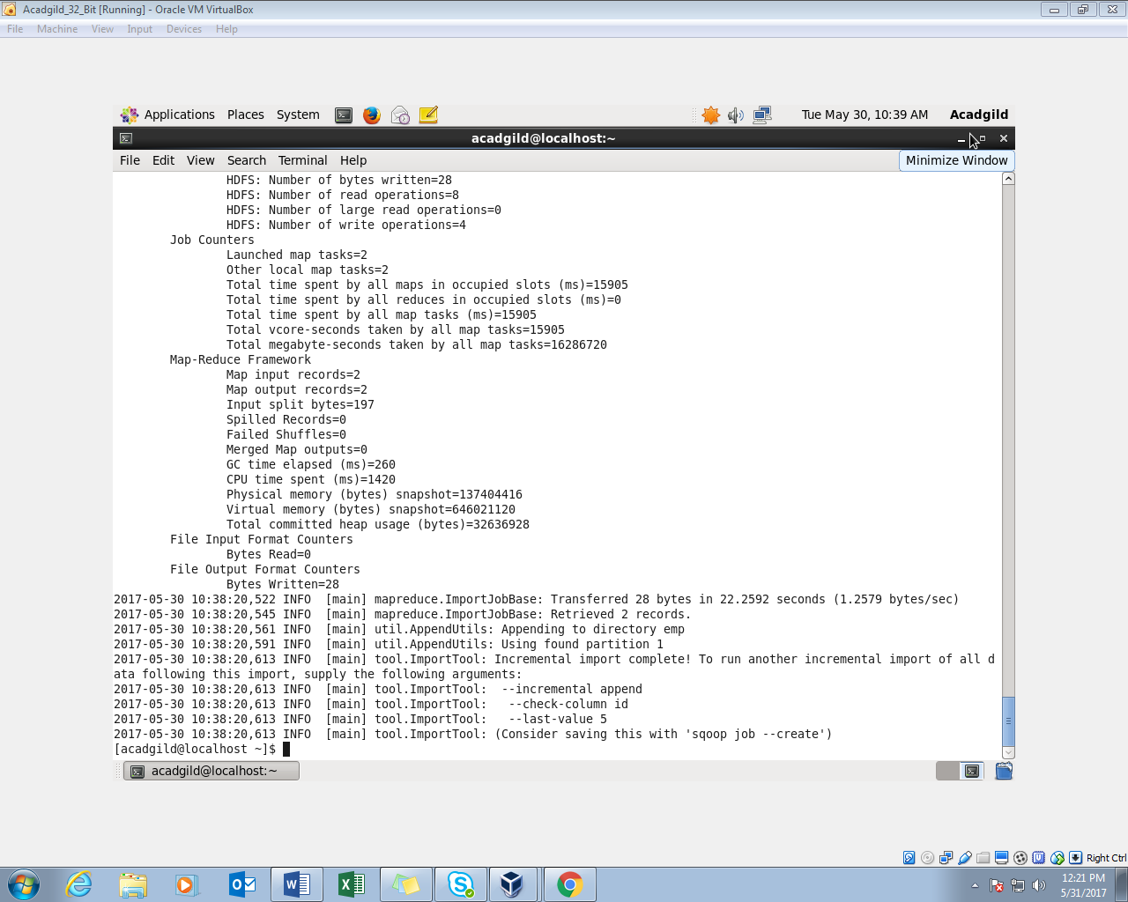

STEP 7: READING THE TABLE CONTENTS AFTER DOING INCREMENTAL APPEND

