Linux Programming: Assignment-4:
Name:Vigneshwaran P
Class:3C
USN:ENG24CY0069
DATE:27/09/2025

- A system has a file /etc/passwd. How would you use grep + tee to extract usernames and save them to a file while also displaying them on screen?
Soln:
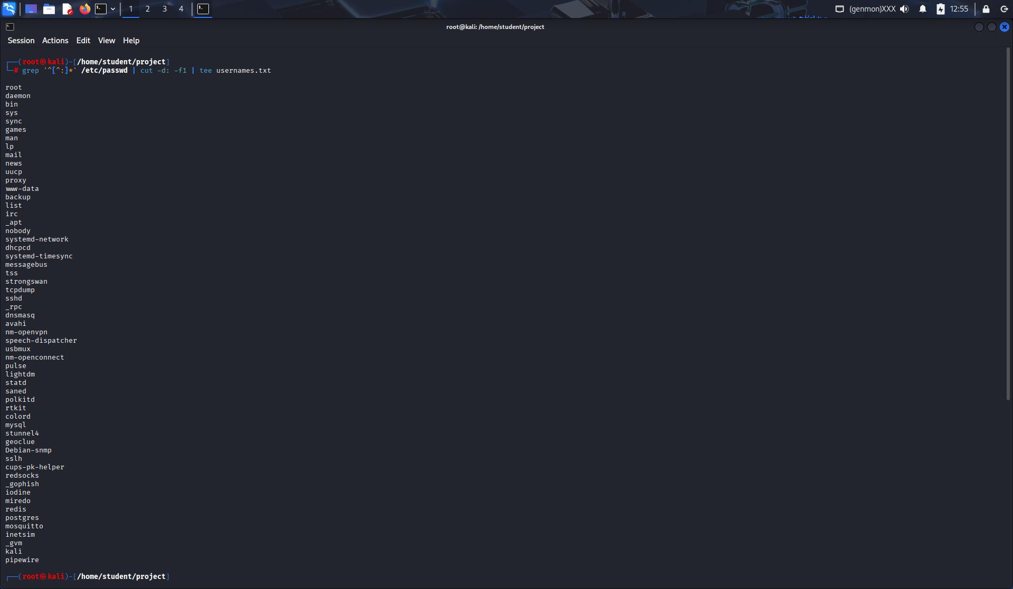

- A binary isn’t found in $PATH. How would you use commands (which, find, locate) to troubleshoot and fix the issue?
Soln:
- which command → Check if executable is in path.
- find / -name command 2>/dev/null → Search whole system.
- locate command → Search database quickly.
export PATH=$PATH:/path/to/binary

- Write a command pipeline that finds all .log files modified in the last 24 hours in /var/log and saves results into log_report.txt.
Soln:
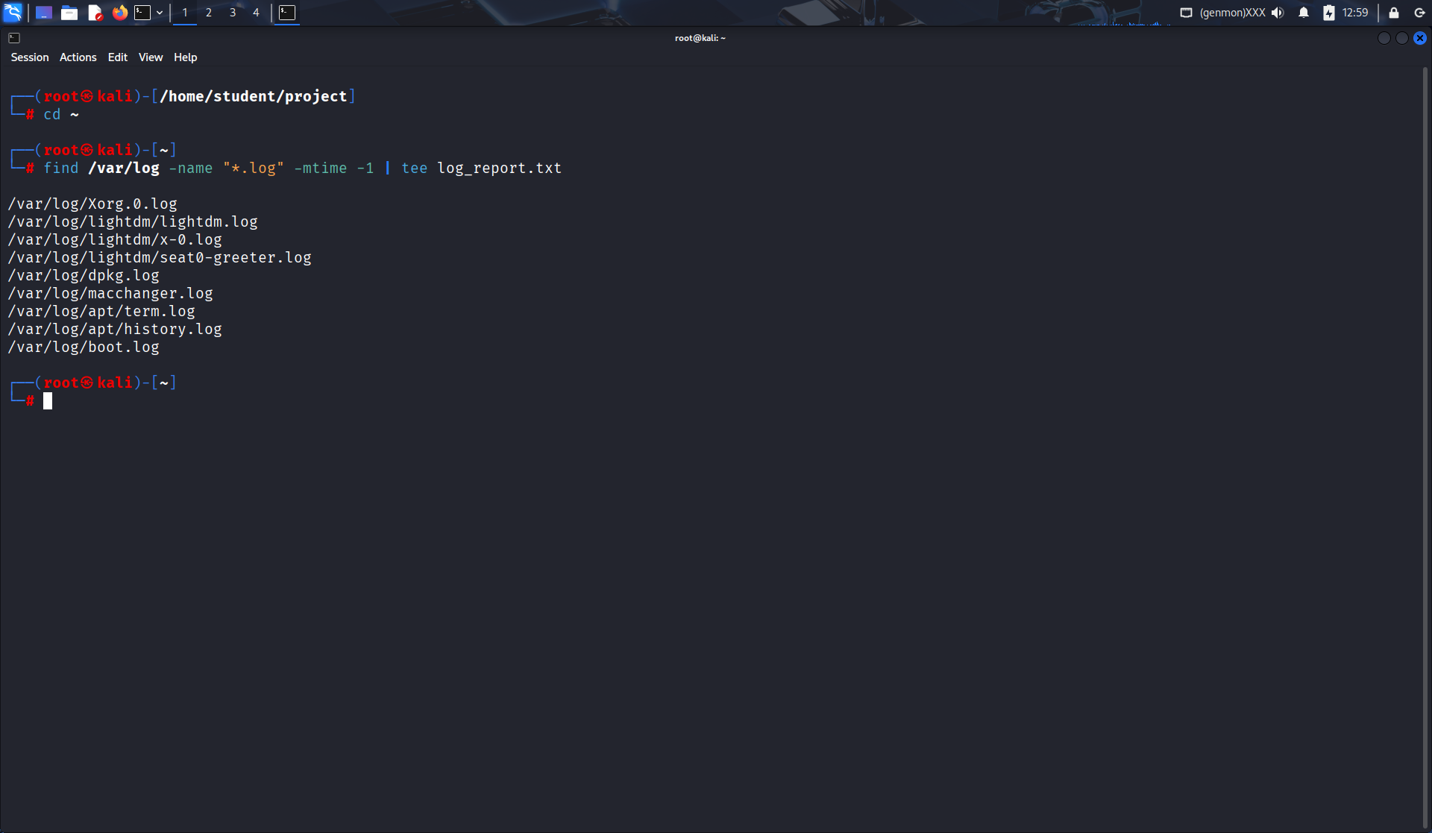

- What is the difference between shutdown -r now and reboot?
Soln:
- shutdown -r now: Gracefully stops all processes, then reboots.
- reboot: Immediately reboots system (less graceful).

- How can you use the tee command to debug a script that generates both standard output and error messages?
Soln:
./myscript.sh 2>&1 | tee debug_output.txt
Captures both stdout and stderr for debugging.
- Explain any three real-world applications of Linux in industries.
Soln:
- Web servers (Apache, Nginx on Linux power most websites).
- Cloud computing (Linux is backbone of AWS, Azure, GCP).
- Embedded systems/IoT (routers, Android OS, smart devices).
- Differentiate application, system and utility software in the context of Linux environment.
Soln:
- Application: User-level programs (LibreOffice, Firefox).
- System: Core OS software (Linux kernel, device drivers).
- Utility: Support tools (backup, file compression, text editors).

- What are the key differences between open-source and proprietary operating systems?
Soln:
- Open-source: Free, modifiable, transparent (Linux, BSD).
- Proprietary: Closed-source, licensed, controlled by vendor (Windows, macOS).
9. Write the command to display the system’s kernel version.
Soln:
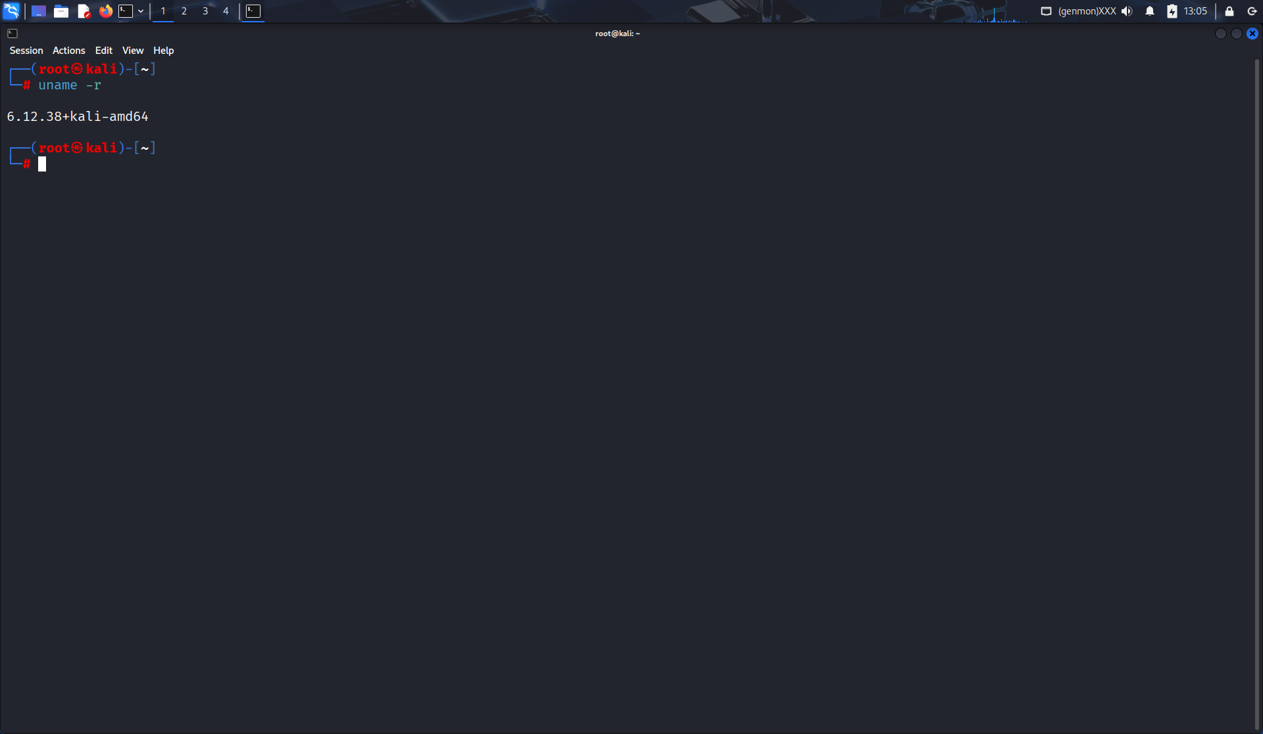

- What is the difference between head and tail commands in text processing?
Soln:
- head: Shows first 10 lines (default). Example: head file.txt.
- tail: Shows last 10 lines. Example: tail file.txt.

