PROJECT ENHANCEMENT DOCUMENT
1. PROJECT TITLE
MM-DAViT: Multimodal Multi-Disease Domain-Adaptive Vision Transformer for Explainable Thoracic Diagnosis with Clinical Metadata Integration
This title is unique and precisely reflects the transition from a unimodal, single-disease baseline architecture to an advanced, multimodal framework that processes both images and clinical tabular metadata for multi-label classification and spatial localization.
2. ANALYZED RESEARCH GAPS
Based on the analysis of the base DAViT paper and recent literature, the following critical research gaps have been identified in the existing architecture:
- Single-Disease Limitation (Unimodal Target): Inability to detect co-occurring thoracic diseases.
- Absence of Multimodal Clinical Context: Sole reliance on image pixels, ignoring vital clinical metadata (Age, Sex, View Position).
- Lack of Spatial Localization: Absence of explicit bounding-box coordinates for identifying exact lesion locations.
- Restricted Explainability (Unimodal Heatmaps): Interpretability is limited strictly to visual spatial regions without cross-modal token relevance.
3. GAP DISCUSSION
Gap 1: Single-Disease Limitation (Unimodal Target)
The baseline DAViT model was designed exclusively for binary and multi-class pneumonia detection (Normal vs. Viral vs. Bacterial). In a real-world clinical setting, thoracic conditions frequently co-occur (e.g., Pneumonia presenting alongside a Pleural Effusion). A model restricted to single-disease classification is insufficient for comprehensive radiology automation.
Gap 2: Absence of Multimodal Clinical Context
Human radiologists rarely diagnose chest X-rays in isolation; they heavily rely on patient demographics, vitals, and tabular metadata (such as Age, Sex, and AP/PA view position) to make accurate assessments. Current AI models experience a semantic gap by failing to integrate this non-image structured tabular data.
Gap 3: Lack of Spatial Localization
While the base model provides post-hoc Grad-CAM heatmaps for explainability, it does not explicitly predict bounding boxes. Clinicians require strict spatial localization (object detection) of lesions, nodules, and infiltrates to expedite the measurement and biopsy workflows.
Gap 4: Restricted Explainability (Unimodal Heatmaps)
Current explainability modules like standard Grad-CAM only highlight pixels on the X-ray. When introducing multimodal inputs (like clinical metadata), the model must also be able to explain which specific clinical variables (e.g., Age > 65) heavily influenced the multi-disease prediction alongside the visual heatmap.
4. PROPOSED CHANGES & ARCHITECTURAL ENHANCEMENTS
To address the identified gaps, the following enhancements will be implemented as discussed:
- Multimodal Integration Strategy (Cross-Attention Fusion): Transitioning from an image-only model to a dual-branch feature extractor. We will integrate a Vision Feature Branch (DAViT / DINOv2 backbone) and a Tabular Metadata Branch (to process Age, Sex, View Position). These modalities will be fused using a Cross-Attention Multimodal Fusion Module to establish joint visual-clinical context.
- Multi-Disease Classification Head: Replacing the simple softmax classification head with a Sigmoid Multi-Disease Classification Head capable of diagnosing 14+ distinct thoracic conditions simultaneously. An asymmetric loss function will be employed to handle severe multi-label class imbalance.
- Spatial Localization Head (YOLOv8 Neck): Implementing an intermediate CNN path utilizing a YOLOv8 Detection Neck and Coordinate Regressor. This will output localized bounding boxes (B, K, 5) for specific lesions (e.g., using the VinDr-CXR dataset).
- Advanced Preprocessing: Applying Anisotropic Diffusion Filters to raw X-rays to smooth background noise while preserving critical edge boundaries (e.g., ribs and lung fissures). Incorporating SMOTE-Tomek resampling techniques to address multi-label class imbalances at the batch level.
- Multimodal Explainability Workflow: Upgrading the explainability suite to combine standard Grad-CAM with DINOv2 Attention Rollout. Additionally, an 'Attribution Aggregator' will be introduced to output a unified report showing both visual ROI heatmaps and clinical variable relevance.
5. TECHNOLOGY STACK
The updated architecture requires a comprehensive and robust technology stack to support multi-modal deep learning, localization, and explainability:
- Core Deep Learning Framework: PyTorch, PyTorch Lightning (for distributed multi-task training).
- Vision & NLP Architecture Backbones: HuggingFace transformers, timm (PyTorch Image Models), DINOv2 (ViT Encoder), Shallow CNN layers.
- Localization/Object Detection: YOLOv8 architecture (Ultralytics) for the bounding box regression head.
- Explainable AI (XAI) Libraries: captum, pytorch-grad-cam (for visual heatmaps and cross-attention rollout).
- Data Processing & Augmentation: OpenCV (Anisotropic Diffusion Filtering), imbalanced-learn (SMOTE-Tomek for class imbalance), Pandas & NumPy (Tabular metadata processing), Albumentations (Image augmentation).
- Evaluation Metrics: Scikit-learn (Hamming Loss, Mean Average Precision (mAP), Macro/Micro F1, Subset Accuracy).
6. DATASET DESCRIPTION
To effectively train the multimodal and multi-disease enhancements (excluding the MIMIC-CXR dataset due to PhysioNet credentialing delays), the project will leverage alternative benchmark datasets that offer both medical imagery and structured clinical metadata.
The primary datasets will be CheXpert and NIH ChestX-ray14, which provide rich multi-disease labels (14 thoracic conditions) alongside readily available tabular metadata such as Age, Sex, and AP/PA View Position. For the spatial localization enhancement (bounding boxes), the VinDr-CXR dataset will be utilized, as it provides radiologist-annotated local findings required by the YOLOv8 regression head.
7. DATASET CONFIGURATION TABLE
Below is the comprehensive dataset configuration table detailing the datasets, their primary enhancements, key specifications, availability, and official download links:
Dataset Name | Description / Primary Enhancement | Key Details (Size, Modalities, Labels) | Access & Availability | Download Link
CheXpert  (Stanford AIMI) | Multi-Disease & Structured Metadata: Perfect for testing tabular clinical metadata fusion alongside multi-disease classification. | • Size: 224,316 radiographs from 65,240 patients.  • Modalities: Radiographs + tabular metadata (Age, Sex, View AP/PA).  • Labels: 14 thoracic categories with uncertainty labels. | Open Access (Quick access upon registration, no CITI wait). | Stanford CheXpert Link  (https://stanfordmlgroup.github.io/competitions/chexpert/)
NIH ChestX-ray14 | Multi-Disease Expansion: Ideal for large-scale multi-label baseline benchmarking without access delays. | • Size: 112,120 frontal view X-rays from 30,805 unique patients.  • Modalities: X-ray images + basic patient metadata.  • Labels: 14 distinct thoracic pathology labels. | Fully Open Access (NIH Box / Google Cloud Public). | NIH ChestX-ray14 Link  (https://nihcc.app.box.com/v/ChestX-ray-NIHCC)
VinDr-CXR | Multi-Disease & Spatial Localization: Best choice for implementing object localization and bounding box regression (YOLOv8). | • Size: 18,000 chest X-rays annotated by expert radiologists.  • Modalities: X-ray images with bounding boxes for lesion localization.  • Labels: 28 local findings/lesions + 6 global thoracic diagnoses. | Credentialed Access / Open Research Subset (Quick approval 1-3 days). | VinDr-CXR Link  (https://physionet.org/content/vindr-cxr/1.0.0/)
Kermany et al. | Baseline Benchmark: Used strictly for baseline pediatric comparisons. | • Size: 5,856 pediatric chest X-ray images.  • Modalities: Chest X-rays.  • Labels: Normal, Viral Pneumonia, Bacterial Pneumonia. | Fully Open Access. | Kermany Dataset Link  (https://data.mendeley.com/datasets/rscbjbr9hq/2)
8. ARCHITECTURE DIAGRAM
Below is the architectural representation detailing the Multi-Modal fusion, visual feature extraction via Vision Transformers, and the specific Explainability stages using chest X-rays.
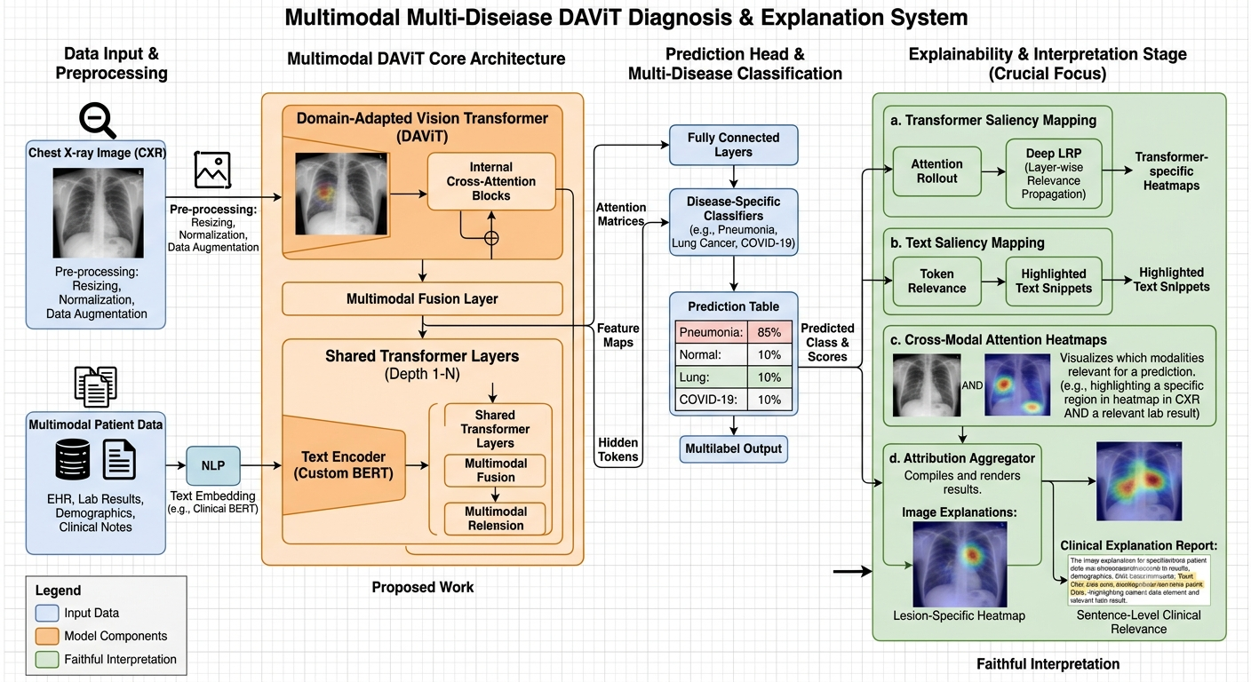
9. WORKFLOW DIAGRAM
Below is the process flowchart depicting the end-to-end data pipeline, multimodal fusion, multi-label diagnostic tasks, and the generation of localized and explainable outputs.


