Software Requirements Specification
for X-Fusion: An Explainable Tri-Modal Deep Learning Framework for Accurate Multimodal Chest X-Ray Diagnosis

Version 1.0 approved
Prepared by Project Team:
P. Deepesh Reddy (24BD1A055E)
Racha Vignesh (24BD1A055G)
R. Sidhardh Reddy (24BD1A055H)
Saharsh Machendra (24BD1A055J)
V. Surya Venkat (24BD1A055Y)
Mentor: Dr. K Vishal Reddy
Date: September 15, 2026
IMPORTANT NOTICE: X-Fusion is an ongoing academic research and development project. This document reflects the current implementation status as of the document date. It does not constitute a regulatory submission or clinical certification.

Table of Contents
Table of Contents 2
1. Introduction 5
1.1 Purpose 5
1.2 Document Conventions 5
1.3 Intended Audience and Reading Suggestions 5
1.4 Product Scope 5
1.5 References 6
2. Overall Description 6
2.1 Product Perspective 6
2.2 Product Functions 6
2.3 User Classes and Characteristics 6
2.4 Operating Environment 7
2.5 Design and Implementation Constraints 7
2.6 User Documentation 7
2.7 Assumptions and Dependencies 7
3. External Interface Requirements 7
3.1 User Interfaces 7
3.2 Hardware Interfaces 7
3.3 Software Interfaces 7
3.4 Communications Interfaces 8
4. System Features 8
4.1 Tri-Modal Data Ingestion and Preprocessing 8
4.2 Multimodal Feature Encoding 8
4.3 Contrastive Alignment and Cross-Attention Fusion 8
4.4 Multi-Disease Classification 8
4.5 Multimodal Explainability and Diagnostic Card 8
4.6 Analysis History and Report Generation 9
5. Other Nonfunctional Requirements 9
5.1 Performance Requirements 9
5.2 Safety Requirements 9
5.3 Security Requirements 9
5.4 Software Quality Attributes 9
5.5 Business Rules 9
6. Other Requirements 9
6.1 Dataset and Data-Management Requirements 9
6.2 Interoperability and Reuse Requirements 9
Appendix A: Glossary 10
Appendix B: Analysis Models 10
B.1 Proposed System Architecture 10
B.2 Data and Workflow Diagram 10
B.3 Implemented UI Screenshots 11
Appendix C: To Be Determined List 14

1. Introduction

1.1 Purpose
This Software Requirements Specification (SRS) describes the functional and non-functional requirements for X-Fusion: An Explainable Tri-Modal Deep Learning Framework for Accurate Multimodal Chest X-Ray Diagnosis. The document covers Version 1.0 of the X-Fusion system, reflecting the current implementation status as of September 2026.
The SRS specifies the complete system: input ingestion, preprocessing, multimodal feature encoding, contrastive alignment, cross-attention fusion, multi-label disease classification, and explainability output. It also documents those subsystems that are currently planned or partially implemented, clearly distinguishing them from functionality that is already operational. This document is intended for internal use by the development team and for evaluation by the project mentor. It does not constitute a regulatory submission, a clinical-trial protocol, or a deployment specification.

1.2 Document Conventions
The following conventions are used throughout this document:
- Requirement identifiers follow the format `XF-FR-nnn` for functional requirements and `XF-NFR-nnn` for non-functional requirements.
- Priority levels — HIGH, MEDIUM, LOW — are assigned to system features.
- Implementation status labels are used consistently throughout the document:
- [IMPLEMENTED]: functionality that is operational in the current prototype.
- [PARTIAL]: functionality that is partially implemented; further work is required.
- [PLANNED]: functionality intended for a future development iteration; not yet implemented.
- TBD references are numbered TBD-01, TBD-02, etc. and are collected in Appendix C.

1.3 Intended Audience and Reading Suggestions
This document is addressed to the following audiences:
- Development Team: All sections; especially Sections 3, 4, 5
- Project Mentor / Academic Evaluator: All sections; especially Sections 1, 2, 4, 5, Appendix B
- Radiologists / Clinicians: Sections 1.4, 2.2, 2.3, 3.1, 4.4, 4.5
- Technical Reviewers / Testers: Sections 4, 5, Appendix A, Appendix C
- Medical Researchers: Sections 2.1, 2.5, 4, 6, Appendix B

1.4 Product Scope
X-Fusion is an AI-based clinical decision-support research prototype for thoracic disease analysis. It processes three complementary data modalities simultaneously:
1. Radiological modality: chest X-ray images.
2. Textual modality: unstructured clinical notes and physician indication text.
3. Tabular modality: structured patient demographic and vital information (e.g., age, sex).
By combining these modalities, X-Fusion addresses four documented deficiencies in current unimodal AI diagnostic tools: isolation of visual context, modality imbalance, shallow fusion, and unexplainable (black-box) decision output. The system is designed to predict probability scores for up to 14 thoracic pathology labels simultaneously and to generate a structured, human-readable Diagnostic Card that justifies each prediction through visual heatmaps, text attributions, and tabular feature explanations.
Benefits:
- Improved diagnostic context through tri-modal evidence fusion.
- Transparent, explainable AI output that supports clinician trust.
- A modular, extensible architecture that can incorporate improved encoders as the research field advances.

1.5 References
- [1] IEEE-SRS.pdf: IEEE Recommended Practice for Software Requirements Specifications (IEEE Std 830-1998 / template).
- [2] Untitled_document_final_updated.docx: X-Fusion design and architecture document. Source for problem statement, research gaps, architectural enhancements, and dataset descriptions.
- [3] XFusion_Project_Progress_Simple_Bright (1).pptx: X-Fusion project progress presentation. Authoritative source for current implementation status.
- [4] DAViT Paper: A Domain-Adapted Vision Transformer for Automated Pneumonia Detection and Explanation Using Chest X-Ray Images. (Supporting literature)

2. Overall Description

2.1 Product Perspective
X-Fusion is a new, self-contained AI research prototype developed to address documented limitations in unimodal chest X-ray diagnostic AI systems. It operates as a standalone decision-support application that integrates three independent input modalities into a unified inference and explanation pipeline.
It comprises:
- A web-based clinical user interface. [IMPLEMENTED]
- A backend inference engine. [IMPLEMENTED — 85% integrated]
- Three specialized feature encoders (visual, textual, tabular). [PARTIAL]
- A contrastive alignment and cross-attention fusion module. [PARTIAL]
- A multi-label disease classification head (14 pathologies). [IMPLEMENTED — baseline]
- A multimodal explainability engine. [PARTIAL]

2.2 Product Functions
- F-01 — Tri-Modal Input Acceptance: Accept a chest X-ray image, unstructured clinical notes, and structured patient data.
- F-02 — Data Validation and Preprocessing: Validate format; apply modality-specific preprocessing.
- F-03 — Multimodal Feature Encoding: Extract latent feature representations from each modality using domain-adapted encoders.
- F-04 — Contrastive Alignment and Fusion: Balance and align cross-modal feature representations; fuse them using multi-head cross-attention.
- F-05 — Multi-Disease Prediction: Output probability scores for up to 14 thoracic pathology categories simultaneously.
- F-06 — Explainability Generation: Produce visual heatmaps, text token attributions, and tabular feature importance scores compiled into a Diagnostic Card.
- F-07 — History and Reporting: Maintain an inference history log and generate an exportable structured diagnostic report.

2.3 User Classes and Characteristics
- Radiologist / Clinician: Primary end user. Uses X-Fusion to obtain a structured AI-assisted second opinion on chest X-ray findings.
- Hospital IT / Integration Team: Responsible for deploying and maintaining the backend and UI.
- Medical Researcher: Studies the framework to investigate multimodal AI behaviour.
- Development Team: Designs, implements, trains, and evaluates all components.

2.4 Operating Environment
- Hardware: GPU-enabled server or workstation (CUDA-compatible).
- Deep-Learning Framework: PyTorch and PyTorch Lightning.
- Pretrained Models: BiomedCLIP and CXR-BERT (or ClinicalBERT).
- Python Environment: Python 3.x.

2.5 Design and Implementation Constraints
- C-01 — GPU Dependency: Training and high-throughput inference require GPU-enabled compute.
- C-02 — Pretrained Model Dependency: The visual encoder and text encoder are domain-adapted pretrained models.
- C-03 — Dataset Access Restrictions: VinDr-CXR and MIMIC-CXR datasets require credentialed access.
- C-04 — Tri-Modal Data Requirement: Full system operation requires all three input modalities (handles graceful fallback).
- C-05 — Multi-Label Classification: The classification head must support simultaneous multi-label prediction.
- C-06 — Privacy and Data Handling: Training datasets contain PHI; output must comply with regulations.

2.6 User Documentation
No formal user manual is provided for the current Version 1.0 research prototype. This SRS serves as the primary system documentation.

2.7 Assumptions and Dependencies
- A-01: The clinical UI is accessed via a web browser on a local inference server.
- A-02: Clinical notes entered into the system are in English.
- D-01: Availability and licensing of BiomedCLIP pretrained weights.
- D-02: Availability and licensing of CXR-BERT or ClinicalBERT.
- D-03: Access to CheXpert, MIMIC-CXR, NIH ChestX-ray14, and VinDr-CXR datasets.

3. External Interface Requirements

3.1 User Interfaces
The X-Fusion clinical user interface is delivered as a web-based application accessible through a standard browser.
- Screen 1 — New X-Ray Analysis [IMPLEMENTED]: Upload field, age/sex, vitals entry, clinical notes, "Run" trigger button.
- Screen 2 — Analysis Results [IMPLEMENTED]: Primary finding label, LayerCAM visual heatmap, 14-class diagnostic breakdown.
- Screen 3 — History and Generated Report [IMPLEMENTED]: Inference history log, NeuralCXR diagnostic report export.
(See Appendix B for UI Screenshots from project progress presentation)

3.2 Hardware Interfaces
X-Fusion does not interface with physical medical devices. A CUDA-compatible GPU is required for model training and inference.

3.3 Software Interfaces
- PyTorch / PyTorch Lightning: Core deep-learning framework and orchestration.
- HuggingFace Transformers: Pretrained text encoder (CXR-BERT / ClinicalBERT).
- BiomedCLIP & timm: Vision-language encoder & Vision Transformers backbone.
- LayerCAM & Captum & SHAP: Visual explainability, Model attribution, Feature importance.
- OpenCV & Pandas: Image preprocessing, tabular data handling.

3.4 Communications Interfaces
The frontend UI communicates with the backend inference engine via an HTTP-based API. Requests carry the tri-modal input payload, and the backend returns structured result sets including predictions, confidences, and heatmaps. No external network communication interfaces are implemented for inference; operations run locally.

4. System Features

4.1 Tri-Modal Data Ingestion and Preprocessing
- Description and Priority (HIGH): Acceptance, validation, and preprocessing of chest X-ray image, clinical notes, and structured patient vitals.
- XF-FR-001: Accept tri-modal analysis request through the clinical UI. [IMPLEMENTED]
- XF-FR-002: Validate X-ray image field and file format before initiating analysis. [IMPLEMENTED]
- XF-FR-003: Apply modality-specific preprocessing (contrast enhancement, tokenization, standardization). [PARTIAL]
- XF-FR-004: Fallback gracefully when clinical notes text is absent, continuing analysis using image and tabular modalities. [PLANNED]

4.2 Multimodal Feature Encoding
- Description and Priority (HIGH): Extraction of latent feature representations using specialized domain-adapted encoders.
- XF-FR-005: Extract visual feature representations using BiomedCLIP encoder. [PARTIAL]
- XF-FR-006: Extract text representations using CXR-BERT/ClinicalBERT. [PARTIAL]
- XF-FR-007: Encode structured tabular data using MLP or TabNet. [PARTIAL]

4.3 Contrastive Alignment and Cross-Attention Fusion
- Description and Priority (HIGH): Balances representations across modalities (InfoNCE loss) and fuses them (multi-head cross-attention).
- XF-FR-009: Apply contrastive latent alignment during training to prevent modality overpowering. [PARTIAL]
- XF-FR-010: Implement multi-head cross-attention fusion layers to dynamically connect image patches with text tokens. [PARTIAL]
- XF-FR-011: Use fused multimodal representation as the sole input to the classification head. [PARTIAL]

4.4 Multi-Disease Classification
- Description and Priority (HIGH): Multi-label classification head for up to 14 thoracic pathologies.
- XF-FR-012: Produce independent probability scores for 14 specific thoracic pathology categories simultaneously. [IMPLEMENTED — baseline]
- XF-FR-013: Use a multi-label sigmoid output. [IMPLEMENTED]
- XF-FR-014: Use Asymmetric Loss during training to mitigate class imbalance. [IMPLEMENTED]
- XF-FR-015: Display probability scores in the UI diagnostic breakdown panel. [IMPLEMENTED]

4.5 Multimodal Explainability and Diagnostic Card
- Description and Priority (HIGH): Generates per-modality explanations compiled into a unified Diagnostic Card.
- XF-FR-016: Generate LayerCAM visual attention heatmap overlaid on the input X-ray. [IMPLEMENTED]
- XF-FR-017: Generate text attribution highlights (Captum). [PLANNED]
- XF-FR-018: Generate SHAP-based tabular feature importance scores. [PLANNED]
- XF-FR-019: Compile visual, textual, and tabular explanations into an integrated Diagnostic Card. [PARTIAL]

4.6 Analysis History and Report Generation
- Description and Priority (MEDIUM): Persistence of previous records and exportable structured reports.
- XF-FR-021: Maintain an inference history log recording finding, confidence, and 14-class breakdown. [IMPLEMENTED]
- XF-FR-023: Generate exportable structured NeuralCXR diagnostic report. [IMPLEMENTED]

5. Other Nonfunctional Requirements

5.1 Performance Requirements
- XF-NFR-001: Generate predictions and explanations within 5 seconds on GPU infrastructure. [PLANNED]
- XF-NFR-002: Support batch processing of multiple analysis requests without memory exhaustion. [PLANNED]
- XF-NFR-003: Capable of executing full-scale GPU training on NIH ChestX-ray14 and VinDr-CXR datasets. [PLANNED]

5.2 Safety Requirements
- XF-NFR-004: Decision Support Role — explicit second-opinion tool; no output shall be presented as an authoritative diagnosis. [IMPLEMENTED]
- XF-NFR-005: No Autonomous Diagnosis — must always provide confidence scores and supporting evidence. [IMPLEMENTED]

5.3 Security Requirements
- XF-NFR-006: Patient Data De-identification in outputs, logs, and exported reports. [PLANNED]
- XF-NFR-007: Local Processing Preference to prevent sensitive healthcare data from being transmitted to public clouds. [PLANNED]
- XF-NFR-009: Comply strictly with dataset provider access agreements. [IMPLEMENTED]

5.4 Software Quality Attributes
- XF-NFR-010: Robustness — Graceful handling of missing modalities without crashes.
- XF-NFR-011: Modularity — Independent encoders and fusion components.
- XF-NFR-013: Usability — Output format interpretable by a radiologist without AI specialist knowledge.

5.5 Business Rules
- BR-01: X-Fusion is for research and clinical decision support only.
- BR-02: A chest X-ray image is a mandatory input.

6. Other Requirements

6.1 Dataset and Data-Management Requirements
- XF-DR-001: Trained on the CheXpert dataset. [PARTIAL — baseline trained]
- XF-DR-002: Incorporate MIMIC-CXR for multimodal text-image pair training. [PARTIAL]
- XF-DR-003: Evaluated and validated on NIH ChestX-ray14 and VinDr-CXR. [PLANNED]

6.2 Interoperability and Reuse Requirements
Encoders (BiomedCLIP, CXR-BERT, MLP/TabNet) shall be implemented using HuggingFace Transformers and timm APIs to ensure model weights can be updated from community repositories.

Appendix A: Glossary
- BiomedCLIP: A pretrained vision-language model fine-tuned on biomedical image-text pairs.
- LayerCAM: A layer-wise class activation mapping method used to generate visual heatmaps.
- Multi-Label Classification: A classification setting where an input may simultaneously belong to multiple classes (e.g., 14 pathologies).
- Tri-Modal: Simultaneous use of three distinct data modalities: visual, textual, and tabular.

Appendix B: Analysis Models

B.1 Proposed System Architecture
The diagram below illustrates the high-level tri-modal processing pipeline.
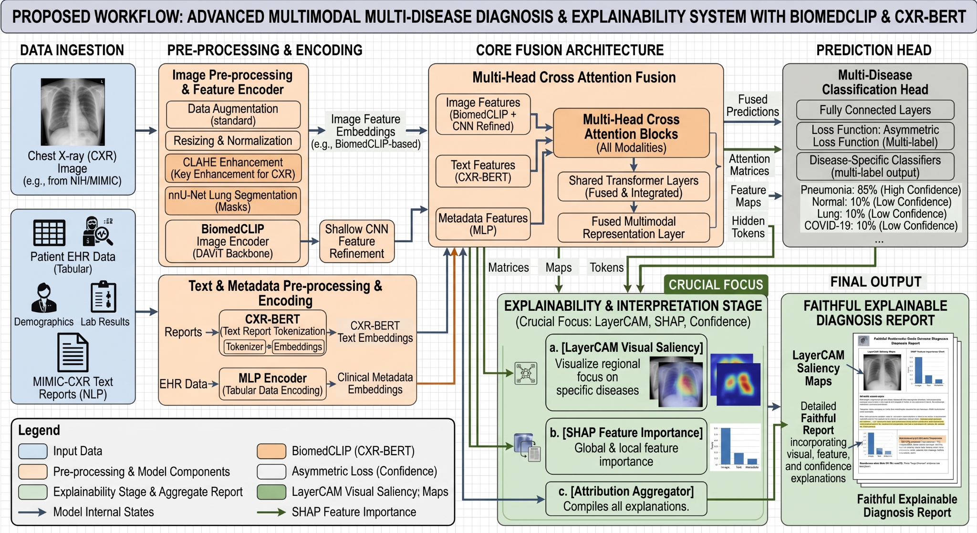
Figure: Architecture Diagram

B.2 Data and Workflow Diagram
Step-by-step data flow from ingestion to explanation output.
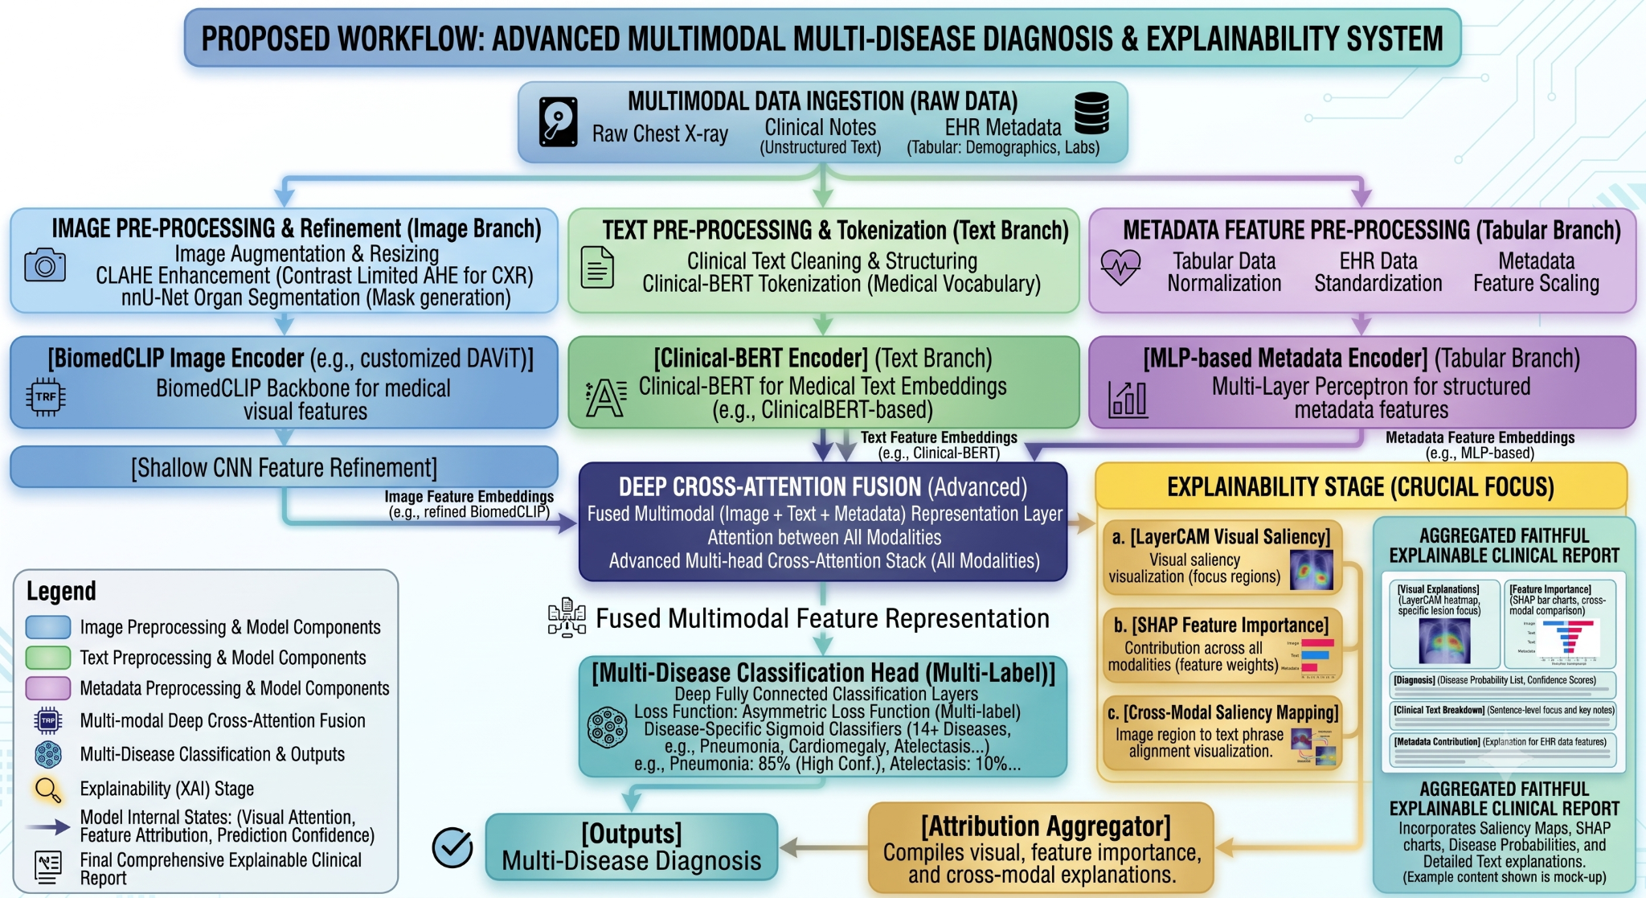
Figure: Workflow Diagram

B.3 Implemented UI Screenshots
Screen 1: New X-Ray Analysis & Screen 2: Analysis Results
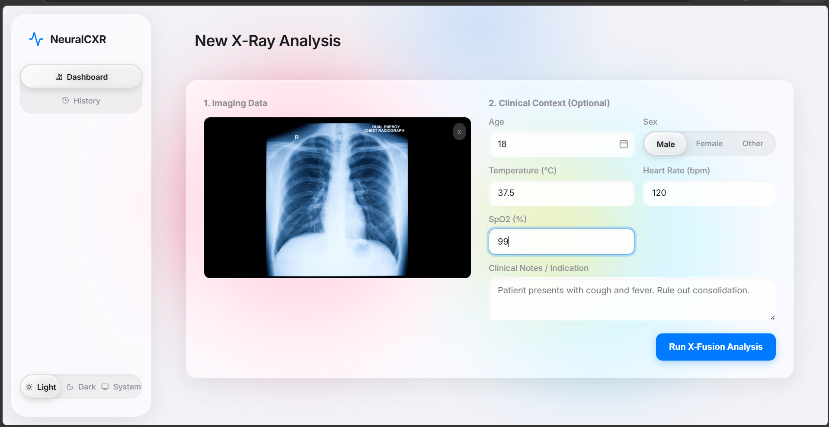
Figure: UI Screenshot 1
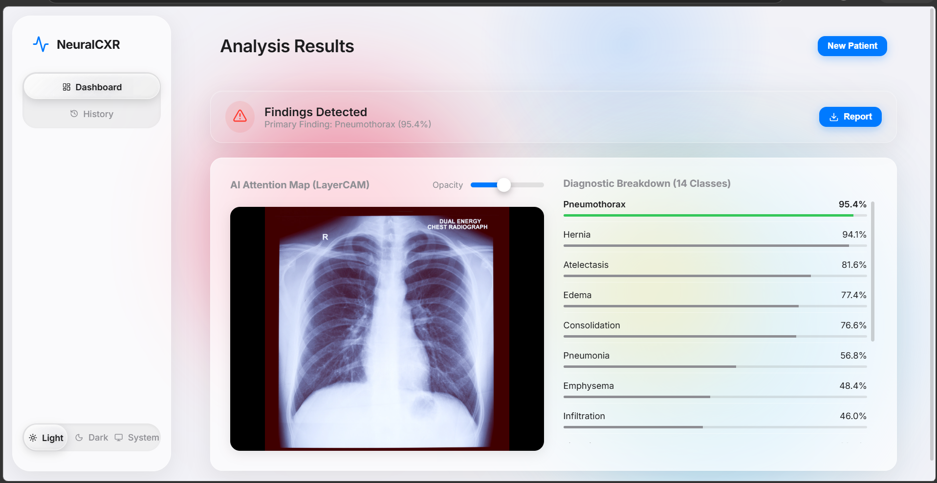
Figure: UI Screenshot 2
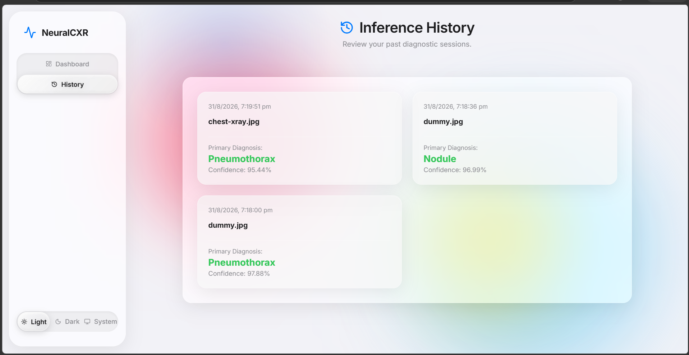
Figure: UI Screenshot 3
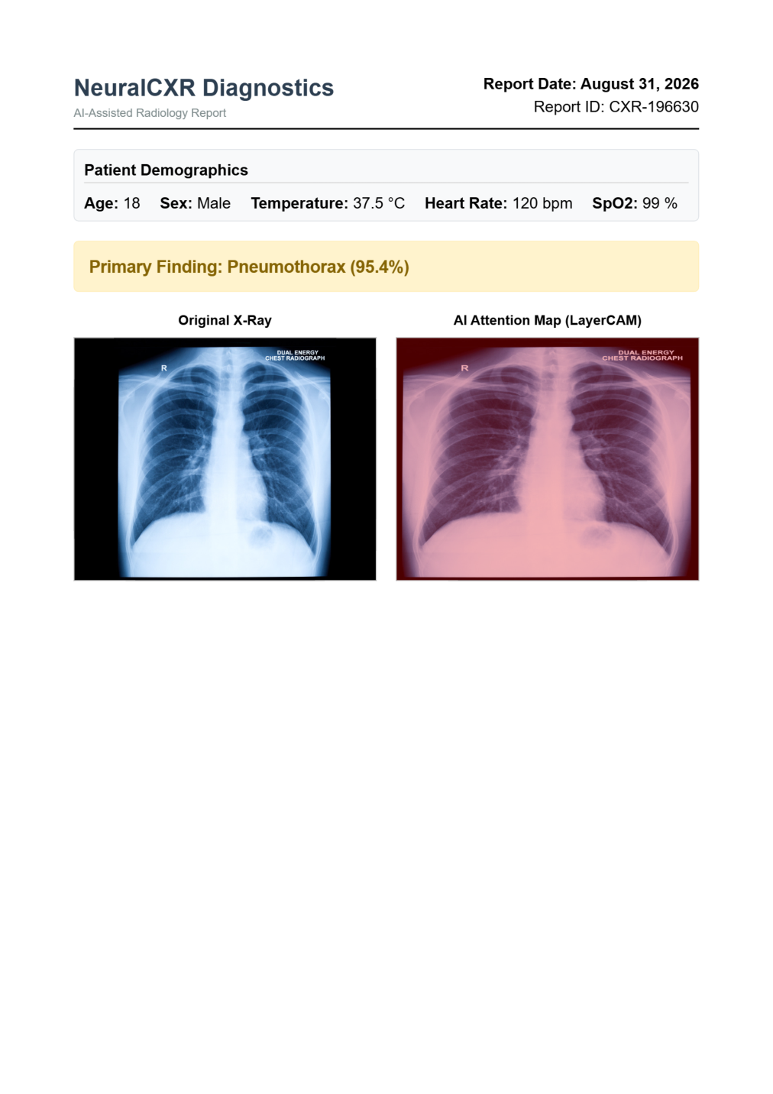
Figure: UI Screenshot 4

Appendix C: To Be Determined List
- TBD-01: Exact GPU model, VRAM, RAM, CPU, and Python versions required for inference.
- TBD-02: Final text encoder selection (CXR-BERT vs ClinicalBERT/RoBERTa).
- TBD-03: Rendering format for text attribution and tabular feature importance.
- TBD-04: Full multimodal training completion timeline and parameters.
- TBD-05: Final verified performance metrics (Macro/Micro AUC-ROC, etc.) on NIH ChestX-ray14 and VinDr-CXR.
- TBD-06: Specific frontend technology framework (e.g., React, Streamlit).

