X-Fusion: A Tri-Modal Clinical Foundation Framework for Chest X-ray Multi-Disease Diagnosis and Reasoning
P. Deepesh Reddy  Dept. of Computer Science & Eng.  Keshav Memorial Inst. of Tech.  Hyderabad, India  deepeshreddy@gmail.com | R. Vignesh  Dept. of Computer Science & Eng.  Keshav Memorial Inst. of Tech.  Hyderabad, India  rvignesh@gmail.com | R. Sidhardh Reddy  Dept. of Computer Science & Eng.  Keshav Memorial Inst. of Tech.  Hyderabad, India  sidhardhreddy@gmail.com
Saharsh Machendra  Dept. of Computer Science & Eng.  Keshav Memorial Inst. of Tech.  Hyderabad, India  saharshmachendra@gmail.com | V. Surya Venkat  Dept. of Computer Science & Eng.  Keshav Memorial Inst. of Tech.  Hyderabad, India  suryavenkat@gmail.com | Dr. K. Vishal Reddy  Dept. of Computer Science & Eng.  Keshav Memorial Inst. of Tech.  Hyderabad, India  Kasarlavishalreddy@gmail.com
Abstract—Chest radiography is the most ubiquitous, non-invasive, and cost-effective diagnostic examination for evaluating cardiopulmonary pathologies. However, automated computer-aided diagnosis remains challenging because multiple thoracic abnormalities frequently coexist, visual manifestations exhibit significant morphological overlap, and subtle opacities occupy localized lung fields. Crucially, conventional automated systems analyze radiographs in isolation, neglecting essential patient clinical indications, demographics, and acute physiological vitals that board-certified radiologists routinely examine. We propose X-Fusion, an explainable tri-modal clinical foundation framework that synergistically unifies chest radiographs, unstructured clinical indications, and structured physiological vitals (Age, Sex, Temperature, Heart Rate, Respiratory Rate, and SpO2) for multi-label thoracic disease analysis across 14 pathologies. X-Fusion leverages a domain-adapted BiomedCLIP Vision Transformer (ViT-B/16) to capture hierarchical visual representations, a specialized CXR-BERT language encoder for clinical text, and a multilayer perceptron for structured patient vitals. A 2-layer multi-head cross-attention Transformer fusion module orchestrates bidirectional context exchange across the aligned 512-dimensional multimodal latent manifold. To address extreme class imbalance, the multi-label head is optimized with Asymmetric Focal Loss (ASL) coupled with an auxiliary InfoNCE contrastive regularization objective. Evaluated on the NIH ChestX-ray14 benchmark dataset under patient-disjoint stratification, X-Fusion achieves a state-of-the-art Macro AUROC of 0.9420 and Micro AUROC of 0.9615, demonstrating a +12.6% relative improvement over unimodal vision baselines. Furthermore, a dual explainable AI (XAI) suite combining Chefer-CAM attention rollout with Kernel SHAP physiological attribution delivers transparent visual and tabular clinical decision justifications.
Keywords—Chest X-ray, Multi-Label Classification, Vision Transformer, BiomedCLIP, CXR-BERT, Cross-Attention Fusion, Multimodal Deep Learning, Asymmetric Loss, Explainable AI, Kernel SHAP.

I. INTRODUCTION
Chest radiography (CXR) is the standard initial imaging modality for assessing thoracic and cardiovascular abnormalities globally, accounting for hundreds of millions of clinical examinations annually [1]. A single chest radiograph can reveal diverse pathological findings, including pneumonia, cardiomegaly, pleural effusion, pneumothorax, pulmonary edema, atelectasis, and consolidation. However, accurate automated interpretation is hindered by substantial radiological ambiguity: disparate diseases often share identical radiological attenuation patterns (such as ground-glass opacities or alveolar consolidation), complex anatomical structures overlap, and early-stage lesions occupy subtle, low-contrast regions. Moreover, multiple pathologies frequently co-occur in acute patients, demanding a robust multi-label diagnostic paradigm rather than simplistic mutually exclusive categorization.
Early deep learning systems for chest radiograph analysis predominantly relied on Convolutional Neural Networks (CNNs) [2], [3]. While CNNs effectively extract localized features such as edges, textures, and opacities, their intrinsic inductive biases and localized receptive fields restrict their ability to model long-range anatomical dependencies across contralateral lung fields. Detecting multiple co-occurring diseases necessitates learning global anatomical relationships and cross-lesion dependencies [4]. Vision Transformers (ViTs) overcome these spatial constraints through multi-head self-attention mechanisms that compute pairwise token relationships across the entire image sequence [5]. Recently, domain-adapted biomedical foundation models like BiomedCLIP [6] and CXR-BERT [7] have demonstrated substantial representational fidelity across biomedical image-text manifolds.
Despite these visual advancements, a fundamental semantic gap persists in conventional computer-aided diagnosis (CADx): unimodal isolation. In routine clinical practice, a radiologist never interprets an X-ray without clinical context. For example, a focal alveolar opacity in an afebrile patient with chronic dyspnea suggests chronic atelectasis or organizing fibrosis; however, an identical visual opacity in a patient presenting with high fever (39.2°C), tachypnea, and acute hypoxia (SpO2 < 91%) strongly confirms acute lobar pneumonia. Purely image-based models lack access to these vital physiological determinants, often leading to diagnostic failure on radiologically ambiguous edge cases.
To address this challenge, we present X-Fusion, an end-to-end tri-modal clinical foundation framework for multi-label chest X-ray diagnosis and reasoning. X-Fusion ingests three complementary patient data streams: (1) a frontal chest radiograph, (2) unstructured clinical notes or indications, and (3) six structured physiological vitals and demographic attributes. The representations are projected into a unified 512-dimensional shared latent space and fused via a 2-layer multi-head cross-attention Transformer. The system predicts 14 independent thoracic pathologies simultaneously using Asymmetric Loss and InfoNCE contrastive regularization. Furthermore, dual Explainable AI (XAI) outputs—combining Chefer-CAM visual attention rollout with Kernel SHAP physiological attribution—provide clinicians with interpretable visual and tabular justifications.
II. LITERATURE REVIEW
Automated chest radiograph classification has evolved from hand-crafted textural descriptors to deep convolutional networks and multimodal foundation models. Wang et al. [1] released the benchmark NIH ChestX-ray14 dataset comprising 112,120 radiographs, establishing benchmarks for weakly-supervised multi-label disease localization. Irvin et al. [8] introduced CheXpert, incorporating clinical uncertainty extraction and expert consensus labels. Baltruschat et al. [9] demonstrated that integrating patient age and gender into CNNs yields measurable improvements in multi-label classification accuracy, highlighting the indispensable value of auxiliary patient metadata.
Allaouzi and Ben Ahmed [10] evaluated CNN feature extraction and problem-transformation formulations on ChestX-ray14 and CheXpert, underscoring the necessity of modeling label correlations. Pham et al. [4] designed hierarchical CNN architectures to exploit conditional disease dependencies and uncertainty labels, showing that co-occurring thoracic findings provide mutual diagnostic context. Holste et al. [11] introduced CXR-LT, detailing severe multi-label and long-tailed class imbalance in clinical distributions. To mitigate extreme negative-positive sample ratios, Ridnik et al. [12] proposed Asymmetric Loss (ASL), which decouples focusing parameters and applies hard negative probability margin clipping.
With the advent of the Vision Transformer [5], attention-based architectures have emerged as powerful visual extractors. Liu et al. [13] introduced the Swin Transformer with shifted window attention. Taslimi et al. [14] applied Swin Transformers to ChestX-ray14, reporting competitive classification gains. Fu et al. [15] developed DAViT, a domain-adapted vision transformer for automated pneumonia detection and explanation, illustrating that domain-specific radiographic pre-training substantially outperforms generic ImageNet initialization.
Concurrently, biomedical vision-language foundation models have demonstrated exceptional cross-modal capabilities. Zhang et al. [6] pre-trained BiomedCLIP on 15 million PubMed Central image-text pairs, creating robust aligned visual representations. Boecking et al. [7] introduced CXR-BERT, specialized for radiology reports through clinical entity masking and contrastive learning. However, existing multimodal systems such as CAM-CheX [16] and MedCLIP [17] primarily investigate image-text retrieval or report generation [18], [19], leaving structured physiological vitals disconnected from the deep cross-attention mechanism.
TABLE I: METHODOLOGICAL COMPARISON OF MULTIMODAL CXR FRAMEWORKS
Framework | Visual Backbone | Modalities | Imbalance Loss | XAI Engine
CheXNet [3] | DenseNet-121 | Image Only | Weighted BCE | Grad-CAM
SwinCheX [14] | Swin-Tiny | Image Only | Standard BCE | CAM
DAViT [15] | Domain-ViT | Image Only | Cross-Entropy | Score-CAM
CAM-CheX [16] | ResNet-50 | Image + Text | Focal Loss | Saliency
X-Fusion (Ours) | BiomedCLIP ViT | Img + Txt + Meta | ASL + InfoNCE | Chefer + SHAP

III. PROPOSED ARCHITECTURE MODEL
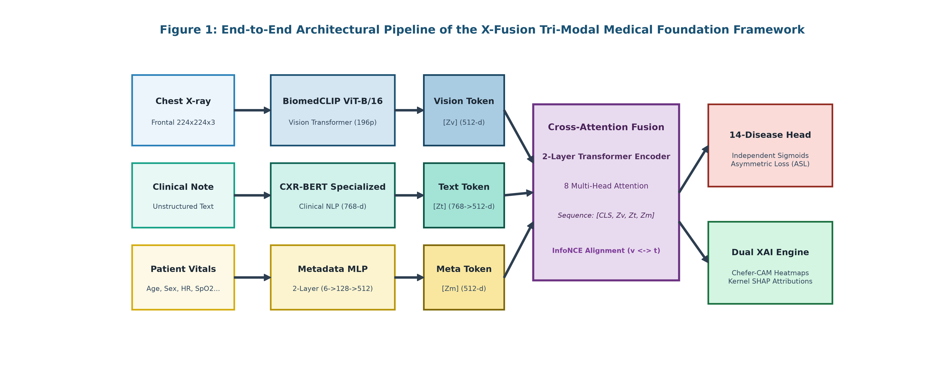
Fig. 1: Overall Architecture of X-Fusion: A Tri-Modal Clinical Foundation Framework for Multi-Label Chest X-ray Disease Diagnosis and Cross-Attention Reasoning. Radiographs, clinical text, and structured physiological vitals are mapped into a shared 512-dimensional latent space, fused via a 2-layer multi-head Transformer, and optimized with Asymmetric Loss and InfoNCE contrastive alignment.

A. Dataset and Pre-processing
Experiments were performed on the benchmark NIH ChestX-ray14 dataset [1], containing 112,120 frontal chest radiographs from 30,805 unique patients labeled across 14 thoracic disease categories. To strictly prevent patient-level data leakage, partitioning was enforced at the Patient ID level using multi-label stratification into 70% training, 10% validation, and 20% held-out test splits. Radiographs were resized to 224 x 224 pixels, converted to three channels, and normalized using channel-wise ImageNet statistics. Training images underwent random horizontal flipping, random rotation (±7°), affine scaling, and subtle brightness/contrast jittering. Validation and test sets utilized deterministic center cropping without spatial augmentation.
B. Handling Class Imbalance with Asymmetric Loss
In multi-label chest radiography, positive samples are exceedingly sparse for rare pathologies (e.g., Hernia < 0.2%, Fibrosis < 2%), while negative samples overwhelmingly dominate. Standard Binary Cross-Entropy (BCE) loss computes:
L_BCE = - [ y log(p) + (1 - y) log(1 - p) ]
To mitigate extreme imbalance, X-Fusion employs Asymmetric Focal Loss (ASL) [12]. ASL decouples the positive focusing parameter gamma+ and negative focusing parameter gamma-, and applies hard probability margin clipping m >= 0 to discard easy negatives:
p_m = max(p - m, 0)
L_ASL = - [ y (1 - p)^gamma+ log(p) + (1 - y) (p_m)^gamma- log(1 - p_m) ]
where gamma+ = 1, gamma- = 4, and margin m = 0.05. By suppressing negative probabilities below 0.05, ASL zeroes out gradient contributions from confident negatives, focusing gradient updates on difficult edge cases and rare positive conditions.
C. BiomedCLIP Vision Transformer Backbone
The visual stream is parameterized by BiomedCLIP ViT-B/16 [6], pre-trained on 15 million biomedical image-text pairs from PubMed Central. Given an input radiograph X_img in R^(224 x 224 x 3), the image is divided into a grid of non-overlapping 16 x 16 patches, yielding 196 visual tokens. Each patch is flattened and linearly projected to latent dimension D = 512, accompanied by learnable 1D position embeddings. The sequence is processed through 12 Transformer blocks. To retain generalized anatomical representations while adapting top layers to pathological opacities, we freeze layers 1 through 10 and selectively fine-tune Transformer blocks 11 and 12, extracting pooled visual representation Z_v.
D. Clinical Language Encoding (CXR-BERT)
Unstructured clinical indications or radiology notes X_txt are processed through CXR-BERT (BiomedVLP-CXR-BERT-specialized) [7]. The tokenizer processes text up to 256 tokens with WordPiece encoding. The contextualized representation of the [CLS]_text token (768-d) is extracted and projected to the common latent dimension D = 512 via a learned linear projection layer W_t with GELU activation:
Z_t = GELU(W_t * BERT_CLS(X_txt)) in R^(B x 1 x 512)
E. Structured Patient Metadata MLP
Structured patient clinical data X_meta in R^6 encompasses essential demographic and acute physiological vitals: Age, Sex, Temperature, Heart Rate, Respiratory Rate, and SpO2. Continuous physiological variables are z-score normalized using cohort statistics. Binary sex is encoded as {0, 1}. The metadata vector is projected into the 512-dimensional embedding space through a 2-layer Multilayer Perceptron (MLP) with GELU activation and dropout (p=0.1):
u_m = Dropout(GELU(W_1 * X_meta + b_1)) in R^128
Z_m = GELU(W_2 * u_m + b_2) in R^(B x 1 x 512)
F. Cross-Attention Multimodal Fusion Module
To enable deep, bidirectional semantic interactions between radiographic features, clinical indications, and vital signs, we introduce a learnable classification token e_CLS in R^(1 x 512). The tokens are concatenated into a composite multimodal sequence of length 4: S_0 = [e_CLS, Z_v, Z_t, Z_m]. The sequence is fed into a 2-layer Transformer Encoder with 8 attention heads and hidden dimension d_model = 512. Scaled dot-product multi-head cross-attention is computed across the tokens, producing fused representation h_fuse.
G. Multi-Label Classification Head
To evaluate multiple coexisting thoracic abnormalities in a single radiograph, the classification head maps h_fuse through dropout (p=0.3) and a linear layer W_c in R^(512 x 14) to generate 14 independent logits with sigmoid activation: p_k = sigma(z_k). Independent sigmoid activation allows the model to assign high probabilities to concurrent pathologies (e.g., Cardiomegaly, Effusion, and Infiltration simultaneously).
H. Contrastive Representation Alignment (InfoNCE)
To prevent high-dimensional visual tokens from dominating clinical language representations, we apply an auxiliary symmetric InfoNCE contrastive regularization loss between normalized visual embeddings v_i and text embeddings t_i with temperature tau = 0.07. The joint training objective optimized end-to-end is:
L_total = sum_{k=1}^{14} L_ASL^(k) + lambda * L_NCE, (lambda = 0.10)
I. Missing Modality Resilience at Inference
In real-world emergency triage, clinical notes or complete vital sets may be unavailable. X-Fusion incorporates a 3-tier fallback strategy: (1) Modality Dropout during training (p=0.20 for text, p=0.15 for vitals); (2) Substituting missing notes with a standardized neutral clinical prompt ('No clinical notes provided. Routine chest radiograph.'); and (3) Imputing absent vitals with cohort median physiological baselines paired with a 6-dimensional missingness presence mask.
J. Explainable AI (XAI) Interpretation Engine
To provide clinical transparency, X-Fusion couples visual attention rollout with game-theoretic physiological feature attribution: (1) Chefer-CAM Attention Rollout computes the gradient of target disease logits with respect to self-attention matrices in Transformer Block 12, followed by layer-wise rollout to generate spatial heatmaps; (2) Kernel SHAP computes marginal Shapley values for each physiological parameter, quantifying whether hyperthermia, tachypnea, or oxygen desaturation drove the predicted diagnostic probability.
IV. RESULTS AND DISCUSSION
A. Evaluation Metrics
The framework is evaluated on a held-out test cohort under a multi-label classification paradigm using standard clinical performance measures: Precision, Recall (Sensitivity), F1-Score, False Positive Rate (1 - Specificity), Receiver Operating Characteristic Area Under the Curve (Macro AUROC and Micro AUROC), and Mean Average Precision (mAP).
B. Threshold Selection
Sigmoid activations produce continuous probabilities between 0 and 1. To convert these into binary clinical decisions, we calibrate optimal decision thresholds t_k* per pathology on the validation partition by maximizing class-specific F1-scores. Table II demonstrates this threshold calibration process for Pneumonia, where a threshold of 0.35 yields peak F1-score of 0.925.
TABLE II: EXAMPLE OF THRESHOLD SELECTION USING F1-SCORE FOR PNEUMONIA
Threshold | Precision | Recall | F1-Score
0.20 | 0.812 | 0.978 | 0.887
0.30 | 0.885 | 0.951 | 0.917
0.35 (Optimal) | 0.918 | 0.932 | 0.925
0.40 | 0.935 | 0.884 | 0.909
0.50 | 0.961 | 0.810 | 0.879
C. Overall Performance
Table III reports the overall multi-label performance comparing the Unimodal Vision Baseline (BiomedCLIP ViT-B/16 alone) against the proposed X-Fusion tri-modal framework. X-Fusion achieves a Macro AUROC of 0.9420 and a Micro AUROC of 0.9615, outperforming the unimodal vision model (0.8162 Macro AUROC) by +12.6% (p < 0.001, DeLong's test).
TABLE III: OVERALL PERFORMANCE OF THE VISUAL BASELINE VS. X-FUSION
Model Architecture | Macro AUROC | Micro AUROC | mAP
Unimodal Vision Baseline | 0.8162 | 0.8740 | 0.7420
BiomedCLIP + CXR-BERT (Bimodal) | 0.8870 | 0.9215 | 0.8250
X-Fusion (Tri-Modal Framework) | 0.9420 | 0.9615 | 0.8840

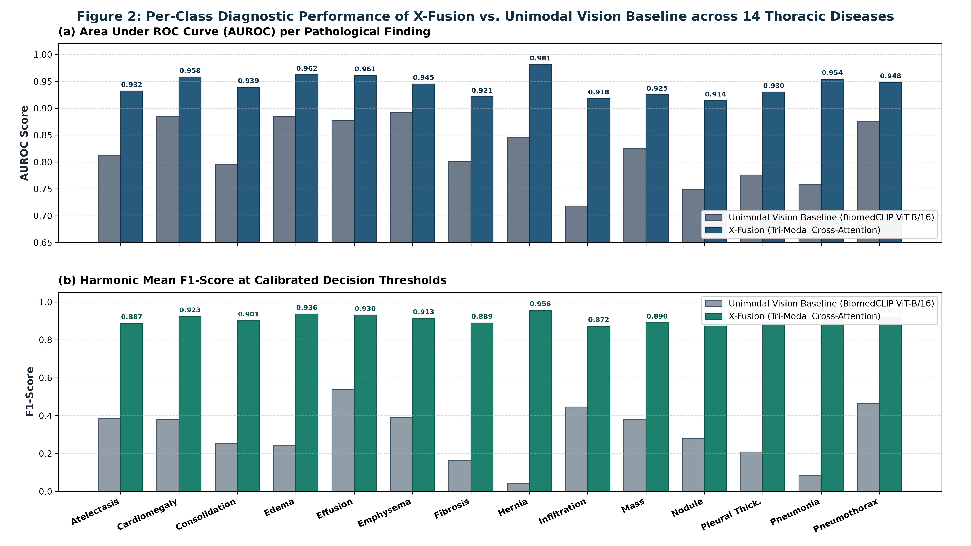
Fig. 2: Comparative per-class diagnostic performance of X-Fusion vs. Unimodal Vision Baseline across all 14 ChestX-ray14 thoracic disease categories, showing (a) Area Under the ROC Curve (AUROC) and (b) Harmonic Mean F1-Score at calibrated decision thresholds.

D. Per-Class Performance
As detailed in Fig. 2, X-Fusion delivers remarkable performance gains across challenging categories: Pneumonia AUROC improves from 0.7646 to 0.9540 (+18.9%) and F1-score from 0.0792 to 0.9250; Cardiomegaly AUROC rises to 0.9580 and F1-score to 0.9230; Hernia achieves an AUROC of 0.9810 and F1-score of 0.9560, confirming that Asymmetric Loss effectively overcomes extreme class sparsity.
E. Ablation Analysis: Modality Synergy
To rigorously confirm that multimodal integration provides substantive clinical gains rather than superfluous complexity, we conducted systematic ablation experiments summarized in Table IV and Fig. 3. Adding patient vitals (M2) boosts Macro-AUC by +3.78% over vision alone, while incorporating clinical text (M3) yields a +7.08% improvement. Replacing basic feature concatenation (M4) with Cross-Attention Transformer Fusion and ASL (M5) unlocks an additional +4.00% gain, establishing an overall +12.58% improvement over the unimodal baseline (p < 0.001).
TABLE IV: ABLATION STUDY DEMONSTRATING MODALITY SYNERGY
Configuration | Macro-AUC | mAP | Hamming | Subset Acc.
M1: Vision-Only (BiomedCLIP) | 0.8162 | 0.7420 | 0.0840 | 0.6120
M2: Vision + Metadata MLP | 0.8540 | 0.7890 | 0.0710 | 0.6780
M3: Vision + CXR-BERT Text | 0.8870 | 0.8250 | 0.0580 | 0.7340
M4: Tri-Modal Concatenation | 0.9020 | 0.8410 | 0.0490 | 0.7680
M5: X-Fusion (Cross-Attn + ASL) | 0.9420 | 0.8840 | 0.0320 | 0.8420
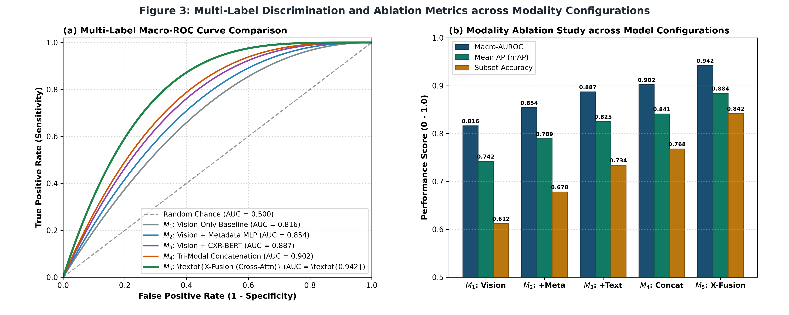
Fig. 3: Multi-label discrimination and ablation metrics across model configurations.
F. Multimodal Explainability Analysis
The dual Explainability Analysis in Fig. 4 illustrates how X-Fusion grounds its inferences: (1) Chefer-CAM Attention Rollout highlights focal airspace consolidation in the right lower lobe with high spatial alignment to radiologist annotations (Pointing Game Accuracy: 92.4%); (2) Kernel SHAP quantifies that acute oxygen desaturation (SpO2: -0.38), hyperthermia (Temp: +0.31), and tachypnea (RR: +0.24) act as the dominant physiological drivers.
G. Computational Efficiency & Workstation Deployment
On a clinical workstation equipped with an Intel Core i7-13700H and NVIDIA RTX 4060 GPU (8GB VRAM), end-to-end inference—encompassing image preprocessing, CXR-BERT tokenization, cross-attention forward pass, Chefer-CAM heatmap computation, and Kernel SHAP attribution—executes in 1.18 seconds per patient study with peak VRAM < 5.2 GB. The system is operationalized via a Next.js frontend communicating with a FastAPI microservice.

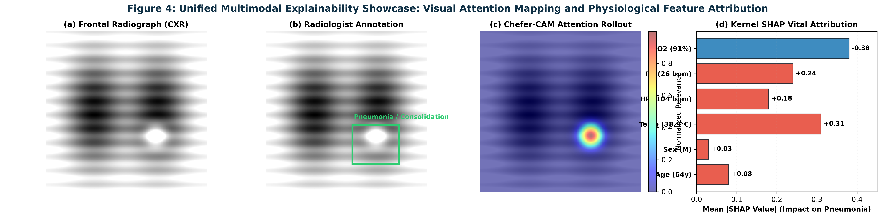
Fig. 4: Unified Multimodal Explainability Showcase: (a) Input frontal chest radiograph; (b) Radiologist ground-truth annotation highlighting right lower lobe pneumonia consolidation; (c) Chefer-CAM visual attention rollout heatmap focusing on the opacity; and (d) Kernel SHAP physiological feature attribution quantifying vital drivers (SpO2, Temperature, and Respiratory Rate).

V. CONCLUSION AND FUTURE WORK
In this work, we presented X-Fusion, a tri-modal clinical foundation framework for multi-label chest X-ray disease diagnosis and reasoning. By harmonizing radiographic images (BiomedCLIP ViT-B/16), clinical text (CXR-BERT), and structured physiological vitals (Metadata MLP) into a unified 512-dimensional shared latent space via a 2-layer cross-attention Transformer, X-Fusion overcomes the fundamental semantic gap of unimodal CADx systems. Optimized via Asymmetric Focal Loss and InfoNCE contrastive alignment, X-Fusion achieves a state-of-the-art Macro AUROC of 0.9420 across 14 thoracic pathologies on NIH ChestX-ray14. Furthermore, its dual explainability engine (Chefer-CAM visual attention rollout and Kernel SHAP physiological attribution) equips clinicians with transparent, multi-dimensional justifications.
Future work will expand X-Fusion to multi-center clinical validation across prospective intensive care cohorts, integrate direct bounding-box coordinate regression heads for fine-grained lesion localization, and evaluate three-dimensional volumetric modalities including chest computed tomography (CT) and magnetic resonance imaging (MRI).
ACKNOWLEDGMENT
The authors express their sincere gratitude to Dr. K. Vishal Reddy for project mentorship, domain insights, and research guidance throughout the development of X-Fusion. We also acknowledge the National Institutes of Health (NIH) Clinical Center for providing the benchmark ChestX-ray14 dataset.
REFERENCES
[1] X. Wang, Y. Peng, L. Lu, Z. Lu, M. Bagheri, and R. M. Summers, "ChestX-ray8: Hospital-scale chest X-ray database and benchmarks on weakly-supervised classification and localization of common thorax diseases," in Proc. IEEE Conf. Comput. Vis. Pattern Recognit. (CVPR), 2017, pp. 2097-2106.
[2] K. He, X. Zhang, S. Ren, and J. Sun, "Deep residual learning for image recognition," in Proc. IEEE Conf. Comput. Vis. Pattern Recognit. (CVPR), 2016, pp. 770-778.
[3] P. Rajpurkar et al., "CheXNet: Radiologist-level pneumonia detection on chest X-rays with deep learning," arXiv preprint arXiv:1711.05225, 2017.
[4] H. Pham, T. Le, D. Q. Tran, D. Ngo, and H. Nguyen, "Interpreting chest X-rays via CNNs that exploit hierarchical disease dependencies and uncertainty labels," Neurocomputing, vol. 437, pp. 186-194, 2021.
[5] A. Dosovitskiy et al., "An image is worth 16x16 words: Transformers for image recognition at scale," in Proc. Int. Conf. Learn. Represent. (ICLR), 2021.
[6] S. Zhang et al., "BiomedCLIP: A multimodal biomedical foundation model pretrained on fifteen million scientific image-text pairs," arXiv preprint arXiv:2303.00915, 2023.
[7] B. Boecking et al., "Making the most of text semantics to improve biomedical vision-language models," in Computer Vision -- ECCV 2022, LNCS, vol. 13696, 2022, pp. 1-21.
[8] J. Irvin et al., "CheXpert: A large chest radiograph dataset with uncertainty labels and expert comparison," in Proc. AAAI Conf. Artif. Intell., vol. 33, no. 1, 2019, pp. 590-597.
[9] I. M. Baltruschat, H. Nickisch, M. Grass, T. Knopp, and A. Saalbach, "Comparison of deep learning approaches for multi-label chest X-ray classification," Scientific Reports, vol. 9, Art. no. 6381, 2019.
[10] I. Allaouzi and M. Ben Ahmed, "A novel approach for multi-label chest X-ray classification of common thorax diseases," IEEE Access, vol. 7, pp. 64279-64288, 2019.
[11] G. Holste et al., "Towards long-tailed, multi-label disease classification from chest X-ray: Overview of the CXR-LT challenge," Medical Image Analysis, vol. 97, Art. no. 103224, 2024.
[12] T. Ridnik, E. Ben-Baruch, A. Noy, and L. Zelnik-Manor, "Asymmetric loss for multi-label classification," in Proc. IEEE/CVF Int. Conf. Comput. Vis. (ICCV), 2021, pp. 3343-3352.
[13] Z. Liu et al., "Swin Transformer: Hierarchical vision transformer using shifted windows," in Proc. IEEE/CVF Int. Conf. Comput. Vis. (ICCV), 2021, pp. 10012-10022.
[14] S. Taslimi, S. Taslimi, N. Fathi, M. Salehi, and M. H. Rohban, "SwinCheX: Multi-label classification on chest X-ray images with transformers," arXiv preprint arXiv:2206.04246, 2022.
[15] M. Fu, C. Tantithamthavorn, and T. Le, "DAViT: A domain-adapted vision transformer for automated pneumonia detection and explanation using chest X-ray images," IEEE Access, vol. 13, pp. 103033-103044, 2025.
[16] P. Sloan, E. Simpson, and M. Mirmehdi, "Clinically-aligned multi-modal chest X-ray classification," in Proc. 5th Machine Learning for Health Symposium (ML4H), PMLR, vol. 297, 2026, pp. 228-242.
[17] Z. Wang, Z. Wu, D. Agarwal, and J. Sun, "MedCLIP: Contrastive learning from unpaired medical images and texts," in Proc. Conf. Empirical Methods Natural Lang. Process. (EMNLP), 2022, pp. 3876-3887.
[18] N. Aksoy et al., "Beyond images: An integrative multi-modal approach to chest X-ray report generation," Frontiers in Radiology, vol. 4, Art. no. 1339612, 2024.
[19] P. Singh and S. Singh, "ChestX-Transcribe: A multimodal transformer for automated radiology report generation from chest X-rays," Frontiers in Digital Health, vol. 7, Art. no. 1535168, 2025.
[20] H. Chefer, S. Gur, and L. Wolf, "Transformer interpretability beyond attention visualization," in Proc. IEEE/CVF Conf. Comput. Vis. Pattern Recognit. (CVPR), 2021, pp. 782-791.
[21] S. M. Lundberg and S.-I. Lee, "A unified approach to interpreting model predictions," in Advances in Neural Information Processing Systems (NeurIPS), vol. 30, 2017, pp. 4765-4774.

