Intensive Prototyping Days
Urbani — Radar UrbiNexus (DPI 2)
October 2026

Table of Contents

Introduction 2
Scope 2
Architecture 6
Assigned Team 8
Prerequisites 8
Logistics & Required Materials 10

Introduction
This document is the single source of truth on the scope, objectives and logistics for all participants of the DPI (Intensive Prototyping Days). All participants must read this document before attending the DPIs and must be clear about their role so that the prototyping sessions are a success.

The event will take place from 9:00 a.m. to 5:00 p.m. on [day 1] and [day 2] of [month] 2026. In addition, there will be a follow-up session afterwards to confirm the actions and next steps post-DPI. This follow-up session will be scheduled separately.

This document corresponds to the DPI 2 of the Urbani use case (Proactive Observability & AI Troubleshooting Assistant, “Radar UrbiNexus”). In DPI 1 the MVP was built: a web observability dashboard on the QA environment, a serverless pipeline of incidents generated with Amazon Bedrock (Nova 2 Lite) and the AI Copilot for querying logs. DPI 2 starts from that base and focuses on the improvements identified in the MVP review, taking it toward a complete, secure, intuitive control center that is ready to scale to production.

Scope

• Objectives of the Intensive Prototyping Day:

The main objectives of the Intensive Prototyping Days are the following:
• Security and access control: move from a single access level to a scheme of granular roles and permissions (RBAC), with SSO/MFA and an audit log of system actions.
• Log management and monitoring: advanced filters and real-time search (severity, source server QA/Main/Payment, date range, keywords or regular expressions), export (CSV, JSON, PDF) and automatic alerts by email, Slack or Microsoft Teams.
• AI chatbot: measure how useful the answers are (feedback), keep the conversation history and make the model's response latency visible.
• Infrastructure KPIs: status panel (health check / uptime) for QA, Main and Payment, and validation that the interface stays smooth under load.
• User experience: Urbani corporate identity (logo and palette), dark mode and personalization of the dashboard widgets.
• Traceability: Verification of the complete sequence of deliverables to ensure 100% coverage of the roadmap.

• Success criteria of the Intensive Prototyping Day:

The main objective of this Intensive Prototyping Day is:
At the close of the DPI, demonstrate a Radar UrbiNexus with role-based access control and expanded monitoring capabilities, operating on the customer's real (LIVE) data and keeping its character as a read-only assistant with a human in the loop (it never executes automatic remediation). It will be considered successful if:
• A user authenticates (SSO/MFA) and operates only with the permissions of their role; a Reader/Auditor cannot modify configuration (validated with test cases per role).
• Configuration actions and sensitive queries are recorded in the audit log with user, action and timestamp.
• Logs can be filtered by severity, server and date, searched by text/regex and exported to CSV, JSON and PDF.
• A critical failure (real or simulated) generates an alert by email and in at least one messaging channel (Slack or Teams).
• Every chatbot response allows recording a like/dislike, previous sessions can be consulted and the response latency is shown.
• The status panel reflects the health of QA, Main and Payment; where there is no access to the source, the surface is labeled MOCK or WAITING_FOR_INTEGRATION, never LIVE.
• The interface stays smooth in a load test with massive log generation (thresholds to be defined with Urbani).
• The DPI 1 provenance model (LIVE / MOCK / WAITING_FOR_INTEGRATION) is preserved: no data or answers are fabricated.

• Non-Technical Description:

This solution will do the following:
• It will let each person on the Urbani team sign in with their corporate account and see only what their role allows (administration, QA operation or read-only/audit), with a record of who did what.
• It will make it faster to find the problem: filter and search the logs by severity, server and date, and download the evidence as files to share or audit.
• It will automatically notify the team (email, Slack or Teams) when a critical failure is detected, without anyone having to watch the dashboard.
• It will make the AI assistant more useful and reliable: users will be able to rate its answers, resume previous conversations and see how long it took to respond.
• It will show at a glance whether the QA, Main and Payment servers are healthy and available.
• It will look and feel like an Urbani tool: brand logo and colors, dark mode for long monitoring sessions and widgets that can be rearranged to suit each person's work.
• It will remain a query assistant: it explains and recommends, but never executes remediation actions on its own.

• Technical Description:

This solution implements this technology as follows:
Already exists (DPI 1) — kept unchanged
• Dashboard: React 18 + Vite SPA served by nginx and a Node.js 20/Express API, in an Amazon ECS Fargate task behind an ALB with TLS and Route 53.
• Incident pipeline (every 5 min, read-only): CloudWatch Logs (QA) → EventBridge → Lambda Collector → Amazon Bedrock Nova 2 Lite with Guardrails → Lambda Alert Writer → DynamoDB. Infrastructure as code with AWS CDK.
• AI Copilot: the dashboard sends the question to the POST /chat endpoint of the Urbani QA API Gateway, which answers with Bedrock (Nova 2 Lite) grounded in recent logs and alerts. The x-api-key is used server-side only.
• Logs and data: /logs endpoints (return only lines flagged as relevant); LIVE / MOCK / WAITING_FOR_INTEGRATION provenance labels; Metrics and Services in MOCK until their endpoints exist.
• Base security: JWT with hashed passwords, secrets in AWS Secrets Manager, read-only and human in the loop. Inherited pending item: rotate the shared Urbani API key and replace the bootstrap administrator password before go-live.
Already exists, but changes in DPI 2
• Dashboard (same ECS Fargate platform): on top of the existing app, role control in the API and routes, audit logs, filters and search, export, chat feedback and history, latency metric, health panel, branding, dark mode and customizable widgets are added.
• Amazon DynamoDB: besides alerts, it stores users and preferences, audit, chat history and feedback. It replaces SQLite, which removes the single-writer restriction and allows more than one task.
• CloudWatch Logs: ingestion is extended from QA to Main and Payment, subject to customer access.
• Logs (API): /logs gains severity, server, date and text/regex parameters, with pagination and CSV/JSON/PDF export from the backend. Since it currently returns only flagged lines, searching the full stream requires CloudWatch Logs Insights or extending that endpoint.
• AI Copilot: the Urbani /chat endpoint is kept; the dashboard backend now records feedback and sessions, and measures end-to-end latency (it includes the Urbani endpoint, not just the model).
New in DPI 2 (does not exist today)
• Amazon Cognito + Google Workspace (SAML/OIDC): SSO sign-in with MFA; groups are mapped to the roles Super Admin, Infrastructure Administrator, QA Operator and Reader/Auditor. The backend validates the token and enforces permissions. Alternative to validate: keep the existing JWT and add TOTP.
• Alerts and notifications: DynamoDB Streams → Lambda Notifier → Amazon SNS (email) and Slack/Teams webhooks (URLs in Secrets Manager), with rules by severity and service, and deduplication.
• Health and KPIs: CloudWatch Synthetics and Route 53 health checks for QA, Main and Payment (metrics source to be confirmed depending on where those servers run) and Container Insights for the dashboard itself.
• ECS operations: Service Auto Scaling (2 or more tasks across 2 Availability Zones) and a least-privilege Task Role for DynamoDB, SNS and CloudWatch.
• Load and quality testing: Distributed Load Testing on AWS (or k6) against the ALB and API; the automated suite is extended to roles, auditing and the new adapters.

• Client Sponsorship:

Name and title/level:
[Name and title of the Urbani sponsor — to be confirmed]

Architecture

Target architecture DPI 2: DPI 1 base (gray) and improvements (orange)

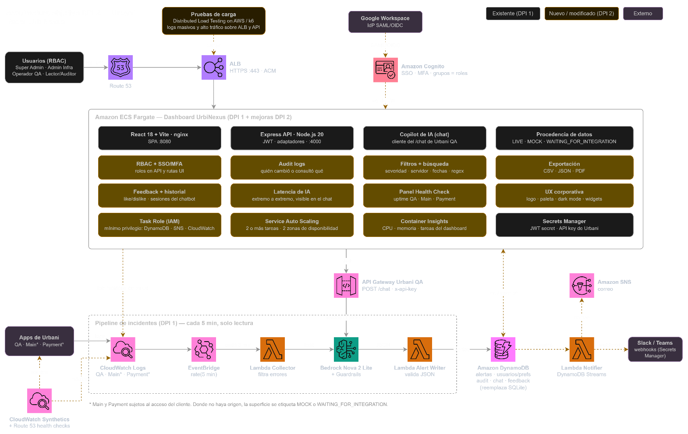

* The services marked in orange are architecture proposals for this DPI (Cognito, DynamoDB instead of SQLite, SNS/Slack/Teams, Synthetics). They will be validated with Urbani at the kickoff; ingestion from Main and Payment depends on access to the source.

Backlog:

ID | Task Description | Estimated Time | AWS Services | Priority | Dependencies | Owner
1 | Migrate persistence from SQLite to DynamoDB (users/preferences, audit, chat, feedback) | 5 h | DynamoDB | P0 | — | TBD
2 | RBAC: Super Admin, Infrastructure Admin, QA Operator and Reader/Auditor roles (API + UI) | 6 h | Cognito | P0 | 1 | TBD
3 | SSO (SAML/OIDC Google Workspace) and MFA | 5 h | Cognito | P1 | 2; IdP access | TBD
4 | Audit logs for configuration and sensitive queries | 4 h | DynamoDB, CloudTrail | P0 | 1, 2 | TBD
5 | Advanced filters and search (severity, server, dates, text/regex) | 6 h | CloudWatch Logs Insights, API Gateway | P0 | Access to Main and Payment | TBD
6 | Log and report export (CSV, JSON, PDF) | 4 h | S3 | P1 | 5 | TBD
7 | Automatic alerts by email, Slack and Teams | 6 h | DynamoDB Streams, Lambda, SNS, Secrets Manager | P1 | 1; customer webhooks | TBD
8 | Chatbot: feedback (like/dislike) and conversation history | 6 h | DynamoDB, Bedrock | P1 | 1 | TBD
9 | AI latency metric visible in the chat | 3 h | Bedrock, CloudWatch | P1 | — | TBD
10 | Health Check / uptime panel (QA, Main, Payment) | 5 h | CloudWatch Synthetics, Route 53 | P1 | Access to Main and Payment | TBD
11 | Corporate branding and dark mode | 4 h | ECS Fargate (frontend) | P1 | Official logo and palette | TBD
12 | Dashboard personalization (rearrangeable widgets) | 4 h | DynamoDB | P2 | 1 | TBD
13 | Load tests for the dashboard and the API | 4 h | Distributed Load Testing on AWS | P2 | 5, 7 | TBD
Estimated total effort: 64 h (≈ 4 builders over 2 working days of 8 h, if the DPI keeps the 2-day format). Priority: P0 = essential; P1 = high; P2 = if capacity allows. Estimates and owners will be confirmed at the kickoff.

Prerequisites

Key Items

Prerequisite tasks to complete before the DPI:

• Physical/virtual access: Provide AWS attendees with access to the facilities (in-person mode) or to the collaboration tools (virtual mode)
• Collaboration tools: Ensure access to the virtual platforms that will be used during the DPI
• Invitation: Send an invitation to all participants with the location, agenda and check-in details

Additional prerequisite tasks, specific to this DPI:

• Access to Main and Payment: enable read access for the builders to the logs and metrics of the Main and Payment servers (in addition to QA), or confirm they will be treated as MOCK.
• Identity provider: administrative access to Urbani's Google Workspace (or equivalent IdP) to configure SAML/OIDC federation and MFA.
• Notification channels: destination email addresses and Slack / Microsoft Teams webhooks authorized by Urbani.
• Visual identity: official logo and corporate color palette in usable formats (SVG/PNG).
• Security inherited from DPI 1: rotate the previously shared Urbani API key and define a strong administrator password and secrets in AWS Secrets Manager.

Checklist:

Category | Task
AWS Account and Landing Zone
AWS sandbox/dev account enabled for the DPI
Status: ☐ Completed ☐ In Progress ☐ N/A
Service Quotas / Soft limits reviewed (Bedrock, SageMaker, EC2 GPU)
Status: ☐ Completed ☐ In Progress ☐ N/A
Access enabled to the required Amazon Bedrock models
Status: ☐ Completed ☐ In Progress ☐ N/A
IAM roles configured for builders and AI services
Status: ☐ Completed ☐ In Progress ☐ N/A
Budget and cost alerts configured (AWS Budgets)
Status: ☐ Completed ☐ In Progress ☐ N/A
Data and Preparation
Data sources identified (structured / unstructured)
Status: ☐ Completed ☐ In Progress ☐ N/A
Test data available and de-identified (PII removed)
Status: ☐ Completed ☐ In Progress ☐ N/A
Data volume and quality validated
Status: ☐ Completed ☐ In Progress ☐ N/A
Data access permissions granted to the team
Status: ☐ Completed ☐ In Progress ☐ N/A
Storage configured (Amazon S3, buckets for training/inference)
Status: ☐ Completed ☐ In Progress ☐ N/A
Data labeling completed (if applicable for supervised ML)
Status: ☐ Completed ☐ In Progress ☐ N/A
AI Model and Service Selection
Foundation model selected (Claude, Nova, Titan, Llama, etc.)
Status: ☐ Completed ☐ In Progress ☐ N/A
AWS AI services evaluated (Bedrock, SageMaker AI, Q Business)
Status: ☐ Completed ☐ In Progress ☐ N/A
Inference strategy defined (on-demand / provisioned throughput)
Status: ☐ Completed ☐ In Progress ☐ N/A
Knowledge Bases / RAG evaluated (if applicable)
Status: ☐ Completed ☐ In Progress ☐ N/A
Agentic architecture defined (Bedrock AgentCore, multi-agent)
Status: ☐ Completed ☐ In Progress ☐ N/A
AI Security and Governance
Guardrails configured in Amazon Bedrock
Status: ☐ Completed ☐ In Progress ☐ N/A
Data privacy policy validated (GDPR, HabeasData)
Status: ☐ Completed ☐ In Progress ☐ N/A
Data encryption at-rest and in-transit (KMS)
Status: ☐ Completed ☐ In Progress ☐ N/A
Responsible AI strategy defined (bias, hallucinations, fairness)
Status: ☐ Completed ☐ In Progress ☐ N/A
Logging and auditing enabled (CloudTrail, Bedrock Model Invocation Logs)
Status: ☐ Completed ☐ In Progress ☐ N/A
Development and Builders
Builders identified and confirmed (minimum 2-3 per track)
Status: ☐ Completed ☐ In Progress ☐ N/A
Language and framework defined (Python, LangChain, LlamaIndex, Strands Agents)
Status: ☐ Completed ☐ In Progress ☐ N/A
Code repository created (CodeCommit, GitHub)
Status: ☐ Completed ☐ In Progress ☐ N/A
IDEs and tools configured (VS Code, Kiro, AWS CLI, Boto3)
Status: ☐ Completed ☐ In Progress ☐ N/A
Access to Kiro / Q Developer for development assistance
Status: ☐ Completed ☐ In Progress ☐ N/A
Prototype Evaluation and Testing
Functional test cases defined
Status: ☐ Completed ☐ In Progress ☐ N/A
Model evaluation metrics defined (accuracy, latency, cost)
Status: ☐ Completed ☐ In Progress ☐ N/A
Response quality evaluation strategy (human-in-the-loop)
Status: ☐ Completed ☐ In Progress ☐ N/A
Load and latency tests planned
Status: ☐ Completed ☐ In Progress ☐ N/A
DPI Logistics
Physical / virtual room reserved with connectivity
Status: ☐ Completed ☐ In Progress ☐ N/A
Invitation sent to sponsors, builders and AWS SMEs
Status: ☐ Completed ☐ In Progress ☐ N/A
Prototyping days agenda shared
Status: ☐ Completed ☐ In Progress ☐ N/A
Roles and responsibilities communicated (Sponsor, PO, Builders, SMEs)
Status: ☐ Completed ☐ In Progress ☐ N/A
Post-DPI follow-up session scheduled
Status: ☐ Completed ☐ In Progress ☐ N/A

Logistics & Required Materials

Table 4: Preparation Materials
Item | Quantity | Notes
For Virtual DPIs
Set up the virtual collaboration rooms (virtual meeting rooms, Scrum boards, digital sticky notes) | Estimated total rooms: 1 room per workstream, | Suggested platforms: Chime, Teams, Miro, Mural
Define a mechanism to "ring the bell" (celebrate achievements) | n/a | Announced to all participants
Define a team for the DPI | n/a | Builds identity and mystique for the event
Set up a dedicated communication channel (Slack / Teams / Chime) | 1 main channel + 1 per workstream | For real-time coordination
Set up collaborative whiteboard tools | 1 per workstream | Miro, Mural, Teams Whiteboard
For In-Person DPIs
Reserve a main room and breakout rooms per workstream | 1 room per workstream + 1 command center + 1 all-hands | With adequate capacity and connectivity
Ensure high-capacity Wi-Fi connectivity | Access for all attendees | Validate bandwidth for multiple developers working in parallel
Screens, projectors and audiovisual equipment | 1 per room | Include HDMI cables, USB-C adapters
Whiteboards, markers and physical sticky notes | 2-3 packs per room | For design thinking and architecture sessions
Define a mechanism to "ring the bell" (celebrate milestones) | 1 physical bell per room | Symbolic tradition to celebrate progress
Define a theme/motto for the DPI | n/a | Posters, banners, event branding
Badges / identification labels | 1 per participant | Include role: Sponsor, PO, Builder, SME, Coach
Technical Materials (Applies to Virtual and In-Person)
AWS sandbox/dev accounts enabled | 1 account per workstream | With pre-configured IAM access
Architecture templates and initial prompts | Per use case | Speeds up the builders' start
Shared pre-reading documentation | 1 package per participant | Scope, agenda, roles and responsibilities
Shared code repository | 1 repo per workstream | GitHub / CodeCommit with permissions granted
Digital Kanban / Scrum board | 1 per workstream | For tracking tasks during the DPI

