|  |  |
| --- | --- |
| EX.NO: 4  DATE: | **SCHOLARSHIP MANAGEMENT SYSTEM** |

**AIM:**

To develop the Online Website for Scholarship Management System using HTML, CSS…

**PROBLEM STATEMENT:**

The current process of managing scholarships for educational institutions is often outdated and inefficient, leading to errors, delays, and frustration for both the scholarship providers and recipients. To address these issues, there is a need for an online scholarship management system that can streamline the application and award process, provide real-time update and feedback, and ensure transparency and fairness in the selection process.

**OBJECTIVES:**

**Streamlining the application process:** One of the primary objectives of an online scholarship system is to simplify and automate the application process, making it easier for students to apply for scholarships.

**Increasing accessibility:** By providing an online scholarship system, educational institutions can make scholarships more accessible to students from all backgrounds, regardless of their location or socioeconomic status.

**Enhancing transparency:** An online scholarship system can promote transparency by providing clear guidelines and requirements for each scholarship, ensuring that students understand what is expected of them.

|  |  |
| --- | --- |
| **1** | **INTRODUCTION** |
| 1.1 | Purpose |
| 1.2 | Product scope |
| **2** | **OVERALL DESCRIPTION** |
| 2.1 | Product perspective |
| 2.2 | Product features |
| **3** | **REQUIREMENT SPECIFICATION** |
| 3.1 | Software |
| 3.2 | Hardware |
| 3.3 | Data base design |

**SRS (SOFTWARE REQUIREMENT SPECIFICATION)**

**1. INTRODUCTION:**

This section gives a scope description and overview of everything included in this SRS document. Also, the purpose for this document is described and a list of abbreviations and definitions is provided.

**1.1 Purpose :**

The main goal of scholarships is to make education more accessible and affordable to deserving students and to support them in achieving their academic and career goals. Scholarships may cover tuition fees, accommodation, books, and other educational expenses.

**1.2 Scope :**

It mainly concentrates on the process of maintaining record of student details. Based on the scholarship management Database the system able to provide Student details.

**2. OVERALL DESCRIPTION**

**Product Perspective :**

The system concentrates on student scholarship activities and some scholarship selection processes. Depending on the student applied the college scholarship management can solve the problems of student which will be helpful for them to concentrate on their students. The objective of the system is to provide easy and friendly access to the users.

**Product Features :**

College admin can able to access information of student details about those are applied.

**Efficient access:**

The system will display the options for retrieving the information of student and their activities in an efficient way.

**High Availability:**

The site is available for 24 hours of day. So the user can use the site at any time. The system can be accessed from anywhere and at anytime.

**PURPOSE OF STUDY:**

The aim of this project is to develop a secured online scholarship management system with the following objectives**:**

* Create a scholarship management system that is easily accessible by customers from the comfort of their homes, offices etc**.**
* Reduce the flow of human traffic and long queues at Offices.
* Reduce the time wasted in going to Offices to stay on queues**.**
* Promote efficient and effective scholarship management for the Offices by focusing on those services that still require physical presence at the scholarship management hall.

**IMPORTANCE OF THE STUDY :**

This will cover the benefits derived in using Scholarship Management and it’s fundamental.

**SCOPE OF THE STUDY :**

The scope of this project is limited to the activities of the operations unit of the scholarship management system which include opening of Account, Deposit of funds, Withdrawal of funds and transfer.

**ONLINE SCHOLARSHIP MANAGEMENT :**

**HOW IS IT DIFFERENT?**

* Many consumers today are turning to the ease and convenience of Scholarship Management to take care of their financial needs. With the new levels of access made possible by the Internet, people can now check the status of their finances with the click of a button.
* The history of Scholarship Management has evolved from simply allowing customers to check balances online, to now being able to trade stocks and bonds from the comfort of their own home!

**WHY USE ONLINE SCHOLARSHIP MANAGEMENT?**

Online scholarship management services have grown from simply allowing customers to check balances, to trading assets. Today, Offices like ING Direct are functioning entirely online, with no brick and mortar building. With the costs saved by requiring fewer employees and the lack of facility expenses, these virtual Offices can often offer higher interest rates than their traditional counter parts. Scholarship Management gives you the power to control your finances completely. You are no longer tied down to managing your money during the hours the institution is open. If you want to transfer a balance after business hours, you can! If you have access to the Internet and have a number of recurring monthly bills, then you should use Scholarship Management to make your life easier.

**FEATURES OF ONLINE SCHOLARSHIP MANAGEMENT :**

* Today, online scholarship management services are quite varied. One of the best features of online scholarship management is putting the user in control. The user controls all bill paying, transfers, and investments from home. There are other features, though of online scholarship management.
* One of these is increased accessibility to your account information. Users of online scholarship management services can access their account information from anywhere in the world! This is particularly helpful for businesses.

**Objective of the Project :**

* To Provide the online information regarding the available services.
* To provide the online appointment facilities.
* To provide the online test reports.
* To provide the information regarding the general enquiry of customers **.**
* To provide web portal service to the customers.

**SCOPE OF PROPOSED SYSTEM :**

The aim of proposed system is to develop a system of improved facilities. The proposed system can overcome all the limitations of the existing system. The system provides proper security and reduces the manual work Security of data**.**

* Ensure data accuracy’s.
* Proper control of the higher officials.
* Minimize manual data entry.
* Minimum time needed for the various processing.
* Greater efficiency.
* Better service.
* User friendliness and interactive.
* Minimum time required.

**3.REQUIREMENT SPECIFICATION**

**3.1 Software requirements :**

* Windows NT operating system.
* Front End : HTML, Microsoft FrontPage
* Middle Tier: HTML.
* Back End :MS Access.

**3.2 Hardware Requirements :**

* Preferably Pentium IV/Celeron/AMD based system,
* 512MB RAM,
* 20 GB HDD,
* Along with Dot-Matrix/Laser jet printer.

**3.3 DATABASE DESIGN:**

The details about the relevant data that came into lay in the system are identified according to the relationship the tables are designed by following the standard database design methods.

The dative for each data in the table is defined. For optimum design of database to have better response time, to have data integrity, to avoid the redundancy and for security of the database tables created and analysed.

A database system can be defined as a representation of an information system in a computer. The general theme behind a database is to handle information as an integrated whole. A database is a collection of interrelated data stored with minimum redundancy to serve many users quickly and efficiently.

The general objective is to make information access easy, quick, inexpensive and flexible for the user. In database design, several specific objectives are considered:

* Controlled redundancy
* Ease of learning and use
* Data independence
* More information at low cost
* Accuracy and integrity
* Recovery from failure
* Privacy and security
* Performance

**UML DIAGRAM**

**1.USECASE DIAGRAM:**

A use-case diagram is graphical depiction of a user’s possible interactions with the system. It describes the high level functions and scope of a system. The use-case and actors in use-case describe what the system does and how the actors use it, but not how the system operate internally.

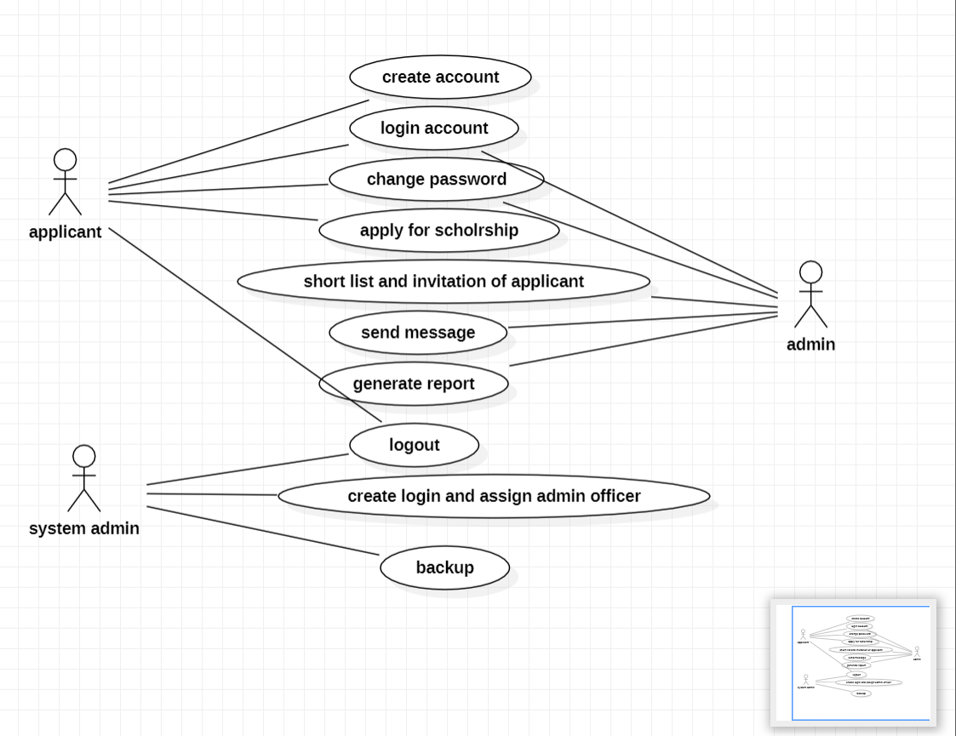

**2.CLASS DIAGRAM:**

Class diagram is illustration of the relationship and source code dependencies among classes in the Unified Modelling Language. Class diagrams are the blueprints of your system or subsystem.

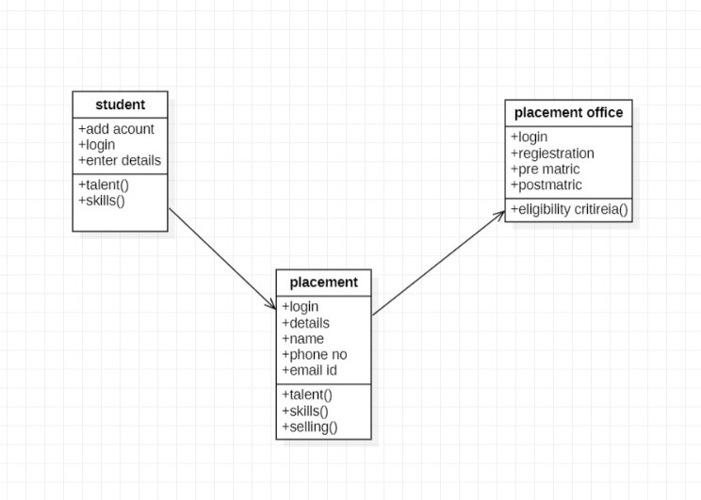

**3.STATE CHART DIAGRAM:**

State chart diagram is used to describe behavior of the system and composed of finite no of states. It enables nice separation of concerns between behavior or logic and presentation

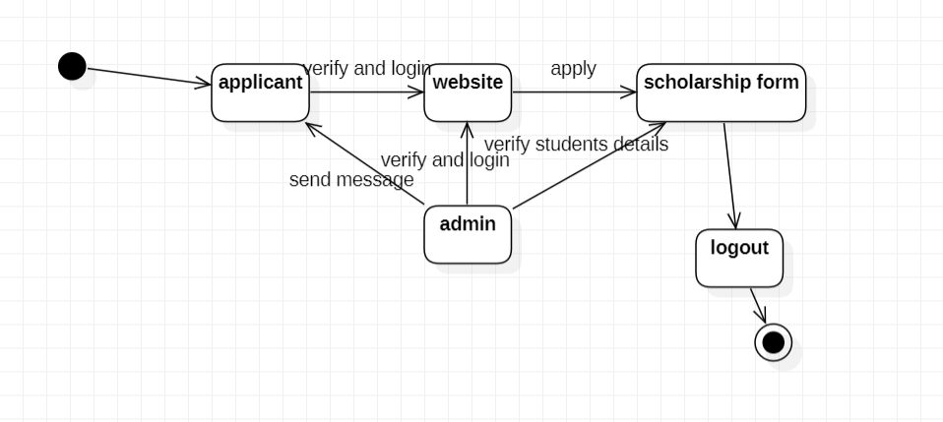

**4.COMPONENT DIAGRAM:**

A component diagram, also known as a UML component diagram, describes the organization and wiring of the physical components in a system.

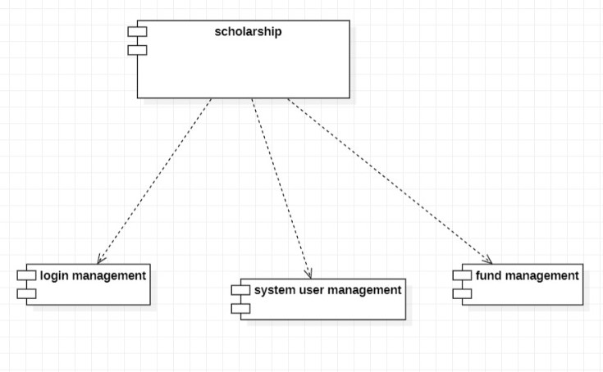

**5.DEPLOYMENT DIAGRAM:**

In UML, deployment diagrams model the physical architecture of a system. Deployment diagrams show the relationships between the software and hardware components in the system and the physical distribution of the processing.

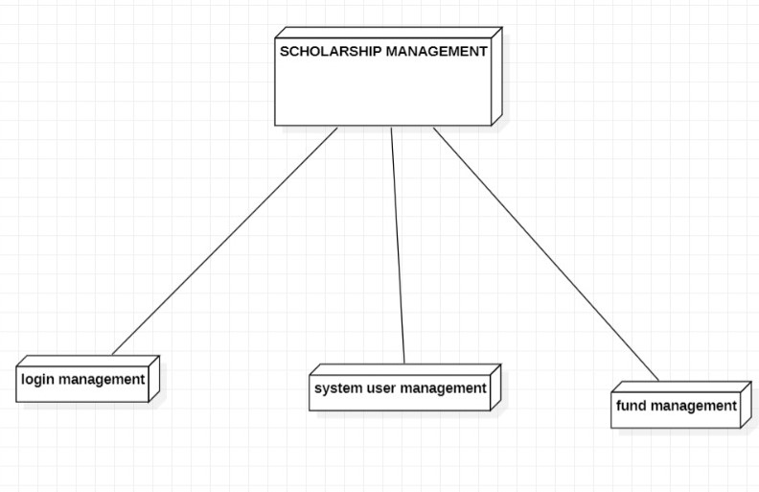

**WEBSITE**

**HOME PAGE:**

The homepage should include a navigation bar, a header with a title, and a section that provides brief information about the website. It should also include links to the scholarship page, application process page, FAQ page, and contact us page.



**SCHOLARSHIP APPLICATION PAGE:**

The scholarship page should include a list of available scholarships, including their names, descriptions, and eligibility criteria. Each scholarship should have a button or link that redirects the user to the apply now page.

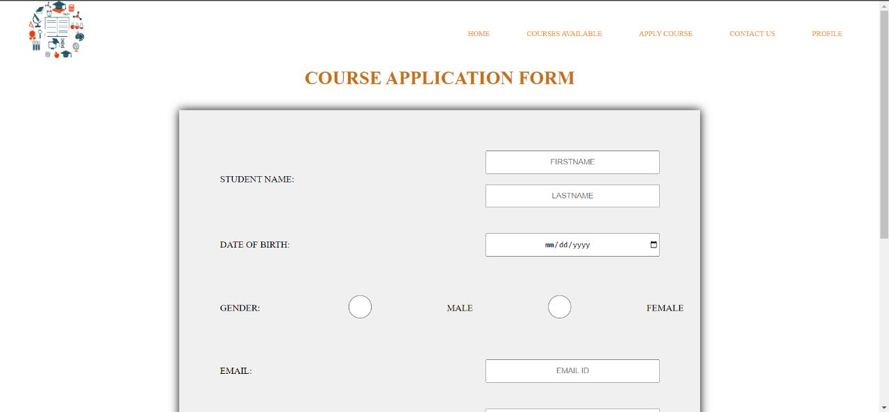

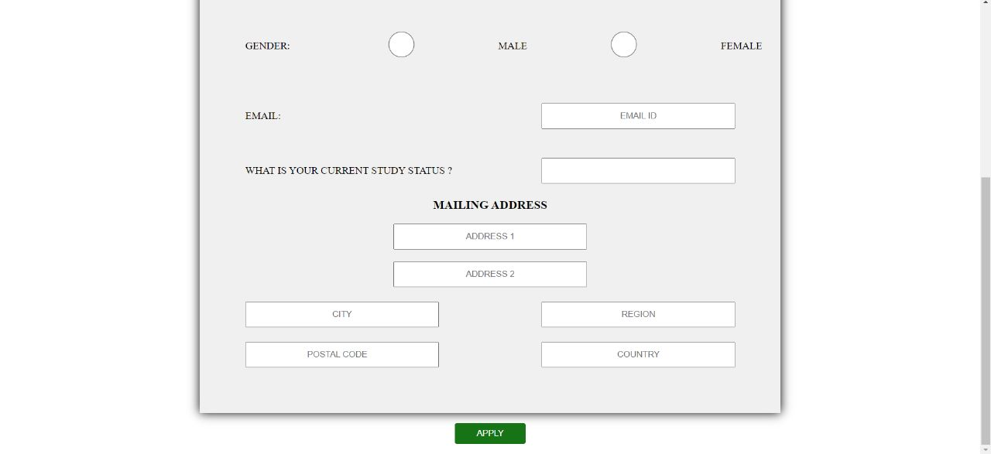

**TYPES OF SCHOLARSHIP PAGE:**

The apply now page should include a form where users can fill out their personal and academic information and upload required documents, such as transcripts and essays. The form should include fields for the scholarship name and a message box for additional comments. The page should also include a submit button to submit the application.

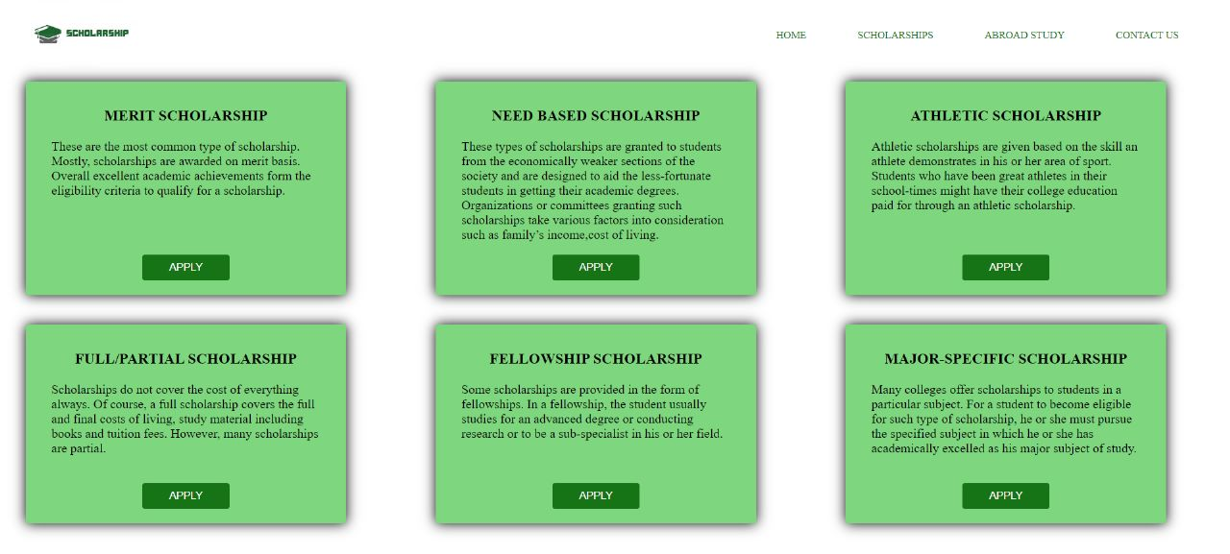

**ABROAD SCHOLARSHIPS PAGE**

The abroad scholarship page should include a contact form where users can send inquiries, suggestions, and feedback about the website. It should also include the website's physical address, email, and phone number.

**ASSESSMENT:**

|  |  |  |  |
| --- | --- | --- | --- |
| **Sl.No.** | **DESCRIPTION** | **WEIGHTAGE** | **MARKS AWARDED** |
| 1 | Logic | 1 |  |
| 2 | Output | 1 |  |
| 3 | Viva | 1 |  |
| Total | | 3 |  |

**Signature of the Faculty**