

ENCRYPTION AND DECRYPTION

INDEX
- Brief Description.
->Project Statement
->Types of users
->Data structures

- Source code and its explanation.
->ClassProg.cpp
->BrainProg.cpp
->Encrypt.cpp
->UserProg.cpp
->AdminProg.cpp

- Input and Output Snapshots

- Limitations and Assumptions

- References and Bibliography

- Conclusion

ENCRYPTION AND DECRYPTION

BRIEF DESCRIPTION:
PROJECT STATEMENT:
The main objective of the project is to demonstrate accessibility to various types of files present in the directory through the program, wherein the files are protected from unauthorized access through encryption.
Each file present in the directory has a password associated with it, which acts as the key initializer and the key generator for encryption and decryption, as shown in the source code below.
TYPES OF USERS:
- ADMIN: The admin can manage the details associated with each file, by either adding a file, or by modifying a file’s details, or by removing a file from the File Database.

- USER: The user can attempt to access the available files, wherein the access will be granted if the password entered by the user is valid.
NOTE: The admin is a super-user, considering the fact that he/she also has access to the File Database.
DATA STRUCTURES:
File (class): It is a derived data type, in order to store the information associated with each file, including its name(entirely with its extension), and its password.
File Database (binary file): It is a binary file storing the information associated with each file, which the admin can access.
Temp (text file): It is a temporary text file used during encryption and decryption, wherein the recently encrypted/decrypted file is first copied to this file, before copying it back to the original file.
SOURCE CODE:
- ClassProg.cpp
#include<iostream>
#include<string.h>
#include<conio.h>
#include<stdlib.h>
#include<stdio.h>
#include<fstream>

using namespace std;

class File
{
char name[20];
char password[20];
public:
void accept()
{
cout.width(30);
cout << "Enter File name(along with extension) : ";
cin.getline(name,20);
cout << endl << endl;
cout.width(30);
cout << "Enter Password : ";
cin.getline(password,20);
}
void modifyaccept()
{
cout.width(45);
cout << "Modification: " << endl << endl;
cout.width(30);
cout << "Enter File name(along with extension) : ";
cin.getline(name,20);
cout << endl << endl;
cout.width(30);
cout << "Enter Password : ";
cin.getline(password,20);
}
void getname(char N[])
{
strcpy(N,name);
}
void getpass(char M[])
{
strcpy(M,password);
}
};

NOTE: The member functions defined inside the class will be of use for the admin(assuming that only the admin has access to the File Database).

- BrainProg.cpp:
#include<iostream>
#include<string.h>
#include<conio.h>
#include<stdlib.h>
#include<stdio.h>
#include<fstream>
#include<math.h>
#include<bitset>
#include "ClassProg.cpp"

using namespace std;

inline char KeyGenerator1(char k,char g)//For Key Generation
{
bitset<8> k1;
bitset<8> k2;
bitset<8> g1;
k1=k;
g1=g;
for(int i=0;i<8;i++)
{
k2[i]=0;
for(int j=0;j<8;j++)
{
k2[i]=(k2[i]+(k1[j]*g1[j]))%2;//Cumulative XOR gate
}
k1[1]=k1[2];//LFSR(Linear Feedback Shift Register)
k1[2]=k1[3];
k1[3]=k1[4];
k1[4]=k1[5];
k1[5]=k1[6];
k1[6]=k1[7];
k1[7]=k2[i];
}
char c=0;
for(int i=0;i<8;i++)
c+=(k2[i]*pow(2,i));
return c;
}

inline char KeyGenerator2(char k,char A[])//For Key Generation;
{
bitset<8> k1=k;
k=0;
for(int i=0;A[i];i++)
{
k=k^(A[i]*k1[i]);//Selective usage of XOR gate for producing next key byte using previous key byte
}
return k;
}

inline void KeyInitializer1(char A[],char &k,char &g)//For Key I Initialization
{
int n=strlen(A);
for(int i=0;i<(n/2);i++)
{
k=k^A[i];
g=g^A[n-1-i];
}
}

inline void KeyInitializer2(char A[],char &k)//For Key initialization;
{
k=0;
for(int i=0;A[i];i++)
{
k=k^A[i];//First key byte is produced by using XOR gate for all characters of characters of the file password;
}
}
inline char Algorithm1(char p,char k)//For Encryption as well as Decryption Decryption
{
bitset<8> p1;
bitset<8> k1;
bitset<8> c1;
p1=p;
k1=k;
for(int i=0;i<8;i++)
{
c1[i]=(p1[i]+k1[i]+1)%2;//XNOR gate;
}
char c=0;
for(int i=0;i<8;i++)
c+=(c1[i]*pow(2,i));
return c;
}

inline char Algorithm2(char p,char k)//For Encryption as well as Decryption Decryption
{
char c;
c=p^k;
return c;
}

LOGIC:

NOTE: Here, the key bit sequences are produced in blocks of 8 bits(that is, 1 byte) for encryption as well as decryption;

- void KeyInitializer1(char A[], char &k, char &g):
This function produces the first block of key bits using the password associated with the file.

Here, the parameter ‘A’ represents the password associated with the file,’ k’ represents the key byte that would be produced in this module and ‘g’ represents the gate sequence(a sequence of 8 bits stored as a byte in the parameter ‘g’) that would be produced in this module(more details when explaining KeyGenerator1() module. ’k’ and ‘g’ are passed by reference.

In this module, the password associated with each file is split into 2 halves, wherein the characters of the first half are used for producing a block of 8 key bits and the characters of the second half are used for producing the 8 bits of the gate sequence.

NOTE: KeyInitializer1() is closely associated with KeyGenerator1() and is not relevant to any other module.

- char KeyGenerator1(char k, char g):
This module plays the role of producing every next block of 8 bits(key byte) for encryption/decryption using the gate sequence and the previous key byte. It has been implemented based on Linear FeedBack Shift Register(LFSR).

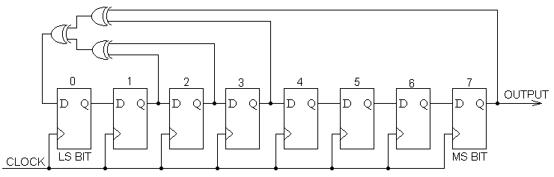

Here, a new key bit is produced from the existing 8 key bits by selectively choosing some of the key bits from 8 of them and subjecting them to XOR gate, as shown above.
The pattern in which we choose the key bits for LFSR is given by the gate sequence bits.

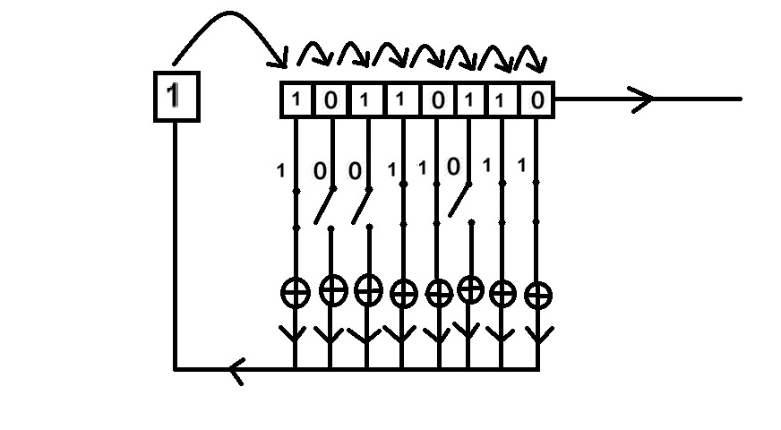

Here, ‘10110110’ represents key bit sequence and ‘10011011’ represents gate sequence. In the gate sequence, ‘0’ depicts the switch/gate being open, meaning that the key bit corresponding to it is not included in the LFSR. Similarly, ‘1’ represents the switch/gate being closed, meaning that the key bit corresponding to it in included in the LFSR.
Thereafter, the bits present in the bitset array swap their positions as shown, leaving a vacancy at the last position for the new key bit to occupy.
If this process is carried out for 8 times, an entirely new bit sequence consisting of 8 bits is produced, thereby producing a new byte for encryption/decryption.
NOTE: In this module, the inbuilt operator for XOR gate is not used, while its actual algorithm has been implemented, for ease of handling bit sequences.

- char Algorithm1(char p, char k):
Here, the algorithm of XNOR gate has been implemented.
Algorithm:
Ciphertextbit=(Plaintextbit+Keybit+1)%2; (For encryption)
Plaintextbit=(Ciphertextbit+Keybit+1)%2; (For decryption)
Here, the plaintext character(p) and the key byte(k) are used for producing the ciphertext character using XNOR gate, which is returned by the function.

NOTE: In all these modules, the 8 bit sequences are appropriately converted to their byte form by converting the binary value to decimal, which would represent the ASCII value of the corresponding byte.
Moreover, it has to be noted that the algorithm for encryption as well as decryption are the same.

- void KeyInitializer2(char A[],char &k):
Here, all characters of the password are subjected to XOR gate, thereby producing a new byte(initial key byte) for encryption/decryption

- char KeyGenerator2(char k,char A[]):
Here, the new key byte is produced by selectively choosing certain characters among the first 8 characters of the password to be subjected to XOR gate, based on the bit sequence of the previous key byte(here, the parameter ’ k’ represents the previous key byte and the array name ‘A’ represents the password array).
NOTE: This method is similar to LFSR, but bytes(i.e. characters) are chosen here instead of bits. Here, every previous key bit acts as the gate sequence and the gate sequence here is varying or dynamic.

- char Algorithm2(char p,char k):
Basic implementation of XOR gate is done here, by using the inbuilt operator. ’p’ represents the plaintext character and ‘k’ represents the key byte.

NOTE: Here, KeyInitializer1() and KeyGenerator1() act as one pair(say, Pair 1), as their logics are closely interrelated. In a similar way, KeyInitializer2() and KeyGenerator2() act as a pair(say, Pair 2), as their logics are interrelated. ANY ONE of these 2 pairs can be used for encryption and decryption altogether.
The difference between these 2 pairs lies in their Time Execution and Logic strength.

Pair 1 | Pair 2
More effective in terms of Logic Strength as it works on bits. | Less effective in terms of Logic Strength as it works on bytes.
Slower in terms of Execution Time. | Faster in terms of Execution Time.

- Encrypt.cpp:
#include<iostream>
#include<string.h>
#include<conio.h>
#include<stdlib.h>
#include<stdio.h>
#include<fstream>
#include "BrainProg.cpp"

using namespace std;

void Cryption(char A[],char X[])
{
ifstream fout(A,ios::binary|ios::in);
fstream fout2("Temp.txt",ios::binary|ios::out);
char gate=0;
char key=0;
char s;
KeyInitializer1(X,key,gate);
while (fout.read(&s, sizeof(char)))
{

s = Algorithm1(s,key);
fout2.write(&s, sizeof(s));
key=KeyGenerator1(key,gate);
}
fout.close();
fout2.close();
fout.open("Temp.txt", ios::binary | ios::in);
fout2.open(A, ios::binary|ios::out);
s=0;
key=0;
while (fout.read(&s, sizeof(char)))
{
fout2.write(&s, sizeof(s));
}
fout.close();
fout2.close();
}
NOTE: This program is used both for encryption as well as decryption.
- UserProg.cpp:
#include<iostream>
#include<string.h>
#include<conio.h>
#include<stdlib.h>
#include<stdio.h>
#include<fstream>
#include<time.h>
#include<windows.h>
#include"Encrypt.cpp"

using namespace std;

int main()
{
system("COLOR F0");
char FileName[20],Password[20];
ifstream fbin("FileDatabase.dat",ios::binary|ios::in);
char P[20],Q[20];
File f;
while(fbin.read((char*)&f,sizeof(f)))
{
f.getname(P);
f.getpass(Q);
Cryption(P,Q);
}
fbin.close();
char opt;
int k=1;
int l=0;
do
{
do
{
system("cls");
cout.width(50);
cout << "FILE ACCESSING POINT" << endl << endl;
cout.width(50);
cout << "Available Files are: " << endl << endl;
ifstream fin("FileDatabase.dat",ios::binary|ios::in);
File f;
while(fin.read((char*)&f,sizeof(f)))
{
cout.width(35);
char fname[20];
f.getname(fname);
cout << "-->" << fname << endl << endl;
}
fin.close();
ifstream fin2("FileDatabase.dat",ios::binary|ios::in);
cout.width(45);
if(l!=0)
{
if(k!=0)
{
cout << "Invalid File name!!" << endl;
cout.width(45);
cout << "Re-enter File name(along with extension): ";
}
}
else
cout << "Enter File name(along with extension): ";
cin.getline(FileName,20);
cout << endl;
while(fin2.read((char*)&f,sizeof(f)) && k!=0)
{
char flname[20];
f.getname(flname);
k=strcmp(FileName,flname);
}
fin2.close();
if(k!=0)
{
system("cls");
}
l++;
}while(k!=0);
ifstream fin3("FileDatabase.dat",ios::binary|ios::in);
File z;
char flpass[20];
int r=1;
while(fin3.read((char*)&z,sizeof(z)) && r!=0)
{
char flname[20];
z.getname(flname);
r=strcmp(flname,FileName);
if(r==0)
z.getpass(flpass);
}
cout.width(45);
cout << "Enter password : ";
char c;
int h=0;
c=getch();
while(c!=13 && h<20)
{
if(c!=8)
{
cout << "*";
Password[h]=c;
h++;
}
if(c==8)
{
if(h!=0)
{
cout << c;
cout << " ";
cout << c;
h--;
}
if(h==0)
;
}
c=getch();
}
Password[h]='\0';
if(strcmp(Password,flpass)==0)
{
Cryption(FileName,Password);
cout << endl << endl << endl;
cout.width(45);
for(int i=0;i<3;i++)
{
cout << "LOADING";
Sleep(500);
cout << ".";
Sleep(500);
cout << ".";
Sleep(500);
cout << ".";
Sleep(500);
for(int j=1;j<=10;j++)
cout << (char)8 << " " << (char)8;
}
system(FileName);
}
else
{
system("cls");
system("COLOR FC");
cout.width(445);
for(int i=1;i<=3;i++)
{
cout << "ACCESS DENIED!!!";
Sleep(500);
for(int j=1;j<=16;j++)
cout << (char)8 << " " << (char)8;
Sleep(500);
cout << "INVALID PASSWORD!!";
Sleep(500);
for(int j=1;j<=18;j++)
cout << (char)8 << " " << (char)8;
Sleep(500);
}
system("cls");
cout.width(445);
for(int i=5;i>=1;i--)
{
cout << "THE PROGRAM WILL TERMINATE IN "<< i << " SECONDS ";
Sleep(200);
cout << ".";
Sleep(200);
cout << ".";
Sleep(200);
cout << ".";
Sleep(200);
system("cls");
cout.width(445);
}
system(FileName);
}
system("cls");
cout << endl << endl << endl;
cout.width(40);
system("COLOR F0");
cout << "Do you wish to continue(Y/N): ";
cin >> opt;
k=1;
l=-1;
if(!(opt=='Y' || opt=='y'))
{
Sleep(1000);
exit(0);
}
}while(opt=='Y' ||opt=='y');
}
NOTE: This is the program through which the user will attempt to access the files.

- AdminProg.cpp:
#include<iostream>
#include<string.h>
#include<conio.h>
#include<stdlib.h>
#include<stdio.h>
#include<fstream>
#include<time.h>
#include<windows.h>
#include "ClassProg.cpp"

using namespace std;

int main()
{
system("COLOR F0");
ifstream fin("FileDatabase.dat",ios::binary|ios::in);
char c=0;
int i=0;
File f;
while(fin.read((char*)&f,sizeof(f)))
{
i++;
}
fin.close();
do
{
cout.width(45);
cout << "FILE DATABASE" << endl << endl;
cout.width(30);
cout << "1. " << "Add a file to database" << endl << endl;
cout.width(30);
cout << "2. " << "Modify file details in database" << endl << endl;
cout.width(30);
cout << "3. " << "Delete a file from database" << endl << endl;
cout.width(30);
cout << "4." << " Exit Program" << endl << endl;
cout.width(30);
cout << "Enter your option: ";
c=getch();
while(c!='1' && c!='2' && c!='3' && c!='4')
c=getch();
cout << c;
cin.get();
if(c=='1')
{
system("cls");
cout.width(45);
cout << "FILE DATABASE" << endl << endl;
cout.width(75);
cout << "Files present: " << i << endl << endl;
cout.width(30);
ofstream fout("FileDatabase.dat",ios::binary|ios::out|ios::app);
f.accept();
fout.write((char*)&f,sizeof(f));
i++;
fout.close();
system("cls");
}
if(c=='2')
{
system("cls");
int k=1;
int l=0;
do
{
cout.width(45);
cout << "FILE DATABASE" << endl << endl;
cout.width(75);
cout << "Files present: " << i << endl << endl;
cout.width(50);
cout << "Available Files are: " << endl << endl;
ifstream fbin("FileDatabase.dat",ios::binary|ios::in);
char fname[20];
while(fbin.read((char*)&f,sizeof(f)))
{
f.getname(fname);
cout.width(35);
cout << "-->" << fname << endl << endl;
}
fbin.close();
char P[20];
cout.width(45);
if(l!=0)
{
if(k!=0)
{
cout << "Invalid File name!!" << endl;
cout.width(45);
cout << "Re-enter File name(along with extension): ";
}
}
else
cout << "Enter File name(along with extension): ";
cin.getline(P,20);
fstream fin("FileDatabase.dat",ios::binary|ios::in);
while(fin.read((char*)&f,sizeof(f)) && k!=0)
{
char fname[20];
f.getname(fname);
k=strcmp(P,fname);
if(k==0)
{
f.modifyaccept();
}
}
l++;
system("cls");
}while(k!=0);
}
if(c=='3')
{
system("cls");
int k=1;
int l=0;
int w=0;
if(i!=0)
{
do
{
cout.width(45);
cout << "FILE DATABASE" << endl << endl;
cout.width(75);
cout << "Files present: " << i << endl << endl;
cout.width(50);
cout << "Available Files are: " << endl << endl;
ifstream fbin("FileDatabase.dat",ios::binary|ios::in);
char fname[20];
while(fbin.read((char*)&f,sizeof(f)))
{
f.getname(fname);
cout.width(35);
cout << "-->" << fname << endl << endl;
}
fbin.close();
char P[20];
cout.width(45);
if(l!=0)
{
if(k!=0)
{
cout << "Invalid File name!!" << endl;
cout.width(45);
cout << "Re-enter File name(along with extension): ";
}
}
else
cout << "Enter File name(along with extension): ";
cin.getline(P,20);
fstream fin("FileDatabase.dat",ios::binary|ios::in);
fstream fin2("TempDatabase.dat",ios::binary|ios::out);
while(fin.read((char*)&f,sizeof(f)))
{
char fname[20];
f.getname(fname);
k=strcmp(P,fname);
if(k!=0)
{
fin2.write((char*)&f,sizeof(f));
}
else
w++;
}
fin.close();
fin2.close();
fin.open("FileDatabase.dat",ios::binary|ios::out);
fin2.open("TempDatabase.dat",ios::binary|ios::in);
while(fin2.read((char*)&f,sizeof(f)))
{
fin.write((char*)&f,sizeof(f));
}
l++;
cout << endl << endl << endl;
cout.width(55);
cout << "THE FILE HAS BEEN SUCCESSFULLY DELETED...";
Sleep(5000);
system("cls");
i--;
}while(w!=1);
}
else
{
cout.width(50);
cout << "NO FILES PRESENT...." ;
Sleep(5000);
exit(0);
}
}
}while(c!='4');
}
NOTE: This program is highly specific to the admin alone.
INPUT AND OUTPUT SNAPSHOTS:
For AdminProg.cpp:
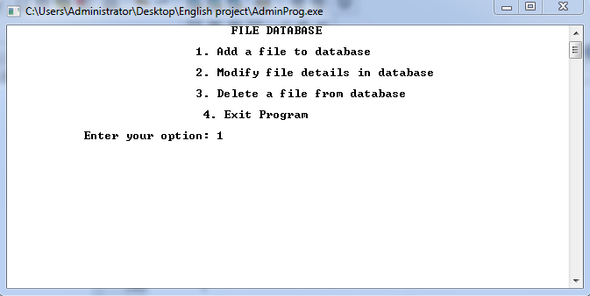
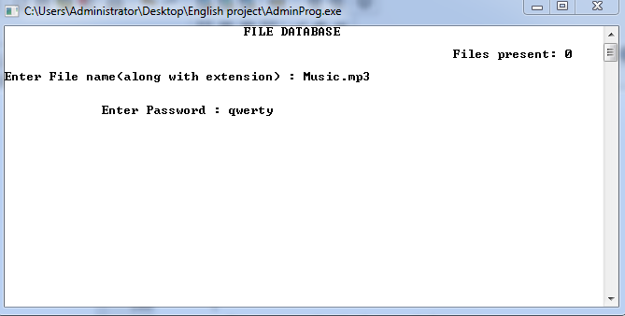
NOTE: Addition of all files have not been shown.
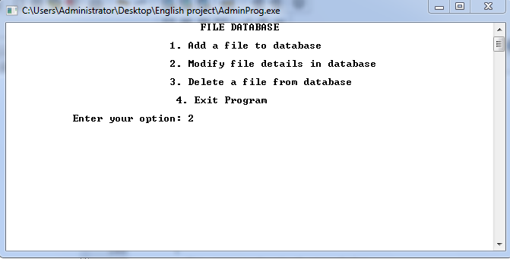
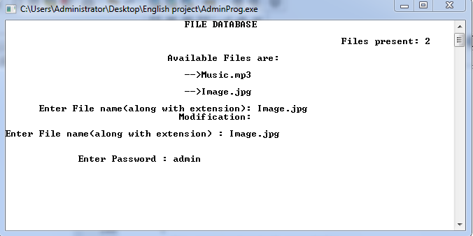
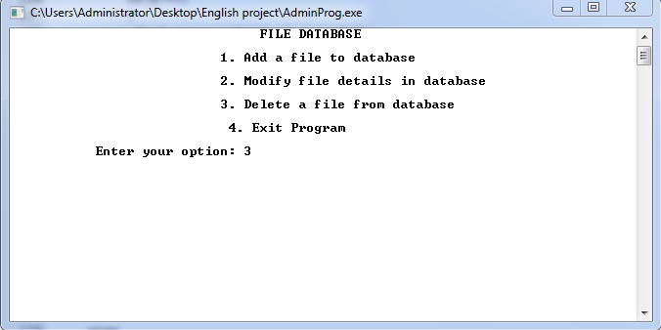
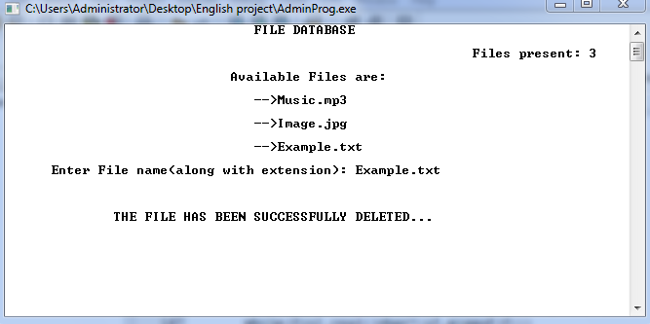

For UserProg.cpp:
- When entering INVALID file name:

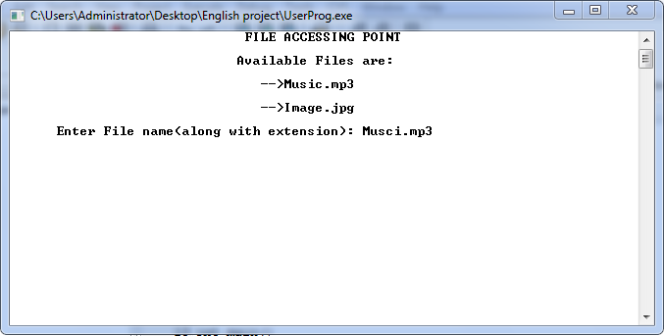
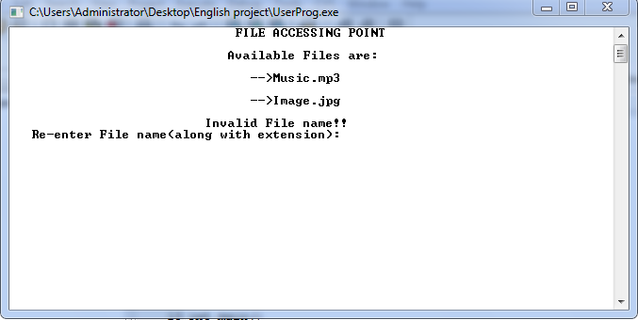

When entering VALID file name:
If the password is INVALID(for an image file):
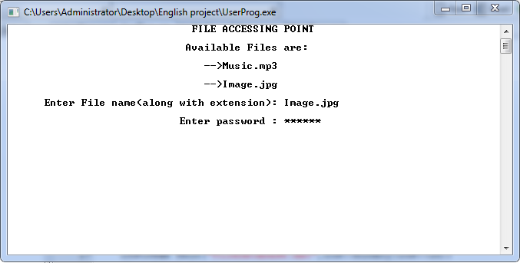
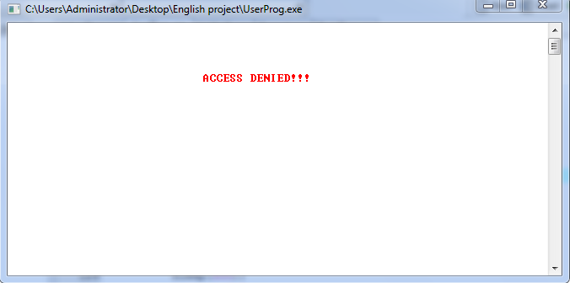

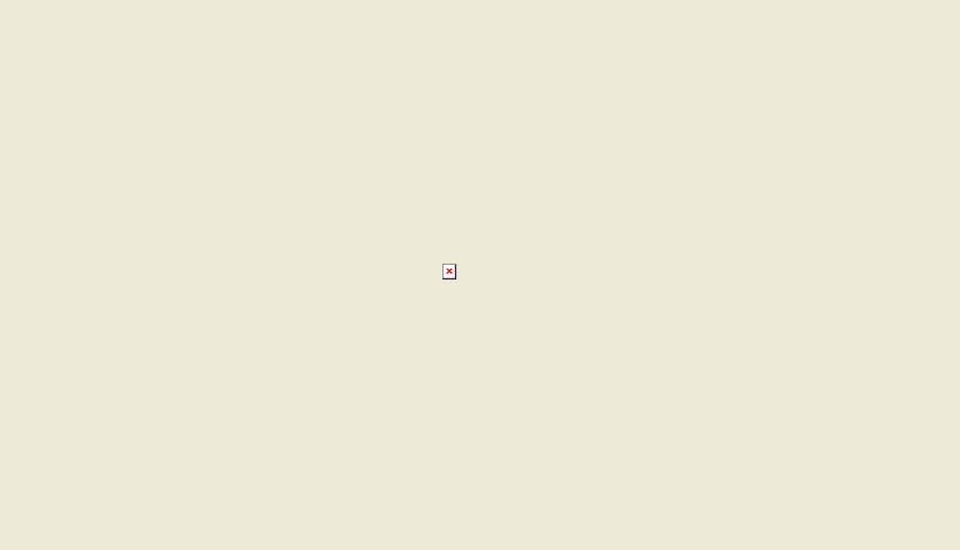

If the password is VALID(for an image file):
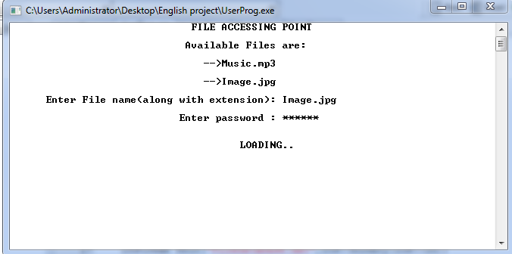
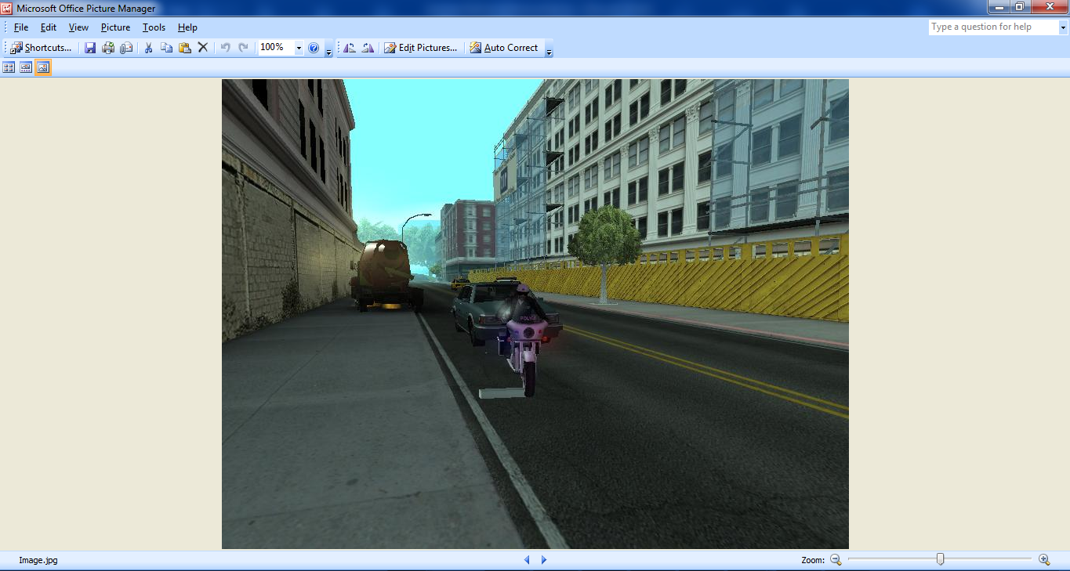

If the password entered is INVALID(for an mp3 file):
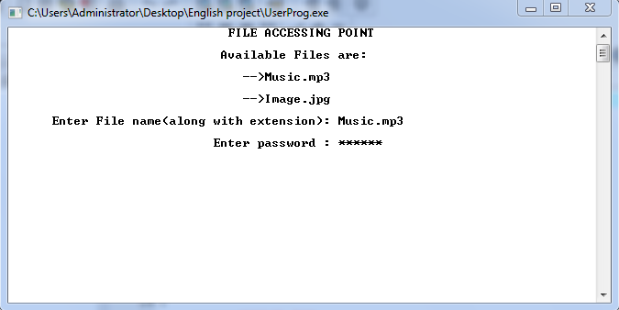
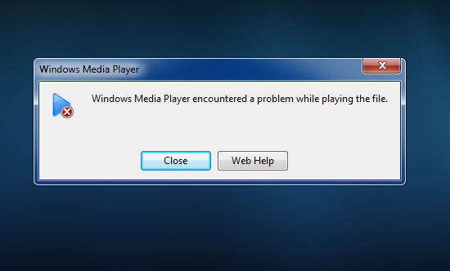
If the password is VALID(for an mp3 file):
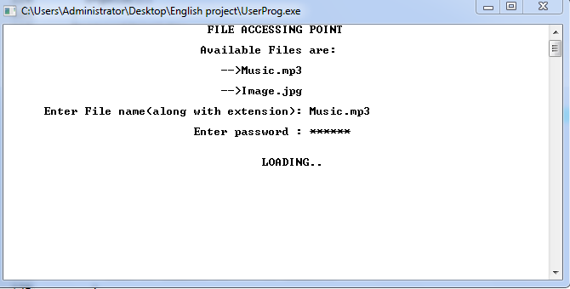
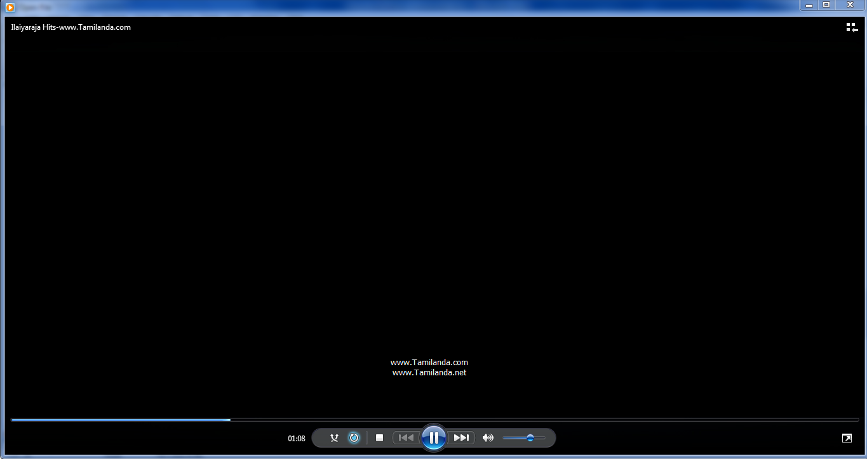

NOTE:
It can similarly be shown for word documents, text files, video files(preferably of small size), etc..
Furthermore, in this program, if the user inputs invalid password once and then tries to access the original file directly, it still continues to exist encrypted.

LIMITATIONS AND ASSUMPTIONS:
- It has to be assumed that the user tries to access the files only through the code.
- It has to be assumed that the user does not access the admin’s program or the file database.
- It has to be assumed that the user does close and run the program again if the file exists encrypted, as it would defy the program’s logic and its aim.
- Only the files present in the directory can be included in the file database.
- The admin cannot enter details of any file that does not belong to the program’s directory.

REFERENCES AND BIBLIOGRAPHY:
- Christof Paar’s stream cipher.
CONCLUSION: The project titled ENCRYTION AND DECRYPTION done by by B.VIGNESH and P.R.VIGNESH for the academic year has has been completed and compiled, tested and executed successfully successfully.

