Mini Knowledge Graph Builder - Milestone 1 Report
📅 Date: 2025-11-03
👤 Student Name: Saivignesh Marapelli
📂 Project Folder: Mini_KnowledgeGraph

Project Title:
Mini Knowledge Graph Builder

Dataset Description:
The dataset used for this project contains sentences related to organizations, people, and events. It includes data from various domains like education, healthcare, business, and technology. Each record represents factual statements such as collaborations, announcements, or releases.

Extracted Entities and Relationships:
Using Named Entity Recognition (NER) and relation extraction, the system identified entities like:
- People: Johnson, Walker, Sachs
- Organizations: MIT, Pfizer, University
- Dates: 2020, 2021, 2023
- Places: India, July, October
Relations extracted include actions such as 'conducted', 'reported', 'launched', 'presented', and 'collaborated'. Each relationship connects two entities to represent knowledge triples.

Knowledge Graph Visualization:
The following screenshots show the generated Knowledge Graph visualizations. Entities are represented as nodes (light blue for subjects, light green for objects), and relationships are displayed as labeled edges.
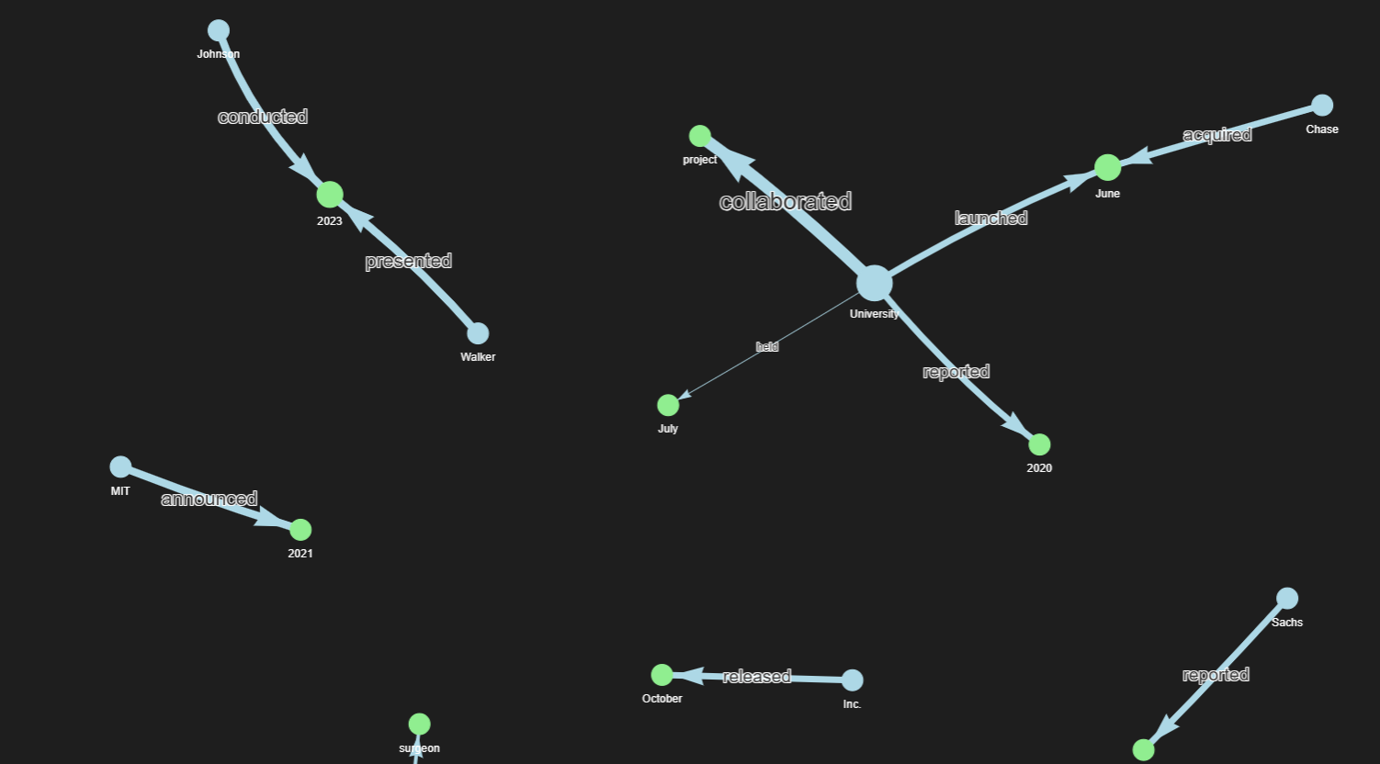
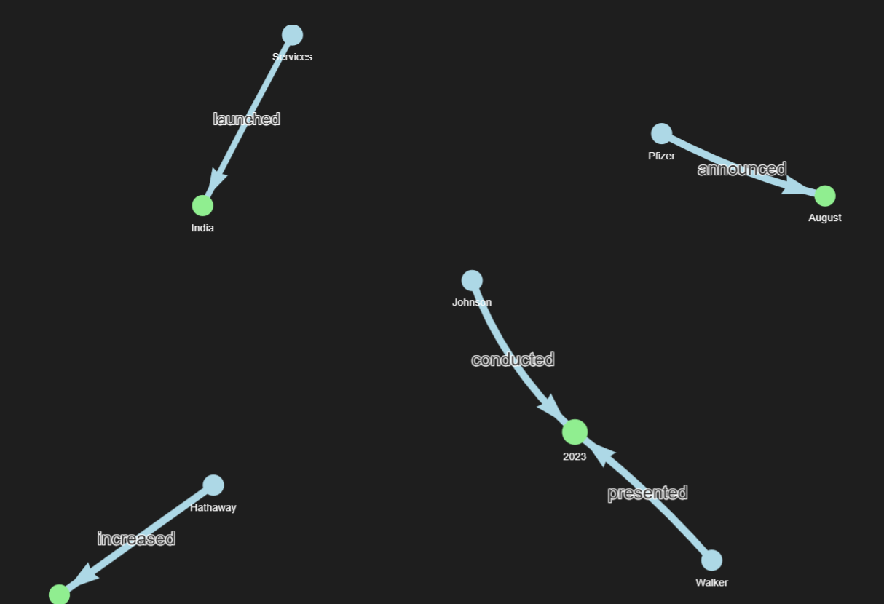

Reflection: What I Learned from Milestone 1
During this milestone, I learned how to:
• Preprocess and clean textual datasets for NLP tasks
• Extract entities and relationships using spaCy
• Represent knowledge as triples
• Visualize graphs using NetworkX
The key challenge was ensuring clear visualization of complex graphs, especially when many nodes overlapped. By tuning layout parameters and filtering nodes, I achieved a cleaner, more readable result.

