VIGNESH.P
192424040
1. Arithmetic operations in 8085 microprocessors

A. 8-bit addition with carry using direct addressing

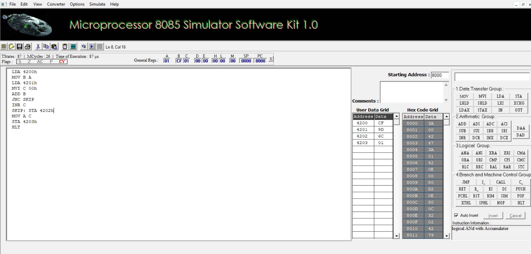

B. 8-bit addition using indirect addressing

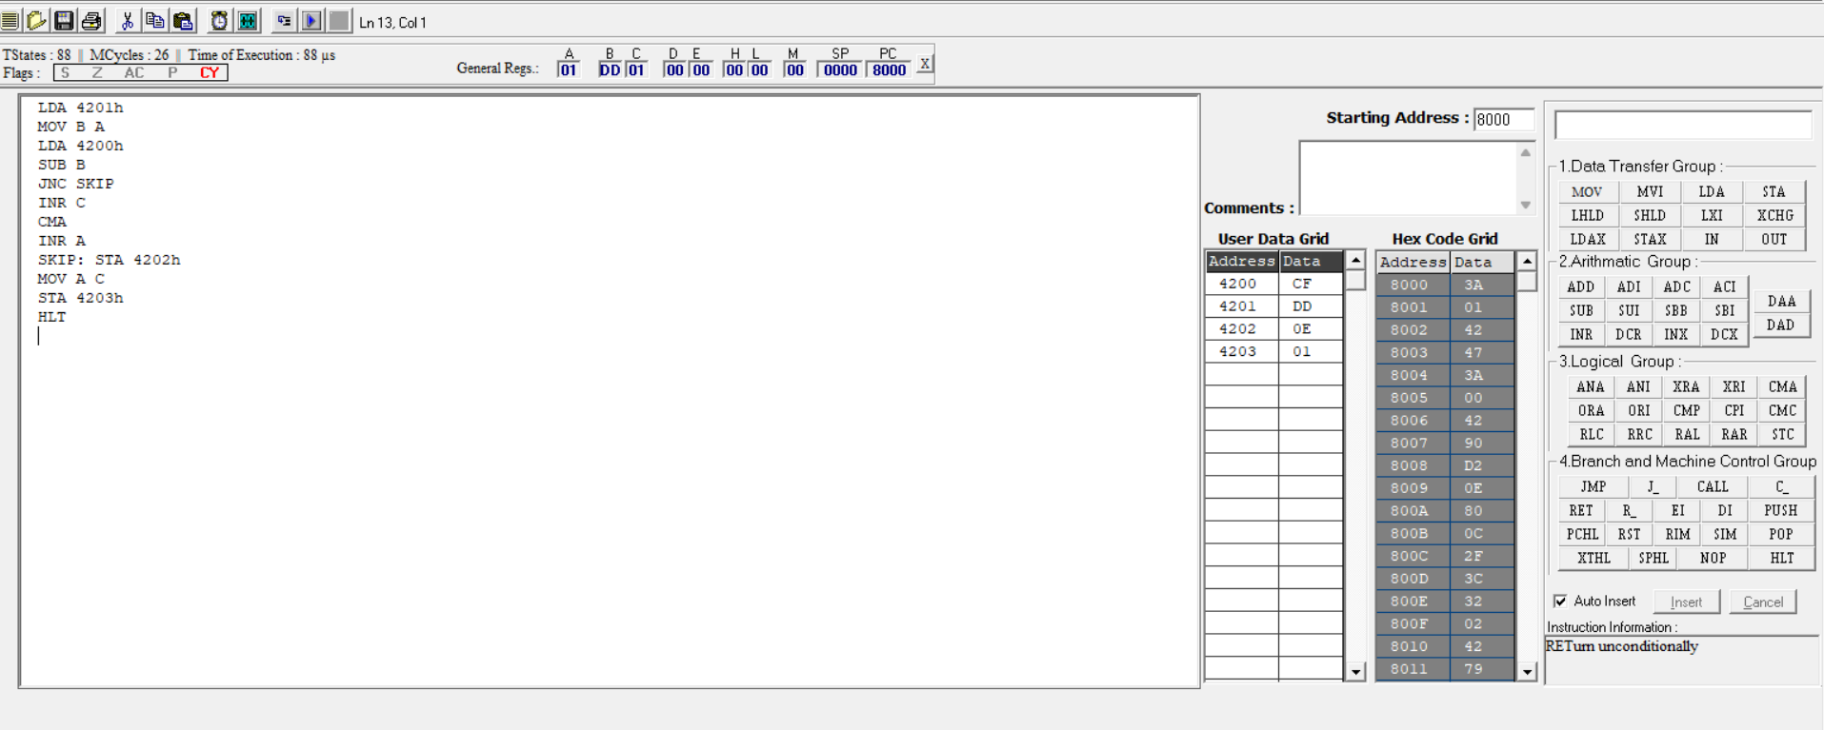

C. 8-bit subtraction without borrow

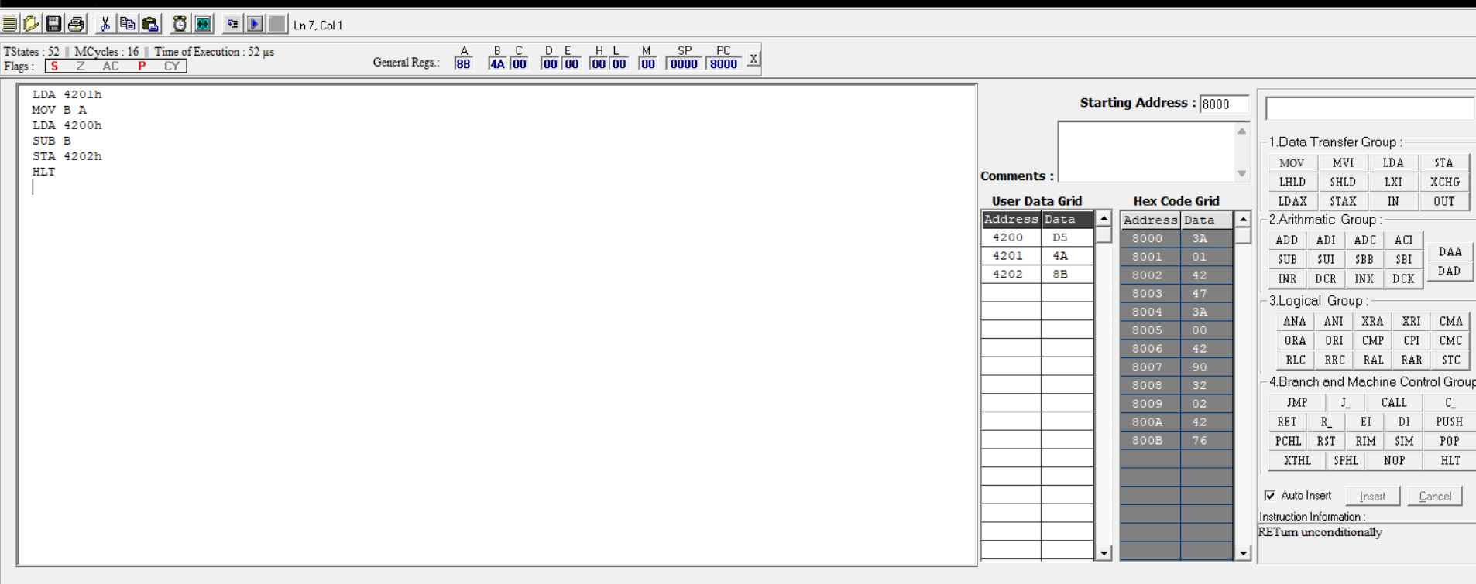

D. 8-bit subtraction with borrow using direct addressing

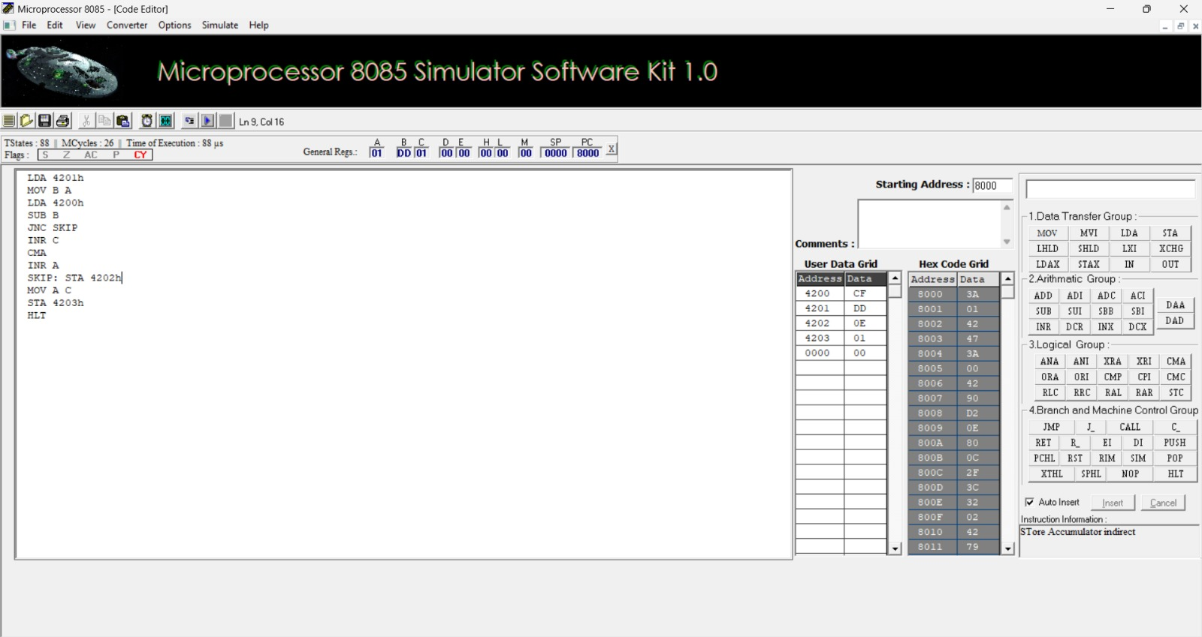

E. 8-bit multiplication operations using 8085 microprocessor

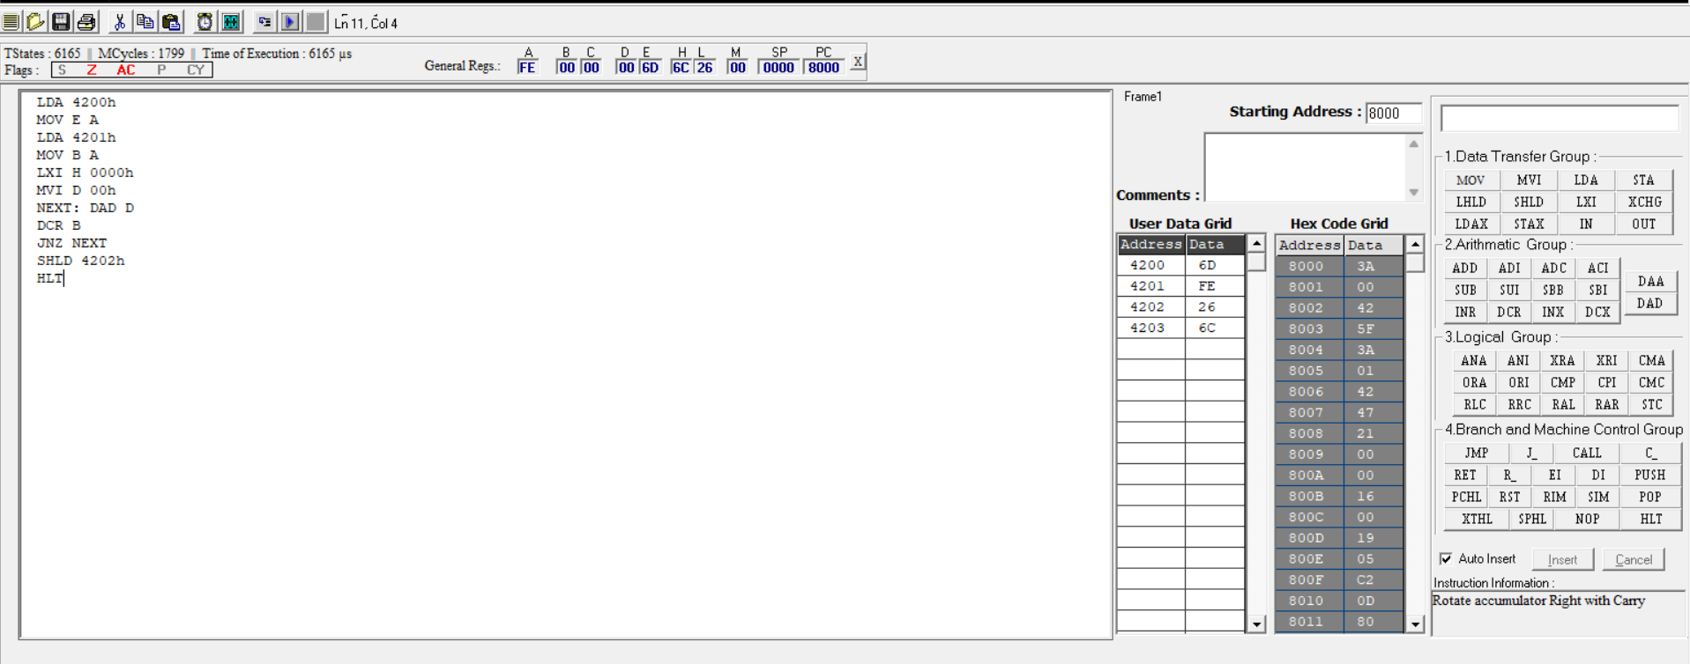

F. 8-bit division operations using 8085 microprocessor

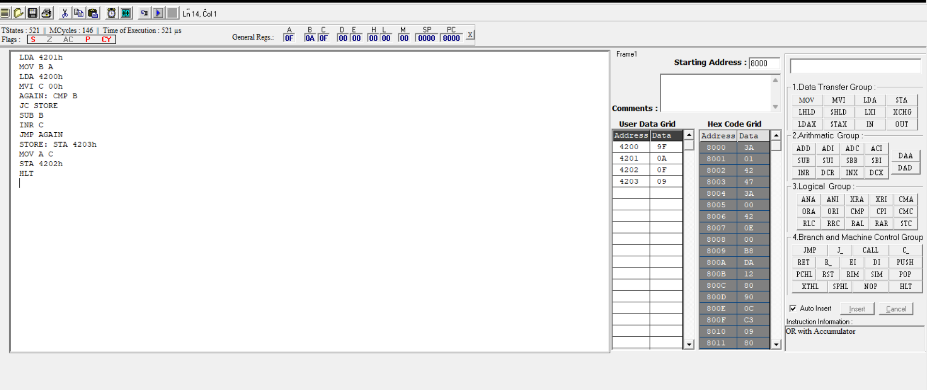

2. A. Sort an array of data in ascending order

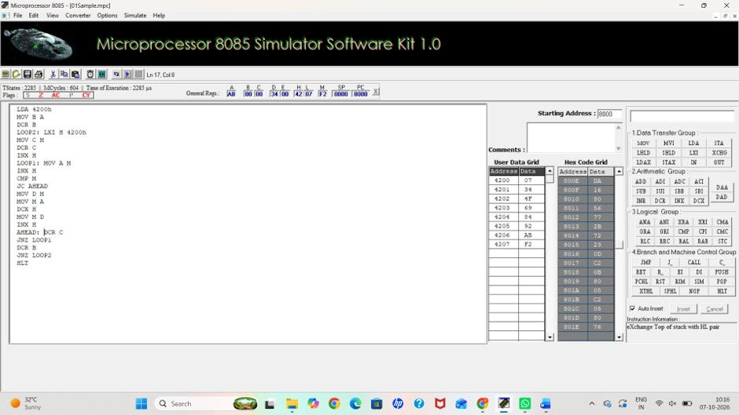

B. Sort an array of data in descending order

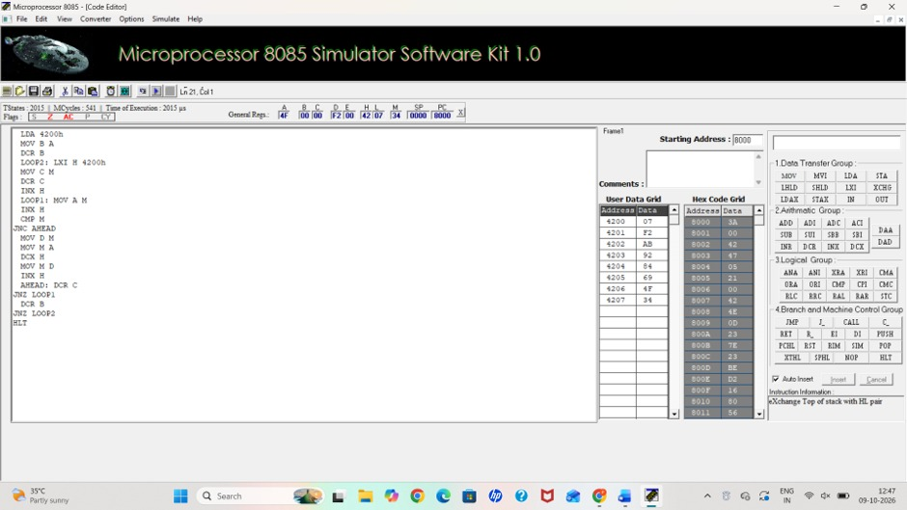

3. Ascii code to hex code conversion

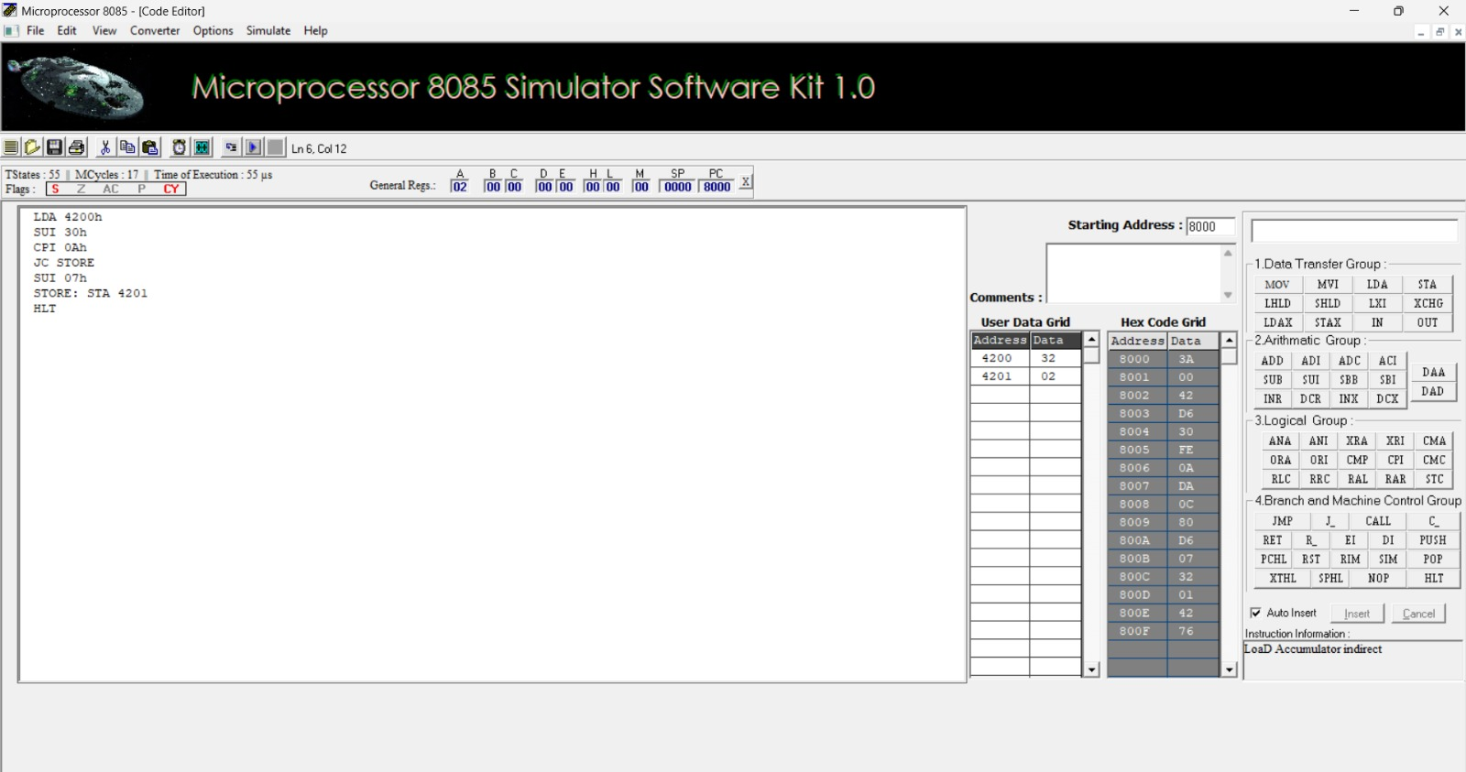

4.transferring a block of data between memory locations

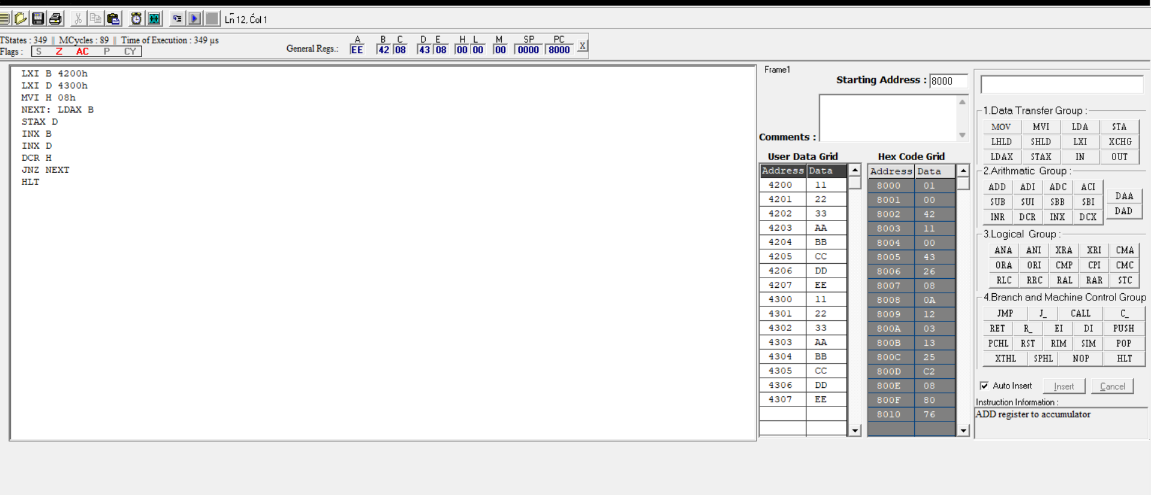

5. A. Masking and setting of lower nibbles on given data

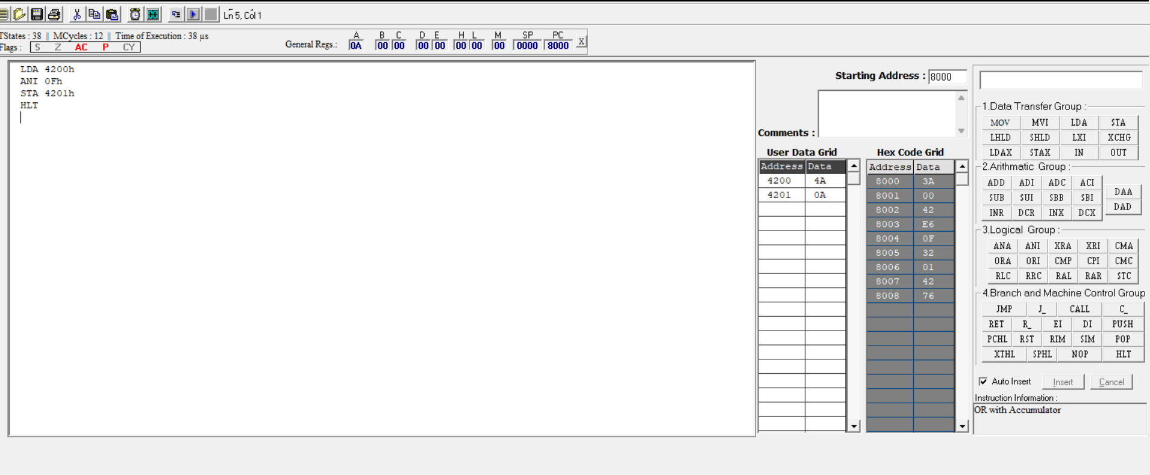

B. One’s and two’s complement

