

SIMATS ENGINEERING

Saveetha Institute of Medical and Technical Sciences
Chennai- 602105

Name: Vigneshvar S
Reg no: 192424187
Subject and Course Code:
CSA1402 – COMPILER DESIGN
CO3- AT2

Set 1 – Question 4
Question:
A statically typed programming language enforces type checking during compilation to ensure correctness. Evaluate how such a type system helps detect errors early, prevents invalid operations, and improves software reliability, while also discussing any limitations in flexibility compared to dynamically typed systems.
Introduction:
Type checking is a semantic analysis phase in which the compiler verifies that the operations performed in a program are consistent with the data types of the operands involved. In a statically typed language, this verification happens entirely at compile time.
Explanation:
Every variable and expression in a statically typed language has a type that is known before the program runs. The compiler builds a symbol table containing the declared type of each identifier, and during semantic analysis it walks the syntax tree, checking that each operator is applied to operands of compatible types. If a mismatch is found — for example, adding a string to an integer without a defined conversion rule — the compiler reports a type error immediately instead of allowing the program to run.
How Early Detection Improves Reliability:
- Errors such as assigning a float to a boolean variable are caught before execution, saving debugging time.
- Invalid operations, like calling a method that does not exist on a given type, are rejected during compilation.
- Because every variable has a fixed, known type, the compiler can allocate the correct amount of memory and choose efficient machine instructions.
- Large programs become easier to maintain because the type of every function parameter and return value is documented and enforced by the compiler.
C Program Logic (Simplified Type Checking Idea):
/* Simplified logic showing how a compiler checks type compatibility */
#include <stdio.h>
#include <string.h>

int isCompatible(char *type1, char *type2) {
if (strcmp(type1, type2) == 0)
return 1;
/* allow int -> float widening */
if (strcmp(type1, "int") == 0 && strcmp(type2, "float") == 0)
return 1;
return 0;
}

int main() {
char op1Type[] = "int";
char op2Type[] = "float";

if (isCompatible(op1Type, op2Type))
printf("Type check passed: operation allowed\n");
else
printf("Type error: incompatible operands\n");

return 0;
}

Limitations Compared to Dynamically Typed Systems:
- Static typing requires explicit type declarations, which can make quick prototyping slower.
- Generic or highly flexible code (for example, a function that works on any data type) needs extra mechanisms such as templates or generics.
- Some valid but unconventional patterns used freely in dynamic languages, such as changing a variable's type at runtime, are not permitted.
Conclusion:
Static type checking trades some flexibility for early error detection, safer code, and better performance, making it well suited for large, reliability-critical software systems.

Output:
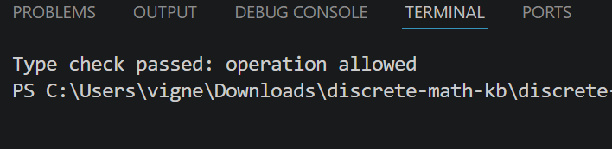

Set 2 – Question 2
Question:
A software company is building a compiler for an educational programming language that supports integer, float, and boolean datatypes. During compilation, the semantic analyzer must verify assignment compatibility and detect undeclared variables. The development team decides to implement a simple type checker using type expressions and conversion rules. However, programs containing mixed datatypes frequently generate semantic errors during expression evaluation. Examine how type systems and type conversions can improve semantic correctness and discuss the role of type equivalence in resolving datatype compatibility issues.
Introduction:
In this scenario, the semantic analyzer must handle three datatypes — integer, float, and boolean — and ensure that expressions and assignments involving them are semantically valid.
Explanation:
A type checker represents the type of every expression using a type expression, which can be a basic type (int, float, bool) or a composite type built from basic types. When the parser detects an undeclared variable, the type checker consults the symbol table; if no entry exists, a semantic error is reported. For expressions with mixed types, such as int + float, the compiler applies coercion (implicit type conversion) rules so that the integer operand is widened to a float before the operation is performed.
Role of Type Equivalence:
- Name equivalence: two types are considered the same only if they share the same declared name.
- Structural equivalence: two types are considered the same if their underlying structure (fields, base type) is identical, even if declared separately.
- Type equivalence rules decide whether an assignment like float x = intValue; is legal directly or requires an explicit conversion function.
C Program Logic (Assignment Compatibility Check):
#include <stdio.h>
#include <string.h>

/* Returns the resulting type after an assignment, or "ERROR" */
char* checkAssignment(char *lhsType, char *rhsType) {
if (strcmp(lhsType, rhsType) == 0)
return lhsType;
if (strcmp(lhsType, "float") == 0 && strcmp(rhsType, "int") == 0)
return "float (implicit int->float conversion)";
return "ERROR: incompatible types";
}

int main() {
printf("Result: %s\n", checkAssignment("float", "int"));
printf("Result: %s\n", checkAssignment("bool", "int"));
return 0;
}

Conclusion:
By combining a systematic type checker with well-defined conversion and equivalence rules, the compiler can automatically resolve most mixed-datatype expressions, reducing spurious semantic errors while still catching genuinely invalid operations such as assigning a boolean to an integer without an explicit conversion.
Output:
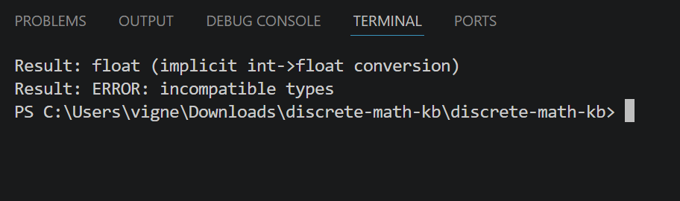

Set 3 – Question 1
Question:
A software company is developing a mini programming language for scientific calculations, where arithmetic expressions must be translated into syntax trees before code generation. During compilation, the compiler team notices that inherited and synthesized attributes are not being evaluated correctly for nested expressions. Initially, they use S-attributed definitions for bottom-up evaluation but later require L-attributed definitions to support function parameters and variable scopes. The compiler must also perform semantic checks to ensure that integer and floating-point operations are compatible. To improve reliability, the team plans to integrate automatic type conversion wherever necessary.
Introduction:
Syntax-Directed Definitions (SDDs) attach semantic rules to the productions of a context-free grammar, allowing the compiler to compute useful information — such as syntax trees, types, or values — as it parses the input.
a) How Syntax-Directed Definitions Help in Syntax Tree Construction:
Each grammar production is associated with semantic rules that build a node of the syntax tree. Synthesized attributes carry information upward from children to parent (for example, the type or the tree-node reference of a sub-expression), while inherited attributes pass information downward or sideways (for example, the expected type context). For an expression grammar such as E -> E1 + T, the semantic rule E.node = new Node('+', E1.node, T.node) constructs an internal node whose children are the sub-trees already built for E1 and T. Repeating this for every production produces a complete syntax tree that mirrors the structure of the source expression.
b) S-Attributed vs L-Attributed Definitions:
- S-attributed definitions use only synthesized attributes, which are computed purely from the attribute values of child nodes. They fit naturally with bottom-up (LR) parsing, where values are computed as each production is reduced.
- L-attributed definitions allow both synthesized attributes and inherited attributes, provided each inherited attribute depends only on attributes of the parent or on sibling nodes to its left. This ordering makes them suitable for evaluation during top-down (LL) parsing as well as during a left-to-right depth-first traversal.
- In this scenario, simple arithmetic expressions were handled correctly with S-attributed definitions because every value flowed upward. Function parameters and variable scopes, however, require passing contextual information (such as the declared type of a parameter) down into sub-expressions, which only inherited attributes can express — hence the move to L-attributed definitions.
Semantic Check and Type Conversion Logic (C Program):
#include <stdio.h>
#include <string.h>

typedef struct Node {
char type[10]; /* "int" or "float" */
double value;
} Node;

/* Synthesized attribute computation for E -> E1 + E2 */
Node combine(Node left, Node right) {
Node result;
if (strcmp(left.type, "float") == 0 || strcmp(right.type, "float") == 0) {
strcpy(result.type, "float"); /* automatic type conversion */
} else {
strcpy(result.type, "int");
}
result.value = left.value + right.value;
return result;
}

int main() {
Node a = { "int", 5 };
Node b = { "float", 2.5 };
Node r = combine(a, b);
printf("Result type: %s, value: %.2f\n", r.type, r.value);
return 0;
}

Conclusion:
Using L-attributed definitions along with automatic type conversion allows the compiler to correctly build syntax trees for nested expressions while enforcing type compatibility between integer and floating-point operations.

Output:

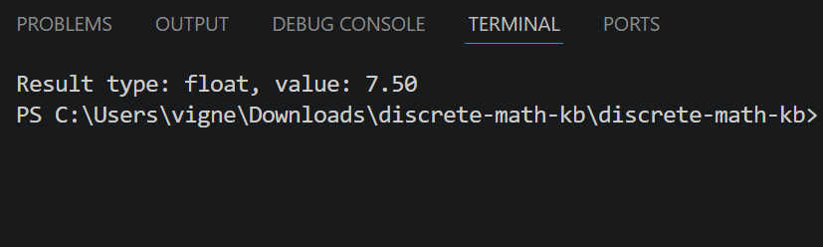

Set 4 – Question 1
Question:
A game development company is creating a custom scripting language for controlling character movements and animations. The compiler team uses syntax-directed definitions to generate syntax trees for arithmetic and logical expressions during parsing. Initially, bottom-up evaluation with S-attributed definitions works well for simple expressions, but difficulties arise when inherited attributes are needed for function calls and nested scopes. During semantic analysis, the compiler detects several type mismatches between integer, float, and boolean variables. To ensure smooth execution, the developers implement a type checker with automatic type conversion support.
Introduction:
The scripting language needs to translate arithmetic and logical expressions into syntax trees and simultaneously check that operand types are compatible, which is a classic application of syntax-directed translation combined with semantic analysis.
a) How Syntax-Directed Definitions Assist in Syntax Tree Construction:
Every production in the grammar is paired with a semantic action that creates or links a syntax-tree node. For example, for the rule E -> E1 AND E2 (a logical expression), the semantic rule creates a node labelled AND whose children are the tree nodes already synthesized for E1 and E2. As parsing proceeds, these local tree fragments are combined bottom-up, so that by the time the start symbol is reduced, the compiler has one syntax tree representing the entire expression, ready for type checking and code generation.
b) Why Type Conversions Are Necessary in Semantic Analysis:
- Character animations may mix integer frame counts with floating-point time values (e.g., delay = frameCount * 0.5), so the compiler must convert int to float automatically to keep the expression meaningful.
- Logical/boolean expressions must not be silently mixed with arithmetic values; the type checker uses conversion rules to allow safe coercions (int to float) while rejecting unsafe ones (float to bool without an explicit comparison).
- Without conversion rules, every mismatched pair of types would be flagged as an error, even legitimate operations, making the language unusable for real scripting tasks.
- Type conversion ensures that the final generated code operates on values of a single, well-defined type, preventing runtime corruption of animation data.
C Program Logic (Type Checker with Conversion):
#include <stdio.h>
#include <string.h>

char* typeCheck(char *t1, char *t2, char *op) {
if (strcmp(t1, "bool") == 0 || strcmp(t2, "bool") == 0) {
if (strcmp(op, "AND") == 0 || strcmp(op, "OR") == 0)
return "bool";
return "ERROR: boolean not valid for arithmetic op";
}
if (strcmp(t1, "float") == 0 || strcmp(t2, "float") == 0)
return "float"; /* implicit conversion applied */
return "int";
}

int main() {
printf("Result type: %s\n", typeCheck("int", "float", "+"));
printf("Result type: %s\n", typeCheck("bool", "bool", "AND"));
printf("Result type: %s\n", typeCheck("float", "bool", "+"));
return 0;
}

Conclusion:
Syntax-directed definitions give the compiler a systematic way to build syntax trees for movement and animation scripts, while an integrated type checker with conversion rules ensures that mixed int, float, and bool expressions execute correctly and safely.
Output:
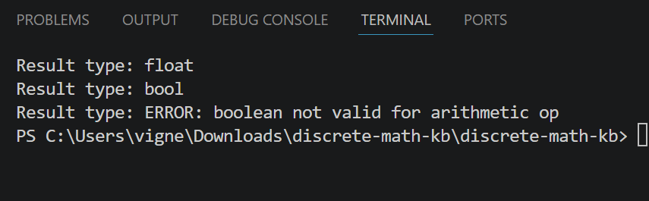

Set 5 – Question 4
Question:
A mobile application development company is creating a source-to-source translator that converts high-level programs into optimized intermediate representations. The translator uses syntax-directed translation schemes to evaluate semantic actions during parsing. During testing, expressions containing mixed datatypes such as integer, float, and boolean values generate semantic inconsistencies across different modules. The development team decides to introduce a simple type checker with conversion handling mechanisms. Analyze how type checking and type conversion policies improve translation correctness and prevent semantic errors during intermediate code generation.
Introduction:
A syntax-directed translation scheme (SDT) embeds semantic actions directly within the grammar productions so that intermediate code, such as three-address code, can be generated as the source program is parsed.
Explanation:
As each production is applied, its associated action executes — for example, emitting a three-address instruction for an arithmetic operation. Before an instruction is emitted, the type checker inspects the types of the operands using information already computed and stored in the symbol table and attribute records. If the operand types differ, a conversion policy decides the outcome: numeric widening (int to float) is performed automatically, while incompatible combinations (such as float to bool) are reported as semantic errors and translation for that expression is aborted.
How Type Checking and Conversion Improve Correctness:
- Prevents the emission of intermediate instructions that operate on incompatible operand types, which would otherwise produce corrupted or meaningless intermediate code.
- Ensures consistency across modules by applying the same conversion rules everywhere a mixed-type expression is translated.
- Allows the translator to insert explicit conversion instructions (e.g., INT_TO_FLOAT t1, x) directly into the intermediate representation, making later optimization and code generation phases simpler.
- Improves reliability of the final generated code by catching type errors at translation time rather than causing failures on the target device at runtime.
C Program Logic (Type Checking During Intermediate Code Generation):
#include <stdio.h>
#include <string.h>

/* Emits a pseudo three-address instruction, inserting a conversion if needed */
void emitInstruction(char *op, char *type1, char *type2) {
if (strcmp(type1, "bool") == 0 || strcmp(type2, "bool") == 0) {
printf("Semantic Error: boolean operand invalid for '%s'\n", op);
return;
}
if (strcmp(type1, "int") == 0 && strcmp(type2, "float") == 0) {
printf("INT_TO_FLOAT t1, operand1\n");
printf("%s t2, t1, operand2\n", op);
} else {
printf("%s t1, operand1, operand2\n", op);
}
}

int main() {
emitInstruction("ADD", "int", "float");
emitInstruction("MUL", "bool", "int");
return 0;
}

Conclusion:
Integrating type checking with clear conversion policies into the syntax-directed translation scheme allows the translator to detect semantic inconsistencies early and to generate correct, consistent intermediate code across all modules of the application.
Output:
