


SIMATS ENGINEERING

Saveetha Institute of Medical and Technical Sciences
Chennai- 602105

Name: Vigneshvar S
Reg no: 192424187
Subject and Course Code:
CSA1402 – COMPILER DESIGN
CO4-AT2

SET 1 - QUESTION 3

E-Commerce Product Recommendation Engine
1. Question
An e-commerce company uses a rule-based recommendation engine developed using a custom programming language. The compiler processes declarations, assignment statements, and Boolean conditions to generate recommendations dynamically. During seasonal sales, delays occurred because of improper handling of case statements and inefficient intermediate code generation. The organization wants to redesign the compiler to improve execution speed and maintainability.
Tasks: (i) Generate intermediate representation for the recommendation logic. (K3) (ii) Discuss how case statements can efficiently handle product category selection. (K4) (iii) Analyze the role of compiler design in improving large-scale e-commerce applications. (K5)
2. Aim
To design and demonstrate a simplified compiler-based recommendation logic model that uses declarations, Boolean expressions, case statements, and three-address code (TAC) to generate product recommendations efficiently.
3. Objectives
- To represent recommendation conditions using Boolean expressions.
- To generate a simplified three-address code (TAC) for the recommendation logic.
- To use a switch/case construct for efficient product category selection.
- To analyze how compiler design improves the performance of e-commerce systems.
4. Concepts Used
- Intermediate Code Generation
- Three-Address Code (TAC)
- Boolean Expressions
- Case Statements
- Compiler Optimization
5. Algorithm / Procedure
- Start the program and declare variables for category and rating.
- Read the product category and rating from the user.
- Evaluate Boolean expressions t1 (rating >= 4) and t2 (category == ELECTRONICS).
- Compute t3 as the logical AND of t1 and t2.
- Use a switch statement to select the category-specific recommendation logic.
- Display the recommendation result and the generated three-address code.
- Stop.
6. C Program
File name: ecommerce_recommendation.c
/* SET 1 - QUESTION 3
E-Commerce Product Recommendation Engine
Demonstrates: declarations, assignment, Boolean expressions,
switch/case, simple Three-Address Code (TAC) representation
*/

#include <stdio.h>

int main()
{
int category; /* 1=Electronics, 2=Clothing, 3=Books */
int rating; /* product rating out of 5 */
int t1, t2, t3; /* intermediate (TAC) result holders */

printf("=====================================\n");
printf(" E-COMMERCE RECOMMENDATION ENGINE\n");
printf("=====================================\n");

printf("Enter category (1-Electronics 2-Clothing 3-Books): ");
scanf("%d", &category);
printf("Enter product rating (0-5): ");
scanf("%d", &rating);

/* Boolean expression evaluation (mirrors TAC below) */
t1 = (rating >= 4);
t2 = (category == 1);
t3 = (t1 && t2);

printf("\n--- Recommendation ---\n");
switch (category)
{
case 1:
printf("Category: Electronics\n");
if (t3)
printf("Result: HIGHLY RECOMMENDED\n");
else
printf("Result: Standard listing\n");
break;
case 2:
printf("Category: Clothing\n");
printf("Result: %s\n", (rating >= 4) ? "RECOMMENDED" : "Standard listing");
break;
case 3:
printf("Category: Books\n");
printf("Result: %s\n", (rating >= 4) ? "RECOMMENDED" : "Standard listing");
break;
default:
printf("Invalid category.\n");
}

printf("\n--- Intermediate Code (TAC) ---\n");
printf("t1 = rating >= 4 -> %d\n", t1);
printf("t2 = category == ELEC -> %d\n", t2);
printf("t3 = t1 AND t2 -> %d\n", t3);
printf("if t3 goto L1\n");
printf("goto L2\n");
printf("L1: recommend = HIGH\n");
printf("L2: recommend = STD\n");

printf("\nExecution completed successfully.\n");
return 0;
}

7. Sample Input
Category: 1 (Electronics)
Rating: 5
8. Output
The program prints the selected category, whether the product is HIGHLY RECOMMENDED or given a standard listing, followed by the generated three-address code and a completion message.
9. Output Screenshot
OUTPUT:
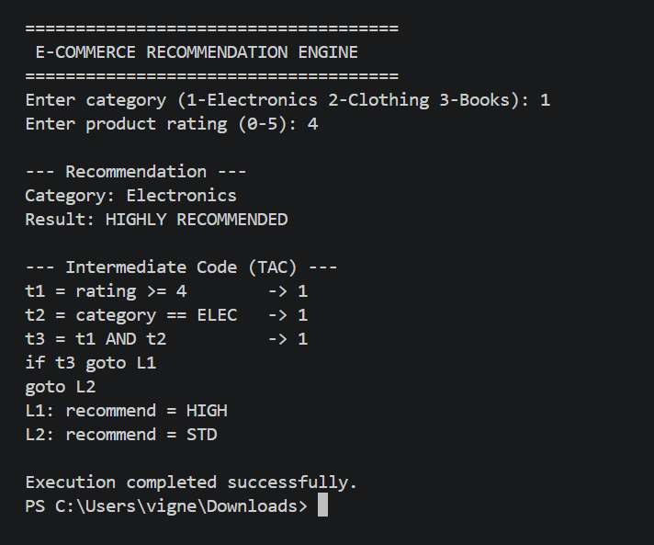

10. Intermediate Code / Three-Address Code (TAC)
Note: This is a simplified intermediate representation used to demonstrate compiler-design concepts.
t1 = rating >= 4
t2 = category == ELECTRONICS
t3 = t1 AND t2
if t3 goto L1
goto L2
L1: recommend = HIGH
L2: recommend = STD

11. Answer to Task (ii)
Case (switch) statements allow the compiler to translate a single multi-way category decision into an efficient jump-table or a sequence of comparison instructions, instead of a long chain of nested if-else statements. For product category selection, this means the recommendation engine can directly branch to the code block for Electronics, Clothing, or Books based on the category value, reducing the number of comparisons performed at runtime. This is especially valuable during high-traffic periods such as seasonal sales, where thousands of recommendation requests must be evaluated quickly. Efficient case handling also improves code readability and maintainability, making it easier to add new product categories in the future.
12. Answer to Task (iii)
Compiler design plays a critical role in large-scale e-commerce applications because the speed and correctness of rule evaluation directly affect user experience and revenue. A well-designed compiler generates optimized intermediate code that reduces redundant computations, uses efficient branching for category and condition checks, and minimizes execution time under heavy load. Techniques such as constant folding, dead-code elimination, and efficient jump-table generation for case statements help the recommendation engine respond in real time even during traffic spikes like flash sales. Overall, sound compiler design ensures scalability, maintainability, and reliability of the underlying rule-processing engine that powers dynamic recommendations.
13. Result
A simplified compiler-based recommendation engine was successfully designed and implemented in C, demonstrating Boolean expression evaluation, case-statement based category selection, and three-address code generation.
Viva Points
- Intermediate code is a machine-independent representation generated by a compiler between the source program and the target code, making optimization and portability easier.
- Three-Address Code (TAC) is a form of intermediate code in which each instruction has at most three operands, typically one operator and up to two operands, e.g., t1 = a + b.
- Boolean expressions let a program evaluate conditions (true/false) so it can make automatic decisions, essential for real-time and rule-based systems.
- Switch/case statements provide efficient multi-way branching, often implemented as jump tables, which is faster than long chains of if-else statements.
- Compiler optimization improves the generated code's speed and resource usage without changing its output, e.g., through dead-code elimination or constant folding.

SET 2 - QUESTION 4

Smart Agriculture Monitoring System
1. Question
An agritech company is developing a smart agriculture platform that monitors soil moisture, temperature, and irrigation systems automatically. The compiler in the embedded controller processes declarations, assignment statements, and Boolean expressions to activate irrigation based on environmental conditions. Inefficient handling of intermediate code caused delays in irrigation control during critical farming conditions. The software team aims to improve compiler performance for real-time agricultural automation.
Tasks: (i) Develop intermediate code for irrigation control and environmental monitoring. (K3) (ii) Explain the role of Boolean expressions in automated farming systems. (K4) (iii) Evaluate how compiler optimization enhances efficiency in smart agriculture applications. (K5)
2. Aim
To design and demonstrate a simplified compiler-based irrigation control model that evaluates soil moisture and temperature using Boolean expressions and generates the corresponding three-address code (TAC).
3. Objectives
- To read and process soil moisture and temperature values.
- To evaluate irrigation activation conditions using Boolean expressions.
- To generate a simplified three-address code for the irrigation decision logic.
- To evaluate how compiler optimization benefits real-time agricultural automation.
4. Concepts Used
- Intermediate Code Generation
- Three-Address Code (TAC)
- Boolean Expressions
- Compiler Optimization
5. Algorithm / Procedure
- Start the program and declare variables for moisture and temperature.
- Read the soil moisture and temperature values from the user.
- Evaluate Boolean expressions t1 (moisture < 30) and t2 (temperature > 35).
- Compute t3 as the logical AND of t1 and t2.
- If t3 is true, set irrigation to ON, otherwise set it to OFF.
- Display the irrigation status and the generated three-address code.
- Stop.
6. C Program
File name: smart_agriculture.c
/* SET 2 - QUESTION 4
Smart Agriculture Monitoring System
Demonstrates: declarations, assignment, Boolean expressions,
simple Three-Address Code (TAC) representation
*/

#include <stdio.h>

int main()
{
int moisture; /* soil moisture percentage */
int temperature; /* temperature in Celsius */
int irrigation; /* 1 = ON, 0 = OFF */
int t1, t2, t3; /* intermediate (TAC) result holders */

printf("=====================================\n");
printf(" SMART AGRICULTURE MONITORING SYSTEM\n");
printf("=====================================\n");

printf("Enter soil moisture (%%): ");
scanf("%d", &moisture);
printf("Enter temperature (C): ");
scanf("%d", &temperature);

/* Boolean expressions */
t1 = (moisture < 30);
t2 = (temperature > 35);
t3 = (t1 && t2);

if (t3)
irrigation = 1;
else
irrigation = 0;

printf("\n--- Status ---\n");
printf("Moisture: %d%% Temperature: %dC\n", moisture, temperature);
printf("Irrigation: %s\n", irrigation ? "ON" : "OFF");

printf("\n--- Intermediate Code (TAC) ---\n");
printf("t1 = moisture < 30 -> %d\n", t1);
printf("t2 = temperature > 35 -> %d\n", t2);
printf("t3 = t1 AND t2 -> %d\n", t3);
printf("if t3 goto L1\n");
printf("goto L2\n");
printf("L1: irrigation = 1\n");
printf("L2: irrigation = 0\n");

printf("\nExecution completed successfully.\n");
return 0;
}

7. Sample Input
Soil Moisture: 20
Temperature: 40
8. Output
The program displays the current moisture and temperature readings, states whether irrigation is turned ON or OFF, and prints the generated three-address code followed by a completion message.
9. Output Screenshot
OUTPUT:
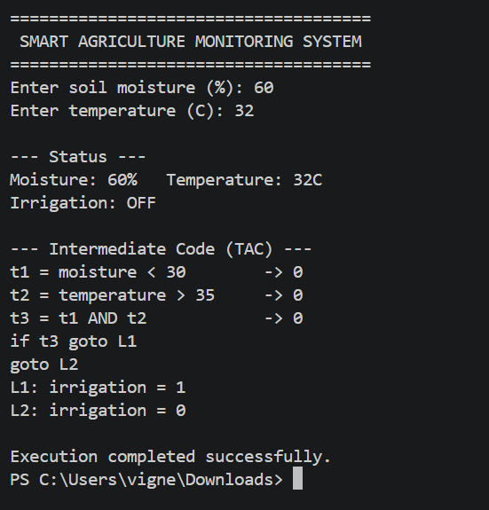

10. Intermediate Code / Three-Address Code (TAC)
Note: This is a simplified intermediate representation used to demonstrate compiler-design concepts.
t1 = moisture < 30
t2 = temperature > 35
t3 = t1 AND t2
if t3 goto L1
goto L2
L1: irrigation = 1
L2: irrigation = 0

11. Answer to Task (ii)
Boolean expressions form the decision-making core of automated farming systems. Conditions such as moisture < 30 or temperature > 35 allow the embedded controller to continuously evaluate environmental sensor data and decide, without human intervention, whether irrigation or other corrective actions are required. Combining multiple conditions using logical operators (AND/OR) enables the system to respond to complex real-world scenarios, such as activating irrigation only when the soil is dry AND the temperature is high, preventing unnecessary water usage. Accurate and efficient Boolean evaluation is therefore essential for reliable, real-time farm automation.
12. Answer to Task (iii)
Compiler optimization directly improves the responsiveness of smart agriculture applications, which often run on resource-constrained embedded controllers. Optimizations such as short-circuit evaluation of Boolean expressions, elimination of redundant sensor-value comparisons, and efficient generation of conditional jump instructions reduce the time taken to evaluate irrigation conditions. In time-critical situations, such as sudden temperature spikes, faster intermediate code execution ensures irrigation is triggered without delay, preventing crop damage. Overall, an optimized compiler improves energy efficiency, response time, and reliability of real-time agricultural automation systems.
13. Result
A simplified compiler-based irrigation control model was successfully implemented in C, demonstrating Boolean expression evaluation and three-address code generation for environmental monitoring.
Viva Points
- Intermediate code is a machine-independent representation generated by a compiler between the source program and the target code, making optimization and portability easier.
- Three-Address Code (TAC) is a form of intermediate code in which each instruction has at most three operands, typically one operator and up to two operands, e.g., t1 = a + b.
- Boolean expressions let a program evaluate conditions (true/false) so it can make automatic decisions, essential for real-time and rule-based systems.
- Compiler optimization improves the generated code's speed and resource usage without changing its output, e.g., through dead-code elimination or constant folding.

SET 3 - QUESTION 5

Smart Warehouse Inventory Management System
1. Question
A retail company is implementing a smart warehouse inventory system that automatically tracks product movement and stock levels. The compiler processes assignment statements, Boolean expressions, and case statements to update inventory records and manage automated storage systems. During seasonal sales, delays in intermediate code execution affected stock synchronization and order fulfillment. The company plans to optimize the compiler to improve inventory accuracy and warehouse efficiency.
Tasks: (i) Design intermediate code for inventory tracking and stock update operations. (K3) (ii) Explain how case statements help manage multiple product categories efficiently. (K4) (iii) Analyze the importance of compiler optimization in warehouse automation systems. (K5)
2. Aim
To design and demonstrate a simplified compiler-based inventory tracking model that uses Boolean expressions and case statements to monitor stock levels and generate the corresponding three-address code (TAC).
3. Objectives
- To read and classify products by category using a case statement.
- To evaluate the reorder condition using a Boolean expression.
- To generate a simplified three-address code for the stock-update decision logic.
- To analyze the importance of compiler optimization in warehouse automation.
4. Concepts Used
- Intermediate Code Generation
- Three-Address Code (TAC)
- Boolean Expressions
- Case Statements
- Compiler Optimization
5. Algorithm / Procedure
- Start the program and declare variables for category and stock.
- Read the product category and current stock level from the user.
- Evaluate the Boolean expression t1 (stock < reorder_level).
- Use a switch statement to display the classified product category.
- If t1 is true, mark the item status as REORDER REQUIRED, else Stock Sufficient.
- Display the inventory status and the generated three-address code.
- Stop.
6. C Program
File name: smart_warehouse.c
/* SET 3 - QUESTION 5
Smart Warehouse Inventory Management System
Demonstrates: declarations, assignment, Boolean expressions,
switch/case, simple Three-Address Code (TAC) representation
*/

#include <stdio.h>

int main()
{
int category; /* 1=Electronics, 2=Grocery, 3=Furniture */
int stock;
int reorderLevel = 20;
int t1; /* intermediate (TAC) result holder */

printf("=====================================\n");
printf(" SMART WAREHOUSE INVENTORY SYSTEM\n");
printf("=====================================\n");

printf("Enter category (1-Electronics 2-Grocery 3-Furniture): ");
scanf("%d", &category);
printf("Enter current stock: ");
scanf("%d", &stock);

t1 = (stock < reorderLevel);

printf("\n--- Inventory Status ---\n");
switch (category)
{
case 1:
printf("Category: Electronics\n");
break;
case 2:
printf("Category: Grocery\n");
break;
case 3:
printf("Category: Furniture\n");
break;
default:
printf("Category: Unknown\n");
}

printf("Stock: %d (Reorder Level: %d)\n", stock, reorderLevel);
printf("Status: %s\n", t1 ? "REORDER REQUIRED" : "Stock Sufficient");

printf("\n--- Intermediate Code (TAC) ---\n");
printf("t1 = stock < reorder_level -> %d\n", t1);
printf("if t1 goto REORDER\n");
printf("goto CONTINUE\n");
printf("REORDER: status = 1\n");
printf("CONTINUE: status = 0\n");

printf("\nExecution completed successfully.\n");
return 0;
}

7. Sample Input
Category: 1 (Electronics)
Stock: 10
8. Output
The program prints the product category, current stock against the reorder level, whether reorder is required, the generated three-address code, and a completion message.
9. Output Screenshot
OUTPUT:
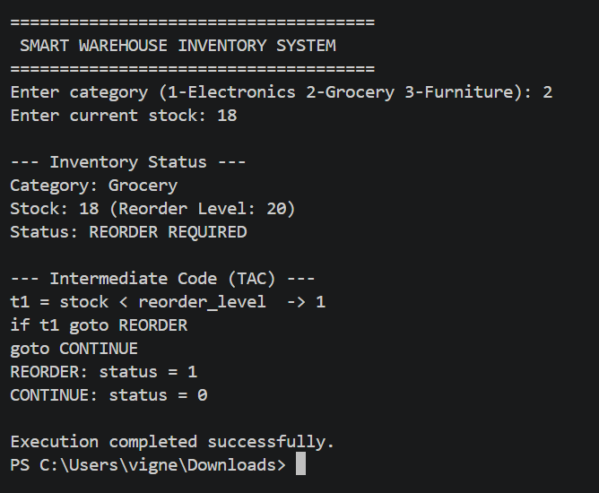

10. Intermediate Code / Three-Address Code (TAC)
Note: This is a simplified intermediate representation used to demonstrate compiler-design concepts.
t1 = stock < reorder_level
if t1 goto REORDER
goto CONTINUE
REORDER: status = 1
CONTINUE: status = 0

11. Answer to Task (ii)
Case statements allow the compiler to efficiently direct control flow to the correct handling logic for each of the many product categories found in a warehouse, without requiring long chains of if-else comparisons. When a category code is read from a scanner or sensor, a switch/case construct can translate it into a jump table, letting the system immediately execute the classification or update logic associated with that category. This significantly reduces processing time when handling thousands of inventory transactions during peak periods such as seasonal sales, while also keeping the code organized and easy to extend with new product categories.
12. Answer to Task (iii)
Compiler optimization is essential in warehouse automation systems because inventory operations must be processed continuously and accurately, often under heavy transactional load during sales events. Optimized intermediate code reduces the number of instructions needed to evaluate stock conditions and update records, minimizing latency between a stock change and its reflection in the system. Techniques such as efficient branch generation for case statements and elimination of redundant condition checks help ensure that stock synchronization and order fulfillment keep pace with real-world warehouse activity, directly improving inventory accuracy and customer satisfaction.
13. Result
A simplified compiler-based inventory tracking model was successfully implemented in C, demonstrating case-statement based classification, Boolean-expression based reorder detection, and three-address code generation.
Viva Points
- Intermediate code is a machine-independent representation generated by a compiler between the source program and the target code, making optimization and portability easier.
- Three-Address Code (TAC) is a form of intermediate code in which each instruction has at most three operands, typically one operator and up to two operands, e.g., t1 = a + b.
- Boolean expressions let a program evaluate conditions (true/false) so it can make automatic decisions, essential for real-time and rule-based systems.
- Switch/case statements provide efficient multi-way branching, often implemented as jump tables, which is faster than long chains of if-else statements.
- Compiler optimization improves the generated code's speed and resource usage without changing its output, e.g., through dead-code elimination or constant folding.

SET 4 - QUESTION 4

Automated Library Management System
1. Question
A university is implementing an automated library management system to handle book issuance, returns, and digital catalog management. The compiler processes declarations, assignment statements, and procedure calls for member verification and book tracking operations. During semester examinations, inefficient intermediate code generation delayed transaction updates and fine calculations. The university plans to improve compiler efficiency for faster and more reliable library services.
Tasks: (i) Develop intermediate code for book issue and return operations. (K3) (ii) Explain how procedure calls improve modularity in library management systems. (K4) (iii) Evaluate the significance of compiler optimization in educational information systems. (K5)
2. Aim
To design and demonstrate a simplified compiler-based library transaction model that uses procedure/function calls for member verification, book issuance, book return, and fine calculation, along with the corresponding three-address code (TAC).
3. Objectives
- To verify library members using a dedicated verification function.
- To modularize book issue, return, and fine-calculation operations using functions.
- To generate a simplified three-address code for the issue/return procedure calls.
- To evaluate the significance of compiler optimization in educational information systems.
4. Concepts Used
- Intermediate Code Generation
- Three-Address Code (TAC)
- Procedure/Function Calls
- Compiler Optimization
5. Algorithm / Procedure
- Start the program and declare variables for member ID, book ID, and days late.
- Read the member ID, book ID, and number of days late from the user.
- Call the verifyMember() function to validate the member.
- If verified, call issueBook() to issue the book.
- Call returnBook(), which internally calls calculateFine() to compute any fine.
- Display the transaction details and the generated three-address code.
- Stop.
6. C Program
File name: library_management.c
/* SET 4 - QUESTION 4
Automated Library Management System
Demonstrates: declarations, assignment, procedure/function calls,
simple Three-Address Code (TAC) representation
*/

#include <stdio.h>

int verifyMember(int memberId)
{
/* simple verification: any positive ID is valid */
return (memberId > 0);
}

void issueBook(int bookId)
{
printf("Book %d issued successfully.\n", bookId);
}

int calculateFine(int daysLate)
{
int finePerDay = 5;
return (daysLate > 0) ? (daysLate * finePerDay) : 0;
}

void returnBook(int bookId, int daysLate)
{
int fine = calculateFine(daysLate);
printf("Book %d returned. Days late: %d, Fine: Rs. %d\n",
bookId, daysLate, fine);
}

int main()
{
int memberId, bookId, daysLate, verified;

printf("=====================================\n");
printf(" AUTOMATED LIBRARY MANAGEMENT SYSTEM\n");
printf("=====================================\n");

printf("Enter Member ID: ");
scanf("%d", &memberId);
printf("Enter Book ID: ");
scanf("%d", &bookId);
printf("Enter Days Late (0 if on time): ");
scanf("%d", &daysLate);

verified = verifyMember(memberId);

printf("\n--- Transaction ---\n");
if (verified)
{
issueBook(bookId);
returnBook(bookId, daysLate);
}
else
{
printf("Member verification failed.\n");
}

printf("\n--- Intermediate Code (TAC) ---\n");
printf("t1 = call verifyMember(memberId)\n");
printf("if t1 goto ISSUE\n");
printf("goto REJECT\n");
printf("ISSUE: call issueBook(bookId)\n");
printf("t2 = call calculateFine(daysLate)\n");
printf("REJECT: exit\n");

printf("\nExecution completed successfully.\n");
return 0;
}

7. Sample Input
Member ID: 101
Book ID: 5
Days Late: 2
8. Output
The program confirms member verification, prints the book issue confirmation, the return confirmation with the calculated fine, the generated three-address code, and a completion message.
9. Output Screenshot
OUTPUT:
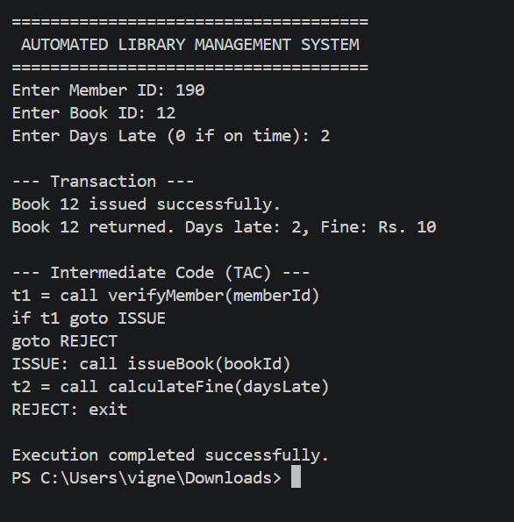

10. Intermediate Code / Three-Address Code (TAC)
Note: This is a simplified intermediate representation used to demonstrate compiler-design concepts.
t1 = call verifyMember(memberId)
if t1 goto ISSUE
goto REJECT
ISSUE: call issueBook(bookId)
t2 = call calculateFine(daysLate)
REJECT: exit

11. Answer to Task (ii)
Procedure (function) calls allow a library management system to be broken down into small, independent, and reusable units such as verifyMember(), issueBook(), returnBook(), and calculateFine(). Each function handles a single, well-defined responsibility, which makes the overall system easier to understand, test, and maintain. When a change is needed, such as updating the fine calculation formula, only the calculateFine() function needs to be modified, without affecting the rest of the program. This modular structure also allows multiple transactions (issue, return, verification) to reuse the same procedures consistently, improving reliability and reducing code duplication.
12. Answer to Task (iii)
Compiler optimization is highly significant in educational information systems such as library management platforms, especially during high-demand periods like semester examinations when many students issue and return books simultaneously. An optimized compiler generates efficient intermediate code for function calls, minimizing the overhead of parameter passing and return-value handling, which speeds up transaction processing. Efficient handling of procedure calls also reduces delays in fine calculation and record updates, ensuring that students receive immediate confirmation of their transactions. This results in a faster, more dependable library service that can handle peak academic-period loads smoothly.
13. Result
A simplified compiler-based library transaction model was successfully implemented in C, demonstrating modular procedure calls for member verification, book issuance, book return, and fine calculation, along with three-address code generation.
Viva Points
- Intermediate code is a machine-independent representation generated by a compiler between the source program and the target code, making optimization and portability easier.
- Three-Address Code (TAC) is a form of intermediate code in which each instruction has at most three operands, typically one operator and up to two operands, e.g., t1 = a + b.
- Boolean expressions let a program evaluate conditions (true/false) so it can make automatic decisions, essential for real-time and rule-based systems.
- Procedure/function calls break a program into modular, reusable units, improving readability, maintainability, and testability.
- Compiler optimization improves the generated code's speed and resource usage without changing its output, e.g., through dead-code elimination or constant folding.

SET 5 - QUESTION 1

Smart Parking Management System
1. Question
A smart city development company is designing an automated parking management system to monitor vehicle entry, slot allocation, and parking fee calculation. The compiler embedded in the control software processes declarations, assignment statements, Boolean expressions, and case statements to manage parking availability and security verification. During peak hours, inefficient intermediate code generation caused delays in slot assignment and payment confirmation. The company plans to redesign the compiler to improve real-time response and system efficiency.
Tasks: (i) Design intermediate code for parking slot allocation and fee calculation logic. (K3) (ii) Explain how Boolean expressions and case statements help manage parking operations efficiently. (K4) (iii) Analyze the role of compiler optimization in improving smart parking management systems. (K5)
2. Aim
To design and demonstrate a simplified compiler-based parking management model that uses Boolean expressions and case statements to allocate parking slots and compute fees, along with the corresponding three-address code (TAC).
3. Objectives
- To read vehicle type and slot availability from the user.
- To evaluate slot allocation conditions using Boolean expressions.
- To classify vehicles and compute fees using a switch/case construct.
- To generate a simplified three-address code for the slot-allocation logic.
4. Concepts Used
- Intermediate Code Generation
- Three-Address Code (TAC)
- Boolean Expressions
- Case Statements
- Compiler Optimization
5. Algorithm / Procedure
- Start the program and declare variables for vehicle type and slot availability.
- Read the vehicle type and slot availability status from the user.
- Evaluate Boolean expressions t1 (available == 1) and t2 (vehicle == CAR).
- If t1 is true, use a switch statement to allocate a slot and compute the fee based on vehicle type.
- If t1 is false, display a message indicating no slots are available.
- Display the allocation result and the generated three-address code.
- Stop.
6. C Program
File name: smart_parking.c
/* SET 5 - QUESTION 1
Smart Parking Management System
Demonstrates: declarations, assignment, Boolean expressions,
switch/case, simple Three-Address Code (TAC) representation
*/

#include <stdio.h>

int main()
{
int vehicle; /* 1=Bike, 2=Car, 3=SUV */
int available; /* 1 = slot available, 0 = not available */
int fee = 0;
int t1, t2, t3; /* intermediate (TAC) result holders */

printf("=====================================\n");
printf(" SMART PARKING MANAGEMENT SYSTEM\n");
printf("=====================================\n");

printf("Enter vehicle type (1-Bike 2-Car 3-SUV): ");
scanf("%d", &vehicle);
printf("Slot available? (1-Yes 0-No): ");
scanf("%d", &available);

t1 = (available == 1);
t2 = (vehicle == 2);
t3 = (t1 && t2);

printf("\n--- Slot Allocation ---\n");
if (t1)
{
switch (vehicle)
{
case 1:
fee = 20;
printf("Vehicle Type: Bike\n");
printf("Slot: A1\n");
break;
case 2:
fee = 50;
printf("Vehicle Type: Car\n");
printf("Slot: A12\n");
break;
case 3:
fee = 80;
printf("Vehicle Type: SUV\n");
printf("Slot: A20\n");
break;
default:
printf("Invalid vehicle type.\n");
}
printf("Parking Fee: Rs. %d\n", fee);
}
else
{
printf("No slots available.\n");
}

printf("\n--- Intermediate Code (TAC) ---\n");
printf("t1 = available == 1 -> %d\n", t1);
printf("t2 = vehicle == CAR -> %d\n", t2);
printf("t3 = t1 AND t2 -> %d\n", t3);
printf("if t1 goto ALLOCATE\n");
printf("goto REJECT\n");
printf("ALLOCATE: fee = compute(vehicle)\n");
printf("REJECT: exit\n");

printf("\nExecution completed successfully.\n");
return 0;
}

7. Sample Input
Vehicle Type: 2 (Car)
Slot Available: 1 (Yes)
8. Output
The program prints the vehicle type, allocated slot number, parking fee, the generated three-address code, and a completion message.
9. Output Screenshot
OUTPUT:
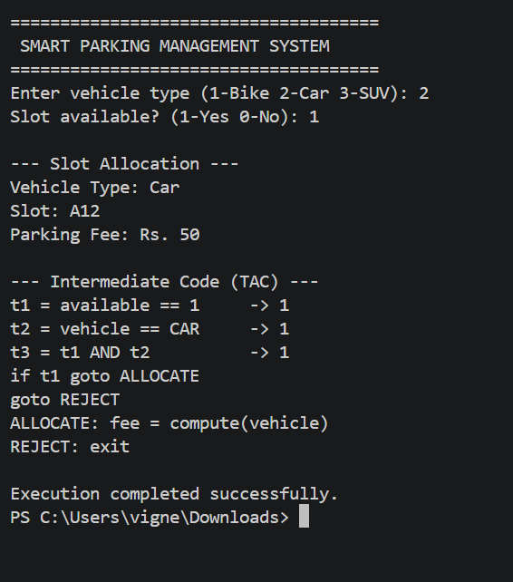

10. Intermediate Code / Three-Address Code (TAC)
Note: This is a simplified intermediate representation used to demonstrate compiler-design concepts.
t1 = available == 1
t2 = vehicle == CAR
t3 = t1 AND t2
if t1 goto ALLOCATE
goto REJECT
ALLOCATE: fee = compute(vehicle)
REJECT: exit

11. Answer to Task (ii)
Boolean expressions and case statements work together to make parking management efficient and responsive. Boolean expressions, such as checking whether a slot is available, allow the system to quickly decide whether allocation should proceed at all before performing any further processing. Once availability is confirmed, a case statement based on the vehicle type (Bike, Car, SUV) efficiently branches to the correct slot-allocation and fee-calculation logic, avoiding lengthy chains of comparisons. Together, these constructs let the embedded controller make rapid, accurate decisions even when many vehicles are entering the facility simultaneously during peak hours.
12. Answer to Task (iii)
Compiler optimization plays a key role in improving the real-time performance of smart parking management systems, where slow decision-making directly leads to vehicle queues and driver dissatisfaction. Optimized intermediate code reduces the number of operations required to evaluate availability conditions and select the correct fee-calculation branch, resulting in faster slot assignment and payment confirmation. Techniques such as efficient jump-table generation for case statements and minimization of redundant Boolean checks are particularly valuable during peak hours, ensuring that the embedded control software can keep up with high vehicle throughput without introducing delays.
13. Result
A simplified compiler-based parking management model was successfully implemented in C, demonstrating Boolean-expression based availability checking, case-statement based vehicle classification, and three-address code generation.
Viva Points
- Intermediate code is a machine-independent representation generated by a compiler between the source program and the target code, making optimization and portability easier.
- Three-Address Code (TAC) is a form of intermediate code in which each instruction has at most three operands, typically one operator and up to two operands, e.g., t1 = a + b.
- Boolean expressions let a program evaluate conditions (true/false) so it can make automatic decisions, essential for real-time and rule-based systems.
- Switch/case statements provide efficient multi-way branching, often implemented as jump tables, which is faster than long chains of if-else statements.
- Compiler optimization improves the generated code's speed and resource usage without changing its output, e.g., through dead-code elimination or constant folding.

