

SIMATS ENGINEERING

Saveetha Institute of Medical and Technical Sciences
Chennai- 602105

Name: Vigneshvar S
Reg no: 192424187
Subject and Course Code:
CSA1402 – COMPILER DESIGN

COMPILER DESIGN

CO3-AT1

Experiment 1: Syntax Directed Definition (SDD) Evaluation
Aim:
To evaluate arithmetic expressions using Syntax Directed Definitions (SDD) with synthesized attributes.
Theory:
Syntax Directed Definitions use attributes attached to grammar symbols to compute values during parsing. Synthesized attributes are computed from the attribute values of child nodes and passed upward to the parent node, allowing an expression to be evaluated as the parse tree is built bottom-up.
Grammar with Semantic Rules:
E -> E + T { E.val = E1.val + T.val }
E -> E - T { E.val = E1.val - T.val }
E -> T { E.val = T.val }
T -> T * F { T.val = T1.val * F.val }
T -> T / F { T.val = T1.val / F.val }
T -> F { T.val = F.val }
F -> ( E ) { F.val = E.val }
F -> digit { F.val = digit }

Algorithm:
1. Read the arithmetic expression as input.
2. Parse the expression according to the given grammar.
3. Apply the semantic rules associated with each production.
4. Evaluate the attribute values bottom-up (synthesized attributes).
5. Display the final evaluated result.
Program (C):
#include <stdio.h>
#include <ctype.h>
#include <string.h>

int pos = 0;
char expr[100];

int E();
int T();
int F();

int F() {
int val;
if (expr[pos] == '(') {
pos++;
val = E();
pos++; /* skip ')' */
} else {
val = expr[pos] - '0';
pos++;
}
return val;
}

int T() {
int val = F();
while (expr[pos] == '*' || expr[pos] == '/') {
char op = expr[pos];
pos++;
int f = F();
if (op == '*')
val = val * f;
else
val = val / f;
}
return val;
}

int E() {
int val = T();
while (expr[pos] == '+' || expr[pos] == '-') {
char op = expr[pos];
pos++;
int t = T();
if (op == '+')
val = val + t;
else
val = val - t;
}
return val;
}

int main() {
printf("Enter an arithmetic expression: ");
scanf("%s", expr);

pos = 0;
int result = E();

printf("Result = %d", result);
return 0;
}

Output:
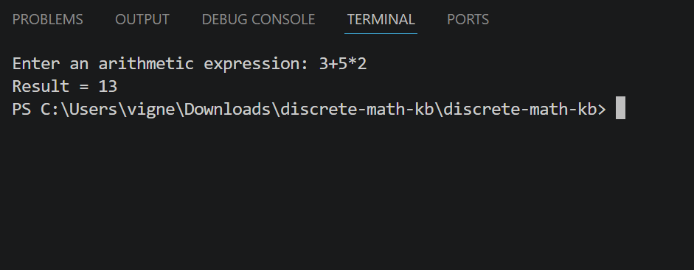

Result:
The arithmetic expression was successfully evaluated using Syntax Directed Definition with synthesized attributes.
Experiment 2: Postfix Expression Evaluation
Aim:
To evaluate postfix expressions using a stack-based method.
Theory:
A postfix expression has operators placed after their operands. It can be evaluated efficiently using a stack: operands are pushed onto the stack, and when an operator is encountered, the required number of operands are popped, the operation is performed, and the result is pushed back onto the stack.
Algorithm:
1. Initialize an empty stack.
2. Scan the postfix expression from left to right.
3. If the scanned character is an operand, push it onto the stack.
4. If the scanned character is an operator, pop the required number of operands from the stack.
5. Perform the operation on the popped operands.
6. Push the result back onto the stack.
7. Repeat until the expression is fully scanned; the final result is the value at the top of the stack.
Program (C):
#include <stdio.h>
#include <ctype.h>

int stack[100], top = -1;

void push(int x) {
stack[++top] = x;
}

int pop() {
return stack[top--];
}

int main() {
char exp[100];
int i, a, b;

printf("Enter postfix expression: ");
scanf("%s", exp);

for (i = 0; exp[i] != '\0'; i++) {
if (isdigit(exp[i])) {
push(exp[i] - '0');
} else {
b = pop();
a = pop();
switch (exp[i]) {
case '+': push(a + b); break;
case '-': push(a - b); break;
case '*': push(a * b); break;
case '/': push(a / b); break;
}
}
}

printf("Result = %d", pop());
return 0;
}

Output:
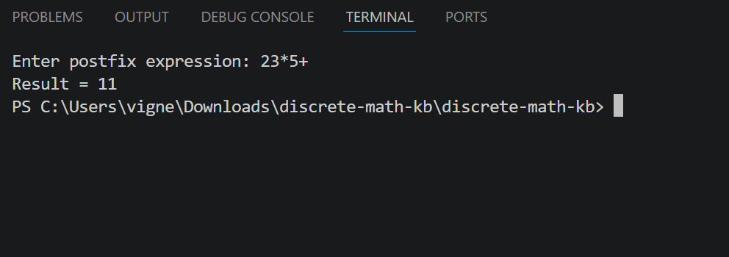

Result:
The postfix expression was successfully evaluated using the stack-based method.

Experiment 3: L-Attributed Definition
Aim:
To evaluate expressions using inherited attributes based on an L-attributed definition.
Theory:
An L-attributed definition allows inherited attributes to be passed from a parent node to its child nodes, and also from left siblings to right siblings, in a single left-to-right depth-first traversal of the parse tree. Inherited attributes are typically implemented using function parameters that carry context (such as running totals or precedence information) down the parse tree, enabling top-down evaluation of expressions.
Algorithm:
1. Read the input values required for the expression.
2. Pass inherited attribute values (such as intermediate results) down the parse tree using function parameters.
3. Evaluate sub-expressions according to operator precedence using top-down, function-based evaluation.
4. Combine the inherited and computed values to obtain the final result.
5. Display the final result.
Program (C):
#include <stdio.h>

/* T(a, inh) evaluates a term using the inherited value 'inh' */
int T(int b, int c, int inh) {
/* inherited attribute inh is combined with locally computed value */
int val = b * c;
return inh + val;
}

/* E(a, b, c) is the top level rule using inherited attributes */
int E(int a, int b, int c) {
int inh = a; /* inherited attribute passed down */
int result = T(b, c, inh);
return result;
}

int main() {
int a, b, c, result;

printf("Enter values of a, b, c: ");
scanf("%d %d %d", &a, &b, &c);

result = E(a, b, c);

printf("Result = %d", result);
return 0;
}

Output:
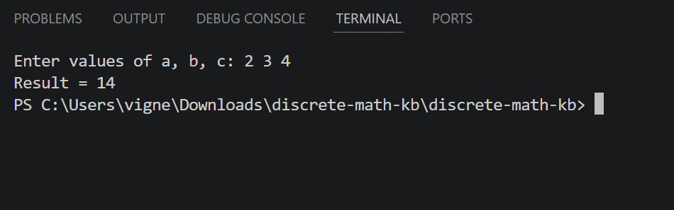

Result:
The expression was successfully evaluated using an L-attributed definition with inherited attributes.

Experiment 4: Type Equivalence Checking
Aim:
To check the equivalence of two given type expressions (e.g. int, float, int*, float*).
Theory:
Type equivalence checking determines whether two type expressions represent the same type. Two types are said to be structurally equivalent if they are built from the same basic types using the same constructors (such as pointer, array, or function) in the same way. In this experiment, type expressions are compared as strings to determine equivalence.
Algorithm:
1. Read the first type expression.
2. Read the second type expression.
3. Compare the two type expressions.
4. If they match exactly, report the types as equivalent.
5. Otherwise, report the types as not equivalent.
Program (C):
#include <stdio.h>
#include <string.h>

int main() {
char t1[20], t2[20];

printf("Enter type 1 (e.g. int, float, int*, float*): ");
scanf("%s", t1);

printf("Enter type 2 (e.g. int, float, int*, float*): ");
scanf("%s", t2);

if (strcmp(t1, t2) == 0)
printf("Equivalent Types");
else
printf("Not Equivalent Types");

return 0;
}

Output:
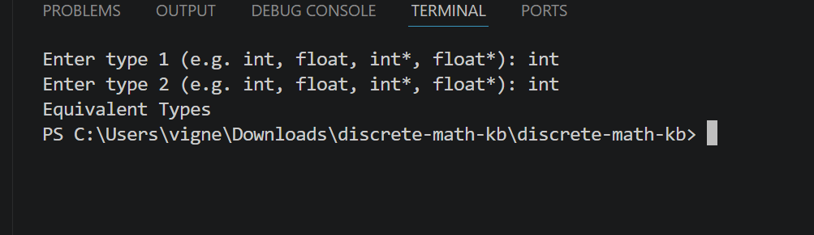

Result:
The equivalence of the two given type expressions was checked and reported successfully.

Experiment 5: Type Checking in Expressions
Aim:
To detect semantic type errors in expressions, such as invalid combinations of operand types.
Theory:
Type checking verifies that the operands used with an operator are of compatible types, according to the type rules of the language. If an operator is applied to operands of incompatible types (for example, int + char*), a semantic type error is reported. This experiment checks whether two operand types are compatible for a given operator.
Algorithm:
1. Read the type of the first operand.
2. Read the operator to be applied.
3. Read the type of the second operand.
4. Check whether the two operand types are compatible according to the type rules.
5. If compatible, print that the expression is valid.
6. If not compatible, print that a type error has occurred.
Program (C):
#include <stdio.h>
#include <string.h>

int main() {
char type1[10], type2[10], op;

printf("Enter type of operand1 (int/float/char*): ");
scanf("%s", type1);

printf("Enter operator: ");
scanf(" %c", &op);

printf("Enter type of operand2 (int/float/char*): ");
scanf("%s", type2);

if ((strcmp(type1, "int") == 0 && strcmp(type2, "int") == 0) ||
(strcmp(type1, "float") == 0 && strcmp(type2, "float") == 0)) {
printf("Valid Expression");
} else {
printf("Type Error: Incompatible operand types (%s %c %s)", type1, op, type2);
}

return 0;
}

Output:
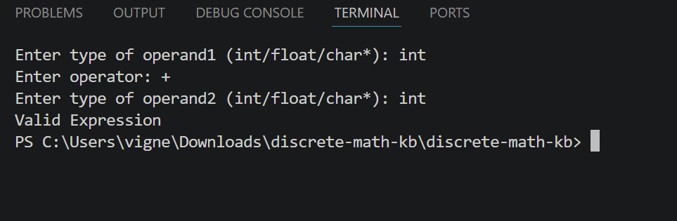

Result:
Semantic type checking was performed successfully, and type errors in expressions were correctly detected.

FINAL RESULT
All the above experiments were implemented and executed successfully, and the outputs were verified.

