Vigneshvar . S (192424187)
DSA0502 QUERY PROCESSING FOR DATA SCIENCE
PRACTICE – 1

Write a Python program to demonstrate the benefits of data wrangling by removing missing and invalid values from a dataset.
Code:
# Benefits of Data Wrangling

data = {"raw_data": [None, 23, 45, None, 67, "NA", 89]}

cleaned_data = [x for x in data["raw_data"] if x not in [None, "NA"]]

print("Raw Data:", data["raw_data"])
print("Cleaned Data:", cleaned_data)
Output:
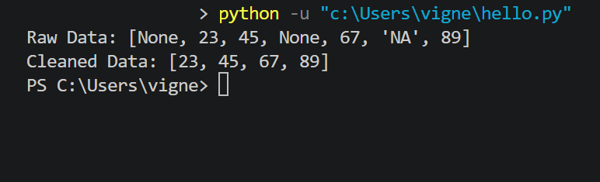
Question:
Write a Python program to clean a dataset by handling missing values using the Pandas library.
Code:
import pandas as pd

data = {
'Name': ['Alice', 'Bob', None, 'David'],
'Age': [25, None, 30, 'NA']
}

df = pd.DataFrame(data)

df['Age'] = pd.to_numeric(df['Age'], errors='coerce')
df_cleaned = df.dropna()

print("Original Data:")
print(df)

print("\nCleaned Data:")
print(df_cleaned)

Output:
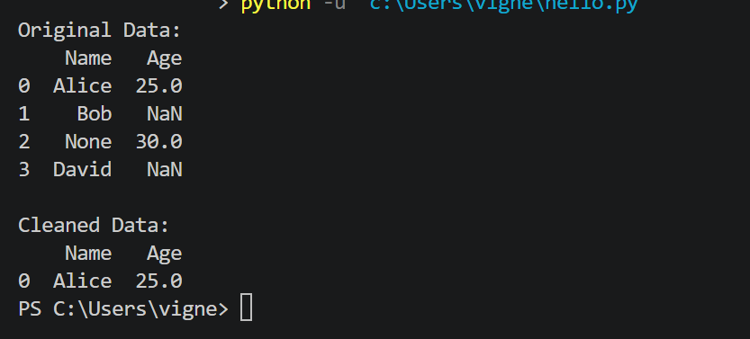
Question:
Write a Python program to normalize numerical data using the Min-Max normalization technique.
Code:
import numpy as np

data = np.array([10, 20, 30, 40, 50])

normalized_data = (data - np.min(data)) / (np.max(data) - np.min(data))

print("Original Data:", data)
print("Normalized Data:", normalized_data)
Output:
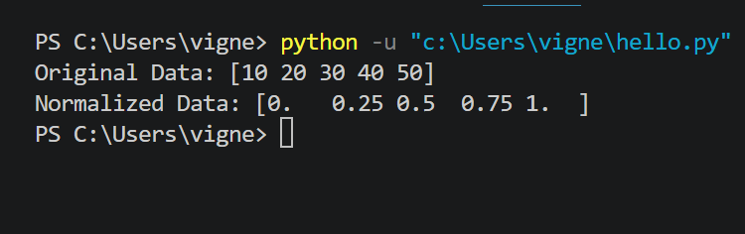
Question:
Write a Python program to demonstrate basic Python syntax by printing a message and performing addition.
Code:
print("Hello, World!")

x = 10
y = 20

print("Sum:", x + y)

Output:
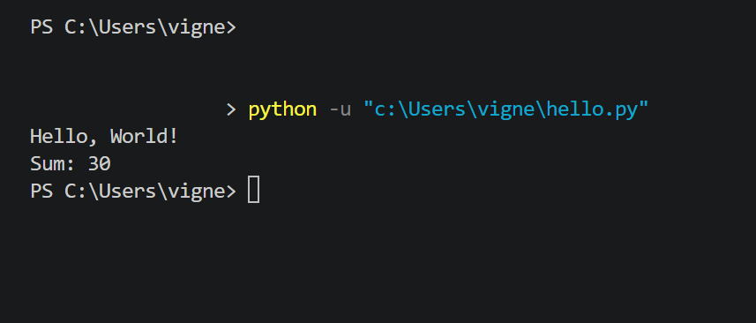

Question:
Write a Python program to create, write, and read a CSV file using the Pandas library.
Code:
import pandas as pd

data = {
'Name': ['Alice', 'Bob'],
'Age': [25, 30]
}

df = pd.DataFrame(data)

df.to_csv("example.csv", index=False)

df_read = pd.read_csv("example.csv")

print("CSV File Data:")
print(df_read)

Output:
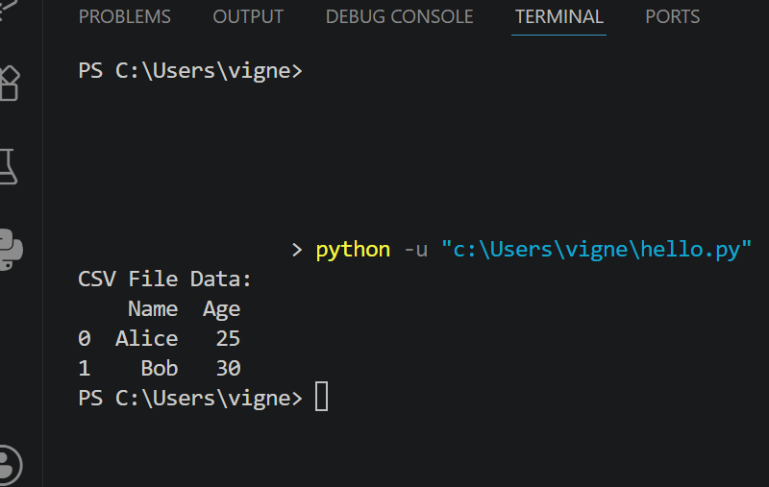
Question:
Write a Python program to read and parse JSON data.
Code:
import json

data = '{"Name": "Alice", "Age": 25}'

parsed_data = json.loads(data)

print("JSON Data:")
print(parsed_data)

Output:
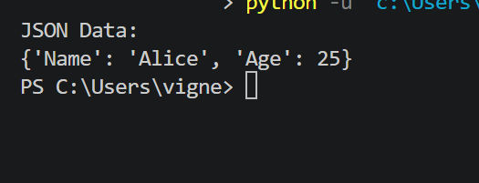

Question:
Write a Python program to parse XML data and display the values.
Code:
import xml.etree.ElementTree as ET

xml_data = """
<person>
<name>Alice</name>
<age>25</age>
</person>
"""

root = ET.fromstring(xml_data)

print("Name:", root.find("name").text)
print("Age:", root.find("age").text)
Output:
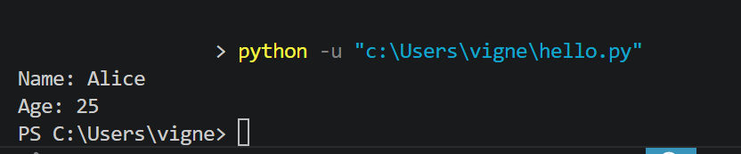

Question:
Write a Python program to create a table in SQLite and retrieve its database schema.
Code:
import sqlite3

conn = sqlite3.connect(":memory:")
cursor = conn.cursor()

cursor.execute("""
CREATE TABLE users (
id INTEGER,
name TEXT,
age INTEGER
)
""")

cursor.execute('INSERT INTO users VALUES (1, "Alice", 25)')
conn.commit()

cursor.execute("PRAGMA table_info(users)")
schema = cursor.fetchall()

print("Database Schema:")

for column in schema:
print(column)

conn.close()

Output:
