

SIMATS ENGINEERING

Saveetha Institute of Medical and Technical Sciences
Chennai- 602105

Name: Vigneshvar S
Reg no: 192424187
Subject and Course Code:
DSA0502 QUERY PROCESSING FOR DATA SCIENCE
5.Write a Pandas program to create a bar plot of the trading volume of Alphabet Inc. stock between two specific dates.
Code:
import pandas as pd
import matplotlib.pyplot as plt

data = {
"Date": ["2024-01-01", "2024-01-02", "2024-01-03", "2024-01-04", "2024-01-05"],
"Volume": [1200000, 1500000, 1300000, 1700000, 1600000]
}

df = pd.DataFrame(data)

plt.bar(df["Date"], df["Volume"])

plt.title("Alphabet Inc. Trading Volume")
plt.xlabel("Date")
plt.ylabel("Trading Volume")
plt.xticks(rotation=45)

plt.show()
Output:
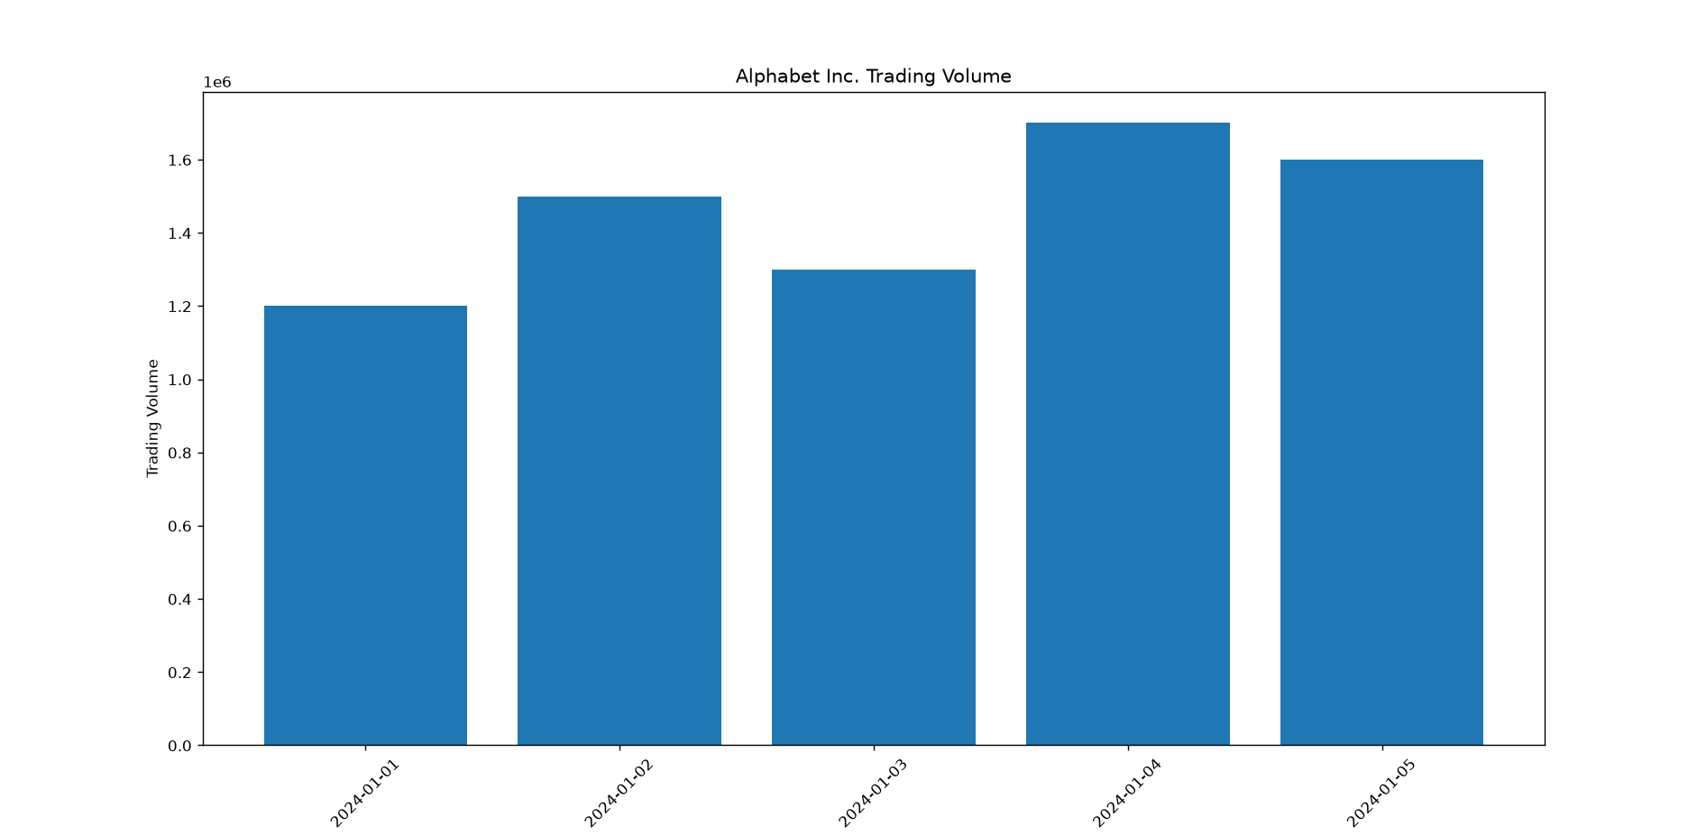

6.Write a Pandas program to create a scatter plot of the trading volume/stock prices of Alphabet Inc. stock between two specific dates.
Code:
import pandas as pd
import matplotlib.pyplot as plt

data = {
"Volume": [1200000, 1500000, 1300000, 1700000, 1600000],
"Close": [140, 142, 141, 145, 147]
}

df = pd.DataFrame(data)

plt.scatter(df["Volume"], df["Close"])

plt.title("Trading Volume vs Stock Price")
plt.xlabel("Trading Volume")
plt.ylabel("Stock Price")

plt.show()
Output:
