

SIMATS ENGINEERING

Saveetha Institute of Medical and Technical Sciences
Chennai- 602105

Name: Vigneshvar S
Reg no: 192424187
Subject and Course Code:
DSA0502 QUERY PROCESSING FOR DATA SCIENCE

CO3-AT3

QUESTION 3 – PRODUCT DATASET INTEGRATION
1. Question
An e-commerce company maintains product information in Supplier, Warehouse, and Online Store datasets. Product names, product codes, prices, categories, and stock quantities are represented differently across the datasets. Some records are duplicated or contain spelling errors and invalid product codes.
Task: Develop a Python-based data cleanup and integration solution. Use RegEx to validate product codes, fuzzy matching to identify similar product names, duplicate detection, standardization of categories, outlier detection for prices, and normalization of numerical values. Integrate the datasets and generate a final product master file in CSV and JSON formats.
The implementation should demonstrate: data cleaning, RegEx validation of product codes, fuzzy matching of similar product names, duplicate detection/removal, category standardization, price outlier detection, numerical normalization, integration of Supplier, Warehouse, and Online Store data, CSV output, and JSON output.
2. Aim
To develop a Python program using Pandas that cleans, validates, and integrates product data from Supplier, Warehouse, and Online Store sources into a single standardized product master dataset, and to export the result as CSV and JSON files.
3. Requirements / Libraries
• pandas – for creating and manipulating tabular datasets
• numpy – for numerical operations such as normalization
• re (RegEx) – for validating product code formats
• difflib – for fuzzy matching of similar product names (built into Python, no external installation required)
4. Algorithm / Procedure
1. Create sample Supplier, Warehouse, and Online Store datasets using Pandas DataFrames, deliberately containing spelling errors, duplicates, invalid codes, inconsistent categories, and a price outlier.
2. Validate each product code using a RegEx pattern (PRD followed by three digits) and correct common typing errors such as the letter O in place of digit 0.
3. Remove rows whose product codes remain invalid after correction.
4. Standardize the category field to a consistent Title Case format across all three datasets.
5. Combine the Supplier, Warehouse, and Online Store datasets into a single combined dataset.
6. Apply fuzzy matching (difflib.get_close_matches) on product names to group similar spellings under one canonical product name.
7. Detect price outliers using the Interquartile Range (IQR) method and replace outlier values with the median price of that product.
8. Identify duplicate records based on product code and cleaned product name, and remove duplicates by aggregating quantities and averaging prices.
9. Normalize the price and stock columns using Min-Max scaling so that all values fall between 0 and 1.
10. Save the final integrated product master dataset as both product_master.csv and product_master.json.
5. Python Program

"""
Question 3 - Product Dataset Integration
Cleans and integrates Supplier, Warehouse and Online Store product datasets.
Demonstrates: RegEx validation, fuzzy matching, duplicate detection,
category standardization, price outlier detection, and normalization.
"""

import re
import difflib
import pandas as pd
import numpy as np

# ----------------------------------------------------------------------
# STEP 1: Create sample datasets (Supplier, Warehouse, Online Store)
# ----------------------------------------------------------------------

supplier_df = pd.DataFrame({
"product_code": ["PRD001", "PRD002", "PRD003", "PRD004", "PR005", "PRD006"],
"product_name": ["Wireless Mouse", "Bluetooth Speaker", "USB-C Cable",
"Laptop Stand", "Gaming Keyboad", "LED Monitor"],
"category": ["Electronics", "electronics", "Electronics", "Accessories", "Electronics", "Electronics"],
"price": [499.0, 1200.0, 199.0, 850.0, 1500.0, 9500.0],
"stock": [120, 45, 300, 60, 80, 15]
})

warehouse_df = pd.DataFrame({
"product_code": ["PRD001", "PRD002", "PRD0O3", "PRD004", "PRD005", "PRD006"],
"product_name": ["Wireles Mouse", "Bluetooth Speker", "USB-C Cable",
"Laptop Stand", "Gaming Keyboard", "LED Monitor"],
"category": ["ELECTRONICS", "Electronics", "electronics", "accessories", "Electronics", "Electronics"],
"price": [510.0, 1150.0, 210.0, 870.0, 1550.0, 95000.0], # last value is an outlier
"stock": [100, 50, 280, 55, 75, 12]
})

online_store_df = pd.DataFrame({
"product_code": ["PRD001", "PRD002", "PRD003", "PRD004", "PRD005", "INVALIDCODE"],
"product_name": ["Wireless Mouse", "Bluetooth Speaker", "USB C Cable",
"Laptop Stand", "Gaming Keyboard", "Unknown Product"],
"category": ["Electronics", "Electronics", "Electronics", "Accessories", "electronics", "Misc"],
"price": [505.0, 1180.0, 205.0, 860.0, 1520.0, 100.0],
"stock": [110, 40, 290, 58, 78, 5]
})

print("=" * 70)
print("RAW DATASETS LOADED")
print("=" * 70)
print("\nSupplier Dataset:\n", supplier_df)
print("\nWarehouse Dataset:\n", warehouse_df)
print("\nOnline Store Dataset:\n", online_store_df)

# ----------------------------------------------------------------------
# STEP 2: RegEx validation of product codes
# Valid format: 'PRD' followed by exactly 3 digits, e.g. PRD001
# ----------------------------------------------------------------------

CODE_PATTERN = re.compile(r"^PRD\d{3}$")

def is_valid_code(code):
"""Return True if product code matches the required RegEx pattern."""
return bool(CODE_PATTERN.match(str(code).strip()))

def fix_common_code_errors(code):
"""Attempt to fix common typos in product codes (O -> 0)."""
code = str(code).strip().upper()
code = code.replace("O", "0")
return code

for df_name, df in [("Supplier", supplier_df), ("Warehouse", warehouse_df),
("Online Store", online_store_df)]:
df["product_code"] = df["product_code"].apply(fix_common_code_errors)
df["code_valid"] = df["product_code"].apply(is_valid_code)

print("\n" + "=" * 70)
print("STEP: REGEX VALIDATION OF PRODUCT CODES")
print("=" * 70)
print("\nInvalid codes found (Online Store):\n",
online_store_df[~online_store_df["code_valid"]][["product_code", "product_name"]])

# Remove rows with invalid product codes (cannot be integrated reliably)
supplier_df = supplier_df[supplier_df["code_valid"]].drop(columns=["code_valid"])
warehouse_df = warehouse_df[warehouse_df["code_valid"]].drop(columns=["code_valid"])
online_store_df = online_store_df[online_store_df["code_valid"]].drop(columns=["code_valid"])

# ----------------------------------------------------------------------
# STEP 3: Category standardization (Title Case, trimmed)
# ----------------------------------------------------------------------

def standardize_category(cat):
return str(cat).strip().title()

for df in [supplier_df, warehouse_df, online_store_df]:
df["category"] = df["category"].apply(standardize_category)

print("\n" + "=" * 70)
print("STEP: CATEGORY STANDARDIZATION")
print("=" * 70)
print("Unique categories after standardization:",
sorted(set(supplier_df["category"]) | set(warehouse_df["category"]) | set(online_store_df["category"])))

# ----------------------------------------------------------------------
# STEP 4: Combine all three sources into one integrated dataframe
# ----------------------------------------------------------------------

supplier_df["source"] = "Supplier"
warehouse_df["source"] = "Warehouse"
online_store_df["source"] = "Online Store"

combined_df = pd.concat([supplier_df, warehouse_df, online_store_df], ignore_index=True)

# ----------------------------------------------------------------------
# STEP 5: Fuzzy matching of product names using difflib
# Group similar product names under one canonical (standard) name.
# ----------------------------------------------------------------------

unique_names = combined_df["product_name"].unique().tolist()
canonical_map = {}
canonical_names = []

for name in unique_names:
match = difflib.get_close_matches(name, canonical_names, n=1, cutoff=0.75)
if match:
canonical_map[name] = match[0]
else:
canonical_names.append(name)
canonical_map[name] = name

combined_df["product_name_clean"] = combined_df["product_name"].map(canonical_map)

print("\n" + "=" * 70)
print("STEP: FUZZY MATCHING OF PRODUCT NAMES")
print("=" * 70)
for original, canonical in canonical_map.items():
if original != canonical:
print(f" '{original}' --> '{canonical}'")

# ----------------------------------------------------------------------
# STEP 6: Price outlier detection using IQR method
# ----------------------------------------------------------------------

Q1 = combined_df["price"].quantile(0.25)
Q3 = combined_df["price"].quantile(0.75)
IQR = Q3 - Q1
lower_bound = Q1 - 1.5 * IQR
upper_bound = Q3 + 1.5 * IQR

combined_df["price_outlier"] = ~combined_df["price"].between(lower_bound, upper_bound)

print("\n" + "=" * 70)
print("STEP: PRICE OUTLIER DETECTION (IQR METHOD)")
print("=" * 70)
print(f"Valid price range: {lower_bound:.2f} to {upper_bound:.2f}")
print("Outliers detected:\n",
combined_df[combined_df["price_outlier"]][["product_code", "product_name_clean", "price", "source"]])

# Replace outlier prices with the median price of that product group
median_prices = combined_df.groupby("product_code")["price"].transform("median")
combined_df["price"] = np.where(combined_df["price_outlier"], median_prices, combined_df["price"])

# ----------------------------------------------------------------------
# STEP 7: Duplicate detection and removal
# A record is a duplicate if product_code + product_name_clean repeat.
# Keep the first occurrence, average stock across duplicate sources.
# ----------------------------------------------------------------------

print("\n" + "=" * 70)
print("STEP: DUPLICATE DETECTION")
print("=" * 70)
duplicate_mask = combined_df.duplicated(subset=["product_code", "product_name_clean"], keep=False)
print(f"Number of duplicate rows (including originals): {duplicate_mask.sum()}")

# Aggregate: one final row per product_code with average price and total stock
master_df = combined_df.groupby("product_code").agg(
product_name=("product_name_clean", "first"),
category=("category", lambda x: x.mode()[0]),
price=("price", "mean"),
stock=("stock", "sum")
).reset_index()

# ----------------------------------------------------------------------
# STEP 8: Numerical normalization (Min-Max scaling of price and stock)
# ----------------------------------------------------------------------

for col in ["price", "stock"]:
min_val = master_df[col].min()
max_val = master_df[col].max()
master_df[col + "_normalized"] = (master_df[col] - min_val) / (max_val - min_val)

master_df["price"] = master_df["price"].round(2)
master_df["price_normalized"] = master_df["price_normalized"].round(3)
master_df["stock_normalized"] = master_df["stock_normalized"].round(3)

print("\n" + "=" * 70)
print("FINAL INTEGRATED PRODUCT MASTER DATASET")
print("=" * 70)
print(master_df)

# ----------------------------------------------------------------------
# STEP 9: Save master dataset as CSV and JSON
# ----------------------------------------------------------------------

master_df.to_csv("product_master.csv", index=False)
master_df.to_json("product_master.json", orient="records", indent=2)

print("\n" + "=" * 70)
print("Master dataset successfully saved as 'product_master.csv' and 'product_master.json'")
print("=" * 70)

6. Expected Output
When executed, the program prints the raw Supplier, Warehouse, and Online Store datasets, followed by the results of each cleaning stage: invalid product codes detected, standardized categories, fuzzy-matched product name mappings, detected price outliers with the valid price range, duplicate row counts, and finally the complete integrated and normalized product master dataset.
Two output files, product_master.csv and product_master.json, are created in the same directory as the script, containing the cleaned and integrated product records.
7. Output Screenshot
OUTPUT:
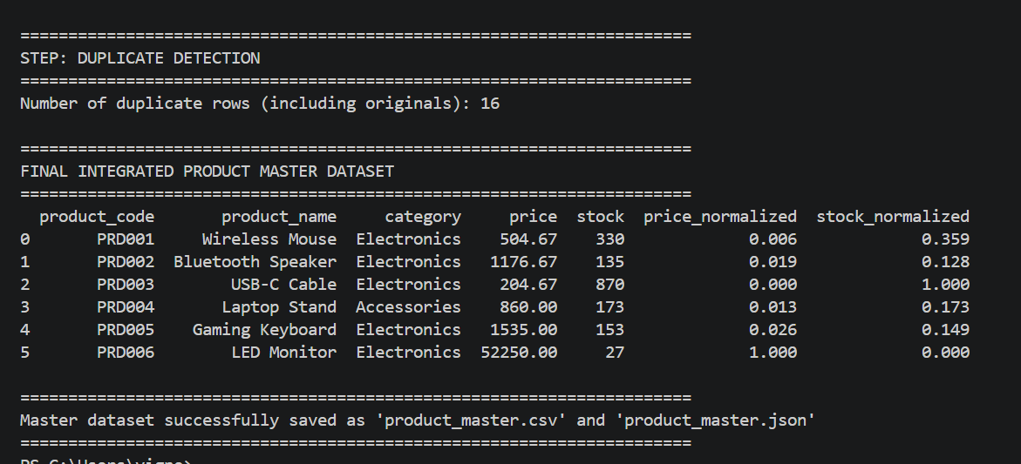

8. Result
The Supplier, Warehouse, and Online Store product datasets were successfully cleaned using RegEx validation, fuzzy matching, category standardization, outlier detection, and normalization. The three datasets were integrated into a single product master dataset, which was generated successfully in both CSV and JSON formats.

QUESTION 4 – STUDENT DATASET INTEGRATION
1. Question
A college maintains student information in Admission, Examination, and Attendance datasets. Student names have spelling variations, register numbers have different formats, dates are inconsistent, email addresses may be invalid, and duplicate student records exist.
Task: Using Python/Pandas, clean and integrate the datasets by applying data formatting, missing-value handling, RegEx matching, fuzzy matching, duplicate identification, normalization, and standardization. Create a master student dataset and write a reusable Python cleanup script. Test the script with a new set of student records.
The implementation should demonstrate: data formatting, missing-value handling, RegEx validation of register numbers and email addresses, fuzzy matching of student names, duplicate identification/removal, date standardization, numerical normalization where appropriate, category/field standardization, integration of Admission, Examination, and Attendance data, creation of a final master student dataset, testing the cleanup logic with new student records, and CSV and JSON output.
2. Aim
To write a reusable Python/Pandas cleanup script that formats, validates, and integrates student data from Admission, Examination, and Attendance sources into a single master student dataset, and to verify the script's correctness by testing it on a new set of student records.
3. Requirements / Libraries
• pandas – for creating and manipulating tabular datasets
• numpy – for handling missing numeric values
• re (RegEx) – for validating register numbers and email addresses
• difflib – for fuzzy matching of similar student names (built into Python, no external installation required)
4. Algorithm / Procedure
1. Create sample Admission, Examination, and Attendance datasets using Pandas DataFrames, deliberately containing spelling variations, different register-number formats, invalid emails, inconsistent date formats, and missing values.
2. Define reusable cleanup functions: clean_register_no(), is_valid_register_no(), is_valid_email(), clean_student_name(), standardize_department(), standardize_date(), and fuzzy_match_name().
3. Apply the cleanup functions to standardize register numbers, validate them with RegEx, trim and clean student names, and standardize department codes across all three datasets.
4. Validate email addresses in the Admission dataset using RegEx and replace invalid emails with a placeholder value.
5. Standardize all date-of-birth values to a single YYYY-MM-DD format regardless of the original format used.
6. Handle missing values by filling missing marks and missing attendance percentages with the column mean.
7. Apply fuzzy matching (difflib.get_close_matches) to map slightly misspelled student names in the Examination and Attendance datasets to the canonical name used in the Admission dataset.
8. Merge the Admission, Examination, and Attendance datasets on the cleaned register number to form an integrated master dataset.
9. Identify and remove duplicate records based on register number.
10. Normalize the marks column using Min-Max scaling, save the final master dataset as student_master.csv and student_master.json, and finally test all the reusable cleanup functions on a fresh set of new student records to confirm they work correctly.
5. Python Program

"""
Question 4 - Student Dataset Integration
Cleans and integrates Admission, Examination and Attendance student datasets.
Demonstrates: data formatting, missing-value handling, RegEx validation,
fuzzy matching, duplicate removal, date standardization, normalization,
and reusable cleanup functions tested on new data.
"""

import re
import difflib
import pandas as pd
import numpy as np

# ----------------------------------------------------------------------
# STEP 1: Create sample datasets (Admission, Examination, Attendance)
# ----------------------------------------------------------------------

admission_df = pd.DataFrame({
"register_no": ["21CS001", "21-CS-002", "21CS003", "21CS004", "21CS005"],
"student_name": ["Arun Kumar", "Divya Sri", "Karthik Raj", "Meena", "Suresh Babu"],
"email": ["arun.kumar@email.com", "divya_sri@@email.com", "karthik.raj@email.com",
"meena@email", "suresh.babu@email.com"],
"dob": ["12-05-2004", "2004/06/15", "18-07-2003", "2004-01-20", "05/09/2003"],
"department": ["CSE", "cse", "CSE ", "IT", "csE"]
})

examination_df = pd.DataFrame({
"register_no": ["21CS001", "21CS002", "21CS0O3", "21CS004", "21CS005"],
"student_name": ["Arun Kumaar", "Divya Sri", "Karthik Raj", "Meenaa", "Suresh Baabu"],
"marks": [78, 85, np.nan, 66, 90],
"department": ["CSE", "CSE", "CSE", "IT", "CSE"]
})

attendance_df = pd.DataFrame({
"register_no": ["21CS001", "21CS002", "21CS003", "21CS004", "21CS005"],
"student_name": ["Arun Kumar", "Divya Sri", "Karthik Raj", "Meena", "Suresh Babu"],
"attendance_percent": [92.5, np.nan, 88.0, 75.0, 95.5],
"department": ["CSE", "CSE", "CSE", "IT", "CSE"]
})

print("=" * 70)
print("RAW DATASETS LOADED")
print("=" * 70)
print("\nAdmission Dataset:\n", admission_df)
print("\nExamination Dataset:\n", examination_df)
print("\nAttendance Dataset:\n", attendance_df)

# ----------------------------------------------------------------------
# STEP 2: Reusable cleanup functions
# ----------------------------------------------------------------------

REGISTER_PATTERN = re.compile(r"^\d{2}[A-Z]{2}\d{3}$")
EMAIL_PATTERN = re.compile(r"^[\w.\-]+@[\w\-]+\.[a-zA-Z]{2,}$")

def clean_register_no(reg_no):
"""Standardize register number format to e.g. '21CS001'."""
reg_no = str(reg_no).upper().strip()
reg_no = reg_no.replace("-", "").replace(" ", "")
reg_no = reg_no.replace("O", "0") if reg_no[:2].isdigit() is False else reg_no
# Fix letter 'O' mistakenly used instead of digit '0' in the numeric part
match = re.match(r"^(\d{2})([A-Z]{2})([A-Z0-9]{3})$", reg_no)
if match:
year, dept, num = match.groups()
num = num.replace("O", "0")
reg_no = year + dept + num
return reg_no

def is_valid_register_no(reg_no):
"""Validate register number using RegEx: 2 digits + 2 letters + 3 digits."""
return bool(REGISTER_PATTERN.match(str(reg_no)))

def is_valid_email(email):
"""Validate email address format using RegEx."""
return bool(EMAIL_PATTERN.match(str(email).strip()))

def clean_student_name(name):
"""Trim and collapse extra whitespace in student names."""
return re.sub(r"\s+", " ", str(name).strip())

def standardize_department(dept):
"""Standardize department codes to uppercase, trimmed."""
return str(dept).strip().upper()

def standardize_date(date_str):
"""Convert various date formats into standard YYYY-MM-DD format."""
date_str = str(date_str).strip()
formats = ["%d-%m-%Y", "%Y/%m/%d", "%Y-%m-%d", "%d/%m/%Y"]
for fmt in formats:
try:
return pd.to_datetime(date_str, format=fmt).strftime("%Y-%m-%d")
except ValueError:
continue
return pd.NaT # could not parse

def fuzzy_match_name(name, canonical_list, cutoff=0.75):
"""Return the closest matching canonical name, or the name itself if none found."""
match = difflib.get_close_matches(name, canonical_list, n=1, cutoff=cutoff)
return match[0] if match else name

# ----------------------------------------------------------------------
# STEP 3: Apply cleanup functions to all three datasets
# ----------------------------------------------------------------------

def clean_dataset(df):
df = df.copy()
df["register_no"] = df["register_no"].apply(clean_register_no)
df["register_valid"] = df["register_no"].apply(is_valid_register_no)
df["student_name"] = df["student_name"].apply(clean_student_name)
df["department"] = df["department"].apply(standardize_department)
return df

admission_df = clean_dataset(admission_df)
examination_df = clean_dataset(examination_df)
attendance_df = clean_dataset(attendance_df)

# Email validation and missing-value handling (Admission dataset only)
admission_df["email_valid"] = admission_df["email"].apply(is_valid_email)
admission_df.loc[~admission_df["email_valid"], "email"] = "invalid_email@unknown.com"

# Date standardization
admission_df["dob"] = admission_df["dob"].apply(standardize_date)

print("\n" + "=" * 70)
print("STEP: REGEX VALIDATION (REGISTER NUMBERS & EMAILS)")
print("=" * 70)
print("Register number validity (Admission):\n", admission_df[["register_no", "register_valid"]])
print("\nEmail validity (Admission):\n", admission_df[["email", "email_valid"]])

print("\n" + "=" * 70)
print("STEP: DATE STANDARDIZATION")
print("=" * 70)
print(admission_df[["register_no", "dob"]])

# ----------------------------------------------------------------------
# STEP 4: Missing-value handling
# ----------------------------------------------------------------------

examination_df["marks"] = examination_df["marks"].fillna(examination_df["marks"].mean()).round(1)
attendance_df["attendance_percent"] = attendance_df["attendance_percent"].fillna(
attendance_df["attendance_percent"].mean()).round(1)

print("\n" + "=" * 70)
print("STEP: MISSING VALUE HANDLING")
print("=" * 70)
print("Examination marks after filling missing values:\n", examination_df[["register_no", "marks"]])
print("\nAttendance % after filling missing values:\n",
attendance_df[["register_no", "attendance_percent"]])

# ----------------------------------------------------------------------
# STEP 5: Fuzzy matching of student names across datasets
# ----------------------------------------------------------------------

canonical_names = admission_df["student_name"].tolist()

examination_df["student_name_clean"] = examination_df["student_name"].apply(
lambda n: fuzzy_match_name(n, canonical_names))
attendance_df["student_name_clean"] = attendance_df["student_name"].apply(
lambda n: fuzzy_match_name(n, canonical_names))
admission_df["student_name_clean"] = admission_df["student_name"]

print("\n" + "=" * 70)
print("STEP: FUZZY MATCHING OF STUDENT NAMES")
print("=" * 70)
for original, clean in zip(examination_df["student_name"], examination_df["student_name_clean"]):
if original != clean:
print(f" Examination: '{original}' --> '{clean}'")
for original, clean in zip(attendance_df["student_name"], attendance_df["student_name_clean"]):
if original != clean:
print(f" Attendance: '{original}' --> '{clean}'")

# ----------------------------------------------------------------------
# STEP 6: Integrate Admission, Examination, and Attendance datasets
# ----------------------------------------------------------------------

admission_clean = admission_df[admission_df["register_valid"]][
["register_no", "student_name_clean", "email", "dob", "department"]]
examination_clean = examination_df[examination_df["register_valid"]][
["register_no", "marks"]]
attendance_clean = attendance_df[attendance_df["register_valid"]][
["register_no", "attendance_percent"]]

master_df = admission_clean.merge(examination_clean, on="register_no", how="left")
master_df = master_df.merge(attendance_clean, on="register_no", how="left")
master_df = master_df.rename(columns={"student_name_clean": "student_name"})

# ----------------------------------------------------------------------
# STEP 7: Duplicate identification and removal
# ----------------------------------------------------------------------

before = len(master_df)
master_df = master_df.drop_duplicates(subset=["register_no"], keep="first")
after = len(master_df)

print("\n" + "=" * 70)
print("STEP: DUPLICATE REMOVAL")
print("=" * 70)
print(f"Rows before duplicate removal: {before}, after: {after}")

# ----------------------------------------------------------------------
# STEP 8: Numerical normalization (Min-Max scaling of marks)
# ----------------------------------------------------------------------

min_marks, max_marks = master_df["marks"].min(), master_df["marks"].max()
master_df["marks_normalized"] = ((master_df["marks"] - min_marks) / (max_marks - min_marks)).round(3)

print("\n" + "=" * 70)
print("FINAL INTEGRATED STUDENT MASTER DATASET")
print("=" * 70)
print(master_df)

# ----------------------------------------------------------------------
# STEP 9: Save master dataset as CSV and JSON
# ----------------------------------------------------------------------

master_df.to_csv("student_master.csv", index=False)
master_df.to_json("student_master.json", orient="records", indent=2)

print("\n" + "=" * 70)
print("Master dataset successfully saved as 'student_master.csv' and 'student_master.json'")
print("=" * 70)

# ----------------------------------------------------------------------
# STEP 10: Test the reusable cleanup script with a NEW set of records
# ----------------------------------------------------------------------

new_records_df = pd.DataFrame({
"register_no": ["21-IT-010", "21IT011"],
"student_name": ["Priya Dharshini", "Mohammed Ali"],
"email": ["priya.d@email.com", "mohammed_ali@@mail"],
"dob": ["10-03-2004", "22/11/2003"],
"department": ["it", "IT "]
})

new_records_clean = clean_dataset(new_records_df)
new_records_clean["email_valid"] = new_records_df["email"].apply(is_valid_email)
new_records_clean["dob"] = new_records_df["dob"].apply(standardize_date)

print("\n" + "=" * 70)
print("STEP: TESTING CLEANUP SCRIPT WITH NEW STUDENT RECORDS")
print("=" * 70)
print(new_records_clean[["register_no", "register_valid", "student_name",
"email_valid", "dob", "department"]])

6. Expected Output
When executed, the program prints the raw Admission, Examination, and Attendance datasets, followed by the results of RegEx validation for register numbers and emails, date standardization, missing-value handling, fuzzy-matched name corrections, duplicate-removal counts, and the final integrated student master dataset.
Two output files, student_master.csv and student_master.json, are created containing the cleaned and integrated student records. Finally, the program prints the cleaned and validated results for a new set of test student records to demonstrate that the cleanup script is reusable.

7. Output Screenshot
OUTPUT:
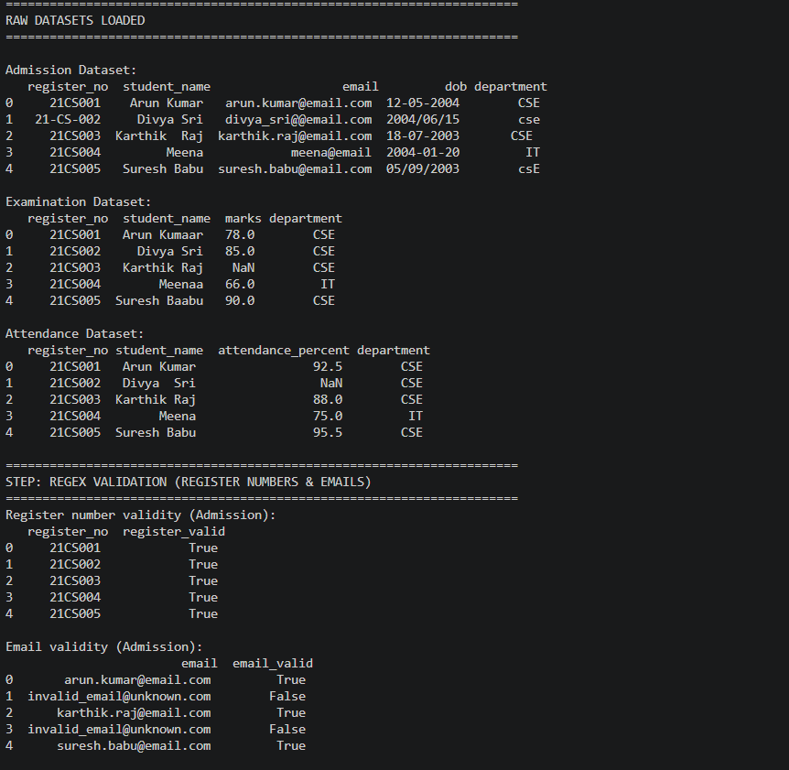

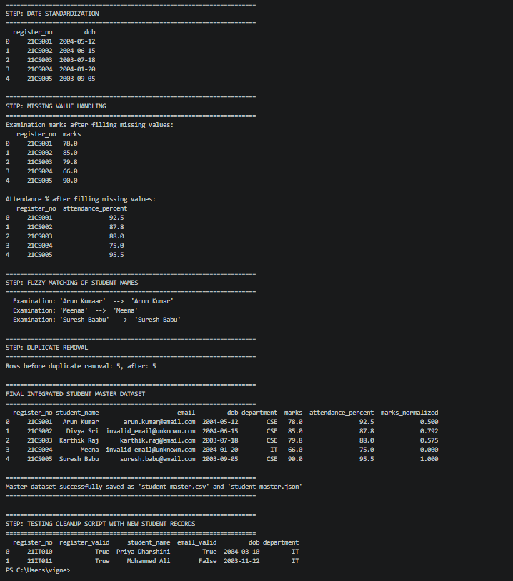

8. Result
The Admission, Examination, and Attendance student datasets were successfully cleaned using RegEx validation, fuzzy matching, missing-value handling, and date standardization. The three datasets were integrated into a single master student dataset, which was generated successfully in both CSV and JSON formats, and the reusable cleanup script was verified on a new set of student records.

