SIMATS ENGINEERING

Saveetha Institute of Medical and Technical Sciences
Chennai- 602105

Name: VIGNESHVAR .S
Reg no: 192424187
Subject and Course Code:
DSA0502 - QUERY PROCESSING FOR DATA SCIENCE

CO2_AT2

Question 4 — Library Management System
1. Problem Statement
A public or institutional library needs to maintain an electronic record of its members, its collection of books, and the transactions that take place when a book is issued to a member and subsequently returned. The system must record who each member is, the details of each book in the collection, and a complete history of which member borrowed which book, along with the date of issue and the date of return. Since a single member may borrow several books over time, and a single book may be issued to different members at different times, the system must be designed to correctly capture this many-to-many pattern of borrowing through a dedicated transactional record.
2. Objectives
- To design a normalized relational database schema that stores member, book, and book-issue information without redundancy.
- To correctly model the many-to-many relationship between members and books using an associative (linking) entity.
- To implement the schema using SQLite and demonstrate Create, Read, Update, and Delete (CRUD) operations using Python.
- To ensure the database can answer practical queries such as which books a member currently holds and which books have not yet been returned.
3. Entities
- Member — represents an individual who is registered with the library and is entitled to borrow books.
- Book — represents a single title available in the library's collection.
- Issue — represents a single borrowing transaction that links one member to one book, including the dates of issue and return.
4. Attributes
Entity | Attributes
Member | MemberID, Name
Book | BookID, Title, Author
Issue | MemberID, BookID, IssueDate, ReturnDate
5. Primary Keys
- Member.MemberID — uniquely identifies each member.
- Book.BookID — uniquely identifies each book.
- Issue — a composite/surrogate identifier is required because a member may borrow the same book on different occasions and a book may be issued to several members over time; the implementation therefore uses an auto-generated IssueID as the primary key of the Issue table.
6. Foreign Keys
- Issue.MemberID references Member.MemberID.
- Issue.BookID references Book.BookID.
7. Relationships
A Member can borrow many Books over time, and a Book can be borrowed by many Members over time. This is inherently a Many-to-Many relationship between Member and Book. In a relational database, a Many-to-Many relationship cannot be represented directly between two tables; it must be resolved using an associative (linking) entity. The Issue table performs this role: each row in Issue connects exactly one Member to exactly one Book for a specific borrowing event.
- Member to Issue: One-to-Many (one member can have many issue records).
- Book to Issue: One-to-Many (one book can appear in many issue records).
- Member to Book (through Issue): Many-to-Many (the overall relationship the schema is designed to support).

9. Database Schema
The following SQLite-compatible SQL script creates the three tables described above. It can be executed directly using cursor.executescript().
sql_script = """
CREATE TABLE IF NOT EXISTS Member (
MemberID INTEGER PRIMARY KEY AUTOINCREMENT,
Name TEXT NOT NULL
);

CREATE TABLE IF NOT EXISTS Book (
BookID INTEGER PRIMARY KEY AUTOINCREMENT,
Title TEXT NOT NULL,
Author TEXT NOT NULL
);

CREATE TABLE IF NOT EXISTS Issue (
IssueID INTEGER PRIMARY KEY AUTOINCREMENT,
MemberID INTEGER NOT NULL,
BookID INTEGER NOT NULL,
IssueDate TEXT NOT NULL,
ReturnDate TEXT,
FOREIGN KEY (MemberID) REFERENCES Member(MemberID),
FOREIGN KEY (BookID) REFERENCES Book(BookID)
);
"""

cursor.executescript(sql_script)
Output Screenshot (SQL Table Creation)
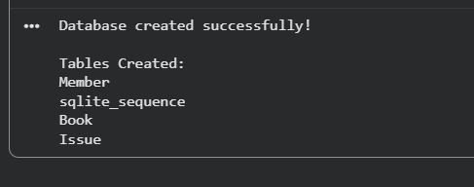

10. Python CRUD Program
The single Python program below connects to the SQLite database, creates the schema, inserts sample records, and performs and displays the result of every CRUD operation. It uses only the built-in sqlite3 library, requires no user input, and runs directly in Google Colab.
import sqlite3

# --- Connect to database ---
conn = sqlite3.connect('library.db')
cursor = conn.cursor()

# --- Create schema ---
cursor.executescript("""
DROP TABLE IF EXISTS Issue;
DROP TABLE IF EXISTS Member;
DROP TABLE IF EXISTS Book;

CREATE TABLE Member (
MemberID INTEGER PRIMARY KEY AUTOINCREMENT,
Name TEXT NOT NULL
);

CREATE TABLE Book (
BookID INTEGER PRIMARY KEY AUTOINCREMENT,
Title TEXT NOT NULL,
Author TEXT NOT NULL
);

CREATE TABLE Issue (
IssueID INTEGER PRIMARY KEY AUTOINCREMENT,
MemberID INTEGER NOT NULL,
BookID INTEGER NOT NULL,
IssueDate TEXT NOT NULL,
ReturnDate TEXT,
FOREIGN KEY (MemberID) REFERENCES Member(MemberID),
FOREIGN KEY (BookID) REFERENCES Book(BookID)
);
""")
conn.commit()

def show_table(table_name):
print(f"\n--- Current contents of {table_name} ---")
cursor.execute(f"SELECT * FROM {table_name}")
rows = cursor.fetchall()
col_names = [d[0] for d in cursor.description]
print(col_names)
for row in rows:
print(row)

# --- CREATE: insert sample members and books ---
cursor.execute("INSERT INTO Member (Name) VALUES ('Ananya Rao')")
cursor.execute("INSERT INTO Member (Name) VALUES ('Karthik Iyer')")
cursor.execute("INSERT INTO Book (Title, Author) VALUES ('The Hobbit', 'J.R.R. Tolkien')")
cursor.execute("INSERT INTO Book (Title, Author) VALUES ('1984', 'George Orwell')")
conn.commit()
print("CREATE: Sample members and books inserted.")
show_table('Member')
show_table('Book')

# --- CREATE: insert sample issue records ---
cursor.execute("INSERT INTO Issue (MemberID, BookID, IssueDate, ReturnDate) "
"VALUES (1, 1, '2026-01-05', NULL)")
cursor.execute("INSERT INTO Issue (MemberID, BookID, IssueDate, ReturnDate) "
"VALUES (2, 2, '2026-01-07', '2026-01-20')")
conn.commit()
print("\nCREATE: Sample issue records inserted.")
show_table('Issue')

# --- READ: display all issue records with member and book names ---
print("\n--- READ: Issue records with Member and Book names ---")
cursor.execute("""
SELECT Issue.IssueID, Member.Name, Book.Title, Issue.IssueDate, Issue.ReturnDate
FROM Issue
JOIN Member ON Issue.MemberID = Member.MemberID
JOIN Book ON Issue.BookID = Book.BookID
""")
for row in cursor.fetchall():
print(row)

# --- UPDATE: mark the first issue record as returned ---
cursor.execute("UPDATE Issue SET ReturnDate = '2026-01-25' WHERE IssueID = 1")
conn.commit()
print("\nUPDATE: ReturnDate updated for IssueID 1.")
show_table('Issue')

# --- DELETE: remove the second issue record ---
cursor.execute("DELETE FROM Issue WHERE IssueID = 2")
conn.commit()
print("\nDELETE: IssueID 2 removed.")
show_table('Issue')

# --- Close connection ---
conn.close()
print("\nDatabase connection closed.")
Output Screenshot (Python CRUD Program)
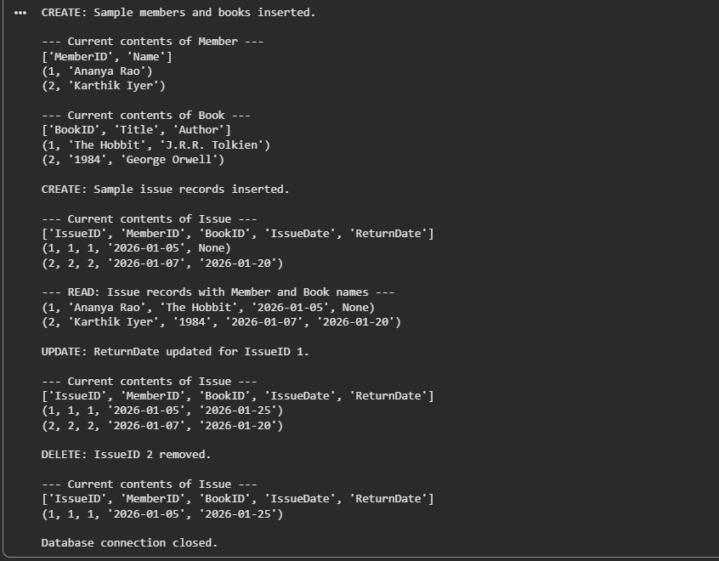

11. Viva Answers
Q1. Explain the relationship between Member and Book through the Issue table.
Member and Book are not directly connected to each other. Instead, they are connected through the Issue table, which acts as a bridge between them. Each row in Issue records one borrowing event and stores the MemberID of the member who borrowed the book and the BookID of the book that was borrowed, along with the issue and return dates. Because one member can appear in many Issue rows (borrowing many books) and one book can appear in many Issue rows (being borrowed by many members over time), the Issue table converts the underlying Many-to-Many relationship between Member and Book into two simple One-to-Many relationships, which is how relational databases must represent such a relationship.
Q2. How would you modify the schema to track overdue fines?
To track overdue fines, the Issue table can be extended with two additional columns: a DueDate column that stores the date by which the book should have been returned, and a FineAmount column that stores the penalty accumulated if the book is returned after the due date. Optionally, a FineStatus column (for example, Paid or Unpaid) can be added to track whether the fine has been settled. The fine amount can then be calculated by the application whenever a book is returned, by comparing ReturnDate with DueDate and applying a fixed rate per day of delay. For a more scalable design, a separate Fine table (FineID, IssueID, Amount, PaymentStatus) could also be created and linked to Issue through a foreign key, keeping fine records normalized and independent of the core issue transaction.
12. Result
The Library Management System database was successfully designed, normalized, and implemented in SQLite. The schema correctly resolves the Many-to-Many relationship between Member and Book through the Issue associative entity, and the accompanying Python program demonstrates that all four CRUD operations function correctly against the database, confirming that the design satisfies the requirements of the given problem statement.

Question 6 — Employee Payroll System
1. Problem Statement
An organization needs to maintain a database to manage its employees, the departments they belong to, and the monthly salary payments made to each employee. Each employee belongs to exactly one department, and each department may contain many employees. In addition, every employee receives a salary record for each month they work, so the system must be able to store multiple payroll entries per employee over time. The database must therefore separate employee, department, and payroll information into distinct, related tables so that department details are not duplicated for every employee and salary history can be maintained accurately over multiple months.
2. Objectives
- To design a normalized relational database schema that separates employee, department, and payroll data.
- To correctly model the One-to-Many relationship between departments and employees, and between employees and payroll records.
- To implement the schema using SQLite and demonstrate Create, Read, Update, and Delete (CRUD) operations using Python.
- To eliminate data redundancy that would occur if department information were repeated in every employee record.
3. Entities
- Employee — represents a staff member working in the organization.
- Department — represents an organizational unit to which employees belong.
- Payroll — represents a single monthly salary payment record for an employee.
4. Attributes
Entity | Attributes
Employee | EmployeeID, Name, DepartmentID
Department | DepartmentID, DepartmentName
Payroll | PayrollID, EmployeeID, Salary, Month
5. Primary Keys
- Employee.EmployeeID — uniquely identifies each employee.
- Department.DepartmentID — uniquely identifies each department.
- Payroll.PayrollID — uniquely identifies each payroll (salary) record.
6. Foreign Keys
- Employee.DepartmentID references Department.DepartmentID.
- Payroll.EmployeeID references Employee.EmployeeID.
7. Relationships
A Department can contain many Employees, but each Employee belongs to only one Department at a time. This is a One-to-Many relationship from Department to Employee. Similarly, an Employee can have many Payroll records (one for each month), but each Payroll record belongs to exactly one Employee. This is a One-to-Many relationship from Employee to Payroll. There is no Many-to-Many relationship in this schema, since neither an employee is shared across multiple departments simultaneously, nor is a payroll record shared across multiple employees.
- Department to Employee: One-to-Many.
- Employee to Payroll: One-to-Many.
- One-to-One and Many-to-Many relationships: Not applicable in this schema.

8. Database Schema
The following SQLite-compatible SQL script creates the three tables described above. It can be executed directly using cursor.executescript().
sql_script = """
CREATE TABLE IF NOT EXISTS Department (
DepartmentID INTEGER PRIMARY KEY AUTOINCREMENT,
DepartmentName TEXT NOT NULL
);

CREATE TABLE IF NOT EXISTS Employee (
EmployeeID INTEGER PRIMARY KEY AUTOINCREMENT,
Name TEXT NOT NULL,
DepartmentID INTEGER NOT NULL,
FOREIGN KEY (DepartmentID) REFERENCES Department(DepartmentID)
);

CREATE TABLE IF NOT EXISTS Payroll (
PayrollID INTEGER PRIMARY KEY AUTOINCREMENT,
EmployeeID INTEGER NOT NULL,
Salary REAL NOT NULL,
Month TEXT NOT NULL,
FOREIGN KEY (EmployeeID) REFERENCES Employee(EmployeeID)
);
"""

cursor.executescript(sql_script)
Output Screenshot (SQL Table Creation)
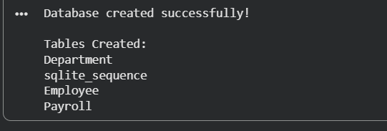

9. Python CRUD Program
The single Python program below connects to the SQLite database, creates the schema, inserts sample records, and performs and displays the result of every CRUD operation. It uses only the built-in sqlite3 library, requires no user input, and runs directly in Google Colab.
import sqlite3

# --- Connect to database ---
conn = sqlite3.connect('payroll.db')
cursor = conn.cursor()

# --- Create schema ---
cursor.executescript("""
DROP TABLE IF EXISTS Payroll;
DROP TABLE IF EXISTS Employee;
DROP TABLE IF EXISTS Department;

CREATE TABLE Department (
DepartmentID INTEGER PRIMARY KEY AUTOINCREMENT,
DepartmentName TEXT NOT NULL
);

CREATE TABLE Employee (
EmployeeID INTEGER PRIMARY KEY AUTOINCREMENT,
Name TEXT NOT NULL,
DepartmentID INTEGER NOT NULL,
FOREIGN KEY (DepartmentID) REFERENCES Department(DepartmentID)
);

CREATE TABLE Payroll (
PayrollID INTEGER PRIMARY KEY AUTOINCREMENT,
EmployeeID INTEGER NOT NULL,
Salary REAL NOT NULL,
Month TEXT NOT NULL,
FOREIGN KEY (EmployeeID) REFERENCES Employee(EmployeeID)
);
""")
conn.commit()

def show_table(table_name):
print(f"\n--- Current contents of {table_name} ---")
cursor.execute(f"SELECT * FROM {table_name}")
rows = cursor.fetchall()
col_names = [d[0] for d in cursor.description]
print(col_names)
for row in rows:
print(row)

# --- CREATE: insert sample departments and employees ---
cursor.execute("INSERT INTO Department (DepartmentName) VALUES ('Finance')")
cursor.execute("INSERT INTO Department (DepartmentName) VALUES ('Human Resources')")
cursor.execute("INSERT INTO Employee (Name, DepartmentID) VALUES ('Priya Sharma', 1)")
cursor.execute("INSERT INTO Employee (Name, DepartmentID) VALUES ('Rahul Verma', 2)")
conn.commit()
print("CREATE: Sample departments and employees inserted.")
show_table('Department')
show_table('Employee')

# --- CREATE: insert sample payroll records ---
cursor.execute("INSERT INTO Payroll (EmployeeID, Salary, Month) VALUES (1, 55000, 'January')")
cursor.execute("INSERT INTO Payroll (EmployeeID, Salary, Month) VALUES (2, 48000, 'January')")
conn.commit()
print("\nCREATE: Sample payroll records inserted.")
show_table('Payroll')

# --- READ: display payroll records with employee and department names ---
print("\n--- READ: Payroll records with Employee and Department names ---")
cursor.execute("""
SELECT Payroll.PayrollID, Employee.Name, Department.DepartmentName,
Payroll.Salary, Payroll.Month
FROM Payroll
JOIN Employee ON Payroll.EmployeeID = Employee.EmployeeID
JOIN Department ON Employee.DepartmentID = Department.DepartmentID
""")
for row in cursor.fetchall():
print(row)

# --- UPDATE: give employee 1 a salary revision ---
cursor.execute("UPDATE Payroll SET Salary = 60000 WHERE PayrollID = 1")
conn.commit()
print("\nUPDATE: Salary updated for PayrollID 1.")
show_table('Payroll')

# --- DELETE: remove the payroll record for employee 2 ---
cursor.execute("DELETE FROM Payroll WHERE PayrollID = 2")
conn.commit()
print("\nDELETE: PayrollID 2 removed.")
show_table('Payroll')

# --- Close connection ---
conn.close()
print("\nDatabase connection closed.")
Output Screenshot (Python CRUD Program)
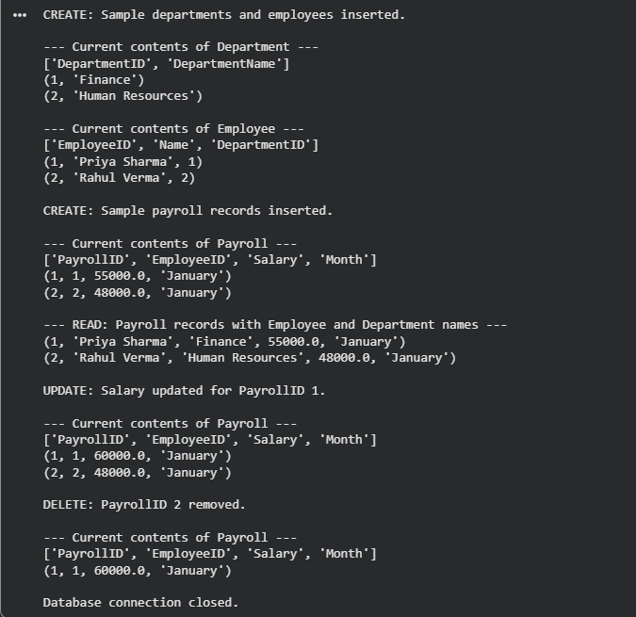

11. Viva Answers
Q1. Why is Department information separated into a different table?
Department information is kept in its own table because a department is a distinct entity that can be associated with many employees, and its details (such as DepartmentName) describe the department itself rather than any single employee. By storing DepartmentID, DepartmentName once in a separate Department table and referencing it from Employee through a foreign key, the database follows the principle of normalization, avoiding the need to repeat department details in every employee row. This also means that if a department's name needs to change, it only needs to be updated in one place.
Q2. What redundancy issues would arise if department details were stored in Employee records?
If department details such as DepartmentName were stored directly inside every Employee record, the same department name would be repeated once for every employee belonging to that department. This wastes storage space and, more importantly, creates update anomalies: if a department is renamed, every single employee row referencing that department would need to be updated, and missing even one row would leave the data inconsistent. It could also lead to insertion anomalies, where a new department cannot be recorded until at least one employee is assigned to it, and deletion anomalies, where removing the last employee of a department would accidentally delete all record of that department's existence. Keeping Department as a separate table avoids all of these problems.
12. Result
The Employee Payroll System database was successfully designed, normalized, and implemented in SQLite. The schema correctly models the One-to-Many relationships between Department and Employee, and between Employee and Payroll, and the accompanying Python program demonstrates that all four CRUD operations function correctly against the database, confirming that the design satisfies the requirements of the given problem statement while avoiding data redundancy.

