

SIMATS ENGINEERING

Saveetha Institute of Medical and Technical Sciences
Chennai- 602105

Name: Vigneshvar.S
Reg no: 192424187
Course Code: DSA0502
Course: QUERY PROCESSING

SET - 11
21.Write a Pandas program to swap the cases of a specified character column in a given DataFrame.
CODE:
import pandas as pd

# Built-in dataset
data = {
"Name": ["JAM", "RAM", "PRIYA", "VIGNESH", "KUMAR"],
"Age": [18, 20, 19, 21, 22]
}

# Create DataFrame
df = pd.DataFrame(data)

# Swap cases of the Name column
df["Name"] = df["Name"].str.swapcase()

# Display updated DataFrame
print("\nDataFrame after swapping cases:")
print(df)

OUTPUT:
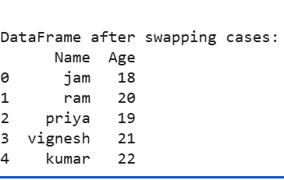
22.Write a Python program to draw a line with suitable label in the x axis, y axis and a title.
CODE:
import matplotlib.pyplot as plt
# X-axis values
x = [1, 2, 3, 4, 5]
# Y-axis values
y = [10, 20, 30, 40, 50]
# Draw line
plt.plot(x, y, marker="o")
# X-axis label
plt.xlabel("X Axis")
# Y-axis label
plt.ylabel("Y Axis")
# Graph title
plt.title("Simple Line Graph")
# Display graph
plt.show()

OUTPUT:
