

SIMATS ENGINEERING

Saveetha Institute of Medical and Technical Sciences
Chennai- 602105

Name: Vigneshvar.S
Reg no: 192424187
Course Code: DSA0502
Course: QUERY PROCESSING

SET - 16
31.Write a Python program to create a stacked bar plot with error bars.
CODE:
import numpy as np
import matplotlib.pyplot as plt

# Data
categories = ['A', 'B', 'C', 'D']
boys = [20, 35, 30, 35]
girls = [25, 32, 34, 20]

# Error values
boys_error = [2, 3, 2, 4]
girls_error = [3, 2, 3, 2]
x = np.arange(len(categories))
# Stacked bar plot
plt.bar(x, boys, yerr=boys_error, capsize=5, label='Boys')
plt.bar(x, girls, bottom=boys, yerr=girls_error, capsize=5, label='Girls')

plt.xlabel('Categories')
plt.ylabel('Values')
plt.title('Stacked Bar Plot with Error Bars')
plt.xticks(x, categories)
plt.legend()

plt.show()

OUTPUT:
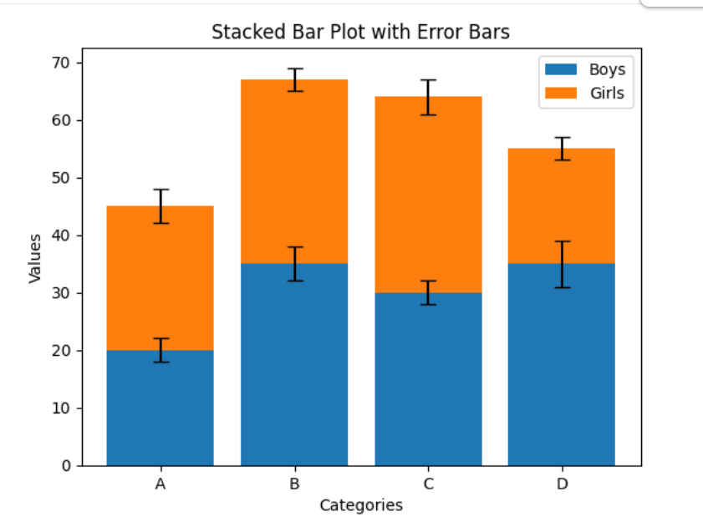

32.Write a Python program to draw a scatter graph taking a random distribution in X and Y and plotted against each other.

CODE:
import numpy as np
import matplotlib.pyplot as plt

# Generate random values for X and Y
np.random.seed(10)

x = np.random.rand(50)
y = np.random.rand(50)

# Scatter plot
plt.scatter(x, y)

plt.xlabel('X Values')
plt.ylabel('Y Values')
plt.title('Scatter Plot of Random X and Y Values')

plt.show()

OUTPUT:
