CO1-AT2
DATA WRANGLING PRACTICAL ASSIGNMENT
Practical Record

Course Code: DSA0502
Course Title: QUERY PROCESSING FOR DATA SCIENCE
Title: Data Wrangling Practical Assignment
Name: Vigneshvar. S
Reg No: 192424187

Question 1 – Student Performance Analysis
A college stores student details in students.csv containing Name, Roll Number, Department, and Marks. The dataset is read, analysed, and updated using Python and Pandas.
Aim
To read student data from a CSV file, calculate the average marks, determine the pass/fail result of each student, and display students who scored above the class average.
Algorithm
1. Import the Pandas library.
2. Read the student data from the file students.csv into a DataFrame.
3. Calculate the average marks of all students using the mean() function.
4. Create a new column named Result that stores 'Pass' if marks are 40 or above, and 'Fail' otherwise.
5. Filter and display the students whose marks are greater than the average marks.
6. Save the updated DataFrame back to a CSV file.
7. Print the average marks and the updated dataset on the screen.
Python Code
# Program to analyse student performance using Pandas
import pandas as pd

# Step 1: Read the CSV file into a DataFrame
df = pd.read_csv("students.csv")

# Step 2: Calculate the average marks of all students
average_marks = df["Marks"].mean()
print("Average Marks:", average_marks)

# Step 3: Add a new column 'Result' based on passing mark of 40
df["Result"] = df["Marks"].apply(lambda m: "Pass" if m >= 40 else "Fail")

# Step 4: Display students who scored above the class average
above_average = df[df["Marks"] > average_marks]
print("\nStudents who scored above average:")
print(above_average)

# Step 5: Save the updated dataset to a new CSV file
df.to_csv("students_updated.csv", index=False)
print("\nUpdated dataset saved as students_updated.csv")

Sample Input
students.csv

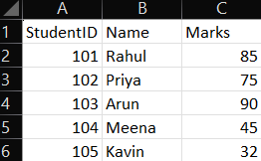
Output

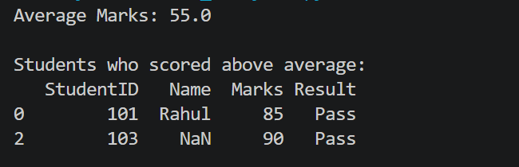

Result
The Python program was executed successfully using Pandas. The average marks were calculated, the Result column was added correctly, and students scoring above the class average were displayed. The objective of the program has been achieved.
Question 2 – Sales Data Analysis
Monthly sales information of different products is available in sales.csv. The dataset is analysed using Python and Pandas to summarise key sales details.
Aim
To read the sales data from a CSV file, calculate the total and average sales, identify the best-selling product, and display products with above-average sales.
Algorithm
1. Import the Pandas library.
2. Read the sales data from the file sales.csv into a DataFrame.
3. Calculate the total sales by summing the Sales column.
4. Find the product with the highest sales using the idxmax() function.
5. Calculate the average monthly sales using the mean() function.
6. Filter and display the products whose sales are greater than the average sales.
7. Save the sales summary details to a new CSV file.
8. Print the total sales, top product, and average sales on the screen.
Python Code
# Program to analyse monthly sales data using Pandas
import pandas as pd

# Step 1: Read the CSV file into a DataFrame
df = pd.read_csv("sales.csv")

# Step 2: Calculate the total sales of all products
total_sales = df["Sales"].sum()
print("Total Sales:", total_sales)

# Step 3: Find the product with the highest sales
top_product = df.loc[df["Sales"].idxmax(), "Product"]
print("Product with Highest Sales:", top_product)

# Step 4: Calculate the average monthly sales
average_sales = df["Sales"].mean()
print("Average Sales:", average_sales)

# Step 5: Display products with sales greater than the average
above_average = df[df["Sales"] > average_sales]
print("\nProducts with above-average sales:")
print(above_average)

# Step 6: Save the sales summary to a new CSV file
summary = pd.DataFrame({
"Total Sales": [total_sales],
"Top Product": [top_product],
"Average Sales": [average_sales]
})
summary.to_csv("sales_summary.csv", index=False)
print("\nSales summary saved as sales_summary.csv")
Sample Input
sales.csv
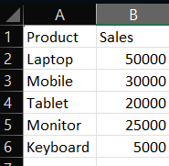Output
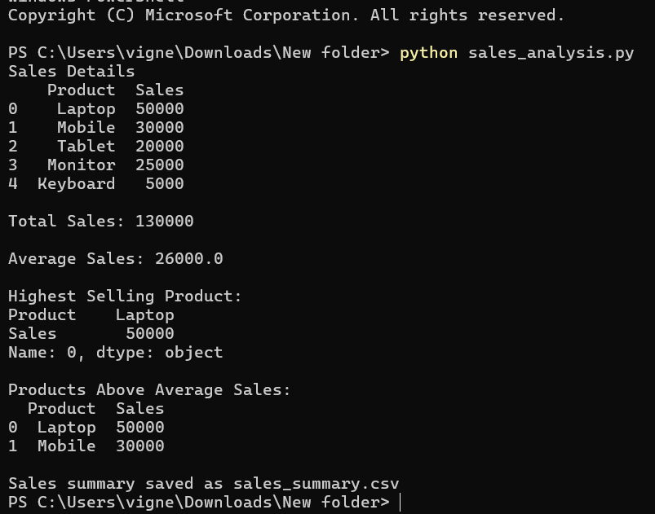

Result
The Python program was executed successfully using Pandas. The total sales, the highest-selling product, and the average monthly sales were calculated correctly, and the sales summary was saved. The objective of the program has been achieved.

