

SIMATS ENGINEERING

Saveetha Institute of Medical and Technical Sciences
Chennai- 602105

Name: Vigneshvar.S
Reg no: 192424187
Course Code: DSA0502
Course: QUERY PROCESSING

SET - 9
17.Write a Pandas program to split the following dataframe by school code and get mean, min, and max value of age for each school.
Code:
import pandas as pd

# Create DataFrame
data = {
'Name': ['John', 'Alice', 'Bob', 'David', 'Emma', 'Tom'],
'School_Code': ['S1', 'S1', 'S2', 'S2', 'S1', 'S2'],
'Age': [15, 16, 14, 15, 17, 16]
}

df = pd.DataFrame(data)

print("Original DataFrame:")
print(df)

# Split by School_Code and calculate mean, minimum and maximum age
result = df.groupby('School_Code')['Age'].agg(['mean', 'min', 'max'])

print("\nMean, Minimum and Maximum Age for each School:")
print(result)

Output
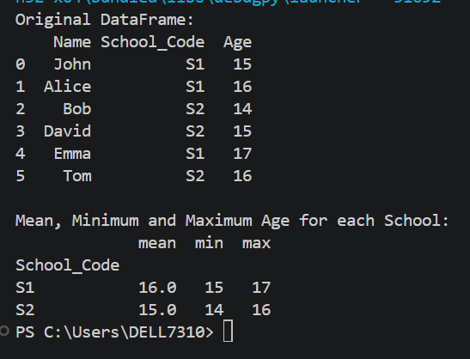

18.Write a Pandas program to split the following given dataframe into groups based on school code and class.

Code:
import pandas as pd
# Create DataFrame
data = {
'Name': ['John', 'Alice', 'Bob', 'David', 'Emma', 'Tom'],
'School_Code': ['S1', 'S1', 'S2', 'S2', 'S1', 'S2'],
'Class': [10, 10, 9, 9, 10, 9],
'Age': [15, 16, 14, 15, 17, 16]
}
df = pd.DataFrame(data)
print("Original DataFrame:")
print(df)

# Split DataFrame based on School_Code and Class
groups = df.groupby(['School_Code', 'Class'])

print("\nGroups:")
for name, group in groups:
print("\nGroup:", name)
print(group)

Output
