

SIMATS ENGINEERING

Saveetha Institute of Medical and Technical Sciences
Chennai- 602105

Name: Vigneshvar S
Reg no: 192424187
Subject and Course Code:
DSA0502 QUERY PROCESSING FOR DATA SCIENCE
7.Write a Pandas program to create a Pivot table and find the maximum and minimum
Code:
import pandas as pd

# Sample data
data = {
'Item': ['Pen', 'Pen', 'Book', 'Book', 'Pencil', 'Pencil'],
'Sales': [120, 150, 300, 280, 80, 100]
}

df = pd.DataFrame(data)

# Pivot table
pivot = pd.pivot_table(
df,
values='Sales',
index='Item',
aggfunc=['max', 'min']
)

print("Maximum and Minimum Sale Value:")
print(pivot)
Output:
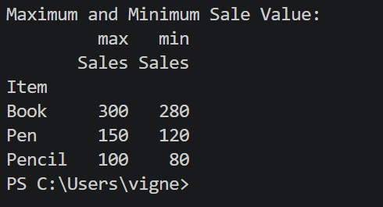

8.Write a Pandas program to create a Pivot table and find the item wise unit sold.
Code:
import pandas as pd

# Sample data
data = {
'Item': ['Pen', 'Pen', 'Book', 'Book', 'Pencil', 'Pencil'],
'Units Sold': [10, 15, 8, 12, 20, 25]
}

df = pd.DataFrame(data)

# Pivot table
pivot = pd.pivot_table(
df,
values='Units Sold',
index='Item',
aggfunc='sum'
)

print("Item-wise Units Sold:")
print(pivot)
Output:
