

SIMATS ENGINEERING

Saveetha Institute of Medical and Technical Sciences
Chennai- 602105

Name: Vigneshvar S
Reg no: 192424187
Subject and Course Code:
DSA0502 QUERY PROCESSING FOR DATA SCIENCE

C01 AT1
QUESTION 1:
Crime Record Analysis
Files:
- Crimes.csv
- PoliceStations.csv
- Crimes.json
- Crimes.xml
Merge crime and police station datasets, identify crime-prone areas, summarize crime
type statistics, and export the cleaned dataset.

Aim:
To merge crime and police station datasets, identify crime-prone areas, summarize crime type statistics, and export the cleaned dataset using Python and Pandas.

Software Requirements:
- Python 3.x
- VS Code
- Pandas Library
Code:
import pandas as pd
# Read datasets
crimes_csv = pd.read_csv("Crimes.csv")
stations = pd.read_csv("PoliceStations.csv")
crimes_json = pd.read_json("Crimes.json")
crimes_xml = pd.read_xml("Crimes.xml")
# Combine all crime datasets
all_crimes = pd.concat(
[crimes_csv, crimes_json, crimes_xml],
ignore_index=True
)
# Merge with police station dataset
merged_data = pd.merge(
all_crimes,
stations,
on="StationID",
how="left"
)
# Find crime-prone areas
crime_prone = merged_data.groupby("Area").size().reset_index(name="Total Crimes")
# Crime type statistics
crime_stats = merged_data.groupby("CrimeType").size().reset_index(name="Count")
# Remove duplicate records
cleaned_data = merged_data.drop_duplicates()
# Export cleaned dataset
cleaned_data.to_csv("Cleaned_Crime_Dataset.csv", index=False)

# Display results
print("Merged Dataset")
print(merged_data)

print("\nCrime-Prone Areas")
print(crime_prone)

print("\nCrime Type Statistics")
print(crime_stats)

print("\nCleaned dataset exported successfully as 'Cleaned_Crime_Dataset.csv'")

Input Datasets:
Dataset 1 : Crimes.csv
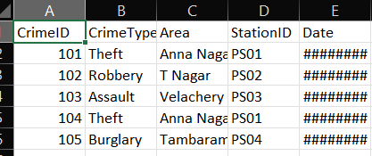
Dataset 2: PoliceStations.csv
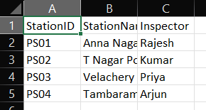
Dataset 3: Crimes.json
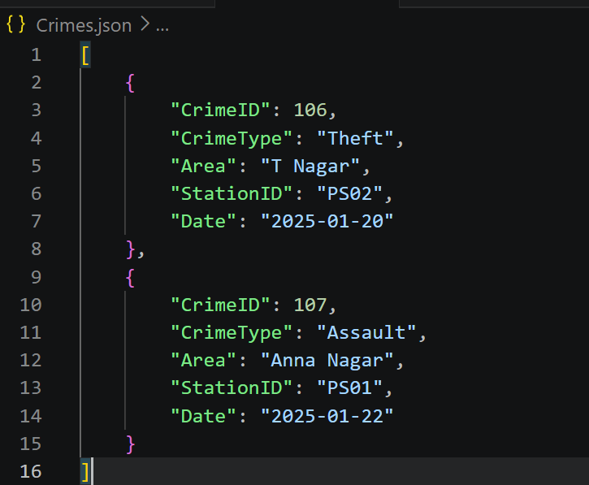
Dataset 4: Crimes.xml
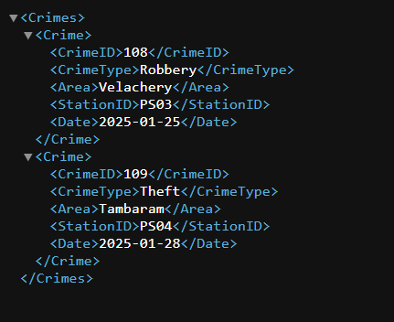
Algorithm
- Start the program.
- Import the Pandas library.
- Read Crimes.csv, PoliceStations.csv, Crimes.json, and Crimes.xml.
- Combine all crime datasets into a single dataset.
- Merge the combined crime dataset with the police station dataset using StationID.
- Identify crime-prone areas by counting crimes in each area.
- Generate crime type statistics.
- Remove duplicate records from the merged dataset.
- Export the cleaned dataset as Cleaned_Crime_Dataset.csv.
- Display the results.
- Stop the program.

Input:
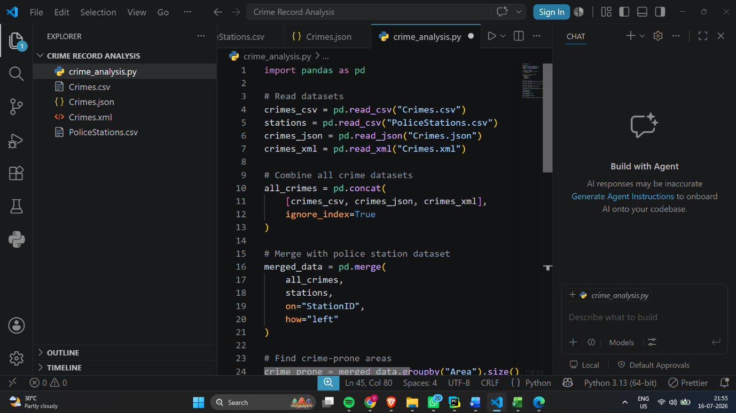
Output:
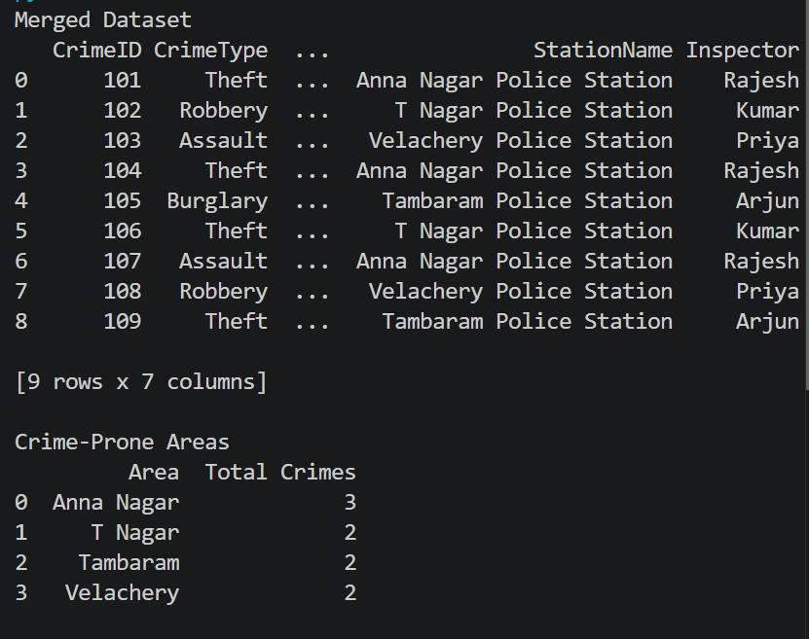
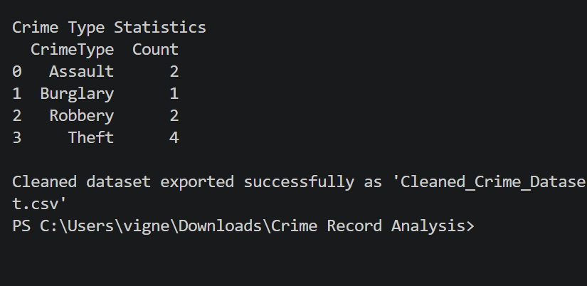

Exported Cleaned Dataset:

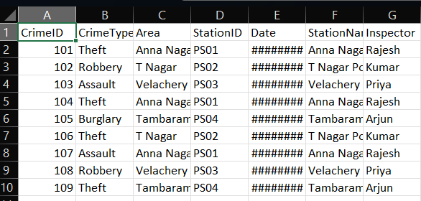

Result:
The crime records from CSV, JSON, and XML files were successfully merged with the police station dataset. Crime-prone areas and crime type statistics were generated, duplicate records were removed, and the cleaned dataset was exported successfully.

QUESTION 2:
Files:
• Movies.csv
• Genres.csv
• Movies.json
• Movies.xml
Task:
Read datasets from CSV, JSON, and XML formats. Inspect the datasets, handle missing values,
remove duplicate records, validate data types, merge related CSV datasets using a common key,
perform aggregation and summary statistics, identify the category with the highest value, and
export the cleaned dataset to a new CSV file.
Aim:
To read movie datasets from CSV, JSON, and XML formats, inspect and clean the datasets, handle missing values, remove duplicate records, validate data types, merge movie and genre datasets, perform summary statistics, identify the highest-rated category, and export the cleaned dataset to a new CSV file.

Software Requirements:
- Python 3.x
- Visual Studio Code
- Pandas Library

Code:
import pandas as pd

# Read datasets
movies_csv = pd.read_csv(r"C:\Users\vigne\Downloads\Movie Ratings\Movies.csv")
genres = pd.read_csv(r"C:\Users\vigne\Downloads\Movie Ratings\Genres.csv")
movies_json = pd.read_json(r"C:\Users\vigne\Downloads\Movie Ratings\Movies.json")
movies_xml = pd.read_xml(r"C:\Users\vigne\Downloads\Movie Ratings\Movies.xml")

# Combine all movie datasets
all_movies = pd.concat(
[movies_csv, movies_json, movies_xml],
ignore_index=True
)

# Inspect datasets
print("Missing Values:")
print(all_movies.isnull().sum())

# Handle missing values
all_movies = all_movies.fillna("Unknown")

# Remove duplicate records
all_movies = all_movies.drop_duplicates()

# Validate data types
print("\nData Types:")
print(all_movies.dtypes)

# Merge with genres dataset
merged_data = pd.merge(
all_movies,
genres,
on="GenreID",
how="left"
)

# Summary statistics
print("\nSummary Statistics:")
print(merged_data["Rating"].describe())

# Average rating by genre
genre_summary = (
merged_data.groupby("GenreName")["Rating"]
.mean()
.reset_index()
)

print("\nAverage Rating by Genre:")
print(genre_summary)

# Highest rated genre
highest = genre_summary.loc[genre_summary["Rating"].idxmax()]
print("\nHighest Rated Genre:")
print(highest)

merged_data.to_csv(
r"C:\Users\vigne\Downloads\Movie Ratings\Cleaned_Movies.csv",
index=False
)

print("\nCleaned dataset exported successfully as 'Cleaned_Movies.csv'")

Dataset 1: Movies.csv
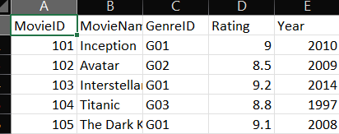
Dataset 2: Genres.csv
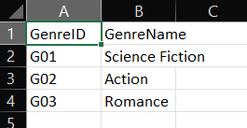
Dataset 3: Movies.json
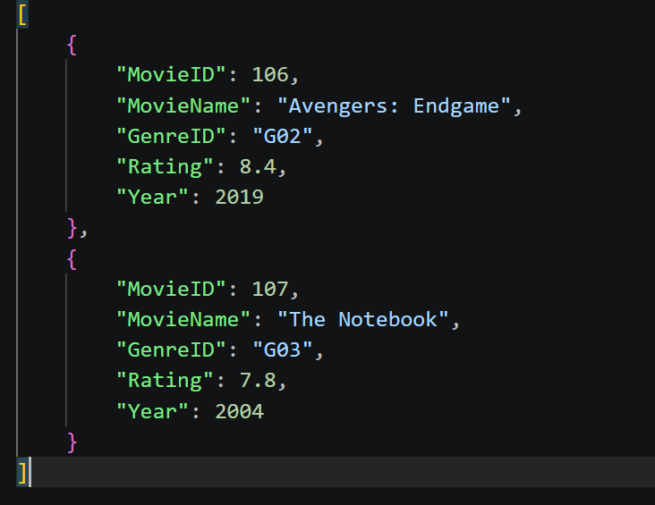

Dataset 4: Movies.xml
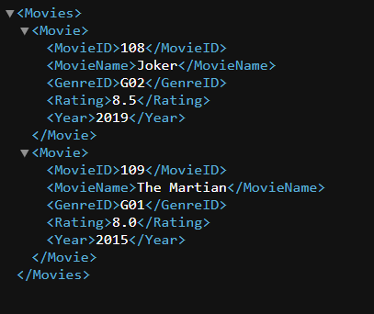
Algorithm:
- Start the program.
- Import the Pandas library.
- Read Movies.csv, Genres.csv, Movies.json, and Movies.xml.
- Inspect all datasets for missing values and duplicate records.
- Fill or remove missing values if present.
- Remove duplicate records from the movie datasets.
- Validate the data types of each column.
- Combine the movie datasets from CSV, JSON, and XML.
- Merge the combined movie dataset with the genres dataset using GenreID.
- Perform aggregation and summary statistics on movie ratings.
- Identify the genre with the highest average movie rating.
- Export the cleaned dataset to Cleaned_Movies.csv.
- Display the results.
- Stop the program.

Input:
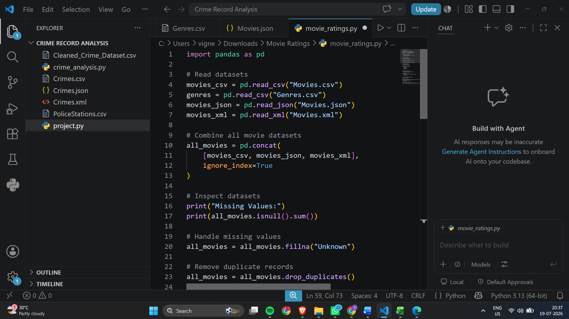
Output:
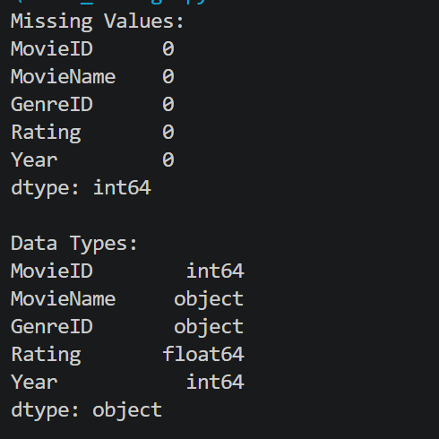
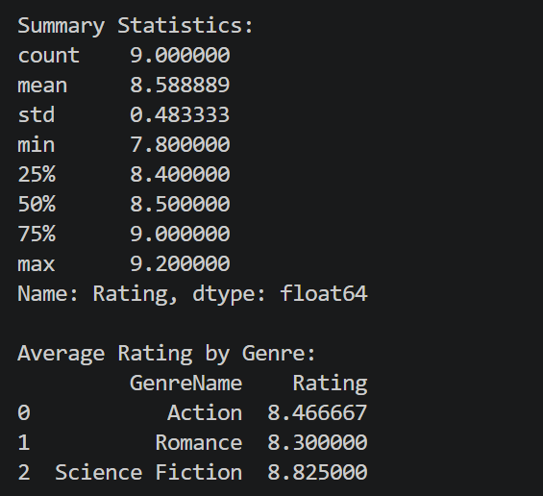
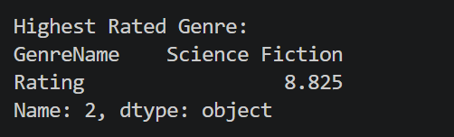

Exported Cleaned Dataset:

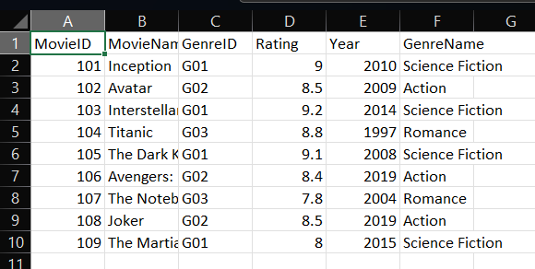

Result:
The movie datasets from CSV, JSON, and XML formats were successfully read and inspected. Missing values were checked, duplicate records were removed, data types were validated, the movie and genre datasets were merged successfully, summary statistics were generated, the highest-rated genre was identified as Science Fiction, and the cleaned dataset was exported successfully as Cleaned_Movies.csv.

