

SIMATS ENGINEERING

Saveetha Institute of Medical and Technical Sciences
Chennai- 602105

Name: Vigneshvar S
Reg no: 192424187
Subject and Course Code:
DSA0502 QUERY PROCESSING FOR DATA SCIENCE
SET 6

Experiment No. 11
Highlighting NaN Values in a Pandas DataFrame
1. Aim
To write a Python program using the Pandas library to create a DataFrame of ten rows and four columns containing random values, introduce NaN values into it, and highlight the NaN values using the Pandas Styler.
2. Algorithm
1. Import the pandas and numpy libraries.
2. Set a random seed for reproducibility of results.
3. Create a DataFrame with 10 rows and 4 columns filled with random values using numpy.
4. Randomly select a few cell positions in the DataFrame.
5. Replace the values at the selected positions with NaN using np.nan.
6. Display the original DataFrame containing the NaN values.
7. Define a custom styling function that returns a red background and white text color for NaN cells, and an empty style for other cells.
8. Apply the styling function to the DataFrame using the Styler's map() method.
9. Display the styled DataFrame with the NaN values highlighted.

3. Python Program
# Experiment 11
# Program to highlight NaN values in a Pandas DataFrame

import pandas as pd
import numpy as np

# Set a random seed for reproducibility
np.random.seed(42)

# Create a DataFrame with 10 rows and 4 columns of random values
df = pd.DataFrame(np.random.rand(10, 4), columns=['A', 'B', 'C', 'D'])

# Randomly select a few cell positions to replace with NaN
rows = np.random.randint(0, 10, 4)
cols = np.random.randint(0, 4, 4)

for r, c in zip(rows, cols):
df.iat[r, c] = np.nan

# Display the original DataFrame with NaN values
print("Original DataFrame with NaN values:")
print(df)

# Function to highlight NaN cells with yellow background and black text
def highlight_nan(val):
if pd.isna(val):
return 'background-color: yellow; color: black'
return ''

# Apply the styling function to the DataFrame
styled_df = df.style.map(highlight_nan)

# Display the styled DataFrame (renders with colors in Jupyter Notebook)
styled_df

4. Output
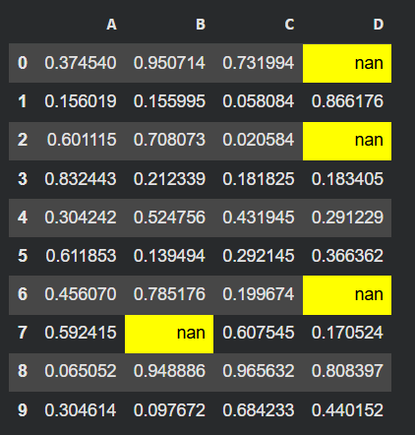

5. Result
The Python program was executed successfully, and a DataFrame with random values and NaN entries was created. The Pandas Styler was used to highlight the NaN cells with a red background and white text, allowing missing values to be easily identified.

Experiment No. 12
Styling DataFrame Background and Font Color
1. Aim
To write a Python program using the Pandas library to create a DataFrame of ten rows and four columns containing random values, and to style the DataFrame so that the background color is black and the font color is yellow using the Pandas Styler.
2. Algorithm
1. Import the pandas and numpy libraries.
2. Set a random seed for reproducibility of results.
3. Create a DataFrame with 10 rows and 4 columns filled with random values using numpy.
4. Display the original DataFrame.
5. Define a custom styling function that returns a black background color and yellow font color for every cell.
6. Apply the styling function to the entire DataFrame using the Styler's map() method.
7. Display the styled DataFrame with the black background and yellow font applied.
3. Python Program
# Experiment 12
# Program to set DataFrame background color black and font color yellow

import pandas as pd
import numpy as np

# Set a random seed for reproducibility
np.random.seed(42)

# Create a DataFrame with 10 rows and 4 columns of random values
df = pd.DataFrame(np.random.rand(10, 4), columns=['A', 'B', 'C', 'D'])

# Display the original DataFrame
print('Original DataFrame:')
print(df)

# Define a styling function to set black background and yellow font
def black_yellow_style(val):
return 'background-color: black; color: yellow'

# Apply the styling function to every cell in the DataFrame
styled_df = df.style.map(black_yellow_style)

# Display the styled DataFrame (renders with colors in Jupyter/HTML)
styled_df

4. Output
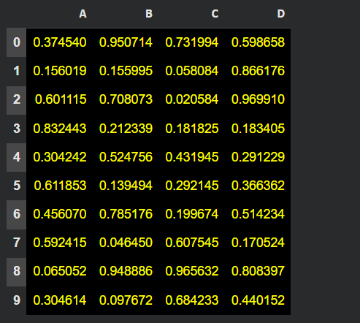

5. Result
The Python program was executed successfully, and a DataFrame with random values was created. The Pandas Styler was used to set the background color of the DataFrame to black and the font color to yellow, producing a visually styled output.

