

SIMATS ENGINEERING

Saveetha Institute of Medical and Technical Sciences
Chennai- 602105

Name: Vigneshvar S
Reg no: 192424187
Subject and Course Code:
DSA0502 QUERY PROCESSING FOR DATA SCIENCE

C01 AT1
QUESTION:
Crime Record Analysis
Files:
- Crimes.csv
- PoliceStations.csv
- Crimes.json
- Crimes.xml
Merge crime and police station datasets, identify crime-prone areas, summarize crime
type statistics, and export the cleaned dataset.

Aim:
To merge crime and police station datasets, identify crime-prone areas, summarize crime type statistics, and export the cleaned dataset using Python and Pandas.

Software Requirements:
- Python 3.x
- VS Code
- Pandas Library
Input Datasets:
Dataset 1 : Crimes.csv
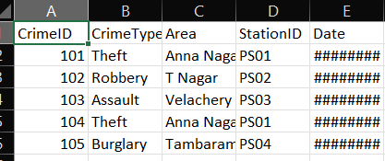
Dataset 2: PoliceStations.csv
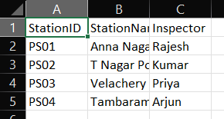
Dataset 3: Crimes.json
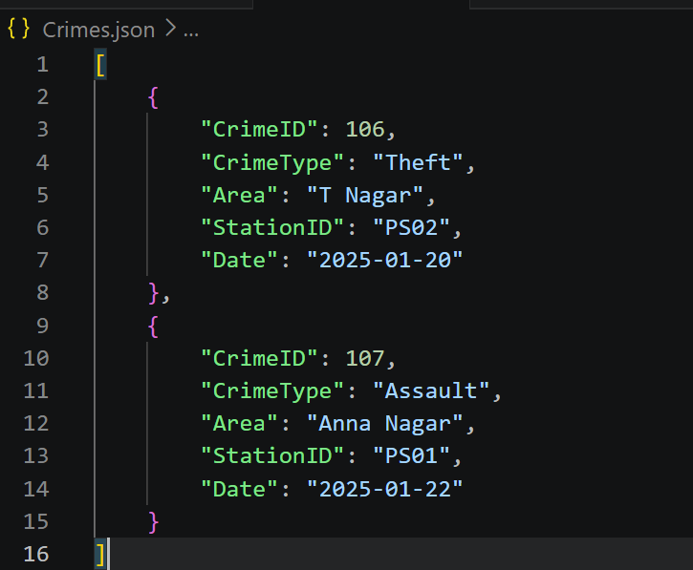
Dataset 4: Crimes.xml
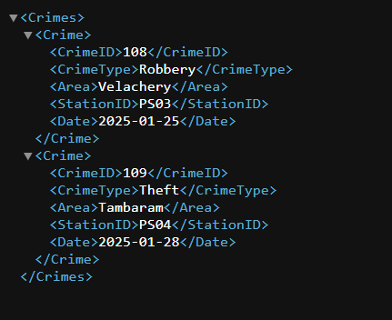
Algorithm
- Start the program.
- Import the Pandas library.
- Read Crimes.csv, PoliceStations.csv, Crimes.json, and Crimes.xml.
- Combine all crime datasets into a single dataset.
- Merge the combined crime dataset with the police station dataset using StationID.
- Identify crime-prone areas by counting crimes in each area.
- Generate crime type statistics.
- Remove duplicate records from the merged dataset.
- Export the cleaned dataset as Cleaned_Crime_Dataset.csv.
- Display the results.
- Stop the program.

Input:
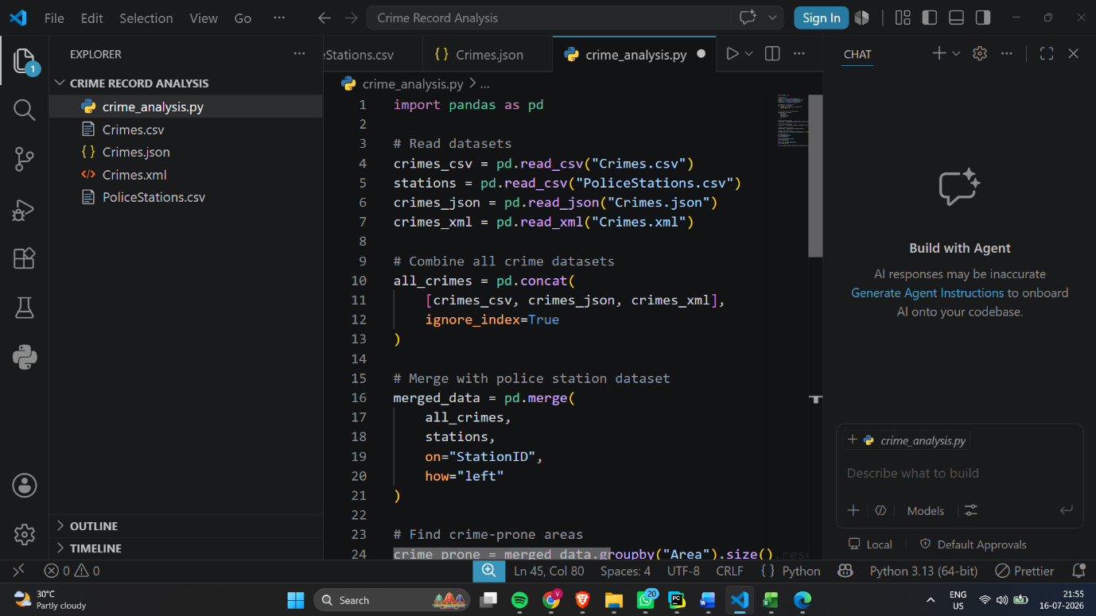

Output:
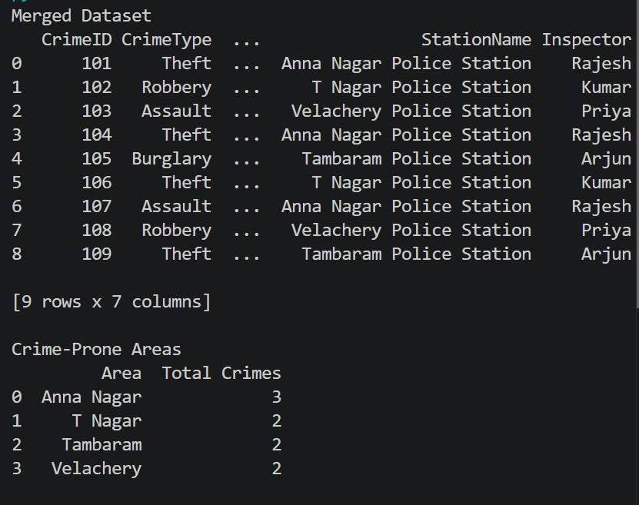
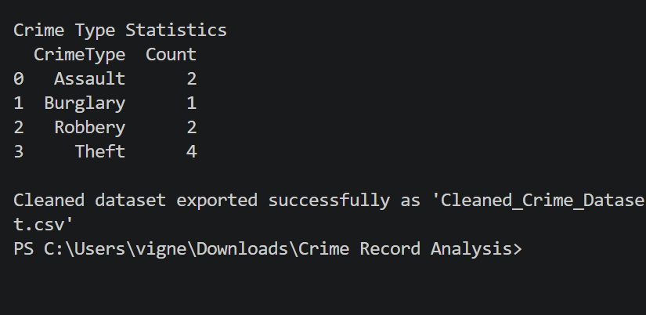

Exported Cleaned Dataset:

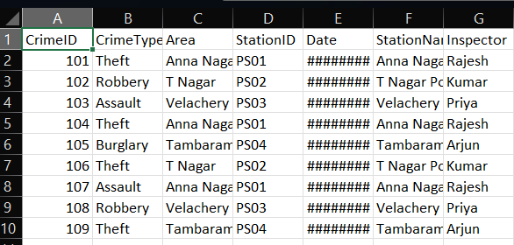

Result:
The crime records from CSV, JSON, and XML files were successfully merged with the police station dataset. Crime-prone areas and crime type statistics were generated, duplicate records were removed, and the cleaned dataset was exported successfully.

