SIMATS ENGINEERING

Saveetha Institute of Medical and Technical Sciences
Chennai- 602105

Name: VIGNESHVAR .S
Reg no: 192424187
Subject and Course Code:
DSA0502 - QUERY PROCESSING FOR DATA SCIENCE

CO2_AT1

Scenario 4 - Library Management System

1. Problem Statement
A large academic library manages thousands of books, journals, magazines, and digital resources for its students and faculty members. The existing manual system of tracking issued and returned books is time-consuming and prone to errors, often resulting in misplaced records and inaccurate tracking of book availability. There is a need for an automated database system that can efficiently manage book records, author and publisher details, member information, and borrowing transactions, while also calculating overdue fines and generating inventory reports.

2. Objectives
- To design a normalized relational database for managing library operations.
- To maintain accurate records of books, authors, publishers, and members.
- To track book issue and return transactions efficiently.
- To automatically calculate fines for overdue books.
- To generate inventory and book-availability reports.
- To implement database connectivity using Python for performing CRUD operations.

3. Entities
- Publisher
- Author
- Book
- Book_Author (associative entity resolving the many-to-many relationship between Book and Author)
- Member
- Transactions

4. Attributes
Entity | Attributes
Publisher | publisher_id, publisher_name, address, phone, email
Author | author_id, author_name, nationality, email
Book | book_id, title, isbn, category, edition, price, total_copies, available_copies, publisher_id
Book_Author | book_id, author_id
Member | member_id, member_name, member_type, email, phone, address, join_date
Transactions | transaction_id, book_id, member_id, issue_date, due_date, return_date, fine_amount, status

5. Primary Keys
Entity | Primary Key
Publisher | publisher_id
Author | author_id
Book | book_id
Book_Author | book_id, author_id (composite)
Member | member_id
Transactions | transaction_id

6. Foreign Keys
Entity | Foreign Key | References
Book | publisher_id | Publisher (publisher_id)
Book_Author | book_id | Book (book_id)
Book_Author | author_id | Author (author_id)
Transactions | book_id | Book (book_id)
Transactions | member_id | Member (member_id)

7. Relationships
- A Publisher publishes many Books, but each Book is published by one Publisher (one-to-many).
- A Book can have multiple Authors, and an Author can write multiple Books; this many-to-many relationship is resolved through the Book_Author associative entity.
- A Member can borrow multiple Books over time, and a Book can be issued to multiple Members over time; this many-to-many relationship is resolved through the Transactions entity.
- Each Transaction record links exactly one Book with one Member for a specific borrowing period and stores the issue date, due date, return date, and fine amount.

8. ER Diagram
Chain 1: Publisher - Book - Author (via Book_Author)

+----------------+
| PUBLISHER |
+----------------+
|
1
|
publishes
|
M
v
+----------------+
| BOOK |
+----------------+
|
1
|
linked in
|
M
v
+----------------+
| BOOK_AUTHOR |
+----------------+
|
M
|
written by
|
1
v
+----------------+
| AUTHOR |
+----------------+

Chain 2: Book - Transactions - Member

+----------------+
| BOOK |
+----------------+
|
1
|
issued in
|
M
v
+----------------+
| TRANSACTIONS |
+----------------+
|
M
|
borrowed by
|
1
v
+----------------+
| MEMBER |
+----------------+

9. Database Schema (SQL)
Code 1 - SQL Database Schema
-- ===================================================================
-- Library Management System - Database Schema
-- Run directly in SQLite / Google Colab using cursor.executescript()
-- ===================================================================

CREATE TABLE PUBLISHER (
publisher_id INTEGER PRIMARY KEY AUTOINCREMENT,
publisher_name TEXT NOT NULL,
address TEXT,
phone TEXT,
email TEXT
);

CREATE TABLE AUTHOR (
author_id INTEGER PRIMARY KEY AUTOINCREMENT,
author_name TEXT NOT NULL,
nationality TEXT,
email TEXT
);

CREATE TABLE BOOK (
book_id INTEGER PRIMARY KEY AUTOINCREMENT,
title TEXT NOT NULL,
isbn TEXT UNIQUE,
category TEXT,
edition TEXT,
price REAL,
total_copies INTEGER NOT NULL,
available_copies INTEGER NOT NULL,
publisher_id INTEGER,
FOREIGN KEY (publisher_id) REFERENCES PUBLISHER(publisher_id)
);

CREATE TABLE BOOK_AUTHOR (
book_id INTEGER,
author_id INTEGER,
PRIMARY KEY (book_id, author_id),
FOREIGN KEY (book_id) REFERENCES BOOK(book_id),
FOREIGN KEY (author_id) REFERENCES AUTHOR(author_id)
);

CREATE TABLE MEMBER (
member_id INTEGER PRIMARY KEY AUTOINCREMENT,
member_name TEXT NOT NULL,
member_type TEXT CHECK (member_type IN ('Student','Faculty')),
email TEXT,
phone TEXT,
address TEXT,
join_date TEXT
);

CREATE TABLE TRANSACTIONS (
transaction_id INTEGER PRIMARY KEY AUTOINCREMENT,
book_id INTEGER,
member_id INTEGER,
issue_date TEXT NOT NULL,
due_date TEXT NOT NULL,
return_date TEXT,
fine_amount REAL DEFAULT 0,
status TEXT DEFAULT 'Issued',
FOREIGN KEY (book_id) REFERENCES BOOK(book_id),
FOREIGN KEY (member_id) REFERENCES MEMBER(member_id)
);

Code 2 - Python CRUD Program
# =====================================================================
# Library Management System - Python CRUD Program (sqlite3)
# Single file. Google Colab compatible. No input() used.
# =====================================================================
import sqlite3

conn = sqlite3.connect("library.db")
cursor = conn.cursor()

# ---------------- CREATE TABLES ----------------
cursor.executescript("""
DROP TABLE IF EXISTS TRANSACTIONS;
DROP TABLE IF EXISTS BOOK_AUTHOR;
DROP TABLE IF EXISTS BOOK;
DROP TABLE IF EXISTS MEMBER;
DROP TABLE IF EXISTS AUTHOR;
DROP TABLE IF EXISTS PUBLISHER;

CREATE TABLE PUBLISHER (
publisher_id INTEGER PRIMARY KEY AUTOINCREMENT,
publisher_name TEXT NOT NULL,
address TEXT,
phone TEXT,
email TEXT
);

CREATE TABLE AUTHOR (
author_id INTEGER PRIMARY KEY AUTOINCREMENT,
author_name TEXT NOT NULL,
nationality TEXT,
email TEXT
);

CREATE TABLE BOOK (
book_id INTEGER PRIMARY KEY AUTOINCREMENT,
title TEXT NOT NULL,
isbn TEXT UNIQUE,
category TEXT,
edition TEXT,
price REAL,
total_copies INTEGER NOT NULL,
available_copies INTEGER NOT NULL,
publisher_id INTEGER,
FOREIGN KEY (publisher_id) REFERENCES PUBLISHER(publisher_id)
);

CREATE TABLE BOOK_AUTHOR (
book_id INTEGER,
author_id INTEGER,
PRIMARY KEY (book_id, author_id),
FOREIGN KEY (book_id) REFERENCES BOOK(book_id),
FOREIGN KEY (author_id) REFERENCES AUTHOR(author_id)
);

CREATE TABLE MEMBER (
member_id INTEGER PRIMARY KEY AUTOINCREMENT,
member_name TEXT NOT NULL,
member_type TEXT CHECK (member_type IN ('Student','Faculty')),
email TEXT,
phone TEXT,
address TEXT,
join_date TEXT
);

CREATE TABLE TRANSACTIONS (
transaction_id INTEGER PRIMARY KEY AUTOINCREMENT,
book_id INTEGER,
member_id INTEGER,
issue_date TEXT NOT NULL,
due_date TEXT NOT NULL,
return_date TEXT,
fine_amount REAL DEFAULT 0,
status TEXT DEFAULT 'Issued',
FOREIGN KEY (book_id) REFERENCES BOOK(book_id),
FOREIGN KEY (member_id) REFERENCES MEMBER(member_id)
);
""")
conn.commit()
print("Tables created successfully.\n")

# ---------------- INSERT SAMPLE RECORDS (CREATE) ----------------
cursor.executescript("""
INSERT INTO PUBLISHER (publisher_name, address, phone, email) VALUES
('Pearson Education', 'Chennai', '9840012345', 'contact@pearson.com'),
('McGraw Hill', 'Bangalore', '9840054321', 'contact@mheducation.com');

INSERT INTO AUTHOR (author_name, nationality, email) VALUES
('R.K. Bansal', 'Indian', 'rkbansal@mail.com'),
('Herbert Schildt', 'American', 'hschildt@mail.com'),
('Yashwant Kanetkar', 'Indian', 'ykanetkar@mail.com');

INSERT INTO BOOK (title, isbn, category, edition, price, total_copies, available_copies, publisher_id) VALUES
('Database Management Systems', '978-0071234567', 'Computer Science', '3rd', 650.00, 5, 5, 2),
('Java The Complete Reference', '978-0071809252', 'Programming', '11th', 750.00, 4, 4, 2),
('Let Us C', '978-8183331630', 'Programming', '17th', 350.00, 6, 6, 1);

INSERT INTO BOOK_AUTHOR (book_id, author_id) VALUES
(1, 1),
(2, 2),
(3, 3);

INSERT INTO MEMBER (member_name, member_type, email, phone, address, join_date) VALUES
('Arun Kumar', 'Student', 'arun@student.edu', '9876543210', 'Chennai', '2025-06-01'),
('Dr. Priya Sharma', 'Faculty', 'priya@faculty.edu', '9876512345', 'Chennai', '2024-01-15');

INSERT INTO TRANSACTIONS (book_id, member_id, issue_date, due_date, return_date, fine_amount, status) VALUES
(1, 1, '2026-07-01', '2026-07-15', NULL, 0, 'Issued'),
(2, 2, '2026-07-05', '2026-07-19', '2026-07-25', 30, 'Returned');
""")
conn.commit()
print("Sample records inserted successfully.\n")

# ---------------- READ ----------------
print("---- All Books ----")
cursor.execute("""
SELECT BOOK.book_id, BOOK.title, BOOK.category, BOOK.available_copies, PUBLISHER.publisher_name
FROM BOOK
JOIN PUBLISHER ON BOOK.publisher_id = PUBLISHER.publisher_id
""")
for row in cursor.fetchall():
print(row)

print("\n---- All Members ----")
cursor.execute("SELECT * FROM MEMBER")
for row in cursor.fetchall():
print(row)

print("\n---- All Transactions ----")
cursor.execute("""
SELECT TRANSACTIONS.transaction_id, BOOK.title, MEMBER.member_name,
TRANSACTIONS.issue_date, TRANSACTIONS.due_date, TRANSACTIONS.return_date,
TRANSACTIONS.fine_amount, TRANSACTIONS.status
FROM TRANSACTIONS
JOIN BOOK ON TRANSACTIONS.book_id = BOOK.book_id
JOIN MEMBER ON TRANSACTIONS.member_id = MEMBER.member_id
""")
for row in cursor.fetchall():
print(row)

# ---------------- UPDATE ----------------
cursor.execute("""
UPDATE TRANSACTIONS
SET return_date = '2026-07-20', fine_amount = 15, status = 'Returned'
WHERE transaction_id = 1
""")
cursor.execute("""
UPDATE BOOK
SET available_copies = available_copies + 1
WHERE book_id = 1
""")
conn.commit()
print("\nTransaction 1 updated (book returned, fine calculated).")

cursor.execute("SELECT * FROM TRANSACTIONS WHERE transaction_id = 1")
print(cursor.fetchone())

# ---------------- DELETE ----------------
cursor.execute("DELETE FROM TRANSACTIONS WHERE transaction_id = 2")
conn.commit()
print("\nTransaction 2 deleted successfully.")

print("\n---- Remaining Transactions ----")
cursor.execute("SELECT * FROM TRANSACTIONS")
for row in cursor.fetchall():
print(row)

# ---------------- INVENTORY REPORT ----------------
print("\n---- Inventory Report ----")
cursor.execute("SELECT title, total_copies, available_copies FROM BOOK")
for row in cursor.fetchall():
print(row)

conn.close()

Output Screenshot

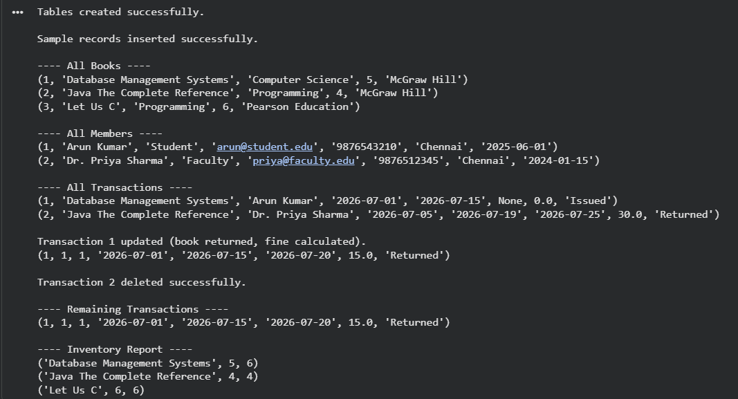

10. Result
The proposed database design successfully models the library's book, author, publisher, member, and transaction data with proper normalization, eliminating redundancy and ensuring data integrity through primary and foreign key constraints. The accompanying Python program demonstrates database connectivity using sqlite3, performing Create, Read, Update, and Delete operations, thereby validating that the schema supports efficient issue and return tracking, fine calculation, and inventory reporting for the library management system.

Scenario 8 - Employee Payroll Management System

1. Problem Statement
A manufacturing company employs hundreds of workers and administrative staff across multiple departments. The Human Resources department currently manages employee information and salary calculations manually using spreadsheets, which is inefficient and often leads to payroll errors, delays, and inconsistencies. The company requires a database-driven payroll system capable of storing employee details, department information, attendance records, salary structures, and tax deductions, and of generating accurate monthly payroll based on attendance and salary components.

2. Objectives
- To design a normalized relational database for employee and payroll management.
- To maintain accurate department-wise employee records.
- To record and track daily employee attendance.
- To store salary structures including basic pay, allowances, and deductions.
- To automate monthly payroll generation based on attendance and salary data.
- To implement database connectivity using Python for performing CRUD operations.

3. Entities
- Department
- Employee
- Attendance
- Salary_Structure
- Payroll

4. Attributes
Entity | Attributes
Department | department_id, department_name, location, manager_name
Employee | employee_id, employee_name, gender, date_of_birth, designation, date_of_joining, email, phone, department_id
Attendance | attendance_id, employee_id, attendance_date, status
Salary_Structure | salary_id, employee_id, basic_salary, hra, da, other_allowances
Payroll | payroll_id, employee_id, pay_month, pay_year, total_days, days_present, gross_salary, tax_deduction, net_salary, generated_date

5. Primary Keys
Entity | Primary Key
Department | department_id
Employee | employee_id
Attendance | attendance_id
Salary_Structure | salary_id
Payroll | payroll_id

6. Foreign Keys
Entity | Foreign Key | References
Employee | department_id | Department (department_id)
Attendance | employee_id | Employee (employee_id)
Salary_Structure | employee_id | Employee (employee_id)
Payroll | employee_id | Employee (employee_id)

7. Relationships
- A Department has many Employees, but each Employee belongs to exactly one Department (one-to-many).
- An Employee has many Attendance records, one for each working day (one-to-many).
- An Employee has exactly one Salary_Structure record defining basic pay and allowances (one-to-one).
- An Employee has many Payroll records, one generated for each month based on attendance and salary structure (one-to-many).

8. ER Diagram
Chain 1: Department - Employee

+----------------+
| DEPARTMENT |
+----------------+
|
1
|
employs
|
M
v
+----------------+
| EMPLOYEE |
+----------------+

Chain 2: Employee - Attendance

+----------------+
| EMPLOYEE |
+----------------+
|
1
|
records
|
M
v
+----------------+
| ATTENDANCE |
+----------------+

Chain 3: Employee - Salary_Structure

+----------------+
| EMPLOYEE |
+----------------+
|
1
|
has
|
1
v
+----------------+
|SALARY_STRUCTURE|
+----------------+

Chain 4: Employee - Payroll

+----------------+
| EMPLOYEE |
+----------------+
|
1
|
generates
|
M
v
+----------------+
| PAYROLL |
+----------------+

9. Database Schema (SQL)
Code 1 - SQL Database Schema
-- ===================================================================
-- Employee Payroll Management System - Database Schema
-- Run directly in SQLite / Google Colab using cursor.executescript()
-- ===================================================================

CREATE TABLE DEPARTMENT (
department_id INTEGER PRIMARY KEY AUTOINCREMENT,
department_name TEXT NOT NULL,
location TEXT,
manager_name TEXT
);

CREATE TABLE EMPLOYEE (
employee_id INTEGER PRIMARY KEY AUTOINCREMENT,
employee_name TEXT NOT NULL,
gender TEXT,
date_of_birth TEXT,
designation TEXT,
date_of_joining TEXT,
email TEXT,
phone TEXT,
department_id INTEGER,
FOREIGN KEY (department_id) REFERENCES DEPARTMENT(department_id)
);

CREATE TABLE ATTENDANCE (
attendance_id INTEGER PRIMARY KEY AUTOINCREMENT,
employee_id INTEGER,
attendance_date TEXT NOT NULL,
status TEXT CHECK (status IN ('Present','Absent','Leave')),
FOREIGN KEY (employee_id) REFERENCES EMPLOYEE(employee_id)
);

CREATE TABLE SALARY_STRUCTURE (
salary_id INTEGER PRIMARY KEY AUTOINCREMENT,
employee_id INTEGER UNIQUE,
basic_salary REAL NOT NULL,
hra REAL DEFAULT 0,
da REAL DEFAULT 0,
other_allowances REAL DEFAULT 0,
FOREIGN KEY (employee_id) REFERENCES EMPLOYEE(employee_id)
);

CREATE TABLE PAYROLL (
payroll_id INTEGER PRIMARY KEY AUTOINCREMENT,
employee_id INTEGER,
pay_month TEXT NOT NULL,
pay_year INTEGER NOT NULL,
total_days INTEGER,
days_present INTEGER,
gross_salary REAL,
tax_deduction REAL,
net_salary REAL,
generated_date TEXT,
FOREIGN KEY (employee_id) REFERENCES EMPLOYEE(employee_id)
);

Output Screenshot

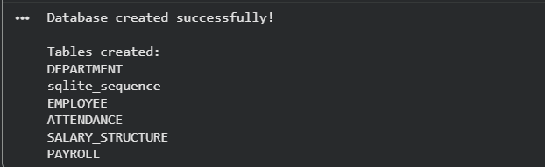

Code 2 - Python CRUD Program
# =====================================================================
# Employee Payroll Management System - Python CRUD Program (sqlite3)
# Single file. Google Colab compatible. No input() used.
# =====================================================================
import sqlite3

conn = sqlite3.connect("payroll.db")
cursor = conn.cursor()

# ---------------- CREATE TABLES ----------------
cursor.executescript("""
DROP TABLE IF EXISTS PAYROLL;
DROP TABLE IF EXISTS SALARY_STRUCTURE;
DROP TABLE IF EXISTS ATTENDANCE;
DROP TABLE IF EXISTS EMPLOYEE;
DROP TABLE IF EXISTS DEPARTMENT;

CREATE TABLE DEPARTMENT (
department_id INTEGER PRIMARY KEY AUTOINCREMENT,
department_name TEXT NOT NULL,
location TEXT,
manager_name TEXT
);

CREATE TABLE EMPLOYEE (
employee_id INTEGER PRIMARY KEY AUTOINCREMENT,
employee_name TEXT NOT NULL,
gender TEXT,
date_of_birth TEXT,
designation TEXT,
date_of_joining TEXT,
email TEXT,
phone TEXT,
department_id INTEGER,
FOREIGN KEY (department_id) REFERENCES DEPARTMENT(department_id)
);

CREATE TABLE ATTENDANCE (
attendance_id INTEGER PRIMARY KEY AUTOINCREMENT,
employee_id INTEGER,
attendance_date TEXT NOT NULL,
status TEXT CHECK (status IN ('Present','Absent','Leave')),
FOREIGN KEY (employee_id) REFERENCES EMPLOYEE(employee_id)
);

CREATE TABLE SALARY_STRUCTURE (
salary_id INTEGER PRIMARY KEY AUTOINCREMENT,
employee_id INTEGER UNIQUE,
basic_salary REAL NOT NULL,
hra REAL DEFAULT 0,
da REAL DEFAULT 0,
other_allowances REAL DEFAULT 0,
FOREIGN KEY (employee_id) REFERENCES EMPLOYEE(employee_id)
);

CREATE TABLE PAYROLL (
payroll_id INTEGER PRIMARY KEY AUTOINCREMENT,
employee_id INTEGER,
pay_month TEXT NOT NULL,
pay_year INTEGER NOT NULL,
total_days INTEGER,
days_present INTEGER,
gross_salary REAL,
tax_deduction REAL,
net_salary REAL,
generated_date TEXT,
FOREIGN KEY (employee_id) REFERENCES EMPLOYEE(employee_id)
);
""")
conn.commit()
print("Tables created successfully.\n")

# ---------------- INSERT SAMPLE RECORDS (CREATE) ----------------
cursor.executescript("""
INSERT INTO DEPARTMENT (department_name, location, manager_name) VALUES
('Production', 'Unit 1', 'Suresh Nair'),
('Human Resources', 'Head Office', 'Anita Rao'),
('Quality Control', 'Unit 2', 'Vikram Singh');

INSERT INTO EMPLOYEE (employee_name, gender, date_of_birth, designation, date_of_joining, email, phone, department_id) VALUES
('Ramesh Babu', 'Male', '1990-04-12', 'Machine Operator', '2018-03-01', 'ramesh@company.com', '9900011122', 1),
('Kavitha Iyer', 'Female', '1988-09-23', 'HR Executive', '2019-07-15', 'kavitha@company.com', '9900033344', 2),
('Suresh Pillai', 'Male', '1992-01-05', 'QC Inspector', '2020-11-20', 'suresh@company.com', '9900055566', 3);

INSERT INTO ATTENDANCE (employee_id, attendance_date, status) VALUES
(1, '2026-07-01', 'Present'),
(1, '2026-07-02', 'Absent'),
(2, '2026-07-01', 'Present'),
(3, '2026-07-01', 'Leave');

INSERT INTO SALARY_STRUCTURE (employee_id, basic_salary, hra, da, other_allowances) VALUES
(1, 18000, 4000, 2000, 1000),
(2, 25000, 6000, 3000, 1500),
(3, 20000, 5000, 2500, 1200);

INSERT INTO PAYROLL (employee_id, pay_month, pay_year, total_days, days_present, gross_salary, tax_deduction, net_salary, generated_date) VALUES
(1, 'July', 2026, 26, 24, 23000, 1200, 21800, '2026-07-31'),
(2, 'July', 2026, 26, 26, 35500, 2000, 33500, '2026-07-31');
""")
conn.commit()
print("Sample records inserted successfully.\n")

# ---------------- READ ----------------
print("---- All Employees ----")
cursor.execute("""
SELECT EMPLOYEE.employee_id, EMPLOYEE.employee_name, EMPLOYEE.designation, DEPARTMENT.department_name
FROM EMPLOYEE
JOIN DEPARTMENT ON EMPLOYEE.department_id = DEPARTMENT.department_id
""")
for row in cursor.fetchall():
print(row)

print("\n---- Salary Structures ----")
cursor.execute("SELECT * FROM SALARY_STRUCTURE")
for row in cursor.fetchall():
print(row)

print("\n---- Payroll Records ----")
cursor.execute("""
SELECT PAYROLL.payroll_id, EMPLOYEE.employee_name, PAYROLL.pay_month, PAYROLL.pay_year,
PAYROLL.days_present, PAYROLL.gross_salary, PAYROLL.tax_deduction, PAYROLL.net_salary
FROM PAYROLL
JOIN EMPLOYEE ON PAYROLL.employee_id = EMPLOYEE.employee_id
""")
for row in cursor.fetchall():
print(row)

# ---------------- UPDATE ----------------
cursor.execute("""
UPDATE SALARY_STRUCTURE
SET basic_salary = basic_salary + 2000
WHERE employee_id = 1
""")
conn.commit()
print("\nSalary structure updated for employee_id 1 (increment applied).")

cursor.execute("SELECT * FROM SALARY_STRUCTURE WHERE employee_id = 1")
print(cursor.fetchone())

cursor.execute("""
INSERT INTO PAYROLL (employee_id, pay_month, pay_year, total_days, days_present, gross_salary, tax_deduction, net_salary, generated_date)
VALUES (3, 'July', 2026, 26, 25, 28700, 1500, 27200, '2026-07-31')
""")
conn.commit()
print("\nPayroll generated for employee_id 3.")

# ---------------- DELETE ----------------
cursor.execute("DELETE FROM ATTENDANCE WHERE employee_id = 1 AND attendance_date = '2026-07-02'")
conn.commit()
print("\nAttendance record deleted for employee_id 1 on 2026-07-02.")

print("\n---- Remaining Attendance Records ----")
cursor.execute("SELECT * FROM ATTENDANCE")
for row in cursor.fetchall():
print(row)

# ---------------- FINAL PAYROLL REPORT ----------------
print("\n---- Final Payroll Report ----")
cursor.execute("""
SELECT EMPLOYEE.employee_name, PAYROLL.pay_month, PAYROLL.pay_year, PAYROLL.net_salary
FROM PAYROLL
JOIN EMPLOYEE ON PAYROLL.employee_id = EMPLOYEE.employee_id
""")
for row in cursor.fetchall():
print(row)

conn.close()

Output Screenshot

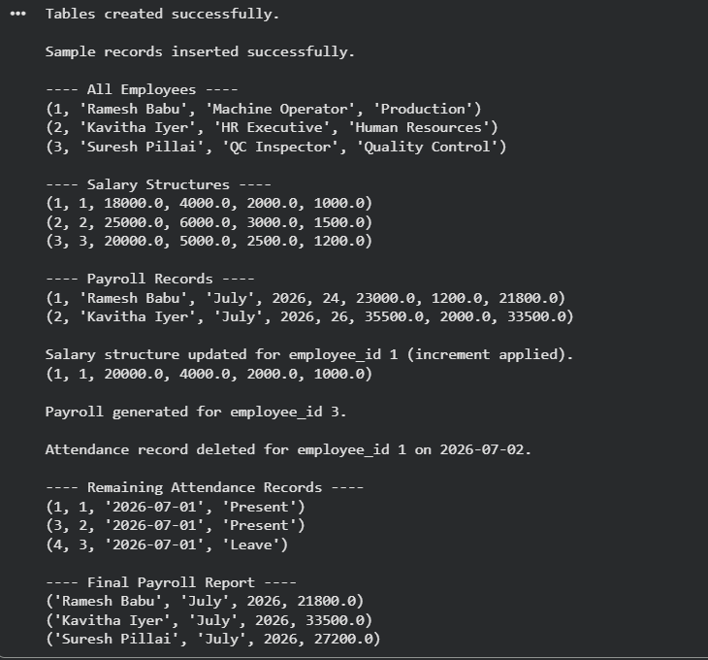

10. Result
The designed database schema normalizes employee, department, attendance, salary, and payroll data, ensuring referential integrity through primary and foreign key relationships. The Python application demonstrates successful database connectivity using sqlite3, performing Create, Read, Update, and Delete operations on employee and payroll records. This confirms that the schema and program together provide an efficient, error-free solution for automating monthly payroll processing based on attendance and salary structure.

