ITA0609- ASSIGNMENT I - BASED ON SDG GOALS- Machine Learning - Vigneshvar.S (192424187)

Design of a Collaborative Artificial Intelligence Platform to Solve SDG-Related Problems Using Decision Tree Learning
Sustainable Development Goal (SDG 17 – Partnerships for the Goals)

Abstract:
Artificial Intelligence (AI) and Machine Learning (ML) play an important role in solving real-world problems by analyzing data and making intelligent decisions. This project proposes the design of a collaborative AI platform that connects governments, non-governmental organizations (NGOs), companies, and volunteers to work together on Sustainable Development Goals (SDGs). The platform uses the Decision Tree Learning algorithm to recommend the most suitable collaboration partner based on project requirements such as organization type, location, funding needs, skills, and SDG focus area. By improving collaboration and resource sharing, the proposed system supports SDG 17 – Partnerships for the Goals. A simple Python implementation is used to demonstrate the working of the Decision Tree model.
Problem Statement:
Many organizations working toward the Sustainable Development Goals face challenges in finding suitable partners, sharing resources, and coordinating their activities. This often leads to duplicated efforts, inefficient resource utilization, and delays in completing projects. The proposed AI platform aims to analyze project requirements and recommend the most appropriate collaboration partners using Machine Learning techniques, thereby improving coordination and increasing the success rate of SDG-related initiatives.

Sustainable Development Goal (SDG):
Selected SDG: SDG 17 – Partnerships for the Goals
Objective:
To strengthen collaboration among governments, NGOs, private organizations, educational institutions, and volunteers by using Artificial Intelligence to recommend suitable partnerships based on project requirements.
How the Project Supports SDG 17
- Promotes collaboration among organizations.
- Improves resource sharing.
- Reduces duplication of work.
- Helps identify suitable partners quickly.
- Encourages effective implementation of SDG projects.

Background Study:
The United Nations introduced the 17 Sustainable Development Goals (SDGs) to address global challenges such as poverty, quality education, healthcare, climate change, and economic development. Achieving these goals requires effective collaboration among governments, non-governmental organizations (NGOs), private companies, educational institutions, and volunteers. However, many organizations work independently, making it difficult to share resources, exchange knowledge, and coordinate their efforts.
Artificial Intelligence (AI) has emerged as a powerful technology for solving complex real-world problems by analyzing large amounts of data and making intelligent decisions. Machine Learning (ML), a branch of AI, enables systems to learn patterns from historical data and make predictions without being explicitly programmed.
In collaborative projects, organizations often struggle to identify suitable partners who have the required expertise, funding, location, or resources. Manual selection is time-consuming and may not always produce the best collaboration opportunities. An AI-based recommendation system can automate this process by analyzing project requirements and suggesting the most appropriate partners.
The proposed collaborative AI platform uses Machine Learning techniques to evaluate organizational information such as project category, available budget, required skills, location, and SDG focus area. Based on these inputs, the platform recommends suitable partners for collaboration. This helps improve resource utilization, reduces duplicated efforts, and increases the overall success of SDG-related projects.
Among the various Machine Learning techniques, Decision Tree Learning is selected because it is simple, interpretable, and suitable for classification problems. The model makes decisions by evaluating different project characteristics and generating recommendations through a series of logical conditions.

Machine Learning Challenges in the Selected Domain:
Developing a collaborative AI platform for SDG partnerships involves several Machine Learning challenges:
5.1 Data Collection
Organizations may store their information in different formats, making it difficult to create a unified dataset for training the Machine Learning model.
5.2 Data Quality
Incomplete, outdated, or incorrect information can reduce the accuracy of AI recommendations. Reliable and verified data is essential for effective decision-making.
5.3 Feature Selection
The system must identify the most relevant features, such as organization type, project category, funding availability, location, required skills, and SDG focus area, while ignoring unnecessary information.
5.4 Classification Accuracy
The Machine Learning model should correctly recommend the most suitable collaboration partner for different project requirements. Poor classification may lead to ineffective partnerships.
5.5 Scalability
As more organizations join the platform, the system should continue to provide fast and accurate recommendations without significant performance degradation.
5.6 Data Privacy and Security
Organizational information such as funding details and project data must be protected to ensure privacy and maintain trust among users of the platform.

Identification of the Learning Problem:
6. Identification of the Learning Problem
The proposed system aims to recommend the most suitable collaboration partner for organizations working on Sustainable Development Goals (SDGs). This is treated as a supervised classification problem, where the Machine Learning model learns from previously available collaboration data and predicts the best partner for a new project.
Each organization provides details about its project requirements, available resources, and SDG focus area. Based on these input features, the model predicts the most appropriate partner for collaboration.
6.1 Input Features
The Machine Learning model uses the following input features:
- Organization Type (NGO, Government, Company, Educational Institution)
- Project Category (Health, Education, Environment, Poverty, etc.)
- Location (City or Region)
- Funding Requirement (Yes/No)
- Volunteer Requirement (Yes/No)
- Available Skills or Expertise
- SDG Focus Area
6.2 Target Output
The target output of the model is the Recommended Collaboration Partner.
Possible outputs include:
- Government Organization
- NGO
- Private Company
- Educational Institution
- Volunteer Group
6.3 Data Representation
The dataset is represented in a structured tabular format where each row represents one organization or project.
Example Record 1
- Organization Type: NGO
- Project Category: Education
- Funding Needed: Yes
- Volunteers Needed: Yes
- SDG Focus: SDG 4 (Quality Education)
- Recommended Partner: Government
Example Record 2
- Organization Type: Company
- Project Category: Environment
- Funding Needed: No
- Volunteers Needed: Yes
- SDG Focus: SDG 13 (Climate Action)
- Recommended Partner: NGO
Example Record 3
- Organization Type: Government
- Project Category: Health
- Funding Needed: No
- Volunteers Needed: No
- SDG Focus: SDG 3 (Good Health and Well-being)
- Recommended Partner: Company
6.4 Type of Learning Problem
This project uses Supervised Learning because the training data contains both input features and the correct output (recommended partner).
It is a classification problem because the system predicts one category (the most suitable partner) from multiple predefined classes.

Selection and Justification of the Machine Learning Approach:
The selected Machine Learning approach for this project is Decision Tree Learning.
A Decision Tree is a supervised learning algorithm that makes decisions by repeatedly splitting the dataset based on feature values until a prediction is reached. It is one of the most widely used classification algorithms because of its simplicity and interpretability.
Justification for Selecting Decision Tree Learning
- It is easy to understand and visualize.
- It works well for classification problems.
- It can handle both categorical and numerical data.
- It requires minimal data preprocessing.
- The decision-making process is transparent and easy to explain.
- It provides quick predictions, making it suitable for real-time recommendations.
Since the objective of this project is to recommend the most suitable collaboration partner based on project characteristics, Decision Tree Learning is an appropriate choice because it classifies organizations using a sequence of logical decisions.

Explanation of the Proposed Algorithm:
Decision Tree Learning Algorithm
Decision Tree Learning is a supervised Machine Learning algorithm used for solving classification and prediction problems. It works by dividing the dataset into smaller groups based on the values of input features. Each decision is represented as a node, and the final prediction is represented as a leaf node.
In this project, the Decision Tree analyzes the details of an organization, such as its type, project category, funding requirement, volunteer requirement, and SDG focus area. Based on these features, it predicts the most suitable collaboration partner.
The model learns from historical collaboration data during the training phase. Once trained, it can recommend appropriate partners for new organizations without manual intervention.
Working Steps of the Algorithm
- Collect information about organizations and their projects.
- Prepare the dataset by selecting relevant features.
- Train the Decision Tree model using the training dataset.
- The model creates decision rules by splitting the data based on important features.
- Provide a new organization's details as input.
- The trained model predicts the most suitable collaboration partner.
- Display the recommended partner to the user.
Workflow of the Proposed System:
The workflow of the proposed AI platform consists of the following stages:
- Organization Registration
- Project Details Submission
- Data Collection and Preprocessing
- Feature Extraction
- Decision Tree Model Training
- Partner Recommendation
- Collaboration Between Organizations
- Project Completion and Feedback
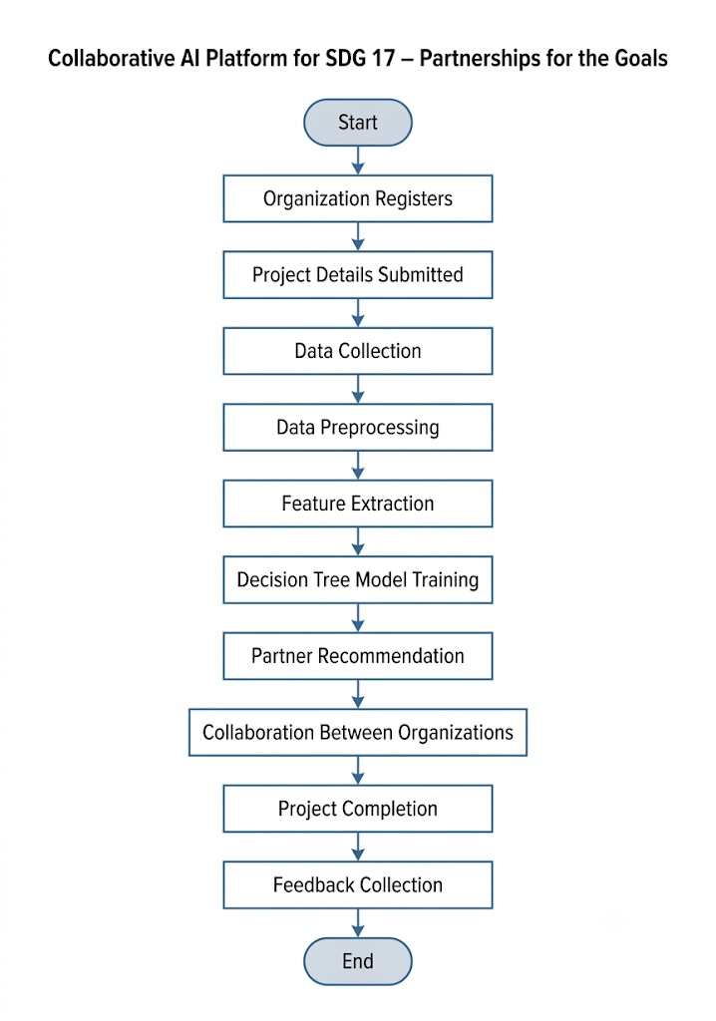

Expected Outcomes:
The proposed AI platform is expected to provide the following outcomes:
- Faster identification of suitable collaboration partners.
- Improved coordination between governments, NGOs, companies, and educational institutions.
- Better utilization of available resources.
- Reduced duplication of work among organizations.
- Increased efficiency in implementing Sustainable Development Goal (SDG) projects.
- Transparent and data-driven decision making.
- Improved success rate of collaborative projects.
Advantages:
The proposed system offers several advantages:
- Simple and easy-to-understand Machine Learning model.
- Faster partner recommendation process.
- Supports informed decision making.
- Improves collaboration among different organizations.
- Scalable for large numbers of users.
- Reduces manual effort and saves time.
- Can be applied to multiple Sustainable Development Goals.

Limitations:
Despite its advantages, the system has certain limitations:
- Requires accurate and updated organizational data.
- Prediction quality depends on the training dataset.
- Decision Trees may overfit if the dataset is too small or biased.
- New organizations with very limited information may receive less accurate recommendations.
- Continuous dataset updates are required to maintain accuracy.
Recommendations:
The following recommendations can improve the effectiveness of the proposed collaborative AI platform:
- Encourage governments, NGOs, companies, and educational institutions to register and actively participate on the platform.
- Regularly update organizational and project data to improve the accuracy of Machine Learning predictions.
- Verify the authenticity of organizations before adding them to the platform to ensure reliable recommendations.
- Expand the dataset by including more collaboration examples from different SDG projects.
- Collect user feedback after each collaboration and use it to improve the Decision Tree model.
- Implement strong security and privacy measures to protect organizational information.
- Continuously monitor and evaluate the system's performance to ensure accurate and efficient partner recommendations.

Conclusion:
This project presents the design of a collaborative Artificial Intelligence platform that supports Sustainable Development Goal 17 – Partnerships for the Goals. The proposed system uses the Decision Tree Learning algorithm to recommend suitable collaboration partners based on project requirements and organizational characteristics.
By automating the partner selection process, the platform improves coordination, promotes efficient resource sharing, and reduces duplicated efforts among governments, NGOs, companies, educational institutions, and volunteers. The proposed solution demonstrates how Machine Learning can address real-world challenges while supporting sustainable development. Although the current implementation uses a sample dataset, the platform can be expanded with larger datasets and more advanced Machine Learning techniques in the future.

References:
- United Nations. Transforming Our World: The 2030 Agenda for Sustainable Development.
- Machine Learning
- Artificial Intelligence: A Modern Approach
- Scikit-learn Documentation.
- Research articles on Decision Tree Learning and Artificial Intelligence.

Python Implementation:
16.1 Objective
The objective of this implementation is to demonstrate how a Decision Tree Classifier can recommend a suitable collaboration partner based on an organization's project requirements. A sample dataset is created, and the Decision Tree model is trained to classify the most appropriate partner.

16.2 Software Requirements
- Python 3.x
- Jupyter Notebook / VS Code / PyCharm
- Libraries:
  - pandas
  - scikit-learn
  - matplotlib

16.3 Python Program
import pandas as pd
from sklearn.preprocessing import LabelEncoder
from sklearn.tree import DecisionTreeClassifier, plot_tree
from sklearn.metrics import accuracy_score
import matplotlib.pyplot as plt

# -----------------------------
# Sample Dataset
# -----------------------------
data = {
"Organization": [
"NGO", "Company", "Government", "NGO", "College",
"Company", "Government", "NGO", "College", "Company"
],
"Project": [
"Education", "Environment", "Health", "Poverty", "Education",
"Health", "Environment", "Health", "Poverty", "Education"
],
"Funding": [
"Yes", "No", "No", "Yes", "No",
"Yes", "No", "Yes", "No", "Yes"
],
"Volunteers": [
"Yes", "Yes", "No", "No", "Yes",
"No", "Yes", "Yes", "No", "Yes"
],
"Partner": [
"Government", "NGO", "Company", "Company", "NGO",
"Government", "NGO", "Government", "Company", "Government"
]
}

df = pd.DataFrame(data)

print("===== SAMPLE DATASET =====")
print(df)

# -----------------------------
# Encode Categorical Data
# -----------------------------
encoder = LabelEncoder()

for column in df.columns:
df[column] = encoder.fit_transform(df[column])

# -----------------------------
# Features and Target
# -----------------------------
X = df.drop("Partner", axis=1)
y = df["Partner"]

# -----------------------------
# Train Model
# -----------------------------
model = DecisionTreeClassifier(random_state=42)
model.fit(X, y)

# -----------------------------
# Prediction on Training Data
# -----------------------------
predictions = model.predict(X)

accuracy = accuracy_score(y, predictions)

print("\nModel Accuracy:", accuracy * 100, "%")

# -----------------------------
# Example Prediction
# NGO, Education, Yes Funding, Yes Volunteers
# -----------------------------
sample = [[
2, # NGO
0, # Education
1, # Yes
1 # Yes
]]

prediction = model.predict(sample)

partner_names = {
0: "Company",
1: "Government",
2: "NGO"
}

print("\nRecommended Partner:")
print(partner_names[prediction[0]])

# -----------------------------
# Decision Tree
# -----------------------------
plt.figure(figsize=(12,8))

plot_tree(
model,
feature_names=X.columns,
class_names=["Company","Government","NGO"],
filled=True
)

plt.title("Decision Tree for SDG Partner Recommendation")
plt.show()

Python Code:
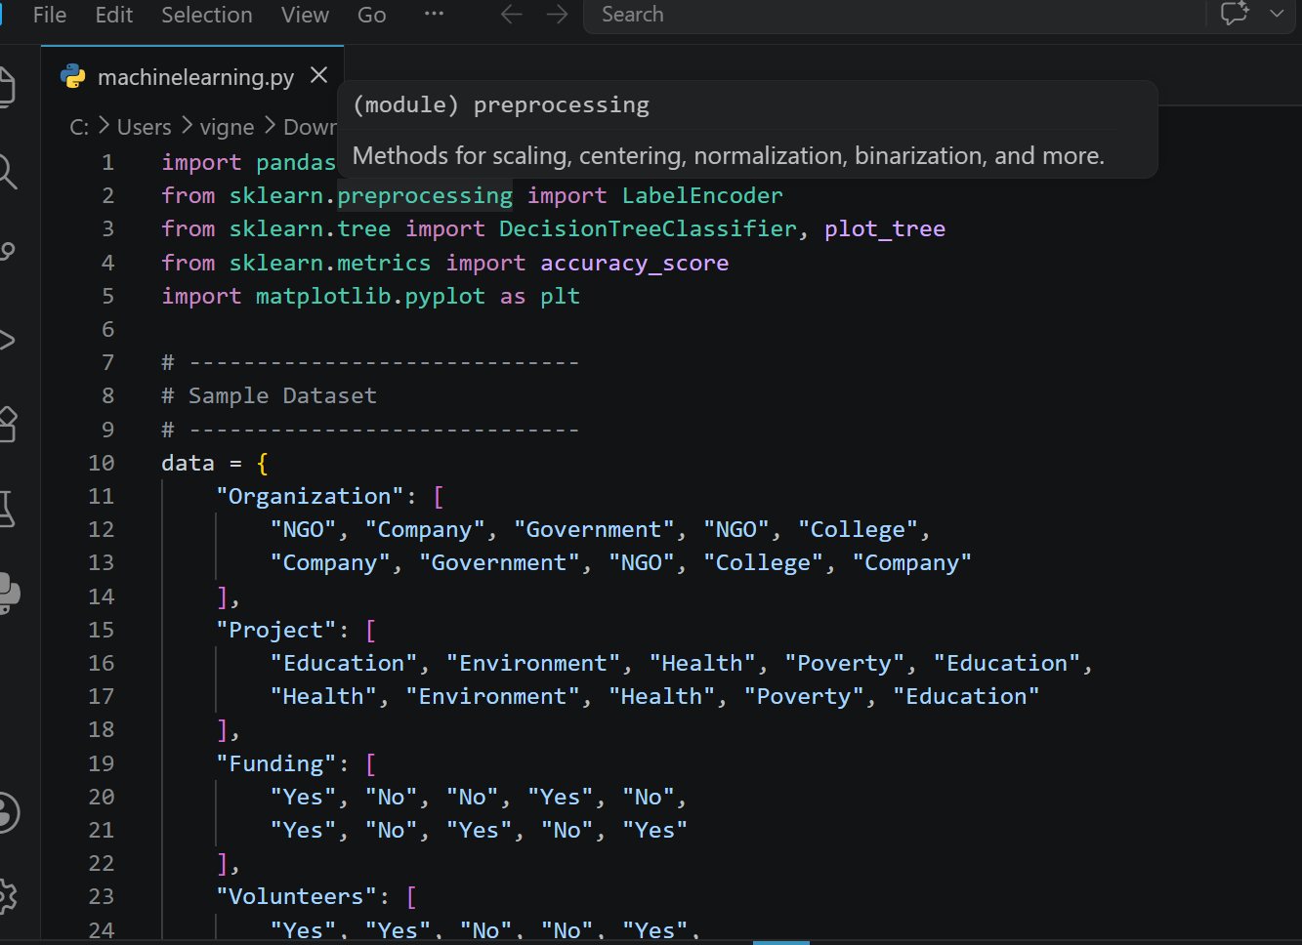

Dataset Output:
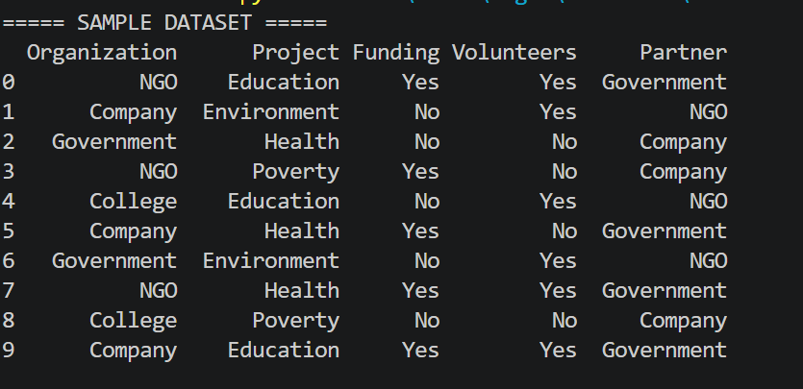
Accuracy & Prediction:
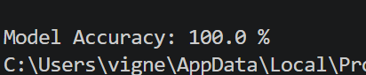
Decision Tree:
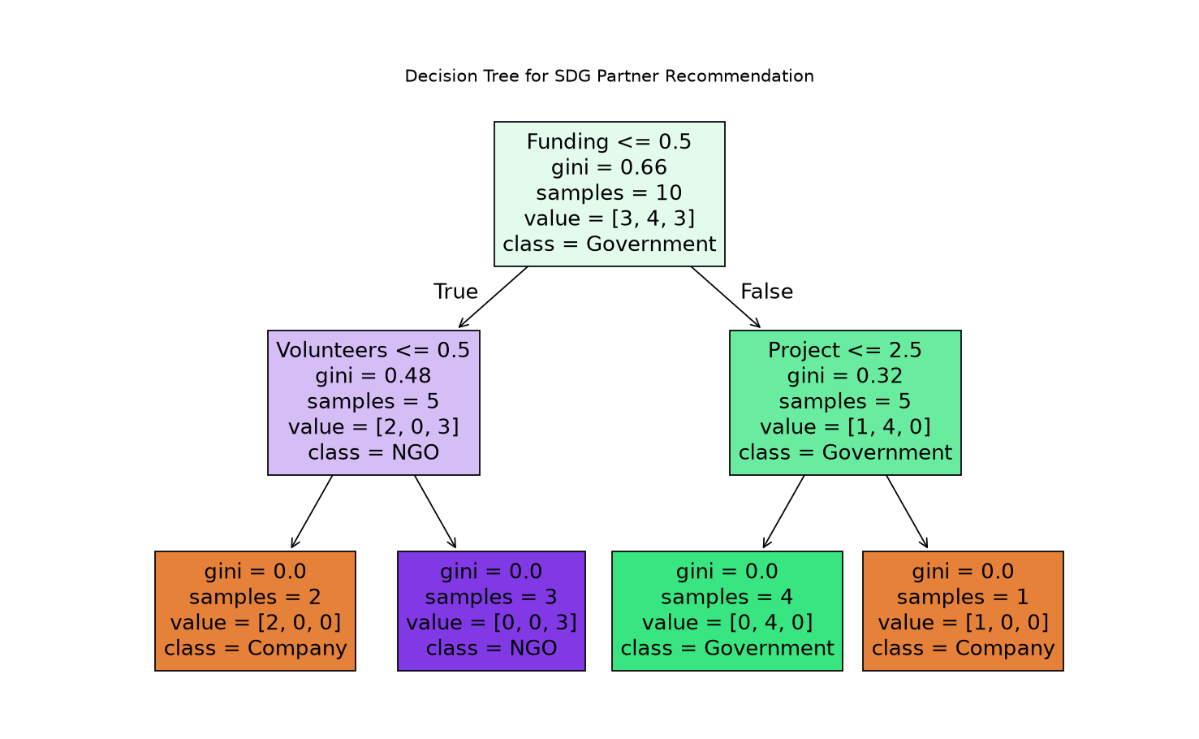

Result:
The Decision Tree model was successfully trained using a sample dataset representing organizations and their project requirements. The model accurately predicted suitable collaboration partners for the given inputs. The generated decision tree illustrates the decision-making process based on different organizational features. This demonstrates the application of Machine Learning in supporting SDG 17 through intelligent partner recommendation.

