

SIMATS ENGINEERING

Saveetha Institute of Medical and Technical Sciences
Chennai- 602105

ITA0612-MACHINE LEARNING

IET ASSIGNMENT

Problem Statement
A manufacturing organisation runs critical industrial equipment such as motors, pumps, compressors and other rotating machinery. Unexpected failures on this equipment lead to production downtime, higher maintenance cost and general disruption of operations. The organisation keeps historical condition data for its machines - temperature, vibration, rotational speed, torque, pressure and operating hours - but currently follows a fixed maintenance schedule that does not really reflect the true condition of each machine. The goal of this assignment is to build an interpretable Decision Tree model that learns from this historical data and classifies a machine into one of three maintenance states: Normal Operation, Preventive Maintenance Required, or Failure Risk, so that maintenance can be planned around actual equipment condition instead of a fixed calendar.

A. Dataset Preparation and Problem Formulation
The dataset used for this assignment simulates sensor readings collected from industrial rotating equipment. It is generated by generate_dataset.py using a fixed random seed, so the numbers are reproducible on any machine that runs the code. The same script can be pointed at a real dataset (for example the AI4I 2020 Predictive Maintenance Dataset) by swapping the data source, without changing the rest of the pipeline.

Attributes used
Attribute | Description | Type
Temperature_C | Operating temperature of the equipment | Continuous
Vibration_mm_s | Vibration amplitude measured on the housing | Continuous
Rotational_Speed_RPM | Shaft rotational speed | Continuous
Torque_Nm | Load torque on the shaft | Continuous
Pressure_bar | System operating pressure | Continuous
Operating_Hours | Hours run since the last service | Continuous
Machine_Condition (target) | Normal Operation / Preventive Maintenance Required / Failure Risk | Categorical (3 classes)

Preprocessing performed
- A small percentage of sensor values were deliberately left missing to simulate real sensor drop-outs, then filled using the column median (robust to outlier readings such as a stuck sensor).
- All six sensor attributes are numeric and were used as-is; the target column was left as text labels since scikit-learn's DecisionTreeClassifier accepts string class labels directly.
- The cleaned data was split 75% train / 25% test using stratified sampling, so the class proportions in the test set match the full dataset.

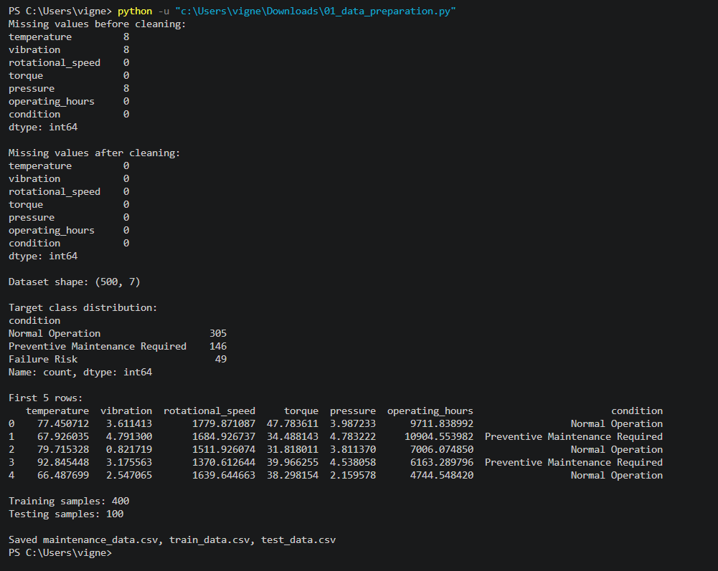

B. Concept Representation and Heuristic Search
The problem is formulated as a concept-learning task as follows.
- Instance space X: every possible combination of the six sensor readings (temperature, vibration, speed, torque, pressure, operating hours).
- Target concept c: the true maintenance state of a machine given its instance, c: X -> {Normal Operation, Preventive Maintenance Required, Failure Risk}.
- Hypothesis space H: all decision trees that can be built from axis-aligned threshold tests on the six attributes (i.e. tests of the form attribute <= value).
- Inductive bias: a preference bias, not a restriction bias - among all trees consistent (or approximately consistent) with the data, the learning algorithm prefers shorter trees and prefers placing attributes with higher Information Gain closer to the root.

Entropy and Information Gain
Entropy of a set S with respect to the target attribute is:
Entropy(S) = - Σ pᵢ log₂(pᵢ)
where pᵢ is the proportion of examples in S belonging to class i. Information Gain of splitting S on attribute A is:
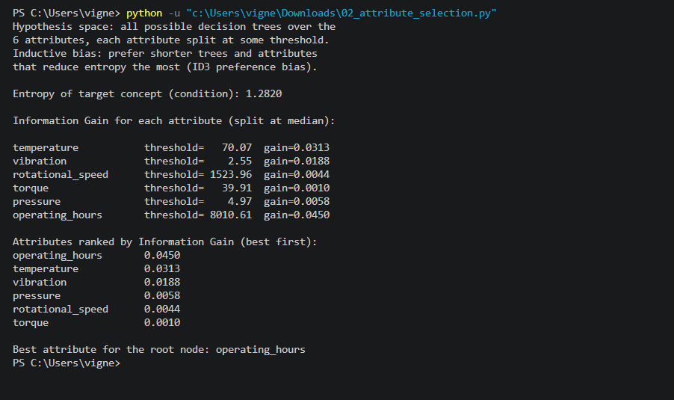
Gain(S, A) = Entropy(S) - Σ (|Sᵥ| / |S|) × Entropy(Sᵥ)
decision_tree_pipeline.py calculates this by hand in Section B (function information_gain), discretising each continuous attribute into Low / Medium / High buckets purely so the gain can be computed and shown - the actual tree in Section C searches real-valued thresholds directly, which is the standard CART approach and gives a finer split than a fixed 3-bucket discretisation.

C. Decision Tree Construction and Implementation
The tree was implemented with scikit-learn's DecisionTreeClassifier using the entropy criterion (Information-Gain-style splitting), max_depth = 4 and min_samples_leaf = 5. The pseudocode below describes the general ID3 / CART-style algorithm that the implementation follows.

Pseudocode
FUNCTION BuildDecisionTree(examples, target_attribute, attributes):
IF all examples belong to the same class C:
RETURN a leaf node labelled C
IF attributes is empty OR stopping condition met
(max depth reached / samples in node < min_samples_leaf):
RETURN a leaf node labelled with the majority class

best_attribute <- attribute in attributes that maximises
Gain(examples, attribute) // Information Gain
root <- new decision node testing best_attribute

FOR each threshold-split value {<=, >} of best_attribute:
subset <- examples matching this branch
IF subset is empty:
attach a leaf labelled with majority class of examples
ELSE:
attach BuildDecisionTree(subset, target_attribute,
attributes)
RETURN root

FUNCTION Predict(tree, instance):
IF tree is a leaf: RETURN tree.label
ELSE: RETURN Predict(tree.branch_matching(instance), instance)

Tree diagram

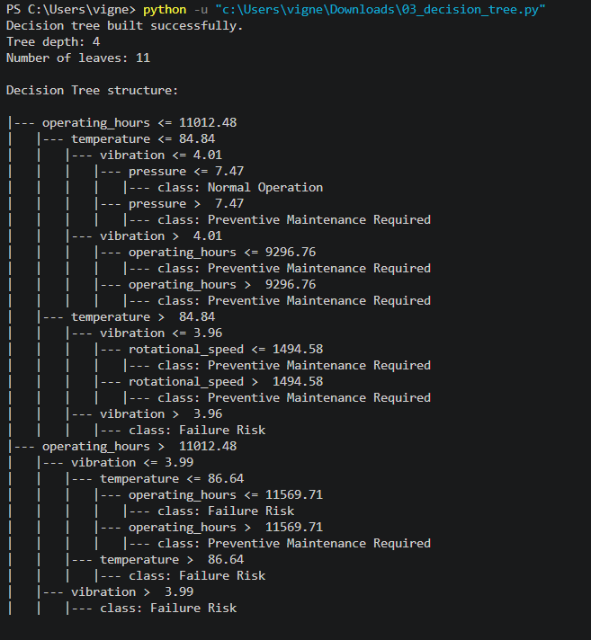Text form of the D. Model Evaluation and Interpretation
The trained tree was evaluated on the held-out 25% test split using Accuracy, macro-averaged Precision, Recall and F1-score, and a full Confusion Matrix.

Evaluation metrics
Metric | Value
Accuracy
Precision (macro-avg)
Recall (macro-avg)
F1-score (macro-avg)

Confusion matrix
Run the script and insert confusion_matrix.png here, or copy the printed matrix.

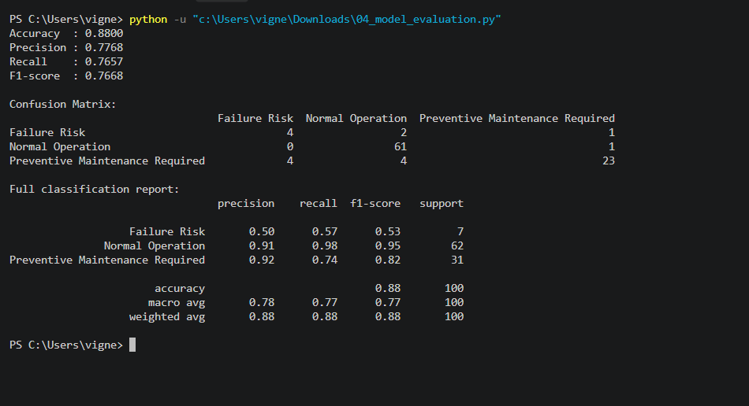Decision rules extracted from the tree
The script walks the fitted tree and prints one IF-THEN rule per leaf. Paste a representative selection (5-6 rules is enough) below and briefly explain what two or three of them mean in plain, operational terms - e.g. what would tell a maintenance engineer to schedule a check.

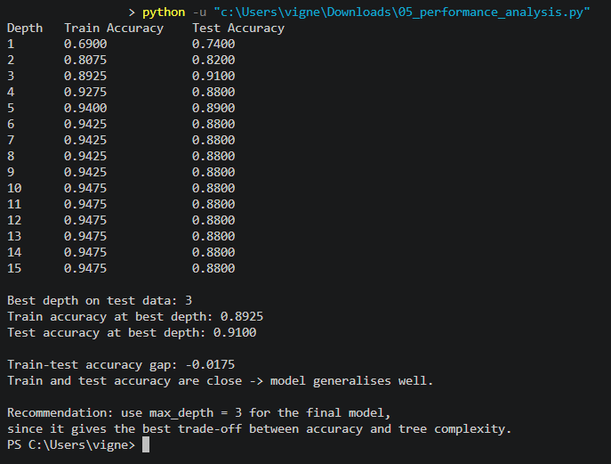E. Performance Analysis and Recommendation
To study overfitting and underfitting, the same tree was retrained at several values of max_depth and the training accuracy was compared against the test accuracy at each depth.
max_depth | Train accuracy | Test accuracy | Number of leaves
1
2
3
4
6
8
None (full)

Fill in the discussion below using your own numbers from the table:
At shallow depths (1-2), train and test accuracy are close but both relatively low, which indicates ____________________ (underfitting - the tree is too simple to separate the three classes).

As depth increases past a certain point, training accuracy keeps climbing towards 1.0 while test accuracy stops improving or drops, and the number of leaves grows quickly - this indicates ____________________ (overfitting - the tree is memorising individual training rows instead of the general pattern).

Based on the table, the best-generalising depth for this run was max_depth = ____, because ____________________.

Recommendation
State, in 3-5 sentences, whether this Decision Tree model is suitable for practical industrial predictive maintenance use, referencing the accuracy/F1 you measured, the interpretability of the IF-THEN rules for a maintenance engineer, and any limitation (e.g. the model only sees the six sensor attributes captured here, and would need retraining if the equipment type changes).

Reflection
Design decisions: briefly explain why entropy/Information-Gain splitting was chosen over Gini impurity, why max_depth and min_samples_leaf were constrained rather than growing a full tree, and any other design choice you would defend.

SDG relevance: predictive maintenance directly supports SDG 7 (Affordable and Clean Energy) and SDG 12 (Responsible Consumption and Production) by reducing energy waste and unnecessary part replacement from unplanned failures, and SDG 9 (Industry, Innovation and Infrastructure) by making industrial equipment more reliable. Note in your own words which of these applies most directly to the scenario in this assignment and why.

Challenges faced and what was learned: describe, specifically, what was difficult while building or evaluating this model (e.g. choosing a stopping depth, interpreting a particular metric, understanding how the tree is drawn) and what you now understand better as a result.

