ITA0609-C01-AT02 - Machine Learning - Vigneshvar.S (192424187)

1. Design a machine learning system for health
analysis to predict diseases such as heart disease or diabetes using patient
data including age, blood pressure, glucose level, and lifestyle factors.
Explain the choice of suitable algorithms and justify their selection. Describe
the steps involved in data preprocessing, feature selection, and model training
to ensure accurate and reliable predictions.
Code:
# Question 1: Disease Prediction using Machine Learning
import pandas as pd
from sklearn.model_selection import train_test_split
from sklearn.tree import DecisionTreeClassifier
from sklearn.metrics import accuracy_score
# Sample dataset
data = {
"Age": [25, 45, 50, 35, 60, 40, 55, 30],
"BloodPressure": [120, 140, 150, 130, 160, 145, 155, 125],
"Glucose": [90, 160, 180, 110, 200, 170, 190, 95],
"Lifestyle": [0, 1, 1, 0, 1, 1, 1, 0], # 0 = Healthy, 1 = Unhealthy
"Disease": [0, 1, 1, 0, 1, 1, 1, 0] # 0 = No Disease, 1 = Disease
}
df = pd.DataFrame(data)
# Features and Target
X = df[["Age", "BloodPressure", "Glucose", "Lifestyle"]]
y = df["Disease"]
# Split dataset
X_train, X_test, y_train, y_test = train_test_split(
X, y, test_size=0.25, random_state=42
)
# Train model
model = DecisionTreeClassifier()
model.fit(X_train, y_train)
# Prediction
predictions = model.predict(X_test)
# Accuracy
accuracy = accuracy_score(y_test, predictions)
print("Disease Prediction using Decision Tree")
print("--------------------------------------")
print("Accuracy:", round(accuracy * 100, 2), "%")
print("\nChosen Algorithm: Decision Tree")
print("Reason: Easy to understand, handles medical data well, and works for classification problems.")
print("\nData Preprocessing Steps:")
print("1. Handle missing values")
print("2. Remove duplicate records")
print("3. Encode categorical data")
print("4. Normalize numerical values")
print("\nFeature Selection:")
print("- Age")
print("- Blood Pressure")
print("- Glucose Level")
print("- Lifestyle")
print("\nModel Training:")
print("1. Split dataset into training and testing data")
print("2. Train Decision Tree model")
print("3. Predict test data")
print("4. Evaluate using accuracy")
Output:
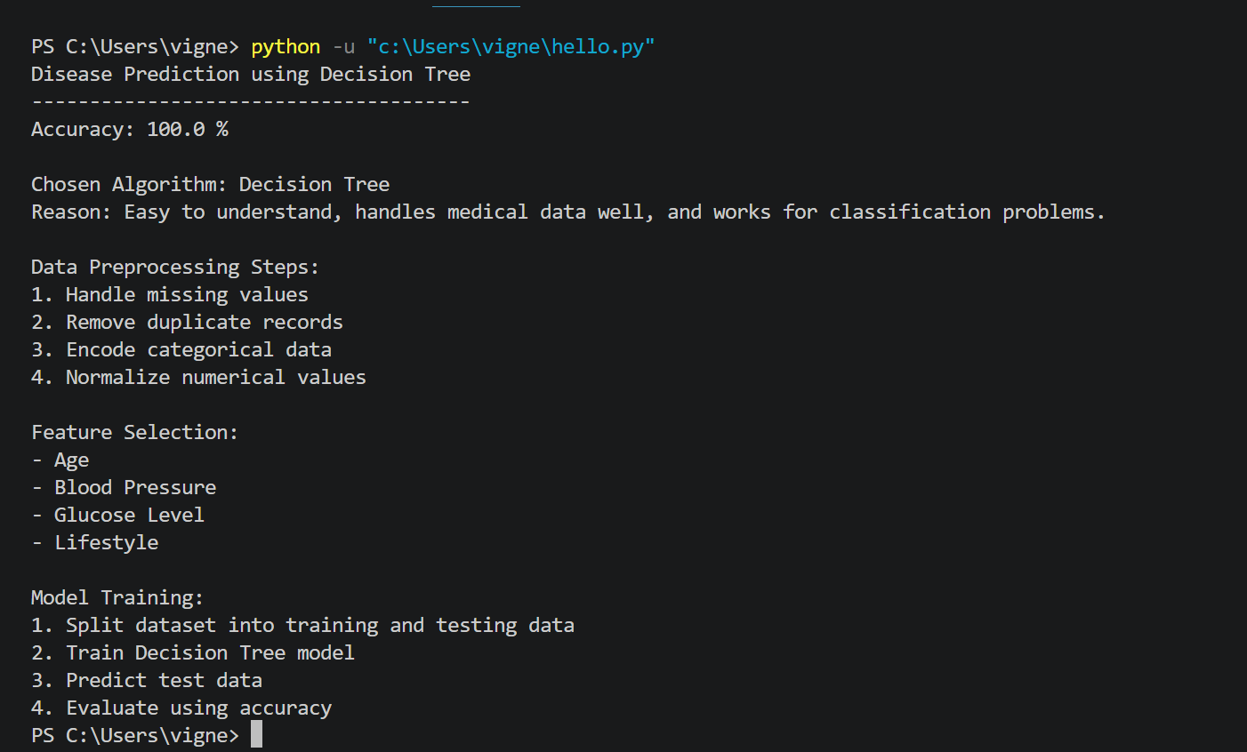

2. In the context of the Find-S algorithm,
consider a dataset used to determine whether a loan should be approved based on
attributes such as Employment Status, Salary Level, Credit Score, and Loan
History. Apply the Find-S algorithm to derive the most specific hypothesis
consistent with the positive examples.
Code:
# Find-S Algorithm
# Dataset
data = [
["Employed", "High", "Good", "Clean", "Yes"],
["Employed", "Medium", "Good", "Clean", "Yes"],
["Unemployed", "Low", "Poor", "Bad", "No"],
["Employed", "Medium", "Excellent", "Clean", "Yes"]
]
# Initialize hypothesis
hypothesis = ["0", "0", "0", "0"]
# Apply Find-S
for row in data:
if row[-1] == "Yes":
for i in range(len(hypothesis)):
if hypothesis[i] == "0":
hypothesis[i] = row[i]
elif hypothesis[i] != row[i]:
hypothesis[i] = "?"
print("Final Hypothesis:")
attributes = ["Employment", "Salary", "Credit Score", "Loan History"]
for attribute, value in zip(attributes, hypothesis):
print(f"{attribute}: {value}")

Output:
