ITA0609-C02-AT01 - Machine Learning - Vigneshvar.S (192424187)

1.A Genetic Algorithm is applied to maximize the function f(x) = x² using an initial population consisting of the values 2, 4, 6, and 8. Determine the fitness value for each individual in the population and select the best candidates based on their fitness scores. Perform a crossover operation by exchanging the least significant bits of the selected individuals to generate new offspring. Additionally, explain the role of mutation in improving the diversity and effectiveness of the solution in Genetic Algorithms.

Code:
# Genetic Algorithm Example

# Initial population
population = [2, 4, 6, 8]

# Fitness function: f(x) = x^2
fitness = []

print("Initial Population and Fitness:")
for x in population:
fit = x ** 2
fitness.append(fit)
print(f"x = {x}, Fitness = {fit}")

# Select the best two individuals
sorted_population = sorted(zip(population, fitness), key=lambda x: x[1], reverse=True)

parent1 = sorted_population[0][0]
parent2 = sorted_population[1][0]

print("\nSelected Parents:")
print("Parent 1:", parent1)
print("Parent 2:", parent2)

# Convert to 4-bit binary
p1 = format(parent1, "04b")
p2 = format(parent2, "04b")

print("\nBinary Representation:")
print("Parent 1:", p1)
print("Parent 2:", p2)

# Crossover (exchange least significant bit)
offspring1 = p1[:-1] + p2[-1]
offspring2 = p2[:-1] + p1[-1]

print("\nAfter Crossover:")
print("Offspring 1 (Binary):", offspring1)
print("Offspring 2 (Binary):", offspring2)

# Convert offspring back to decimal
child1 = int(offspring1, 2)
child2 = int(offspring2, 2)

print("\nOffspring in Decimal:")
print("Child 1:", child1)
print("Child 2:", child2)

# Mutation explanation
print("\nRole of Mutation:")
print("Mutation randomly changes one or more bits in a chromosome.")
print("It increases diversity, prevents premature convergence,")
print("and helps find a better global solution.")
Output:
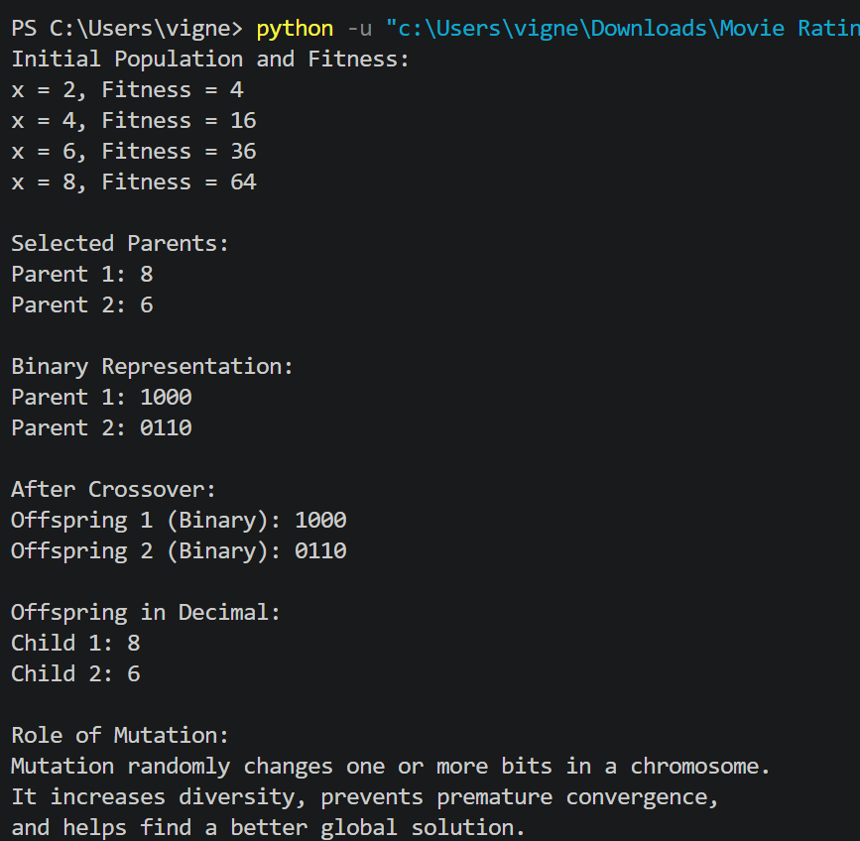

2. A perceptron model is used to classify whether a customer will purchase a product based on two features: advertisement exposure and income level. The weights are 0.5 and 0.3, and the bias is –0.4. For a customer with advertisement exposure = 2 and income level = 1, compute the net input to the perceptron and apply the step activation function. Determine whether the customer makes a purchase or not.

Code:
# Perceptron Model

# Inputs
advertisement = 2
income = 1

# Weights
w1 = 0.5
w2 = 0.3

# Bias
bias = -0.4

# Calculate net input
net_input = (advertisement * w1) + (income * w2) + bias

print("Net Input =", net_input)

# Step Activation Function
if net_input >= 0:
output = 1
else:
output = 0

print("Output =", output)

# Decision
if output == 1:
print("Customer will purchase the product.")
else:
print("Customer will not purchase the product.")

Output:
