ITA0609-C01-AT01 - Machine Learning - Vigneshvar.S (192424187)

1. A parking facility has three sections containing cars of different colors. Section A has
5 red, 3 blue, and 2 black cars; Section B has 4 red, 6 blue, and 5 black cars; and Section
C has 7 red, 2 blue, and 6 black cars. A section is chosen at random, but Section B is
twice as likely to be selected as each of the other sections due to higher usage. A
randomly selected car from the chosen section turns out to be blue. What is the
probability that the car came from Section C?(5 Marks)

Code:
# Question 1: Bayes Theorem - Probability of selecting Section C
# Probability of selecting each section
P_A = 1 / 4
P_B = 1 / 2
P_C = 1 / 4
# Probability of selecting a blue car from each section
P_Blue_A = 3 / 10
P_Blue_B = 6 / 15
P_Blue_C = 2 / 15
# Total probability of selecting a blue car
P_Blue = (P_Blue_A * P_A) + (P_Blue_B * P_B) + (P_Blue_C * P_C)
# Bayes' Theorem
P_C_given_Blue = (P_Blue_C * P_C) / P_Blue
print("Probability that the blue car came from Section C:")
print(P_C_given_Blue)
print(f"Percentage = {P_C_given_Blue * 100:.2f}%")

Output:

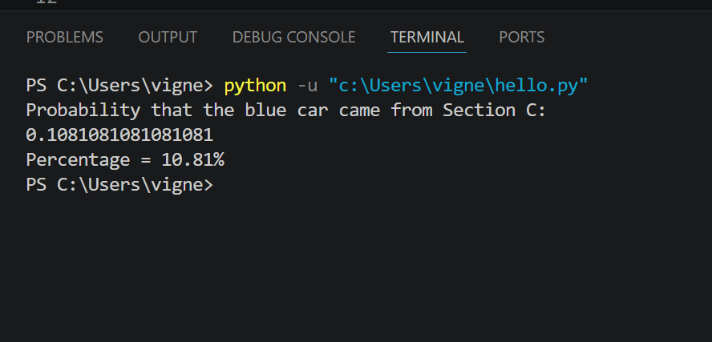

2. Examine the performance of a machine-learning model using its training and
validation loss values over multiple epochs: (5 Marks)
1. (a) Epoch 1: Training Loss = 2.8, Validation Loss = 2.4
2. (b) Epoch 2: Training Loss = 2.5, Validation Loss = 2.2
3. (c) Epoch 3: Training Loss = 2.2, Validation Loss = 2.0
4. (d) Epoch 4: Training Loss = 2.0, Validation Loss = 2.1
5. (e) Epoch 5: Training Loss = 1.8, Validation Loss = 2.3
6. (f) Epoch 6: Training Loss = 1.6, Validation Loss = 2.6
7. (g) Epoch 7: Training Loss = 1.5, Validation Loss = 2.9
8. (h) Epoch 8: Training Loss = 1.3, Validation Loss = 3.2
9. i) Identify the epoch at which the model begins to overfit.
10. ii) Suggest two effective techniques to reduce overfitting in this model.
11. iii) Discuss how overfitting affects the model’s generalization ability on unseen data.
Code:
# Question 2: Training Loss vs Validation Loss Analysis
# Epoch numbers
epochs = [1, 2, 3, 4, 5, 6, 7, 8]
# Training and Validation Loss values
training_loss = [2.8, 2.5, 2.2, 2.0, 1.8, 1.6, 1.5, 1.3]
validation_loss = [2.4, 2.2, 2.0, 2.1, 2.3, 2.6, 2.9, 3.2]
print("Training Loss vs Validation Loss")
print("-" * 45)
print("Epoch\tTraining Loss\tValidation Loss")
for i in range(len(epochs)):
print(f"{epochs[i]}\t{training_loss[i]}\t\t{validation_loss[i]}")
# Detect overfitting
overfit_epoch = None
for i in range(1, len(validation_loss)):
if validation_loss[i] > validation_loss[i - 1]:
overfit_epoch = epochs[i]
break
print("\nAnalysis")
print("-" * 45)
print(f"i) The model begins to overfit at Epoch {overfit_epoch}.")
print(" Validation loss starts increasing while training loss continues decreasing.")
print("\nii) Two techniques to reduce overfitting:")
print("1. Early Stopping")
print("2. Dropout / Regularization")
print("\niii) Effect of Overfitting:")
print("- The model memorizes the training data.")
print("- It learns noise instead of general patterns.")
print("- Training performance improves.")
print("- Performance on unseen (test) data decreases.")
print("- Generalization ability becomes poor.")
Output:
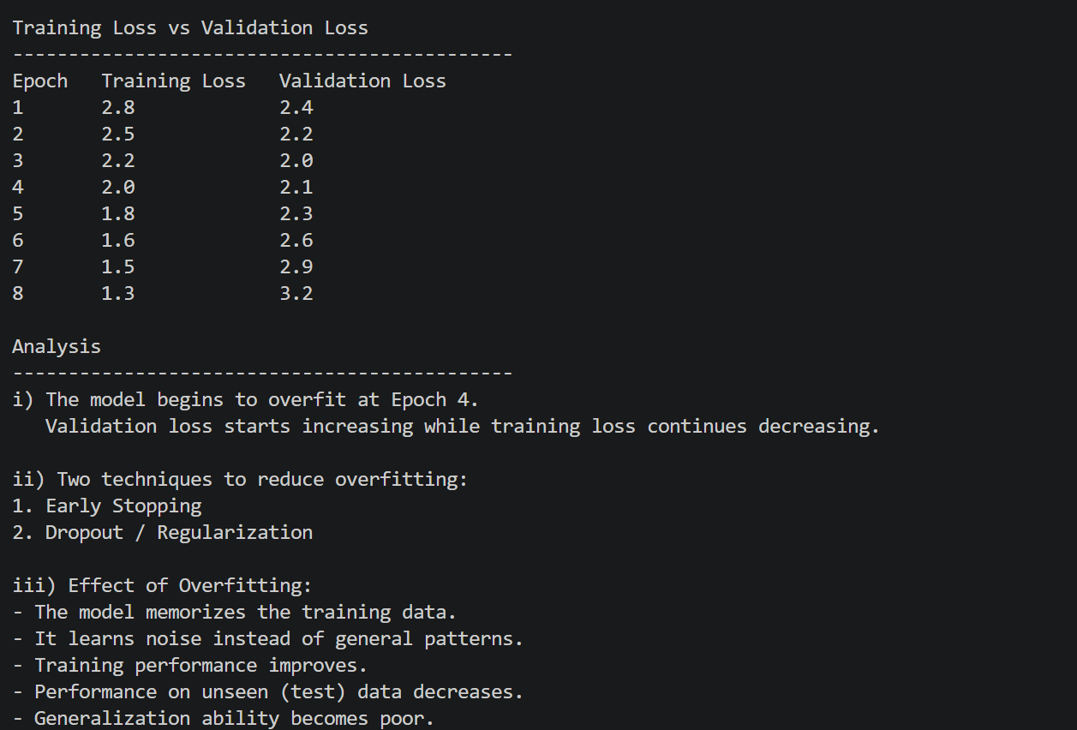

3.Examine the performance of a machine-learning model using training and validation
accuracy over multiple epochs: (5 Marks)
12. (a) Epoch 1: Training Accuracy = 60%, Validation Accuracy = 58%
13. (b) Epoch 2: Training Accuracy = 65%, Validation Accuracy = 63%
14. (c) Epoch 3: Training Accuracy = 70%, Validation Accuracy = 68%
15. (d) Epoch 4: Training Accuracy = 75%, Validation Accuracy = 72%
16. (e) Epoch 5: Training Accuracy = 80%, Validation Accuracy = 73%
17. (f) Epoch 6: Training Accuracy = 85%, Validation Accuracy = 72%
18. (g) Epoch 7: Training Accuracy = 88%, Validation Accuracy = 70%
19. (h)Epoch 8: Training Accuracy = 92%,Validation Accuracy = 68%
20. i) Identify the epoch at which the model starts overfitting.
21. ii) Explain why validation accuracy decreases despite training
accuracy increasing. 22. iii) Suggest two methods to improve validation
performance.
Code:
# Question 3: Training Accuracy vs Validation Accuracy Analysis
# Epoch numbers
epochs = [1, 2, 3, 4, 5, 6, 7, 8]
# Training and Validation Accuracy values
training_accuracy = [60, 65, 70, 75, 80, 85, 88, 92]
validation_accuracy = [58, 63, 68, 72, 73, 72, 70, 68]
print("Training Accuracy vs Validation Accuracy")
print("-" * 50)
print("Epoch\tTraining Accuracy\tValidation Accuracy")
for i in range(len(epochs)):
print(f"{epochs[i]}\t{training_accuracy[i]}%\t\t\t{validation_accuracy[i]}%")
# Detect overfitting
overfit_epoch = None
for i in range(1, len(validation_accuracy)):
if validation_accuracy[i] < validation_accuracy[i - 1]:
overfit_epoch = epochs[i]
break
print("\nAnalysis")
print("-" * 50)
print(f"i) The model begins to overfit at Epoch {overfit_epoch}.")
print(" Validation accuracy starts decreasing while training accuracy continues increasing.")
print("\nii) Why does validation accuracy decrease?")
print("- The model starts memorizing the training data instead of learning general patterns.")
print("- It learns noise from the training dataset.")
print("- As a result, it performs well on training data but poorly on unseen data.")
print("\niii) Two methods to improve validation performance:")
print("1. Early Stopping")
print("2. Regularization (Dropout or L2 Regularization)")
Output:
