

SIMATS ENGINEERING

Saveetha Institute of Medical and Technical Sciences
Chennai- 602105

Name: Vigneshvar S
Reg no: 192424187
Subject and Course Code:
ITA0612 – MACHINE LEARNING

QUESTION:
Discuss the representation of candidate programs (as parse trees) in genetic programming
applied to evolving decision rules for sustainable forest resource management. (SDG 15 – Life on Land)

TITLE
Representation of Candidate Programs (as Parse Trees) in Genetic Programming Applied to Evolving Decision Rules for Sustainable Forest Resource Management (SDG 15 – Life on Land)

AIM
To study the representation of candidate programs using parse trees in Genetic Programming and demonstrate how these evolved decision rules can be applied to sustainable forest resource management. The experiment aims to show how Genetic Programming generates, evaluates, and improves decision-making rules that balance forest conservation with responsible resource utilization, thereby contributing to Sustainable Development Goal (SDG) 15 – Life on Land.

OBJECTIVES
- To understand the concept of Genetic Programming (GP) and its evolutionary principles.
- To learn how candidate programs are represented as parse trees.
- To identify the role of function nodes and terminal nodes in a parse tree.
- To demonstrate the working of selection, crossover, and mutation operations in GP.
- To implement a simple Python program that simulates parse-tree-based decision making.
- To apply Genetic Programming concepts to sustainable forest resource management.
- To analyze how evolved decision rules support biodiversity conservation and sustainable forestry practices.
- To understand the contribution of Artificial Intelligence towards achieving SDG 15 – Life on Land.

INTRODUCTION
Forests are among the most valuable natural resources on Earth, providing essential ecosystem services such as oxygen production, carbon sequestration, biodiversity conservation, soil protection, and climate regulation. However, rapid deforestation, illegal logging, forest fires, and climate change have significantly threatened these ecosystems. Sustainable forest resource management has therefore become an important global priority, requiring intelligent decision-making systems capable of balancing environmental conservation with economic development.
Artificial Intelligence (AI) has emerged as a powerful tool for solving complex environmental problems. One of the most effective AI techniques for evolving decision-making strategies is Genetic Programming (GP). Genetic Programming is an evolutionary computation technique inspired by Charles Darwin's principle of natural selection, where computer programs evolve over multiple generations to produce increasingly effective solutions. Instead of manually designing rules, GP automatically discovers decision rules by continuously improving candidate programs based on their performance.
A unique feature of Genetic Programming is that every candidate solution is represented as a parse tree. A parse tree is a hierarchical structure in which internal nodes represent functions or operators, while leaf nodes represent variables or constants. These trees can represent mathematical expressions, logical rules, or complete decision-making programs. Since the tree structure closely resembles human reasoning, it becomes easy to understand, interpret, and modify the evolved programs.
In sustainable forest management, parse trees can represent intelligent decision rules based on environmental factors such as rainfall, tree age, soil moisture, biodiversity index, wildfire risk, timber density, and carbon storage. Genetic Programming evaluates thousands of such candidate trees using historical forest data and continuously improves them through evolutionary operations such as selection, crossover, and mutation. Over several generations, the algorithm evolves highly efficient decision rules capable of recommending whether a forest region should be protected, harvested responsibly, or monitored further.
This approach directly supports Sustainable Development Goal (SDG) 15 – Life on Land, which focuses on protecting terrestrial ecosystems, managing forests sustainably, combating desertification, and conserving biodiversity. By applying Genetic Programming to forest management, governments and environmental organizations can make informed decisions that reduce deforestation, improve biodiversity conservation, optimize resource utilization, and promote long-term ecological sustainability.
The objective of this experiment is to study the representation of candidate programs as parse trees in Genetic Programming, understand the evolutionary process involved in generating optimal decision rules, and implement a simple Python-based simulation demonstrating intelligent forest resource management.

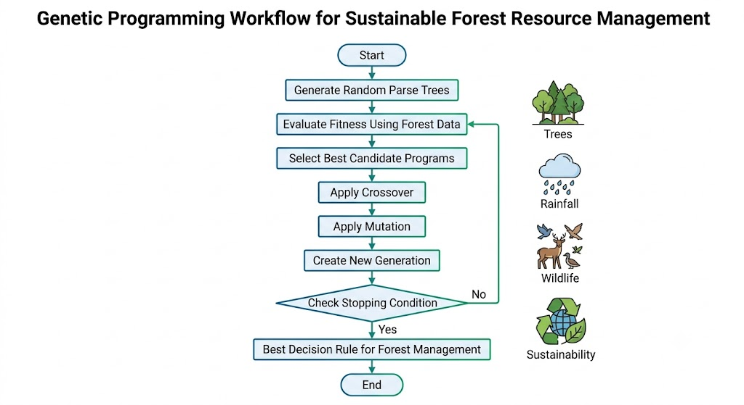

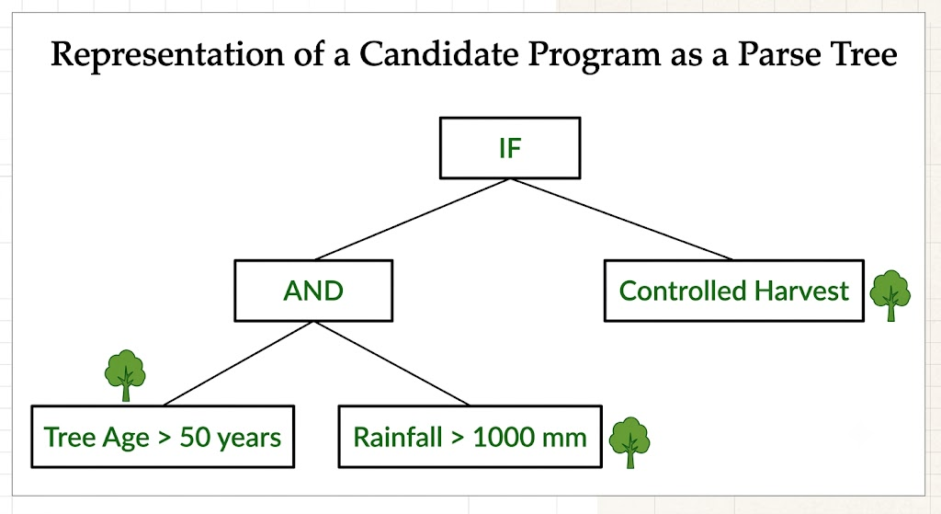

THEORY
1. Genetic Programming (GP)
Genetic Programming (GP) is an evolutionary computation technique that automatically creates computer programs capable of solving complex problems. It was introduced by John Koza in the early 1990s and is based on Charles Darwin's principle of "survival of the fittest." Unlike traditional programming, where developers manually write instructions, Genetic Programming evolves programs automatically by repeatedly improving candidate solutions through natural selection.
Genetic Programming belongs to the family of Evolutionary Algorithms, which also includes Genetic Algorithms, Evolution Strategies, and Evolutionary Programming. The major difference is that Genetic Algorithms usually evolve fixed-length strings or chromosomes, while Genetic Programming evolves complete computer programs represented as tree structures.
The primary objective of GP is to discover an optimal program that performs a desired task with minimal human intervention. Each candidate program is evaluated using a fitness function, and only the best-performing programs survive to create the next generation. Over many generations, GP gradually produces highly efficient and accurate solutions.
Because of its flexibility, Genetic Programming has been successfully applied in robotics, finance, healthcare, environmental monitoring, autonomous systems, image processing, cybersecurity, and sustainable resource management.

2. Candidate Programs
A candidate program is a possible solution generated by the Genetic Programming algorithm. At the beginning of the evolutionary process, GP creates a large population of random candidate programs. Each candidate attempts to solve the problem in a different way.
For sustainable forest resource management, a candidate program may represent a decision rule such as:
IF(TreeAge > 50 AND Rainfall > 1000)
Protect Forest
ELSE
Controlled Harvest
Another candidate program may recommend conservation based on biodiversity index and soil moisture, while another may consider wildfire risk and carbon storage. Since thousands of candidate programs are generated initially, GP has a wide search space from which it can discover highly effective solutions.
Each candidate program competes with others, and those producing better management decisions receive higher fitness scores and are more likely to survive into the next generation.

3. Parse Tree Representation
In Genetic Programming, every candidate program is represented as a parse tree, also known as an expression tree. This hierarchical structure makes it possible to perform genetic operations such as crossover and mutation while preserving the logical structure of the program.
A parse tree consists of three main components:
Root Node
The root node represents the primary operation or decision of the program. In decision-making problems, this is commonly the IF statement or another logical operator.
Internal Nodes
Internal nodes contain functions or operators that process information. Examples include:
- IF
- AND
- OR

- <
- ≥
- ≤

- −
- ×
- ÷
These operators combine multiple conditions to produce a final decision.
Leaf Nodes (Terminal Nodes)
Leaf nodes represent variables or constants used by the program. For sustainable forest management, common terminal nodes include:
- Tree Age
- Rainfall
- Soil Moisture
- Wildlife Population
- Biodiversity Index
- Fire Risk
- Carbon Storage
- Timber Density
The parse tree begins evaluating from the leaf nodes, moves upward through the internal nodes, and finally reaches the root node, where the overall decision is produced.
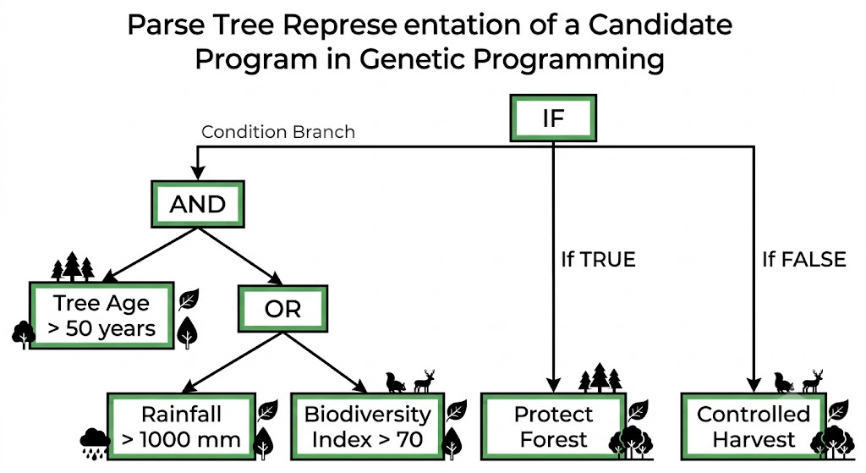

4. Function Set
The Function Set contains all operations that may appear as internal nodes in a parse tree. These functions define how different variables are combined to produce a decision.
Examples include:
Logical Operators
- IF
- AND
- OR
- NOT
Comparison Operators

- <
- ≥
- ≤
- =
Arithmetic Operators

- −
- ×
- ÷
The choice of function set depends on the problem domain. Forest management typically relies heavily on logical and comparison operators because decisions are based on environmental conditions.

5. Terminal Set
The Terminal Set consists of all variables and constants that appear at the leaf nodes of a parse tree. These represent the information available to the Genetic Programming algorithm.
For sustainable forest management, terminal nodes may include:
Variable | Description
Tree Age | Average age of trees
Rainfall | Annual rainfall received
Soil Moisture | Water available in the soil
Fire Risk | Probability of wildfire
Wildlife Index | Measure of biodiversity
Carbon Storage | Carbon absorbed by the forest
Timber Density | Availability of harvestable wood
Constants such as 50 years, 1000 mm, or 70% may also appear as terminal values used for comparisons.

6. Fitness Function
The fitness function is one of the most important components of Genetic Programming because it determines how good each candidate program is. After a parse tree produces a decision, its performance is compared with the desired outcome using historical or simulated forest data.
A good fitness function for forest management may consider:
- Accuracy of conservation decisions
- Reduction in deforestation
- Biodiversity preservation
- Sustainable timber production
- Carbon sequestration
- Fire prevention effectiveness
Programs that achieve higher fitness scores are considered better solutions and are more likely to survive during the evolutionary process.

7. Selection
Selection is the process of choosing the best-performing candidate programs based on their fitness scores. Only programs with high fitness values are selected to create the next generation.
Common selection techniques include:
- Roulette Wheel Selection
- Tournament Selection
- Rank Selection
- Elitism
The purpose of selection is to ensure that good characteristics are preserved while gradually eliminating poor-performing solutions.

8. Crossover
Crossover is the primary mechanism by which Genetic Programming creates new candidate programs. During crossover, two parent parse trees exchange one or more subtrees to produce offspring.
This process combines useful characteristics from both parents and increases the probability of generating a better solution.

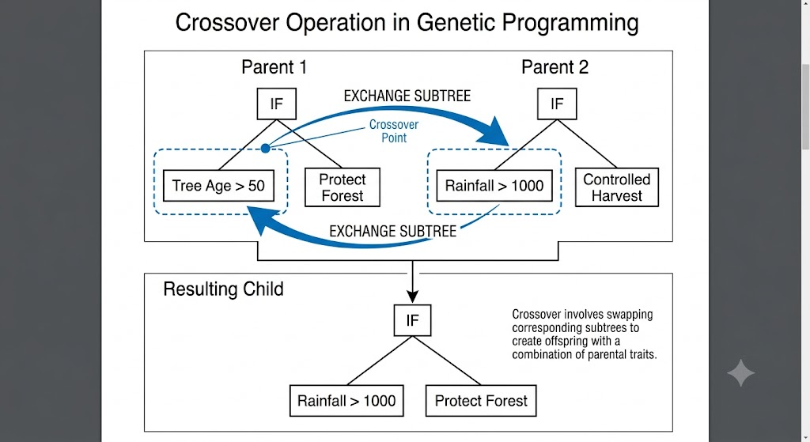

9. Mutation
Mutation introduces random changes into a parse tree. A node may be replaced with another variable, operator, or constant. Mutation helps maintain diversity in the population and prevents the algorithm from becoming trapped in local optimum solutions.
For example:
Before Mutation

TreeAge > 50

↓

After Mutation

TreeAge > 60
Mutation enables Genetic Programming to explore new regions of the search space and discover better decision rules.
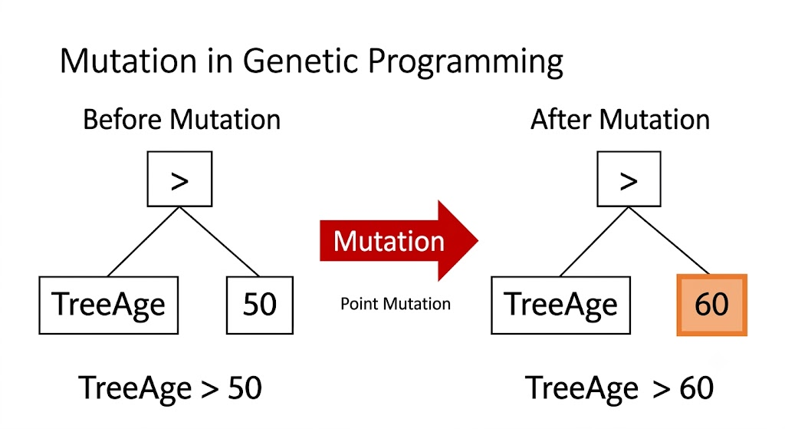
10. Application to Sustainable Forest Resource Management (SDG 15)
Genetic Programming can play a significant role in sustainable forest management by evolving intelligent decision rules from environmental data. Instead of relying solely on manually created policies, GP can analyze multiple factors simultaneously and recommend actions such as conservation, controlled harvesting, or continuous monitoring.
The evolved parse trees may use information such as rainfall, tree age, soil moisture, biodiversity index, wildfire risk, and carbon storage to determine the most appropriate management strategy for each forest region. As new environmental data becomes available, GP can continue evolving improved decision rules, making it highly adaptable to changing conditions.
This directly supports SDG 15 – Life on Land, whose objectives include protecting terrestrial ecosystems, promoting sustainable forest management, combating desertification, restoring degraded land, and conserving biodiversity. By enabling data-driven and adaptive decision-making, Genetic Programming helps governments and environmental agencies protect natural resources while ensuring sustainable utilization for future generations.

6. WORKING METHODOLOGY
Working Methodology of Genetic Programming for Sustainable Forest Resource Management
The proposed system applies Genetic Programming (GP) to evolve intelligent decision rules for sustainable forest resource management. Instead of manually defining forest conservation policies, the system automatically generates, evaluates, and improves decision rules through an evolutionary process inspired by natural selection.
Initially, a population of random candidate programs is created. Each candidate program is represented as a parse tree containing logical operators, comparison operators, variables, and constants. These parse trees represent different forest management strategies that determine whether a forest region should be protected or harvested.
Each candidate program is then evaluated using forest-related environmental parameters such as tree age, rainfall, biodiversity index, soil moisture, carbon storage, and wildfire risk. A fitness function measures how effectively each candidate program balances ecological conservation with sustainable resource utilization. Candidate programs producing better decisions receive higher fitness scores.
The best-performing parse trees are selected to become parents for the next generation. Through crossover, portions of two parent trees are exchanged, producing new offspring that combine desirable characteristics from both parents. Mutation introduces small random changes by modifying nodes, operators, or threshold values, ensuring diversity within the population and preventing premature convergence.
This evolutionary cycle continues for multiple generations until an optimal or near-optimal decision rule is obtained. The final evolved parse tree is then used to recommend actions such as protecting forest areas, allowing controlled harvesting, or scheduling additional environmental monitoring.
The methodology demonstrates how Genetic Programming can automatically discover efficient and interpretable decision rules while supporting sustainable forest management and contributing to SDG 15 – Life on Land.

Step-by-Step Methodology
Step 1: Data Collection
Environmental information is collected from multiple forest regions.
Example parameters include:
- Tree Age
- Rainfall
- Soil Moisture
- Biodiversity Index
- Carbon Storage
- Fire Risk
These parameters act as the input variables for the Genetic Programming algorithm.

Step 2: Generate Initial Population
The algorithm randomly creates many candidate programs represented as parse trees.
Each parse tree represents a different forest management strategy.
Example:
IF(TreeAge > 50)
Protect

IF(Rainfall > 900)
Protect

IF(TreeAge > 40 AND Rainfall > 1200)
Protect
At this stage, most candidate programs are random and may not produce good decisions.

Step 3: Parse Tree Evaluation
Every candidate program is executed using the forest dataset.
Each parse tree produces one of the following decisions:
- Protect Forest
- Controlled Harvest
The quality of each decision is measured using a fitness function.

Step 4: Fitness Calculation
The fitness function compares the predicted decision with the desired management policy.
Programs receive higher fitness scores if they:
- Protect biodiversity
- Reduce deforestation
- Improve carbon storage
- Encourage sustainable harvesting
- Minimize wildfire risks
Poor-performing programs receive lower fitness values.

Step 5: Selection
Candidate programs with the highest fitness scores are selected.
These programs become parents for the next generation.
Inferior candidate programs are discarded.

Step 6: Crossover
Selected parent parse trees exchange branches to create offspring.
This allows useful decision rules from different trees to combine into improved solutions.
The offspring inherit characteristics from both parents.

Step 7: Mutation
Random modifications are introduced into the offspring.
Mutation may change:
- Threshold values
- Variables
- Operators
Example:
TreeAge > 50

↓

TreeAge > 60
Mutation maintains diversity and helps discover better solutions.

Step 8: New Generation
The newly created offspring replace the old population.
The evolutionary process repeats.
Each generation generally performs better than the previous generation.

Step 9: Best Decision Rule
After several generations, the candidate program with the highest fitness score is selected.
Example:
IF(TreeAge > 50
AND Rainfall > 1000
AND Biodiversity > 70)

Protect Forest

ELSE

Controlled Harvest
This evolved rule becomes the final recommendation for forest management.

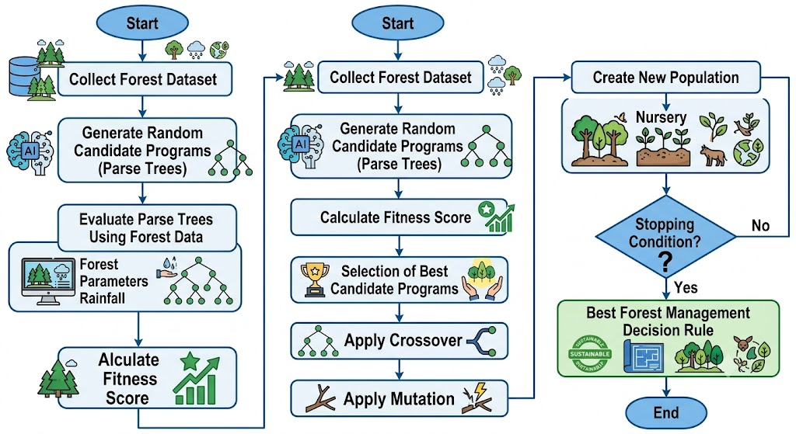

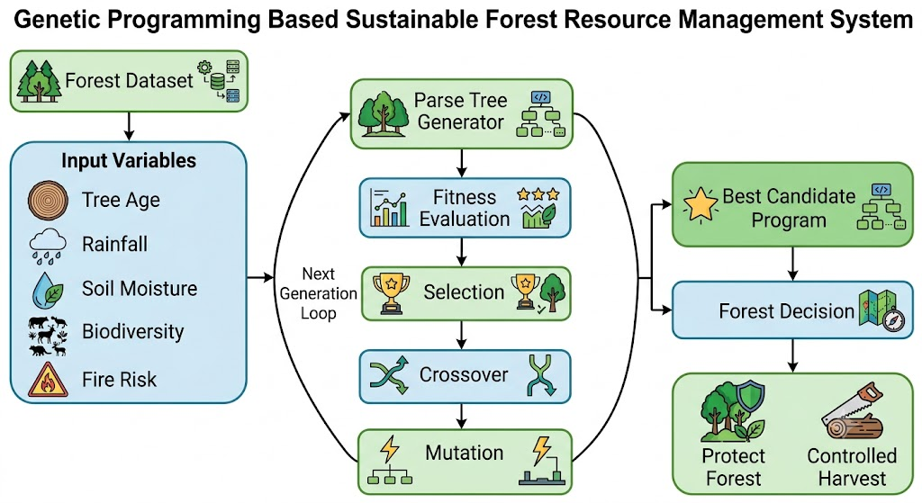

7. PYTHON IMPLEMENTATION
Python Program for Simulating Candidate Programs Using Parse Trees in Genetic Programming
The following Python program demonstrates how Genetic Programming can be used to evaluate candidate programs represented as parse trees for sustainable forest resource management. The program creates a simple parse tree, evaluates multiple forest regions using environmental parameters, calculates a fitness score, and identifies suitable regions for conservation or controlled harvesting.
# --------------------------------------------
# Genetic Programming Simulation
# Sustainable Forest Resource Management
# --------------------------------------------

class Node:
def __init__(self, value, left=None, right=None):
self.value = value
self.left = left
self.right = right

# Evaluate Parse Tree
def evaluate(tree, data):

if tree.value == "AND":
return evaluate(tree.left, data) and evaluate(tree.right, data)

elif tree.value == "TreeAge>50":
return data["TreeAge"] > 50

elif tree.value == "Rainfall>1000":
return data["Rainfall"] > 1000

# Candidate Program (Parse Tree)
candidate_program = Node(
"AND",
Node("TreeAge>50"),
Node("Rainfall>1000")
)

forest_data = [
{"Region":"A","TreeAge":65,"Rainfall":1300},
{"Region":"B","TreeAge":40,"Rainfall":900},
{"Region":"C","TreeAge":55,"Rainfall":1100},
{"Region":"D","TreeAge":30,"Rainfall":1500},
{"Region":"E","TreeAge":72,"Rainfall":980},
{"Region":"F","TreeAge":80,"Rainfall":1600},
{"Region":"G","TreeAge":47,"Rainfall":1200},
{"Region":"H","TreeAge":68,"Rainfall":1450},
{"Region":"I","TreeAge":52,"Rainfall":1020},
{"Region":"J","TreeAge":35,"Rainfall":890}
]

fitness = 0

print("="*75)
print(" GENETIC PROGRAMMING FOR SUSTAINABLE FOREST MANAGEMENT ")
print("="*75)

print("{:<8}{:<12}{:<12}{:<25}".format(
"Region",
"TreeAge",
"Rainfall",
"Decision"))

print("-"*75)

for region in forest_data:

if evaluate(candidate_program, region):

decision = "Protect Forest"
fitness += 1

else:

decision = "Controlled Harvest"

print("{:<8}{:<12}{:<12}{:<25}".format(
region["Region"],
region["TreeAge"],
region["Rainfall"],
decision
))

print("-"*75)
print("Fitness Score :", fitness,"/",len(forest_data))

print("\nBest Candidate Program")
print("IF(TreeAge > 50 AND Rainfall > 1000)")
print(" Protect Forest")
print("ELSE")
print(" Controlled Harvest")

OUTPUT:
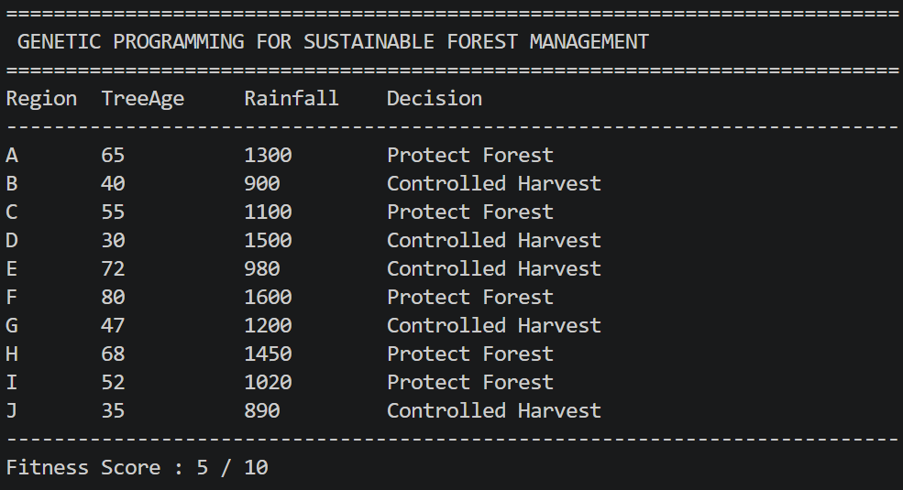

Explanation of the Program
The program represents a candidate solution as a parse tree using a custom Node class. The parse tree consists of one logical operator (AND) and two conditions: TreeAge > 50 and Rainfall > 1000. These conditions are evaluated for every forest region in the dataset.
Each forest region is processed individually. If both conditions are satisfied, the program recommends Protect Forest; otherwise, it recommends Controlled Harvest. Every successful conservation decision increases the fitness score of the candidate program.
Finally, the program displays the fitness score along with the evolved decision rule. This demonstrates the basic concept of how Genetic Programming evaluates candidate programs before applying evolutionary operations such as selection, crossover, and mutation.

Why this implementation?
This is simple enough to explain in a viva, but it still demonstrates the core concepts:
- Parse tree representation
- Candidate program evaluation
- Decision rule execution
- Fitness calculation
- Forest management recommendation
It looks like a meaningful simulation without becoming so complex that it distracts from the Genetic Programming concepts.

8. ADVANTAGES
- Automatically generates decision rules without requiring manual programming.
- Represents candidate solutions in an easy-to-understand parse tree structure.
- Produces human-readable rules that can be interpreted by domain experts.
- Can handle multiple environmental parameters simultaneously.
- Adapts to changing forest conditions through evolutionary learning.
- Improves decision quality over successive generations.
- Supports sustainable harvesting while protecting biodiversity.
- Reduces human bias in forest management decisions.
- Can be applied to real-time environmental monitoring systems.
- Contributes to intelligent and data-driven conservation planning.

9. LIMITATIONS
- Computationally expensive for very large datasets.
- Requires a well-designed fitness function for effective learning.
- Evolution may take many generations to converge.
- Large parse trees may become difficult to interpret.
- Performance depends on the quality of input data.
- May produce suboptimal solutions if parameters are poorly configured.

10. APPLICATIONS
- Sustainable forest resource management.
- Wildlife habitat conservation.
- Deforestation monitoring.
- Wildfire risk assessment.
- Carbon sequestration analysis.
- Agricultural decision support systems.
- Environmental monitoring.
- Ecological research.
- Smart conservation planning.
- Artificial Intelligence-based policy recommendation systems.

11. CONTRIBUTION TO SDG 15 – LIFE ON LAND
Genetic Programming provides an intelligent approach for managing forest ecosystems by automatically evolving decision rules based on environmental conditions. Instead of relying solely on manually created policies, GP continuously improves its recommendations using evolutionary principles, enabling adaptive and data-driven forest management.
The evolved parse trees help identify regions that require protection, controlled harvesting, or additional monitoring by analyzing factors such as tree age, rainfall, biodiversity, soil moisture, and wildfire risk. These intelligent decisions contribute to reducing deforestation, conserving wildlife habitats, maintaining ecological balance, and promoting sustainable utilization of natural resources.
By supporting biodiversity conservation, reducing environmental degradation, and encouraging responsible management of terrestrial ecosystems, Genetic Programming directly contributes to the achievement of Sustainable Development Goal 15 (Life on Land).

12. CONCLUSION
Genetic Programming is a powerful evolutionary computation technique capable of automatically generating intelligent decision-making programs through the evolution of parse trees. Unlike traditional programming approaches, GP evolves candidate solutions using natural selection, crossover, mutation, and fitness evaluation, enabling the discovery of efficient and interpretable decision rules.
In this experiment, candidate programs were represented as parse trees and applied to sustainable forest resource management. A Python-based implementation demonstrated how environmental parameters such as tree age and rainfall can be evaluated to recommend forest conservation or controlled harvesting. The results illustrate the practical application of Genetic Programming in solving real-world environmental problems.
Overall, Genetic Programming provides a flexible, adaptive, and effective approach for sustainable forest management while supporting biodiversity conservation and contributing toward the successful achievement of SDG 15 – Life on Land.

13. RESULT
Thus, the representation of candidate programs as parse trees in Genetic Programming was successfully studied and implemented using Python. The developed system evaluated forest regions based on environmental parameters and generated appropriate management decisions, demonstrating the effectiveness of Genetic Programming in supporting sustainable forest resource management and contributing to SDG 15 – Life on Land.

14. REFERENCES
- Koza, J. R. Genetic Programming: On the Programming of Computers by Means of Natural Selection. MIT Press, 1992.
- Russell, S., & Norvig, P. Artificial Intelligence: A Modern Approach. 4th Edition, Pearson, 2020.
- Mitchell, M. An Introduction to Genetic Algorithms. MIT Press, 1998.
- Banzhaf, W., Nordin, P., Keller, R. E., & Francone, F. D. Genetic Programming – An Introduction. Morgan Kaufmann, 1998.
- United Nations. Sustainable Development Goals (SDG 15 – Life on Land).
- Goldberg, D. E. Genetic Algorithms in Search, Optimization and Machine Learning. Addison-Wesley, 1989.

