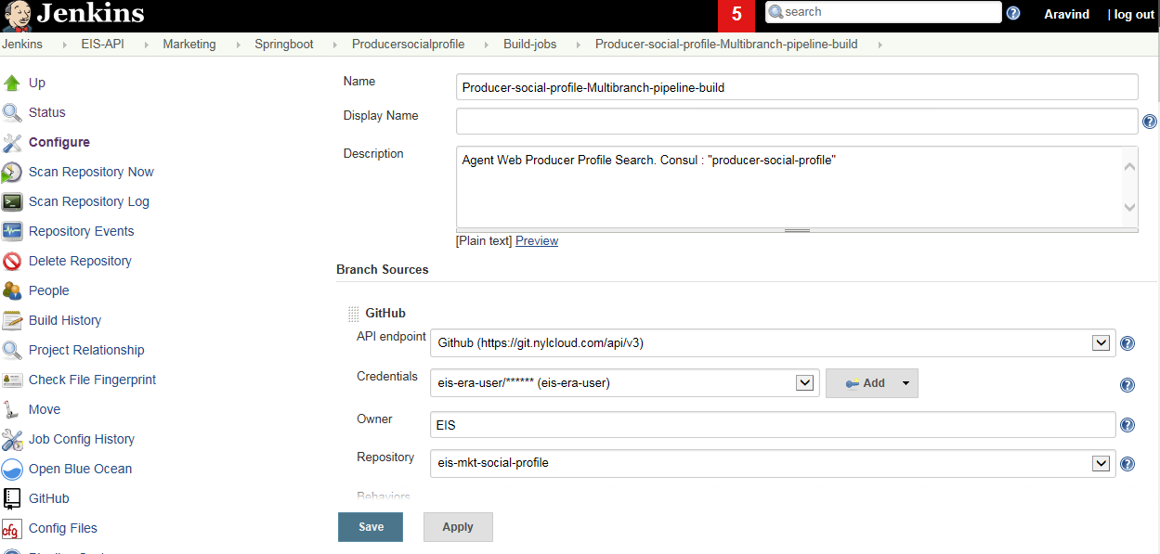

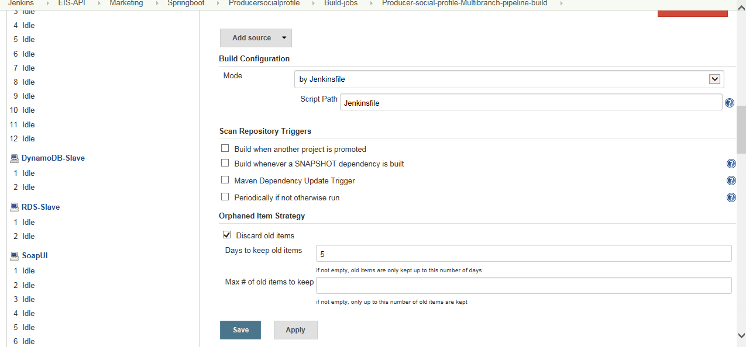

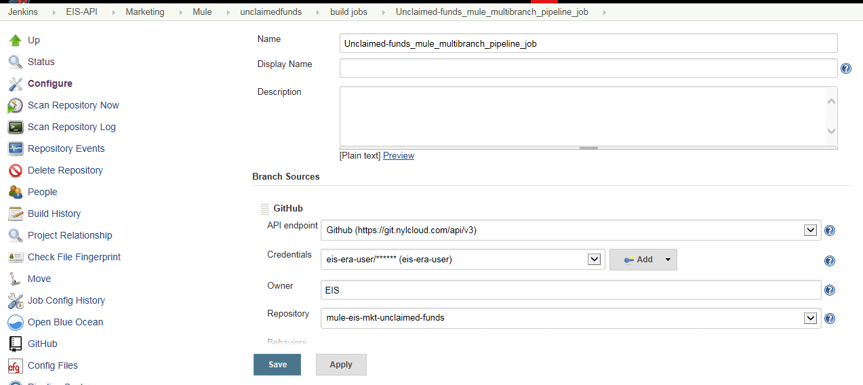

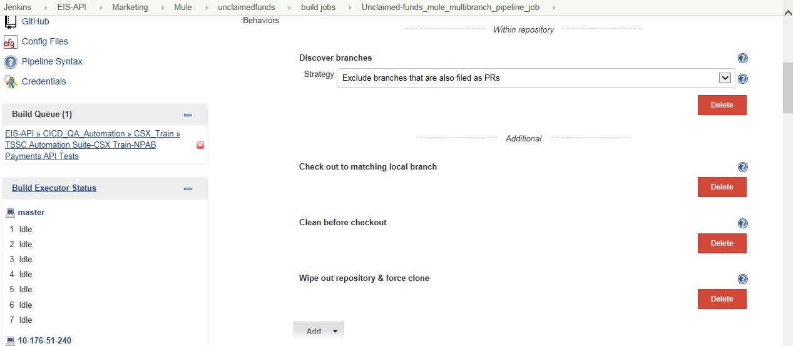

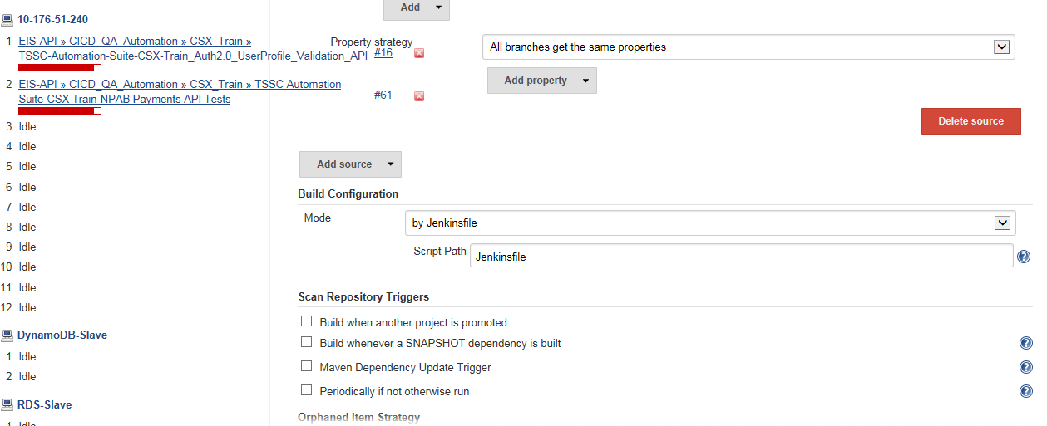

Deploy Job

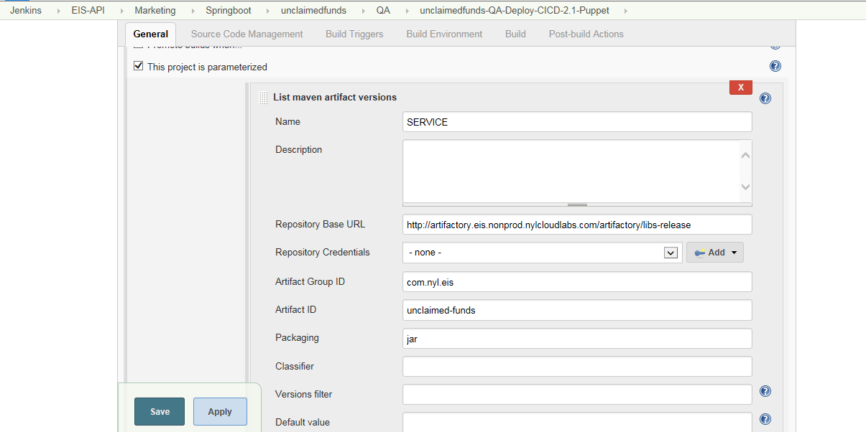

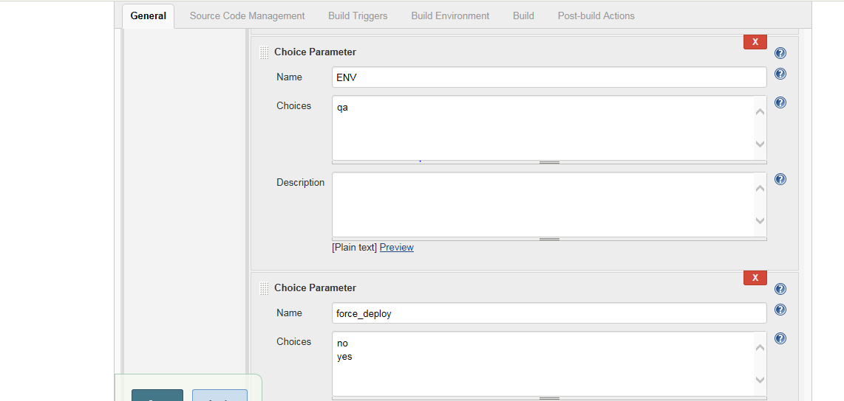

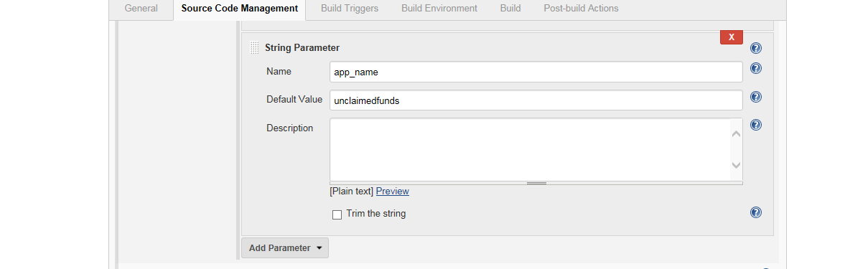

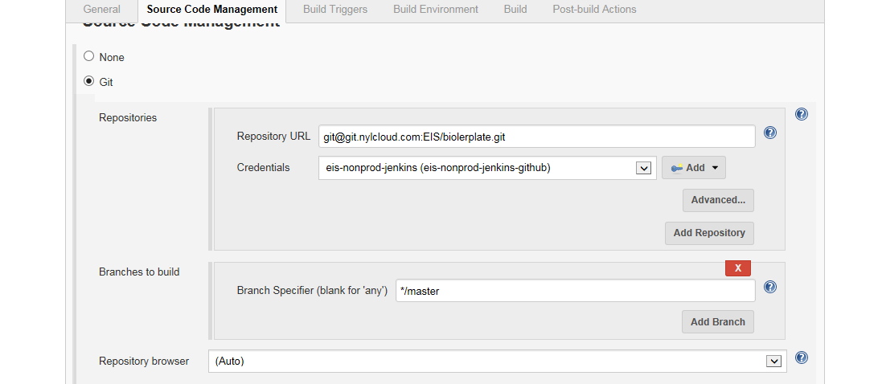

url=`env | grep '_ARTIFACT_URL' | egrep -vi 'vault|jar2consul' | cut -d '=' -f 2`

path=` echo $url | awk 'BEGIN{FS=OFS="/"}{$(NF -1)=""; NF--; print}'`

version=`echo $url | awk -F / '{print $(NF -1) }'`

jar_name=`echo $url | awk -F / '{print $(NF) }'`

if [[ ${force_deploy} == "yes" ]]; then

echo "Proceeding To Deployment..>"

exit 0

else

echo "Proceeding For Puppet Changes"

git pull origin master

curl -s http://artifactory.nylcloud.com/artifactory/eis-software/nyl/automation/puppet/cicd/version_pin.py | python - -i hiera/${ENV}/${app_name}.yaml -p ${path} -v ${version} -f ${jar_name}

if [[ `git status --porcelain` ]]; then

echo "Found Below Git Changes.."

git --no-pager diff

git add .

git commit -m "Commit From: ${BUILD_URL}"

git push origin HEAD:master

else

echo "Found No Changes In Git.. Proceeding To Deployment Phase -->"

fi

fi

