Lab pratices-5

192211784

N.vighneshwar Reddy

Develop a system using UML for Online Voting System. Registration of the new citizen and update can be done in the system. The process of initiating the polling. The voting was done from the citizen’s end and the result publishing should be maintained by the admin.

**AIM:** To draw an UML diagrams for online voting system using Umbrello software.

**USE CASE:**

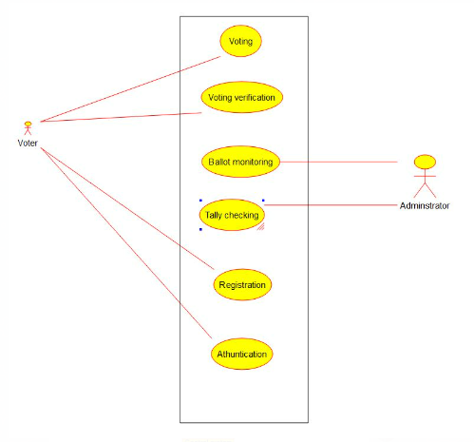

**CLASS DIAGRAM:**

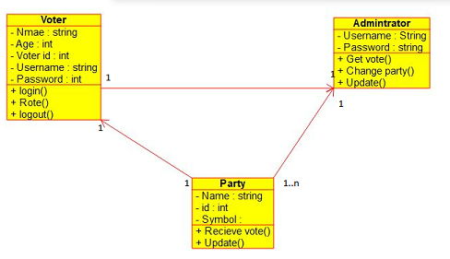

**ACTIVITY DIAGRAM:**

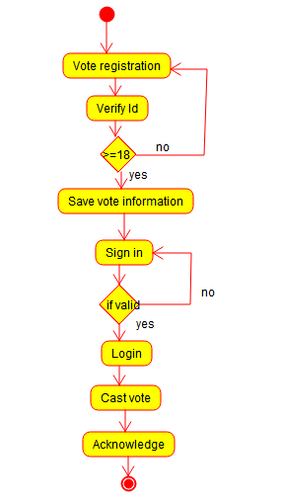

**STATE CHART DIAGRAM:**

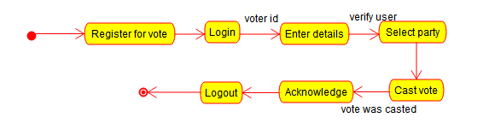

**SEQUENCE DIAGRAM:**

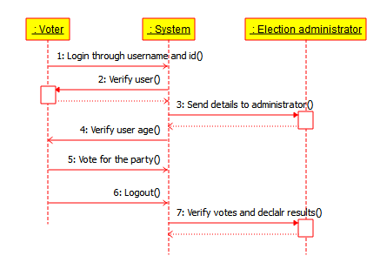

**COMPONENT DIAGRAM:**

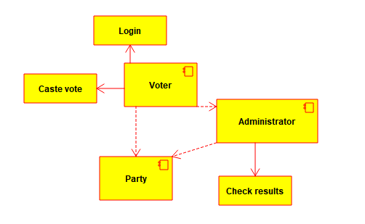

**DEPLOYMENT DIAGRAM: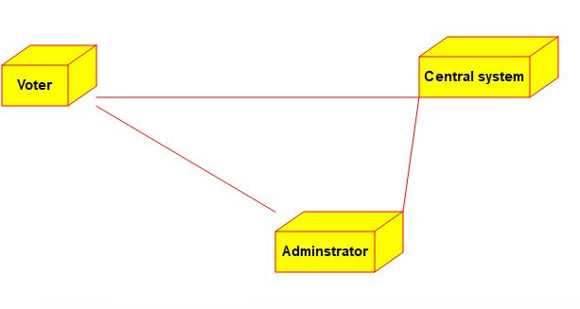 COMMUNICATION DIAGRAM:**

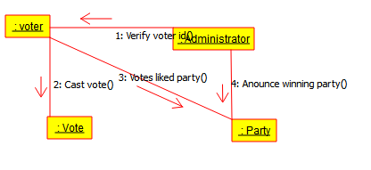 **ENTITY RELATIONSHIP DIAGRAM:**

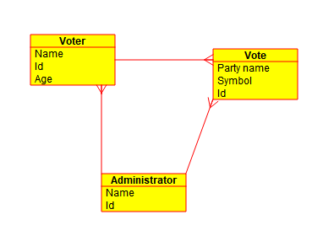

**RESULT:** Thus an UML diagrams for Online voting has been drawn successfully using Umbrello software.

**2)**  Develop a system using UML for Food Order System. In this system,  
the customer can place orders and  
purchase items with the aid of the dealer and  
central food system. These orders are verified, and the items are delivered to the customer.

**AIM:** To draw an UML diagrams for Food order system using Umbrello software

**USE CASE:**

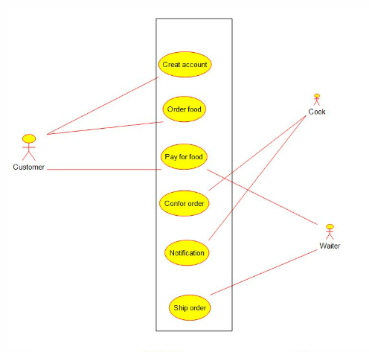

**CLASS DIAGRAM:**

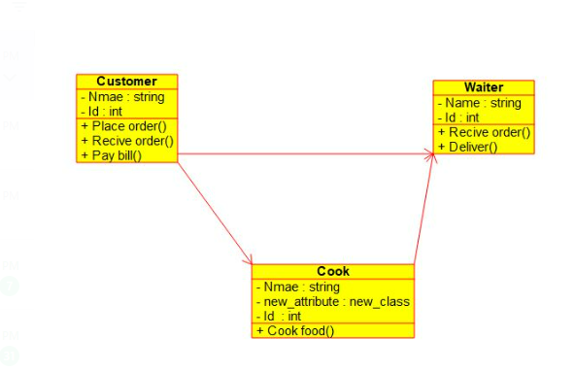

**ACTIVITY DIAGRAM:**

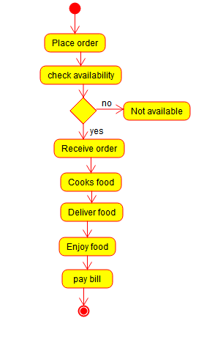 **STATE CHART DIAGRAM: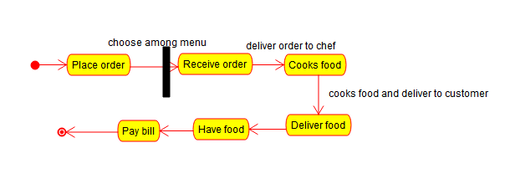 COMPONENT DIAGRAM: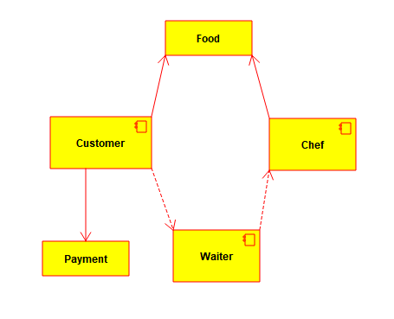 DEPLOYMENT DIAGRAM:**

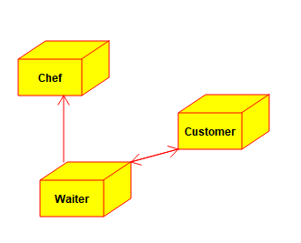

**SEQUENCE DIAGRAM:**

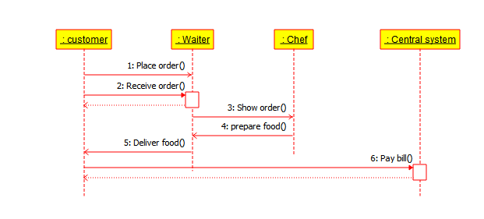

**COMMUNICATION DIAGRAM:**

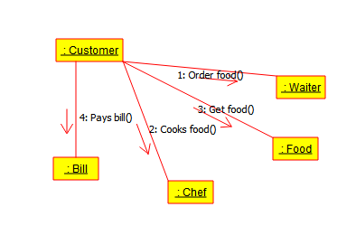

**ENTITY RELATIONSHIP DIAGRAM:**

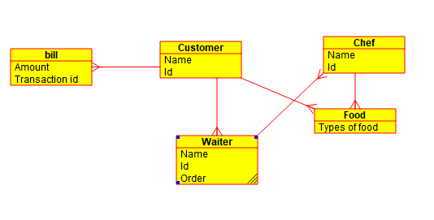

**RESULT:** Thus an UML diagrams for Food Ordering System has been drawn successfully by using Umbrello software.

1. Develop a system using UML for Supermarket Management System. The system should maintain the stock detail, employee detail, and customer details. The system should intimate the product with low stock and nearing the expiry date. The loyalty feature of the customers should be maintained. The offers to the customers should be based on their loyalty features.

**AIM:** To draw an UML diagrams for Super market management system using Umbrello software.

**USE CASE:**

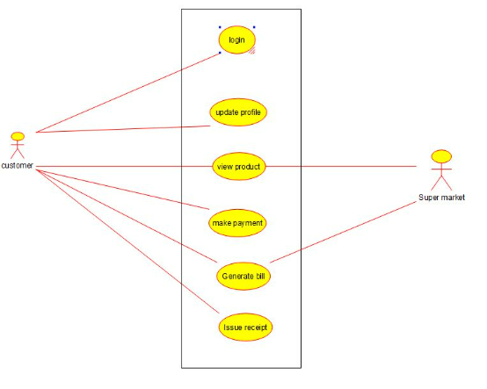

**CLASS DIAGRAM:**

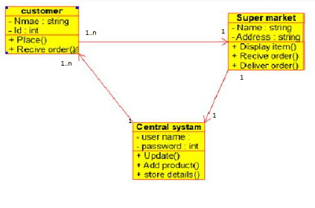 **ACTIVITY DIAGRAM: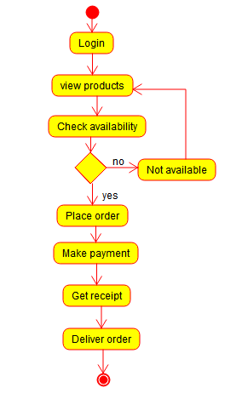 STATE CHART DIAGRAM:**

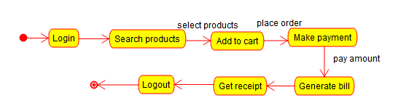

**SEQUENCE DIAGRAM:**

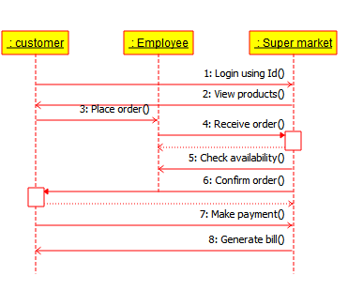

**COMPONENT DIAGRAM:**

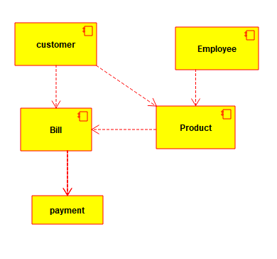 **DEPLOYMENT DIAGRAN: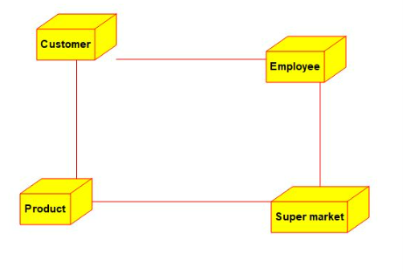 COMMUNICATION DIAGRAM: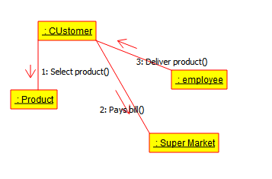 ENTITY RELATIONSHIP DIAGRAM:**

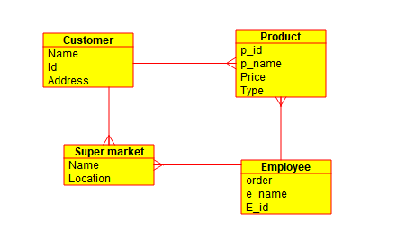

**RESULT:** Thus an UML diagrams for Supermarket system has been drawn successfully.