NovaArc Health
AI-Powered RCM Workflow Platform

Application Features & Functionality Guide — Visual Edition

Version 2.0 · March 2026

300+  Claims Managed | 6  Role-Based Personas | 24  RPA Bots Automated

1. Platform Overview
NovaArc Health is an enterprise-grade AI-powered Revenue Cycle Management (RCM) workflow platform simulating industry-leading systems such as Waystar and R1 RCM. It delivers end-to-end RCM intelligence — from claim creation through payment posting — via a modern, role-aware interface accessible to all RCM team functions.

Technology Stack
Frontend | React 18 + Tailwind CSS + Recharts (Vite — port 5000)
Backend | Python FastAPI (port 8000)
Database | PostgreSQL — 300 seeded claims, 6 work queues, 12 EDI connections, 24 RPA bots
AI Layer | Rule-based AI assistant with 16+ query types; dynamic charts, tables & metric cards
Auth | Role-based persona login; session stored in browser localStorage

Live Platform Metrics
Total AR Outstanding | $1.7M
Total Paid / Collected | $282K
Gross Collection Rate | 16.7%
Net Collection Rate | 53.8%
Revenue Leakage | $1.4M
Denial Rate | 59.0%
Denial Recovery Rate | 0.0%
AR > 90 Days | 97.7%
High-Value At Risk | 59 claims
Total Claims | 300
Clean Claim Rate | 41.0%
Avg Claim Aging | 255.8 days

2. Login & Persona Selection
The platform presents a persona-based login screen on first visit. Users select their role from one of six cards in a 3×2 grid on a dark-themed landing page. Clicking a card auto-authenticates and redirects to the dashboard. A manual sign-in form is also available.
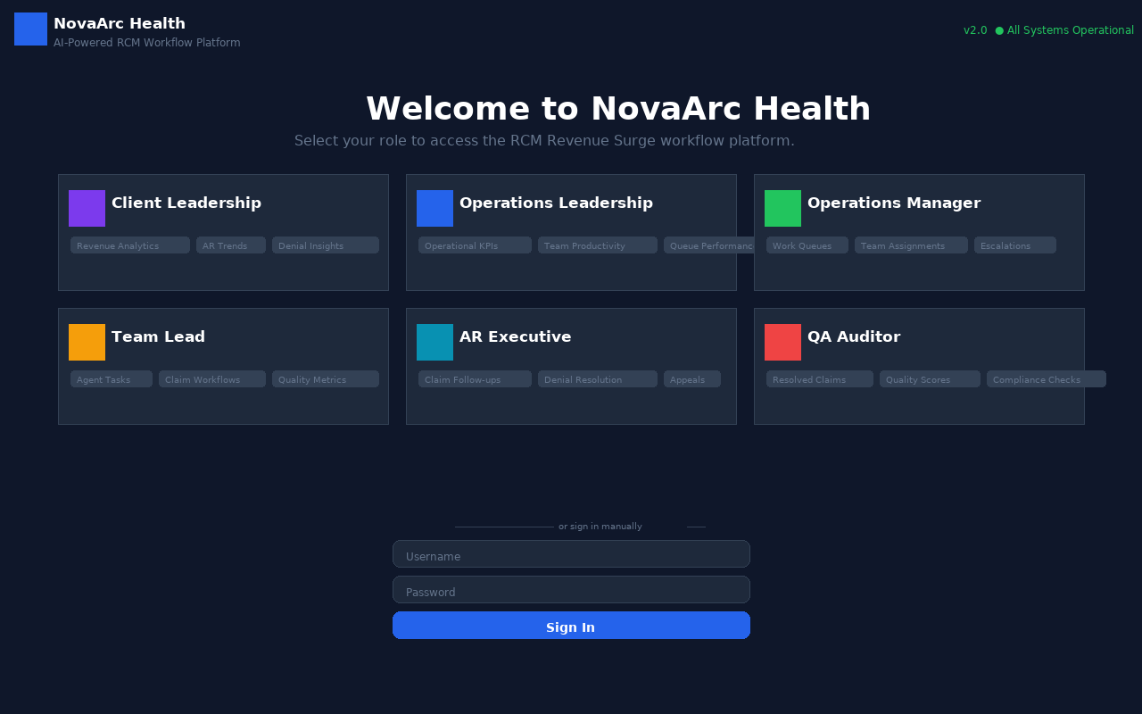
Login Page — Persona Selection Grid

Persona Access Matrix
Persona | Privileges | Module Access | Credentials
Client Leadership | Revenue Analytics, AR Trends, Denial Insights, Financial Impact | Dashboard, Workflow Modules | clientlead / nova123
Operations Leadership | Operational KPIs, Team Productivity, Queue Performance | Dashboard, Workflow Modules | opslead / nova123
Operations Manager | Work Queues, Team Assignments, Escalations | Dashboard, Workflows, Claims, Work Queues, EDI Hub, RPA Bots | opsmgr / nova123
Team Lead | Agent Tasks, Claim Workflows, Quality Metrics | Dashboard, Workflows, Claims, Work Queues, Data Ingestion | teamlead / nova123
AR Executive | Claim Follow-ups, Denial Resolution, Appeals | Dashboard, Workflows, Claims, Work Queues, EDI Hub, RPA Bots | arexec / nova123
QA Auditor | Resolved Claims, Quality Scores, Compliance | Dashboard, Claim Inventory | qaauditor / nova123

3. Executive Intelligence Dashboard
The dashboard is the central hub, accessible to all 6 personas. It presents a tabbed interface with 6 analytical views plus an embedded AI assistant in the bottom-right corner. All data is served live from the PostgreSQL backend.

3.1 Revenue Health
Executive-level financial overview of the entire AR portfolio. Features a bar chart for AR aging distribution across 5 buckets and a Cash Flow Summary progress tracker.
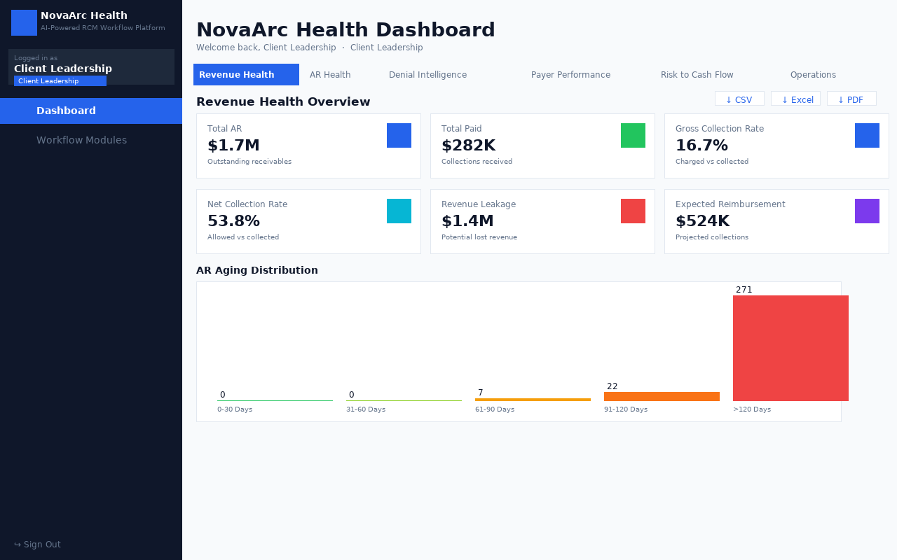
Dashboard — Revenue Health Tab

Total AR Outstanding | $1.7M
Total Paid / Collected | $282K
Gross Collection Rate | 16.7%
Net Collection Rate | 53.8%
Revenue Leakage | $1.4M
Expected Reimbursement | $524K

AR Aging Distribution:
Bucket | Claims | Total Value
0-30 Days | 0 | $0
31-60 Days | 0 | $0
61-90 Days | 7 | $49K
91-120 Days | 22 | $104K
>120 Days | 271 | $1.5M

3.2 AR Health Analysis
Deep analysis of AR health with interactive drill-down by Payer, Specialty, and Facility/Provider. Highlights at-risk receivables needing immediate attention.
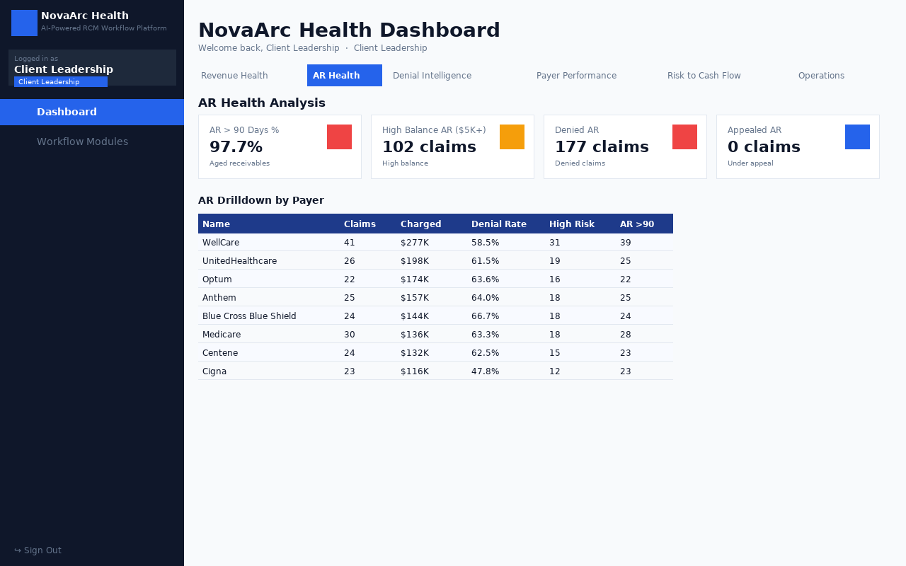
Dashboard — AR Health Tab with Payer Drill-Down

AR > 90 Days (%) | 97.7%
High Balance AR (>$5K) | 102 claims · $1.3M
Denied AR | 177 claims · $1.0M
Appealed AR | 0 claims · $0

3.3 Denial Intelligence
Comprehensive denial analytics with top denial codes, a horizontal bar chart for denial code distribution, and KPIs for denial management effectiveness.
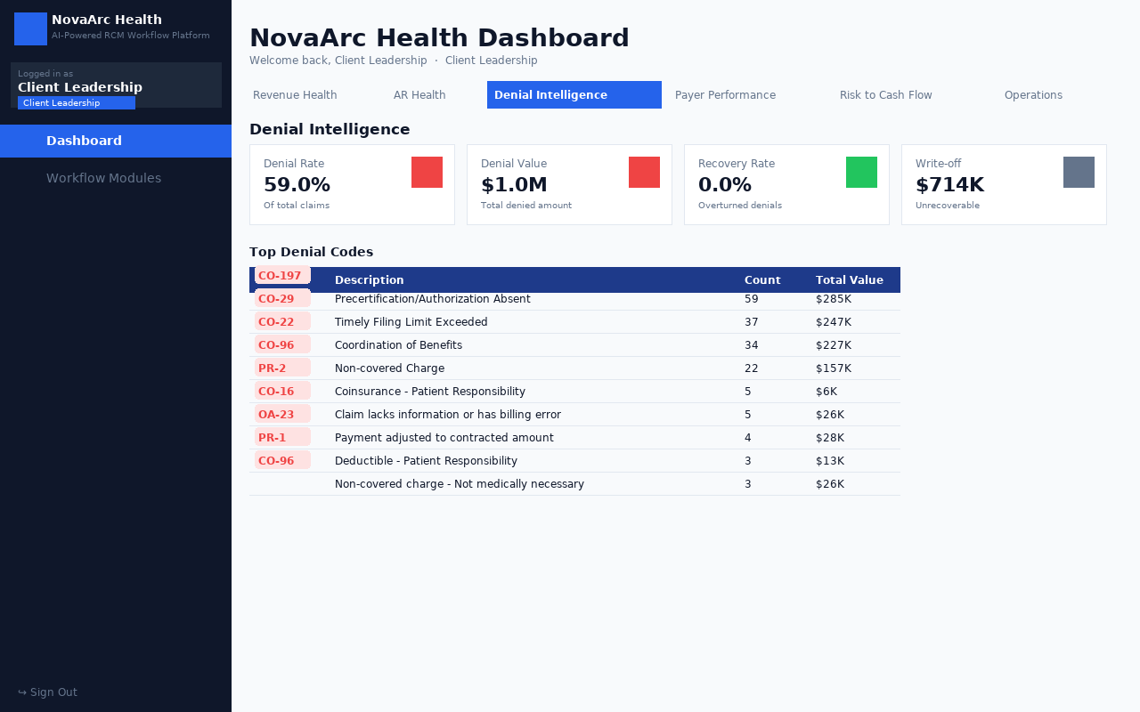
Dashboard — Denial Intelligence Tab

Denial Rate | 59.0%
Total Denial Value | $1.0M
Denial Recovery Rate | 0.0%
Write-off (Denial) | $714K

Top Denial Codes:
Code | Description | Count | Total Value
CO-197 | Precertification/Authorization Absent | 59 | $285K
CO-29 | Timely Filing Limit Exceeded | 37 | $247K
CO-22 | Coordination of Benefits | 34 | $227K
CO-96 | Non-covered Charge | 22 | $157K
PR-2 | Coinsurance - Patient Responsibility | 5 | $6K
CO-16 | Claim lacks information or has billing error | 5 | $26K
OA-23 | Payment adjusted to contracted amount | 4 | $28K
PR-1 | Deductible - Patient Responsibility | 3 | $13K
CO-96 | Non-covered charge - Not medically necessary | 3 | $26K

3.4 Payer Performance
Side-by-side payer comparison with a bar chart (Charged vs Paid by Payer) and a detailed table covering payment timeliness, denial rate, underpayment rate, and AR aging.
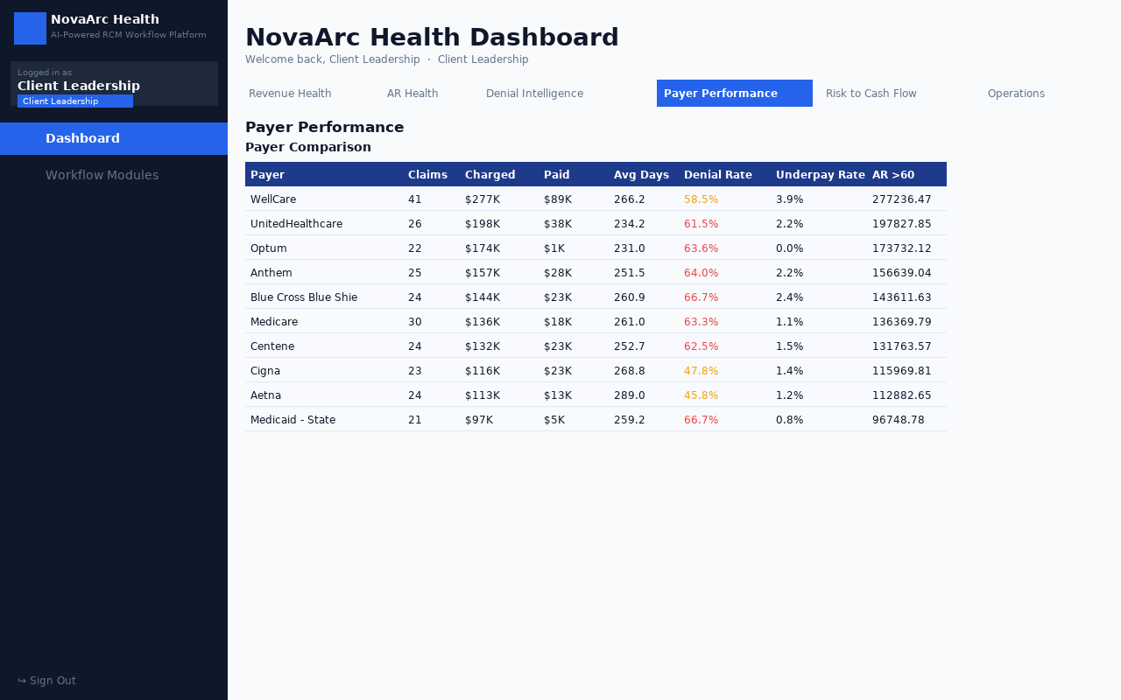
Dashboard — Payer Performance Tab

Payer | Claims | Charged | Paid | Avg Days | Denial Rate | Underpay Rate
WellCare | 41 | $277K | $89K | 266.2 | 58.5% | 3.9%
UnitedHealthcare | 26 | $198K | $38K | 234.2 | 61.5% | 2.2%
Optum | 22 | $174K | $1K | 231.0 | 63.6% | 0.0%
Anthem | 25 | $157K | $28K | 251.5 | 64.0% | 2.2%
Blue Cross Blue Shield | 24 | $144K | $23K | 260.9 | 66.7% | 2.4%
Medicare | 30 | $136K | $18K | 261.0 | 63.3% | 1.1%
Centene | 24 | $132K | $23K | 252.7 | 62.5% | 1.5%

3.5 Risk to Cash Flow
Proactive risk identification across five risk categories. Each card shows count of affected claims and total dollar value at risk, enabling prioritized intervention.
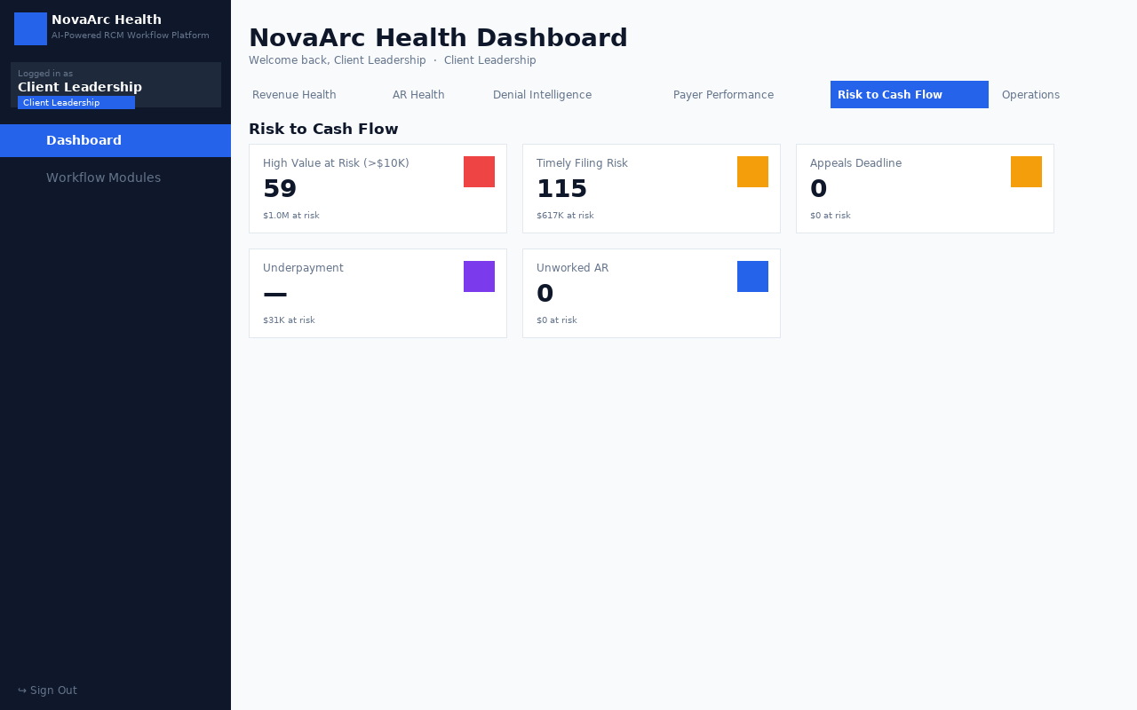
Dashboard — Risk to Cash Flow Tab

High Value at Risk (>$10K) | 59 claims · $1.0M
Timely Filing Risk | 115 claims · $617K
Appeals Deadline | 0 claims · $0
Underpayment | $31K
Unworked AR | 0 claims · $0

3.6 Operations Overview
Operational KPI dashboard covering claim throughput, clean claim rate, AR backlog, work queue summaries, and AI-generated narrative insights.
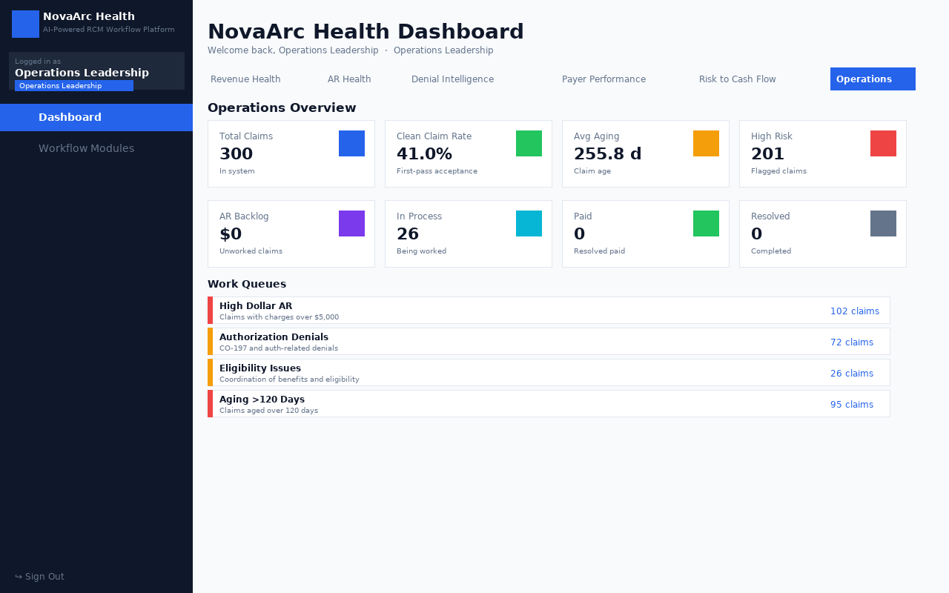
Dashboard — Operations Overview Tab

Total Claims | 300
Clean Claim Rate | 41.0%
Avg Aging | 255.8 days
High Risk Claims | 201
AR Backlog | $0
In Process | 26
Paid Claims | 0

4. AI Assistant (Embedded in Dashboard)
The AI Assistant is a floating conversational chat panel embedded in the bottom-right corner of the dashboard. Users click the purple chat icon to open it without leaving the dashboard. It supports natural language queries about any aspect of the AR portfolio.

■ Features
- Floating panel — 400px wide, expandable to 600px × 85vh
- 10 quick-query suggestion chips shown before first message
- Full chat history with user (blue) and assistant (gradient) bubbles
- Animated typing indicator while AI processes
- Dynamic bar charts rendered inline for numeric/comparative queries
- Metric cards within responses (e.g. 'Claims > 90 Days: 87 · Value: $423K')
- Data tables with up to 8 rows shown inline; CSV export button per response
- Minimize / Expand / Close controls in the panel header

■ Supported Query Types (16+)
- AR over 90 days — count, value, payer breakdown chart
- Denial rate — rate, value, recovery rate, write-off
- Payer performance — comparison table + bar chart
- Collection rate — gross and net rates
- AR aging by specialty — specialty breakdown bar chart
- Revenue leakage — dollar value and percentage
- Unworked claims — count and value
- Claim status breakdown — paid, denied, pending, etc.
- Top denial codes — code, description, count, value table
- Risk indicators — all five risk categories
- High value claims — claims above threshold with detail
- Timely filing risk — approaching deadline claims
- Appeals pending — appeal counts and values
- Payer comparison — charged vs paid chart
- Clean claim rate — first-pass acceptance rate
- Help — lists all available query types

5. Work Queues & Claim Action Board
Work Queues organize claims into priority-driven buckets, enabling efficient AR follow-up. Selecting a claim opens an inline Claim Action Board without navigating away.
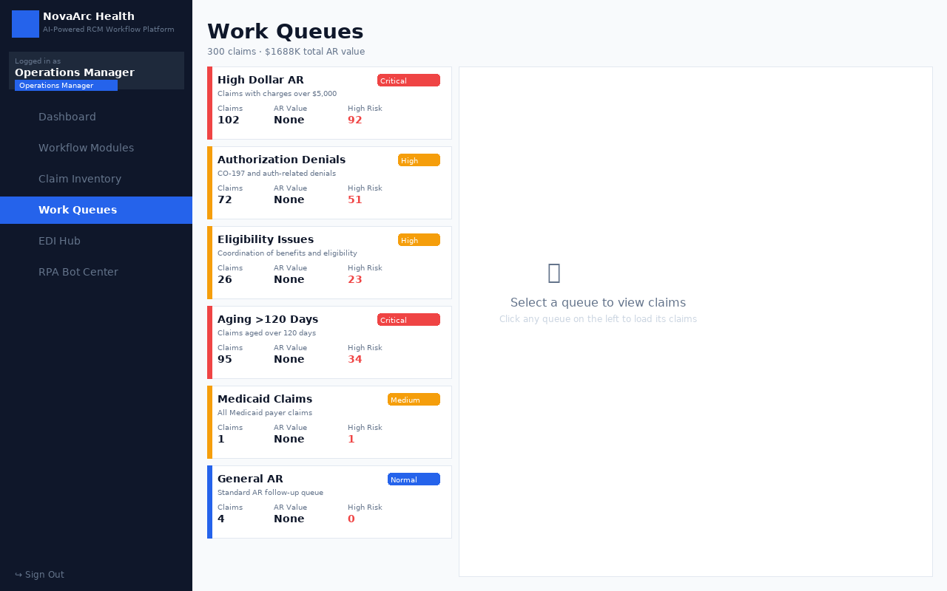
Work Queues — 6 Priority-Based Queue Cards

Queue Name | Priority | Claims | High Risk
High Dollar AR | Critical | 102 | 92
Authorization Denials | High | 72 | 51
Eligibility Issues | High | 26 | 23
Aging >120 Days | Critical | 95 | 34
Medicaid Claims | Medium | 1 | 1
General AR | Normal | 4 | 0

■ Claim Action Board Features
- Blue gradient header with Claim ID, payer, charge amount, and aging days
- Lifecycle Stage Indicator Bar: Submitted → Pending → Under Review → Denied / Paid
- Denial analytics section: denial code, reason, denial date, appeal deadline
- Next Best Action recommendation based on claim status and aging
- Action buttons: View Full Detail, Generate Appeal, EDI Inquiry
- AR Knowledge Base link (arlearningonline.com) for educational resources

6. Claim Inventory
A fully searchable and filterable table of all 300 claims. Supports multi-dimensional filtering and drill-in to individual claim detail pages.
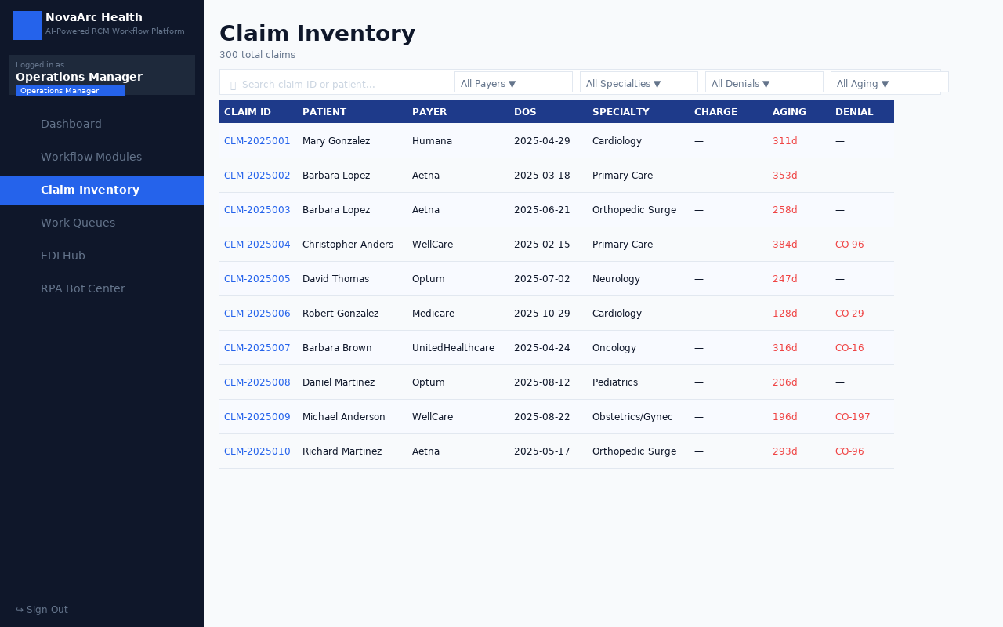
Claim Inventory — Searchable & Filterable Claim Table

Total Claims | 300 claims in the system
Filters | Payer, Specialty, Denial Code, Aging Bucket, Search by Claim ID / Patient
Columns | Claim ID, Patient, Payer, DOS, Specialty, Charge, Aging, Denial Code
Pagination | 25 claims per page with navigation

6.1 Claim Detail Page
Clicking any claim ID navigates to the full Claim Detail page:
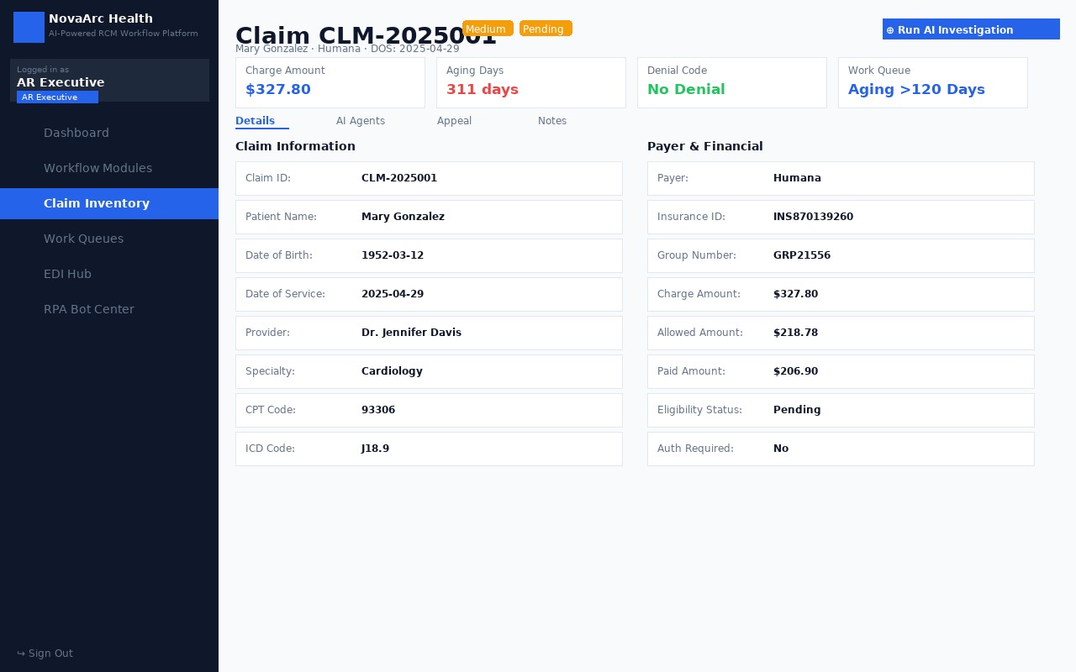
Claim Detail Page — Full Claim Record with AI Investigation

- Full claim header: patient demographics, dates, provider, facility
- Financial summary: billed, allowed, paid amounts
- 4 tabbed sections: Details, AI Agents, Appeal, Notes
- AI Investigation Agent — one-click analysis with next best action
- Appeal Generator — AI-drafted appeal letter with pre-populated denial reason
- Notes field with save capability for claim-level documentation

7. RCM Revenue Surge Workflow Modules
A 5-step guided workflow covering the complete revenue cycle process, simulating enterprise RCM workflow systems.
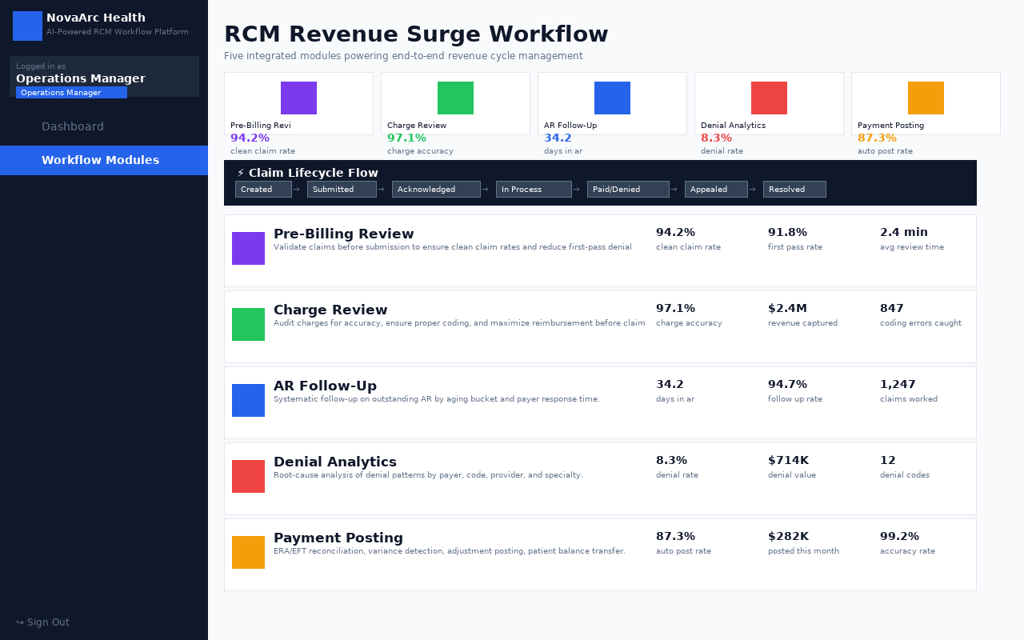
RCM Revenue Surge Workflow — 5 Integrated Modules

Module | Description
Pre-Billing Review | Eligibility verification, authorization checks, charge capture validation before submission.
Charge Review | Charge audit, CDM reconciliation, modifier review, unbundling detection.
AR Follow-Up | Systematic follow-up queue prioritized by aging bucket and payer response time.
Denial Analytics | Root-cause analysis of denial patterns by payer, code, provider, and specialty.
Payment Posting | ERA/EFT reconciliation, variance detection, adjustment posting, patient balance transfer.

8. EDI Hub
Direct electronic payer connectivity through standard HIPAA EDI transactions. Simulates real-world clearinghouse functionality with connection health monitoring.
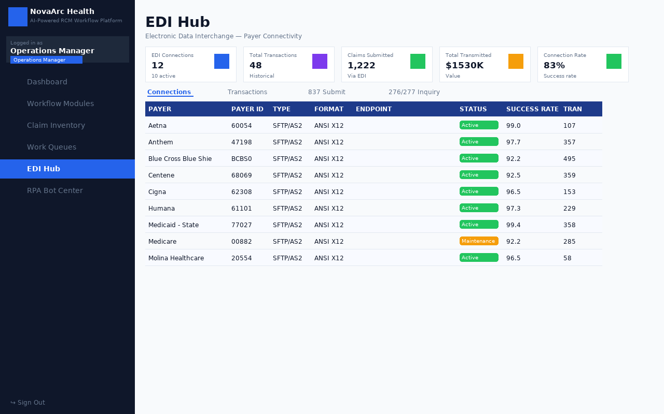
EDI Hub — 12 Payer Connections with Transaction History

- 12 payer EDI connections: Aetna, BCBS, UnitedHealthcare, Cigna, Medicare, Medicaid, Humana, Tricare, Anthem, Molina, WellCare, Centene
- Connection status with color-coded indicators: Active (green), Maintenance (yellow), Error (red)
- 837P — Professional Claim Submission to payer portals
- 276 — Claim Status Request by Claim ID or date range
- 277 — Structured status response display
- Transaction history with 48+ historical records

9. RPA Bot Center
Automated robotic process automation bots executing repetitive RCM tasks across payer portals, replacing manual web-portal navigation with scheduled automation.
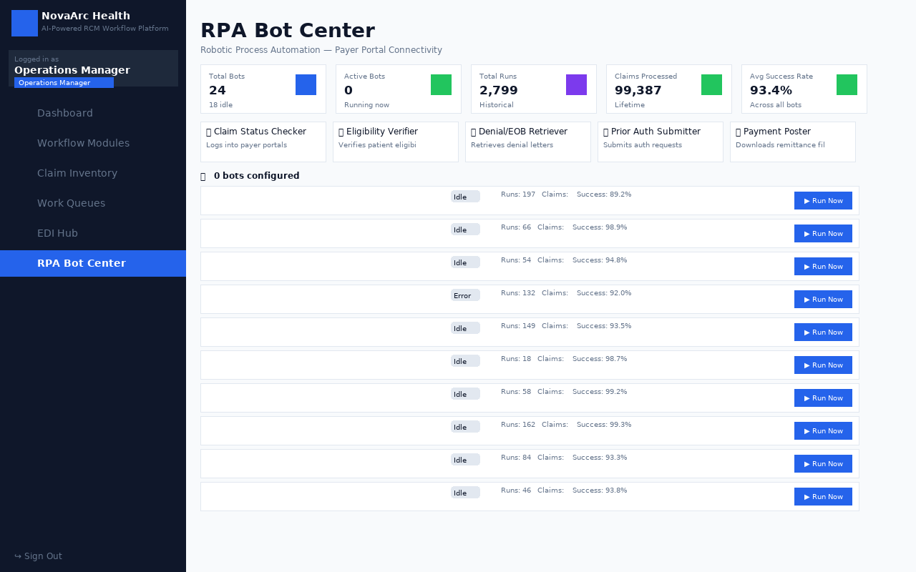
RPA Bot Center — 24 Bots Across 8 Payers

- 24 bots across 8 payers (Aetna, BCBS, UnitedHealthcare, Cigna, Medicare, Medicaid, Humana, Tricare)
- 5 bot types: Claim Status Checker, Eligibility Verifier, Denial/EOB Retriever, Prior Auth Submitter, Payment Poster
- Run bot manually with a single click — displays real-time execution log
- Scheduling: configure automated run times (daily, weekly, on-demand)
- Bot status badges: Idle, Running, Completed, Failed
- 93.4% average success rate across 2,799 total runs

10. Data Ingestion
Bulk claim upload portal exclusively for Team Leads. Supports structured file formats for importing large claim datasets.
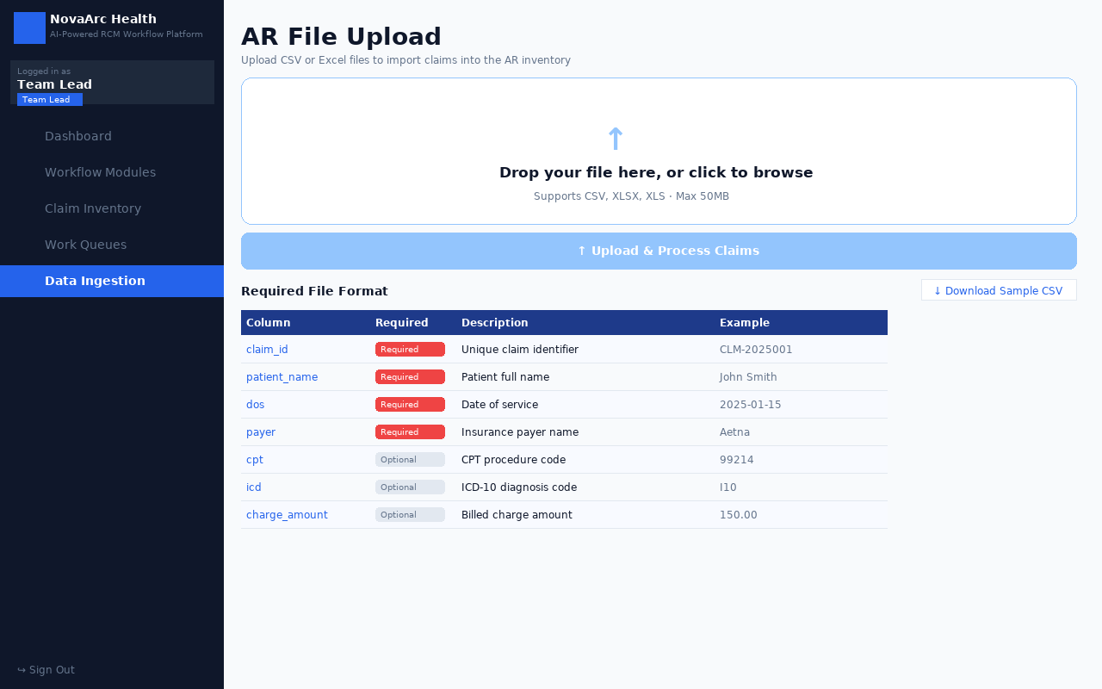
Data Ingestion — Bulk Claim Upload Portal (Team Lead Only)

- Drag-and-drop file upload interface (CSV, XLSX, XLS — max 50MB)
- Column mapping interface to align source fields to the claim schema
- Pre-import validation with row-level error reporting
- Import progress indicator with success/failure counts
- Automatic claim seeding — claims appear immediately in inventory after upload
- Downloadable sample CSV template with all required field definitions

11. Demo Credentials
All accounts use password: nova123

Username | Password | Role
clientlead | nova123 | Client Leadership
opslead | nova123 | Operations Leadership
opsmgr | nova123 | Operations Manager
teamlead | nova123 | Team Lead
arexec | nova123 | AR Executive
qaauditor | nova123 | QA Auditor

Application URL: Access through the Replit preview panel (port 5000 — dev server, port 8000 — production build).

