ALUMNYE
Mobile Application — Product Walkthrough & Functional Reference
Anchor & Member — Screen-by-Screen Specification

Document | Alumnye Mobile App — Product Walkthrough
Version | v1.3
Date | 08 July 2026
Prepared by | Prodian Team
Client | Alumwhale
Release scope | Delta (current customer release) + Golf Tournament Scoring & Management (New Add-On, prototype stage)
Surface | Mobile (React Native / Expo) — Anchor + Member
Audience | Client · Development · QA / Test teams
Status | Living document — circulate & maintain per release

Table of Contents
Table of Contents 2
1. Introduction & How to Use This Document 6
1.1 How each screen is documented 6
1.2 Roles & terminology 6
1.3 What's Changed in This Release (v1.2 — 08 Jul 2026) 6
2. Navigation Model & Information Architecture 8
2.1 Member — Tile Home View 8
2.2 Anchor navigation 8
2.3 Global navigation rules 8
3. Module-Level Implementation Summary 9
4. Module Workflow Diagrams 10
4.1 Group creation & member onboarding 10
4.2 Event planning: Poll → CostGPT → Event update 10
4.3 RSVP → Payment lifecycle 10
4.4 AI profile builder — two-step consent & review 11
4.5 Anchor-driven event lifecycle 11
5. Technical Context (Mobile-Relevant) 12
6. Authentication & Onboarding 13
6.1 Splash Screen 13
6.2 Sign In 13
6.3 Verify Mobile (OTP) 14
6.4 Complete Profile 15
7. User Profiles 17
7.1 Alum Profile 17
7.2 Edit Profile 17
7.3 Professional Details 18
7.4 Academic Details 19
7.5 Preferences 20
7.6 Profile Layer — AI Wizard 21
7.7 Published (Generated Story) 22
7.8 Profile Review (Member) 22
7.9 Member Profile (Anchor view) 22
8. Groups & Membership 24
8.1 Anchor Home 24
8.2 Group Form (Create / Edit) 24
8.3 Group Details 26
8.4 Members (Invite / Upload) 26
8.5 Bulk Preview 28
8.6 Invite Modal 28
8.7 Cohort Members 29
9. Events & Lifecycle 31
9.1 Event Form (Create / Edit) 31
9.2 Event Home 32
9.3 Event Detail 32
9.4 Events Home / All Events 33
10. Polling (D3 / D4) 35
10.1 Poll Type Chooser 35
10.2 Create Poll (Manual D3) 35
10.3 D4 Poll Wizard 36
10.4 D4 Review & Launch 38
10.5 Event Polls List 40
10.6 Poll Landing 40
10.7 Poll Response 41
10.8 Live Tracking 42
10.9 Poll Output 42
11. RSVP 44
11.1 Launch RSVP 44
11.2 RSVP Respond 44
11.3 RSVP Tracker / Track RSVP 45
11.4 Send Follow-Up 46
12. Cost Estimation (CostGPT / EVE) 48
12.1 Cost Estimation Wizard (CostGPT) 48
12.2 Cost Estimator Chat (EVE) 48
12.3 Cost Estimator List 49
13. Payments (Manual — Delta) 51
13.1 Event Payment (Mark as Paid) 51
13.2 New Payment 51
13.3 Payment Transactions 52
13.4 Payment (Member status & checkout) 53
13.5 Payment Confirmed 53
14. Itinerary & Travel 55
14.1 Event Itinerary 55
14.2 Create Itinerary 55
14.3 Update Travel (Transfer to be renamed as Travel) 56
14.4 Travel Details (Transfer to be renamed as Travel) 57
15. Community, Announcements & Engagement 59
15.1 Feed / Library 59
15.2 Post Upload 59
15.3 Notice Board 60
15.4 Create Notice (modal) 61
15.5 Notifications (in-app) 62
15.6 Nominee Management 62
16. Privacy, Consent & Legal Screens 64
16.1 Consent Management 64
16.2 Terms & Conditions 64
16.3 Privacy Policy 65
16.4 AI Usage 66
17. Business Rules & Compliance 67
17.1 Core business rules 67
17.2 AI governance 67
17.3 Privacy & data protection 67
17.4 Regulatory context 67
18. Status, Risks & Deferred Scope 68
18.1 Open risks 68
18.2 Known blockers 68
18.3 Deferred to Alpha (not in mobile Delta) 68
18A. Golf Tournament Scoring & Management (New Add-On Module) 69
18A.1 Positioning & Concept 69
18A.2 Group & Team Structure 69
18A.3 Draw Sheet (Phase 1) 69
18A.4 Scorecard & Score Capture (Phase 1 UI / Phase 2 logic) 69
18A.5 Gross / Net Scoring & Handicap (Phase 2) 69
18A.6 Standings, Live Scoring & Notifications (Phase 2) 70
18A.7 Phased Delivery Plan 70
18A.8 Golf-Specific Risks & Dependencies 70
19. Document Control & Maintenance 71

1. Introduction & How to Use This Document
This document is the single end-to-end functional reference for the Alumnye mobile application as currently implemented for the Delta release. It is intended to be circulated to the client (Alumwhale), the development team, and the QA / test team as a shared source of truth for what the application does, screen by screen.
Scope of this document. Mobile application only, covering both the Anchor (organiser/admin) and Member (alum) experiences. The web frontend, backend internals, and deferred Alpha-phase features are out of scope here and are noted only where they affect a mobile screen.

1.1 How each screen is documented
Every screen below follows the same structure so the document can be read consistently by all three teams:
- Screenshot placeholder — a bordered box for you to paste the live screen capture.
- Purpose — a one or two line statement of what the screen is for.
- Screen elements & what each does — a table listing every interactive element (buttons, fields, toggles, cards, tabs) and its behavior.
- States — empty, active, error, loading and locked states where they exist.
- Screen-level workflow — the navigation/flow path through and out of the screen.

1.2 Roles & terminology
Anchor | Group organizer / administrator. Drives every event phase transition (no auto-advance). Creates groups, adds members, launches polls, runs CostGPT, records payments and expenses, publishes content.
Member (Alum) | Participant. Joins by invitation only (no open join), maintains profile, responds to polls and RSVP, provides travel details, views payments and content.
Delta | The current customer release scope (formerly MVP / QuickLaunch).
Alpha | The next phase (deferred features).
D3 Poll | Event-planning poll across Duration · Date · Destination.
D4 Poll Wizard | 5-step guided poll framing: Year, Dates, Duration, Destination, Budget.
CostGPT / EVE | AI-assisted event cost estimation, Anchor-only, advisory.
Member Code | Initial-based per-member identifier — <First Initial><Last Initial><Sequence>, e.g. JD1, SK2.

Implementation source. Screen inventory and behavior in this document are derived from the implemented build state recorded in the project's PROJECT_SUMMARY and TASK_LOG. Where a behavior is governed by a business rule, the rule ID (e.g. RULE-PAY-001) is cited.

1.3 What's Changed in This Release (v1.2 — 08 Jul 2026)
This section summarises everything that changed relative to v1.1 (30 Jun 2026), consolidating the 30-Jun, 01-Jul and 08-Jul MoMs. Full detail is in the affected sections below; each changed screen card also carries an inline “Updated” or “New” callout.
NEW — Golf Tournament Scoring & Management (standalone add-on module)
- A completely new tile/module — Golf Tournament Scoring & Management — has been added as Section 18A. It is a standalone add-on, separate from the core Delta/Alpha alumni-event scope, currently at prototype/concept stage (30-Jun and 01-Jul kick-off and review sessions).
- Reflected in the Module-Level Implementation Summary (Section 3) and the Member Tile Home View table (Section 2.1) as a new, separately-launched tile set.
UPDATED — Core Delta screens (08-Jul-26 testing & refinement session)
- Verify Mobile (OTP) / Registration — walkthrough re-run using a new mailer and a new mail ID for OTP verification during sign-up (Section 6.3).
- Anchor Home — UI branding aligned to consistent blue Anchor colours (previously inconsistent Alum colours); new intuitive welcome message confirming the Anchor role and guiding first group creation (Section 8.1).
- Profile Layer — AI Wizard — the existing backend feature allowing an Alum/Member to generate their own profile using AI (previously disabled) is being enabled, based on the agreed pricing model (Section 7.6).
- Notice Board / Create Notice — PNG/JPG image attachment support added, mirroring the experience of a physical college notice board (Section 15.4).
- Release & test process — a client-isolated TestFlight build stood up so Alumwhale's UAT data/environment stays separate from internal testing; build/patch pushes are paused while the client is actively testing (Sections 5, 18.2).
STATUS UPDATED — Risks & blockers
- Karix DLT/SMS responsiveness escalated via Alumwhale's mailbox; a Plan B SMS provider (Karix) is being evaluated in parallel (new risk R6, Section 18.1).
- Happy-flow testing is passing; negative-flow / validation issues remain open and are gating the move to live 5–6 user testing (Section 18.2).

2. Navigation Model & Information Architecture
The app uses role-based navigation. On authentication the navigator remounts and maps the bottom tab bar and header to the active role (Anchor or Member). Role switching is supported for users who hold both roles.

2.1 Member — Tile Home View
The Member event experience is organized around a tile layout, ordered to mirror the natural event workflow (Event → Poll → Payment → RSVP):
Tile | Leads to | Workflow stage
Poll | Event polls list / poll response | Decision
Library | Community feed & shared media | Engagement
Payment | Member payment status & checkout | Settlement
Itinerary | Event itinerary timeline | Logistics
Member | Cohort member list | Community
RSVP | RSVP respond / status | Attendance
Chat | Group chat (inclusion pending client confirmation) | Engagement
Golf (NEW) | Golf Tournament Scoring & Management (standalone add-on — see Section 18A) | New Add-On (prototype)

Bottom navigation labels (Delta naming): 'My Groups' (formerly Groups), 'Library' (formerly Feed), 'Your Transactions' (formerly Open Poll). The standalone 'Events' tab has been removed from the bottom nav; events are reached through groups.

2.2 Anchor navigation
Anchors land on the Anchor Home (groups dashboard) and drill into a group → event → event sub-modules (Poll, Cost Estimator, Payment, Expenses, RSVP tracking, Itinerary, Travel, Announcements). The Anchor drives all phase transitions explicitly.

2.3 Global navigation rules
- Header reactivity and navigator remounting keep the UI consistent when a user switches between Anchor and Member roles.
- Pending actions are highlighted in red on the home screen for both roles.
- Homepage shows the full event list, most recent first, each with a status badge.
- Deep links: alumnye://poll/verify and alumnye://polls/:eventId route into the poll invitation / poll list flows.

3. Module-Level Implementation Summary
The table below summarizes each functional module and the principal mobile screens that realize it. Screen-level detail follows in Sections 6–16.
Module | Principal mobile screens
Authentication & Identity | Splash, Sign In, Verify Email (OTP), Complete Profile, Reset Password
User Profiles (manual) | Alum Profile, Edit Profile, Professional Details, Academic Details, Preferences
Profile Builder (AI) + Bio Review | Profile Layer wizard, Published, Profile Review, Member Profile (Anchor)
Groups & Membership | Anchor Home, Group Form, Group Details, Members (Invite/Upload), Cohort Members, Invite modal, Bulk preview
Events & Lifecycle | Event Form, Event Home, Event Detail, Events Home / All Events
Polling (D3 / D4) | Poll Type Chooser, Create Poll, D4 Poll Wizard, D4 Review & Launch, Poll Landing, Poll Response, Live Tracking, Poll Output, Event Polls List
RSVP | Launch RSVP, RSVP Respond, RSVP Tracker / Track RSVP, Send Follow-Up
Cost Estimation (CostGPT / EVE) | Cost Estimation Wizard, Cost Estimator Chat, Cost Estimator List
Payments (manual, Delta) | Event Payment, New Payment, Payment, Payment Transactions, Payment Confirmed, Event Expenses
Itinerary & Travel | Event Itinerary, Create Itinerary, Travel
Community / Library | Feed / Library, Post Upload
Announcements / Notice Board | Notice Board, Create Notice modal
Notifications | In-app notifications (Member/Anchor home), FCM push
Privacy & Consent | Consent Management, Terms & Conditions, Privacy Policy, AI Usage
Nominee Management | Nominee Management
Admin & Governance | —
Golf Scoring & Management (NEW Add-On) | Group/Team Setup, Draw Sheet (round-robin / knockout), Scorecard & Score Capture (gross/net), Live Scoring & Standings — see Section 18A

Deferred to Alpha (not in mobile Delta): WhatsApp (Karix) dispatch, Razorpay payment gateway, alumni booklet PDF, Personal Library, Quick-Add / AI-assisted member addition.

4. Module Workflow Diagrams
The diagrams below show the principal cross-module flows. Each box is color-coded by actor — Anchor (purple), Member (teal), System / AI (navy) — with decision points shown as amber diamonds. Solid arrows are user/navigation steps; dashed arrows are system hand-offs.

4.1 Group creation & member onboarding
How an Anchor stands up a cohort and how a member joins by invitation (no open join). Bulk uploads are previewed before commit; the post-add dialog offers immediate or deferred AI profile generation.
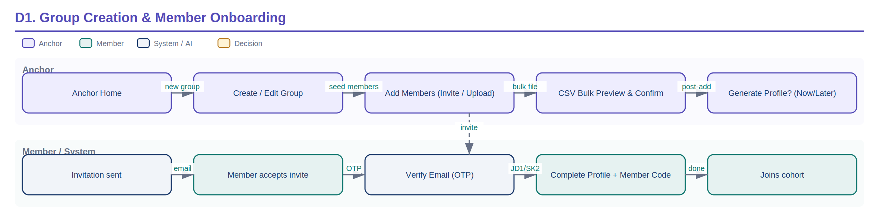
D1 — Group creation & member onboarding flow.

4.2 Event planning: Poll → CostGPT → Event update
The core planning loop. The Anchor frames a poll (manual D3 or the D4 wizard), launches it, and closes it; the closed poll feeds AI analysis and the Poll Output, from which the Anchor moves into CostGPT and updates the event. Poll creation is decoupled from launch.
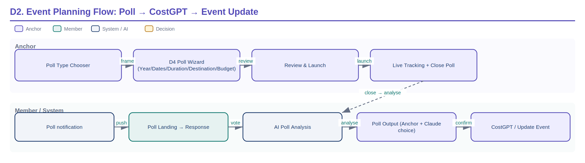
D2 — Event planning flow from poll framing through cost estimation.

4.3 RSVP → Payment lifecycle
RSVP gates payment: a member payment can only be recorded once that member is RSVP = YES (RULE-PAY-003). 'No' and 'Thinking' responders are routed to reminders; expenses are tracked in parallel with per-head and variance calculations.
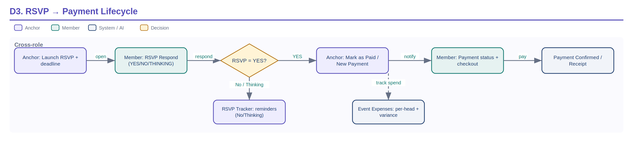
D3 — RSVP and manual payment lifecycle with the RSVP=YES gate.

4.4 AI profile builder — two-step consent & review
The profile builder enforces two consent gates (extract, then publish) and a mandatory human review. Prompts carry no PII and never include the platform name (RULE-012); all AI calls pass through the audited gateway.
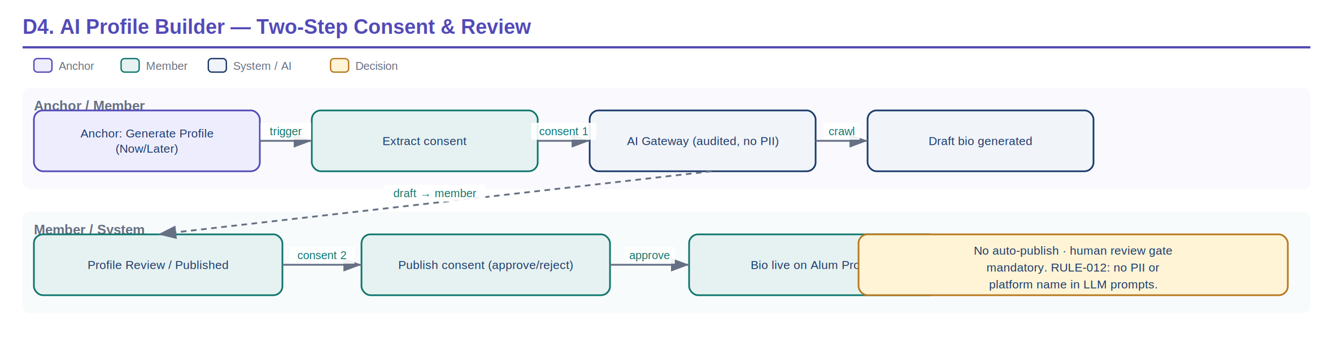
D4 — AI profile builder consent and review workflow.

4.5 Anchor-driven event lifecycle
Every event phase transition is triggered explicitly by the Anchor — no phase advances automatically (RULE-007).
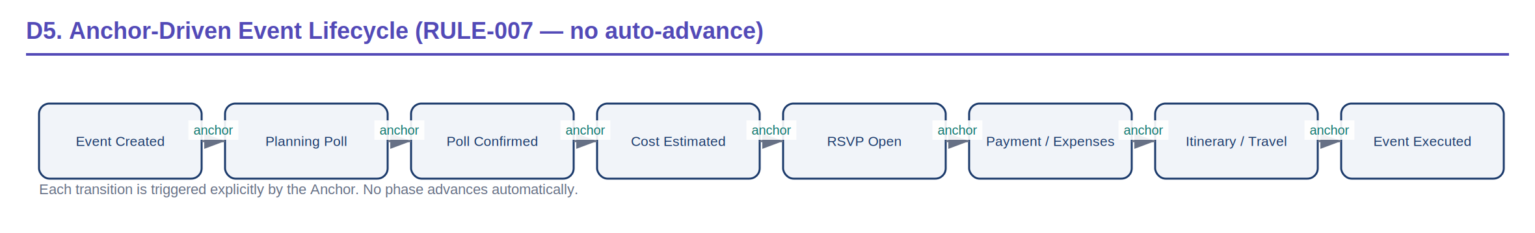
D5 — Anchor-driven event lifecycle states.

5. Technical Context (Mobile-Relevant)
Mobile stack | React Native 0.81 + Expo 54, TypeScript. Canonical app: ALUMNYE_MOBILEAPP_RN. Production token-refresh handling; targets UAT API.
Backend | Spring Boot 3.4.2 / Java 21, REST (OpenAPI). PostgreSQL 14+, schema via Flyway migrations.
AI services | Python FastAPI microservice (ALUMNYE_AGENTS) for Claude + Firecrawl, proxied via an audited Spring Boot gateway (ai_audit_log).
Push | Firebase Cloud Messaging (FCM) via expo-notifications; device tokens saved on login / OAuth / OTP verification.
Auth | Email + JWT, phone OTP, Google OAuth (Android redirect fix + email auto-linking). RBAC enforced on all controllers.
Money | Stored as BIGINT paise. UUID primary keys. Soft deletes via deleted_at.
Data spine | Auth → Profiles → Groups → Events → {Planning Poll, RSVP, Manual Cost, Payment Entry, Itinerary, Announcements} → Notifications / Community.

6. Authentication & Onboarding
Entry flow that establishes identity and creates the user's profile shell. Default registration role is Anchor; role can be adjusted by membership.

6.1 Splash Screen
Role: Both Module: Auth & Identity
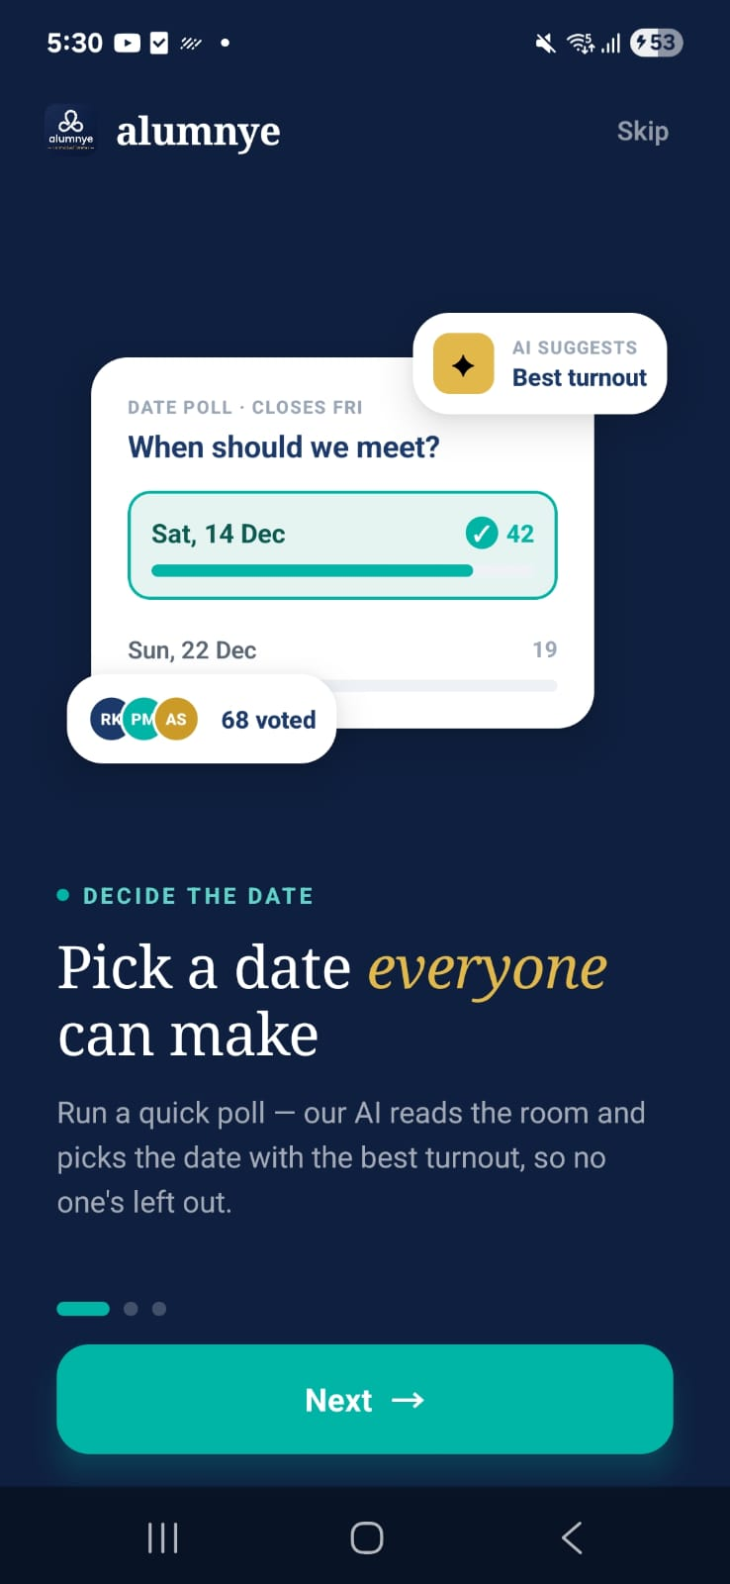 | 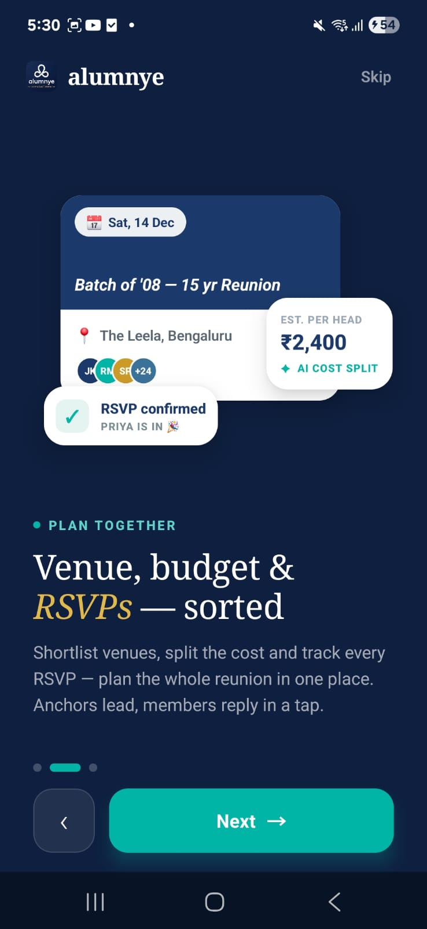 | 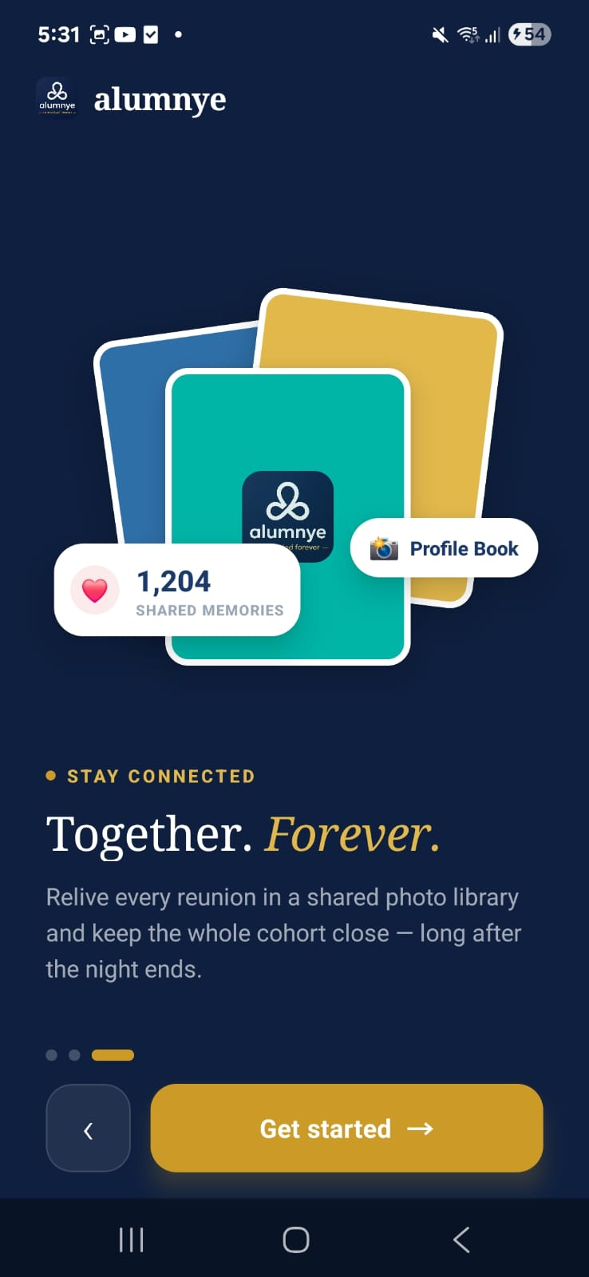

Purpose. Branded launch screen shown while the app initialises, checks stored session/onboarding state, and routes to Sign In or Home.
Screen elements & what each does:
Element | Behaviour / What it does
Alumnye brand mark | Static logo / brand animation during boot.
Auto-route logic | Reads stored auth token & onboarding flag; routes to Home if a valid session exists, else to Sign In. Preserves the alumnye_onboarded key so the guided tour does not repeat.

States:
- Loading — Default state while session is resolved.

Screen-level workflow: App launch → Splash → Sign In (no session) / Home (valid session)

6.2 Sign In
Role: Both Module: Auth & Identity
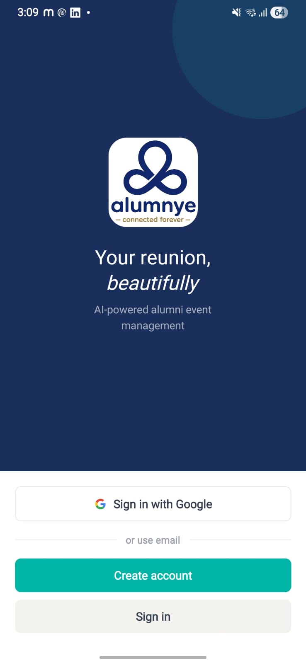 | 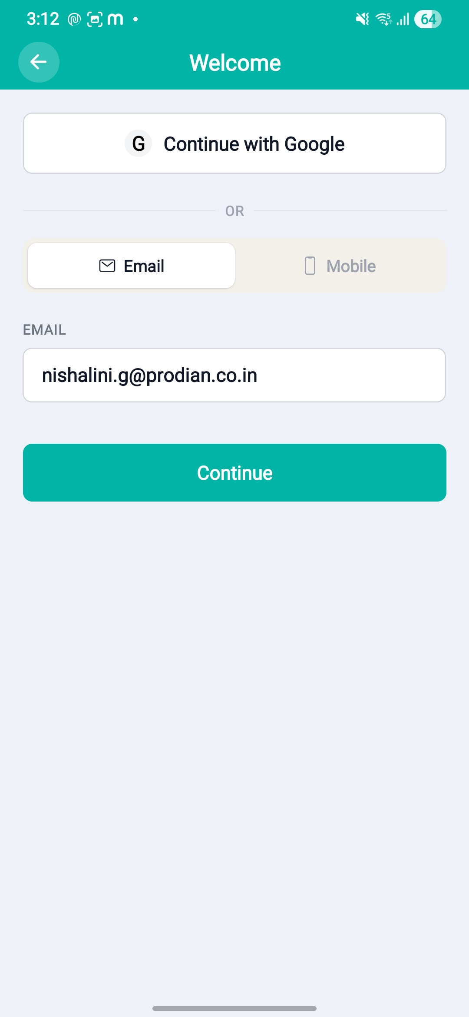 | 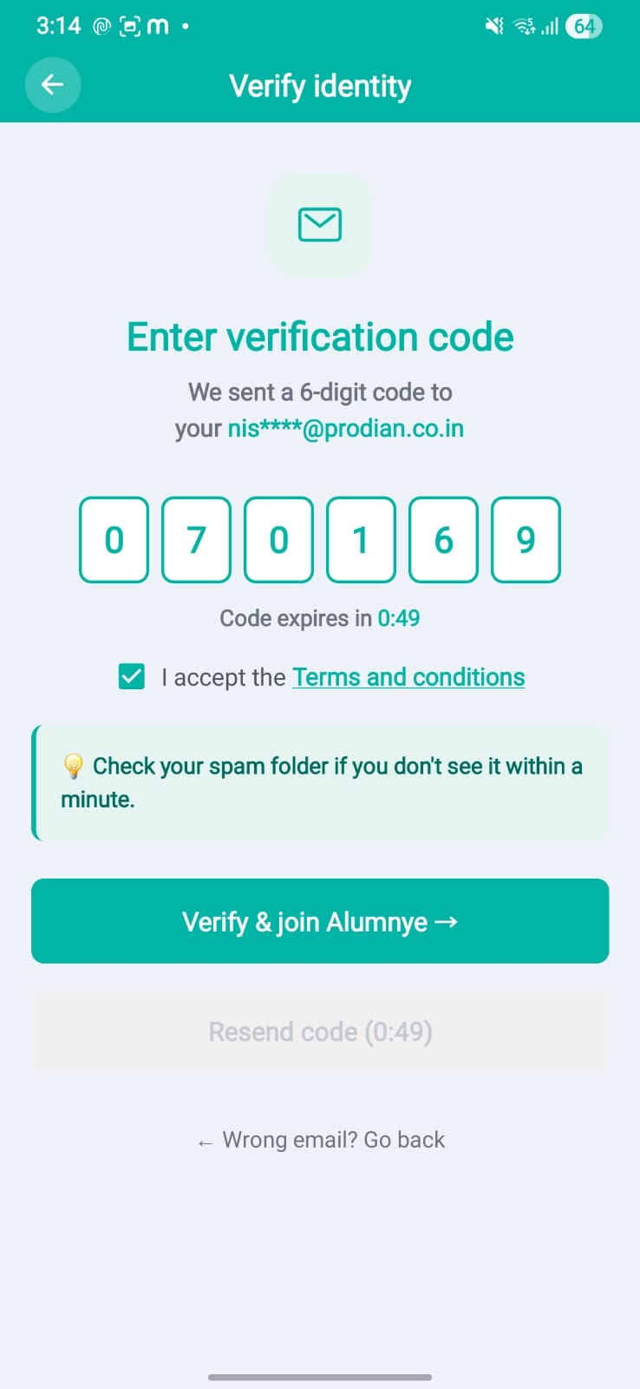

Purpose. Authenticate an existing user by email/password or Google OAuth, or begin email verification for a new sign-up.
Screen elements & what each does:
Element | Behaviour / What it does
Email field | Accepts the user's email; format-validated.
Continue button | Submits credentials; on success issues JWT and routes to Home by role.
Continue with Google | Google OAuth flow; Android redirect handled; auto-links to an existing email account where matched.
Header title | Title of the page

States:
- Error — Invalid credentials / network error surfaced via toast and inline messaging.

Screen-level workflow: Sign In → Verify Email (new) / Home (existing)

6.3 Verify Mobile (OTP)
Role: Both Module: Auth & Identity
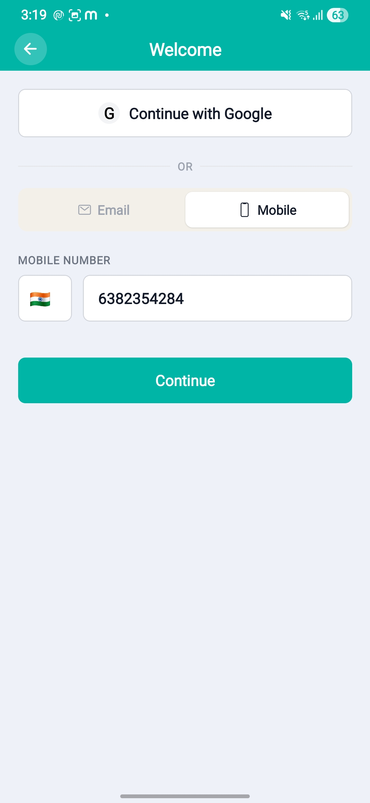 | 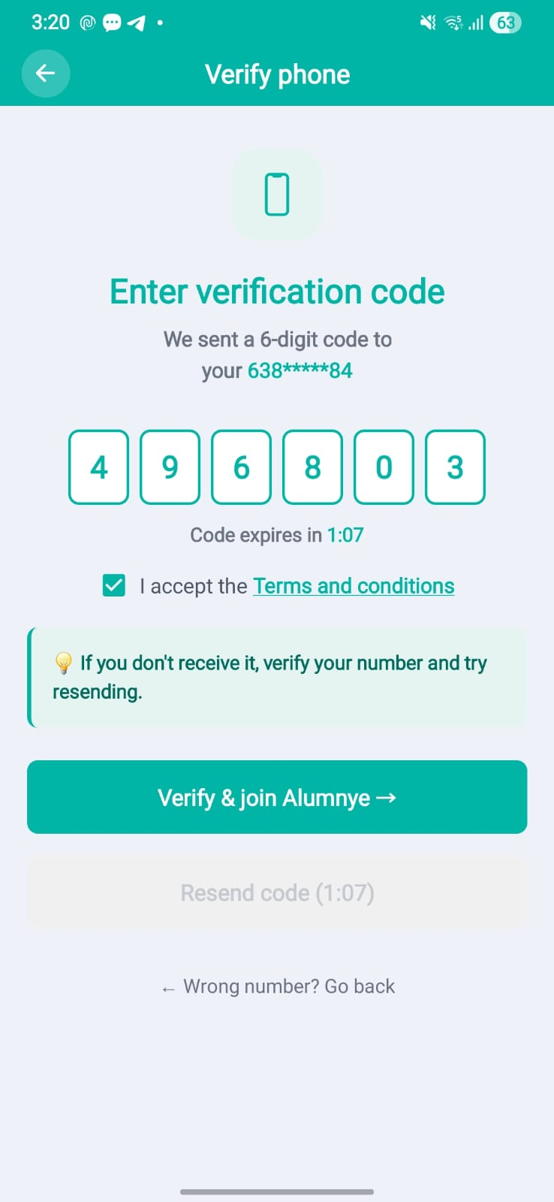

Purpose. Confirm mobile ownership via a one-time passcode during sign-up and certain profile changes.
Screen elements & what each does:
Element | Behaviour / What it does
Masked Mobile number display | Shows the target mobile number with a dynamically-sized asterisk mask.
OTP entry | Numeric one-time-code input.
Terms and Conditions acceptance | Check box with link to Terms and conditions to be read and accepted.
Resend / timer | Background timer governs OTP expiry; resend available after expiry.
'Wrong number? Go back' link | Returns to the previous step to correct the mobile number.
Verify button | Validates the OTP and advances to Complete Profile (sign-up).

States:
- Expired — Expiry handled even when app is backgrounded; user prompted to resend.
- Error — Incorrect OTP surfaced inline.

Screen-level workflow: Sign In / Sign Up → Verify Mobile number → Complete Profile
Updated (08-Jul-2026 release). Registration/OTP flow re-walked-through using a new mailer and a new mail ID for OTP verification during sign-up.

6.4 Complete Profile
Role: Both Module: Auth & Identity
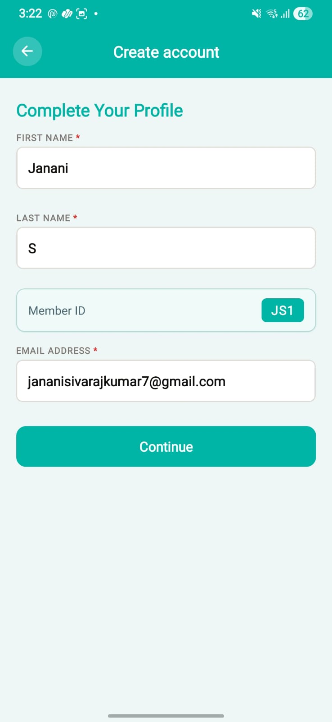 | 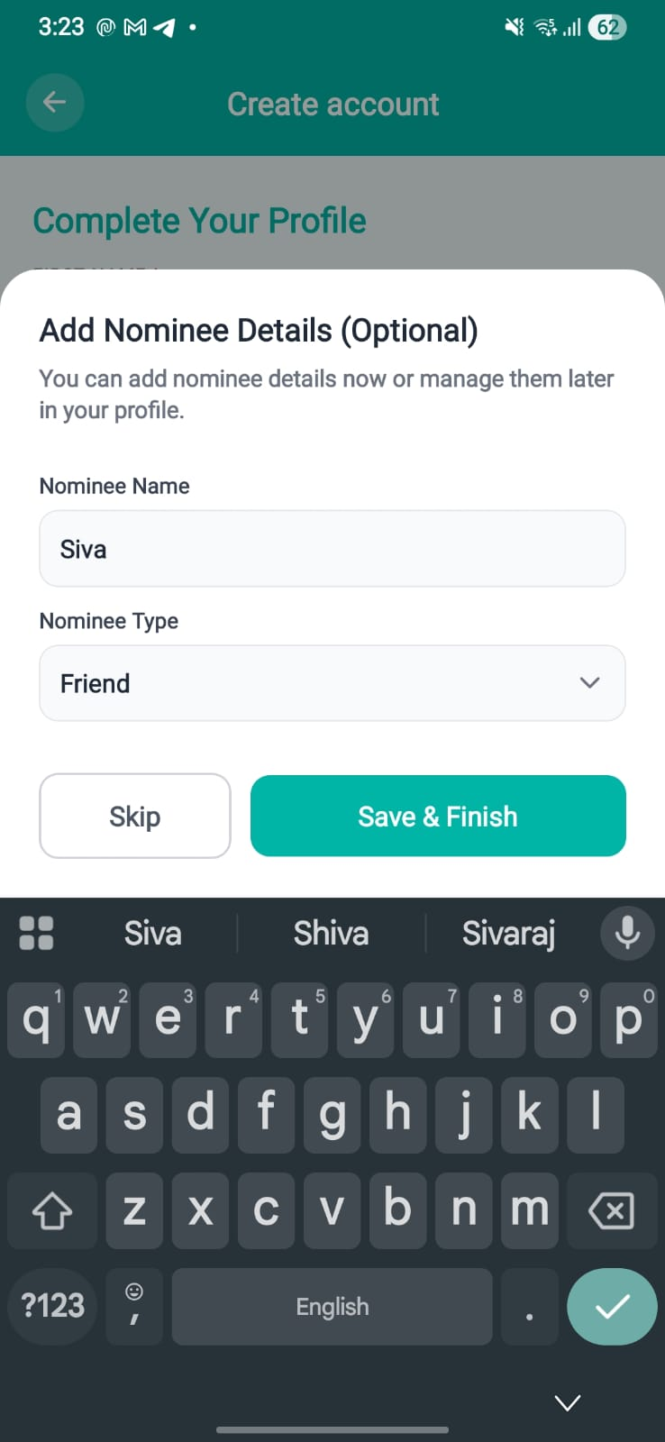 | 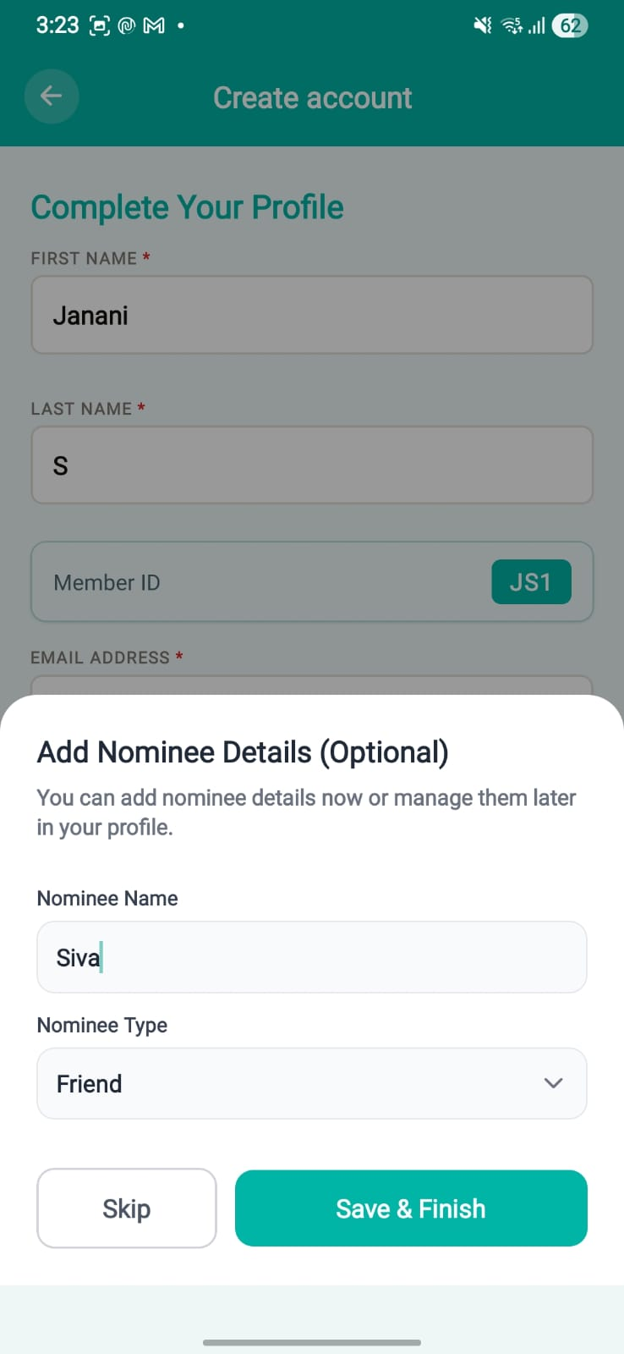

Purpose. Capture the minimum profile data needed to onboard a new user, including first/last name components and the member code preview. Nominee details capture is optional and is explained in later section.
Screen elements & what each does:
Element | Behaviour / What it does
First name / Last name | Separate name component fields (stored as first_name, last_name). Full Name is mandatory and marked with a red asterisk; strict character regex with real-time error feedback.
Required-field markers | All required fields marked with red asterisks.
Member code preview | Real-time preview of the initial-based member code (<FI><LI><Seq>, e.g. JD1) as the name is typed.
Add/Skip Nominee details | Nominee detail entry (optional)
Save & Finish | Persists name components to the backend and completes onboarding.

States:
- Validation — Spaces-only / empty values blocked; inline errors with red borders on save.

Screen-level workflow: Verify Email → Complete Profile → Home

7. User Profiles
Member-owned profile data plus the AI-assisted profile builder and the Anchor-mediated bio review workflow.

7.1 Alum Profile
Role: Member Module: User Profiles
 | 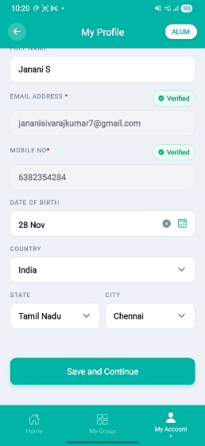 | 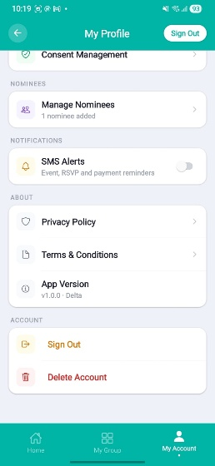

Purpose. The member's own profile home: identity, education, experience, skills, contacts, and approved bio.
Screen elements & what each does:
Element | Behaviour / What it does
Profile picture | Upload via Expo ImagePicker; tappable to change.
Identity card | Name, member code, role; card-based layout.
Approved bio badge | Indicates the bio has passed the review workflow and is live.
Education / Experience / Skills sections | Render saved entries; tap to edit.
Privacy settings card | Controls field visibility filtering for other members.
Sign Out | Consistent 'Sign Out' label across profile screens.
Edit entry points | Navigate to Edit Profile / Professional / Academic detail screens.

Screen-level workflow: Home → Alum Profile → Edit Profile / Professional / Academic

7.2 Edit Profile
Role: Member Module: User Profiles
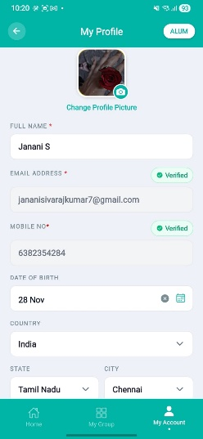 | 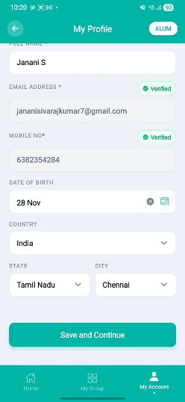

Purpose. Edit core profile fields with conditional editability and verification on sensitive fields.
Screen elements & what each does:
Element | Behaviour / What it does
Full name | Mandatory, marked with star; strict character validation.
Email / Phone (conditional) | Editable only with OTP verification; required-field validation for name, email, mobile.
Location picker | Modalised Country / State / City selectors.
Date of birth | Calendar with stable year-selection grid (year reset bug fixed).
Save | Blocks spaces-only / empty values; inline + toast errors on invalid save.

States:
- Verification — Email/phone changes gated behind OTP.

Screen-level n: Alum Profile → Edit Profile → Alum Profile

7.3 Professional Details
Role: Member Module: User Profiles
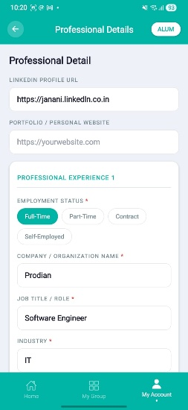 | 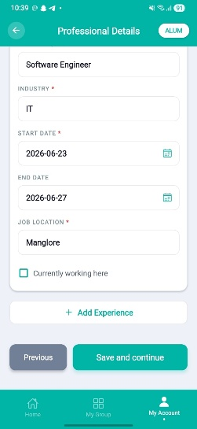

Purpose. Capture employment history entries (company, title, industry, location, dates).
Screen elements & what each does:
Element | Behaviour / What it does
Company / Job Title / Industry / Location | Required fields with inline error indicators (red borders + text) shown at save time.
Start date / Current job toggle | Start date required; 'Add Experience' button hidden when 'current job' is ticked.
Employment status | 'Student' removed from the options list.
Save | validateAllFields() runs on save; toast + inline errors for any missing required field.

States:
- Error — Inline field errors appear only on save attempt (not while typing).

Screen-level workflow: Alum Profile → Professional Details → Alum Profile

7.4 Academic Details
Role: Member Module: User Profiles
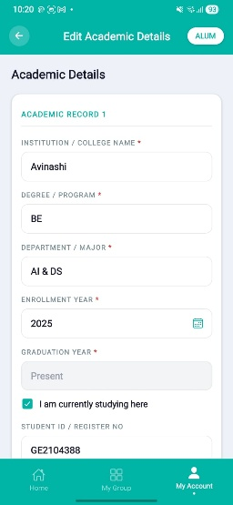 | 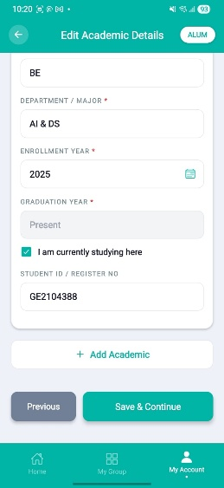

Purpose. Capture education history (institution, degree, field, years).
Screen elements & what each does:
Element | Behaviour / What it does
Institution / Degree / Field of Study | Required; inline errors at save time.
Start year / End year | Required with year-range validation.
Save | Same save-time validation pattern as Professional Details.

Screen-level workflow: Alum Profile → Academic Details → Alum Profile

7.5 Preferences
Role: Member Module: User Profiles
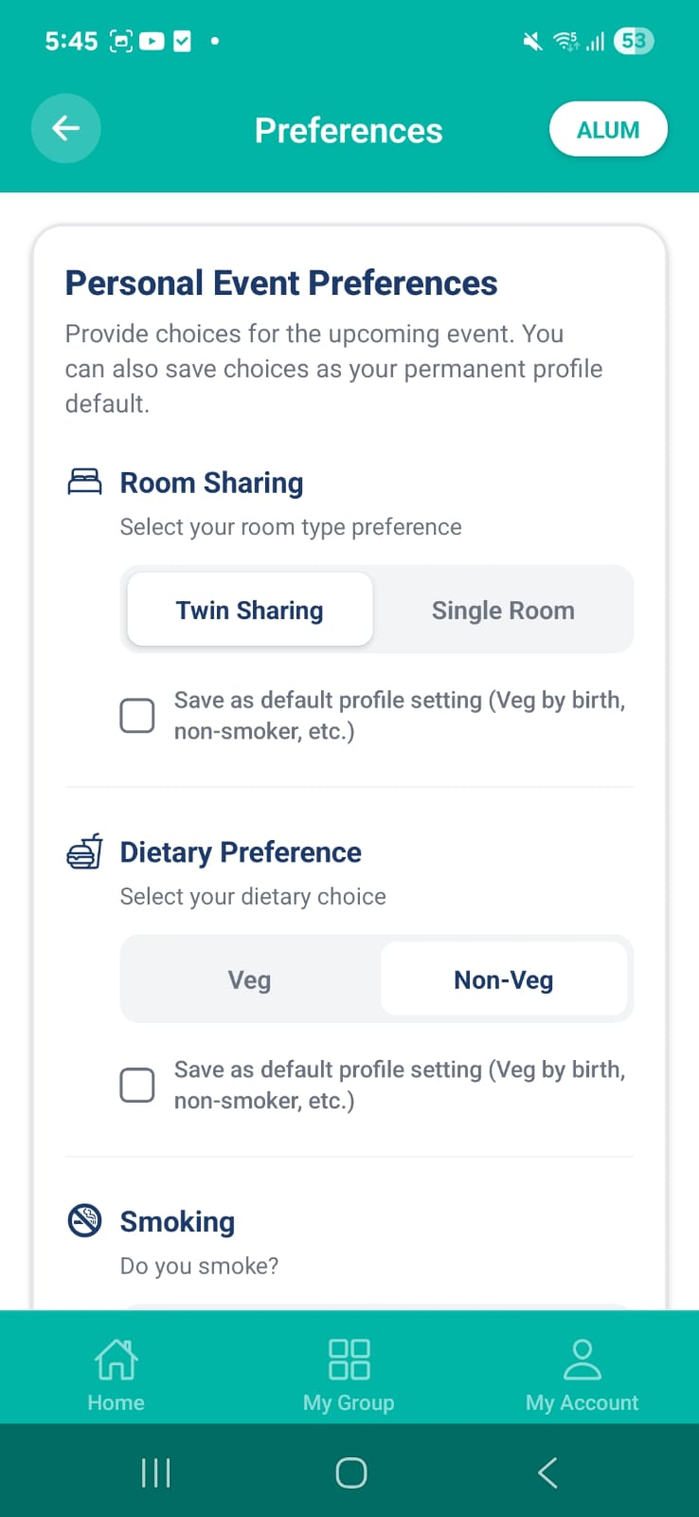 | 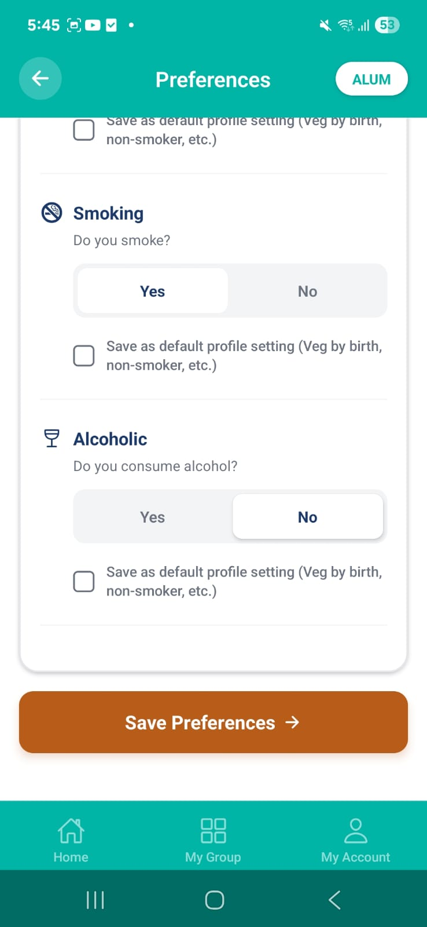 | 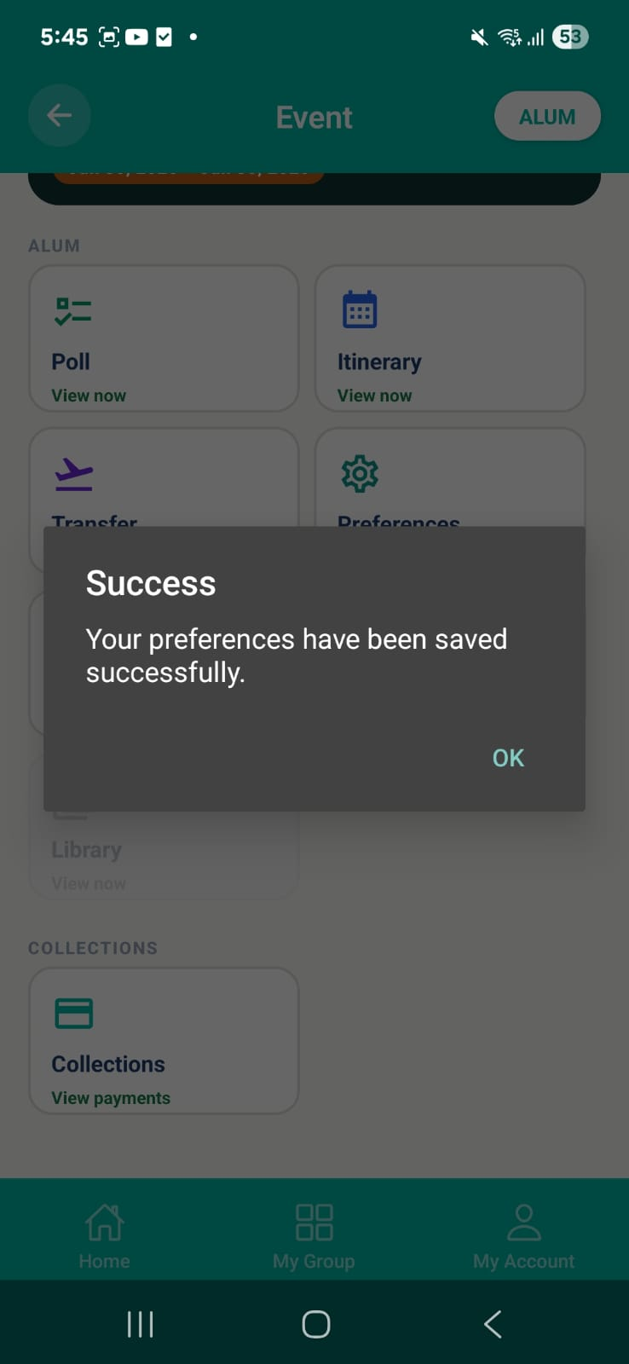

Purpose. Capture member preferences used in event planning and duty-of-care — both selectable and free-text health/assistance items.
Screen elements & what each does:
Element | Behaviour / What it does
Dietary / event preferences | Selectable preference entries used by polls and planning.
Free-text TEXT preferences | Free-text inputs for allergies, medical condition, disability, senior citizen, wheelchair assistance (V19 migration), with contextual icons.
Default mode banner | When opened without an event (permanent defaults), forces the Alum questionnaire view; a home reminder banner prompts when defaults are unconfigured.
Save | Persists per-event or as permanent defaults.

States:
- Default mode — Undefined event ID = permanent default preferences.

Screen-level workflow: Home reminder / Settings / Poll Output → Preferences → Back

7.6 Profile Layer — AI Wizard
Role: Member Module: Profile Builder (AI)
[ SCREENSHOT HERE ]
Profile Layer — AI Wizard — Member — (screenshot pending)

Purpose. Generate a profile bio from a single free-text source using the AI profile builder, with two-step consent. Currently AI option is only enabled for Anchor – do we need to enable for Member also?
Screen elements & what each does:
Element | Behaviour / What it does
Single free-text source input | One source_text field (not separate LinkedIn/Crunchbase fields).
Extract consent checkbox | First consent step before any crawl/extraction.
Multi-round refinement | session_id / candidate_id wired to Phase 2 enrichment; refinement rounds supported.
Generate | Calls the audited AI gateway; no PII / platform name in prompts (RULE-012).

Screen-level workflow: Anchor 'Generate Profile Now/Later' / Member entry → Profile Layer → Published / Review
Notes. No auto-publish: AI output is always routed through review/consent before going live.
Updated (08-Jul-2026 release). The existing backend capability allowing an Alum/Member to generate their own AI profile (previously disabled) is being enabled, based on the agreed pricing model. All existing consent, review and no-auto-publish gates in this wizard remain unchanged.

7.7 Published (Generated Story)
Role: Member Module: Profile Builder (AI)
[ SCREENSHOT HERE ]
Published (Generated Story) — Member — (screenshot pending)

Purpose. Show the AI-generated bio for the member to review and consent to publish.
Screen elements & what each does:
Element | Behaviour / What it does
Generated story view | Calls live generateProfileStory + SavePersonalInformation APIs.
Publish consent | Second consent step; member approves before the bio is shown publicly.

Screen-level workflow: Profile Layer → Published → Alum Profile (bio live)

7.8 Profile Review (Member)
Role: Member Module: Profile Builder (AI)
[ SCREENSHOT HERE ]
Profile Review (Member) — Member — (screenshot pending)

Purpose. Member approves or rejects an Anchor-submitted bio with remarks.
Screen elements & what each does:
Element | Behaviour / What it does
Bio preview | Shows the Anchor-written or AI-generated bio under review.
Approve / Reject | Approve publishes the bio; reject returns remarks to the Anchor.
Remarks field | Optional reviewer remarks.

States:
- Notification-driven — Entered via a PROFILE_REVIEW notification.

Screen-level workflow: PROFILE_REVIEW notification → Profile Review → Bio live / returned

7.9 Member Profile (Anchor view)
Role: Anchor Module: Profile Builder (AI)
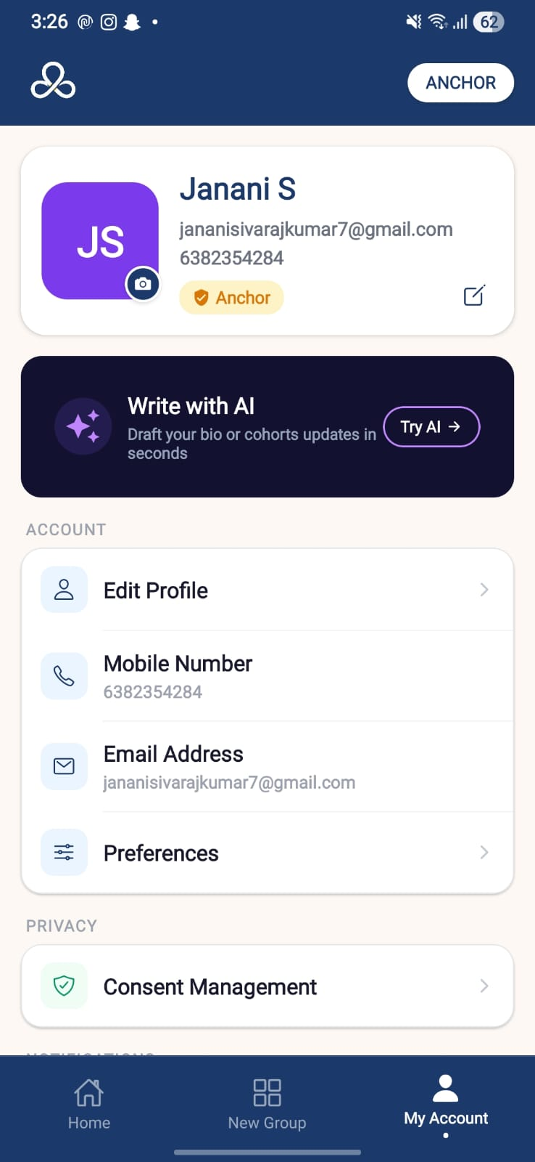 | 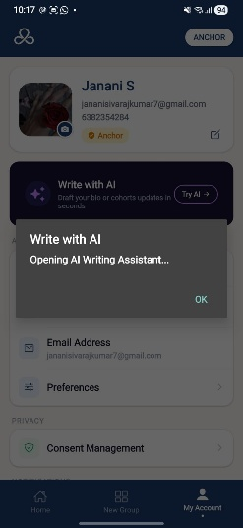

Purpose. Anchor views a member's profile and writes/triggers a bio (manual or AI) for review.
Screen elements & what each does:
Element | Behaviour / What it does
Member profile view | Anchor-visibility gate controls which fields are shown.
Write bio (manual) | Anchor enters a bio manually and submits for member review.
Generate bio (AI) | Triggers the AI wizard; draft routed to the member for publish consent.
Sticky bottom action bar | Primary actions pinned at the bottom.

Screen-level workflow: Group / Member list → Member Profile → Profile Review (member)

8. Groups & Membership
Group (cohort) creation and member management. Members join by invitation only — there is no open join.

8.1 Anchor Home
Role: Anchor Module: Groups & Membership
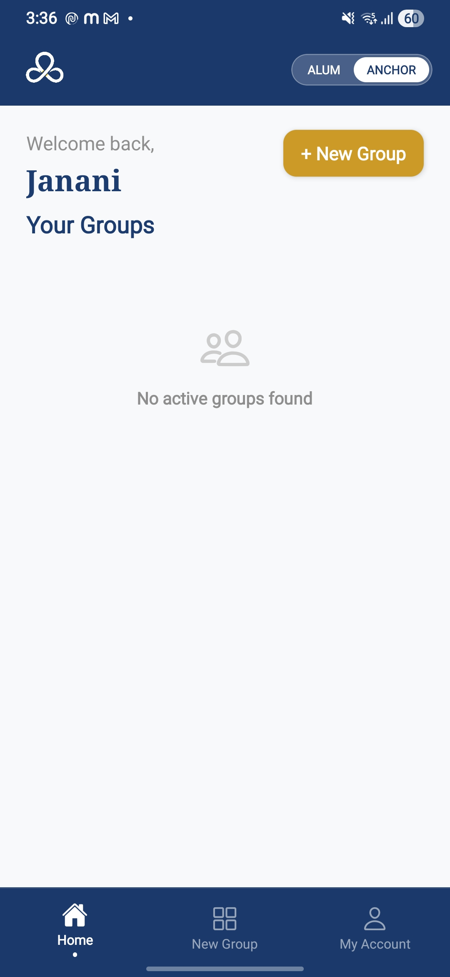 | 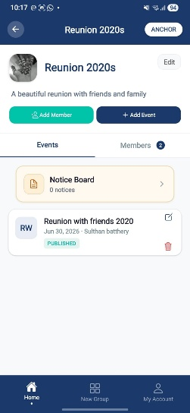

Purpose. Anchor's dashboard listing groups they organise, with entry to create a new group.
Screen elements & what each does:
Element | Behaviour / What it does
Group cards | List of groups; inactive groups greyed out; member + invite counts beside the name; 'Since <date>' shown.
+ New Group | Repositioned primary button; opens Group Form.
Pending actions (red) | Pending items highlighted in red.
Empty state | Welcoming universal message when no groups exist ('Welcome to Alumnye! You don't have any groups yet…') with a centered icon; concise 'No active groups' when groups exist but none are active.

States:
- Empty — No groups → welcome message + icon.
- Active / Inactive — Inactive cohorts greyed out.

Screen-level workflow: Sign In (Anchor) → Anchor Home → Group Details / Group Form

Updated (08-Jul-2026 release). Anchor-side UI now uses the consistent blue Anchor branding (replacing inconsistent Alum colours), and a new intuitive welcome message confirms the Anchor role and guides first-time users into creating their first group.

8.2 Group Form (Create / Edit)
Role: Anchor Module: Groups & Membership
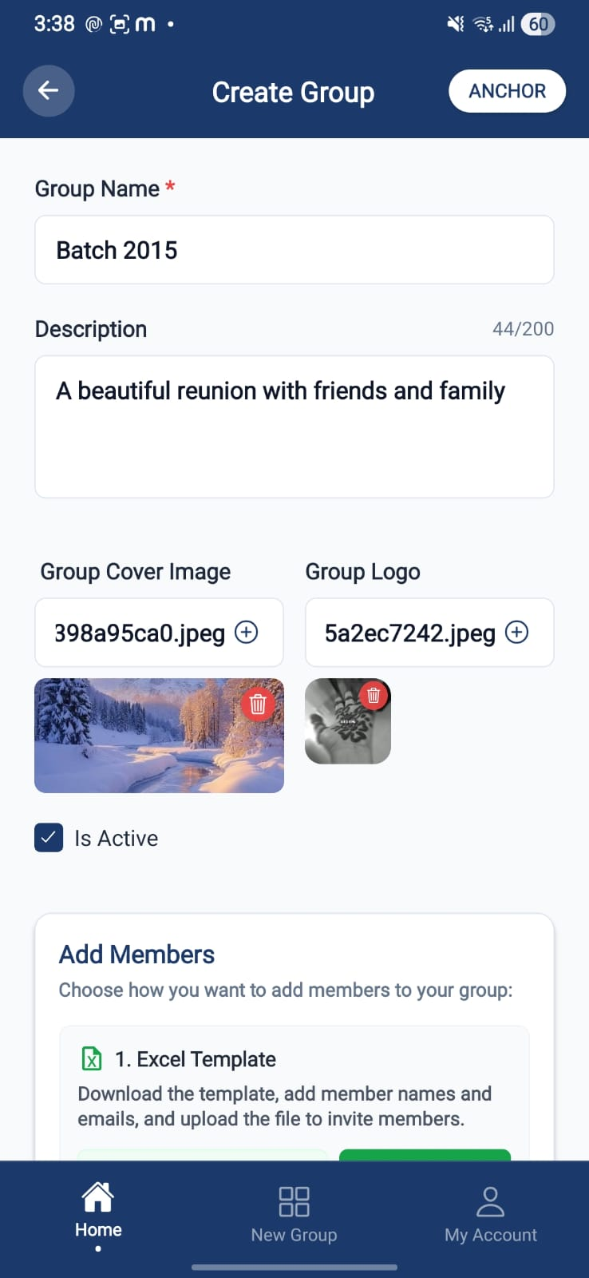 | 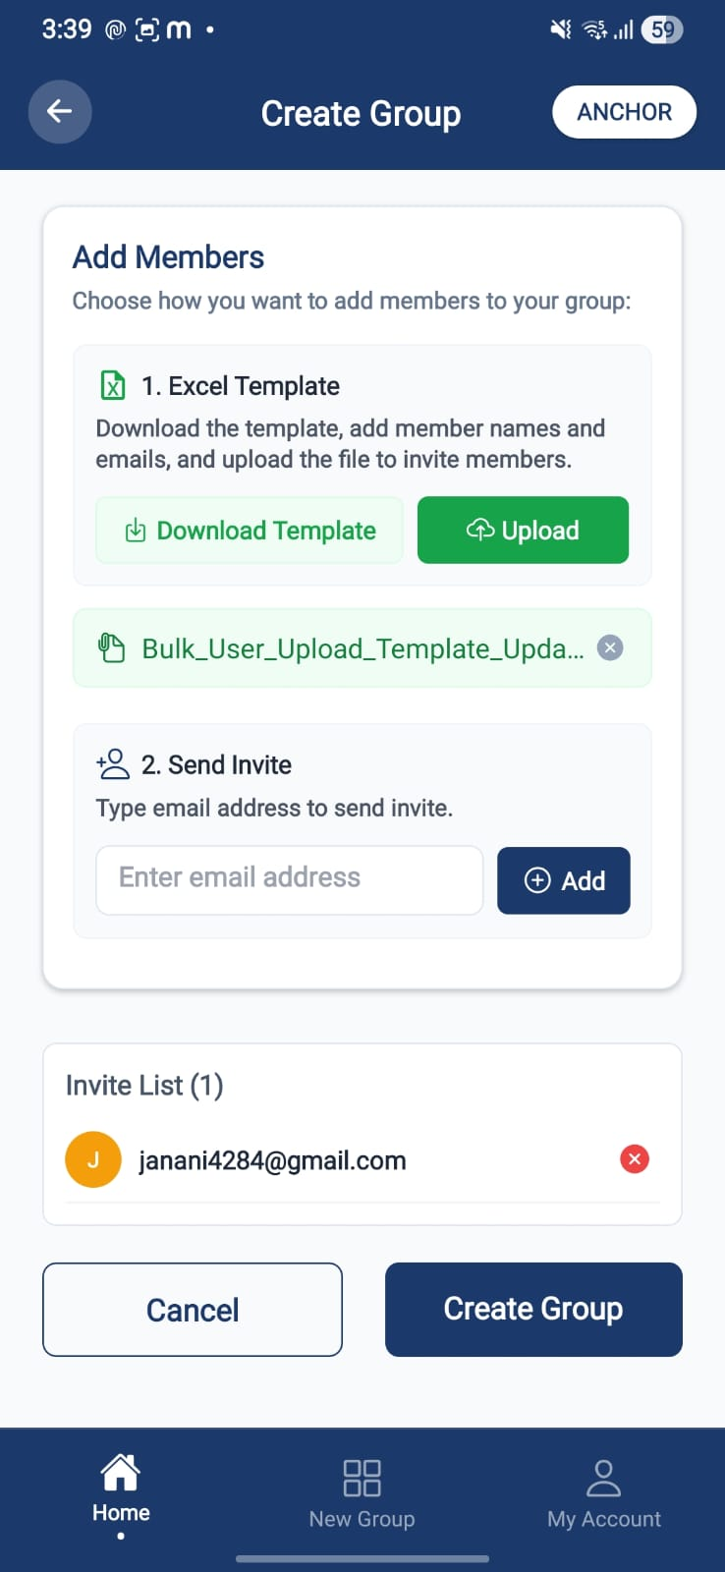 | 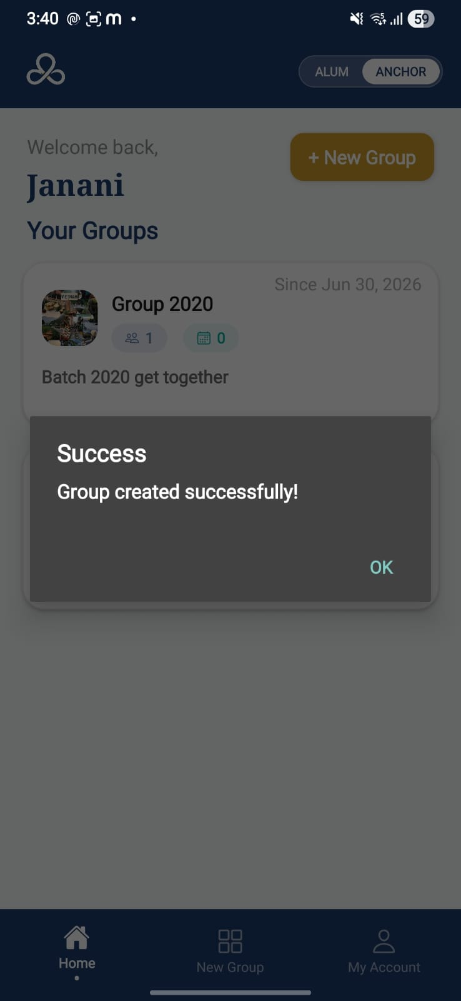
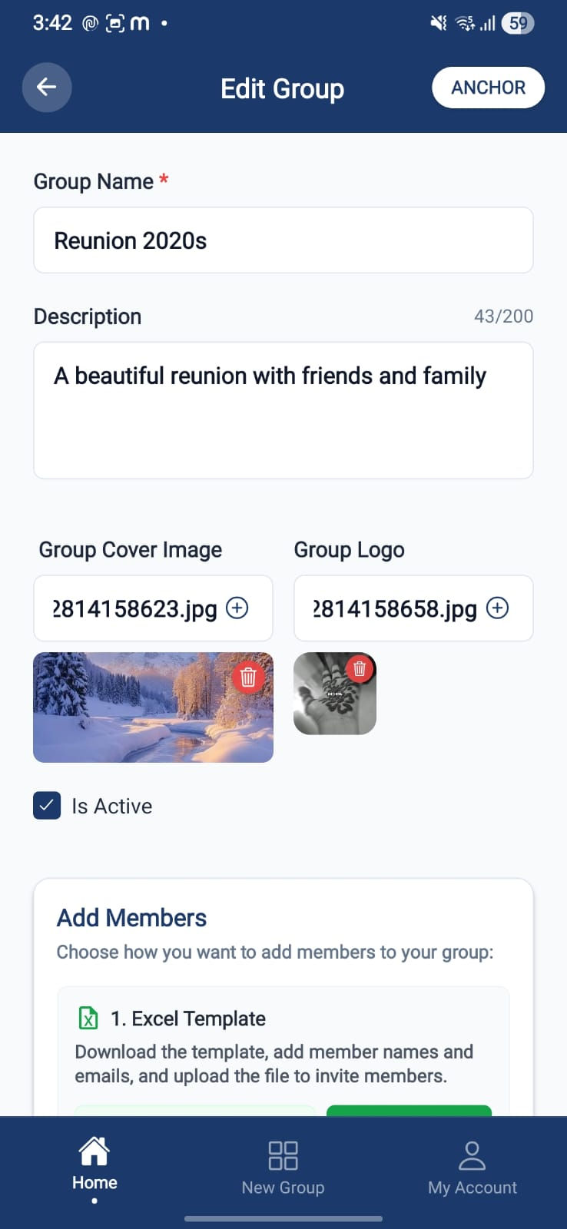 | 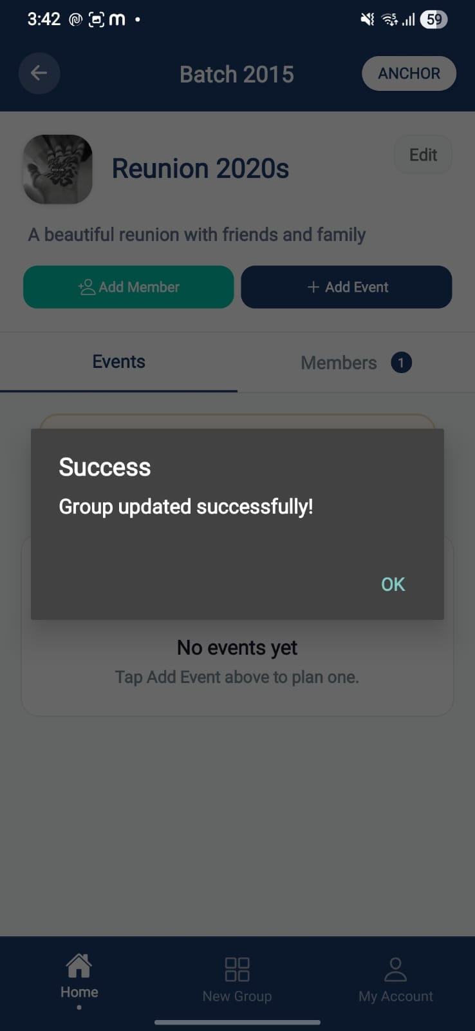

Purpose. Create or edit a group, set cover image/logo, description, and seed members via inline invite.
Screen elements & what each does:
Element | Behaviour / What it does
Group name | Inline validation with specific toast feedback on invalid/duplicate names.
Description | 200-character limit with live counter.
Cover image / Logo | Upload with delete options; text inputs are editable={false} to block manual URL typing; document uploads rejected; empty-preview fetch issue fixed.
Inline invite | Add members during creation/edit; member-suggestion dropdown removed from the manual invite modal.
Member list import | Redesigned card-based import section with template download endpoint.
Save | Creates/updates the group; new-user group creation bug fixed; redirects appropriately.

Screen-level workflow: Anchor Home → Group Form → Group Details

8.3 Group Details
Role: Anchor Module: Groups & Membership
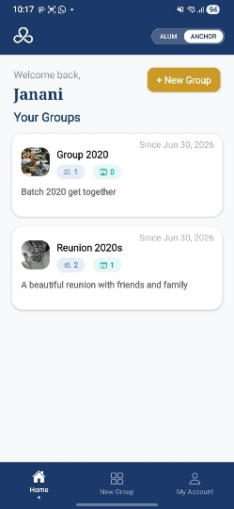 |  | 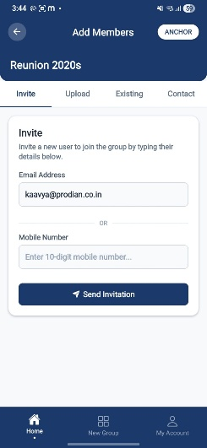

Purpose. The group hub: about, members, events calendar, and group-level actions.
Screen elements & what each does:
Element | Behaviour / What it does
Header card + inline About | About section moved inline into the header card; description truncated to 2 lines with 'See More' / 'Hide View' toggle.
Group name | Resolved dynamically and refreshed on screen focus across the event creation flow.
Member count | Clickable → member list.
Add Event button | Renamed from 'New Event'; opens Event Form.
Add Member entry | Anchor-scoped member addition.
Generate Profile Now/Later dialog | Post-add dialog offering immediate or deferred AI profile generation.

Screen-level workflow: Anchor Home → Group Details → Members / Event Form / Event

8.4 Members (Invite / Upload)
Role: Anchor Module: Groups & Membership
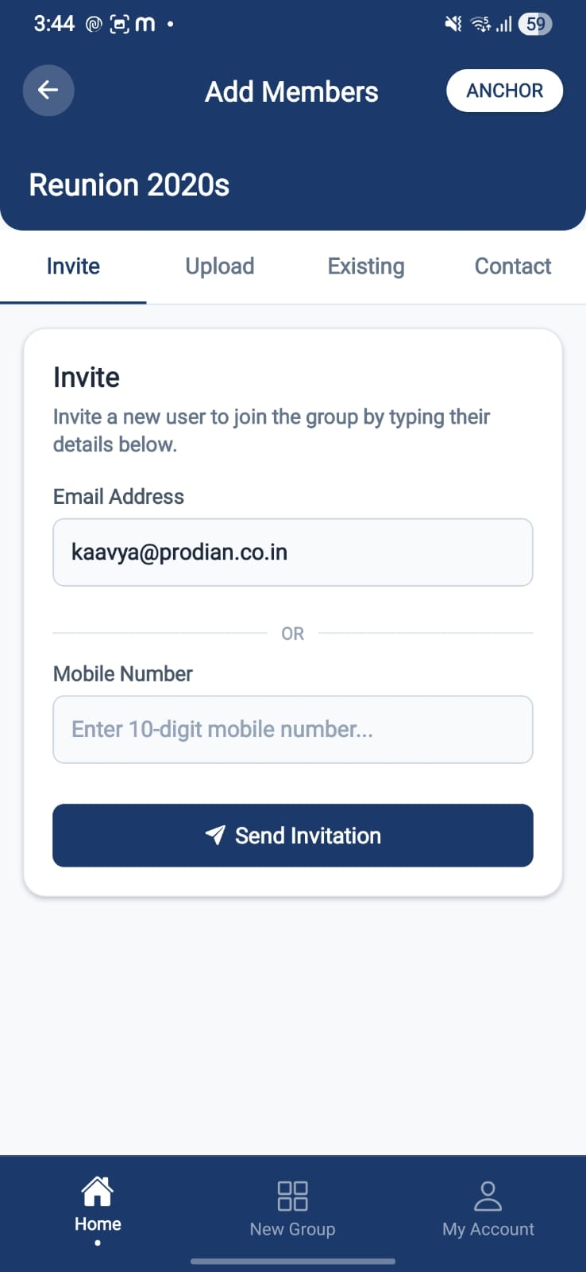 | 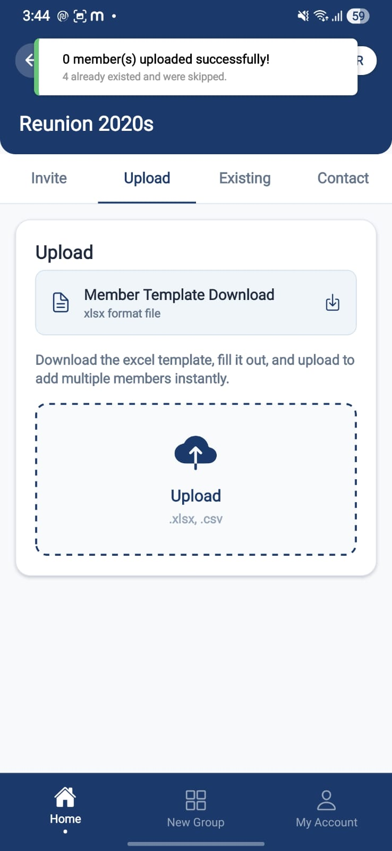 | 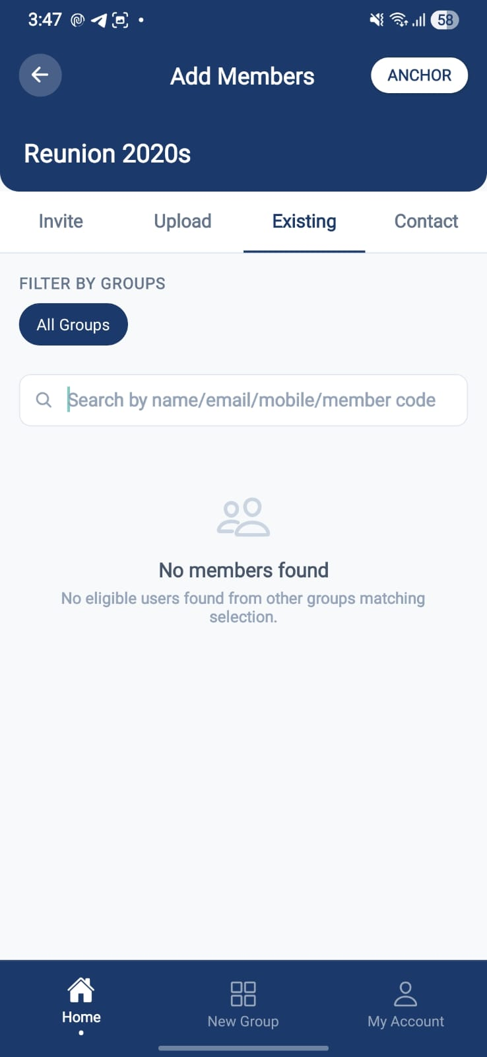
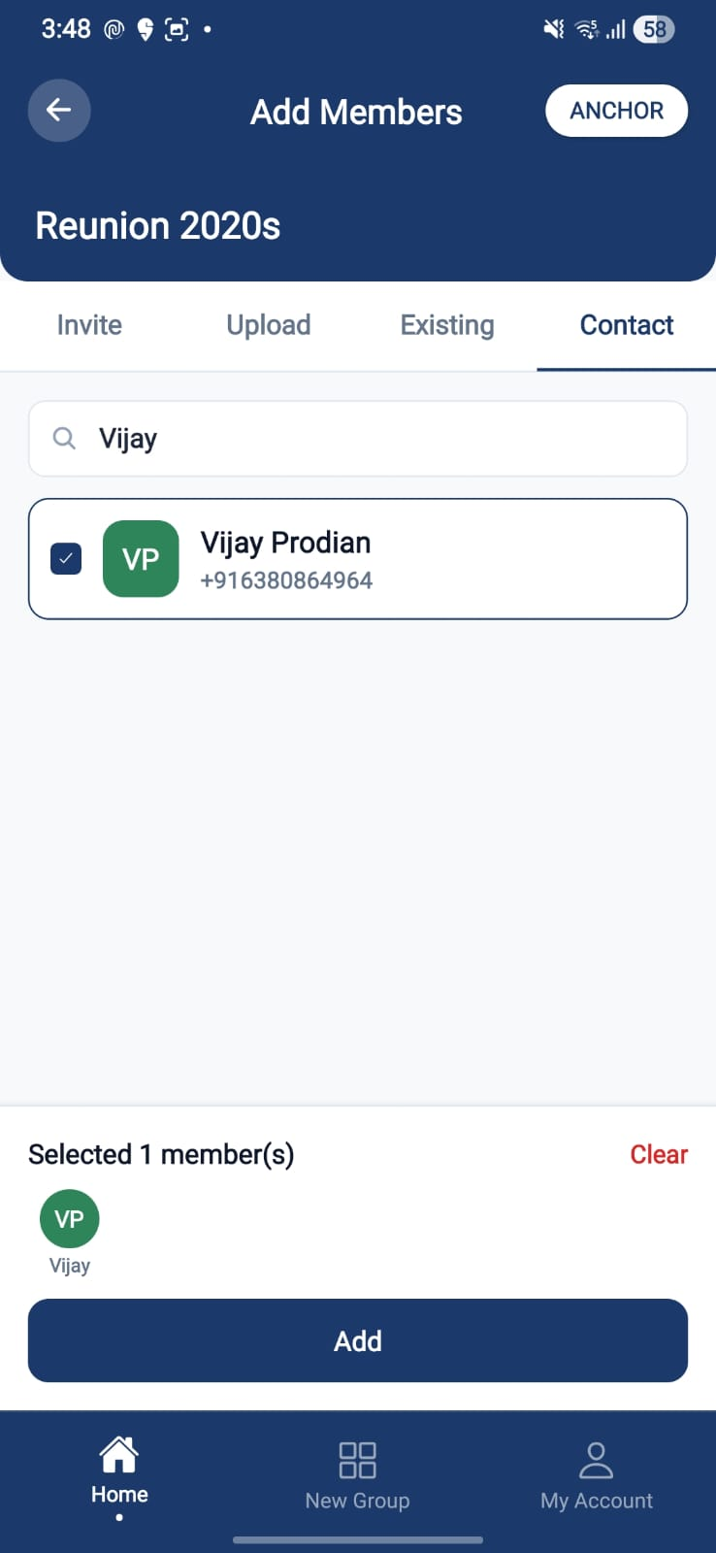 | 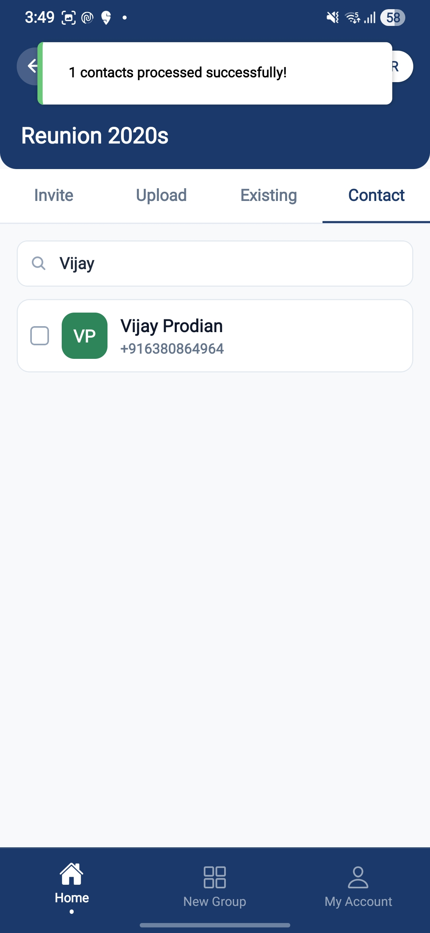

Purpose. Standalone tabbed member-addition screen: add members manually (Invite) or in bulk (Upload).
Screen elements & what each does:
Element | Behaviour / What it does
Tabs: Invite / Upload | Renamed from Manual/Bulk; active tab hooks updated.
Invite tab | One-by-one entry with email space & format validation; self-invite blocked (frontend + backend guard).
Upload tab | CSV/Excel bulk import; raw file stored in AWS as an audit record; predefined field schema; extra columns (UDF) stored but not rendered in Delta.
Header banner | Group name in a flex row with a rounded people-icon chip; 28px corner radius.
Real-time sync | Invitations and member list sync in real time; duplicates de-duplicated on accept.

States:
- Error — Invalid email format / duplicate invite surfaced inline.

Screen-level workflow: Group Details → Members → Bulk Preview (upload) / member added

8.5 Bulk Preview
Role: Anchor Module: Groups & Membership

Purpose. Preview parsed rows from a CSV/Excel upload before committing members.
Screen elements & what each does:
Element | Behaviour / What it does
Parsed rows table | Shows mapped fields per row prior to save.
Confirm import | Commits members; bulk-save loop bug fixed; unregistered emails fall back to a group invite.

Screen-level workflow: Members (Upload) → Bulk Preview → Members

8.6 Invite Modal
Role: Anchor Module: Groups & Membership

Purpose. Quick modal to invite a single member by email.
Screen elements & what each does:
Element | Behaviour / What it does
Email field | Format + space validation; suggestion dropdown removed.
Send invite | Creates a pending invitation; real-time list sync.

Screen-level workflow: Members / Group Details → Invite Modal → Members

8.7 Cohort Members
Role: Both Module: Groups & Membership
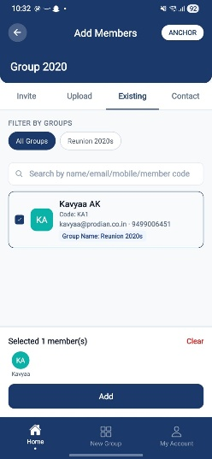

Purpose. List the members of a cohort; opened from a clickable member count.
Screen elements & what each does:
Element | Behaviour / What it does
Member list | Names, member codes, profile photos (visibility fix applied).
Row tap | Opens the member's profile (role-permitting).

Screen-level workflow: Group Details / Member tile → Cohort Members → Member Profile

9. Events & Lifecycle
Events are created within a group and progress through an Anchor-driven lifecycle. No phase auto-advances (RULE-007).

9.1 Event Form (Create / Edit)
Role: Anchor Module: Events & Lifecycle
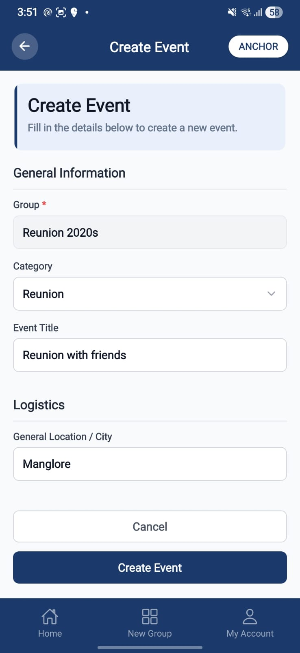 | 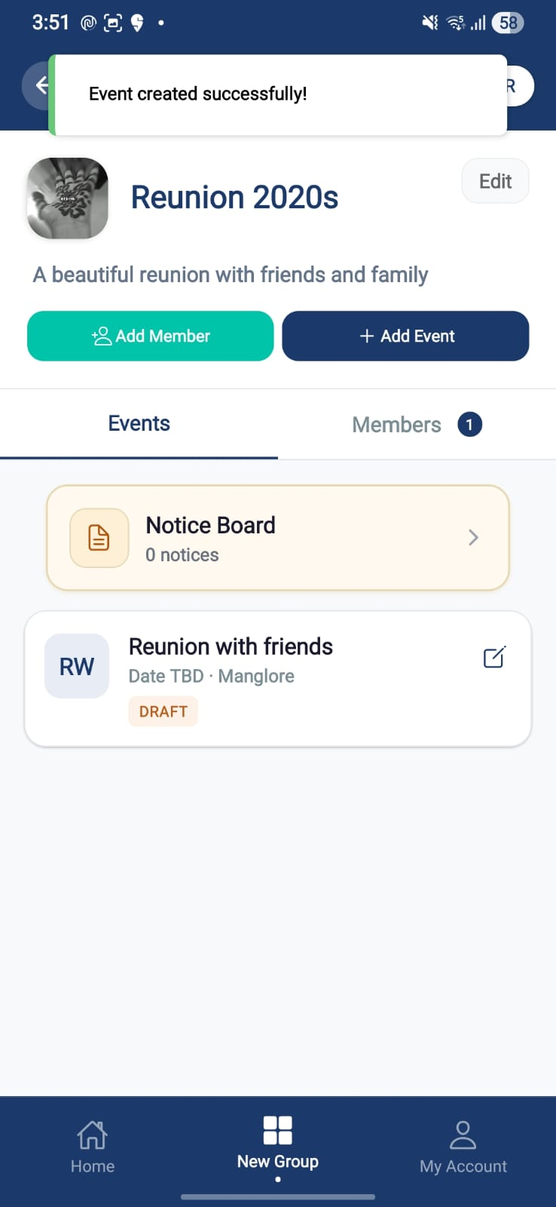 | 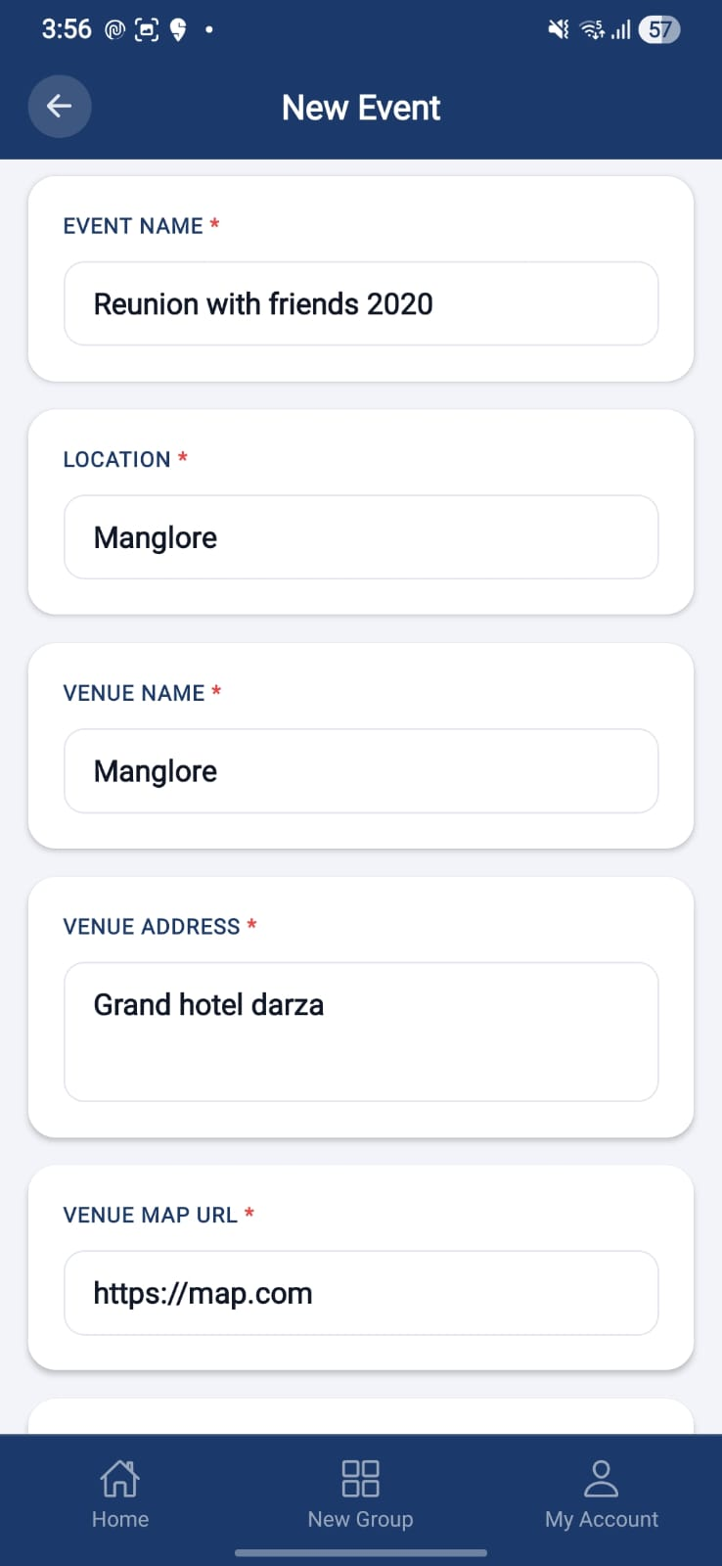
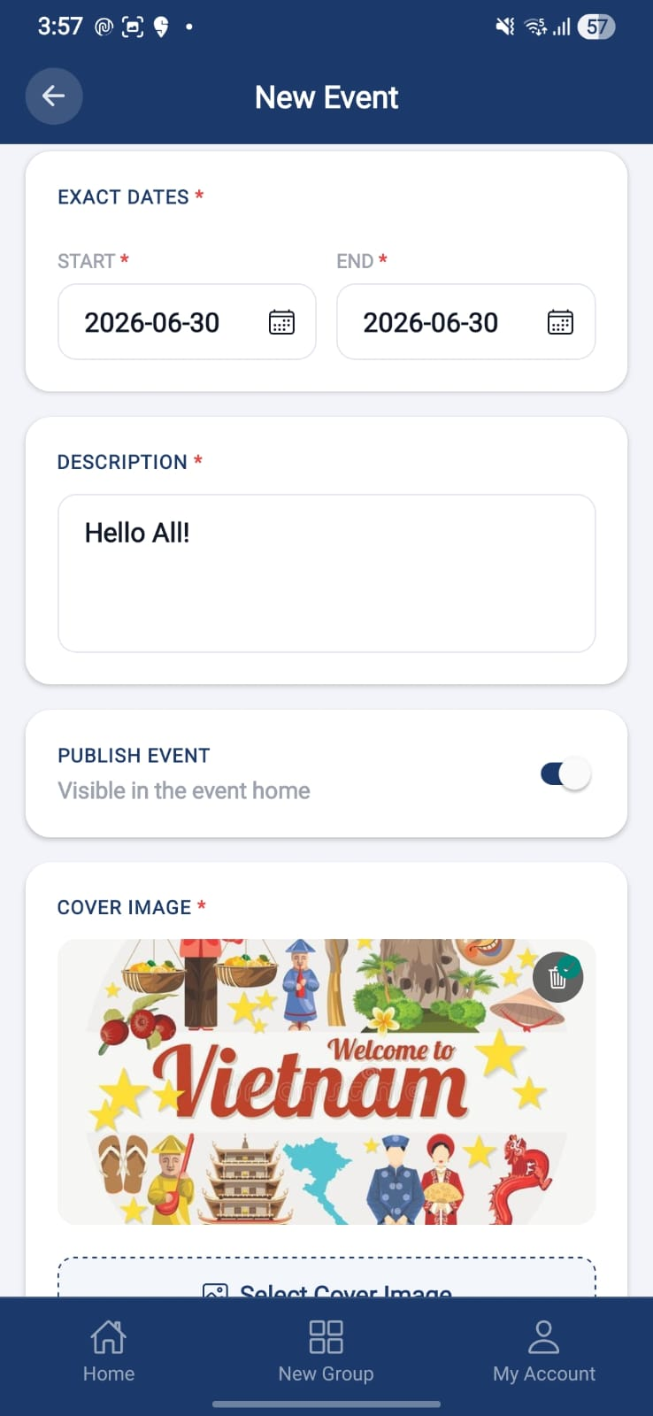 | 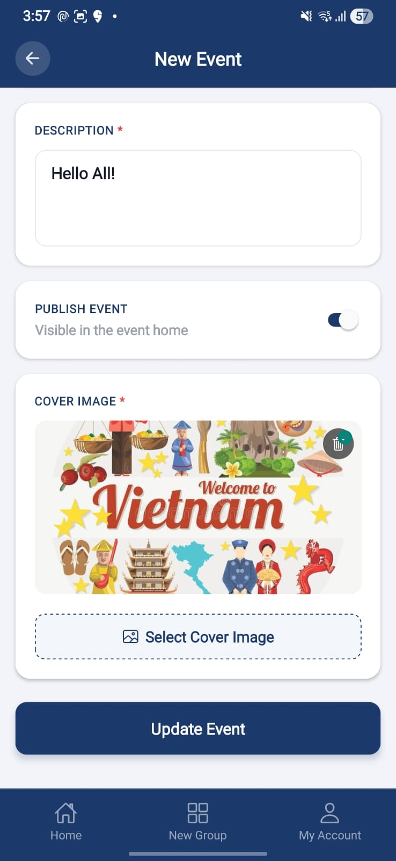 | 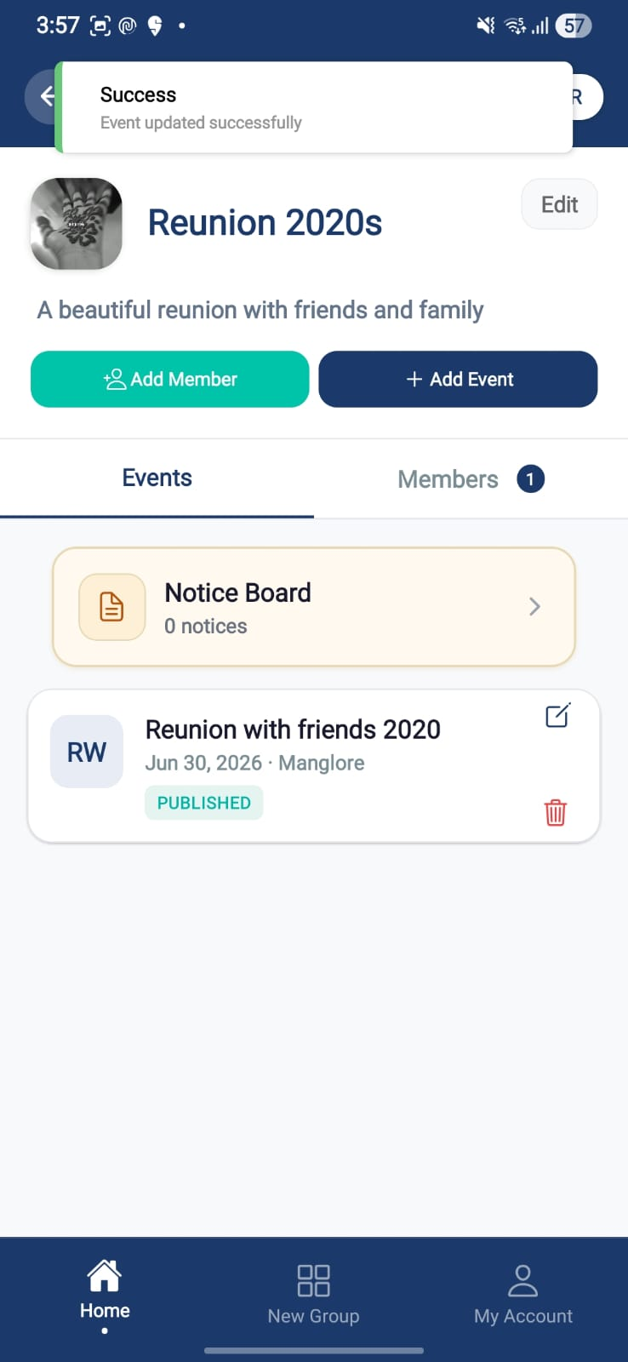

Purpose. Create or edit an event with its category, title, and core details.
Screen elements & what each does:
Element | Behaviour / What it does
Title / details fields | Fields cleared/reset on the Create flow.
Category dropdown | Bottom-sheet dropdown with safe-area padding fix.
Save | Creates/updates the event; redirects to Group Details.

Screen-level workflow: Group Details → Event Form → Group Details / Event Home

9.2 Event Home
Role: Both Module: Events & Lifecycle
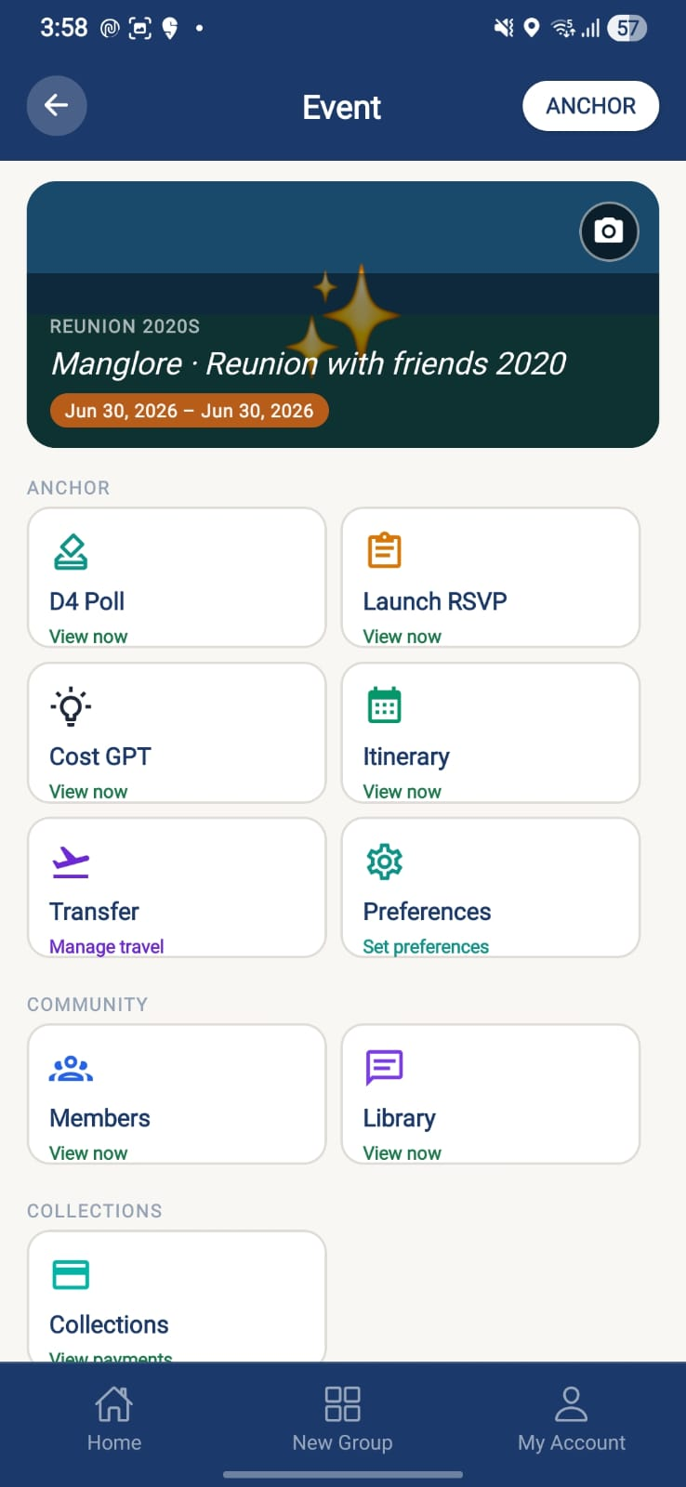 | 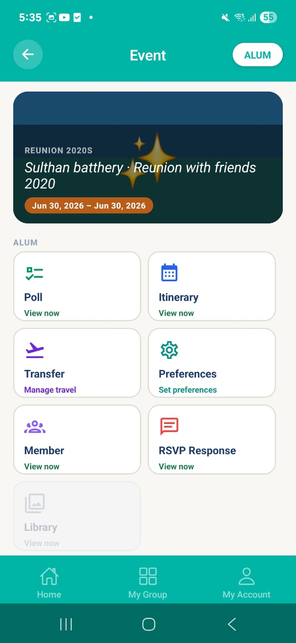

Purpose. The event hub showing the action bar and entry into each event sub-module (renamed from RSVP screen to Event Home).
Screen elements & what each does:
Element | Behaviour / What it does
Action bar | Buttons for Poll, RSVP, Payment, etc.; 'Poll' routes to the Event Polls List (list-first UX).
Sub-module tiles | Entry to Itinerary, Travel, Announcements, Cost (Anchor), Payment.
Status badge | Current event lifecycle stage.

Screen-level workflow: Group Details / Home → Event Home → Poll / RSVP / Payment / Itinerary

9.3 Event Detail
Role: Both Module: Events & Lifecycle
 | 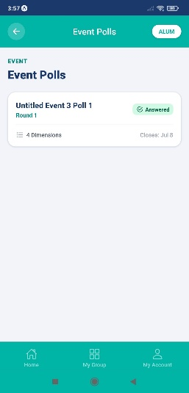 | 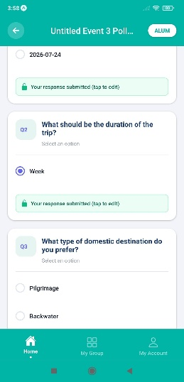

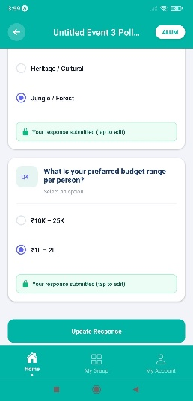 | 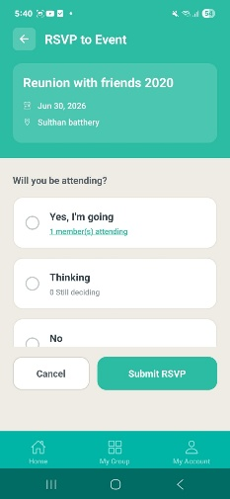

Purpose. Detailed view of a single event including RSVP status normalisation.
Screen elements & what each does:
Element | Behaviour / What it does
Event details | Read from /event/getEventsByEventId; RSVP status normalised from userResponse / memberResponse / response.
Sub-module links | Navigate to polls, RSVP, itinerary, payments.

Screen-level workflow: Event Home / list → Event Detail → Sub-modules

9.4 Events Home / All Events
Role: Both Module: Events & Lifecycle
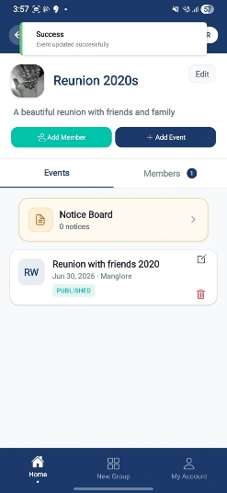 | 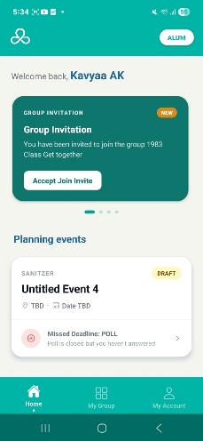

Purpose. Full list of events, most recent first, each with a status badge.
Screen elements & what each does:
Element | Behaviour / What it does
Event list | Chronological (most recent first) with status badges.
Member empty state | 'Welcome to Alumnye! You don't have any events yet…' with a calendar icon when a member has no events.
Upcoming event card | Compact navy card with teal left-accent, UPCOMING badge, icon meta row, divider and text+arrow CTA.

States:
- Empty — Welcoming universal message + calendar icon.

Screen-level workflow: Home → Events Home → Event Home / Detail

10. Polling (D3 / D4)
Poll creation and response across the D3 framework (Duration · Date · Destination) and the guided D4 Poll Wizard. Poll creation is decoupled from launch via a review step. Individual responses are anonymised from Anchors — only aggregate counts are shown.

10.1 Poll Type Chooser
Role: Anchor Module: Polling
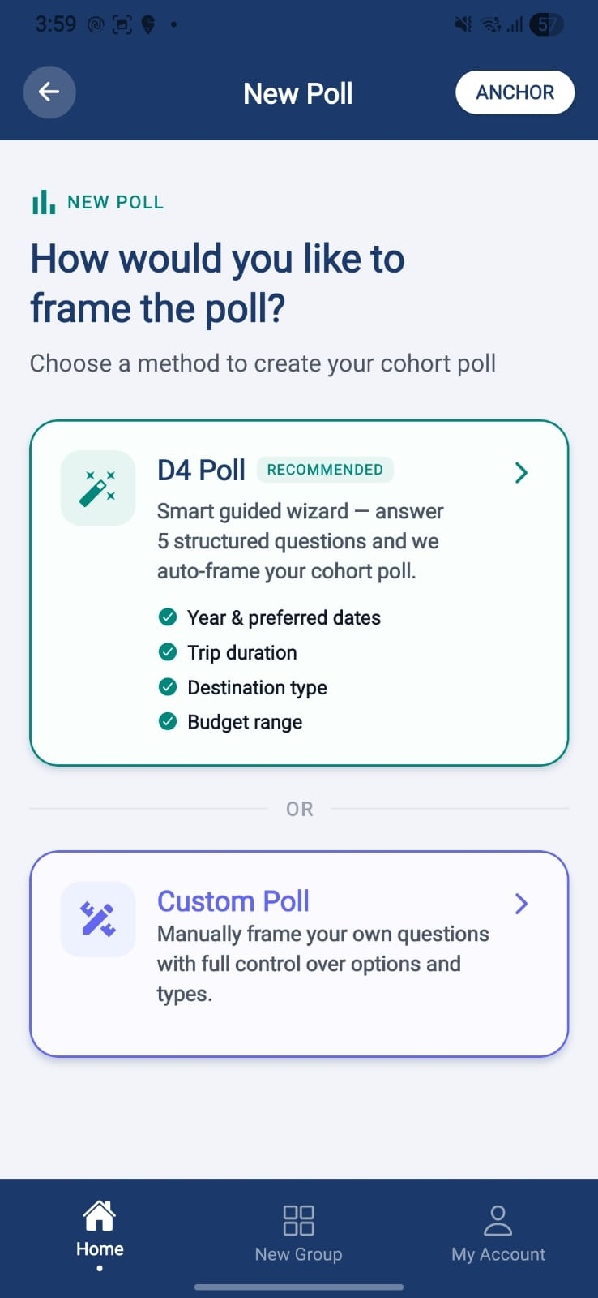

Purpose. Entry point for the Anchor to choose how to frame a poll (manual D3 vs guided D4 wizard).
Screen elements & what each does:
Element | Behaviour / What it does
Poll type options | Select manual poll creation or the D4 guided wizard.

Screen-level workflow: Event Home / Group Details → Poll Type Chooser → Create Poll / D4 Poll Wizard

10.2 Create Poll (Manual D3)
Role: Anchor Module: Polling
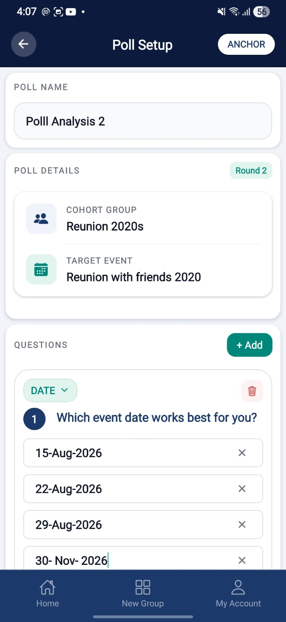 | 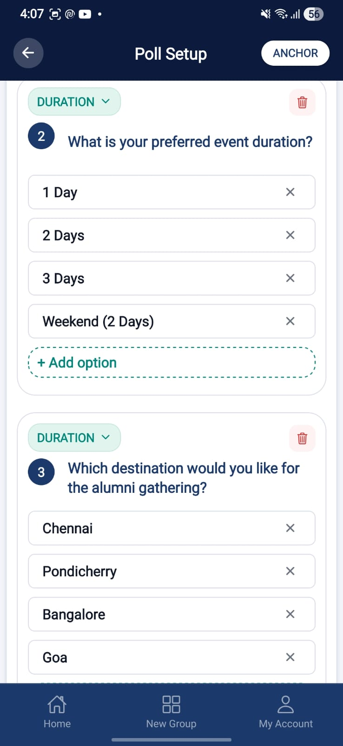 | 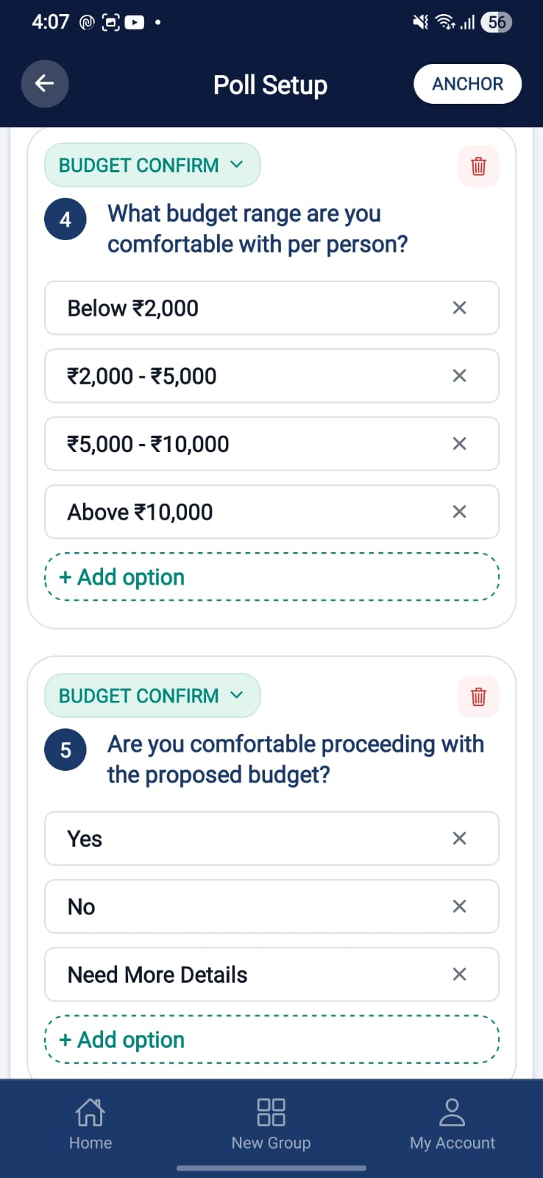
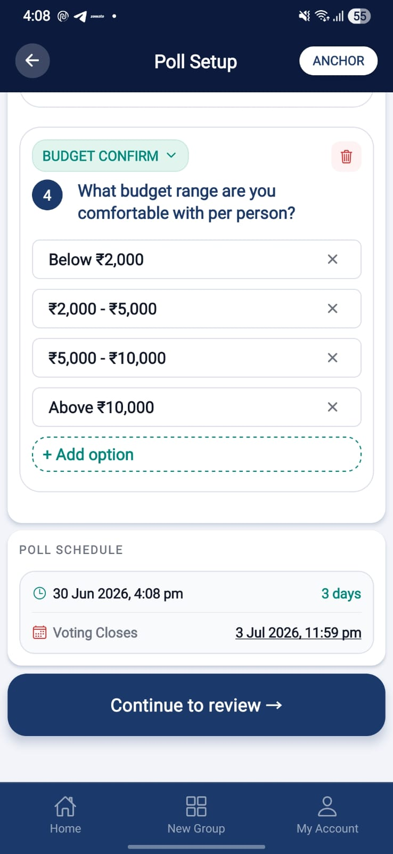

Purpose. Manually create a D3 poll with default questions and optional AI suggestions.
Screen elements & what each does:
Element | Behaviour / What it does
5 default questions | Pre-populated D3 question set.
AI Suggests | Opens the AI suggestions modal to propose questions/options.
Poll name | Empty by default (placeholder visibility fixed).
Custom poll review bypass | Custom D3 poll review bypass & save logic handled.
Save / Continue | Persists the poll; decoupled from launch.

Screen-level workflow: Poll Type Chooser → Create Poll → Review & Launch

10.3 D4 Poll Wizard
Role: Anchor Module: Polling
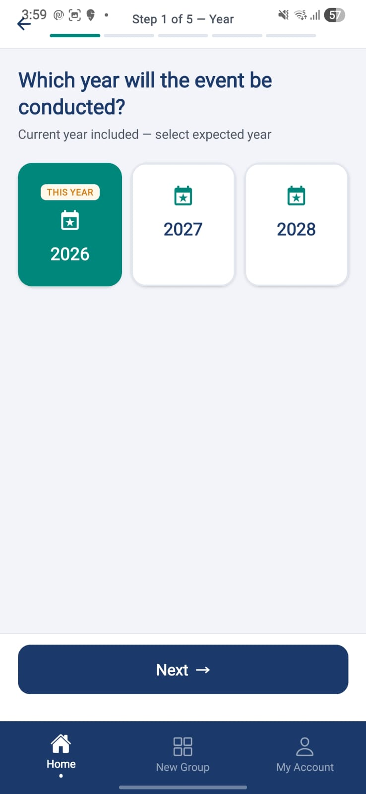 | 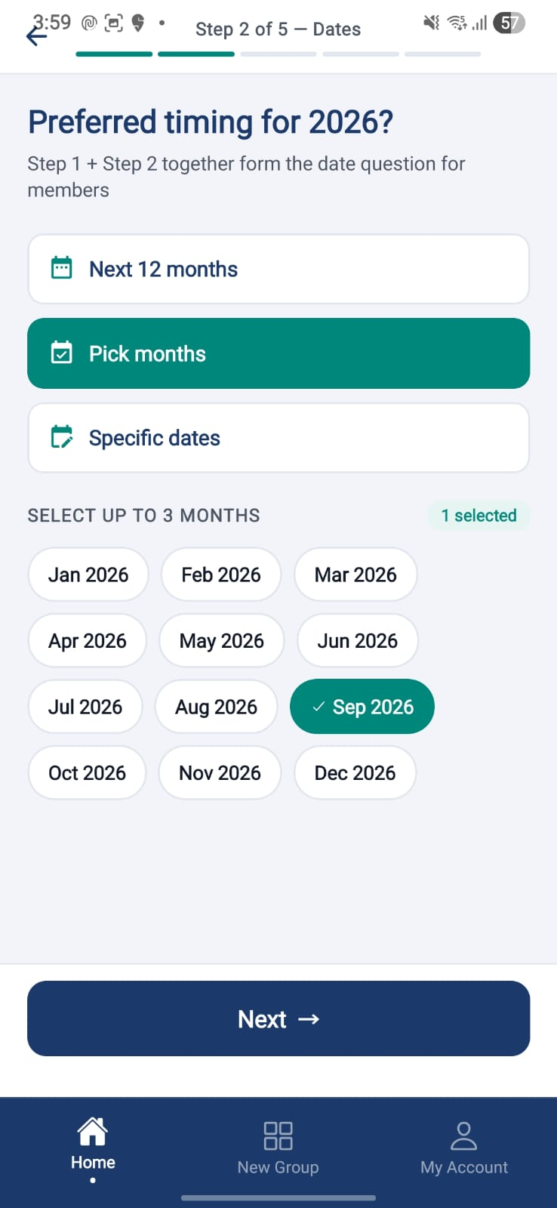 | 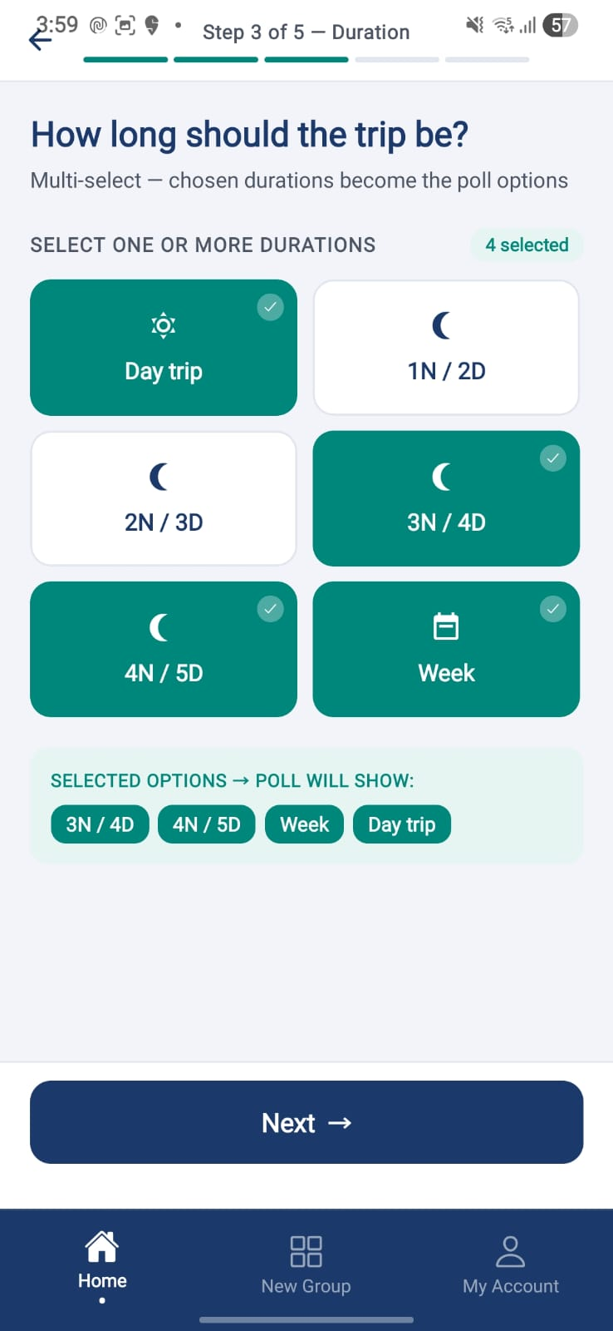
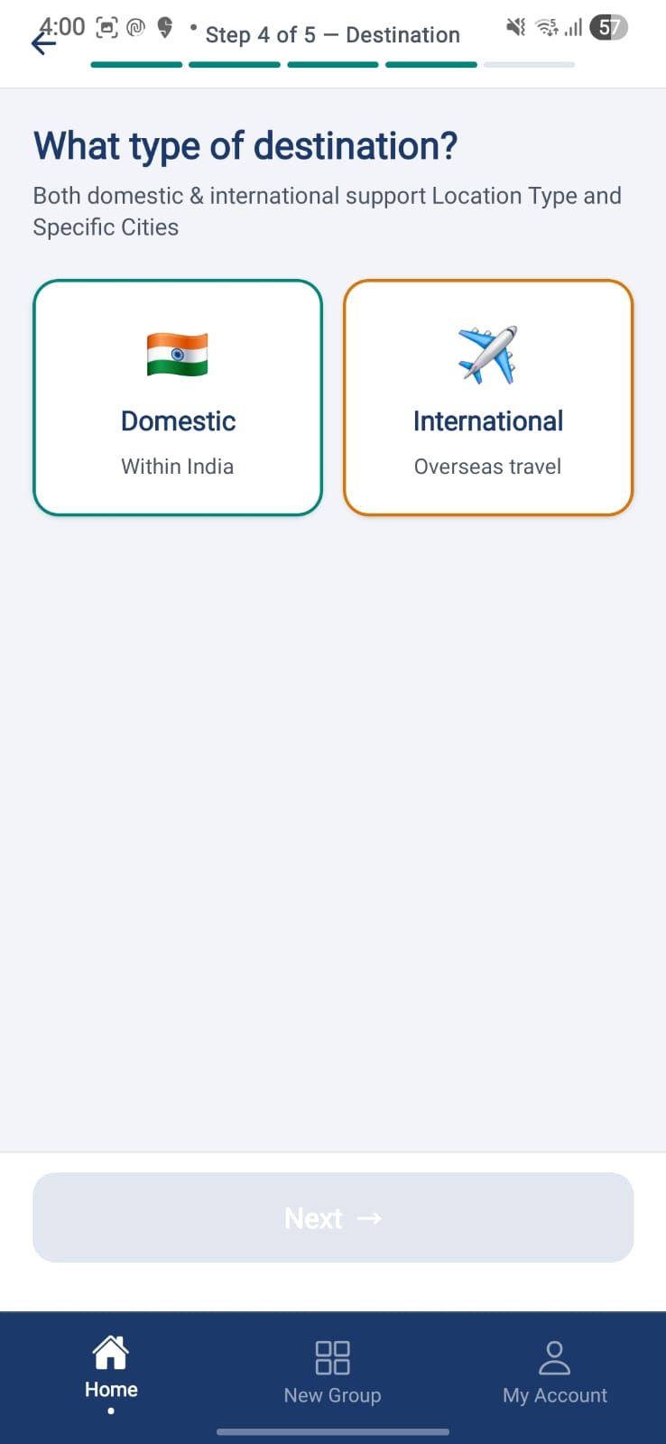 | 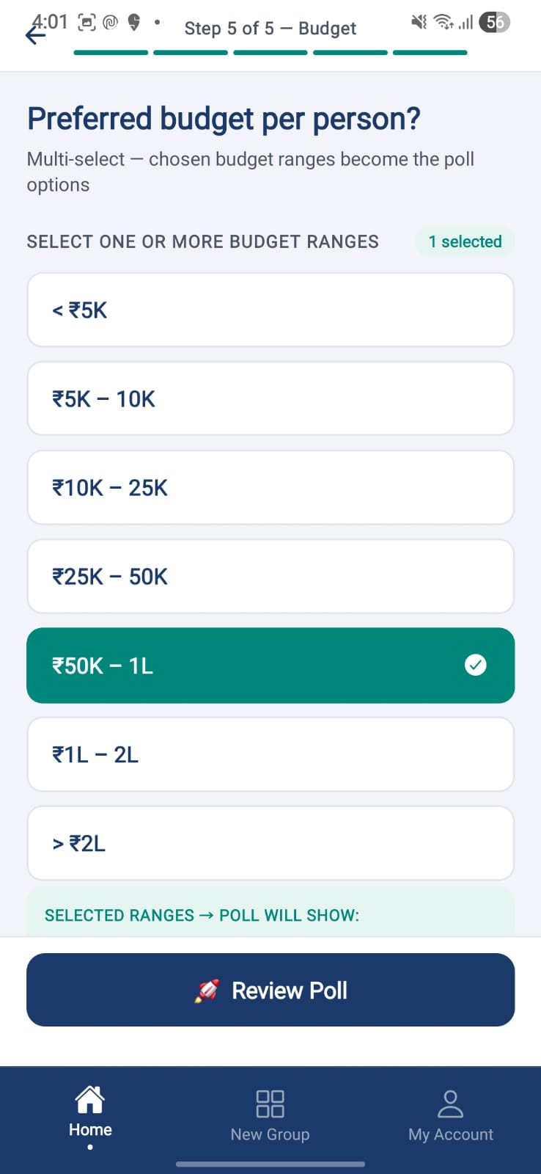 | 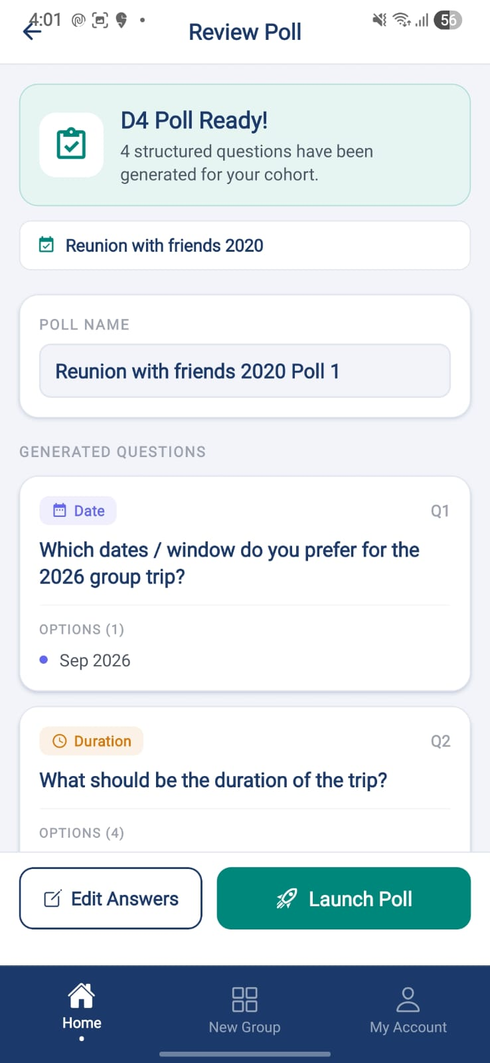
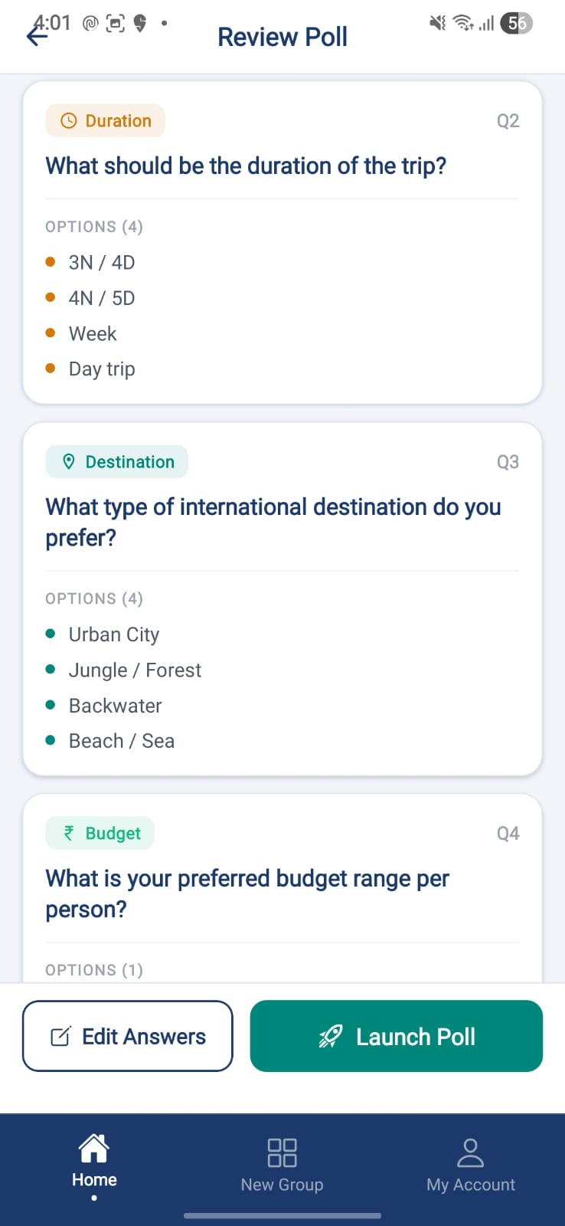 | 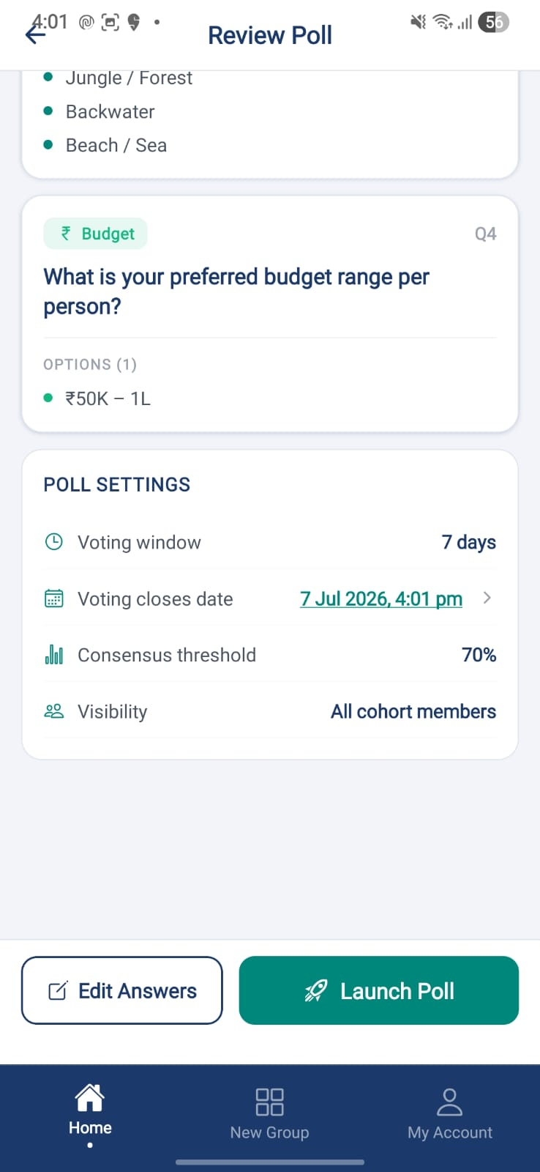 | 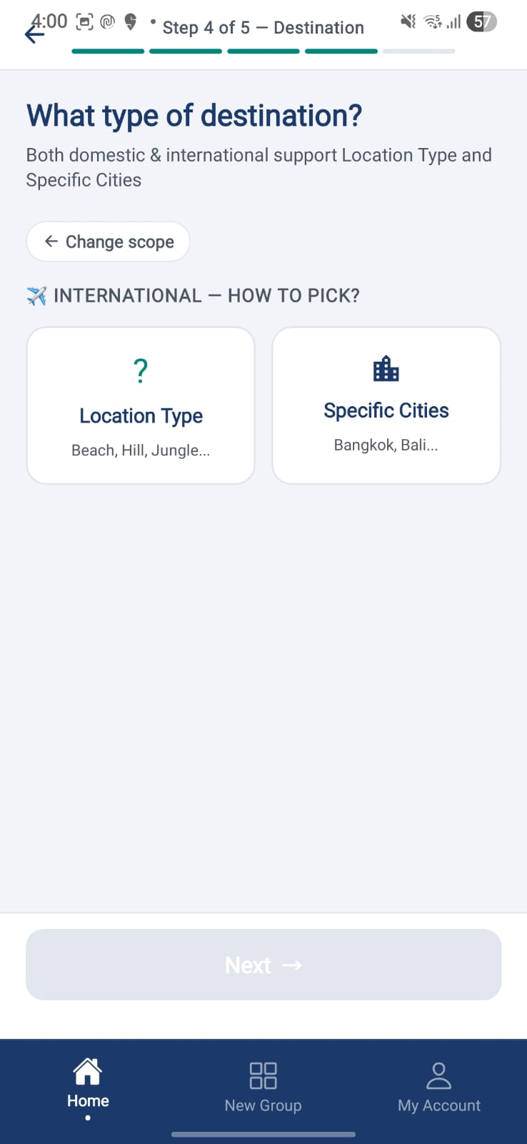
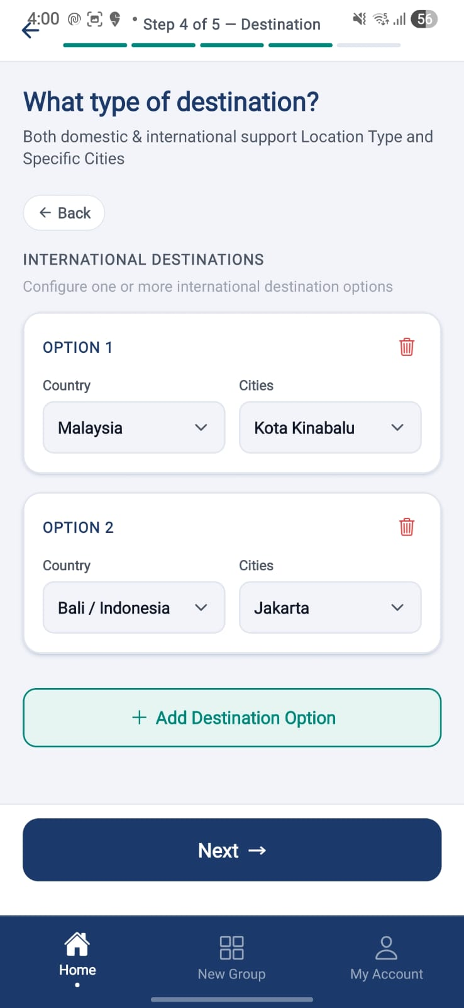 | 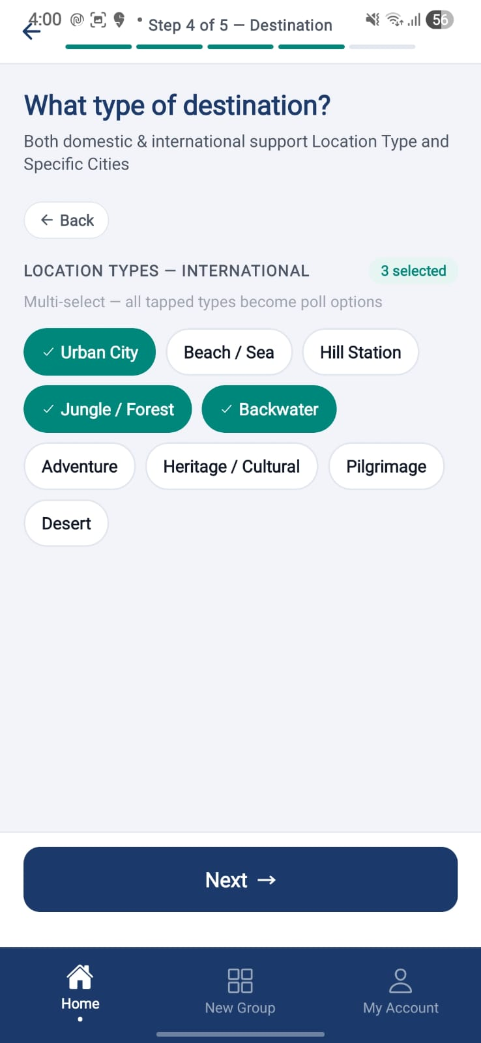

Purpose. 5-step guided poll framing for event planning.
Screen elements & what each does:
Element | Behaviour / What it does
Step 1 — Year | Multi-select year.
Step 2 — Dates | Multi-select candidate dates; dynamic voting window recalculated from the chosen closing date.
Step 3 — Duration | Multi-select; free-text NIGHTS input with '2N/3D' placeholder.
Step 4 — Destination | Multi-select destinations.
Step 5 — Budget | Multi-select; free-text BUDGET input with '10K - 25K' placeholder.
Next / Back | Steps validated as the Anchor advances.

Screen-level workflow: Poll Type Chooser → D4 Poll Wizard → D4 Review & Launch

10.4 D4 Review & Launch
Role: Anchor Module: Polling
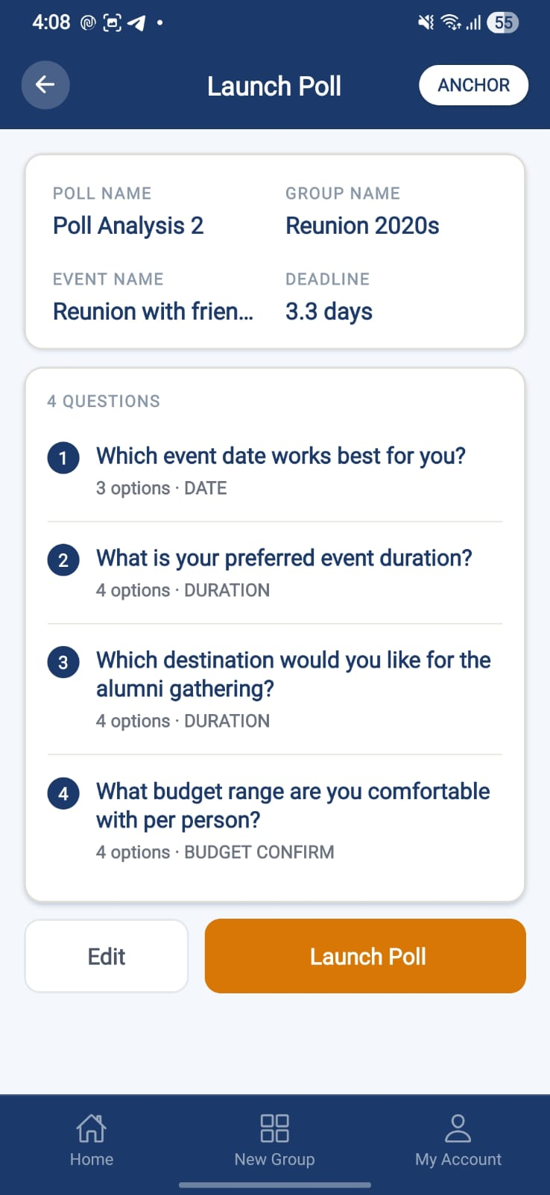 | 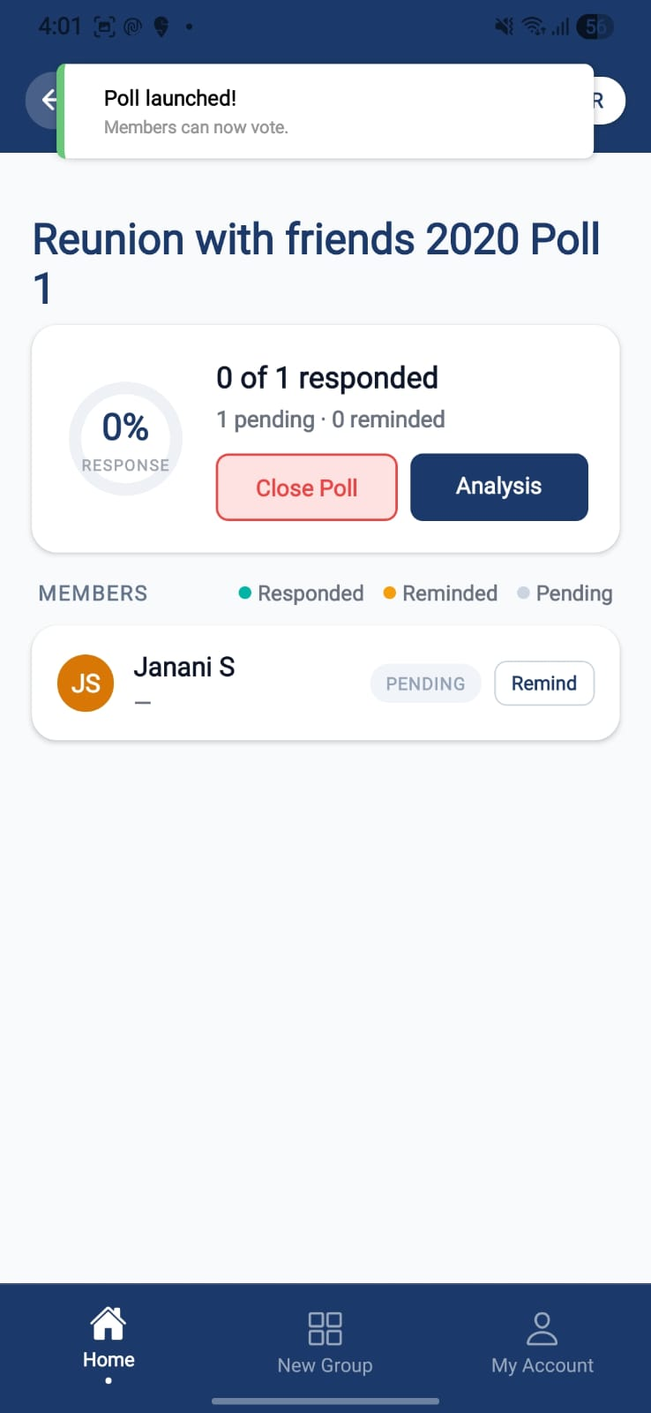 | 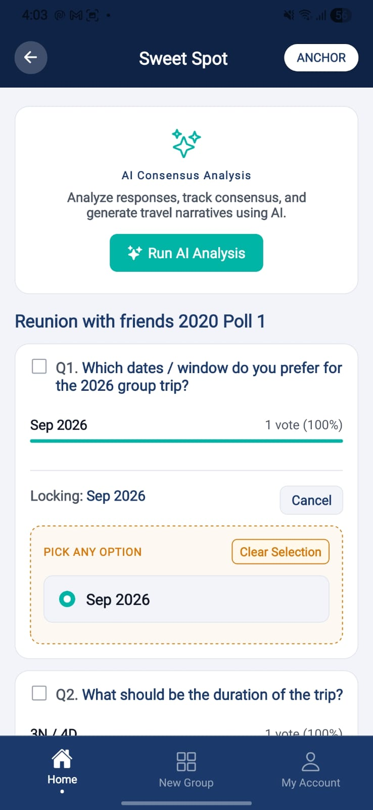
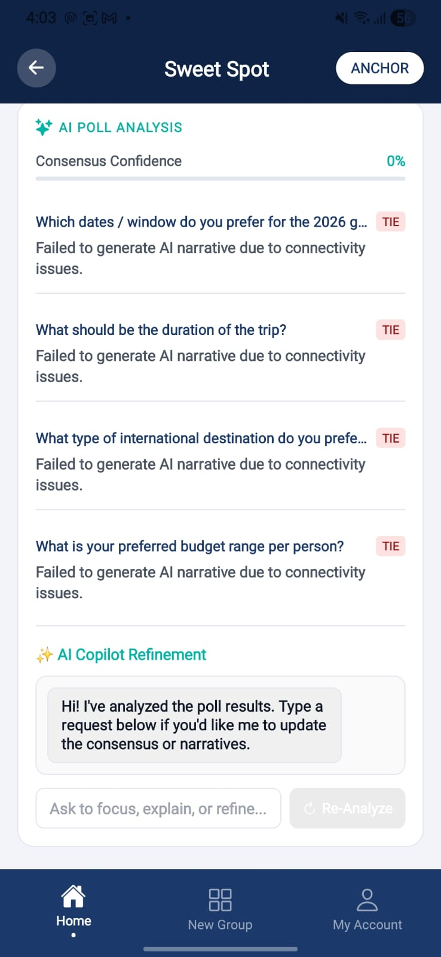 | 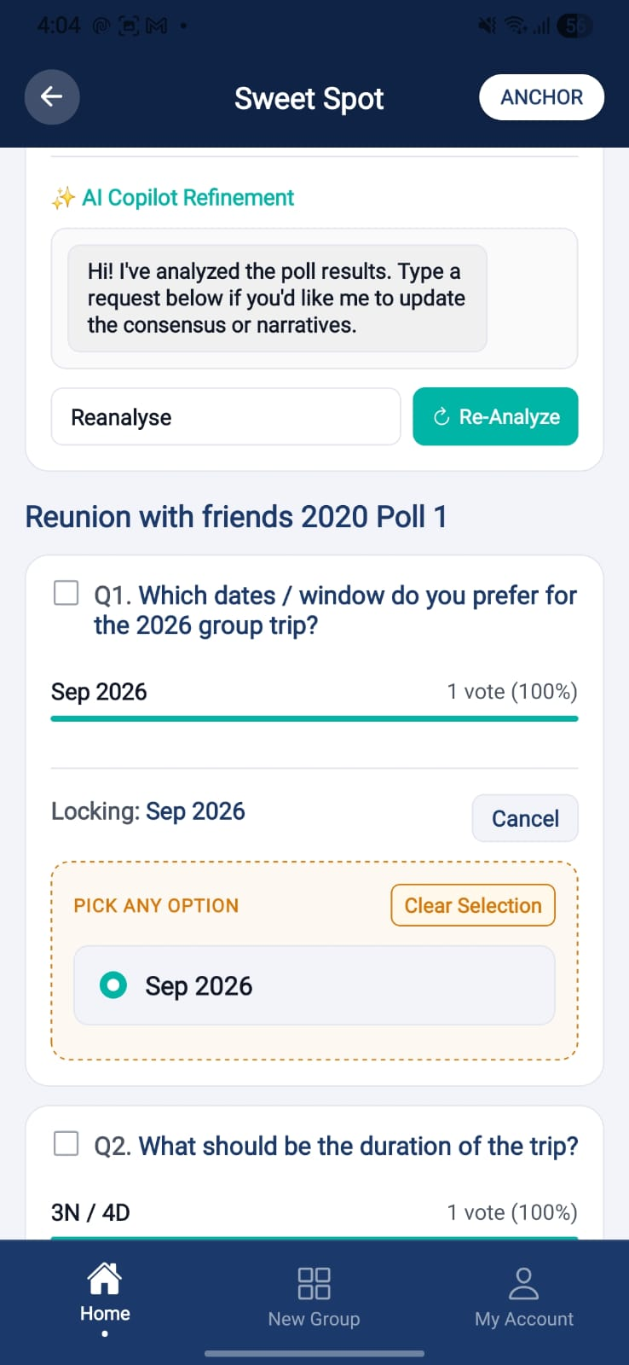 | 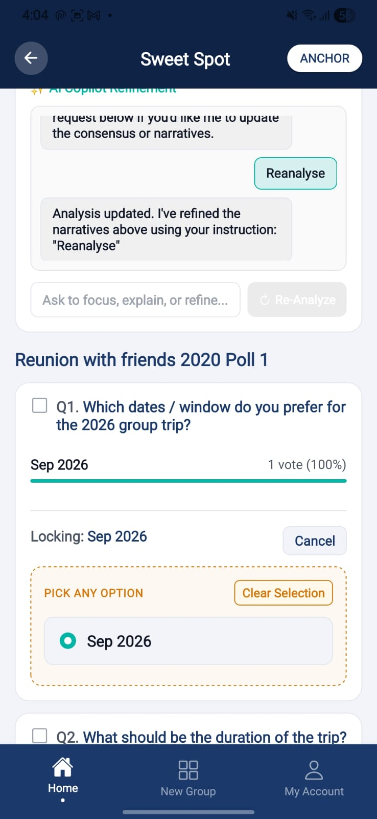
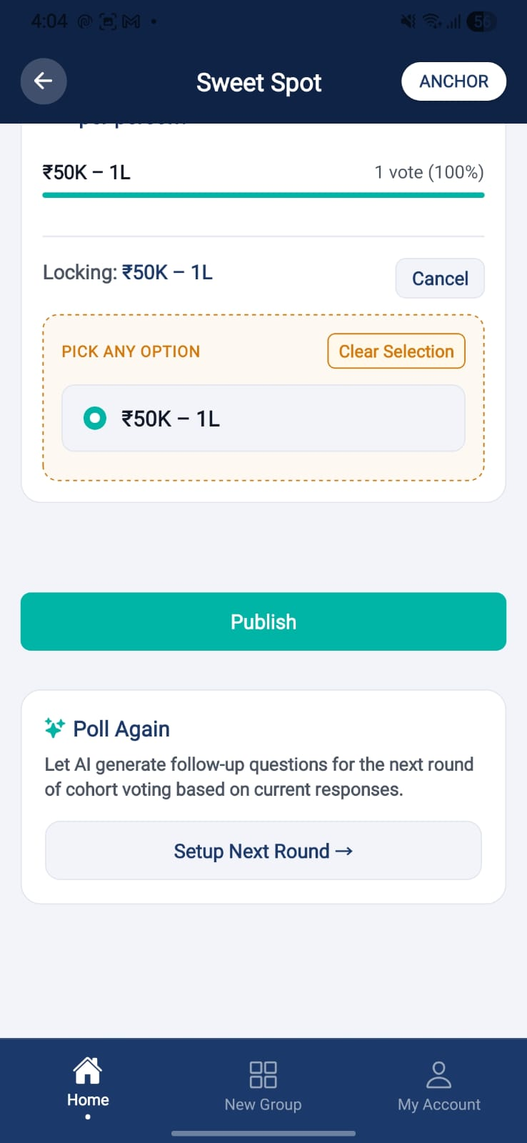

Purpose. Review the framed poll and launch it to members (creation decoupled from launch).
Screen elements & what each does:
Element | Behaviour / What it does
Poll summary | Read-only review of all framed questions/options.
Voting window | Closing date drives the voting window; deadline displayed.
Launch | Publishes the poll; fires launch notifications wired to members; uses poll_set_id to keep distinct poll sets from merging.

Screen-level workflow: D4 Poll Wizard / Create Poll → Review & Launch → Live Tracking

10.5 Event Polls List
Role: Both Module: Polling
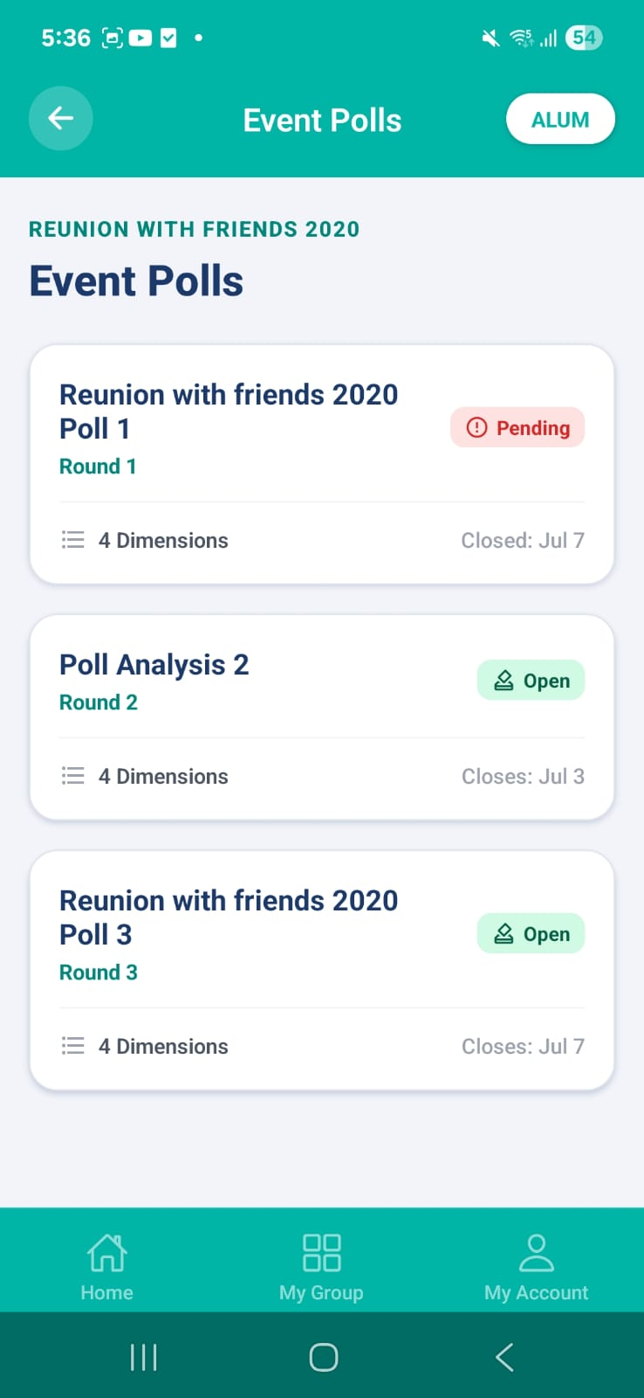

Purpose. List of polls for an event; the list-first entry point that routes by poll status.
Screen elements & what each does:
Element | Behaviour / What it does
Poll cards | Show poll name + status; graceful handling of a 404 'No Polls Found'.
Status routing | Closed → Poll Output; Active → Live Tracking (Anchor) / Poll Response (Member).

States:
- Empty — No polls → friendly empty message (404 handled).

Screen-level workflow: Event action 'Poll' / notification → Event Polls List → Live Tracking / Poll Response / Poll Output

10.6 Poll Landing
Role: Member Module: Polling
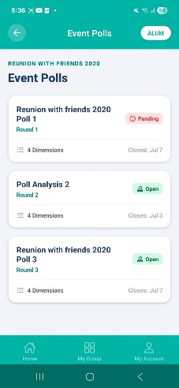
Purpose. Member's landing for an open poll prior to responding.
Screen elements & what each does:
Element | Behaviour / What it does
Poll intro | Context for the poll being voted on.
Begin / Respond | Proceeds to Poll Response.

Screen-level workflow: Event Polls List / notification → Poll Landing → Poll Response

10.7 Poll Response
Role: Member Module: Polling
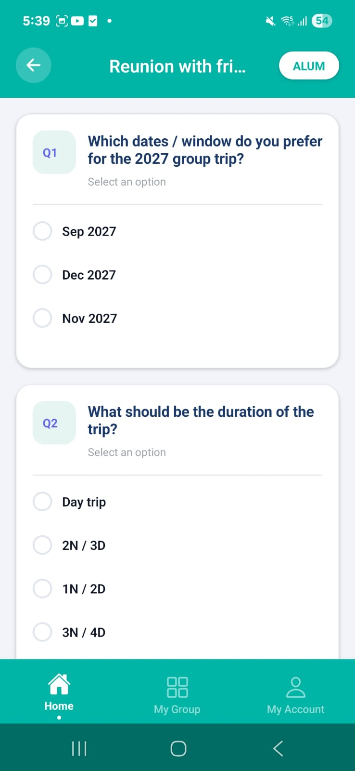 | 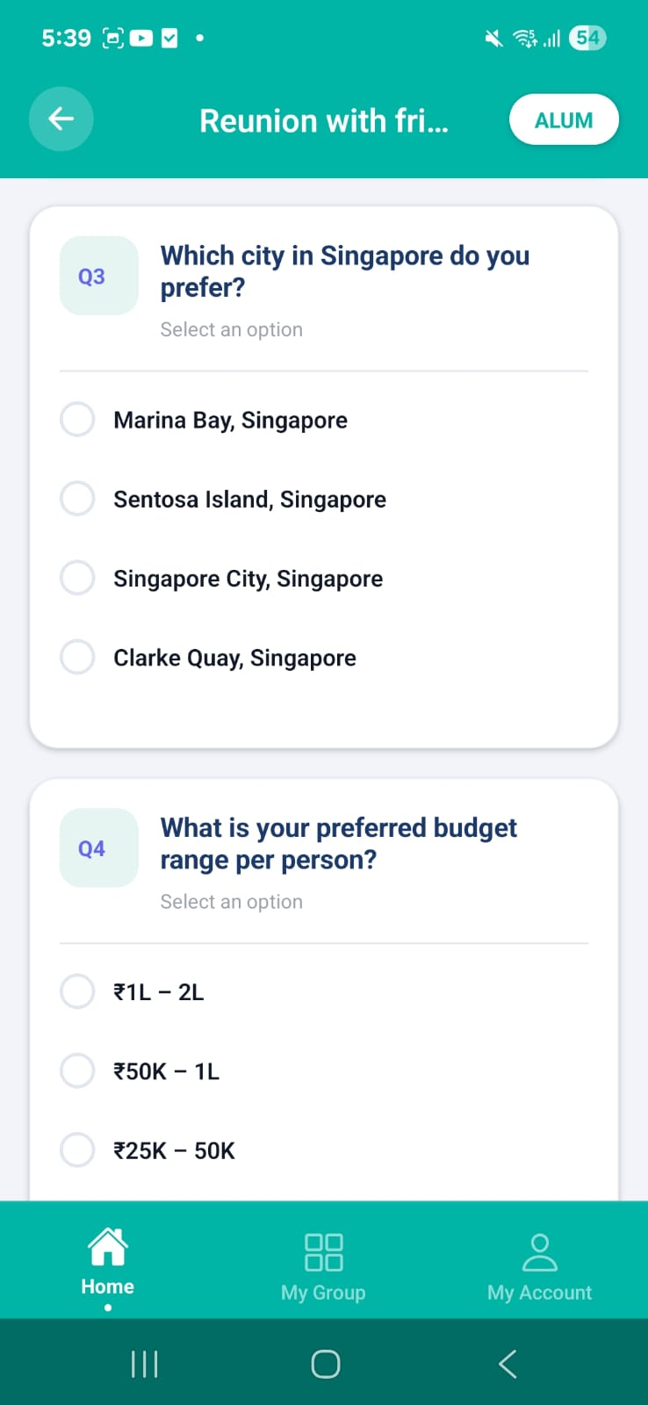 | 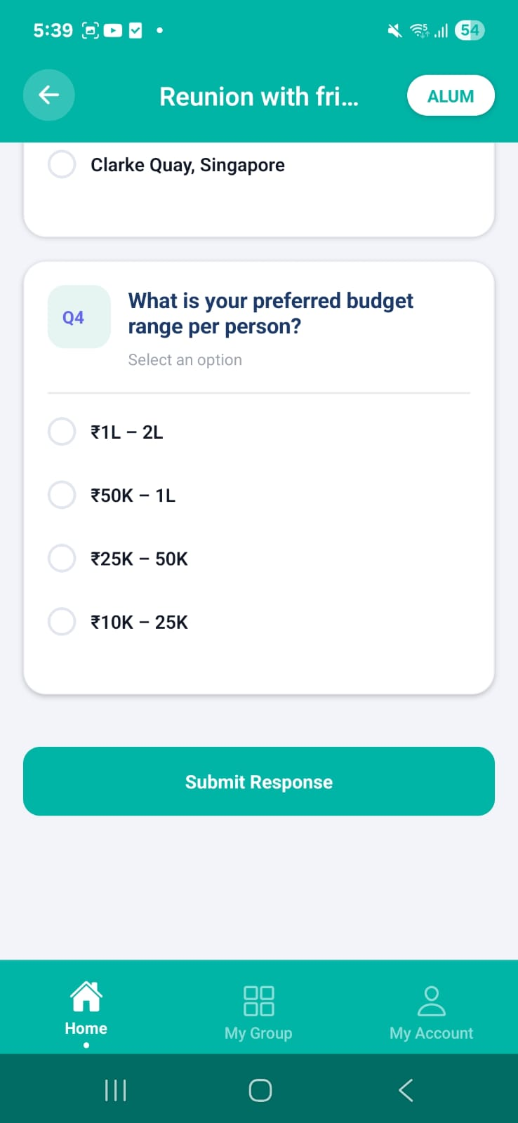

Purpose. Member casts their vote across the poll questions.
Screen elements & what each does:
Element | Behaviour / What it does
Question cards | One card per question with the framed options; member-specific question filtering applied.
Submit | Records the response; optimistic notification dismissal on submit.

Screen-level workflow: Poll Landing / Event Polls List → Poll Response → Confirmation

10.8 Live Tracking
Role: Anchor Module: Polling
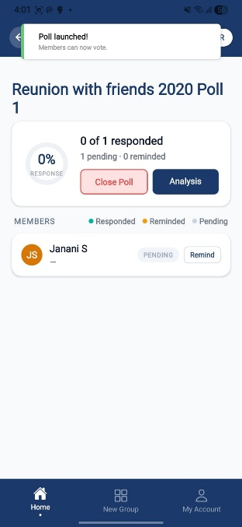
Purpose. Anchor monitors live poll participation and closes the poll / triggers analysis.
Screen elements & what each does:
Element | Behaviour / What it does
Aggregate counts | Live tally; individual responses hidden (anonymised).
Close Poll | Closes voting; supports multiple poll rounds and poll locking.
Analysis | Triggers AI poll analysis; results scoped by poll type.
Light theme | Light-theme transition applied.

Screen-level workflow: Review & Launch / Event Polls List → Live Tracking → Poll Output

10.9 Poll Output
Role: Both Module: Polling
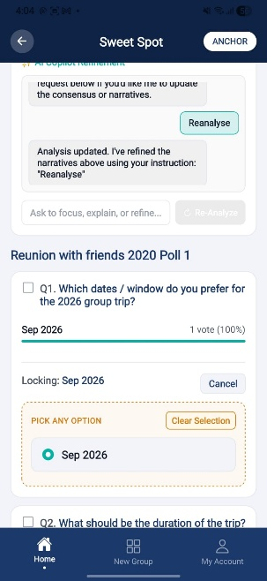
Purpose. Final poll results with the Anchor choice and the Claude popular choice, plus the route into CostGPT and event update.
Screen elements & what each does:
Element | Behaviour / What it does
Results — 2+2 layout | Anchor choice alongside the Claude popular choice.
Locked card | Closed poll outputs shown in a locked card.
Confirmed Poll → CostGPT | Confirming the poll redirects the Anchor to the Cost Estimator.
Update Event | Button redirects to PollEvent to update the event from the poll result.

States:
- Locked — Closed polls render in a locked, read-only card.

Screen-level workflow: Live Tracking / Event Polls List → Poll Output → Cost Estimator / Update Event

11. RSVP
Attendance capture and tracking. Responses are YES / NO / THINKING (RULE-004). Anchors launch RSVP with a deadline; members respond and can revisit their response.

11.1 Launch RSVP
Role: Anchor Module: RSVP
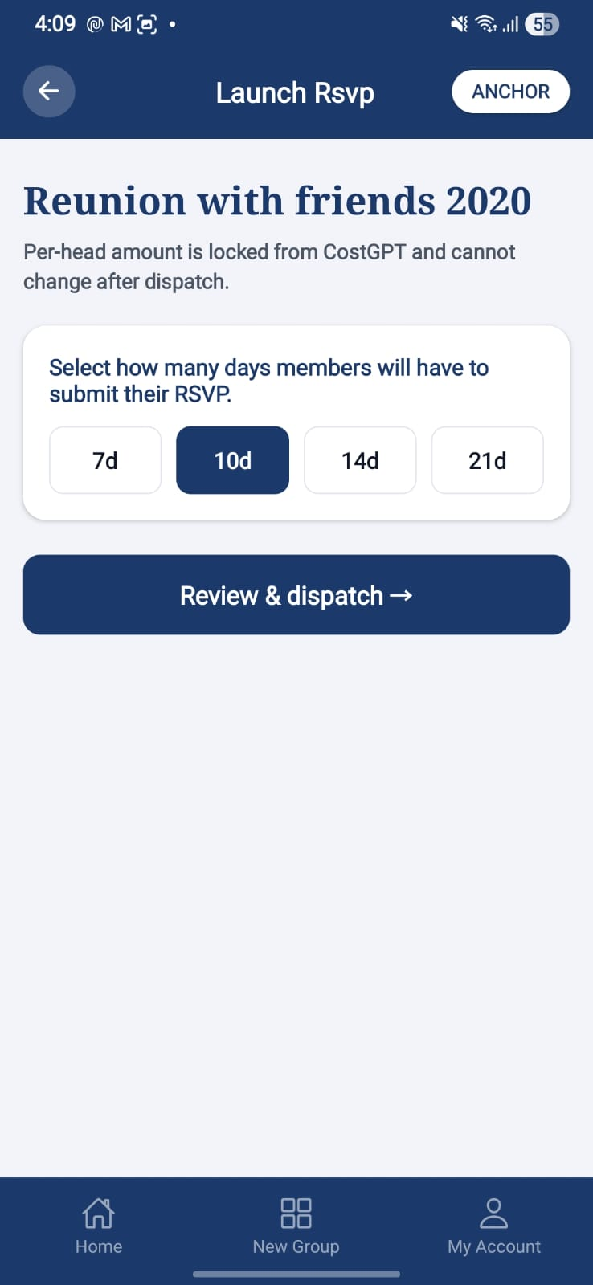

Purpose. Anchor opens RSVP collection for an event and sets the response deadline.
Screen elements & what each does:
Element | Behaviour / What it does
Deadline selector | Helper prompt guides deadline selection; deadline counted from the start of today and set to 23:59:59 on the Nth calendar day.
Launch | Opens RSVP; re-launch resets prior responses; consistent rsvpDeadline + invite expiresAt.

Screen-level workflow: Event Home → Launch RSVP → RSVP Tracker

11.2 RSVP Respond
Role: Member Module: RSVP
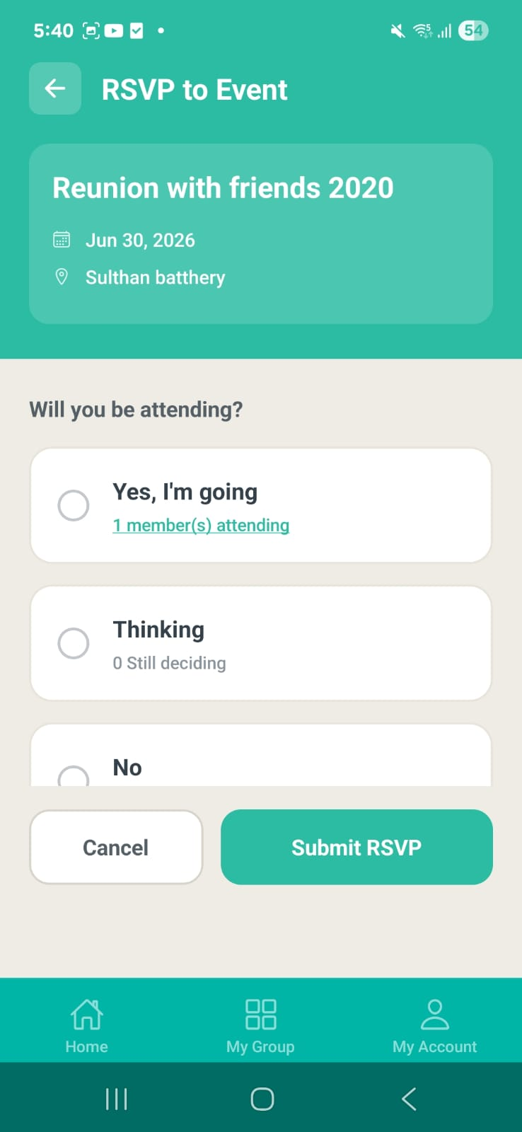 | 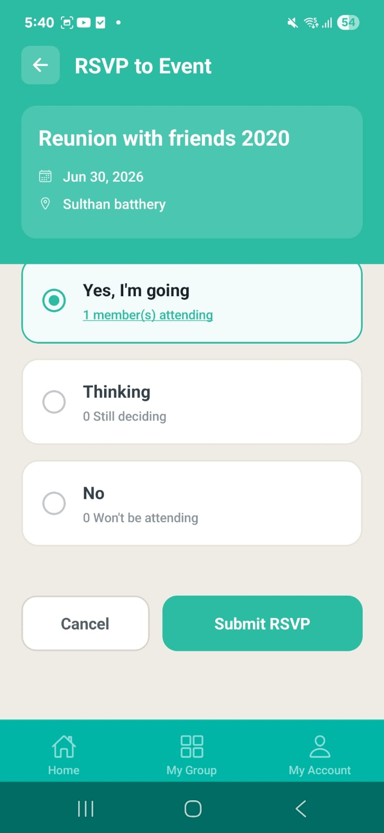

Purpose. Member submits or revisits their RSVP for an event.
Screen elements & what each does:
Element | Behaviour / What it does
YES / NO / THINKING | Three response options (RULE-004).
Deadline pill | Top-right 'Due: <date, time>' pill showing the exact cut-off; expired banner when past.
Previous response restore | On revisit, the prior answer is restored (read from userResponse / memberResponse / response).
Submit | Records the response; duplicate RSVP prevented.

States:
- Expired — Past deadline → response gate closed; expired banner with date + time.
- Revisit — Previously submitted answer pre-selected.

Screen-level workflow: Event / notification → RSVP Respond → Confirmation
Notes. Deadline parsing normalises Spring Boot space-separated datetime strings (replaces space with 'T') so the gate evaluates correctly; the rsvpOpen state flag is no longer used as a deadline shortcut.

11.3 RSVP Tracker / Track RSVP
Role: Anchor Module: RSVP
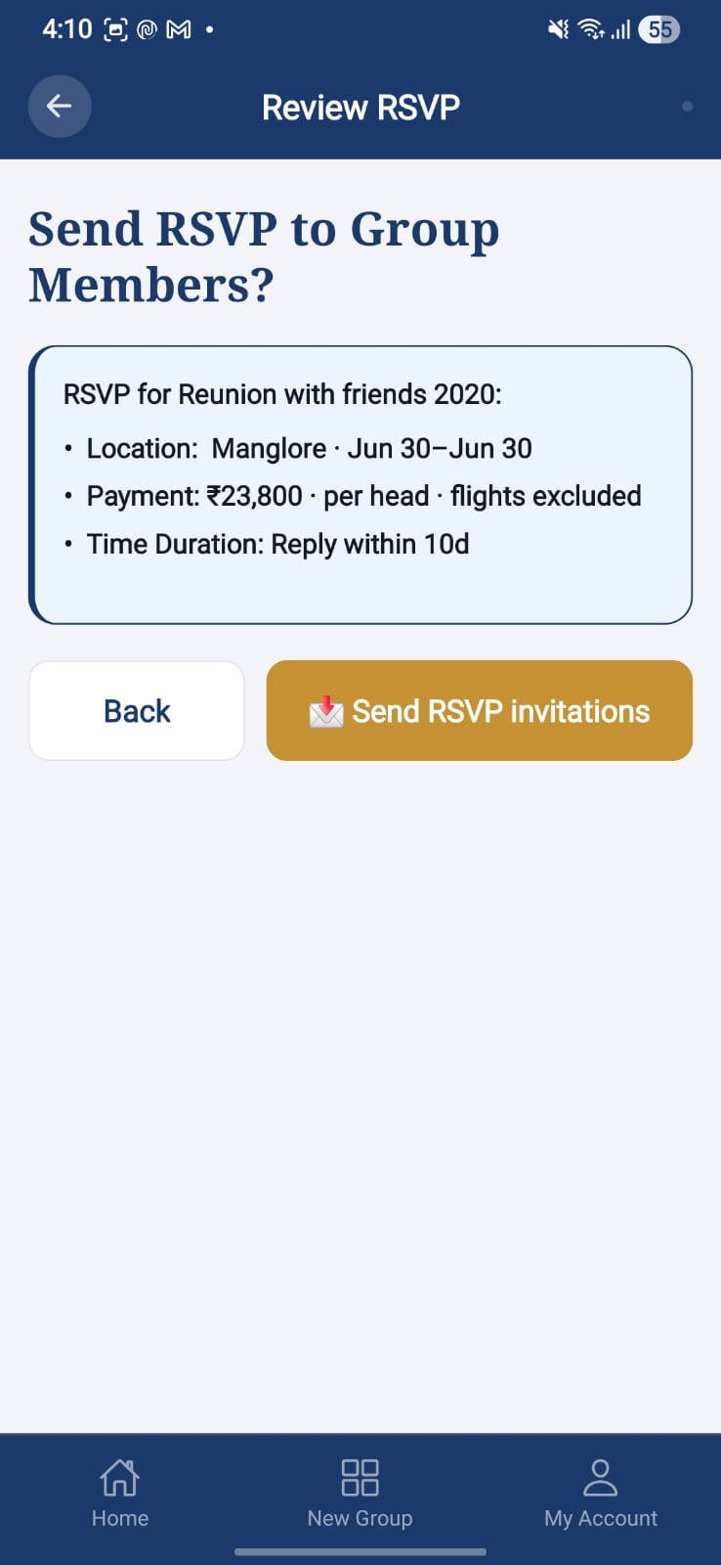 | 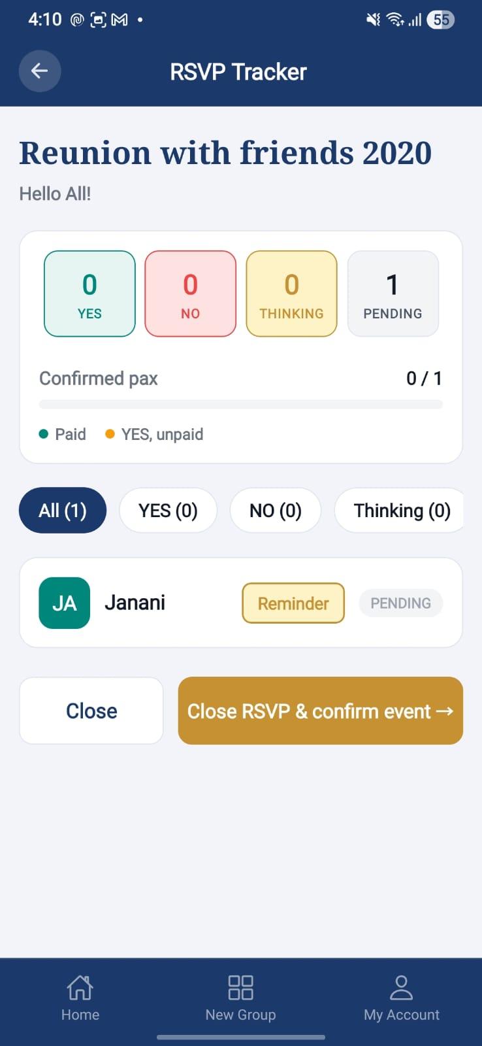

Purpose. Anchor tracks who has responded YES / NO / THINKING and sends reminders.
Screen elements & what each does:
Element | Behaviour / What it does
Response lists | Grouped by YES / NO / THINKING.
Reminders | Reminder prompts for 'No' and 'Thinking' responders.
YES count link | Attendee count shown as a clickable link.

Screen-level workflow: Event Home → RSVP Tracker → Send Follow-Up

11.4 Send Follow-Up
Role: Anchor Module: RSVP
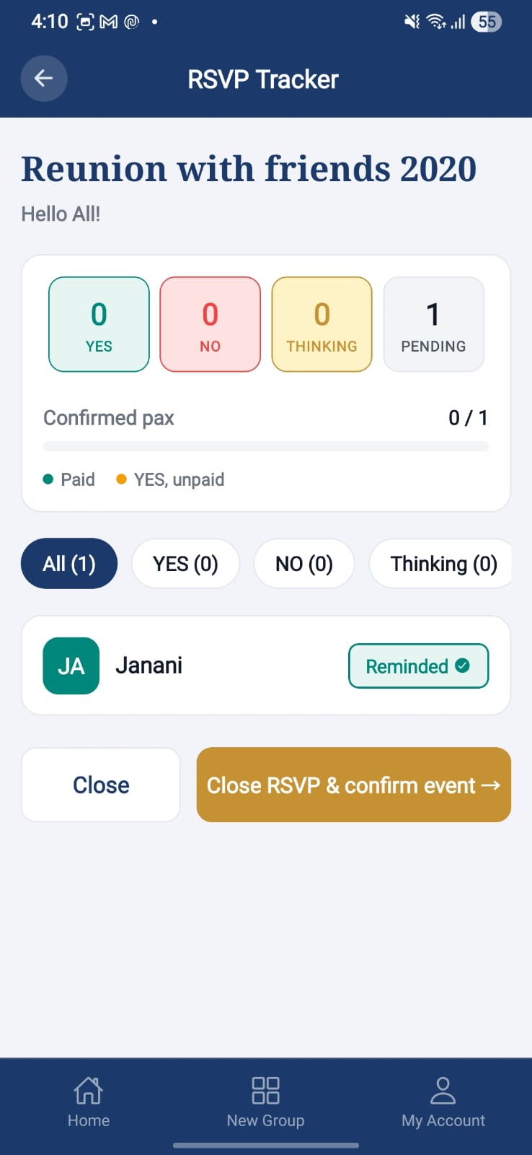

Purpose. Send a follow-up / reminder to selected responders.
Screen elements & what each does:
Element | Behaviour / What it does
Recipient selection | Target by response category.
Send | Dispatches in-app reminders.

Screen-level workflow: RSVP Tracker → Send Follow-Up → RSVP Tracker

12. Cost Estimation (CostGPT / EVE)
Anchor-only, advisory cost estimation. CostGPT pulls confirmed D3 poll results into an editable master prompt; EVE is the conversational multi-turn estimator. No PII or platform name is sent in prompts; output is advisory only (RULE-001 alcohol excluded; RULE-006 advisory).

12.1 Cost Estimation Wizard (CostGPT)
Role: Anchor Module: Cost Estimation
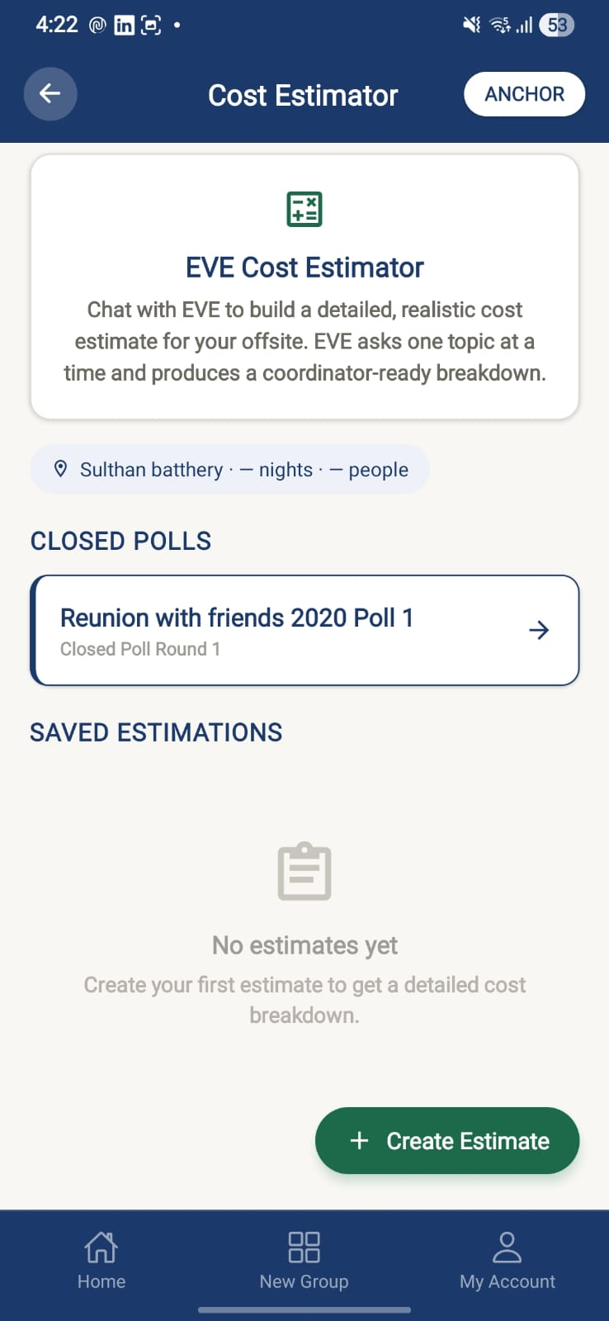

Purpose. Generate a cost estimate from the confirmed D3 poll result via an editable master prompt.
Screen elements & what each does:
Element | Behaviour / What it does
Auto-pulled D3 result | Confirmed poll result auto-loaded into a ~400-word master prompt.
Editable master prompt | Anchor can edit the master_prompt before submission.
Closed polls list | Selectable closed polls feed the estimator.
Estimate | Submits to the embedded LLM via the audited gateway; result auto-saved.

Screen-level workflow: Poll Output (Confirmed) → Cost Estimation Wizard → Cost Estimator List
Notes. Alcohol always excluded from estimates (RULE-001); estimate is advisory only (RULE-006). MakeMyTrip API/MCP is post-Delta.

12.2 Cost Estimator Chat (EVE)
Role: Anchor Module: Cost Estimation
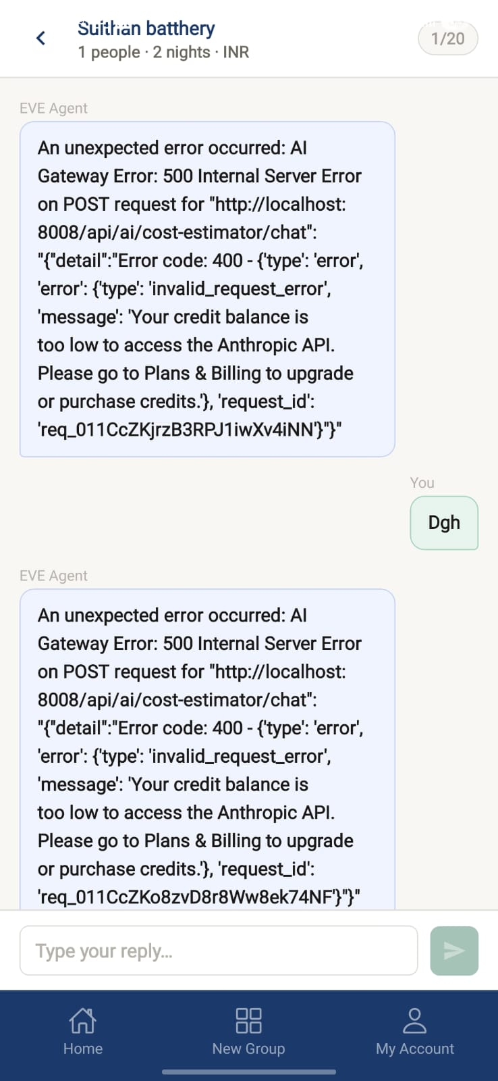

Purpose. Conversational, multi-turn cost estimator within Event Home.
Screen elements & what each does:
Element | Behaviour / What it does
Chat thread | Multi-turn conversation; stateless /api/ai/cost-estimator/chat endpoint.
Cross-tab navigation | Cross-tab navigation fix so the chat opens correctly from the Cost tab.
Group size note | Dynamic group-size note from RSVP-YES / member-count logic.

Screen-level workflow: Event Home (Anchor) → Cost Estimator Chat → Cost Estimator List

12.3 Cost Estimator List
Role: Anchor Module: Cost Estimation
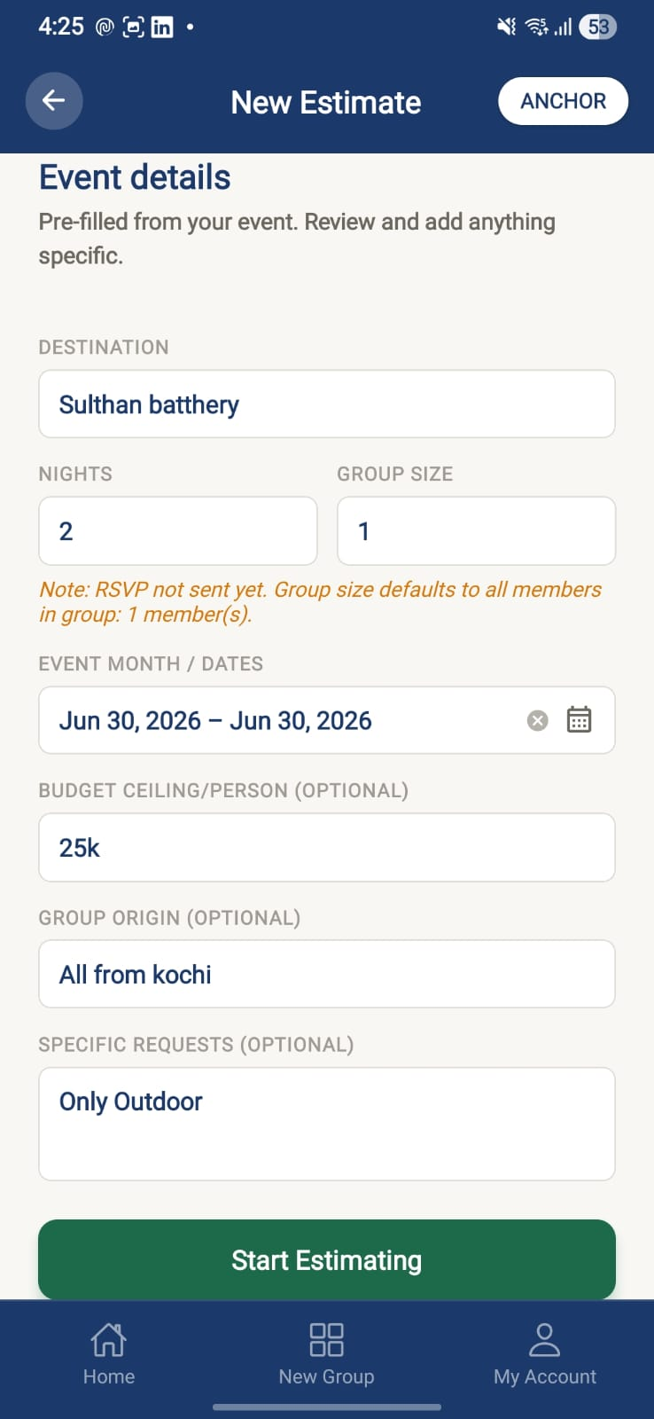

Purpose. Persistent list of saved cost estimates for the event.
Screen elements & what each does:
Element | Behaviour / What it does
Estimate list | Saved estimates with persistent + list view (T-172).
Open estimate | View a saved estimate's detail.

Screen-level workflow: Cost Wizard / Chat → Cost Estimator List → Estimate detail

13. Payments (Manual — Delta)
Delta ships manual payment entry only — no gateway. Two sub-modules: Mark as Paid (member collection) and Expense Tracking. Only Anchors record payments/expenses; members are read-only on their own data (RULE-PAY-001). A simulated checkout exists on the member side for demonstration.

13.1 Event Payment (Mark as Paid)
Role: Anchor Module: Payments
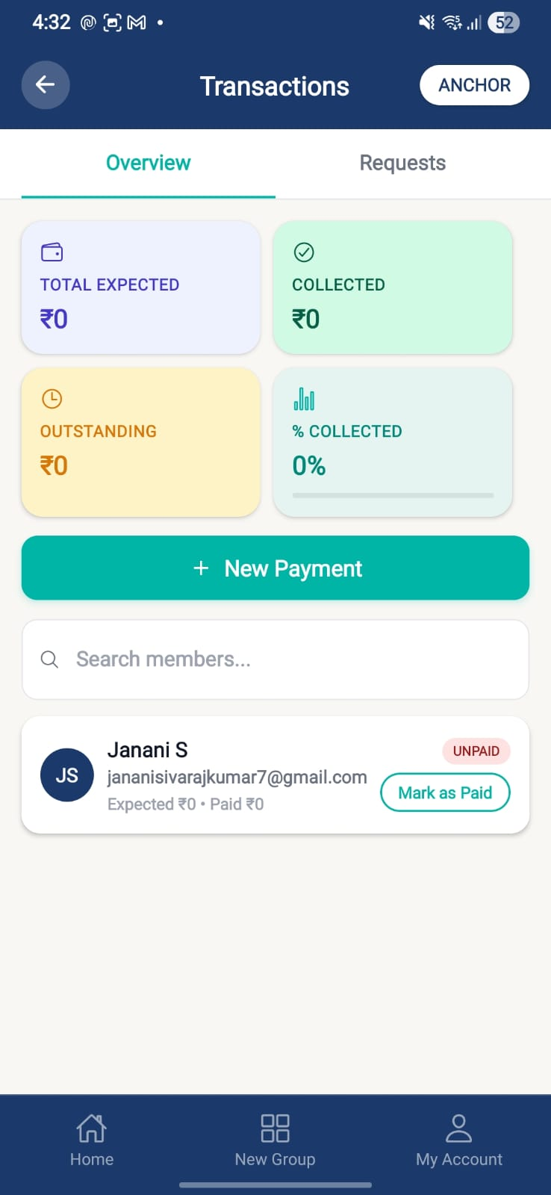

Purpose. Anchor records member payments against an event and views collection summary.
Screen elements & what each does:
Element | Behaviour / What it does
Member rows (RSVP-YES) | All RSVP-YES members with UNPAID / PAID / PARTIALLY_PAID / WAIVED status (RULE-PAY-003: only after RSVP=YES).
Record payment | Paid amount (paise), mode (CASH/UPI/BANK_TRANSFER/OTHER), reference note.
Summary card | Total Expected | Total Collected | Outstanding | % Collected (gradient metric cards).
Search bar | Filter members.
Mark as Paid | Per-row mark; fires an in-app notification to the member.

Screen-level workflow: Event Home (Anchor) → Event Payment → New Payment / member notified
Notes. Expected amount = budgeted total ÷ RSVP-YES headcount, Anchor-overridable per member (RULE-PAY-002).

13.2 New Payment
Role: Anchor Module: Payments
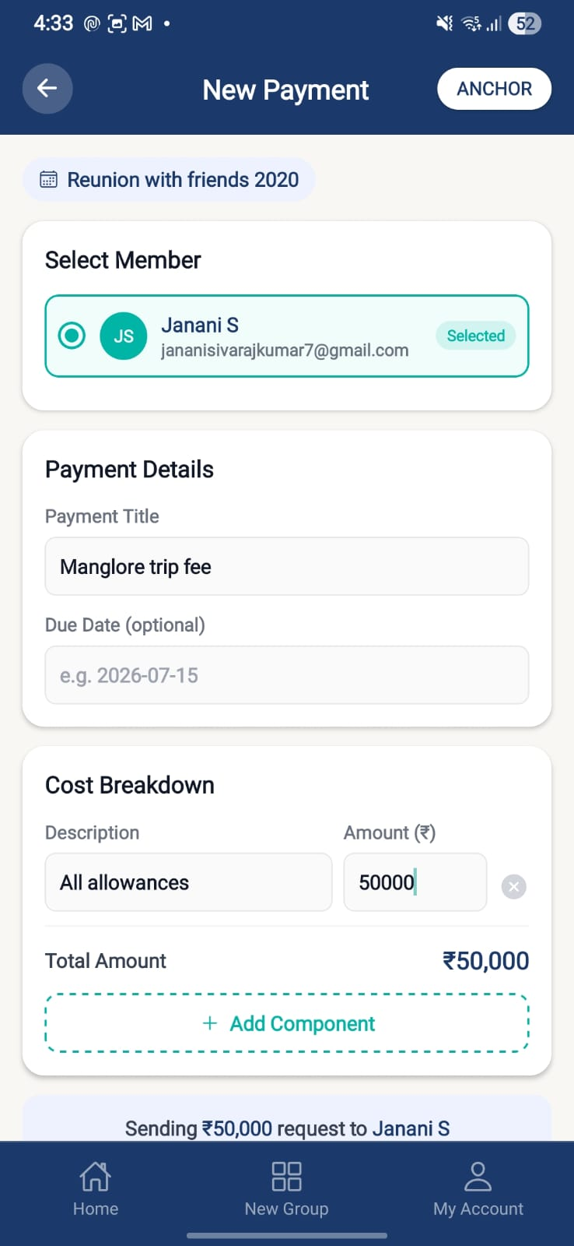 | 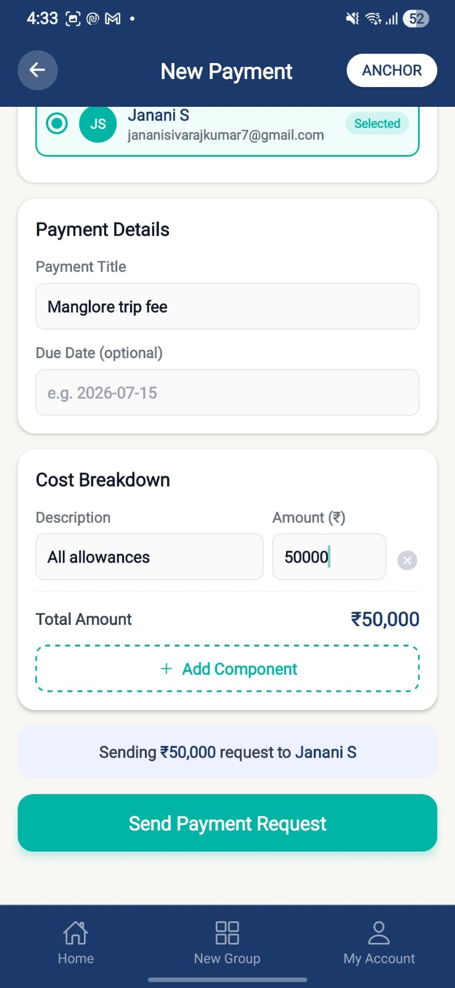 | 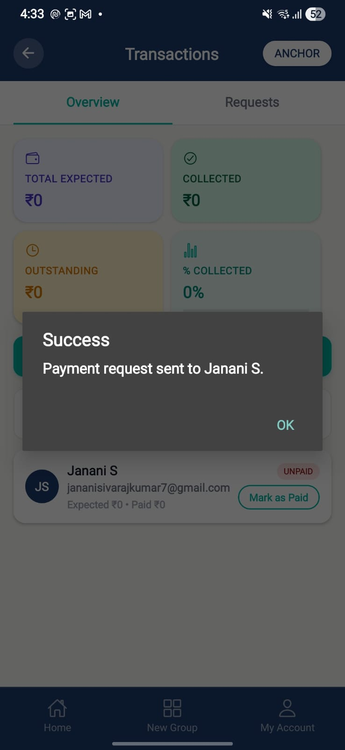

Purpose. Record a new payment transaction for a single member with a multi-component breakdown.
Screen elements & what each does:
Element | Behaviour / What it does
Member radio select | Single-member selection pinned at the top.
Component breakdown | Multi-component amounts tagged to the event.
Save | Persists the transaction (V10 migration, PaymentTransaction entity).

Screen-level workflow: Event Payment / Payment Transactions → New Payment → Payment Transactions

13.3 Payment Transactions
Role: Both Module: Payments
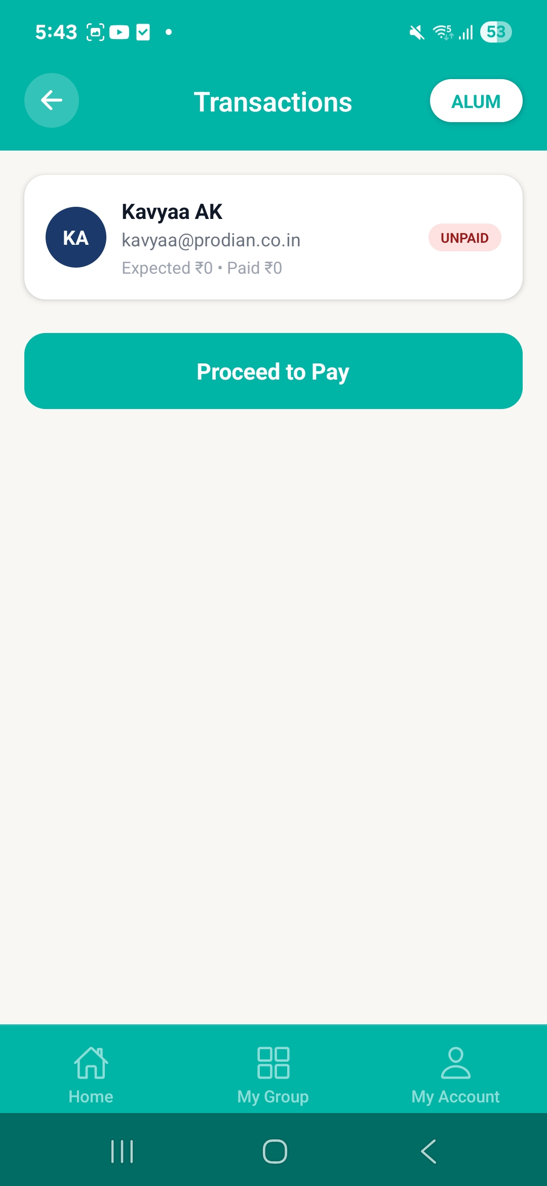

Purpose. Transaction ledger — Anchor sees all; member sees their own.
Screen elements & what each does:
Element | Behaviour / What it does
Transaction list | Anchor: full list + New Payment + per-row Mark as Paid. Member: own transactions only.
Component detail | Member can open a component-level detail view.
PAYMENT_REQUESTED | Notification surfaced on the member home.

Screen-level workflow: Event Home / Home → Payment Transactions → New Payment / detail

13.4 Payment (Member status & checkout)
Role: Member Module: Payments
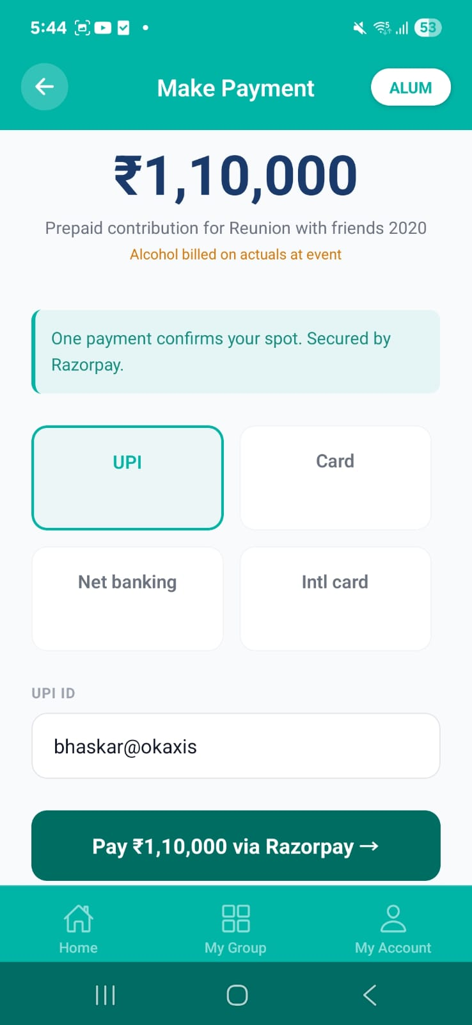

Purpose. Member views their own payment status and proceeds through a simulated checkout.
Screen elements & what each does:
Element | Behaviour / What it does
Own status | Expected and paid amounts for the member.
Proceed to Pay | Feeds event title + outstanding into a simulated Razorpay route (demo only).

Screen-level workflow: Payment tile → Payment → Payment Confirmed

13.5 Payment Confirmed
Role: Member Module: Payments
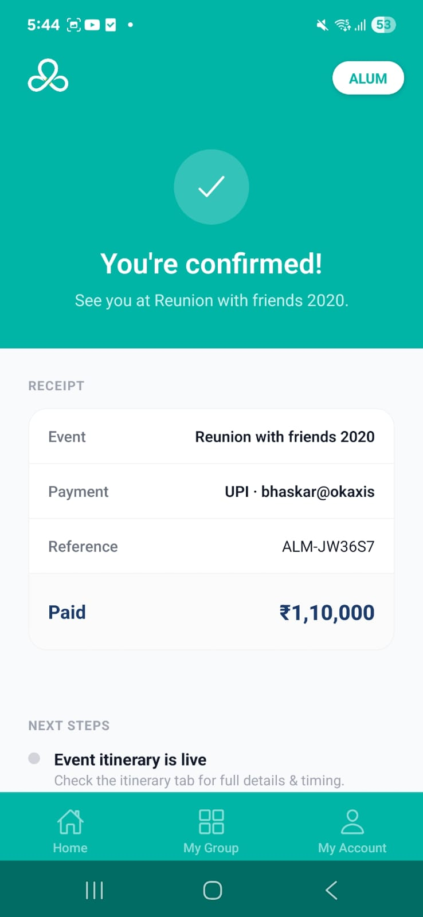 | 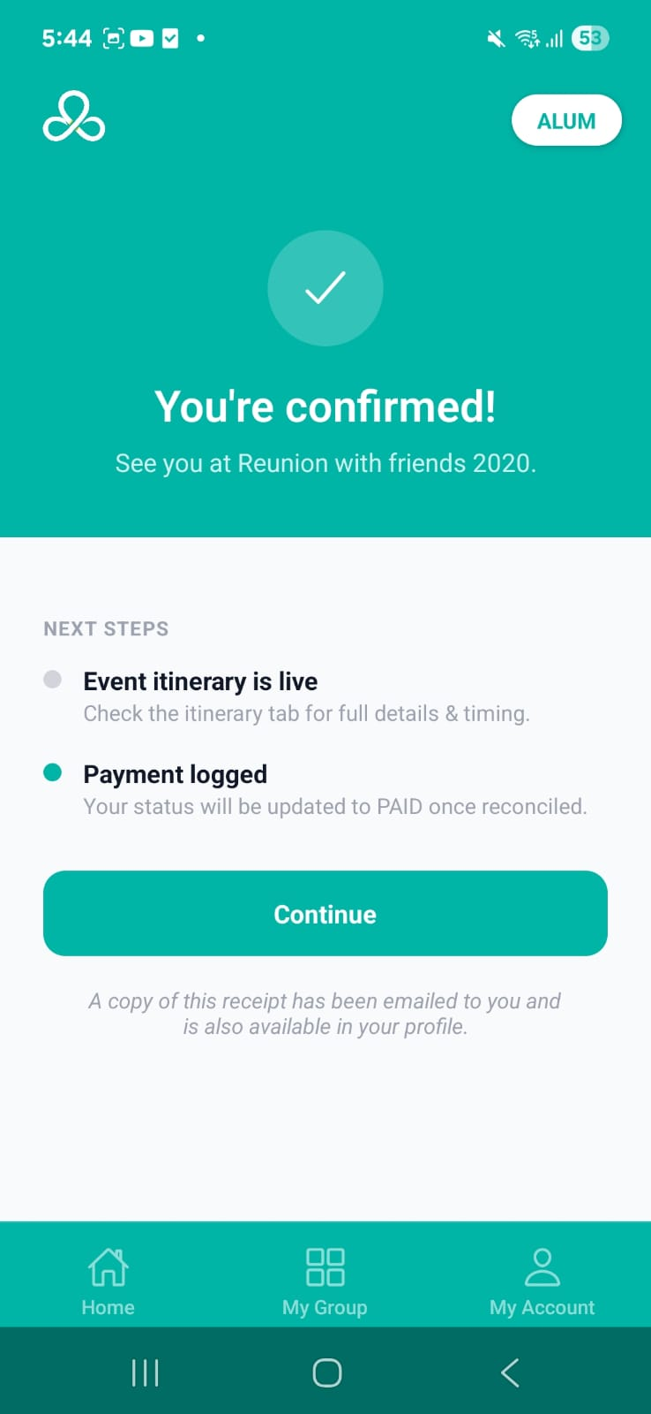

Purpose. Receipt confirmation after the simulated checkout.
Screen elements & what each does:
Element | Behaviour / What it does
Receipt detail | Detailed confirmation / receipt screen.

Screen-level workflow: Payment → Payment Confirmed → Back

14. Itinerary & Travel
Event itinerary timeline and per-member travel details. Anchors can track and remind; members provide their own travel data.

14.1 Event Itinerary
Role: Both Module: Itinerary & Travel
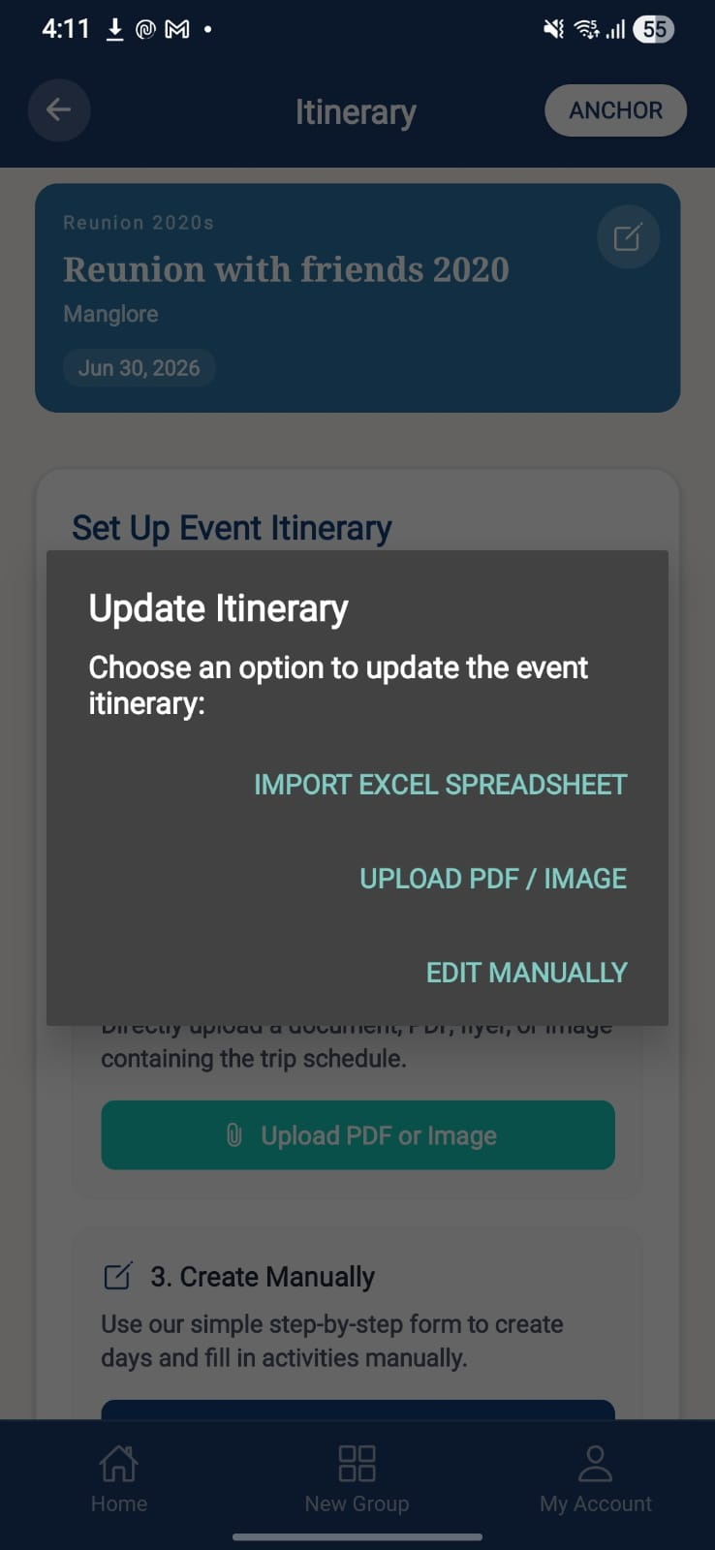 | 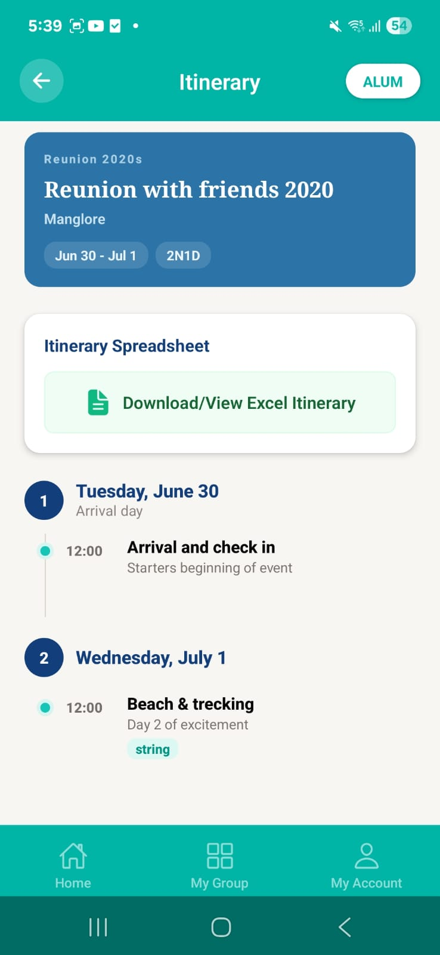

Purpose. Display the event's itinerary timeline.
Screen elements & what each does:
Element | Behaviour / What it does
Timeline view | Ordered itinerary entries.
Error handling | Itinerary API 404 / LogBox errors suppressed (T-197).

Screen-level workflow: Event Home → Event Itinerary → Create Itinerary (Anchor)

14.2 Create Itinerary
Role: Anchor Module: Itinerary & Travel
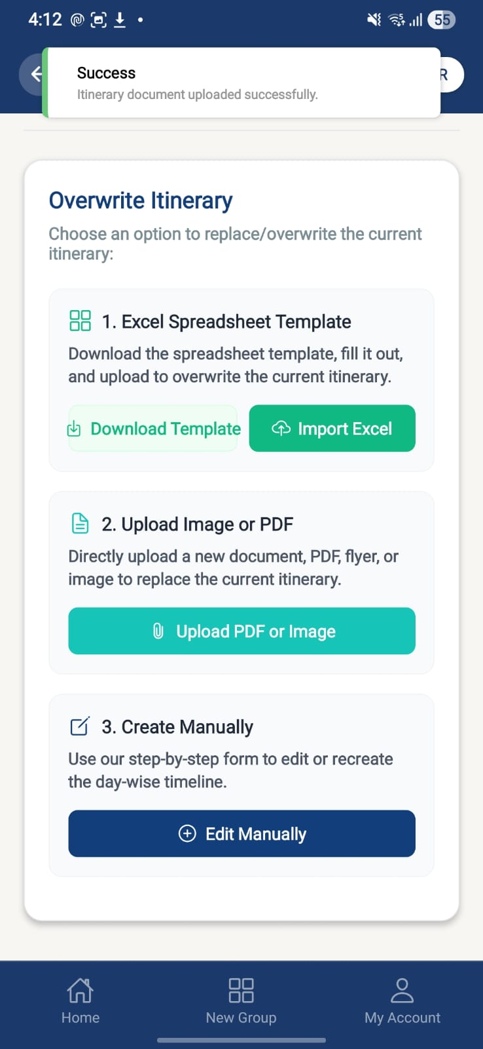 | 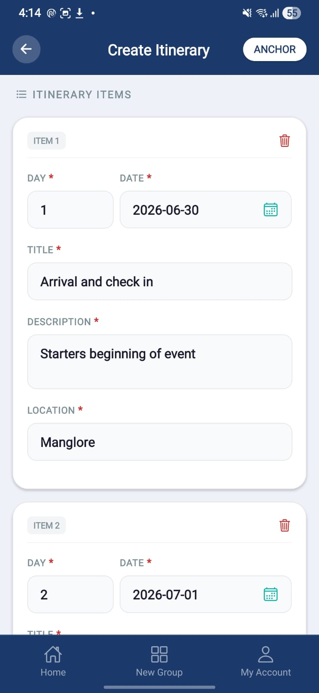 | 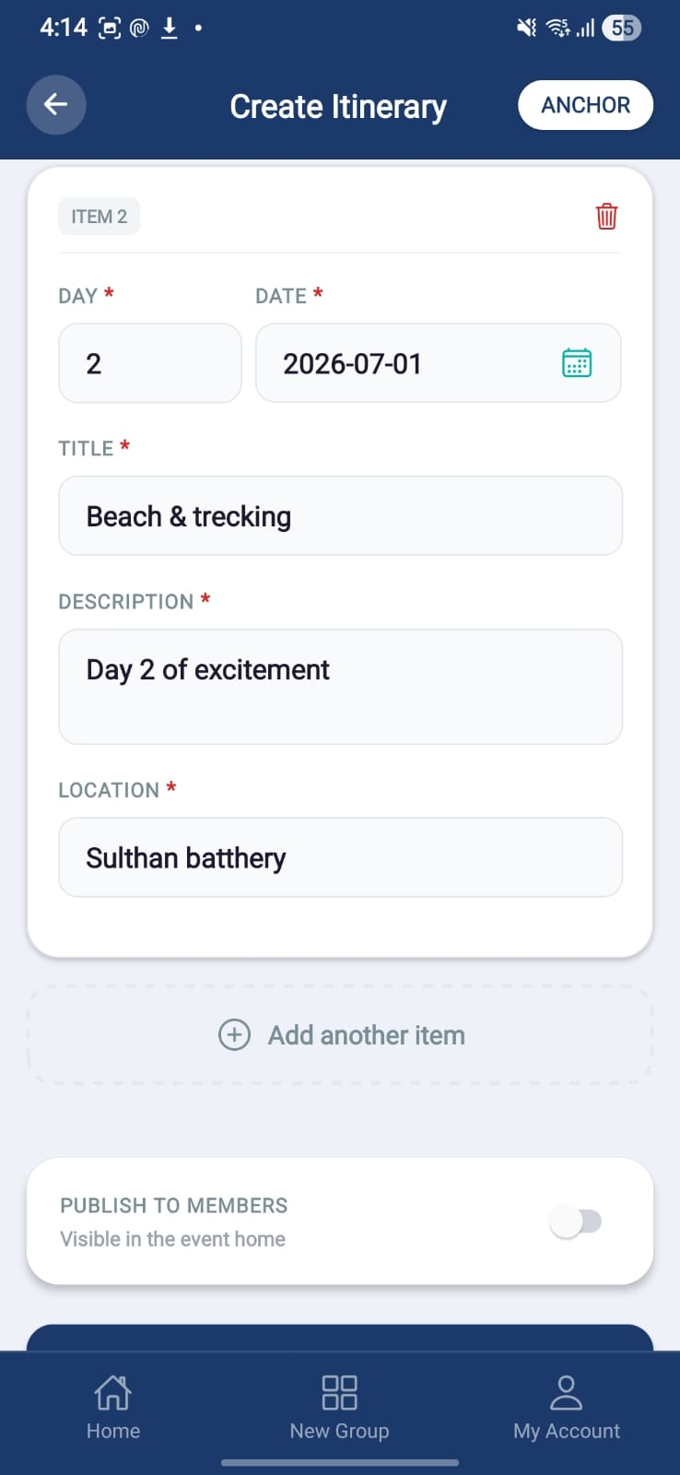
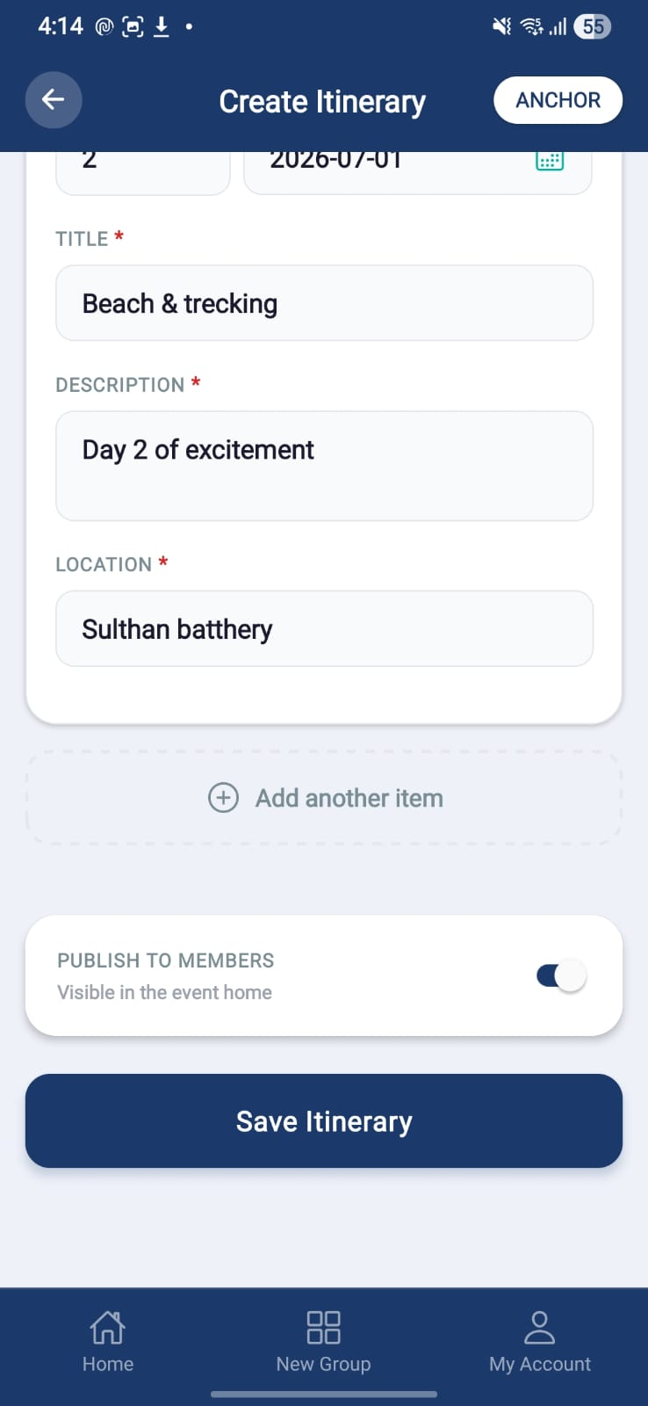

Purpose. Build the itinerary manually or by Excel upload, then publish.
Screen elements & what each does:
Element | Behaviour / What it does
Manual timeline editor | Add/edit timeline entries (requires eventId — 400 error resolved).
Excel upload | Bulk itinerary import via template (template download fixed).
Publish | Publishes the itinerary to members.

Screen-level workflow: Event Itinerary → Create Itinerary → Event Itinerary

14.3 Update Travel (Transfer to be renamed as Travel)
Role: Member Module: Itinerary & Travel
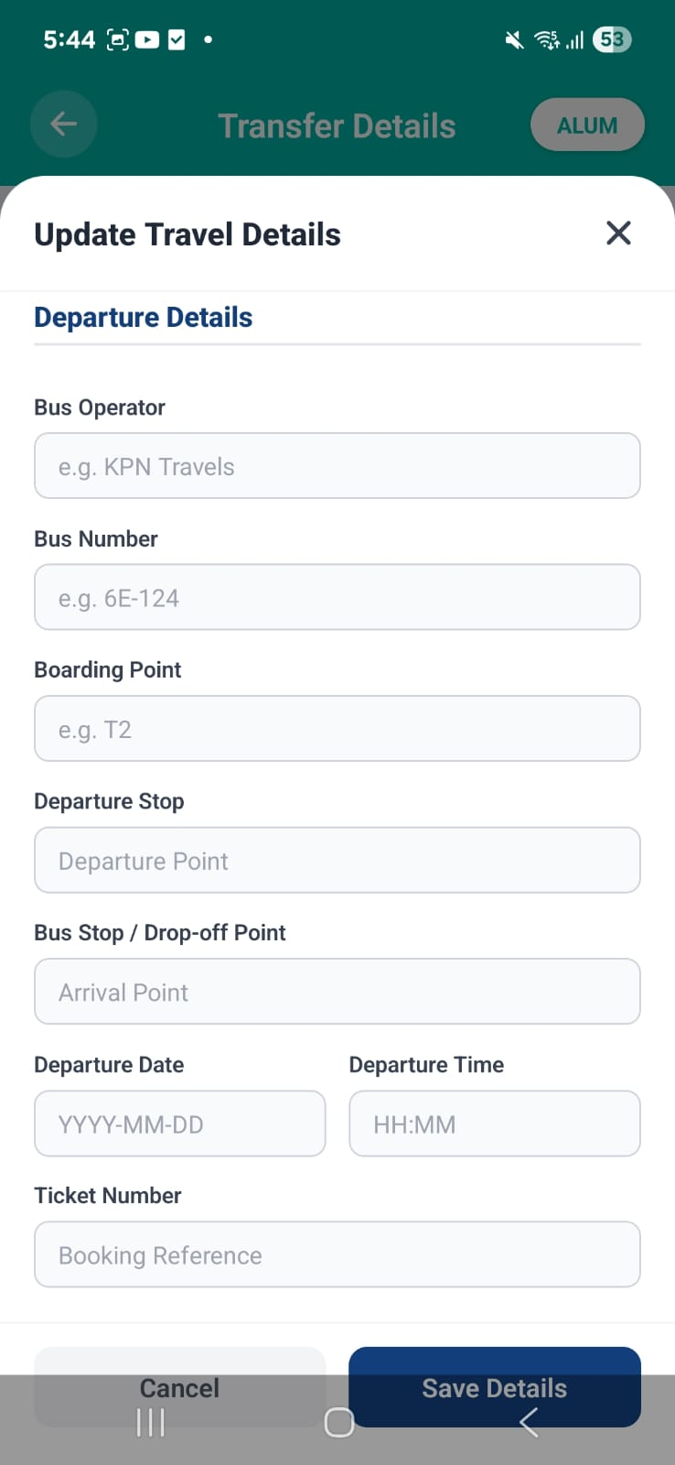 | 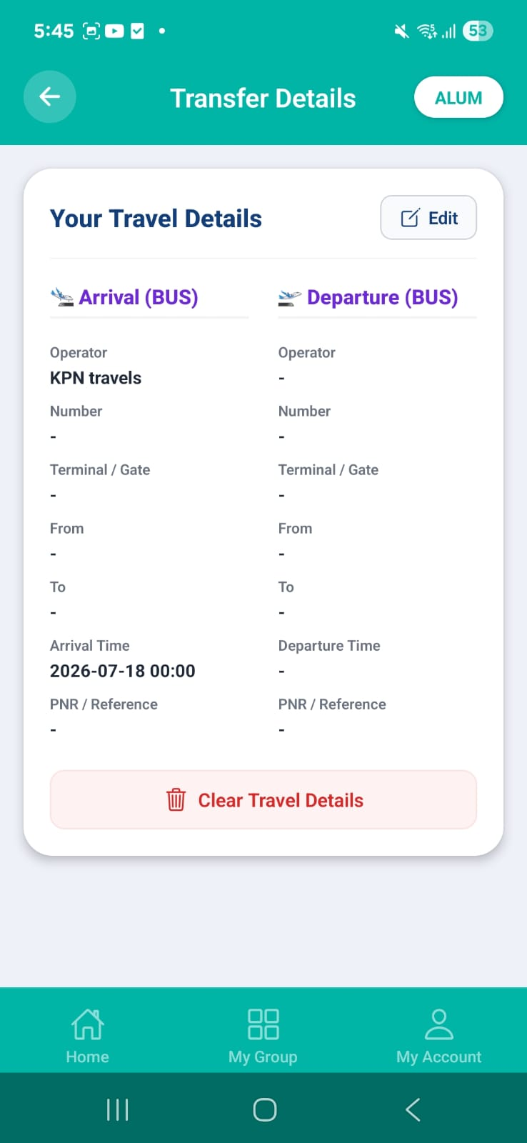

Note: Transfer details will be renamed as Travel
Purpose. Member provides, updates, or deletes their travel details per transport mode.
Screen elements & what each does:
Element | Behaviour / What it does
Flight mode | Flight number, arrival/departure airports, terminals, times.
Train mode | Train number, arrival/departure stations, times.
Bus mode | Arrival/departure bus stands, pickup/drop times.
Other mode | Info box indicating transport mode 'OTHER'.
Save / Delete | Provide / update / delete travel details; view aligns to saved fields per mode.

Screen-level workflow: Event Home → Travel → saved

14.4 Travel Details (Transfer to be renamed as Travel)
Role: Both Module: Itinerary & Travel
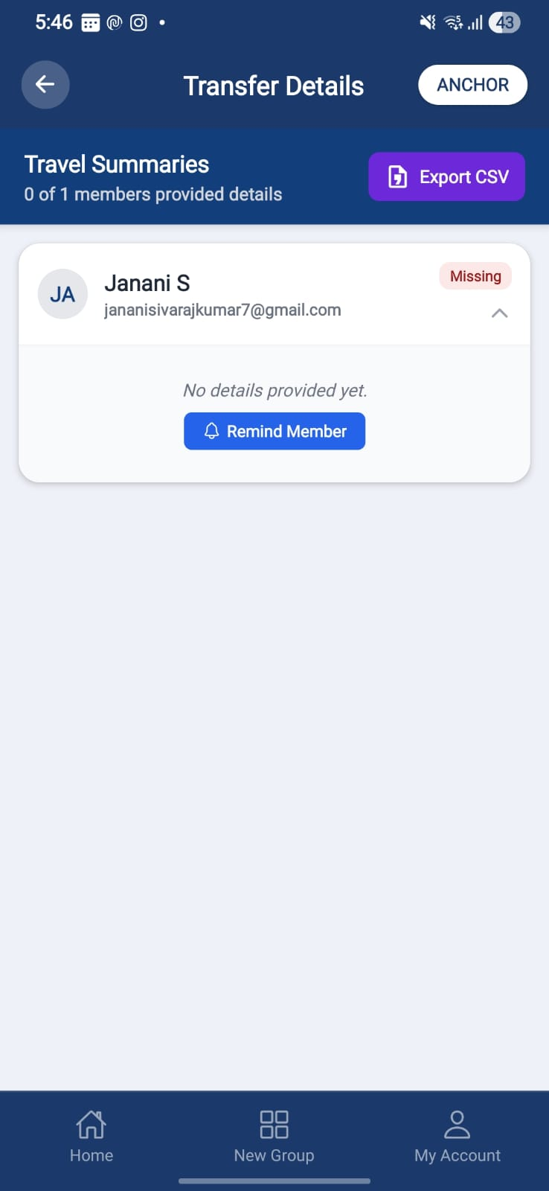

Note: Transfer details will be renamed as Travel

Purpose. Standalone transfer/transport details screen (extracted from Travel).
Screen elements & what each does:
Element | Behaviour / What it does
Transport detail fields | Flight/transport details management; overhauled for restructured entry.
Anchor tracking | Anchor can track, update, remind (in-app) and download a CSV of RSVP-confirmed members' travel info.

Screen-level workflow: Travel / Event Home → Travel → Back

15. Community, Announcements & Engagement
Community library/feed, notice board announcements, in-app + push notifications, and nominee management.

15.1 Feed / Library
Role: Both Module: Community
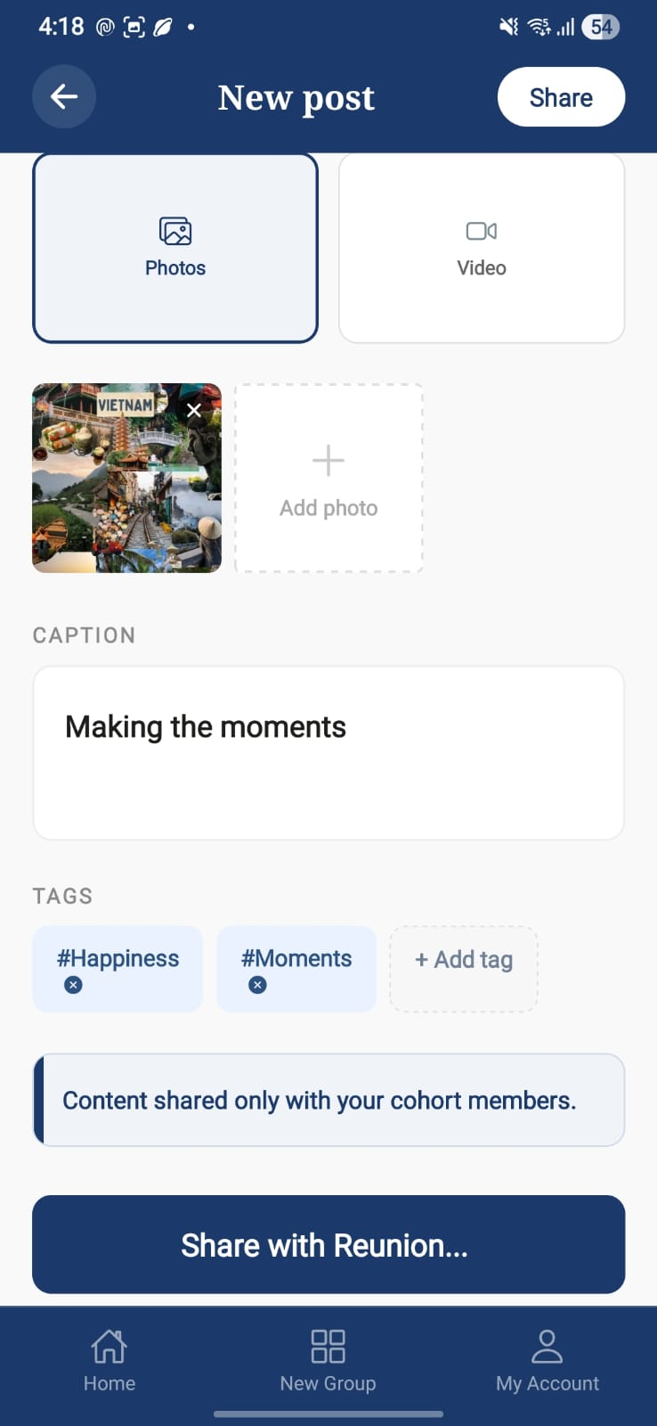 | 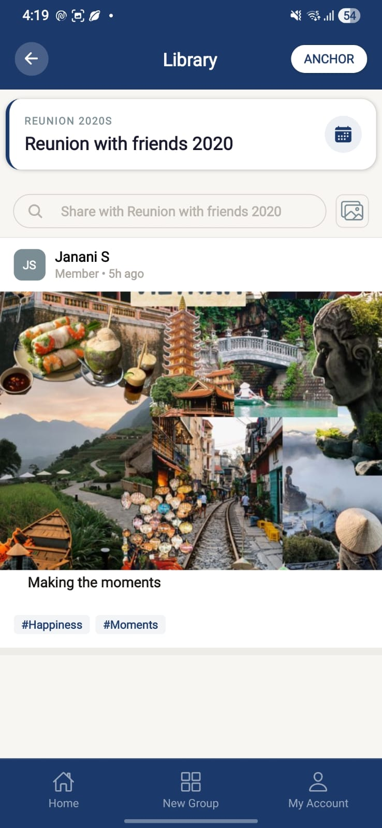

Purpose. Community content stream of posts and shared media (labelled 'Library').
Screen elements & what each does:
Element | Behaviour / What it does
Post list | Posts with media attachments; feed reloads immediately after upload (goBack fix).
Interactions | Like / comment / share handlers currently disabled/commented for Delta; double-tap like disabled.
Event scoping | Posts scoped by event; no auto-select without event params (stale-post fix).

States:
- Empty — No posts for the selected event.

Screen-level workflow: Library tile / tab → Feed → Post Upload

15.2 Post Upload
Role: Both Module: Community
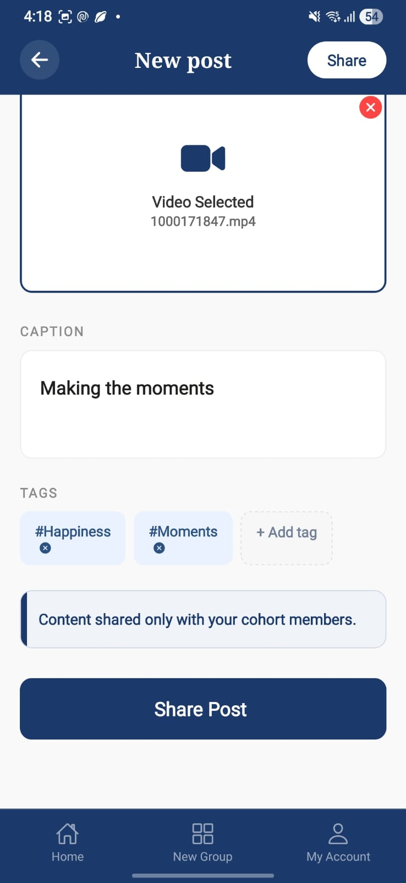 | 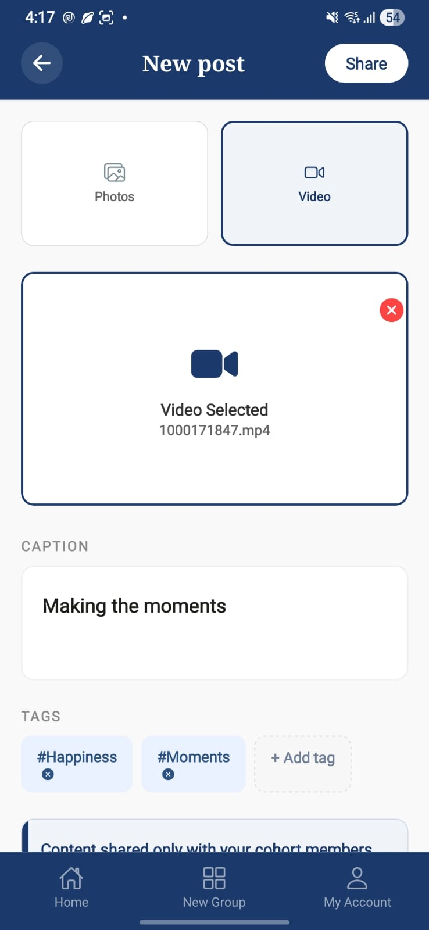

Purpose. Upload a new post with media to the feed.
Screen elements & what each does:
Element | Behaviour / What it does
Media picker / caption | Attach media and caption.
Upload | On success uses goBack() so the feed reloads immediately with the new post.

Screen-level workflow: Feed → Post Upload → Feed (refreshed)

15.3 Notice Board
Role: Both Module: Announcements
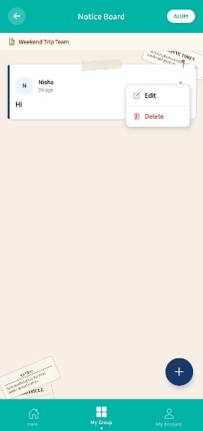

Purpose. Group-level notice board showing announcements; empty and active card states.
Screen elements & what each does:
Element | Behaviour / What it does
Notice cards | Active notices in the card language consistent with sibling cards (purple palette #534AB7 / #3C3489 / #EEEDFE).
Empty state | Empty-state card when no notices exist.
Create entry (Anchor) | Opens the Create Notice modal.

States:
- Empty — Empty notice-board card.
- Active — One or more notice cards.

Screen-level workflow: Group / Event → Notice Board → Create Notice (Anchor)

15.4 Create Notice (modal)
Role: Anchor Module: Announcements
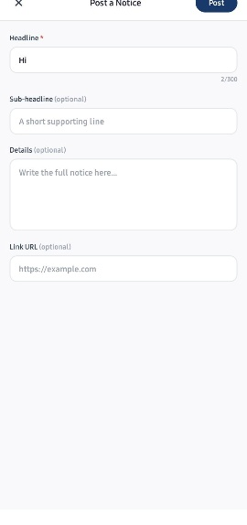

Purpose. Anchor composes and posts a notice to the group/event notice board.
Screen elements & what each does:
Element | Behaviour / What it does
Notice fields | Title / body for the announcement.
Post | Publishes the notice; appears as an active card.

Screen-level workflow: Notice Board → Create Notice → Notice Board
Updated (08-Jul-2026 release). PNG/JPG image attachment support has been added to this modal, so notices can carry an image the way a physical college notice board would.

15.5 Notifications (in-app)
Role: Both Module: Notifications
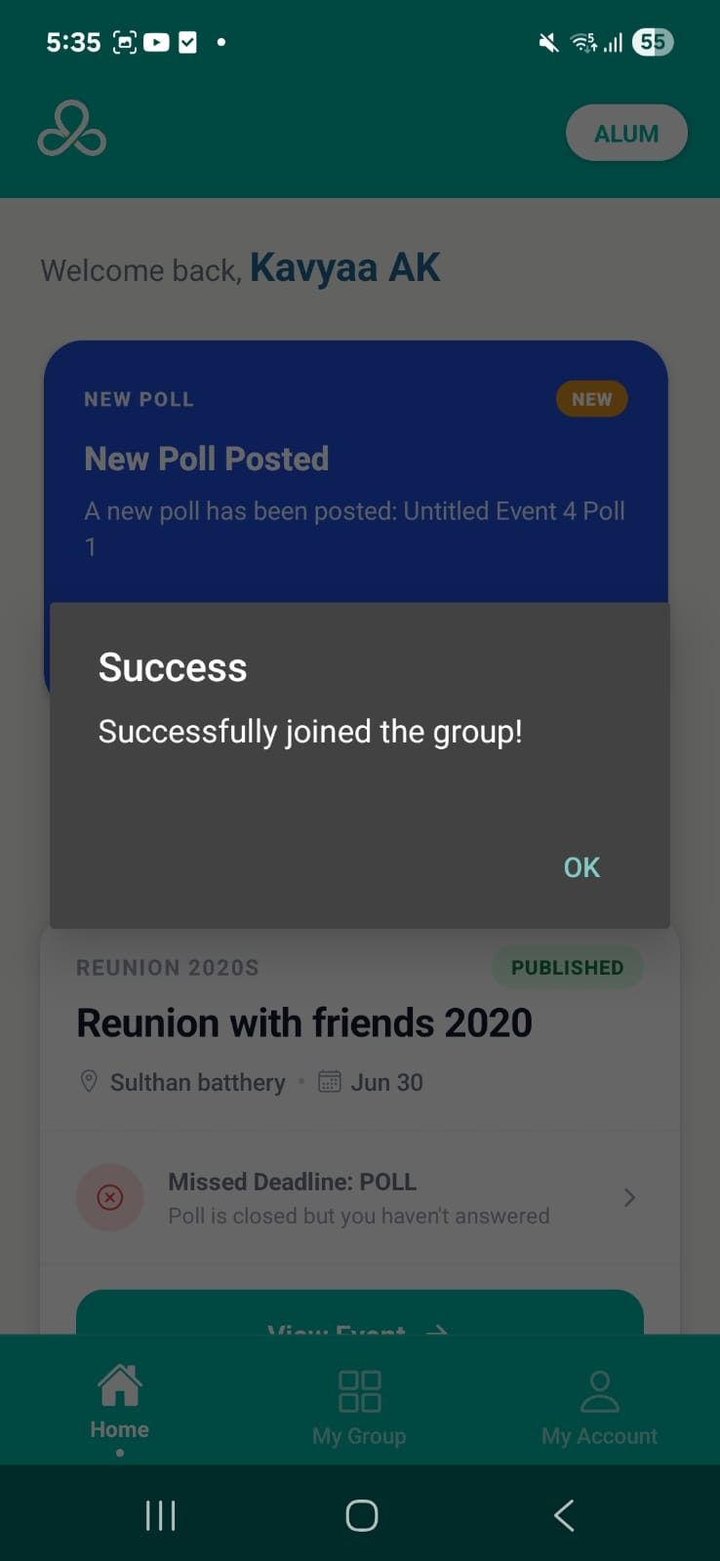

Purpose. In-app notification centre on the home dashboard with read/unread/delete and refresh.
Screen elements & what each does:
Element | Behaviour / What it does
Notification list | Read / unread / delete; dynamic focus-based refresh and pull-to-refresh.
Action routing | POLL_POSTED → Event Polls List; RSVP / PROFILE_REVIEW / PAYMENT_REQUESTED route to their flows.
Push (FCM) | Push delivered via FCM; device token saved on login/OAuth/OTP.

Screen-level workflow: Home → Notification tap → Target screen

15.6 Nominee Management
Role: Member Module: Nominee Management

Purpose. Member records nominee details (with consent capture for nominee data).
Screen elements & what each does:
Element | Behaviour / What it does
Nominee fields | Nominee detail entry.
Consent | Nominee/data-storage consent surfaced in the consent module.
Save | Persists nominee details.

Screen-level workflow: Profile / Settings → Nominee Management → Back

16. Privacy, Consent & Legal Screens
Consent management and the legal screens required for store submission. Built around a consent_master lookup and a user_consents join table.

16.1 Consent Management
Role: Both Module: Privacy & Consent
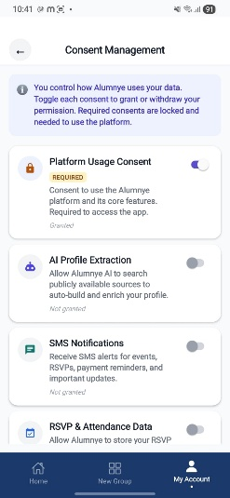 | 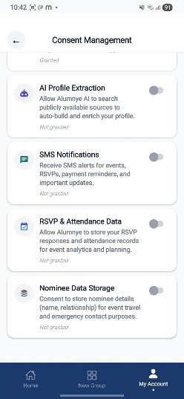

Purpose. User grants or withdraws consents dynamically; platform/mandatory consents are locked.
Screen elements & what each does:
Element | Behaviour / What it does
Consent toggles | Grant/withdraw per consent item; mandatory/platform consents locked.
Contextual icons | Icons for AI Profile Extraction, SMS, RSVP, Nominee/Data Storage items.
Safe-area header | Top header alignment corrected for iOS/Android safe area; enlarged icon chips.
Backend | GET/PUT /api/v1/user/consents/{userId} with security guards.

Screen-level workflow: Settings → Privacy → Consent Management → Back

16.2 Terms & Conditions
Role: Both Module: Privacy & Consent
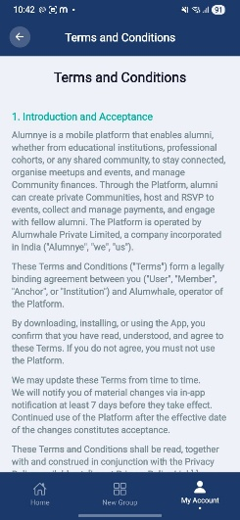 | 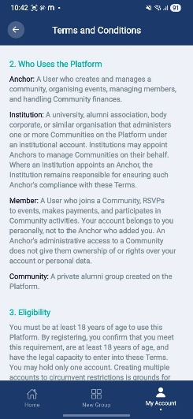 | 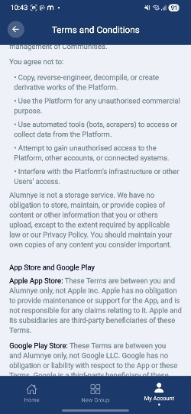

Purpose. Display the Terms & Conditions (required for app store submission).
Screen elements & what each does:
Element | Behaviour / What it does
T&C content | Scrollable legal content; reachable from onboarding and the settings list.

Screen-level workflow: Onboarding / Settings → Terms & Conditions → Back

16.3 Privacy Policy
Role: Both Module: Privacy & Consent
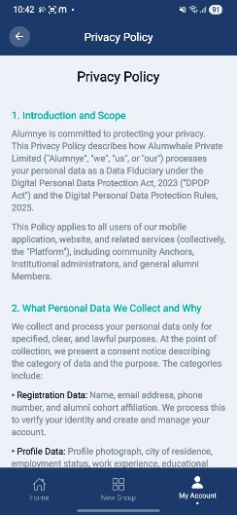 | 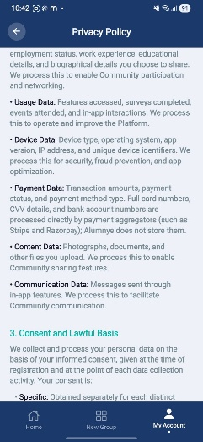

Purpose. Display the Privacy Policy (required for app store submission).
Screen elements & what each does:
Element | Behaviour / What it does
Privacy content | Scrollable policy content; settings list navigation.

Screen-level workflow: Onboarding / Settings → Privacy Policy → Back

16.4 AI Usage
Role: Both Module: Privacy & Consent
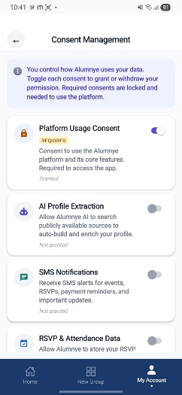 | 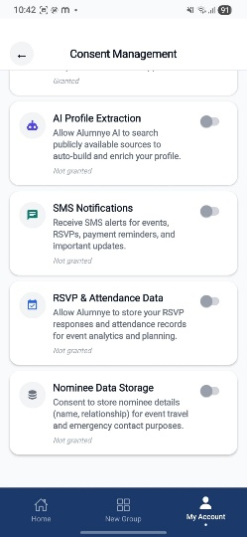

Purpose. Disclose how AI is used in the platform (three lines or fewer).
Screen elements & what each does:
Element | Behaviour / What it does
AI disclosure | Concise AI-usage disclosure for transparency.

Screen-level workflow: Settings → AI Usage → Back

17. Business Rules & Compliance

17.1 Core business rules
Rule | Statement
RULE-001 | Alcohol is always excluded from CostGPT estimates.
RULE-004 | RSVP responses are limited to YES / NO / THINKING.
RULE-006 | CostGPT output is advisory only.
RULE-007 | The Anchor drives every event phase transition; no phase auto-advances.
RULE-012 | No PII (and no platform name 'Alumnye') is sent in prompts to external LLMs.
RULE-PAY-001 | Only Anchors mark payments or record expenses; members are read-only on their own data.
RULE-PAY-002 | Expected amount = budgeted total ÷ RSVP-YES headcount; Anchor can override per member.
RULE-PAY-003 | A payment can only be recorded after the member has RSVP = YES.

17.2 AI governance
- No auto-publish on any AI-generated content; a human review gate is mandatory across all AI elements (profile bios, cost estimates, poll analysis).
- No PII in LLM prompts; the platform name must not appear in prompts sent to external LLMs (RULE-012).
- AI usage disclosure required (three lines or fewer); member consent required before any profile crawl (two-step consent).
- All AI calls are proxied through an audited Spring Boot gateway that writes to ai_audit_log.

17.3 Privacy & data protection
- Consent Management module: consent_master lookup + user_consents join table track grant/withdrawal states per user; platform/mandatory consents are locked.
- Poll anonymisation: individual responses are hidden from Anchors; only aggregate counts are shown.
- CSV uploads: raw files stored in AWS as audit records; extra (UDF) columns stored but not rendered in Delta.
- Money stored as BIGINT paise; UUID primary keys; soft deletes via deleted_at.

17.4 Regulatory context
Feature design is materially shaped by Indian regulatory requirements: the DPDP Act 2023 (consent, data rights), TRAI DLT registration (SMS templates / sender), the IT Act 2000, and SPDI Rules 2011. These primarily affect consent capture, data-subject rights, and messaging — relevant to the Consent, Profile and (deferred) SMS features.

18. Status, Risks & Deferred Scope

18.1 Open risks
# | Risk | Status
R1 | Payment wallet license (Razorpay gateway) | CRITICAL — legal opinion needed (does not block Delta manual entry)
R2 | LinkedIn scraping legality | In review — Firecrawl/DuckDuckGo being explored (LinkedIn login-gated, not feasible)
R3 | Anchor data migration (Excel → app) | CSV field mapping finalisation
R4 | Member identity duplication (mobile number conflicts) | Deduplication logic pending ID document
R5 | Karix onboarding process | In progress
R6 | NEW — Karix DLT/SMS responsiveness & API integration | OPEN — escalated via Alumwhale mailbox; Plan B provider (Carricks) being evaluated

18.2 Known blockers
- Credential rotation (URGENT): secrets moved to environment variables but old values remain in git history; AWS, ZeptoMail, JWT, Google OAuth and Karix keys must be rotated before any deployment.
- Google Play Store identity verification — blocking app store deployment.
- NEW (08-Jul-26). Negative-flow / validation issues: happy-flow testing passes, but negative-flow and other validation issues remain open; live testing with the first 5–6 users is gated on these being resolved.
- NEW (08-Jul-26). Build freeze during client testing: the development team holds off pushing new builds or patches while Alumwhale is actively testing on the isolated client TestFlight build; Prodian is notified once client testing concludes.

18.3 Deferred to Alpha (not in mobile Delta)
- WhatsApp (Karix) dispatch and the no-login HMAC token mechanism.
- Razorpay payment gateway (payment tables remain dormant; manual entry is the Delta substitute).
- Alumni booklet PDF generation.
- Personal Library and Quick-Add / AI-assisted member addition.
- Admin & Governance module (currently under-specified, ~25%).

18A. Golf Tournament Scoring & Management (New Add-On Module)
This section covers the standalone Golf Tournament Scoring & Management add-on, first scoped on 30-Jun-2026 and reviewed with the client (prototype walkthrough) on 01-Jul-2026. Golf is a separate, self-contained module not part of the core Alumnye Delta/Alpha alumni-event roadmap; it reuses the platform's account, notification and hosting infrastructure but has its own group model, screens and scoring engine. Phase 1 has since been built and captured end-to-end in the Alumnye Golf Tournament Scoring & Management User Manual (v3.0, 23-Jul-2026), piloted with a 44-member group ('Green Buddies'). The screen cards below (Sections 18A.3–18A.10) are drawn directly from that manual.

18A.1 Positioning & Concept
A bespoke sports-management system built for multi-week golf tournaments run inside an alumni group's event, designed to simplify tournament administration and scoring and to differentiate from existing consumer apps (e.g. Grint). Framed around three functional pillars: (a) a score-capture UI, (b) group/team-structure creation, and (c) draw-sheet scheduling. The design is intentionally kept flexible so the same draw-sheet and scoring engine can later be adapted to other sports (tennis, pickleball) by adjusting player counts and formats.
Access path. Golf is reached from inside a group's event, not from a standalone tab: Home (ALUM/ANCHOR switch) → My Group → the group's golf event → Activity card (gold trophy icon) → View now → Tournament Detail. If the Anchor hasn't set up the tournament yet, members see “No tournament yet — your anchor hasn't started the tournament for this event yet.”

18A.2 Accessing the Golf Module
Role: Both Module: Golf — Access
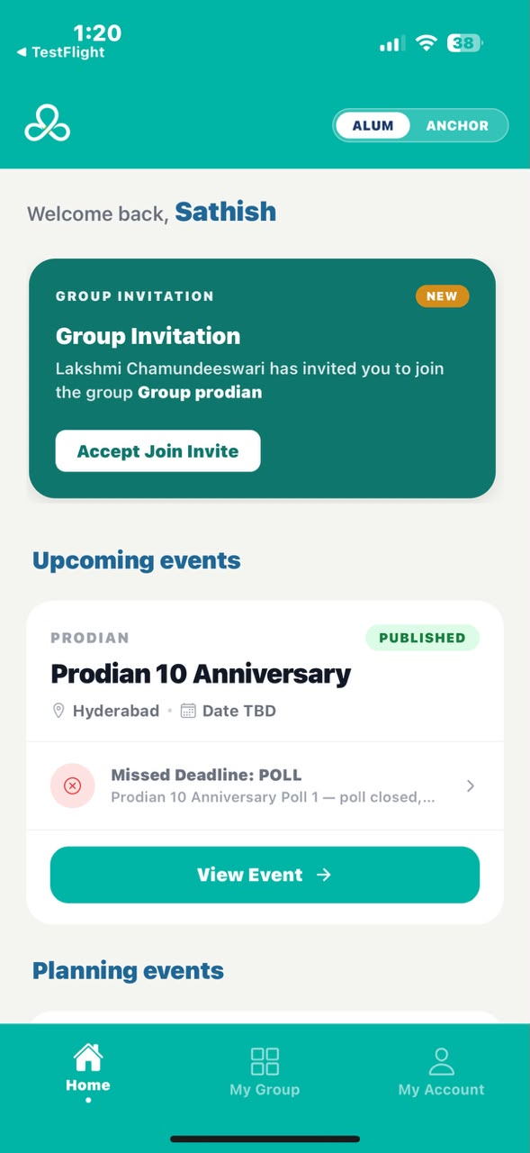 | 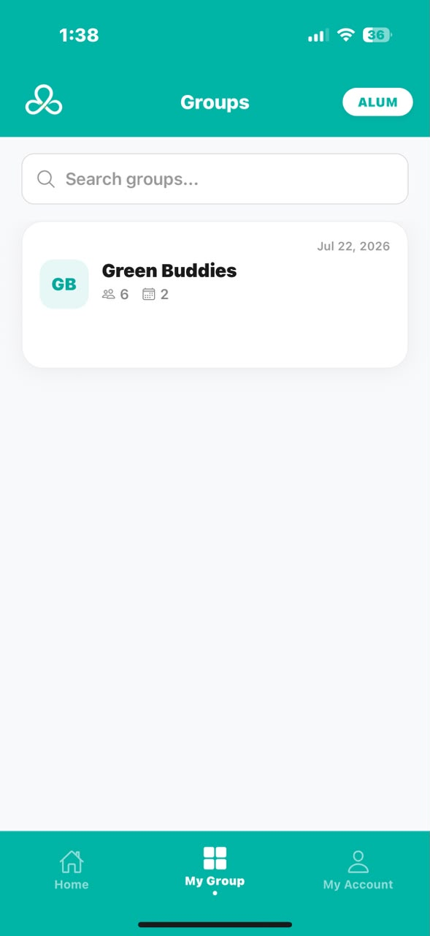 | 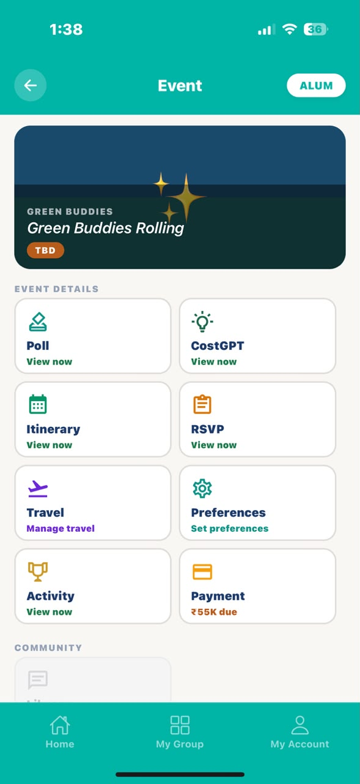

Purpose. Navigate from the app's normal Home/Group/Event structure into the golf tournament behind a group's event.
Screen elements & what each does:
Element | Behaviour / What it does
ALUM / ANCHOR toggle | Pill switch, top-right of Home; most golfers stay on ALUM (member view), organisers switch to ANCHOR to manage the group.
My Group (bottom bar) | Opens the list of groups the user belongs to; tapping a group opens its Events tab.
Golf event card | Tapping the group's golf event (e.g. ‘Green Buddies Trophy’) opens the Event screen.
Activity card | Gold trophy icon on the Event screen; Activity → View now opens the tournament (or a ‘not set up yet’ message if the Anchor hasn't configured it).

States:
- Not set up — Members see “No tournament yet” until the Anchor completes Tournament Setup (Section 18A.4).
- Anchor-only controls — Group screen additionally shows Edit, Add Member and + Add Event for the Anchor; a new golf event may show a DRAFT tag until published.

Screen-level workflow: Home → My Group → Group → Event → Activity card → Tournament Detail

18A.3 Tournament Detail (Tournament Home)
Role: Both Module: Golf — Tournament Home
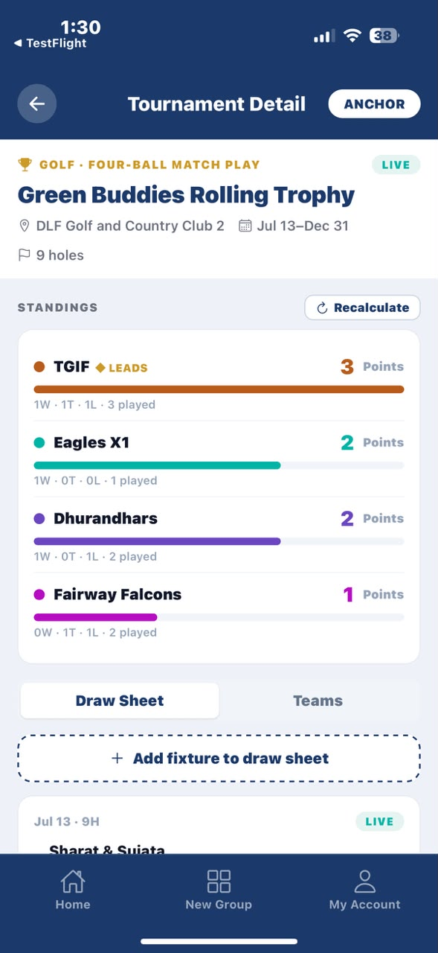 | 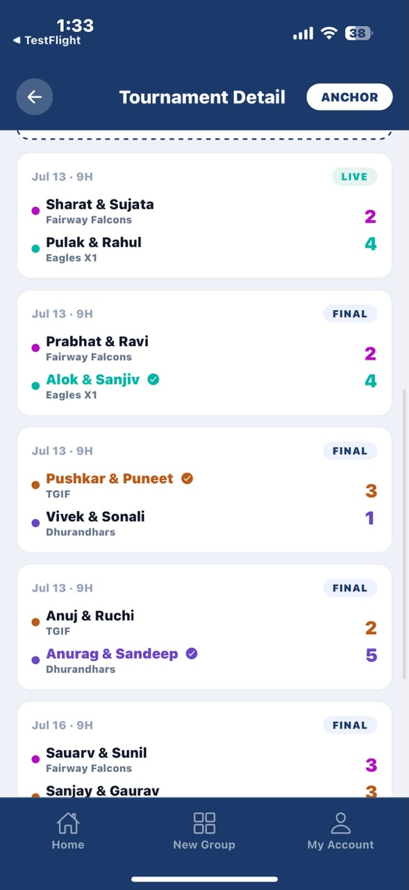

Purpose. Home base for a tournament: shows the live standings and lets the user switch between the Draw Sheet (all matches) and Teams.
Screen elements & what each does:
Element | Behaviour / What it does
Standings list | Team name, points, and a ‘W · T · L · played’ line; the running leaderboard, with the leader marked ◆ LEADS.
Points label | e.g. ‘3 Points’; customisable by the Anchor at setup (for example ‘Stocks’).
Draw Sheet / Teams tabs | Draw Sheet lists every match; Teams lists each player.
Match card | Date, ‘9H’, two pairings, a status pill (LIVE / FINAL); tap to open that match (Section 18A.8).
Recalculate (Anchor only) | Small button by ‘STANDINGS’; re-checks handicaps and scores and refreshes the standings.
Add fixture to draw sheet (Anchor only) | Dashed button; opens the ‘Draw a match’ screen (Section 18A.7).

States:
- Empty draw sheet — Players see “The anchor hasn't drawn the fixtures yet.”; the Anchor sees “Add fixtures above.”
- Captain banner — A Captain sees “You're captain of <team> — assign your players in each fixture.”

Screen-level workflow: Activity card → Tournament Detail → Draw Sheet / Teams → Match Detail

18A.4 Tournament Setup (Create the Tournament)
Role: Anchor Module: Golf — Setup
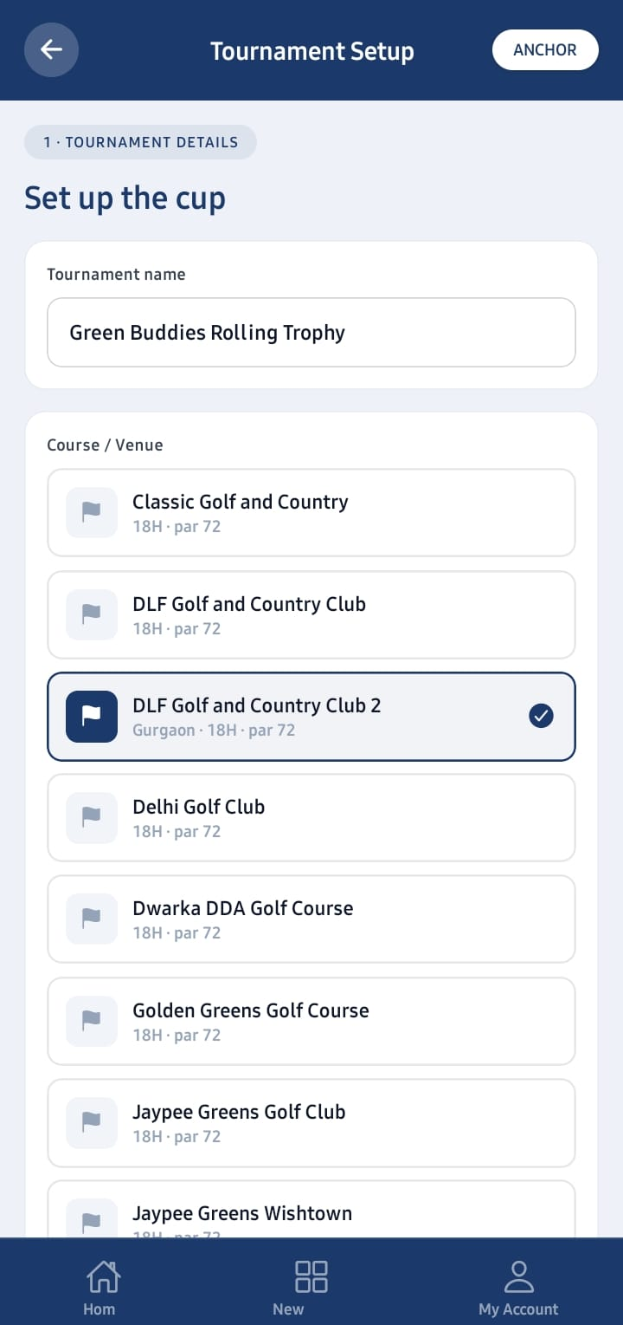

Purpose. Anchor-only screen (players never see it): name the tournament, pick where it's played, set dates and holes, and choose how scoring works.
Screen elements & what each does:
Element | Behaviour / What it does
Tournament name | Text box (e.g. ‘Founders Cup’); the tournament's title.
Course / Venue | List of courses shown as ‘<city> · 18H · par 72’; tap one to select it.
Course not listed? Add a new one | Teal link; opens the New Course form (Section 18A.5).
Dates | Start and End buttons; sets the tournament window.
Format | 9 Holes / 18 Holes — how many holes each match plays.
Scoring format | Net Stroke Play · Net Stableford · Four-Ball Match Play — the default game type (Section 18A.12).
Scoring & Point Rules | Standard Points / League Stocks / Custom — how leaderboard points are named and awarded.
Point / Leaderboard label | Text box (e.g. ‘Points’, ‘Stocks’); the word shown on the standings.
Win / Tie award | Number boxes; points for a win and for a tie.
Handicap allowance (%) | Number box, default 75; how much of each handicap counts (¾ = 75%).
Handicap stroke allocation | Absolute (Standard) / Relative to Lowest Handicapper — how strokes are shared out (Section 18A.12).
Next · Build teams → | Navy button; saves these choices and advances to Build Teams.

States:
- Validation — “Name the tournament” and “Select a course” block continuing until those fields are set.

Screen-level workflow: Tournament Detail (first-time) → Tournament Setup → Add a New Course (optional) → Build Teams

18A.5 Add a New Course
Role: Anchor Module: Golf — Setup
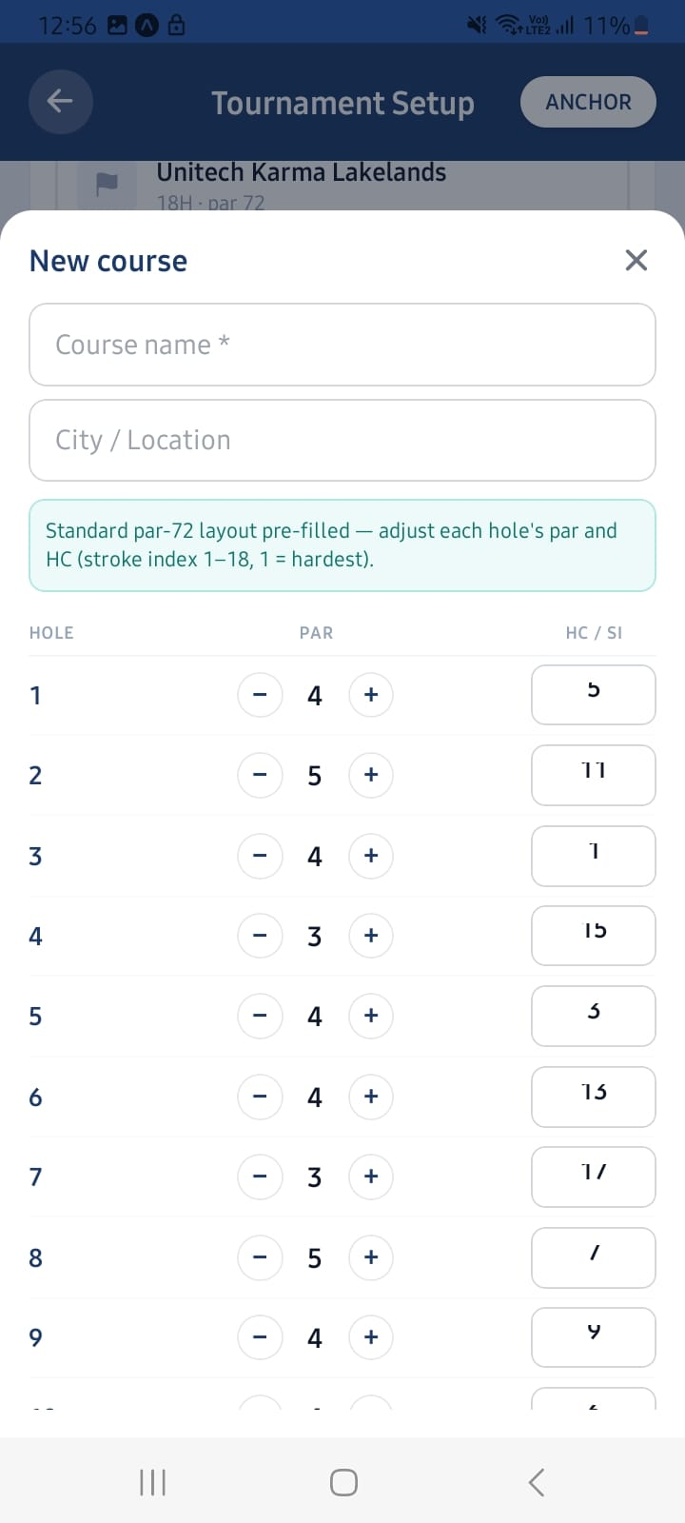

Purpose. Used when the tournament's course isn't already in the list; the course is created immediately, with no separate approval step.
Screen elements & what each does:
Element | Behaviour / What it does
Course name / City | Course name is required; City / Location is optional.
Hole-by-hole par grid | A standard par-72 layout is pre-filled; each hole's par can be adjusted with – / +.
Stroke index (HC/SI) | Each hole set to 1–18, using each number once (1 = hardest hole).
Save course | Creates the course and selects it automatically for the current tournament.

States:
- Validation — “Enter the course name” if blank; “Stroke indexes must be 1–18, each used once” if any HC/SI value is duplicated or out of range.

Screen-level workflow: Tournament Setup → Course not listed? Add a new one → Add a New Course → Tournament Setup (course selected)

18A.6 Build Teams
Role: Anchor Module: Golf — Setup
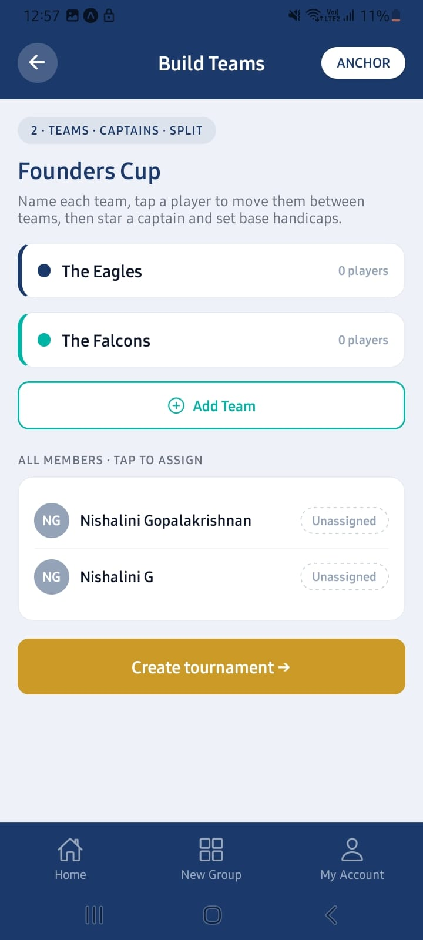

Purpose. Create teams, place members into them, choose one captain per team, and set each player's starting handicap. Players don't build teams themselves — they are placed into one by the Anchor.
Screen elements & what each does:
Element | Behaviour / What it does
Team name | Editable; each team needs a name.
Add Team | Adds another team (a tournament can have several).
ALL MEMBERS · TAP TO ASSIGN | Tap a member to move them into the selected team; tap again to move them on — a direct tap-to-assign interaction (this replaced the earlier drag-and-drop concept following usability feedback).
Captain star | Tap the star on one player per team to mark them captain.
HCP steppers | – / + steppers set each player's starting handicap.
Create tournament → | Finalises setup and creates the tournament.

States:
- Validation — “Every team needs a name”, “<team> has no players”, or “Pick a captain for <team>” block tournament creation until resolved.

Screen-level workflow: Tournament Setup → Build Teams → Create tournament → Tournament Detail

18A.7 Draw a Match (Add a Fixture)
Role: Anchor Module: Golf — Draw Sheet
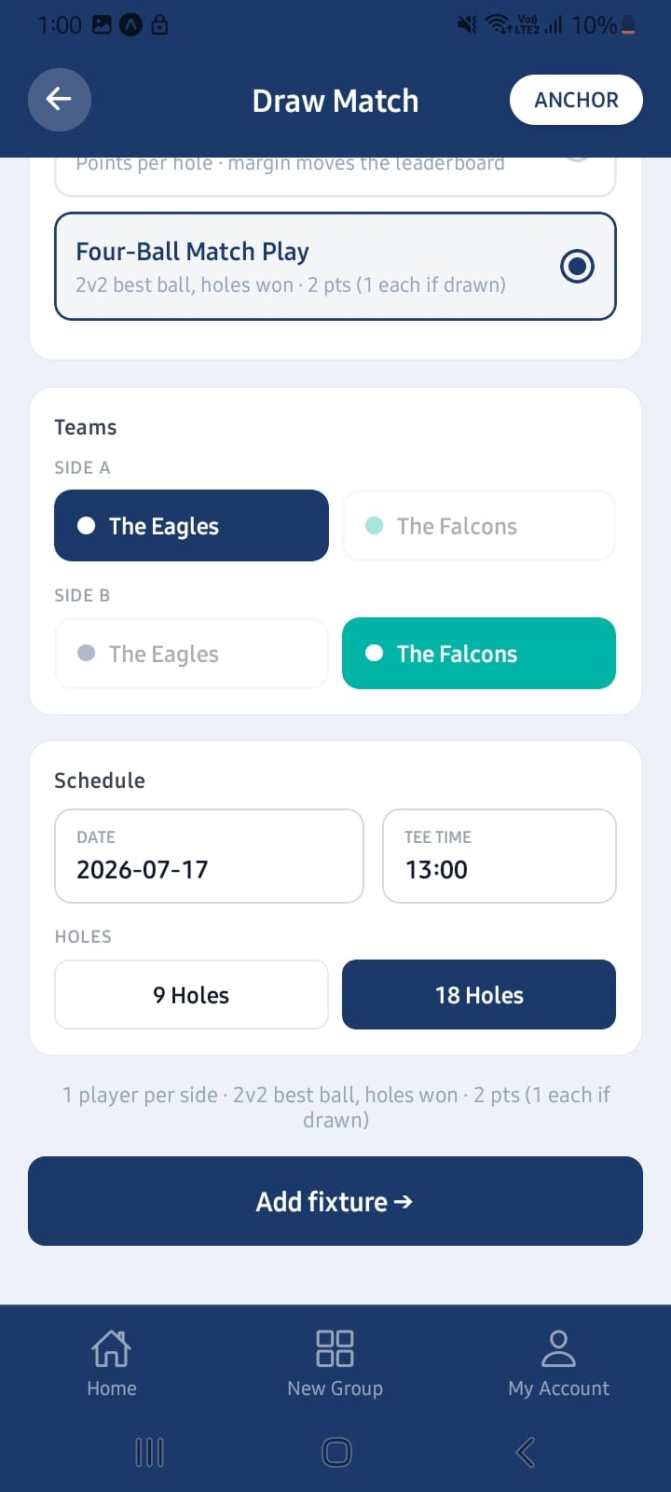

Purpose. Anchor schedules a fixture between two teams; captains choose the actual players afterwards (Section 18A.11, Common Task 4.1).
Screen elements & what each does:
Element | Behaviour / What it does
Match type | 1 v 1 (singles) or 2 v 2 (pairs / four-ball).
Scoring format | The scoring format for this specific match.
Side A / Side B | The two competing teams; they must differ.
Date / Tee time / Holes | Match date, optional tee time, and 9 or 18 holes; for 9 holes, the Front or Back nine loop is selected.
Add fixture → | Creates the match and adds it to the draw sheet.

States:
- Validation — “Pick two teams” or “Teams must differ” if the same team is chosen on both sides.

Screen-level workflow: Tournament Detail → Add fixture to draw sheet → Draw a Match → Tournament Detail (Draw Sheet updated)

18A.8 Match Detail
Role: Both Module: Golf — Match
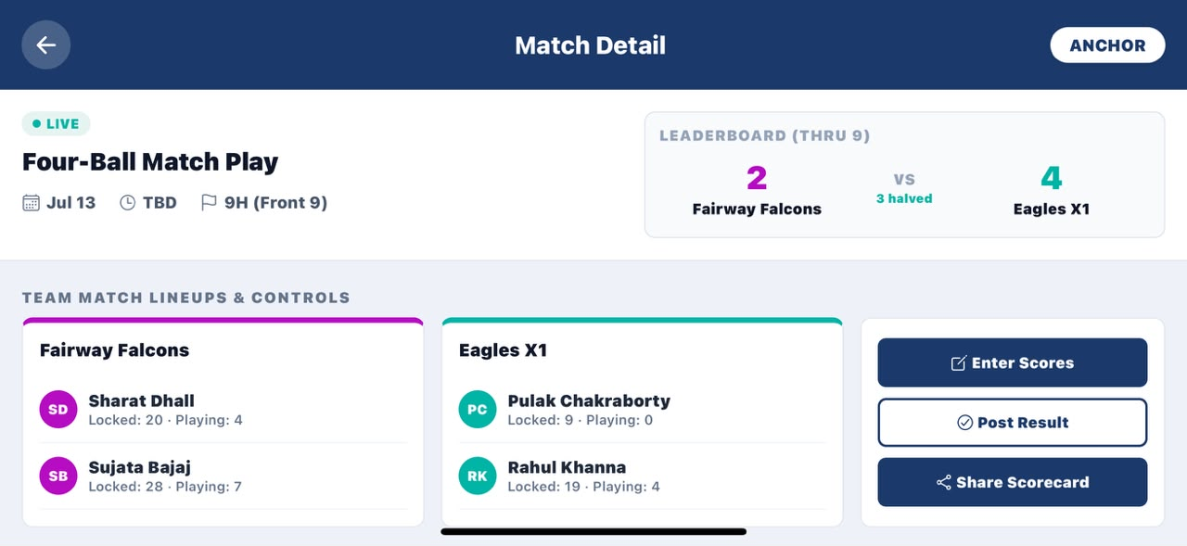

Purpose. Shows one match — who's playing, the live score, and the full scorecard. This is also where an authorised person enters scores and shares the card.
Screen elements & what each does:
Element | Behaviour / What it does
Leaderboard (Thru N) | Two team scores with ‘<n> halved’; the live match score after N holes.
Team lineups | Players shown with ‘Locked: X · Playing: Y’ — Locked is the set handicap, Playing is strokes actually used in this match.
Assign (Anchor / Captain) | Choose which players play, before the match starts.
Start Match (Anchor / a player in the match) | Locks handicaps and begins scoring.
Enter Scores (Anchor / a player in the match) | Opens the hole-by-hole Match Scoring screen (Section 18A.9).
Post Result (Anchor / a player in the match) | Finalises the match result — this action is final and updates the tournament standings.
Share Scorecard | Saves the scorecard as an image to share anywhere.

States:
- Spectator view — A Player who is neither the Anchor nor in the match can watch the live scorecard but does not see Enter Scores or Post Result.

Screen-level workflow: Draw Sheet → Match Detail → Start Match → Enter Scores → Post Result

18A.9 Match Scoring (Enter the Scores)
Role: Both Module: Golf — Scoring
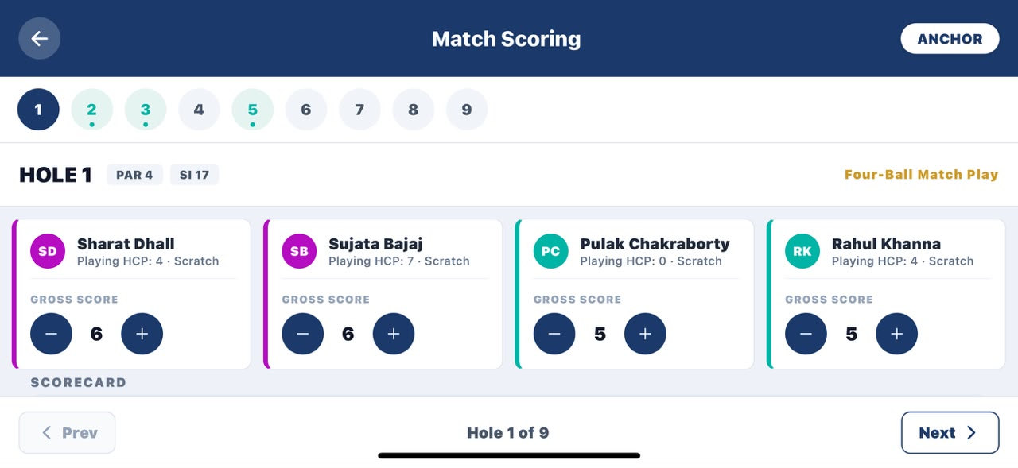 | 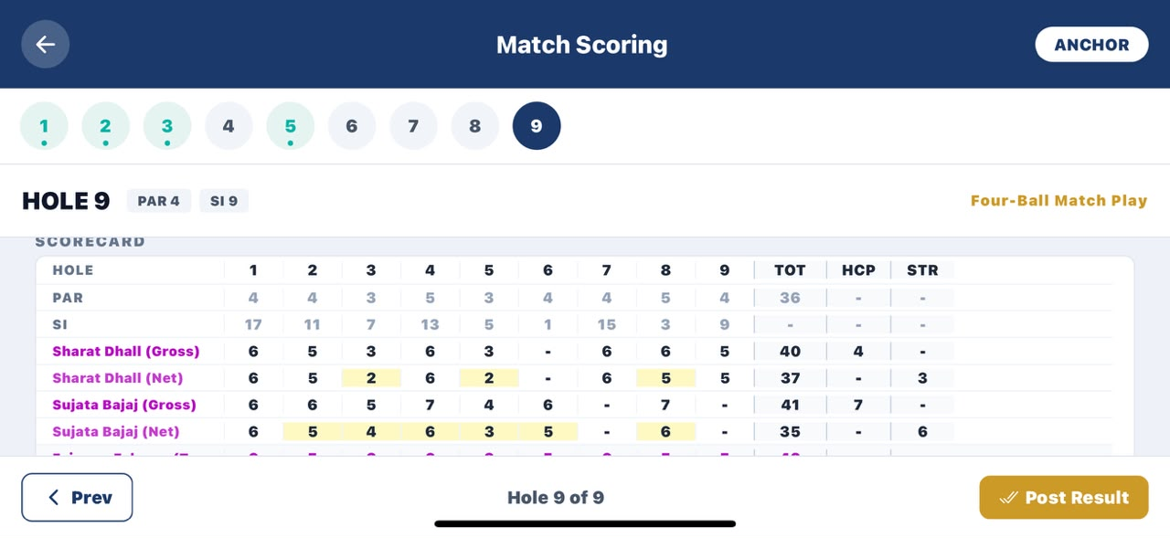

Purpose. One person records the group's scores hole by hole; the screen turns to landscape so all players fit.
Screen elements & what each does:
Element | Behaviour / What it does
Hole selector (1–9) | Round number buttons; tap a hole, or use Prev / Next at the bottom.
Player card | Name, ‘Playing HCP’, and ‘Scratch’ or ‘Recs N stroke’ — tells the scorer whether that player gets handicap strokes on this hole.
Gross Score – / + | Stepper on each card; sets the actual strokes that player took.
Pick Up | Toggle, Stableford only; marks a player as picked up (0 points for the hole).
Scorecard grid | Shows Gross, Net, team totals and the per-hole RESULT as scoring progresses.
Prev / Next | Footer buttons to move between holes; on the last hole, Next becomes Post Result.

States:
- Single scorer — One scorer — the Anchor or any player in the match — records every player's gross score, including their own; everyone else watches. Only the gross (actual) score is entered — the app calculates handicap strokes and the net score.
- Posting is final — Tapping Post Result finalises the match after a confirmation prompt; only post once every hole is entered and correct, since it updates the tournament standings.

Screen-level workflow: Match Detail → Enter Scores → Match Scoring (hole 1–N) → Post Result → Match Detail / Tournament Detail

18A.10 Tournament Results
Role: Both Module: Golf — Results
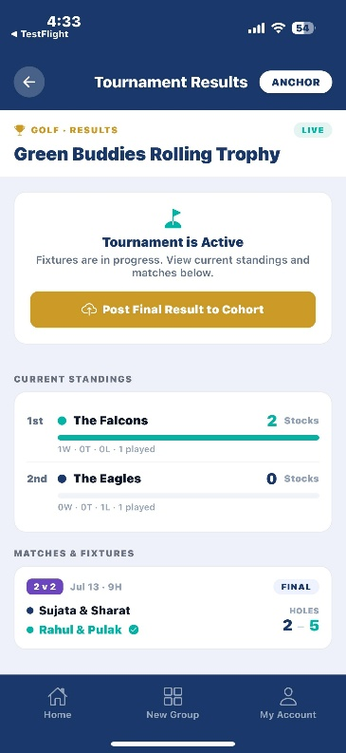

Purpose. Shows the overall standings and, once finished, the champion. While the tournament is running it reads “Tournament is Active.”
Screen elements & what each does:
Element | Behaviour / What it does
Current / Final standings | Ranked team list; the overall leaderboard across all matches.
Champion card | Gold card with the winning team, shown once the final result is posted.
All Square! card | Shown instead of a champion if the top teams are level.
Post Final Result to Cohort (Anchor only) | Gold button; ends the tournament and notifies every member — this action is final and requires confirmation.

States:
- Before posting — “Post Final Result to Cohort” closes the tournament and notifies every member after a “Post Final Results?” confirmation; all matches should be finished first.

Screen-level workflow: Tournament Detail → (all matches FINAL) → Tournament Results → Post Final Result to Cohort

18A.11 Common Tasks (Quick How-Tos)
Short walkthroughs for the things people actually do, each naming exactly which screens to tap:
- Captain: set your team's lineup for a match — Event → Activity → View now; on Tournament Detail select Draw Sheet, tap your match, then Assign on your team's card and choose your players (a 2 v 2 match needs exactly two).
- Enter your group's scores after a round — Open the match from the Draw Sheet; Start Match if not started; Enter Scores; set each player's gross score per hole with Next; on the last hole, Post Result and confirm.
- Check the draw sheet / find your next match — Tournament Detail → Draw Sheet tab; a green LIVE pill means in progress, FINAL means done; tap the match to see lineups and live score.
- Your course isn't listed — On Tournament Setup, tap Course not listed? Add a new one; enter the course name (and city), adjust par and stroke index per hole; Save course adds and selects it immediately.
- Share a scorecard — Match Detail → Share Scorecard → pick where to share (messaging, email, save to photos, etc.).
- Recalculate the standings — Use after changing point rules or handicaps once matches were already scored; Tournament Detail → Recalculate next to STANDINGS.

18A.12 Scoring Formats & Handicap
Three scoring formats are supported at setup: Net Stroke Play (lowest total net score wins; in pairs, each hole counts the better player's net; standard points 1 / ½ / 0), Net Stableford (points per hole — net eagle 4, birdie 3, par 2, bogey 1, worse 0; the margin between sides moves the leaderboard), and Four-Ball Match Play (pairs only; the better net score wins each hole and whoever wins more holes wins the match; standard points 2 / 1 / 0). Under League Stocks or Custom, the Anchor replaces the standard points with its own Win / Tie / Loss values and can rename the leaderboard label.
A handicap lets players of different ability compete fairly. Two allocation policies are available: Absolute (each player uses their own handicap) and Relative to Lowest Handicapper (the best player plays off scratch and others get the difference); nine-hole matches use half the handicap. On the scoring screen each player shows ‘Scratch’ (no stroke on this hole) or ‘Recs N stroke’ (gets N strokes); the scorer always enters the gross score and the app calculates the net.
Open items. Dynamic handicap recalculation logic and the legacy profile handicap basis remain pending Indeevar's confirmation before those specific behaviours are built out further (tracked against the Golf Scoring Methodology document); the allowance % and stroke-allocation policy above are the confirmed Phase 1 mechanics.

18A.13 Phased Delivery Plan
Phase | Scope | Status
New Add-On / Concept | Standalone module framing, three functional pillars, positioning vs. existing apps | Confirmed 30-Jun-26
Phase 1 (Delivered) | Group/team setup (Build Teams, tap-to-assign, captain star, HCP steppers), draw sheet, Tournament Setup, Add a New Course, Match Detail, Match Scoring (gross-score capture), Tournament Results, 44-member pilot (Green Buddies) | Built and captured in Golf User Manual v3.0 (23-Jul-26)
Phase 2 | Dynamic handicap recalculation and legacy profile handicap basis (pending Indeevar's confirmation), live/real-time scoring visibility for spectators, player-authorised score entry with review, match-reminder push notifications, OCR evaluation for paper scorecards | Planned, post-Phase-1
Later | Multi-sport adaptation (tennis, pickleball), official club-handicap API integration, voice-assisted score entry | Deferred / dependency-driven

18A.14 Golf-Specific Risks & Dependencies
- Testing rigour — A hyper-critical testing methodology is required to avoid UI issues, particularly around the landscape Match Scoring screen and the tap-to-assign team builder.
- Shared DLT/SMS dependency — The golf module rides on the same Karix SMS and DLT-registration path as the core Alumnye platform (Section 18.1, risk R6); match-reminder notifications (Phase 2) are exposed to the same blocker; OTP/DLT whitelisting failures were encountered during the 44-member pilot with a temporary bypass in place.
- Open handicap items — Dynamic handicap recalculation logic and legacy profile handicap basis remain pending Indeevar's confirmation before those Phase 2 items are built (Section 18A.12).
- Scope discipline — Golf remains explicitly out of the Delta/Alpha alumni-event scope so the alumni-event roadmap is not impacted by golf-module build-out.

19. Document Control & Maintenance
This is a living document. After each release, update the affected screen cards, refresh the module maturity table (Section 3), paste current screenshots into the placeholders, and bump the version below.
Version | Date | Summary
v1.1 | 30 Jun 2026 | Initial end-to-end mobile walkthrough (Anchor + Member) for the Delta release.
v1.2 | 08 Jul 2026 | Integrated 30-Jun, 01-Jul and 08-Jul MoMs. NEW: Golf Tournament Scoring & Management standalone add-on (Section 18A) — group/team structure, draw sheet, scorecard, gross/net scoring, phased Phase 1/Phase 2/Later plan. UPDATED: Anchor Home (branding + welcome message), Notice Board/Create Notice (image attachments), Profile Layer AI Wizard (Alum AI profile creation enabled), Verify Mobile/OTP (new mailer), release process (client-isolated TestFlight build, build-freeze during client testing). Risks/blockers refreshed: new R6 (Karix DLT/SMS responsiveness, Plan B provider), negative-flow validation issues open. See Section 1.3 for the full change summary.
v1.3 | 24 Jul 2026 | Section 18A rewritten screen-by-screen against the Alumnye Golf Tournament Scoring & Management User Manual v3.0 (23-Jul-26): access path (Home/Group/Event/Activity), Tournament Detail, Tournament Setup, Add a New Course, Build Teams (tap-to-assign), Draw a Match, Match Detail, Match Scoring, Tournament Results, Common Tasks, and Scoring Formats & Handicap, each with screenshots, element tables and workflows. Phased Delivery Plan updated to reflect Phase 1 as delivered (44-member Green Buddies pilot); open items on dynamic handicap recalculation and legacy profile handicap basis carried forward pending Indeevar's confirmation.

Maintenance checklist (for this document):
(1) capture screenshots for every screen
(2) confirm element behaviour against the live build with QA
(3) update workflow lines if navigation changed
(4) reconcile business rules with the latest product decisions
(5) re-circulate to client, development and test team

