ALUMNYE
Green Buddies Trophys
Quick Start Guide
Prepared by / Audience | Indeevar Krishna (Anchor) / First-time users testing the Alumnye app
Version | 1.2 · 12 August 2026
STEP 1 · Sign in your account and verify your mobile number
Since you are a first time user, create your account using your mobile number, wherein you will get an OTP to be verified.
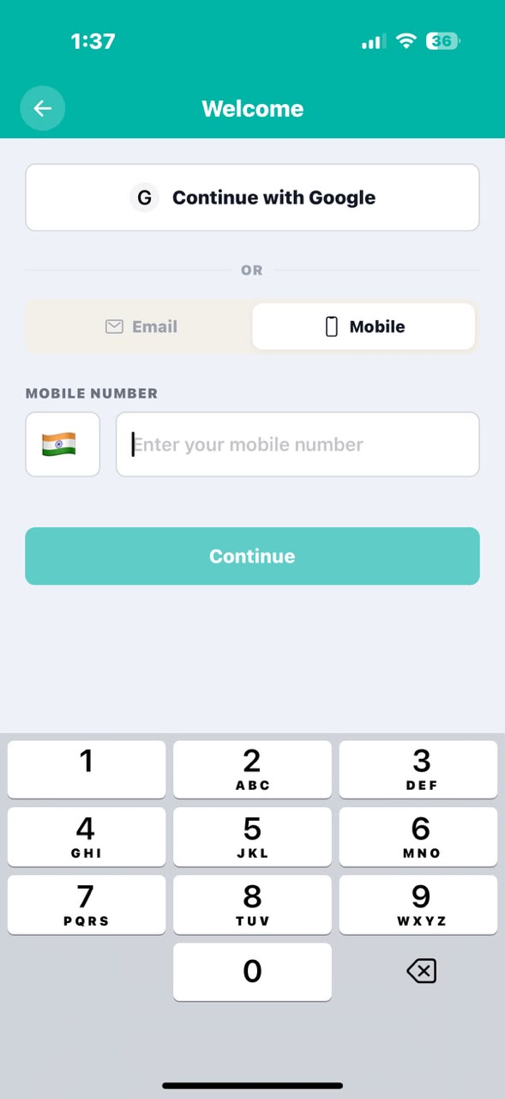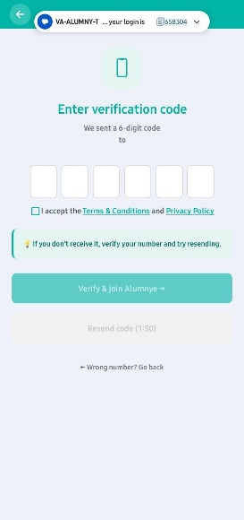

Figure — Mobile number entry and OTP verification
STEP 2 · Join the Green Buddies Trophy
I have already created the Green Buddies Trophy as the anchor. Since you have already been added to the Green Buddies Trophy, you don’t need to accept a separate invite — simply tap directly on the ‘Event’ – ‘Green Buddies Trophy’
Note: Alternatively, you can also click on ‘My Group’ from your home screen to view your group and navigate to Event
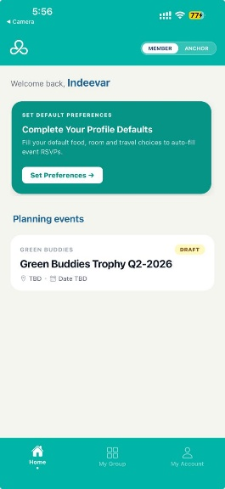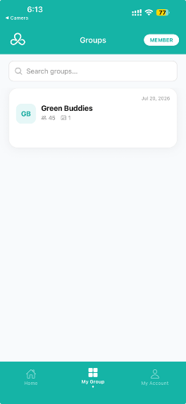
Figure — Home screen showing your group

STEP 3 · Open the tournament
You will land on the page wherein you can click on the tournament titled “Green Buddies Trophy” and enter your tournament world by clicking on “Activity” tile
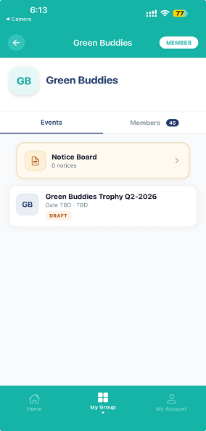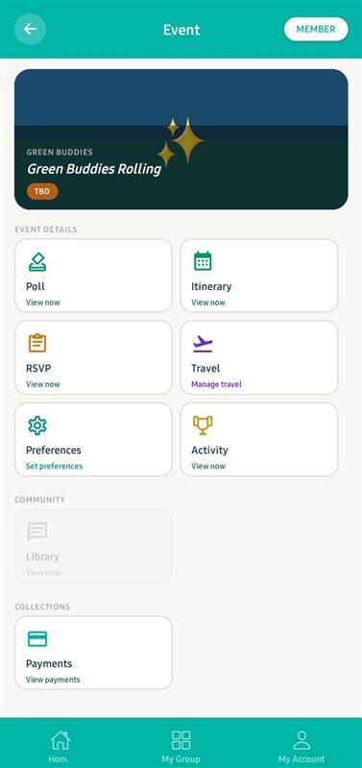

Figure — Group screen with the tournament card
STEP 4 · Tournament Details
This is the home base for a tournament. It shows the live standings (who's leading), and lets you switch between the Draw Sheet (all matches) and the Teams.
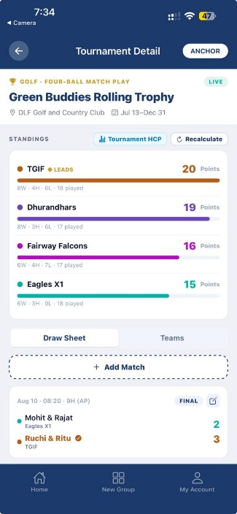

Figure — Tournament Details screen

