**create a document for chatbot using python**

| **720921104099** | **Sridhar S** | **Team Leader** |
| --- | --- | --- |
| **720921104116** | **Vigneshwaran A** | **Team Member** |
| **720921104112** | **Thirumoorthi S** | **Team Member** |
| **720921104091** | **Sathish kumar S** | **Team Member** |
| **720921104076** | **Praveen kumar B** | **Team Member** |

**Introduction:**

In today's digital age, communication between humans and machines has evolved significantly. Chatbots, powered by artificial intelligence and natural language processing, have emerged as a transformative technology in this domain. These intelligent and conversational agents are designed to interact with users, understand their queries, and provide relevant responses or perform tasks, all in a conversational manner. One of the most popular programming languages for building chatbots is Python.

**Problem Definition:**

The challenge is to create a chatbot in Python that provides exceptional customer service, answering user queries on a website or application. The objective is to deliver high-quality support to users, ensuring a positive user experience and customer satisfaction.

**Abstract:**

A chatbot enables a user to simply ask questions in the same manner that they would respond to humans. The most well-known chatbots currently are voices chatbots: SIRI and Alexa. However, chatbots have been adopted and brought into the daily application at a high rate on the computer chat platform. NLP also allows computers and algorithms to understand human interactions through various languages. Recent advances in machine learning have greatly improved the accurate and effective of natural language processing, making chatbots a viable option for many organizations

**Design Thinking:**

**1.Functionality:**

They can automate routine tasks, freeing up time for your human workforce to handle more complex tasks. Data Collection: AI chatbots can collect valuable data from customer interactions, providing insights into customer behavior and needs.

**2.User Interface:**

A *chatbot user interface* (UI) is part of a chatbot that users see and interact with. This can include anything from the text on a screen to the buttons and menus that are used to control a chatbot. The chatbot UI is what allows users to send messages and tell it what they want it to do.

**3. Natural Language Processing (NLP):**

Natural Language Processing (NLP) is a subfield of artificial intelligence (AI). It helps machines process and understand the human language so that they can automatically perform repetitive tasks. Examples include machine translation, summarization, ticket classification, and spell check.

**4.Responses:**

Chatbot responses are messages that a chatbot sends to the user. Chatbots can be powered by pre-programmed responses or artificial intelligence and natural language processing. Based on the applied mechanism, they process human language to understand user queries and deliver matching answers.

**5.Chatbot integration:**

[Chatbots can be integrated with various communication channels such as websites, social media platforms, messaging apps, and voice assistants](https://www.livechat.com/chatbot/)

* [Chatbot integration can be achieved through APIs, webhooks, and third-party services such as Zapier](https://www.livechat.com/marketplace/apps/chatbot/)
* [Chatbots can be integrated with customer relationship management (CRM) systems, marketing automation tools, and other business software to streamline workflows and improve customer service](https://www.chatbot.com/integrations/)
* [Chatbot integration can help businesses automate repetitive tasks, improve customer engagement, and reduce response time](https://www.livechat.com/chatbot/) .

**6.Testing and Improvement:**

Chatbot testing is an essential process that ensures the chatbot’s functionality, reliability, and performance. [Chatbot testing can be done using various techniques such as Natural Language Processing (NLP) testing, End-to-End (E2E) testing, Voice testing, Performance testing, Security testing, and Monitoring](https://bing.com/search?q=chatbot+testing+and+improvement) . [Chatbot testing frameworks can be categorized into three main divisions: Expected Scenarios, Possible Scenarios, and Almost Impossible Scenarios.](https://bing.com/search?q=chatbot+testing+and+improvement)

[When it comes to chatbot improvement, it’s essential to track the chatbot’s performance over time and set up viable goals for the chatbot](https://bing.com/search?q=chatbot+testing+and+improvement) . Chatbots can be improved by analyzing user feedback and interactions and updating the chatbot’s knowledge base accordingly.

**Development:**

**Prerequisites**

Before you begin, ensure you have the following:

* Python (3.x) installed on your system.
* Flask library installed.
* A provided dataset of chat messages.
* Basic knowledge of Python programming.
* Terminal or Command Prompt.

**Implementation**

**Create Project Directory:**

Start by creating a project directory for your application.

**Create Python Script:**

Create a Python script for the chat application. You can use your favorite code editor to create a file, e.g., chat_app.py.

**Import Libraries:**

Import the necessary libraries at the beginning of your Python script.

from flask import Flask, render_template, request

**Set Up Flask App:**

Initialize a Flask web application.

app = Flask(__name__)

**Load the Dataset:**

Load the provided dataset into your Python script, similar to the previous example.

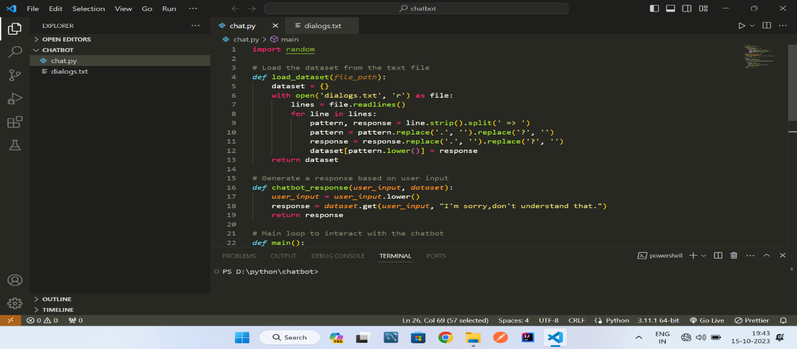

**Create a Route for Chat Interface:**

Define a route in your Flask app to render a web page for the chat interface

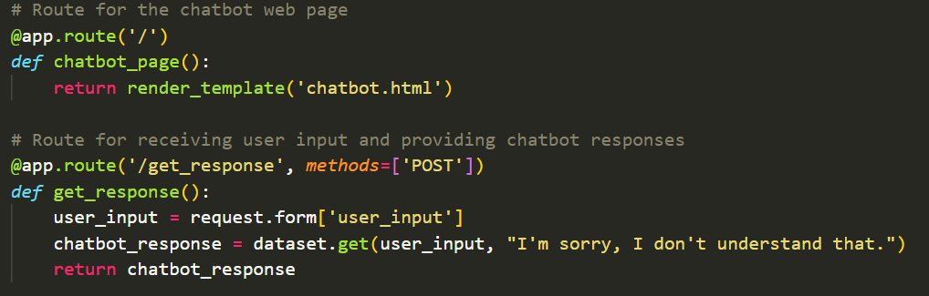

**Create a Chat HTML Template:**

Create an HTML template for the chat interface. You can use the Jinja2 template engine to render chat messages on the web page.

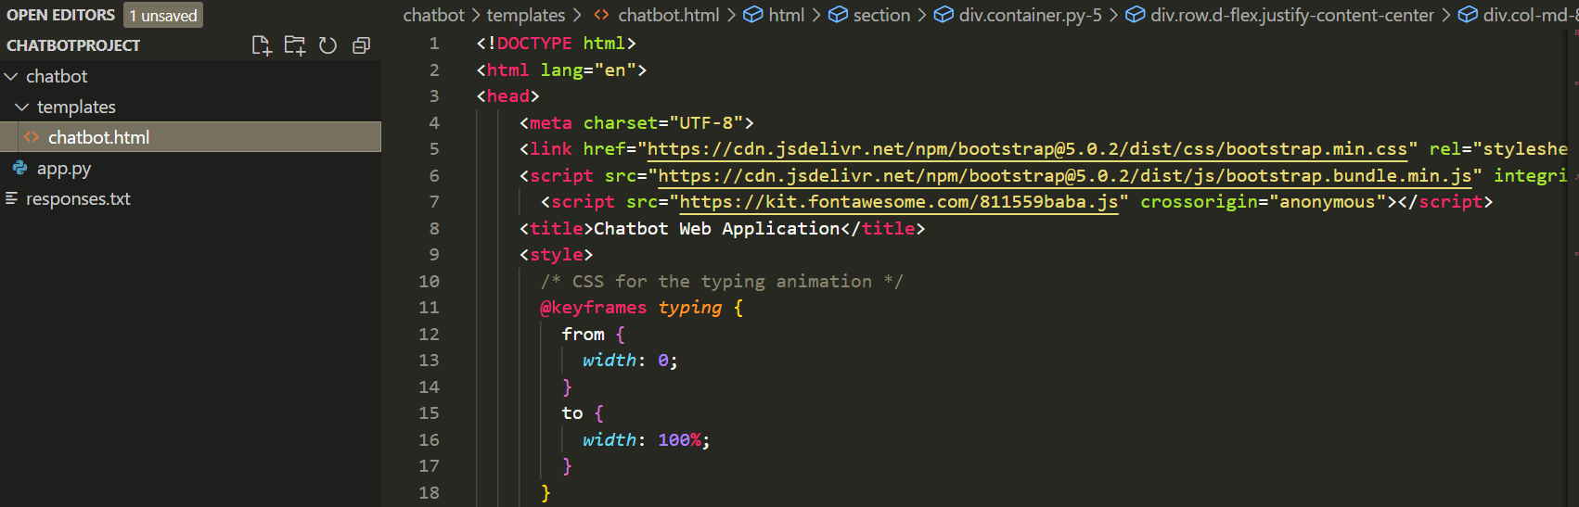

**Run the Flask App:**

Run your Flask application.

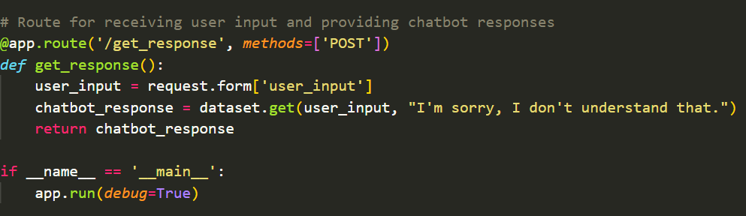

**Testing:**

Open a web browser and navigate to **http://127.0.0.1:5000/** to access the chat interface. You should see the chat messages from the provided dataset displayed on the web page.

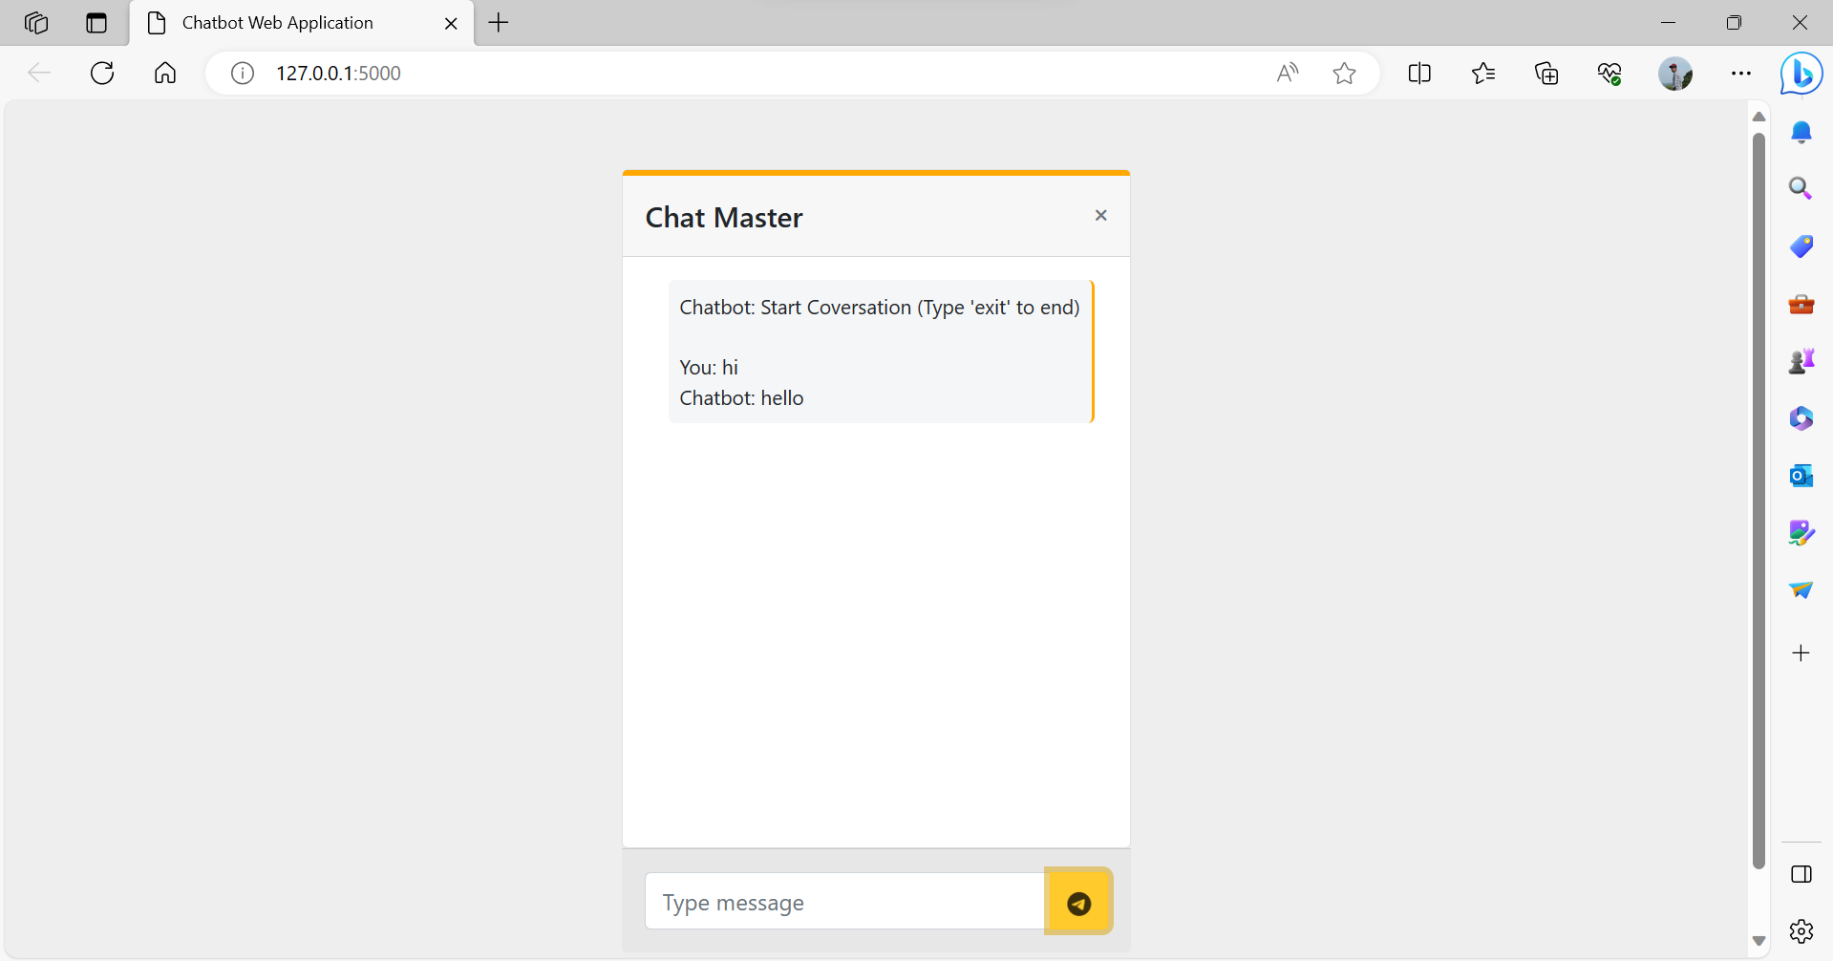

**Improvements:**

You can extend this application by allowing user input, interactive chat features, and real-time updates.

**Sample code:**

**App.py**

fromflaskimportFlask, render_template, request

app =Flask(__name__)

# Load responses from the text file

*def*load_responses():

    dataset = {}

    withopen('responses.txt', 'r') as file:

        lines =file.readlines()

        for line in lines:

            pattern, response =line.strip().split(' => ')

            pattern =pattern.replace('.', '').replace('?', '')

            response =response.replace('.', '').replace('?', '')

            dataset[pattern.lower()] = response

    return dataset

dataset =load_responses()

# Route for the chatbot web page

@app.route('/')

*def*chatbot_page():

    returnrender_template('chatbot.html')

# Route for receiving user input and providing chatbot responses

@app.route('/get_response', *methods*=['POST'])

*def*get_response():

    user_input=request.form['user_input']

    chatbot_response=dataset.get(user_input, "I'm sorry, I don't understand that.")

    returnchatbot_response

if __name__ =='__main__':

    app.run(*debug*=True)

**Chatbot Html File**

<!DOCTYPEhtml>

<htmllang="en">

<head>

    <metacharset="UTF-8">

    <linkhref="https://cdn.jsdelivr.net/npm/bootstrap@5.0.2/dist/css/bootstrap.min.css"rel="stylesheet"integrity="sha384-EVSTQN3/azprG1Anm3QDgpJLIm9Nao0Yz1ztcQTwFspd3yD65VohhpuuCOmLASjC"crossorigin="anonymous">

    <scriptsrc="https://cdn.jsdelivr.net/npm/bootstrap@5.0.2/dist/js/bootstrap.bundle.min.js"integrity="sha384-MrcW6ZMFYlzcLA8Nl+NtUVF0sA7MsXsP1UyJoMp4YLEuNSfAP+JcXn/tWtIaxVXM"crossorigin="anonymous"></script>

      <scriptsrc="https://kit.fontawesome.com/811559baba.js"crossorigin="anonymous"></script>

    <title>Chatbot Web Application</title>

    <style>

      /* CSS for the typing animation */

      @keyframes*typing* {

        from {

*width*: 0;

        }

        to {

*width*: 100%;

        }

      }

      .typing-animation {

*display*: inline-block;

*overflow*: hidden;

*white-space*: nowrap;

*border-right*: 2pxsolid#ffa900; /* Blinking cursor */

*padding-right*: 3px; /* Spacing for cursor */

*animation*: typing 3ssteps(30, end);

      }

    </style>

</head>

<sectionstyle="background-color: #eee; height: 600px;">

    <divclass="container py-5">

      <divclass="row d-flex justify-content-center">

        <divclass="col-md-8 col-lg-6 col-xl-4">

          <divclass="card">

            <divclass="card-header d-flex justify-content-between align-items-center p-3"

              style="border-top: 4px solid #ffa900;">

              <h5class="mb-0">Chat Master</h5>

              <divclass="d-flex flex-row align-items-center">

                <iclass="fas fa-times text-muted fa-xs"></i>

              </div>

            </div>

            <divclass="card-body"data-mdb-perfect-scrollbar="true"style="position: relative; height: auto">

              <divclass="d-flex justify-content-between">

                <pclass="typing-animation small p-2 ms-3 mb-3 rounded-3 "style="background-color: #f5f6f7;"id="chat-output">

                  Chatbot: Start Coversation (Type 'exit' to end)

                  <br>

                  <br>

                </p>

              </div>

              <br>

              <br>  <br>

              <br>  <br>

              <br>  <br>

              <br>  <br>

              <br>  <br>

                </div>

              </div>

            <divclass="card-footer text-muted d-flex justify-content-start align-items-center p-3">

              <divclass="input-group mb-0">

                <inputtype="text"class="form-control"id="user-input"placeholder="Type message"

                  aria-label="Recipient's username"aria-describedby="button-addon2" />

                <buttonclass="btnbtn-warning"type="submit"  id="send-button"style="padding-top: .55rem;">

                    <iclass="fa-brands fa-telegram fa-beat-fade"value="PLAY"onclick="play()"></i>

                    <audioid="audio"src="https://s27.aconvert.com/convert/p3r68-cdx67/c4lpg-az7kc.mp3"></audio>

                  </button>

              </div>

            </div>

          </div>

        </div>

      </div>

    </div>

  </section>

  <body>

<script>

*const*chatOutput=document.getElementById('chat-output');

*const*userInput=document.getElementById('user-input');

*const*sendButton=document.getElementById('send-button');

        sendButton.addEventListener('click', *function* () {

*function*play() {

*var* audio =document.getElementById("audio");

                        audio.play();

                      }

*const* message =userInput.value;

            if(message =='exit')

            {

              window.location.reload("Refresh")

              alert('Your Coversation ends')

            }

*var* audio =new*Audio*('sound.mp3');

            audio.play();

            if (message.trim() !=='') {

                appendMessage('You: '+ message);

                userInput.value='';

                // Send user input to the server and get chatbot response

                fetch('/get_response', {

                    method: 'POST',

                    body: new*URLSearchParams*({ 'user_input': message }),

                })

                .then(*response=>response*.text())

                .then(*data=>* {

                    appendMessage('Chatbot: '+*data*);

                });

            }

        });

*function*appendMessage(*message*) {

*const*messageElement=document.createElement('div');

            messageElement.textContent=*message*;

            chatOutput.appendChild(messageElement);

        }

    </script>

</body>

</html>

**Conclusion**

This document provides aPython-powered chatbots are a vital force in modern communication, offering efficiency and enhanced user experiences. The versatility of Python, coupled with its rich libraries, makes it a prime choice for chatbot development. By harnessing the power of datasets, natural language processing, and thoughtful design, you can craft chatbots that understand and engage users effectively.

These intelligent agents have found applications across diverse industries, from customer support to e-commerce, delivering round-the-clock assistance. The chatbot landscape is dynamic and holds vast potential for innovation. By embracing Python for chatbot development, you can be a part of the transformative future of human-machine interactions, simplifying tasks and enriching user interactions.