

**Fake News Detection Using**

**Data Science and Machine Learning**

**A PROJECT REPORT**

*Submitted by*

**AKASH N (Reg.No:911519205003)**

**VIGNESHWARAN P (Reg.No:911519205027)**

***in partial fulfillment for the award of the degree***

*of*

**BACHELOR OF TECHNOLOGY**

IN

INFORMATION TECHNOLOGY

**MOHAMED SATHAK ENGINEERING COLLEGE**

**KILAKARAI- 623 806**

**ANNA UNIVERSITY :: CHENNAI 600 025**

**MAY 2023**

**ANNA UNIVERSITY:CHENNAI 600 025**

**BONAFIDE CERTIFICATE**

Certified that this project report **“Fake News Detection Using Data Science and Machine Learning****”** is the bonafide work of **“ N. AKASH (911517205003) P. VIGNESHWARAN (911519205027) ”** Who carried out the project work under my supervision.

|  |  |
| --- | --- |
| **SIGNATURE** | **SIGNATURE** |
| **Dr.B. AYSHA BANU M.E., Ph.D.,** | **Mrs. A. RUBA M.E., MISTE.,** |
| **HEAD OF THE DEPARTMENT** | **SUPERVISIOR** |
| Department of Information Technology | Department of Information Technology, |
| Mohamed Sathak Engineering College, | Mohamed Sathak Engineering College, |
| Kilakarai - 623806 | Kilakarai - 623 806 |

Submitted for the University project viva-voce held on …………………

**Internal Examiner External Examiner**

**ACKNOWLEDGEMENT**

We thank God Almighty for giving us an opportunity to study in this prestigious institution Mohamed Sathak Engineering College which provided us tremendous facilities and support.

We are highly indebted to **Our Chairman Alhaj S.M.Mohamed Yousuf,** Mohamed Sathak Trust Chennai, whose complete inspiration and motivation helped us throughout the course of this project.

We undergo much tribute to express my sincere gratefulness to **Principal Dr.R.Senthilkumar M.E.,Ph.D..,**Mohamed Sathak Engineering College, Kilakarai, for making the resources available at right time and providing valuable insights leading to the successful completion of this project.

We take this opportunity to express our profound gratitude and deep regards to **Our Head of the Department Dr.M.AYSA BANU**

**M.E.,Ph.D.,MISTE.** Department of Information Technology for his exemplary guidance, monitoring and constant encouragement throughout the course of this project.

We also extend our gratitude to **the Project Coordinator Mrs.A. RUBA M.E.,MISTE.**,Department of Information Technology for her critical advice and guidance without which this project would not have been possible.

We are sincerely Grateful to **our Project Supervisor Mrs.S.Karthiyayini ME.,MIE.,** Department of Information Technology for sharing is truthful and illuminating views on a number of issues related to this project.

We also thank all other Faculty members and Supporting Staff of Department of Information Technology for their support and encouragement.

We wish to express a sense of gratitude to our friends and our beloved

parents for their manual support, strength and help and for everything.

We take this opportunity to express our gratitude to the people who have

been instrumental in the successful completion of this project.

**ABSTRACT**

Machine Learning (ML) is one of the fast-emerging technologies with increased benefits. Fake news and hoaxes have been there since before the advent of the Internet. The widely accepted definition of Internet fake news is: fictitious articles deliberately fabricated to deceive readers”. Social media and news outlets publish fake news to increase readership or as part of psychological warfare. In general, the goal is profiting through click baits. Click baits lure users and entice curiosity with flashy headlines or designs to click links to increase advertisements revenues. This exposition analysis the prevalence of fake news in light of the advances in communication made possible by the emergence of social networking sites. The purpose of the work is to come up with a solution that can be utilized by users to detect and filter out sites containing false and misleading information. We use simple and carefully selected features of the title and post to accurately identify fake posts. The experimental results show a 99.4% accuracy using logistic classifier

**TABLE OF CONTENT**

**CHAPTER NO. TITLE PAGE NO.**

**BONAFIDE CERTIFICATE i**

**ACKNOWLEDGEMENT ii**

**ABSTRACT iii**

### **LIST OF FIGURES vi**

**LIST OF ABBREVIATIONS vii**

1. **INTRODUCTION 1** 
   1. About the Project 1
2. **SYSTEM ANALYSIS 4** 
   1. Existing System 4
      1. Disadvantages 4
   2. Proposed System 4
      1. Advantages 5
3. **LITERATURE REVIEW 6**
4. **SYSTEM REQUIREMENTS 15** 
   1. Hardware Requirements 15
   2. Software Requirements 15
5. **SOFTWARE ENVIRONMENT 16** 
   1. Java 16
   2. The major Characteristics of JAVA 17
   3. CloudSim 26
6. **SYSTEM DESIGN 29** 
   1. System Architecture 29
   2. Dataflow Diagram 30
   3. ER Diagram 31
   4. Unified Modeling Language Diagram 32
      1. Use Case Diagram 33
      2. Class Diagram 34
      3. Sequence Diagram 35
7. **SCREENSHOTS 43**
8. **CONCLUSION 46** 
   1. **CONCLUSION 46**
   2. **FUTURE ENHANCEMENT 46**

**REFERENCES 47**

**LIST OF FIGURES**

**FIGURE NO FIGURE NAME PAGE NO**

* 1. **SECURITY REQUIREMENT 2**
  2. **CHALLENGES IN IoT SECURITY 3**
  3. **SYSTEM ARCHITECTURE 29**
  4. **DATA FLOW DIAGRAM 30**
  5. **E R DIAGRAM 31** 
     1. **USECASE DIAGRAM 33**
     2. **CLASS DIAGRAM 34**
     3. **SEQUENTIAL DIAGRAM 35**
     4. **COLLABRATIVE DIAGRAM 36**
     5. **ACTIVITY DIAGRAM 37**

**LIST OF ABBREVIATIONS**

**ACRONYMS ABBREVIATION**

**IoT INTERNET OF THINGS**

**AES ADVANCED ENCRYPTION STANDARD**

**DoS DENIAL OF SERVICE**

**QoS QUALITY OF SERVICE**

**SBS SMALL BASE STATION**

**MDU MOBILE DEVICE USERS**

**ECG ELECTRO CARDIAGRAM SIGNAL**

**CHAPTER 1**

**INTRODUCTION**

* 1. **ABOUT THE PROJECT**

The use of social media is increasing with the time. In 2020, there are over 3.6 billion users on social media, and by 2025, it is expected that there will be around 4.41 billion users. The proposed system is essential to provide classify the input news are fake or real users. Hence, the main scope of this study is to activate security for social media users and Social media users which enables clarity about news users. Text Classification is the key entity system for Social environment. A larger storage database is also required, since data from devices are in enormous amount. On behalf of knowing the requirement of Text classification Machine Learning Algorithm on system, this research is carried over on the basis of communication devices and user clarity. These classification are modeled as two levels of classification .

In general classification is performed by taking in account of certain security credentials which defines the individuality of the particular entity. However, classification with single factor and two factors was not sufficient in recent days, due to the growth of adversaries into the system. Hereby, it is a better solution to incorporate multi- text classification in social media environment. As a result, this research scope of Text classifications is employed with multi factor authentication of devices and users.

By knowing the significance of security, the scope of the research is modeled in Social media environment to support a variety of applications in which is composed of sensitive news communication. This type of classification is presented to satisfy end-to-end security in the system. Also, the mitigation of unclassified and fake news entities into the system will certainly increase the level of security. The decrease in level of security is due to permitting of fake entities that are the key to build vulnerabilities into the system.

**Key words**: Online fake news, Machine learning, fake news, Text Classification, social media.

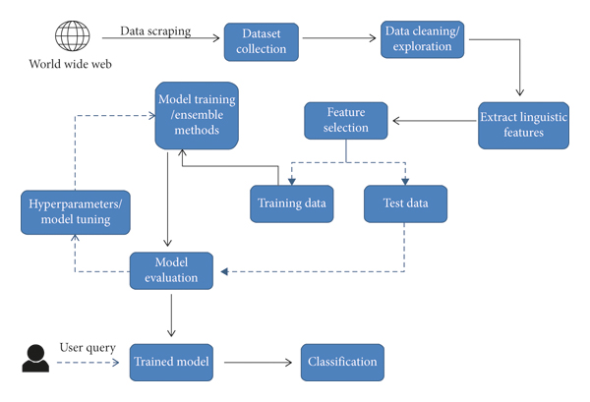

## Figure :- 1.1 System Architecture

Hereby, a set of properties are enlisted to make sure that the fake news system is classify the news are real or fake.

1. Develop an initial test for evaluating the originality of the news content and prioritize them accordingly.
2. Incorporation of machine learning algorithms for performing the processes of encryption and decryption to provide end-to-end security.
3. Activate with a Text classification to identify individuality of the particular News content using quality of text, algorithms and digital certificates.
4. Make use various Machine Learning algorithm for enabling classifying data set (news) from the social media to the other end of dataset.

On the other hand, data searching and retrieval from the cloud by the social media user also creates risks.

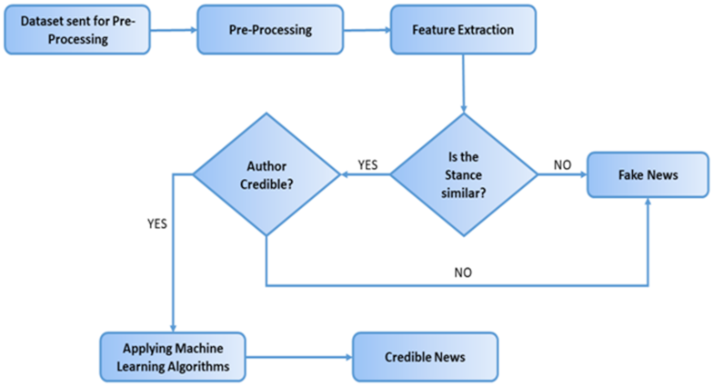

## Figure :- 1.2 work flow

**CHAPTER 2**

**SYSTEM ANALYSIS**

**2.1 EXISTING SYSTEM**

There exists a large body of research on the topic of machine learning methods for deception detection, most of it has been focusing on classifying online reviews and publicly available social media posts. Particularly since late 2019 during the COVID 19 pandemic situtation , the question of determining 'fake news' has also been the subject of particular attention within the literature. Conroy, Rubin, and Chen outlines several approaches that seem promising towards the aim of perfectly classify the misleading articles. They note that simple content-related n-grams and shallow parts-of-speech tagging have proven insufficient for the classification task, often failing to account for important context information.

**2.1.1 DISADVANTGES**

* Accuracy complexity

* Data (news) quality

**2.2 PROPOSED SYSTEM**

In this way using machine learning classification algorithms to news has been send through detecting accuracy increased as 97% as well as we improve the manual detection results. Most of common text classification and fake news detection have two type of way to handle detection online news, web articles like that

* Manual detection
* Automatic detection

**2.2.1 ADVANTAGES**

* Manual detection accuracy Increased

* Classification methods are simplified

.

**CHAPTER 3**

**LITERATURE SURVEY**

**Survey on Fake News Detection using Machine learning Algorithms**

**Dr. S. Rama Krishna, CSE Dept , , Mani Deep CSE Dept. apatla Engineering**

**College, Bapatla, India.**

**Dr. S. V. Vasantha IT Dept, V. S. R. Engineering College Hyderabad, India**

In this paper author delivered Due to easy access, rapid growth, and proliferation of the information available through regular news mediums or social media, it is becoming easy for people to look for news and consume it. These days a lot of information is being shared over social media and we are not able to differentiate between which information is Fake and which is legitimacy. For publishing a news in social media the cost is low, easy access. The extension spread of fake news has the potential for extremely negative impact on individuals and society. The goal of this project is to create an efficient machine learning algorithm for identifying the fake news.

**Drawbacks**

* Accuracy level is low
* Detection complexity

**Z Khanam1 , B N Alwasel1 , H Sirafi1 and M Rashid2 1College of Computing**

**and Informatics, Saudi Electronic University, Dammam, KSA 2School of**

**Computer Science and Engineering, Lovely Professional University, Jalandhar,**

**India.**

The fake news on social media and various other media is wide spreading and is a matter of serious concern due to its ability to cause a lot of social and national damage with destructive impacts. A lot of research is already focused on detecting it. This paper makes an analysis of the research related to fake news detection and explores the traditional machine learning models to choose the best, in order to create a model of a product with supervised machine learning algorithm, that can classify fake news as true or false, by using tools like python scikit-learn, NLP for textual analysis. This process will result in feature extraction and vectorization; we propose using Python scikit-learn library to perform tokenization and feature extraction of text data, because this library contains useful tools like Count Vectorizer and Tiff Vectorizer. Then, we will perform feature selection methods, to experiment and choose the best fit features to obtain the highest precision, according to confusion matrix results

**Alim Al Ayub Ahmed (alim@jju.edu.cn) 1School of Accounting, Jiujiang University, Jiujiang, Jiangxi, CHINA**

**Ayman Aljarbouh 2Department of Computer Science, University of Central Asia, 310 Lenin Street, 722918 Naryn, KYRGYZSTAN**

In this paper, the author presents a detailed survey under the theme of reliable

Internet is one of the important inventions and a large number of persons are its users. These persons use this for different purposes. There are different social media platforms that are accessible to these users. Any user can make a post or spread the news through these online platforms. These platforms do not verify the users or their posts. So some of the users try to spread fake news through these platforms. These fake news can be a propaganda against an individual, society, organization or political party. A human being is unable to detect all these fake news. So there is a need for machine learning classifiers that can detect these fake news automatically. Use of machine learning classifiers for detecting the fake news is described in this systematic literature review.

**Parth Patwa , Shivam Sharma , Srinivas PYKL , Vineeth Guptha,**

**Gitanjali Kumari, Md Shad Akhtar , Asif Ekbal , Amitava Das, Tanmoy**

**IIIT Sri City, India. IIIT Delhi, India IIT Patna, India. Wipro Reseach,**

**India.**

Along with COVID-19 pandemic we are also fighting an ’infodemic’. Fake news and rumours are rampant on social media. Believing in rumours can cause significant harm. This is further exacerbated at the time of a pan- demic. To tackle this, we curate and release a manually annotated dataset of 10,700 social media posts and articles of real and fake news on COVID-19. We perform a binary classification task (real vs fake) and bench- mark the annotated dataset with four machine learning baselines - Decision Tree, Logistic Regression, Gradient Boost, and Support Vector Machine (SVM). We obtain the best performance of 93.32% F1-score with SVM on the test set. The data and code is available at: https://github.com/parthpatwa/ covid19-fake-news-dectection

**Drawbacks**

* Accuracy moderated 93.32%

* Complex features are considered for classification.

**Nihel Fatimar Bahari Computer science department, Mohamed Khider**

**University of Biskra , IEEE EXPLORE 2021**

The phenomenon of Fake news is experiencing a rapid and growing progress with the evolution of the means of communication and Social media. Fake news detection is an emerging research area which is gaining big interest. It faces however some challenges due to the limited resources such as datasets and processing and analysing techniques. In this work, we propose a system for Fake news detection that uses machine learning techniques. We used term frequency-inverse document frequency (TF-IDF) of bag of words and n-grams as feature extraction technique, and Support Vector Machine (SVM) as a classifier. We propose also a dataset of fake and true news to train the proposed system. Obtained results show the efficiency of the system. In this work, we propose a system for Fake news detection that uses machine learning techniques. We used term frequency-inverse document frequency (TF-IDF) of bag of words and n-grams as feature extraction technique, and Support Vector Machine (SVM) as a classifier. We propose also a dataset of fake and true news to train the proposed system. Obtained results show the efficiency of the system.

**CHAPTER 4**

**SYSTEM REQUIREMENTS**

* 1. **SOFTWARE REQUIREMENTS**

**Languages:** Python

Numpy

Pandas

Itertools

Matplotlib

sklearn

**CHAPTER 5**

**SOFTWARE DESCRIPTION AND SYSTEM DESIGN**

**5.1 PYTHON:**

Python was created by [Guido van Rossum](https://gvanrossum.github.io/), and first released on

February 20, 1991. While you may know the python as a large snake, the name of

sketch series called *Monty Python’s Flying Circus*. One of the amazing features of

Python is the Python programming language comes from an old BBC television

comedy the fact this at it is actually one person’s work. Usually, new programming

languages are developed and published by large companies employing lots of

professionals, and due to copyright rules, it is very hard to name any of the people

involved in the project. Python is an exception. Of course, Guido van Rossum did

not develop and evolve all the Python components himself. The speed with which

Python has spread around the world is a result of the continuous work of thousands

(very often anonymous) programmers, testers, users (many of them aren’t IT

specialists) and enthusiasts, but it must be said that the very first idea (the seed from

which Python sprouted) came to one head – Guido

.

**5.2 THE MAJOR CHARACTERISTICS OF PYTHON**

### **Object oriented**

One of the main characteristics of Python is that it is an object-oriented programming language. This means that Python recognizes the concept of class and object encapsulation, which makes coding with Python more efficient in the long run.

As such, Python makes it easy to create inherited object classes. This means that, building from things that have already been done, you can create new classes that will inherit the attributes of the previous ones, which simplifies and improves the long-term efficiency of the code.

### **Open Source**

Yet another of the main characteristics of Python is that it is an open source programming language. Anyone can create and contribute to its development.

This in turn means that it has a large community that works to improve and facilitate the learning of this programming system. Also, it is free to download for any operating system, including Windows, Mac or Linux.

### **Easy to learn**

Python is a very user-friendly code for all types of developers, from those who already have experience with other languages to those who are learning to program from scratch.

If you already have experience with C, C++, Java or C#, Python is a good system with which to continue growing and expanding your programming knowledge. If you’re just starting out, with the right training, it’s easy to jump in and learn how to do things in a very short time.

### **Integration and adaptation**

Another of the main characteristics of Python is that it is an integrated programming language. This means that it executes the code line by line.

What does this imply? It means that Python, unlike other coding languages, does not compile, which makes the process of debugging code much easier and more efficient. Another advantage of this characteristic of Python is that it makes execution easier and saves time in the long run.

### **GUI support**

GUI stands out for Graphical User Interface, which is a key aspect of any programming language as it helps add style to the code and makes the programmer’s work much more visible.

In this sense, Python is compatible with a wide range of GUIs, which can be easily imported, making it a widely used system in Data Science, as it facilitates data visualization.

### **High level programming**

As we said at the beginning, one of the main characteristics of Python is that it has been designed to become a high-level programming language.

That means that, when working with it, you don’t need to know the code structure, architecture, or memory management. This simplifies the work of programmers.

### **Portable**

Let’s see this feature through a practical case: suppose you are working with Python on Windows, but you need to transfer your work to Mac or Linux. With Python you can do this without having to make any changes in the code.

This portability between different operating systems is something that not all programming languages have, which is why Python has become one of the most portable systems today, a great advantage in its main fields of application.

**5.3 ALGORITHMS:**

**NAIVE BAYES CLASSIFIER AND ITS USES:**

In machine learning, naive Bayes classifiers are the part of simple machine learning. Naive Bayes is popular algorithm which is used to find the accuracy of the news whether its real or fake using multinomial NB and pipelining concepts. There are number of algorithms that focus on common principle, so it is not the only algorithm for training such classifiers. To check if the news is fake or real naive Bayes can be used.

It is a kind of algorithm is used in text classification. The use of token is correlated with the news that may be fake or not fake in naïve Bayes classifier and then the accuracy of the news is calculated by using Bayes theorem.

NAÏVE BAYES FORMULA DETAILS The following is the formula for naive Bayes classification uses the probability of the previous event and compares it with the existing event. Each and every probability of the event is calculated and at last the overall probability of the news as compared to the dataset is calculated. Therefore on calculating the overall probability, we can get the approximate value and can detect whether the news is real or fake. P (A|B) = P (B|A) · P (A) / P (B), (1) Finding the probability of event, A when event B is TRUE P (A) = PRIOR PROBABILITY P (A|B) = POSTERIOR PROBABILITY FINDING PROBABILITY: P (A|B1) = P (A1||B1). P (A2||B1). P (A3||B1) (2) P (A|B2) =P (A1||B2). P (A||B2). P (A3||B2) (3) If the probability is 0 P (Word) = Word count +1/ (total number of words+ No. of unique words) Therefore, by using this formula one can find the accuracy of the news.

* **GGN**:

Recent papers like[Graph Neural Networks with Continual Learning for Fake News Detection from Social Media](https://arxiv.org/pdf/2007.03316.pdf) and[User Preference-aware Fake News Detection](https://arxiv.org/pdf/2104.12259.pdf) use a complex combination of attention-based representation of sentences and training a graph neural network with them. This system uses text as well as user metadata (like tweet details or history of such malicious posts) not just to detect false news but also to track users or accounts that are likely to generate false news based on recent behaviour and stop that post from spreading more.

* **Bi-LSTM + Attention:**

This method achieved the second rank in the FNC-1 (Fake News Challenge Stage 1) dataset leaderboard with a weighted accuracy score of 84.60. In the paper,[Combining Similarity Features and Deep Representation Learning for Stance Detection in the Context of Checking Fake News](https://arxiv.org/pdf/1811.00706v1.pdf), bi-directional [Recurrent Neural Networks (RNNs)](https://www.projectpro.io/article/rnn-vs-cnn-the-difference/491) are used together with max-pooling over the temporal/sequential dimension and neural attention for representing the headline, the first two sentences of the news article, and the entire news article. These representations are combined and passed to a final layer that predicts the news media stance.

* **CNN + DNN:**

This relatively straightforward method vectorizes the text using the term

frequency-inverse document frequency (TF-IDF). It computes the similarity

between the headlines and the body text as a new feature. This matrix is fed

to a shallow CNN for feature extraction and then forwards to a feed forwarded

deep neural network that ends with a soft max layer This method works well

for the FNC-1 dataset, given that the distinctions between true news and false

news are so apparent. However, the term frequency-inverse document

frequency (TF-IDF) and the combination of CNN and DNN help recognize

features otherwise missed by standard LSTM-based mode

**5.4** **Proposed model Diagram**

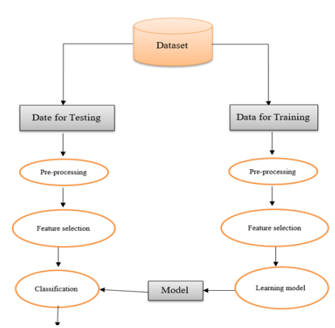

**Scope and features of machine learning algorithms:**

* Classification has cleared.
* Easy to understand by flow chart
* Simple equations
* Logistic method.

**CHAPSYSTEM DESIGN**

**6.1 SYSTEM ARCHITECTURE**

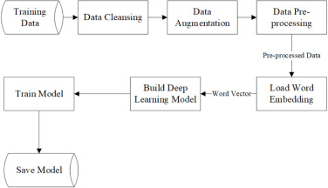

## 6.2 DATA FLOW DIAGRAM

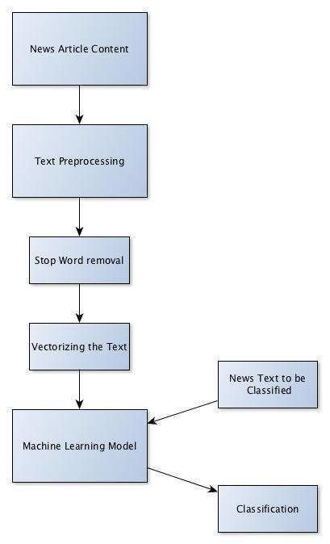

## 6.3 E-R Diagram

In entity-relationship diagram (ERD) is a data modeling technique that graphically illustrates an information system’s entities and the relationships between those entities. An ERD is a conceptual and representational model of data used to represent the entity framework infrastructure.

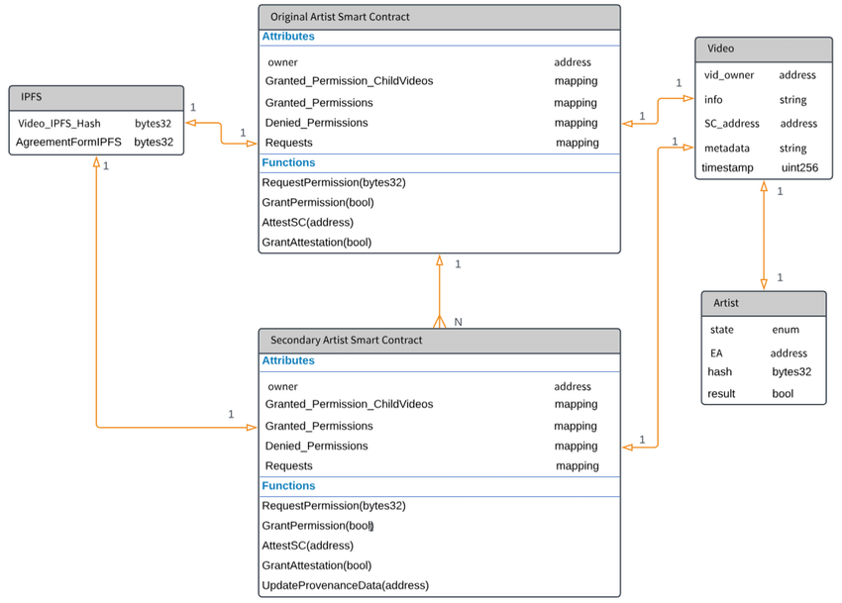

**Figure :- 6.3 E-R Diagram**

**6.4 UNIFIED MODELLING LANGUAGE DIAGRAMS**

UML stands for Unified Modeling Language. This object-oriented system of notation has evolved from the work of Grady Booch, James Rumbaing, Ivar Jacobson, and the Rational Software Corporation. These renowned computer scientists fused their respective technologies into a single, standardized model. Today, UML is accepted by the Object Management Group (OMG) as the standard for modeling object-oriented programs.

A picture is worth a thousand words, this absolutely fits while discussing about UML. Object oriented concepts were introduced much earlier than UML. So, at that time there were no standard methodologies to organize and consolidate the object-oriented development. At that point of time UML came into picture.

There are a number of goals for developing UML but the most important is to define some general-purpose modeling language which all modelers can also it needs to be made simple to understand and use.

UML diagrams are not only made for developers but also for business users, common people and anybody interested to understand the system. The system can be a software or non-software.So it must be clear that UML is not development method rather it accompanies with processes to make a successful system.

At the conclusion the goal of UML can be defined as a simple modeling mechanism to model all possible practical systems in today’s complex environment.

**6.4.1 USE CASE DIAGRAM**

**Figure :- 6.4.1 USE CASE DIAGRAM**

A use case is a methodology used in system analysis to identify, clarify, and organize system requirements. The use case is made up of a set of possible sequences of interactions between systems and users in a particular environment and related to a particular goal.

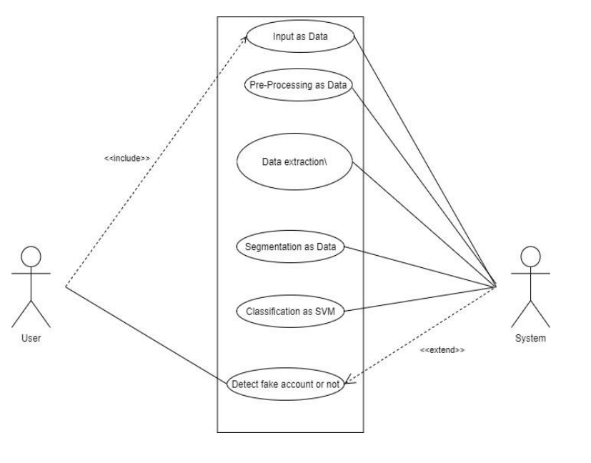

# 6.4.2 CLASS DIAGRAM

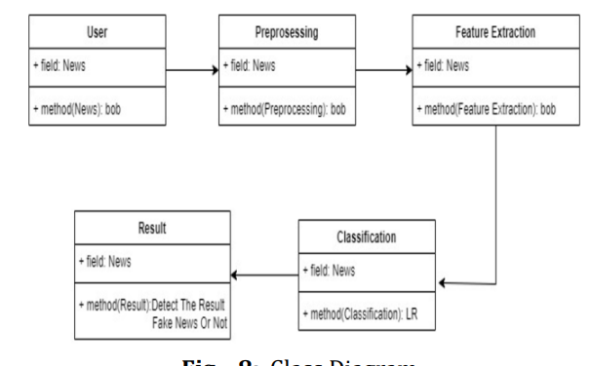

**Figure :- 6.4.2 CLASS DIAGRAM**

A class diagram is an illustration of the relationships and source code dependencies among classes in the Unified Modelling Language (UML). In this context, a class defines the methods and variables in an object, which is a specific entity in a program or the unit of code representing that entity. Class diagrams is useful in all forms of object-oriented programming (OOP). The concept is several years old but has been refined as OOP modelling paradigms have evolved.

**6.4.3 SEQUENCE DIAGRAM**

**Figure :- 6.4.3 SEQUENCE DIAGRAM**

A sequence diagram, in the context of UML, represents object collaboration and is used to define event sequences between objects for a certain outcome. Sequence diagram is an essential component used in processes related to analysis, design and documentation. A sequence diagram is also known as a timing diagram, event diagram and event scenario.

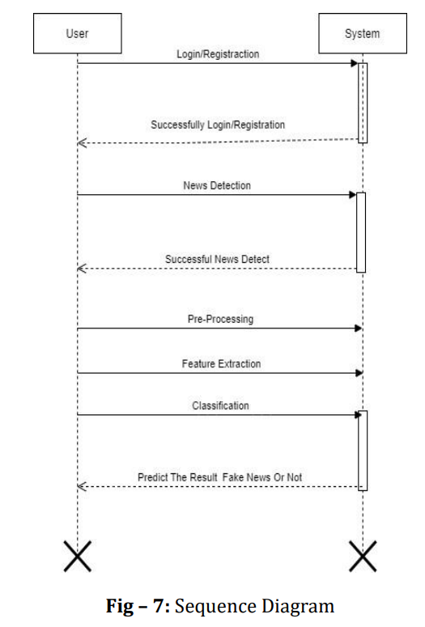

. **CHAPTER 8**

**SCREENSHOTS**

Step 1: install anaconda navigator and open Jupyter notebook

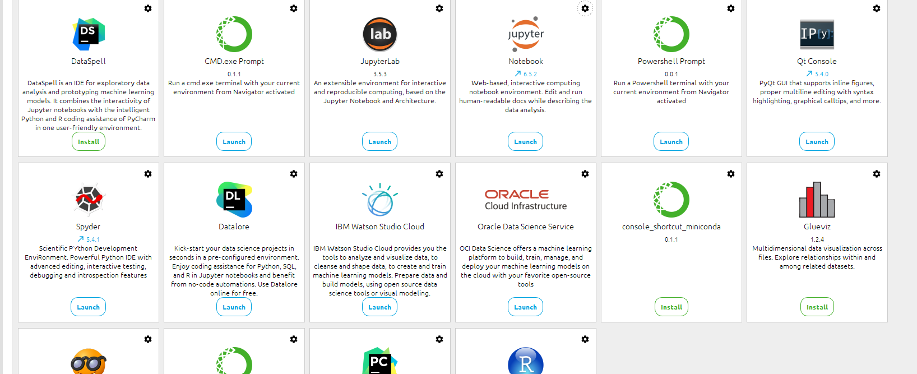

Step 2: Upload the data set to the jupyter notebook

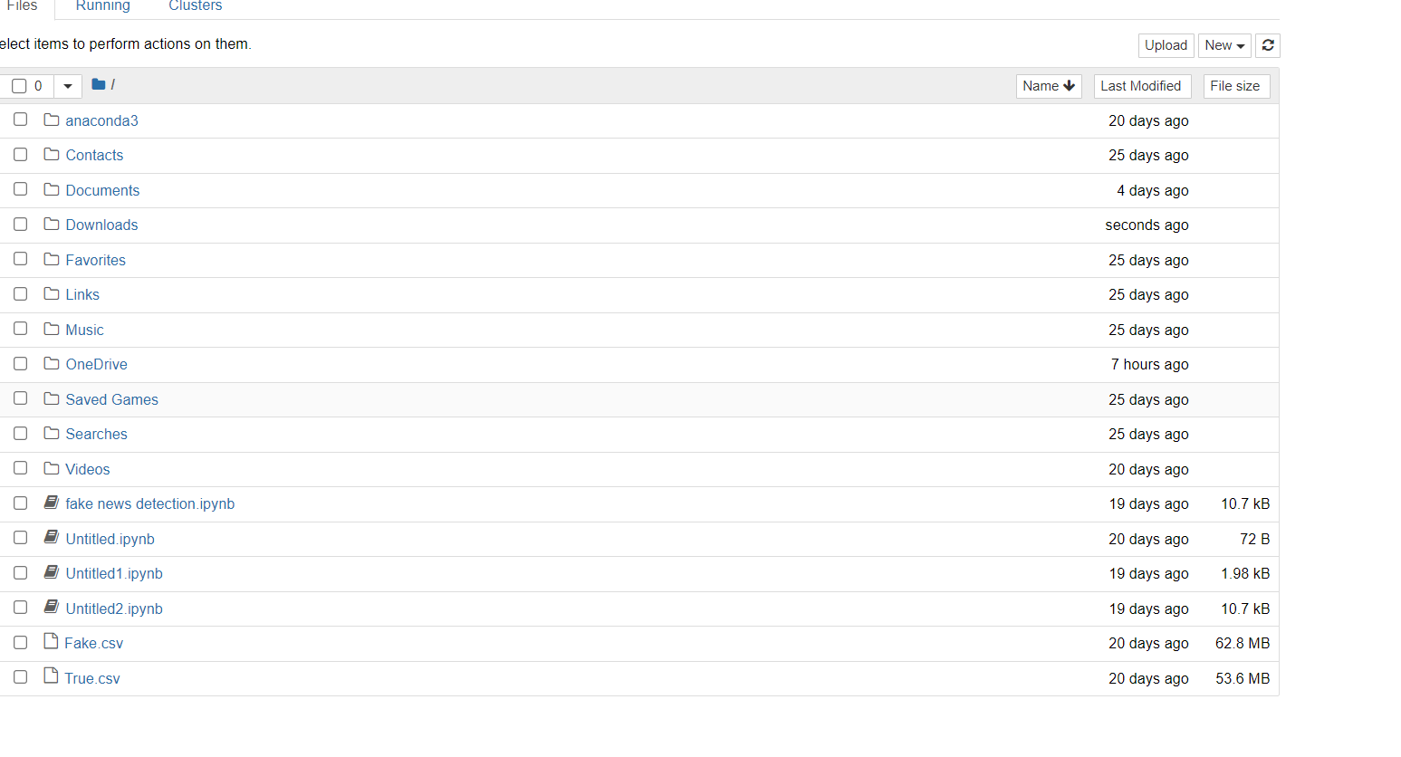

Step 3 : import data sets using pandas and get source from sklearn

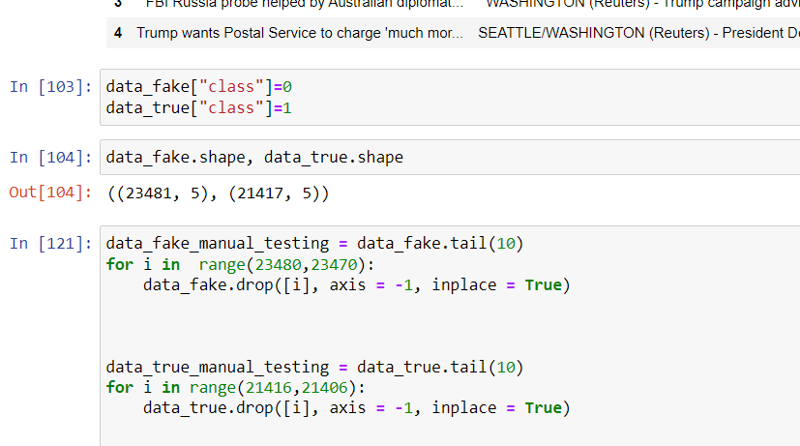

Step 4 : Finally news classified

**CHAPTER 9**

**CONCLUSION & FUTURE ENHANCEMENT**

**9.1 CONCLUSION**

A lightweight load balancing and offloading of computations that identifies the presence of security threats in the based social environment. An effective and secure load balancing and computation offloading model for multi-user, multi-task, multitier machine learning and systems, where mobile device users are reallocated in a well- organized way to balance the load between sBS s and reduce overall communication cost. Further, a new security layer that infuses ECG signal features

**9.2 USE CASE / APPLICATION:**

Fake news detection has a wide range of applications across various industries. Let Us explore some real-world applications of false news detection.

1. **Social Media**

False news spreads quickly on social media platforms, leading to misinformation and confusion. Many leading social media platforms have implemented false news detection algorithms to combat this issue. For example, Twitter uses machine learning to detect and flag potentially misleading or false information in tweets.

1. **News/Journalism**

News organizations use machine learning algorithms to verify information and sources. For example, the BBC developed a tool called "Project Origin," which uses natural language processing (NLP) and machine learning techniques to identify the origin of images and videos and determine if they are authentic or have been manipulated.

1. **Politics**

False news can significantly impact political campaigns and elections. Several political organizations have developed tools to detect false news and misinformation. For example, the German political party CDU developed a tool called "Augmented Intelligence for Quality Journalism" (AIQ), which uses machine learning to identify and fact-check news articles.

1. **Finance**

False news can also significantly impact financial markets. Hedge funds and investment firms use machine learning algorithms to analyze news sources and detect false news that could impact the stock market. For example, Dataminr uses machine learning techniques to analyze social media feeds and news sources to provide real-time alerts on events that could impact financial markets.

1. **Healthcare**

False news can also seriously affect the healthcare industry. Several organizations use machine learning to identify false healthcare and medical research news. For example, researchers at the University of Michigan developed an ‘IRIS’ tool that uses natural language processing and machine learning to identify false news related to healthcare and medical research.

**REFERENCES**

* 1. B. Yang, X. Cao, J. Bassey, X. Li, and L. Qian, “Computation offloading in multi-access edge computing: A multi-task learning approach,” IEEE Transactions on Mobile Computing, 2020.

* 1. Y. Zhan, S. Guo, P. Li, and J. Zhang, “A deep reinforcement learning based offloading game in edge computing,” IEEE Transactions on Computers, 2020.

* 1. N. Tsafack, J. Kengne, B. Abd-El-Atty, A. M. Iliyasu, K. Hirota, and

A. A. Abd EL-Latif, “Design and implementation of a simple dynamical

4-d chaotic circuit with applications in image encryption,” Information Sciences, vol. 515, pp. 191–217, 2020

* 1. I. A. Elgendy, W.-Z. Zhang, Y. Zeng, H. He, Y.-C. Tian, and Y. Yang, “Efficient and secure multi-user multi-task computation offloading for mobile-edge computing in mobile iot networks,” IEEE Transactions on Network and Service Management, 2020.

* 1. J. Ren, G. Yu, Y. He, and G. Y. Li, “Collaborative cloud and edge computing for latency minimization,” IEEE Transactions on Vehicular Technology, vol. 68, no. 5, pp. 5031–5044, 2019.

* 1. S. Li, Y. Tao, X. Qin, L. Liu, Z. Zhang, and P. Zhang, “Energy- aware mobile edge computation offloading for iot over heterogenous networks,” IEEE Access, vol. 7, pp. 13 092–13 105, 2019.

* 1. L. Huang, X. Feng, L. Zhang, L. Qian, and Y. Wu, “Multi-server multi-user multi-task computation offloading for mobile edge computing networks,” Sensors, vol. 19, no. 6, p. 1446, 2019.

* 1. Y. Xiao, Y. Jia, C. Liu, X. Cheng, J. Yu, and W. Lv, “Edge computing security: State of the art and challenges,” Proceedings of the IEEE, vol. 107, no. 8, pp. 1608–1631, 2019.

* 1. S.Shanthi Rekha and P. Saravanan, “Low-cost aes-128 implementation for edge devices in iot applications,” Journal of Circuits, Systems and Computers, vol. 28, no. 04, p. 1950062, 2019.

* 1. M. Hammad, G. Luo, and K. Wang, “Cancelable biometric authentication system based on ecg,” Multimedia Tools and Applications, vol. 78, no. 2, pp. 1857–1887, 2019.

* 1. T. Meng, K. Wolter, H. Wu, and Q. Wang, “A secure and cost- efficient offloading policy for mobile cloud computing against timing attacks,” Pervasive and Mobile Computing, vol. 45, pp. 4–18, 2018.

* 1. S. Almajali, H. B. Salameh, M. Ayyash, and H. Elgala, “A framework for efficient and secured mobility of iot devices in mobile edge computing,” Third International Conference on Fog and Mobile Edge Computing (FMEC). IEEE, 2018, pp. 58–62.2018

* 1. Z. Wang, Z. Zhao, G. Min, X. Huang, Q. Ni, and R. Wang, “User mobility aware task assignment for mobile edge computing,” Future Generation Computer Systems, vol. 85, pp. 1–8, 2018.

* 1. Y.-D. Lin, C. C. Wang, Y.-J. Lu, Y.-C. Lai, and H.-C. Yang, “Twotier dynamic load balancing in sdn-enabled wi-fi networks,” Wireless Networks, vol. 24, no. 8, pp. 2811–2823, 2018.

* 1. M. Hammad, A. Maher, K. Wang, F. Jiang, and M. Amrani, “Detection of abnormal heart conditions based on characteristics of ecg signals,” Measurement, vol. 125, pp. 634–644, 2018

* 1. A. Abdullah, B. M. Alsolami, H. M. Alyahya, and M. H. Alotibi, ``Intrusion detection of DoS attacks in WSNs using classication techniuqes,'' J. Fundam. Appl. Sci., vol. 10, no. 4S, pp. 298303, 2018.

* 1. Y. Hao, M. Chen, L. Hu, M. S. Hossain, and A. Ghoneim, “Energy efficient task caching and offloading for mobile edge computing,” IEEE Access, vol. 6, pp. 11 365–11 373, 2018.

* 1. S. R. Moosavi, E. Nigussie, M. Levorato, S. Virtanen, and J. Isoaho, “Low-latency approach for secure ecg feature based cryptographic key generation,” IEEE Access, vol. 6, pp. 428–442, 2017.

* 1. F. Wang, J. Xu, X. Wang, and S. Cui, “Joint offloading and computing optimization in wireless powered mobile-edge computing systems,” IEEE Transactions on Wireless Communications, vol. 17, no. 3, pp. 1784–1797, 2017.

* 1. X. Chen, L. Jiao, W. Li, and X. Fu, “Efficient multi-user computation offloading for mobile-edge cloud computing,” IEEE/ACM

Transactions on Networking, vol. 24, no. 5, pp. 2795–2808, October 2016.

* 1. X. Lyu and H. Tian, “Adaptive receding horizon offloading strategy under dynamic environment,” IEEE Communications Letters, vol. 20, no. 5, pp. 878–881, 2016.

* 1. IEEE, 2015, pp. 606–610. S. Deb and P. Monogioudis, “Learningbased uplink interference management in 4g lte cellular systems,” IEEE/ACM Transactions on Networking (TON), vol. 23, no. 2, pp. 398– 411, 2015.

* 1. J. Daemen and V. Rijmen, The design of Rijndael: AES-the advanced encryption standard. Springer Science & Business Media, 2013.

* 1. M. Amin and A. A. Abd El-Latif, “Efficient modified rc5 based on chaos adapted to image encryption,” Journal of Electronic imaging, vol.

19, no. 1, p. 013012, 2015.