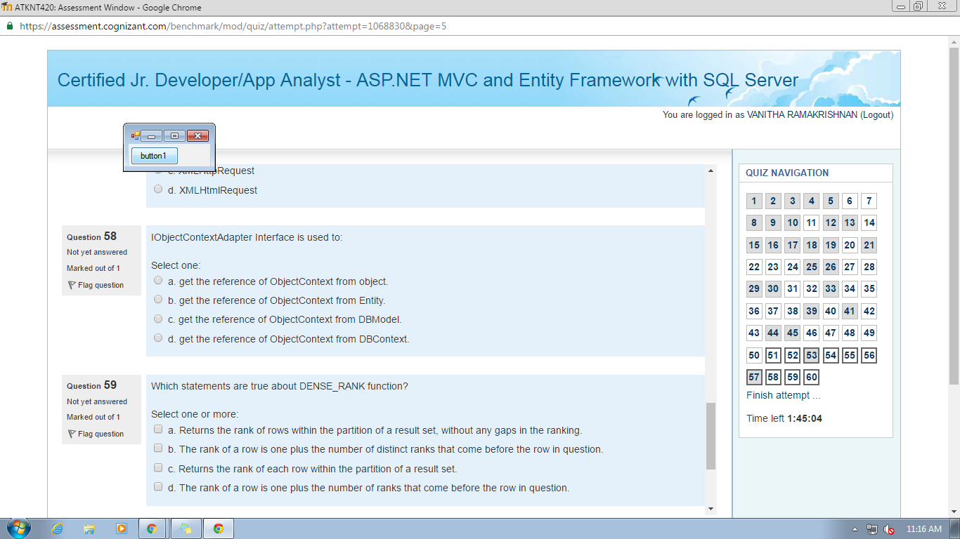6) true or false

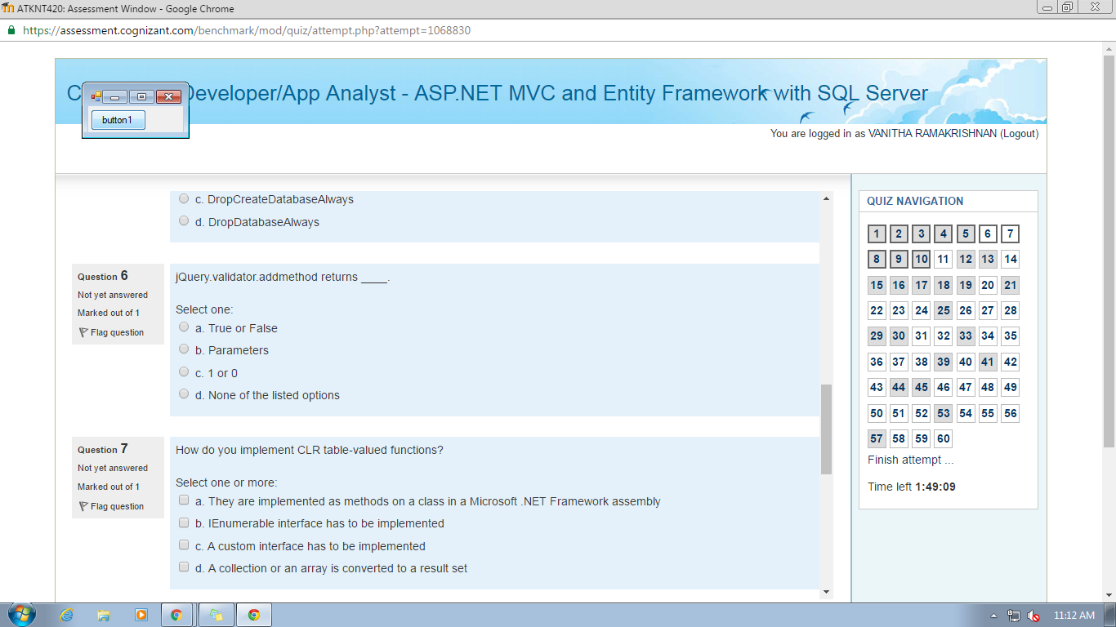7) a,b & d

59) a and b

60) a, b and d

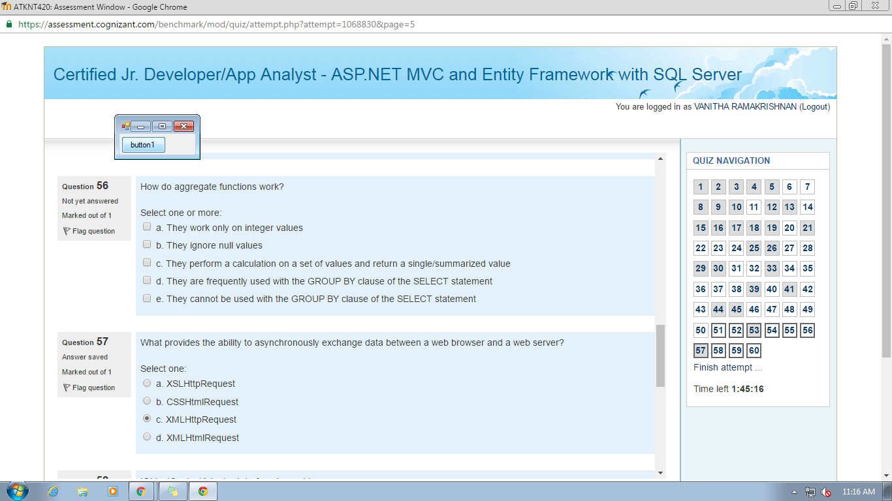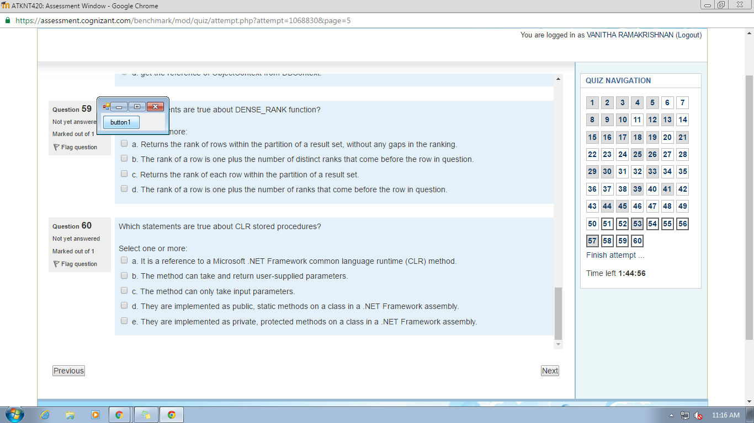58) d

56) b c d

57) c

54) a…….. I and II

55)a b d

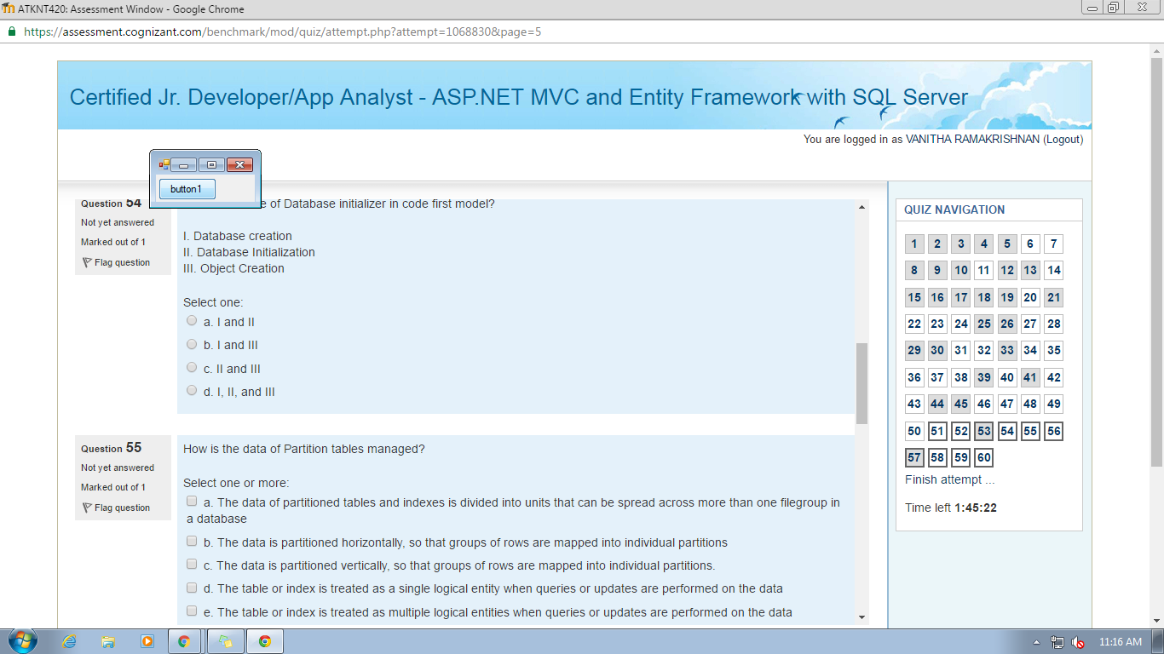

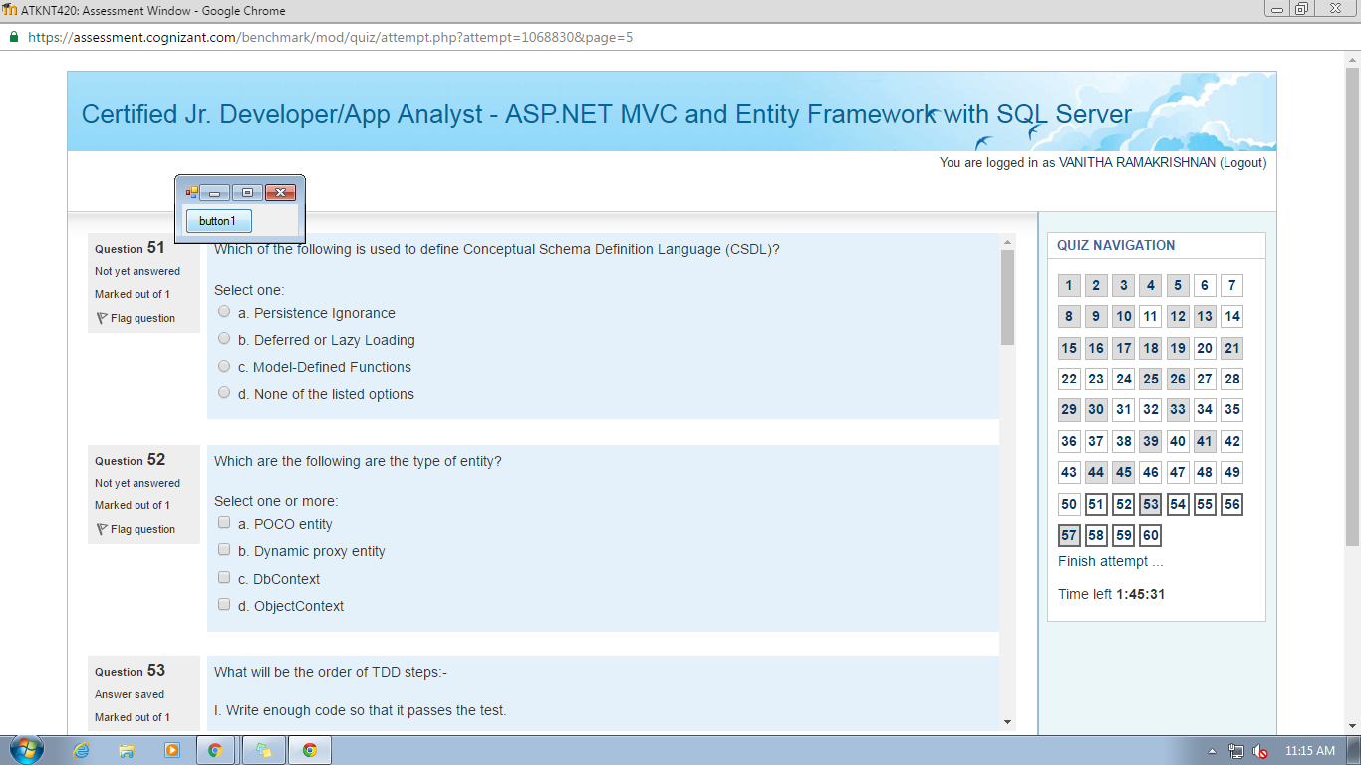

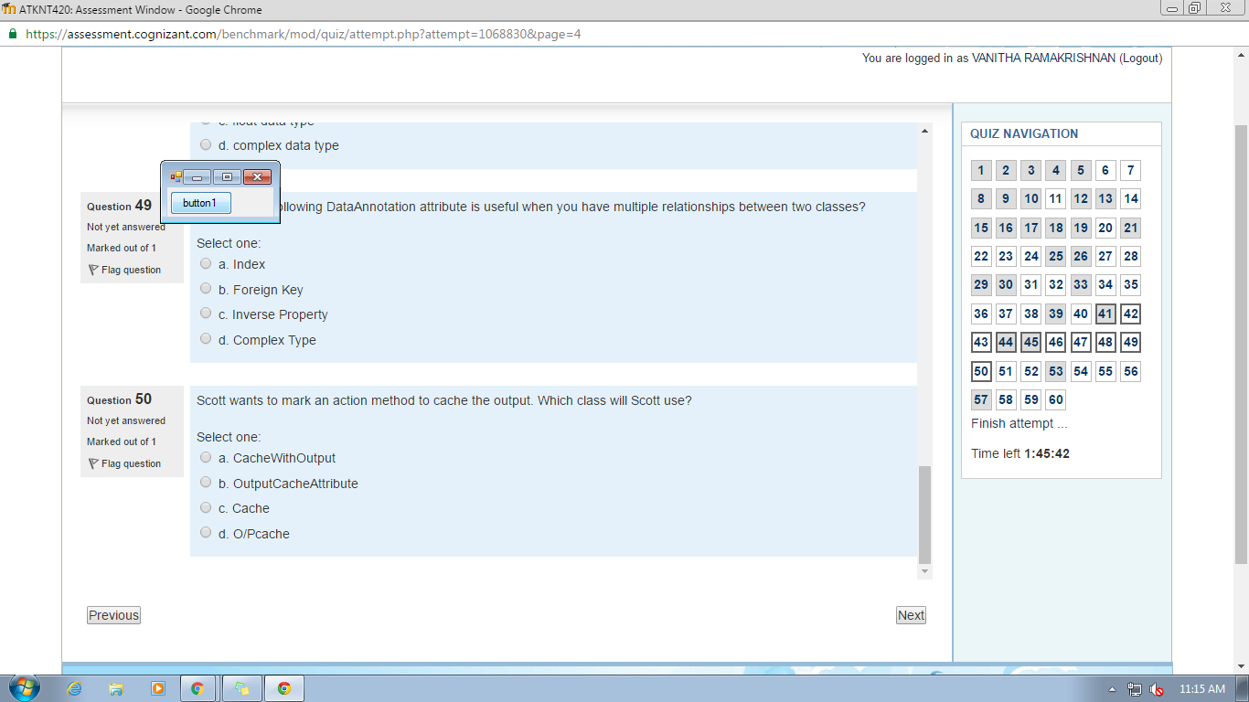51) model defined functions

52) a abd b

49) inverse property

50) output chache attribute

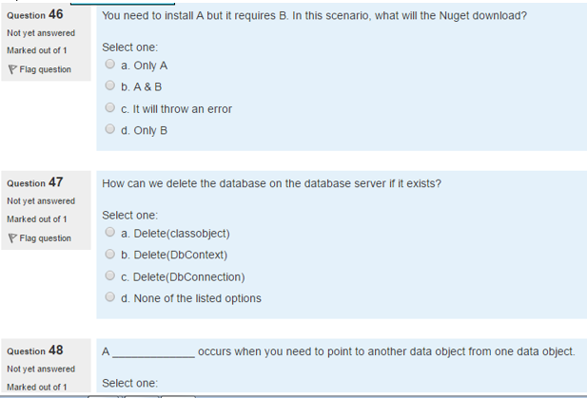

47 ) c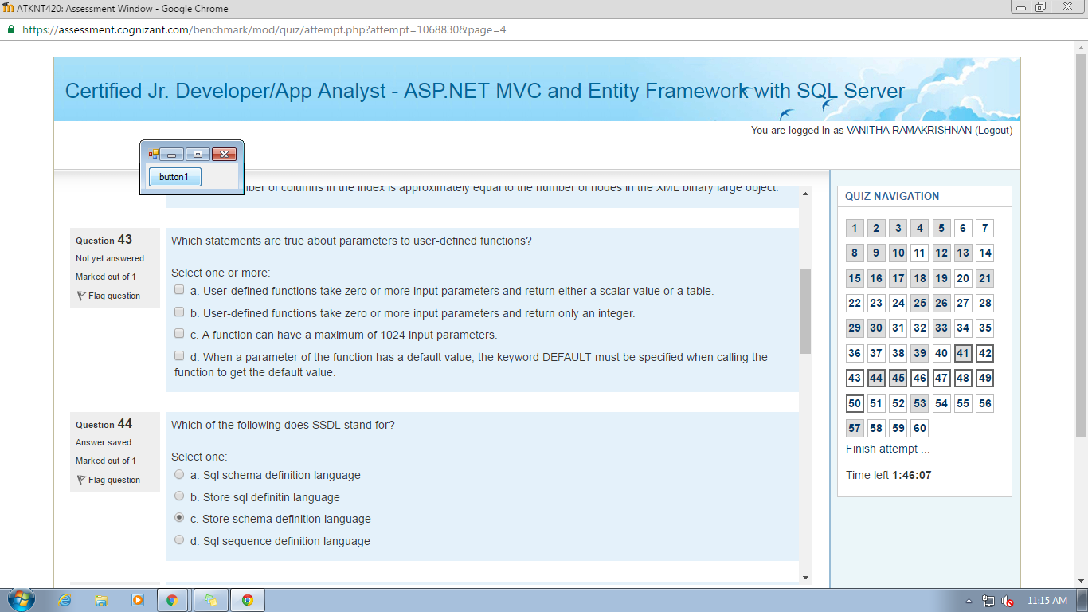

43) a c d

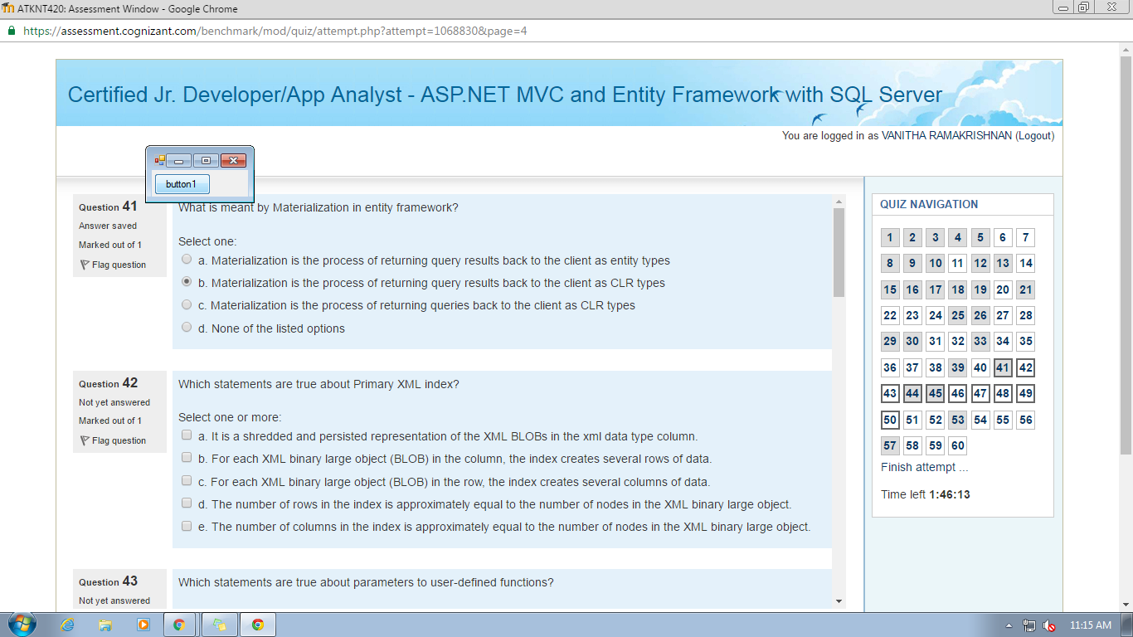

42) a b d

40) a c e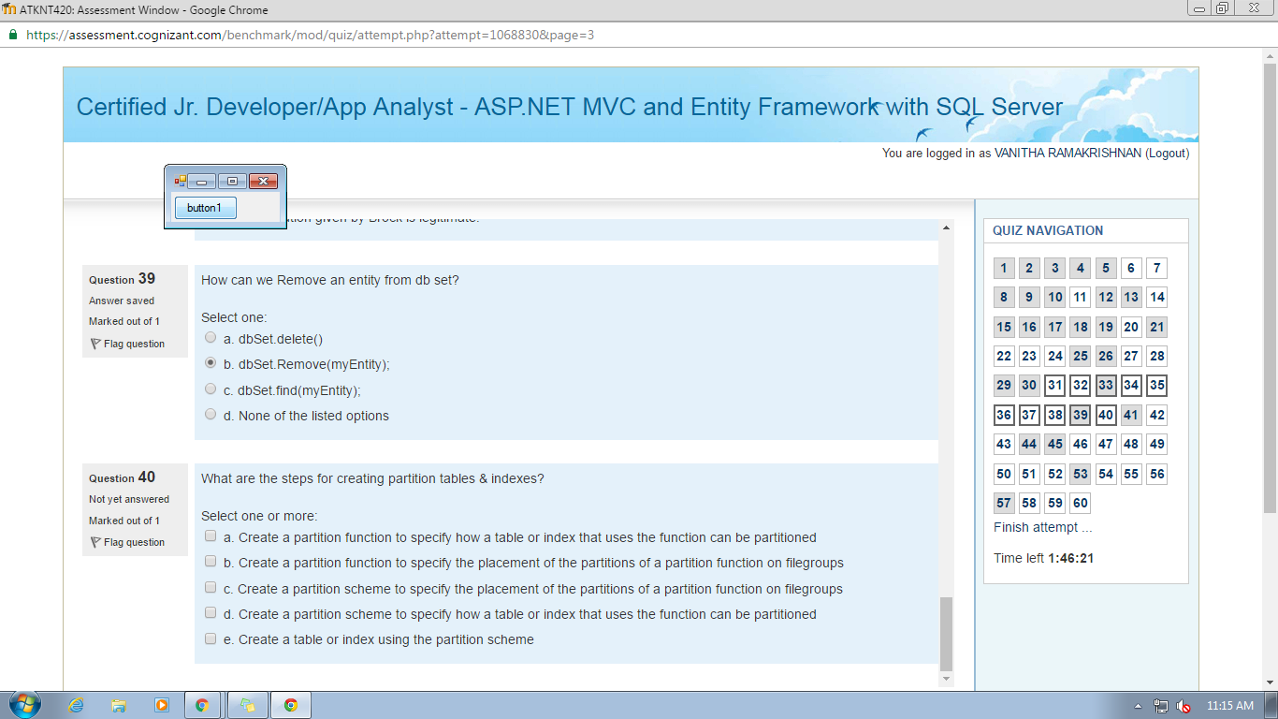

37) true

38) c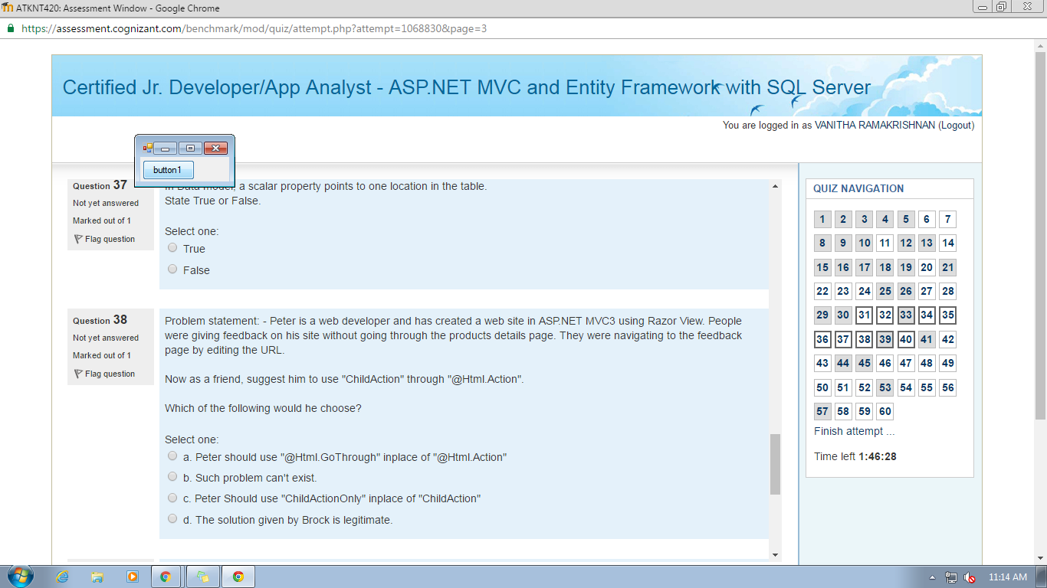

35 ) a

36) using(Html.BeginForm("index","Product"))

{

Html.DropDownList("Range",new selectList(viewBag.Ranges))

<input type="submit" value="filter"/>

}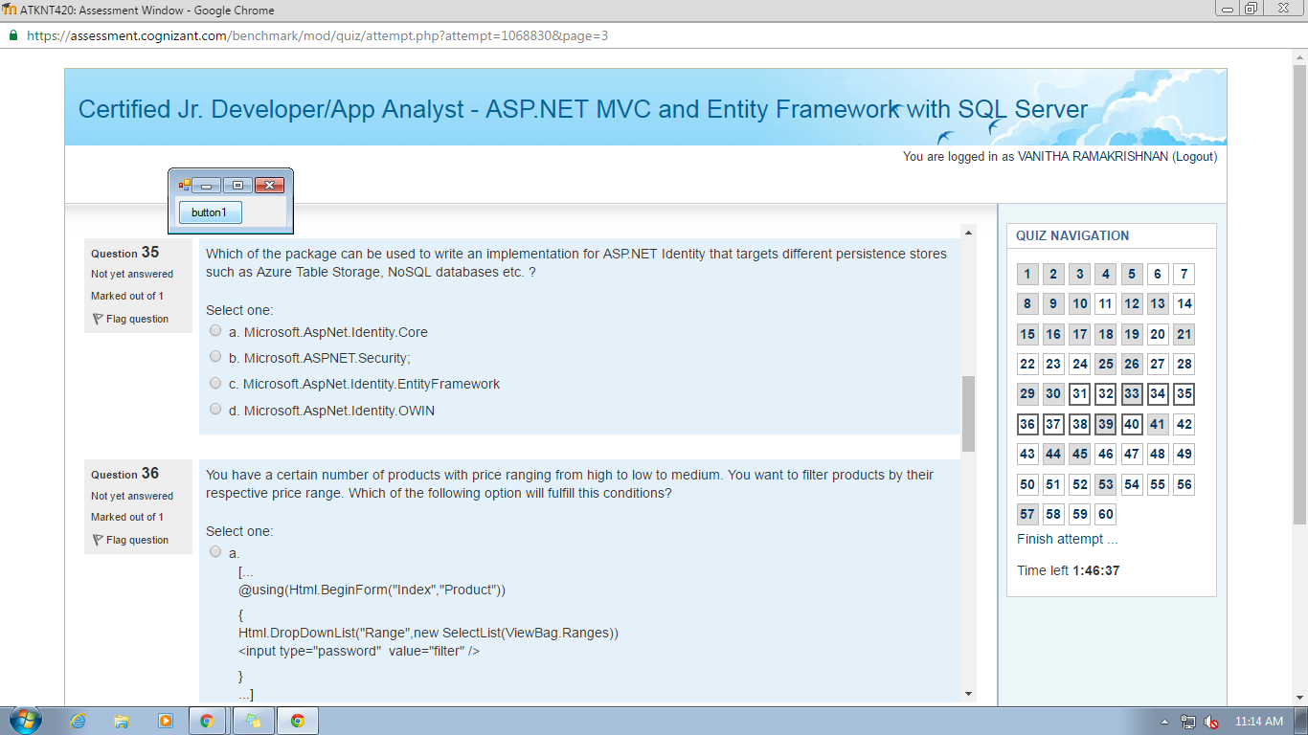

34) b

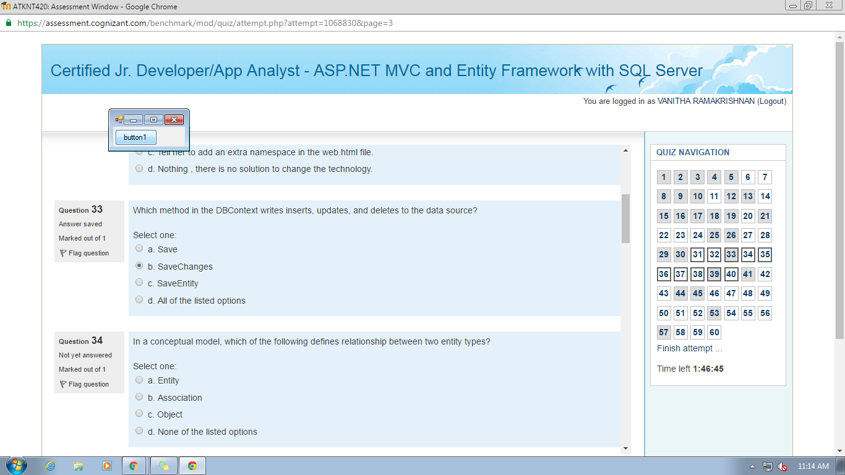

31) a b d e 32) b

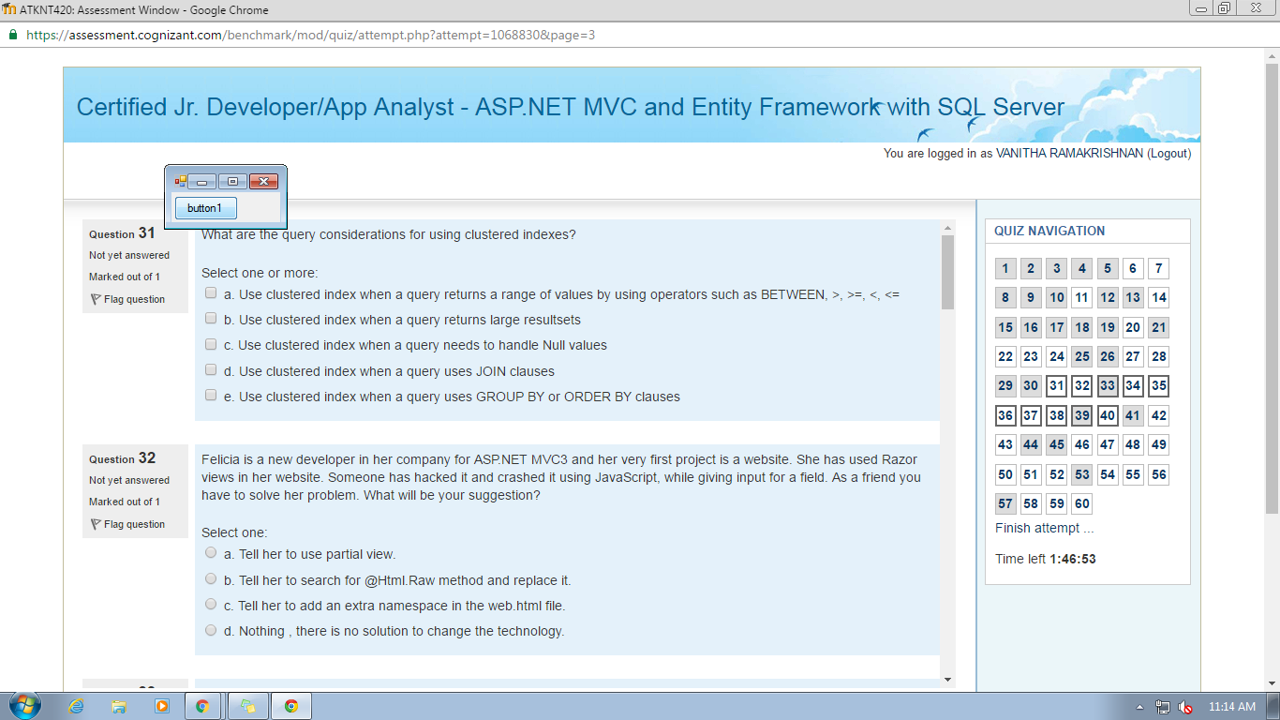

27) c d 28) b

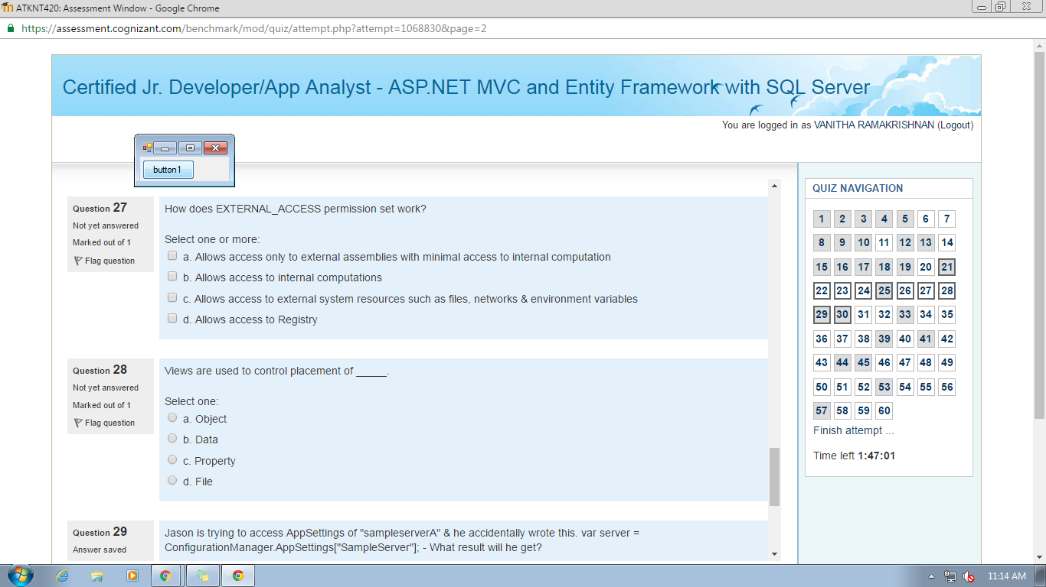

26 ) a 24) b

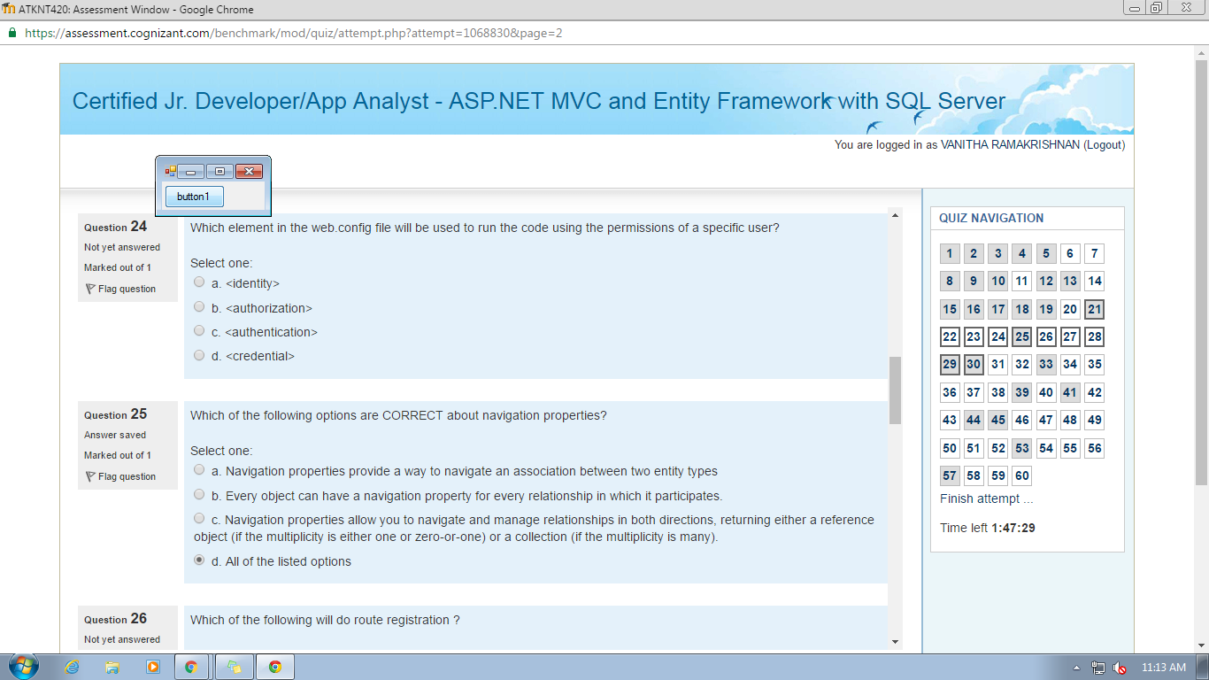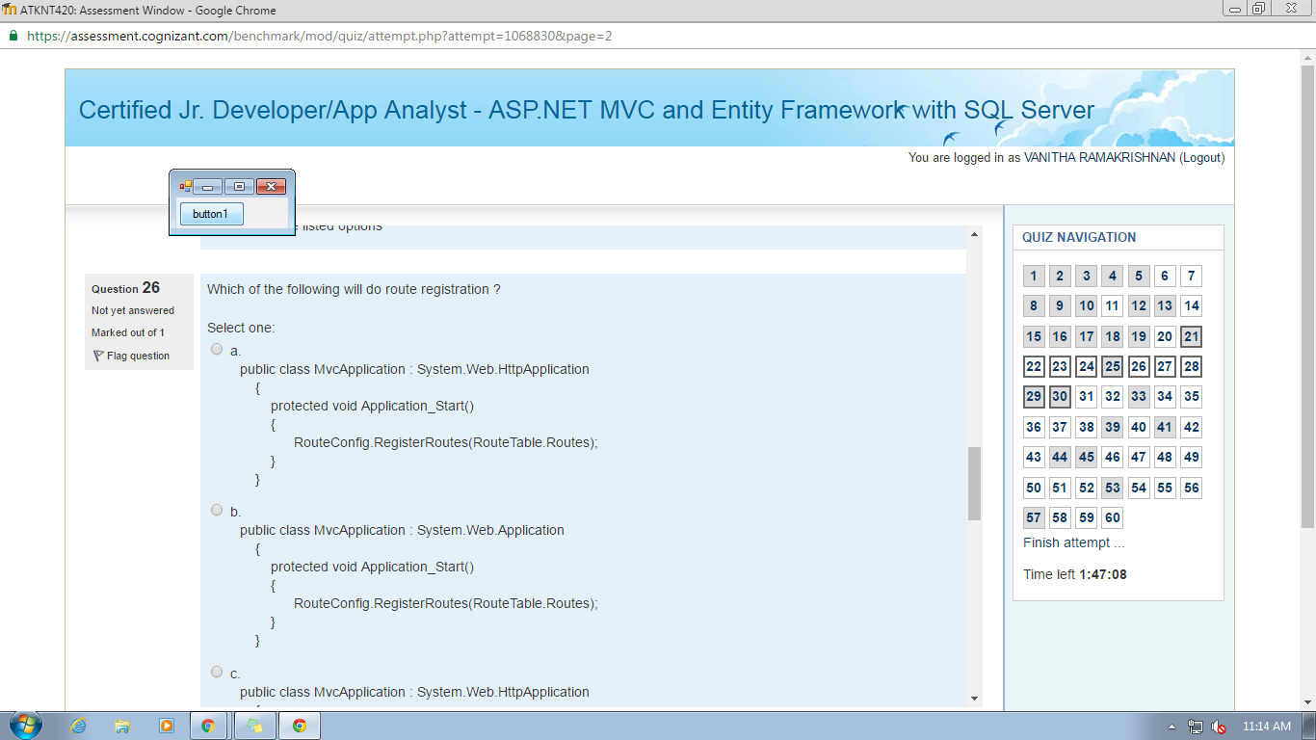

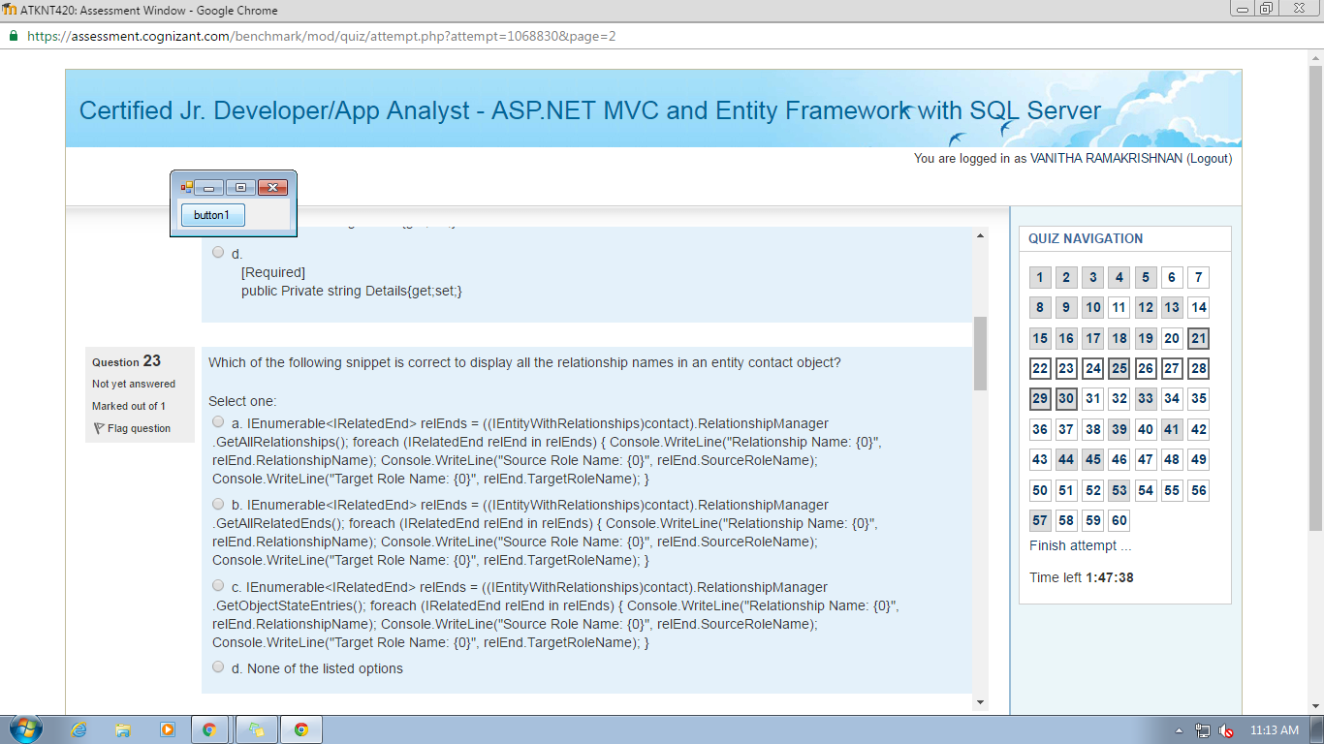

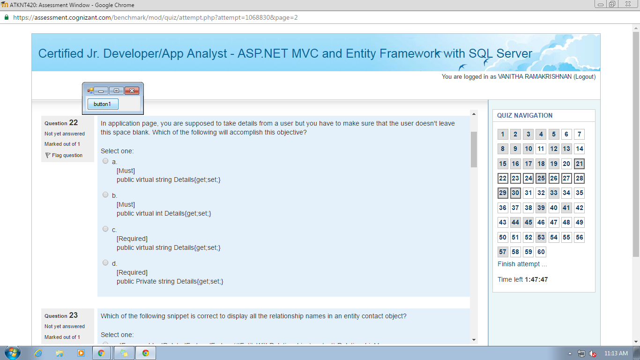

22) c

20.types of indexes-------->clustered,unique,nonclustered,Index with included columns

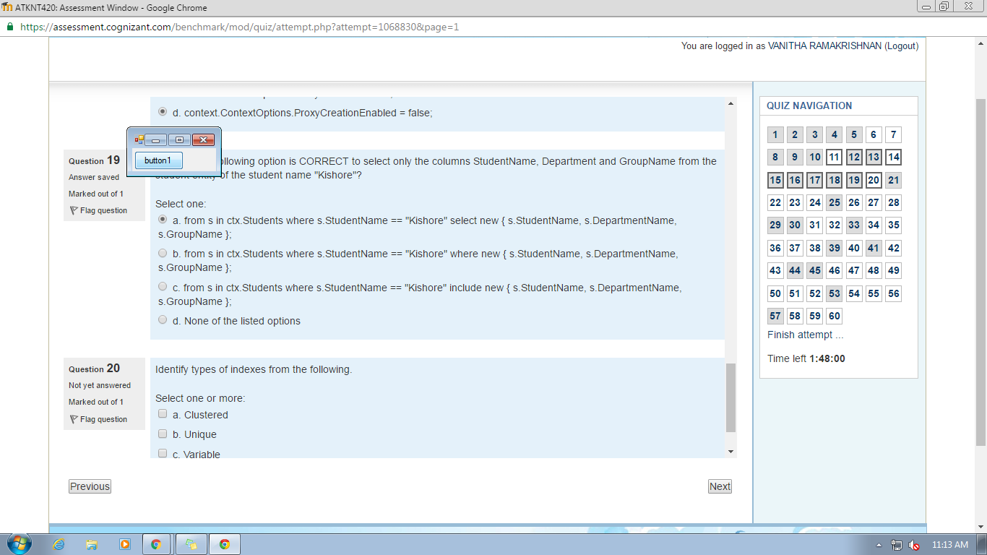

14) a and b

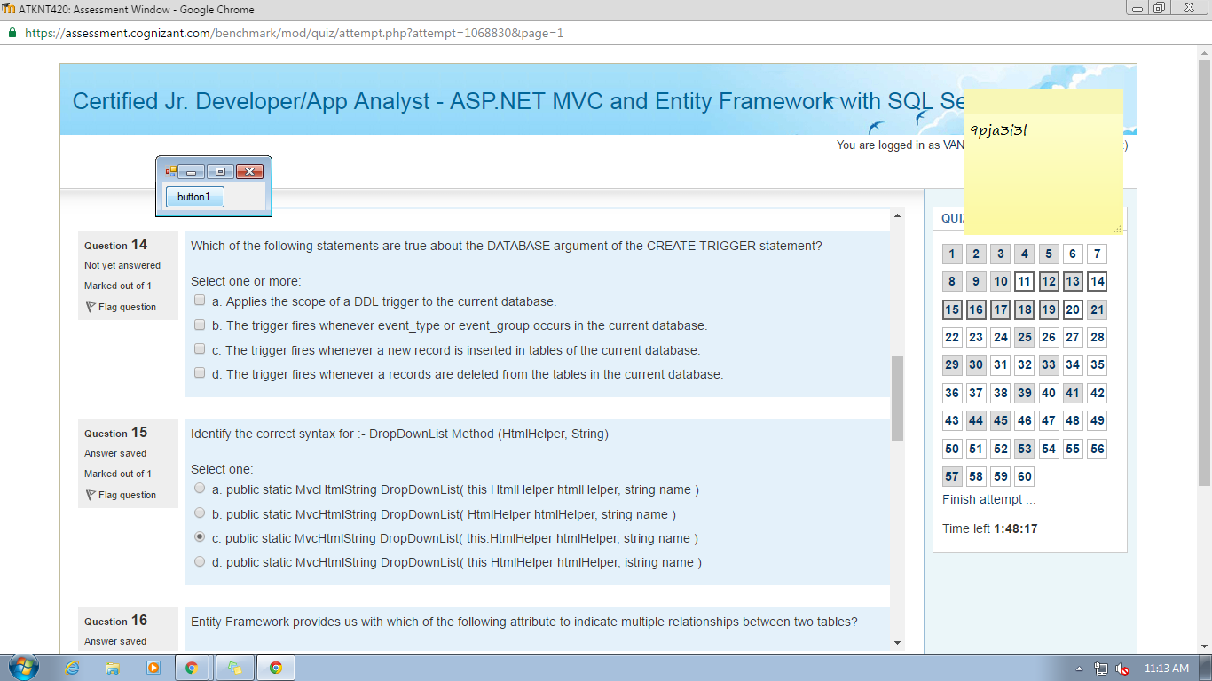

11) b 12) I only

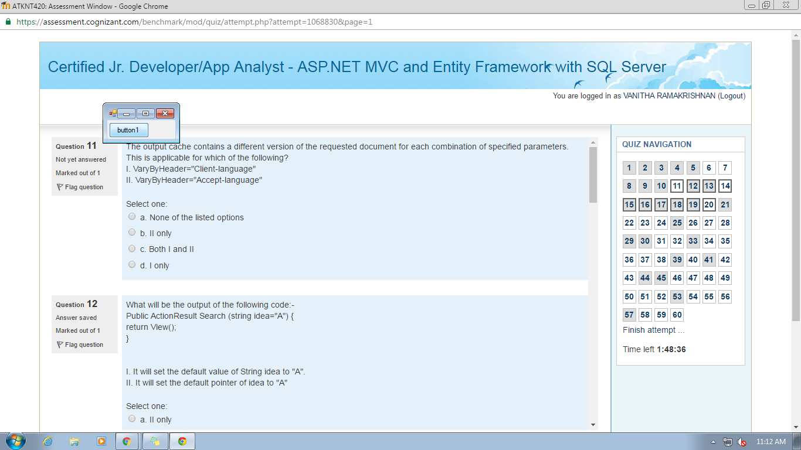

6.jQuery.Vaidator.addmethod----------->a.True or False

7.CLR-table vaued functions----------->

11.VaryByHeader---------->b.

12.String idea="A"-------------------->I only

14.Create trigger---------------------->a & b

15.DropDownList Method Syntax---------->b

19."kishore"-------------->a

20.types of indexes-------->clustered,unique,nonclustered,Index with included columns

22.don't eave the spae blank----------->c

24.web.config-------->b

25.naviation poperties------>d

26.route registration-------->a

27.EXTERNA_ACCESS permission------------>c,d

28.views are used to conro pacement of------------->b

31.consideration of clusered indexes----------------->a,b,d,e

32.Felicia is a new deveoper------------>b

33.which method in DBContext-------------->b

34.relationship between two entity types-------------->b

35.Azure Table storage--------------------->a

36.[...------------------------------------ -----ANS

@using(Html.BeginForm("index","Product"))

{

Html.DropDownList("Range",new selectList(viewBag.Ranges))

<input type="submit" value="filter"/>

}

...]

37.scalar location property points----------->true

38.peter is a web developer----------->c

39.reove an enity from db det--------->b

40.steps for creating partition tables-------->a,c,e

41.maeriazation in entity framework------------>b

42.primary XML index----------->a,b,d

43.paraeters to user-defined functions---------->a,c,d

44.SSDL stands for------------->c

45. scrrenshot ila ma

46.Nuget download------------->a

47.deete the database on the database server if it exist------->c

49.multiple relaionship between two classes---------->c

50.scott wants o mark an action method--------------->b

51.define CSDL------------->model-defined function

52.pe of entiy--------->Dynamic Proxy (POCO Proxy),POCO Entity

53.order of TDD steps----------->write unit test, write enough,run the test,watch

54.database initiaiser----------->database creation and initialization

55.partition table managed--------->a,b,d

The data of partitioned tables and indexes is divided into units that can be spread across more than one filegroup in a database.

The data is partitioned horizontally, so that groups of rows are mapped into individual partitions.

The table or index is treated as a single logical entity when queries or updates are performed on the data.

56.aggregate-function work-------------->b,c,d

57.between web browser and a web server------------>c

58.IObjetContextAdapter---------->d

59.Dese_Rank function------------>a,b

60.CLR-stored procedures--------->a,b,d